Impact of Drinking and Smoking on Diabetes

Group 7
Minh Long Vu
Riyan Gohel
Sheridan College
PROG38063: Data Analysis and Visualization 2
Prof. Farah Hussein
April 08, 2026

Impact of Drinking and Smoking on Diabetes
Task 1: Data Exploration and Preprocessing
  - Introduction to the Dataset:
a) Diabetes Problem
Diabetes is one of the most dangerous diseases in the modern world. A study on diabetes in 2019 [1] estimates that diabetes accounts for roughly 11% of adult deaths in globe. Not only it is dangerous itself, type 2 diabetes, which accounts for 90% of diabetes, could lead to the development of other dangerous diseases such as Chronic Kidney Disease [2]. Smoking and drinking are considered two risk factors of diabetes [3]. These factors usually come together in adult life since an increase in one will lead to an increase in the other [4]. While some sources confirm that smoking does have an impact on diabetes [3][5], the impact of drinking and its joint impact with smoking remains controversial[3].Thus, this study will examine the impact of both smoking and drinking on diabetes. It asks a main research question: “How do smoking and drinking impact the likelihood of diabetes?”.
b) Kaggle dataset
To answer the main research question, we use the dataset "Diabetes Health Indicators Dataset"[6] from Kaggle. It is collected by BRFSS and published on Kaggle by Alex Teboul. It is the collection of more than 400,000 survey for American people in 2015. The dataset [6] has CC0: Public Domain license which mean it can be analyzed without permission [7]. It contains information about individuals’ health conditions, lifestyle behaviors, and demographic characteristics. It includes variables such as BMI, smoking status, alcohol consumption, physical activity, and diabetes status. The dataset is structured in a tabular format where each row represents an individual and each column represents a specific health-related variable
c) Reason for the choice of dataset:
This data set was chosen because it is directly related to the research topic and includes important variables such as smoking and drinking for our research. Furthermore, [6] is one of reliable not synthetic dataset in Kaggle. The large size of the dataset also helps in producing reliable and meaningful results.
1.2: Data Summarization
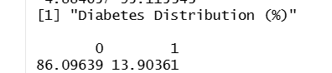
Figure 1. Distribution for diabetes
Diabetes people only have a small propotion which is true since not everyone has diabetes.
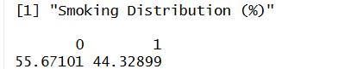
Figure 2. Distribution for Smoking
The figure show that smoking people accounts for substantial proportion compared to non-smoking

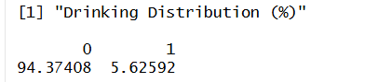
Figure 3. Distribution for Drinking
There are less people who drink compare to those who smoke.

1.3 Data Visualization
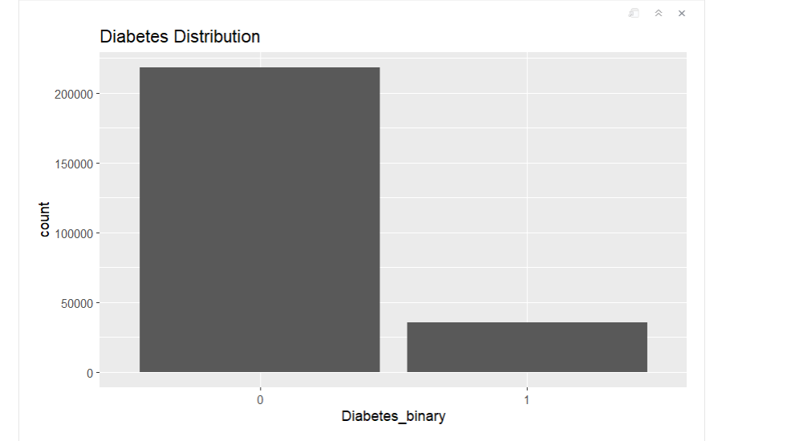
Figure 4. Distribution of diabetes where 0 means no-diabetes and 1 means diabetes

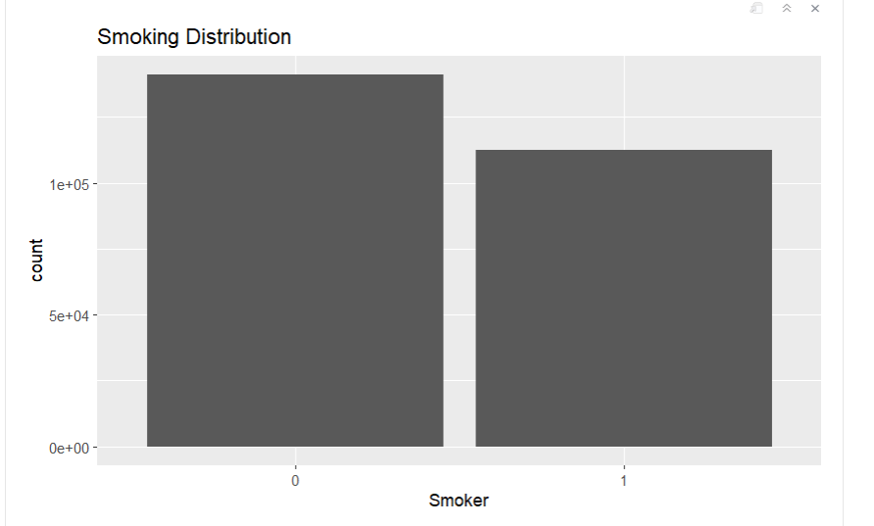
Figure 5. Distribution of smoker where 0 means no smoking and 1 means smoking
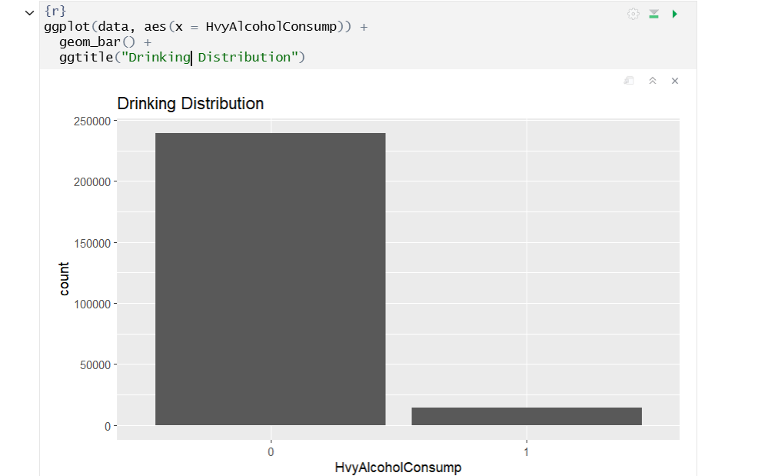
Figure 6. Distribution of drinker where 0 means no and 1 means drinking

1.4. Data Quality Assessment, Data Wrangling and Cleaning:
The dataset is very clean since the author who published it already done the data Cleaning.
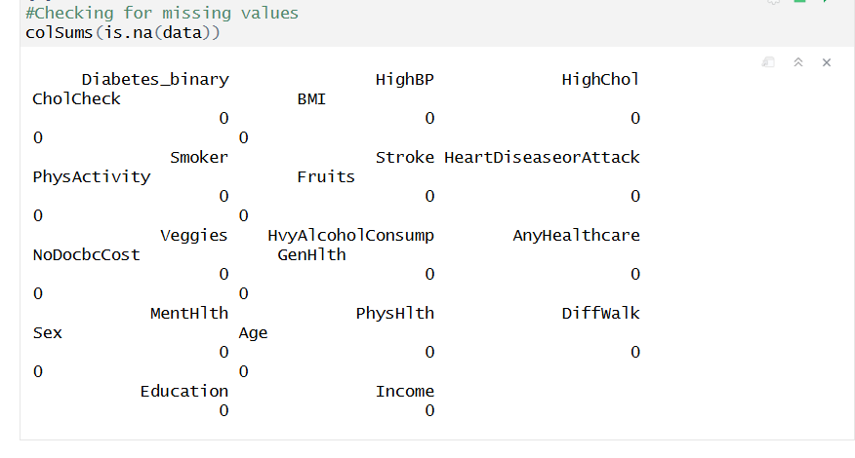
Figure 7. Cleaned dataset
In our study, we only focus effect smoking and drinking for ordinary people. Ordinary people means they don’t have extreme unsual metrics. Thus, we restrict our study only to those who have BMI between 10 and 60.
Task 2: Hypothesis Testing and Statistical Inferences
2.1. Research Question Development:
As stated in Task 1, the main research question for this study is: “How do smoking and heavy alcohol consumption impact the likelihood of diabetes?”. In order to answer this, two sub-questions are asked
(a). Does Smoking or Drinking individually impact the likelihood of diabetes?
(b). How do Smoking and Drinking jointly impact the likelihood of diabetes?
We focus on answer the question (a) in Task 2 by using chi-square test and (b) in Task 3 by using multivariate logistic regression. In this study, we are interested in 3 variables in both task 2 and task 3:
- Smoker (Independent variable)
Question: Have you smoked at least 100 cigarettes in your entire life?
Answer: 0 = No, 1 = Yes
- HvyAlcoholConsump (Independent variable):
Question: Heavy drinkers where adult men having more than 14 drinks per week or adult women having more than 7 drinks per week

Answer: 0 = No, 1 = Yes
- Diabetes_binary (Target variable):
Question: Are you diabetes or Pre/diabetes
Answer: (0 = No diabetes, 1 = PreDiabetes or Diabetes
Since (a) is also broad question, it can be further divided into two sub-questions:
(a.1) Does Smoking impact the likelihood of diabetes?
(a.2) Does Drinking impact the likelihood of diabetes?
2.2 Data Preparation
a) Prepare Contingency table
First we conduct the contingency tables one between Smoking and Diabetes and one between drinking and diabetes
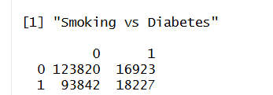
Figure 8. Smoking versus Diabetes Contigency Table

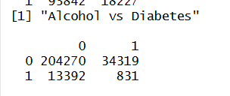
Figure 9. Drinking versus Diabetes Contigency Table
b) Checking assumption
[1] All variables used in the test should be categorical:
In this case, Smoking, Alcohol consumption, and Diabetes are categorical variables, so this condition is satisfied.

[2] The observations should be independent:
Since each row in the dataset represents a different individual, this assumption is also satisfied.

[3] The expected frequency in each cell should be at least 5:
That is given below
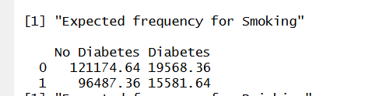
Figure 10. Expected Frequency for Smoking
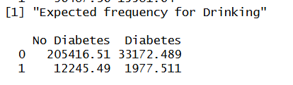
Figure 11. Expected Frequency for Drinking
As we see that each cell has expected frequency above 5 so this condition is satisfied.
All the assumptions are satisfied now so we are ready to conduct our thesis
2.3 Hypothesis construction and testing
Question (1): Does Smoking impact the likelihood of diabetes?
Null H0: Smoking and diabetes are not related
Alternative H1: Smoking and diabetes are related
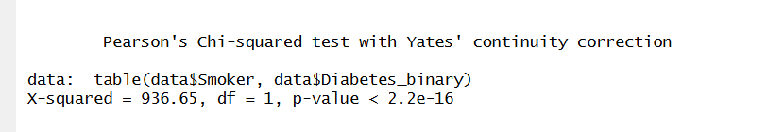
Figure 11. Result of Chi-squared test for Smoking
p-value less than 0.05. We reject the null hypothesis and favor alternative
Question (2): Does Drinking impact the likelihood of diabetes?
Null H0: Drinking and diabetes are not related
Alternative H1: Drinking and diabetes are related
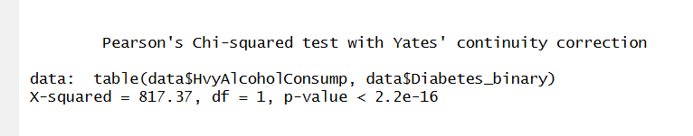
Figure 12. Result of Chi-squared test for Drinking
p-value less than 0.05. We reject the null hypothesis and favor alternative
Result: In both cases, we reject the null hypothesis. This means that both smoking and alcohol
consumption have a statistically significant association with diabetes
status, including no diabetes and diabetes.
2.4 Rationale for test choice
The chi-square test is used because all variables are categorical. It helps in checking whether there is a relationship between two categorical variables. One limitation is that it only shows association and not how strong the relationship is. Also, it does not include other factors.
Task 3: Insight Derivation
3.1. Research Question:
In Task 2, the impact of smoking and alcohol consumption on diabetes was analyzed separately using chi-square test. That helped in understanding their individual effects.
In this task, the focus is on understanding their combined impact. We answer the question
(b). How do Smoking and Drinking jointly impact the likelihood of diabetes?
This is important because in real life, people are often exposed to multiple lifestyle factors together. Furthermore, as stated in [3], the past literature usually look at individual impacts such as what we did in task 2, but their joint impact is not well-studied. So instead of just looking individual impacts like task 2, Task 3 use advance analytical approach by using Multivariate Logistic Regression to study their join impact on the likelihood of having diabetes.
3.2 Model Selection:
a) Multivariate Logistic Regression
[8] taught us that when dealing with categorical variables, we should use Multivariate Logistic Regression. It can be used in R by using Generalized Linear Model lcm
b) Checking Assumption
[1] The dependent variable should be categorical
In this case, Diabetes is categorical, so this condition is satisfied.
[2] The observations should be independent
Each row represents a different individual, so this assumption is satisfied.
[3] There should not be a strong relationship between independent variables
Since only Smoking and Alcohol are used, this issue is minimal.

Those assumptions are satisfied so the regression model will be created
to study the joint effect of smoking and alcohol on diabetes.
3.3: Model Fitting and Evaluation:
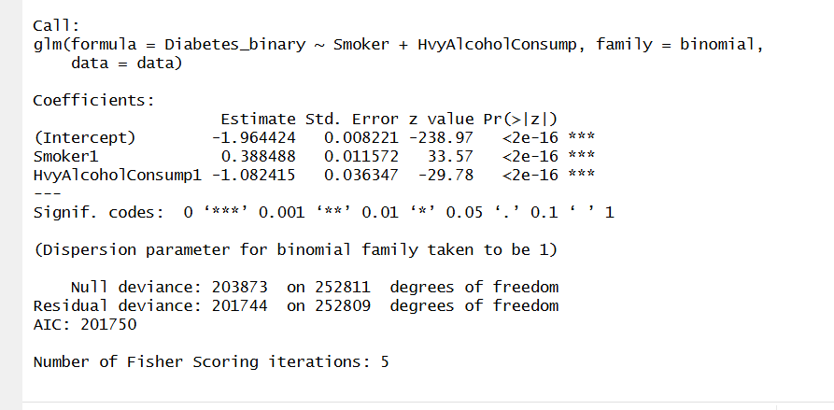
Figure 13. Result of Multivariate Logistic Regression
As seen above, the small p value of both variables are small which double-check the task 2. However, according to [8], the coefficient are in log-odd ratio format which is quite hard to interpret. Thus we convert it to odd ratio using exponent function
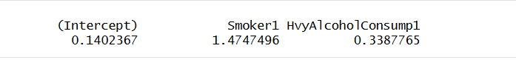
Figure 14. Coefficient for odd ratio of logistic Regression
Smoker: for every unit increase in Smoker1 or Smoking, the likelihood of having diabetes increase by 47,47%
HvyAlcoholConsump1: for every unit increase in HvyAlcoholConsump1 or Drinking, the likelihood of having diabetes decrease by (1- 0.3387765) * 100 = 66,12%
3.4 Insight Extraction
The result of 3.4 is quite surprising result since the impact of Alcohol is larger than the impact of Smoking in reverse direction. Which might indicate that Drinking cancel the consequence of Smoking in term of diabetes.
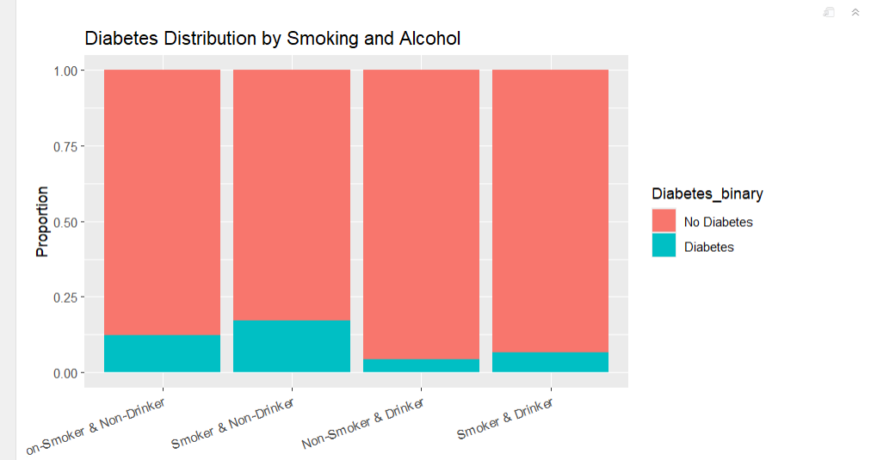
Figure 15. Diabetes Distribution by Drinking and Smoking
Figure above shows us that that whoever drink alcohol will have significantly lower chance of having diabetes. What is more interesting that it is even lower when that person smoke compared to normal people who don’t smoke and drink
Task 4: Discussion and Conclusion
4.1 Result Discussion
In Task 2, we have checked the individual impacts of drinking using chi square test for contingency table. The result of both cases show a small p-value < 0.5 which indicate that both have strong respective impact on the likelihood of having diabetes. However, whether they together increase the likelihood or what is unclear. Thus, in task 3 we examine the joint impact both of them by introducing and using Multivariate Logistic Regression. Logistic not Linear because our respond variable is categorical. The result show that both variable Drinking and Smoking have opposite impacts. Smoking increases the chance of having diabetes whereas Drinking decreases it. What make our study standout is because we found that the impact of Drinking 66,12% is stronger than that of Smoking 47,47%. Even though it has good impact on diabetes, the study doesn't endorse the heavy use of Alcohol to cancel impact of Smoking because Alcohol itself could lead to many other risks. As [3] suggests, we could take advantage of this impact by consuming Alcohol with adequate quantity.
4.2 Limitations of the Analysis:
- Small number of used variables: This dataset consists of many other factors such as BMI or Cholesterol,... up to 21 variables. However our study only involve two factors which are drinking and smoking.
- Pre-diabetes: Our study group diabetes and pre-diabetes as a single group to study about the general diabetes. While this helps in term of simplicity, more complex pattern and insights might require the separation.
- Survey: Even though this is a collection from reliable organization. It is still survey-based which mean that they could make mistake while filling the survey
- BMI Restriction: As stated in task 1, we focus on regular people but the future study might need to accommodate all kind of study
4.3 Improvements
- Actual Record: Instead of having, it might be better to ask the health centre for the actual record. This is better than the patients manually fill the survey due to the strict procedure in Health Centre. However, it might raise some questions about the permission and ethics
- More variables: More variables used in the study could help us in understanding the diabetes more
- Separation for pre-diabetes: By adding the pre-diabetes, we could ask more questions. For example, we could further examine whether Smoking and Drinking leads to pre-diabetes more or directly to diabetes.

References
[1] P. Saeedi et al., “Mortality attributable to diabetes in 20–79 years old adults, 2019 estimates: Results from the International Diabetes Federation Diabetes Atlas, 9th edition,” Diabetes Research and Clinical Practice, vol. 162, Art. no. 108086, 2020, doi: 10.1016/j.diabres.2020.108086.
[2] D. Xie et al., “Global burden and influencing factors of chronic kidney disease due to type 2 diabetes in adults aged 20–59 years, 1990–2019,” Scientific Reports, vol. 13, no. 1, Art. no. 20234, 2023, doi: 10.1038/s41598-023-47091-y.
[3] I. Paz-Graniel et al., “Alcohol, smoking, and their synergy as risk factors for incident type 2 diabetes,” American Journal of Preventive Medicine, vol. 69, no. 5, Art. no. 108011, 2025, doi: 10.1016/j.amepre.2025.108011.
[4] Y. R. Yanjun, C. B. Castro, and J.-P. L., “Drink and smoke; drink or smoke? The interdependence between alcohol and cigarette consumption for men in China,” Empirical Economics, vol. 58, no. 3, pp. 921–955, 2020, doi: 10.1007/s00181-018-1557-x.
[5] Health Canada, “Tobacco and type 2 diabetes,” Jul. 26, 2023. [Online]. Available: https://www.canada.ca/en/health-canada/services/health-concerns/tobacco/legislation/tobacco-product-labelling/tobacco-type-2-diabetes.html
[7] Creative Commons, “Creative Commons — CC0 1.0 Universal,” 2019.[Online]. Available:<https://creativecommons.org/publicdomain/zero/1.0/>
[8] U. Riswanto, “A Beginner’s Guide to Multivariate Logistic Regression in R,” Medium, Apr. 20, 2025. [Online]. Available:<https://ujangriswanto08.medium.com/a-beginners-guide-to-multivariate-logistic-regression-in-r-9aa3b763f564>

