Project 02 - Engineering Full Stack Apps in the Cloud

Because Windows uncomfortable for run CLI like tsc, zip, …

After test oke -> push code to github -> using cloud9 to deploy to Beanstalk.

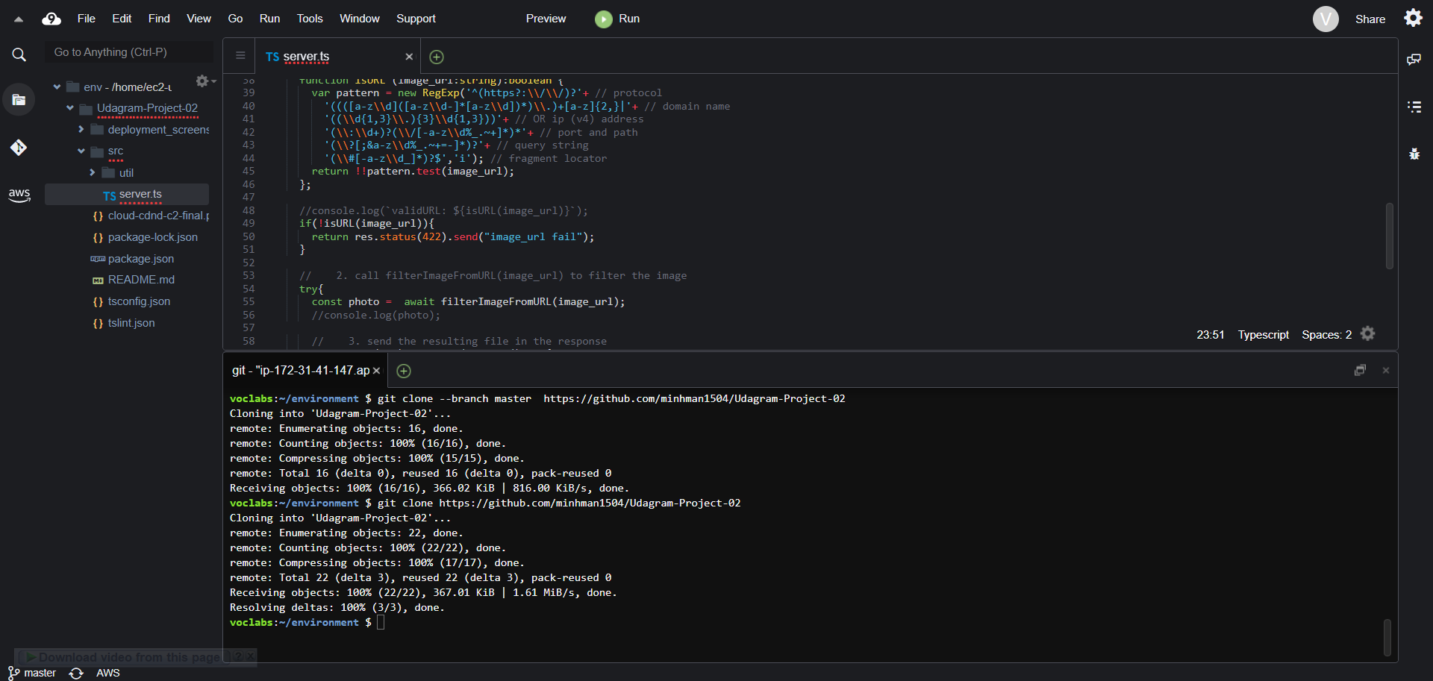

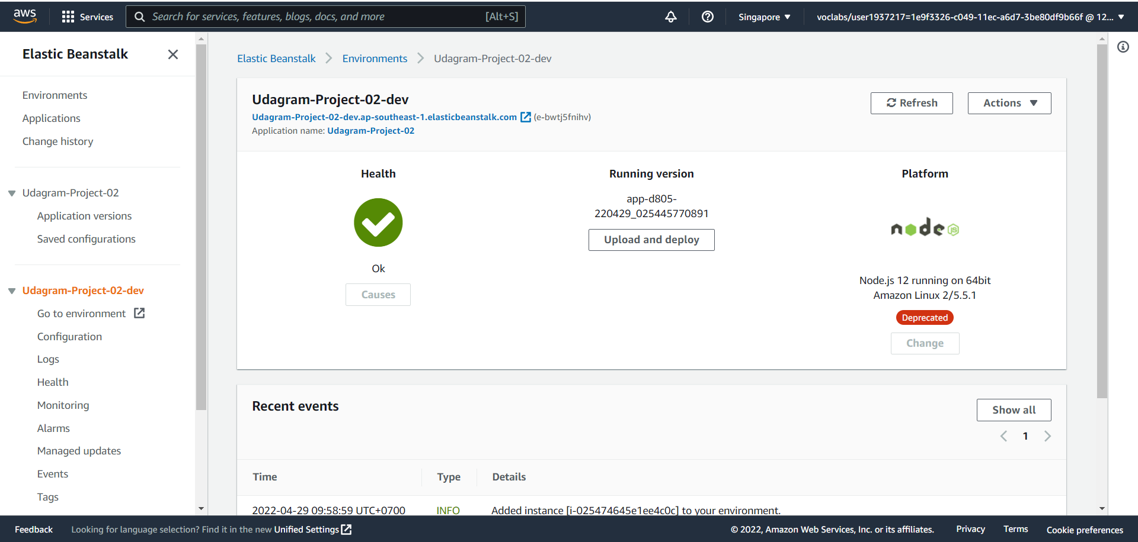

Deploy to beanstalk from c9.

Beanstalk_URL: Udagram-Project-02-dev.ap-southeast-1.elasticbeanstalk.com

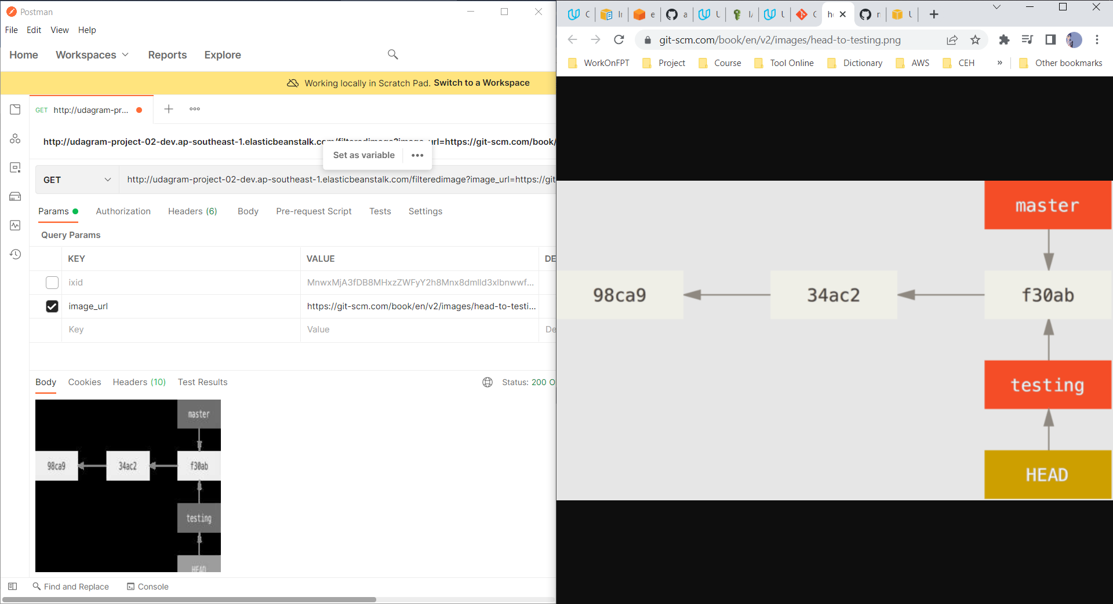

Test oke.