**PRO192- Practice Exam SE17A02 01/07/2022**

Duration : 85 minutes

Develop Library management OOP application with following components and requirements

1. **Create MVC console application in NetBean:**
   1. Define class Book with following attributes and methods: **(2 marks)**  
      + BookID, Book Title, Author, Year published   
      + Constructors, get/set(), toString()   
      + implement method for Comparable
   2. Define class Library with following attributes and methods: **(5 marks)**  
      + List of Book  
      + Read text file to load data for Library – lib.txt is provided (1 mark)   
      + Search book by different criteria (1 mark)  
      + Print any List of Book (1 mark)  
      + Add new Book from console (1 mark)
   3. Develop Library Management class for application **(4 marks)**  
      + Application menu for application include: Display all books, Book Search, Add new Book (1 mark)   
      Hint: An abstract Menu class is provided for use in the application. Override method excecute()  
      + Method for seaching book with searching menu (2 marks)
2. **Technical requirements**:  
   + Create package **model** for Book and Library class.  
   + Create package **view** for Menu and LibraryManagement class.  
   + Checking error for input data.  
   + User interface as sample images below

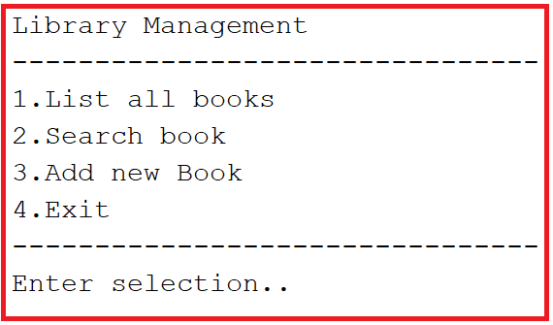

When choose search book:  
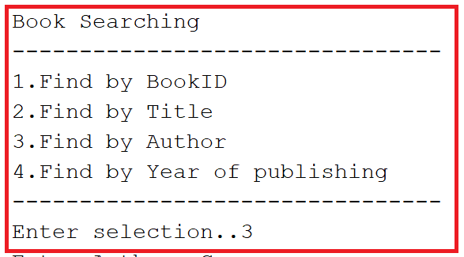

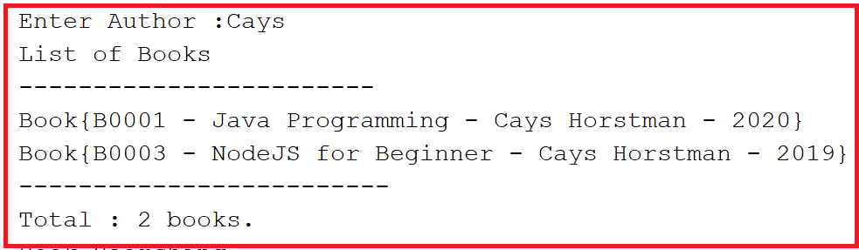

**Notice: Student must strictly follow all requirements as describe above for marking,   
Any modification the requirement detail is not allowed and will get no mark!**