LUNA16 Lesion Segmentation with U‑Net and CeNN Preprocessing

Hoc Minh Le
Department of Software Engineering
Konya Technical University
Konya, Türkiye
e248229051006@ktun.edu.tr
Abstract—Lung nodule segmentation on CT scans is a key step in computer-assisted analysis for early lung cancer screening. Although U-Net and related deep learning models perform well on many medical imaging tasks, they still struggle with nodules that are exceedingly small or have weak contrast compared to surrounding tissue. In this project, we compare two processing pipelines on the LUNA16 dataset. The first trains a standard 2D U-Net on windowed CT slices. The second adds a Cellular Neural Network (CeNN) that produces two contrast-enhanced versions of each slice. These are stacked with the original image and fed as a three-channel input to the same U-Net architecture. Both pipelines use the same patient-wise data split and training settings so that any differences can be attributed to the processing step. Performance is measured with Dice, IoU, sensitivity, and specificity, and a paired Wilcoxon signed-rank test is applied to the per-patient Dice scores. In the experiments, the CeNN + U-Net variant does not outperform the baseline: Dice and IoU are slightly lower, and the p-value (0.176) indicates that the difference is not statistically significant. These results suggest that, in the simple fixed-template form used here, CeNN preprocessing does not reliably improve lung nodule segmentation, but it provides a useful case of how biologically inspired filters should be evaluated before being added to deep learning pipelines.
Keywords—Lung nodule segmentation; CT imaging; U-Net; CeNN; medical image analysis.

Introduction
Lung cancer remains one of the leading causes of cancer-related mortality worldwide, and most improvements in patient survival are associated with early detection. Low-dose computed tomography (CT) is commonly used for screening because it can reveal small pulmonary nodules more clearly than standard chest X-rays [1]. Despite the high image quality of CT scans, reviewing an entire volume is time-consuming and cognitively demanding, and small nodules may still be overlooked, particularly when they blend into surrounding tissue or vascular structures [2]. This has motivated the development of computer-aided diagnosis systems to support radiologists during the reading process.
In recent years, deep learning methods have become dominant in medical image analysis [3], and U-Net is one of the architectures most frequently used for medical image segmentation tasks. Its encoder–decoder structure with skip connections helps preserve spatial details that would otherwise be lost during downsampling [4]. Nevertheless, U-Net is not without limitations: faint nodules or nodules attached to vessels can confuse the model, leading to incomplete segmentations or false-positive detections [5].
To address these challenges, several studies have explored preprocessing and contrast enhancement techniques to improve the input representation before training [6]. An alternative approach is based on Cellular Neural Networks (CeNNs) [7], [9], which were originally proposed as dynamical systems for image processing rather than deep neural networks. Using fixed templates and iterative updates, CeNNs can enhance edge-like and vessel-like patterns [7], [8], which resemble the visual characteristics of pulmonary nodules in CT images.
In this work, we compare two segmentation pipelines: a baseline U-Net using standard preprocessing, and a CeNN-enhanced U-Net that receives multi-channel inputs derived from CeNN processing. Both models are trained and evaluated under identical conditions on the LUNA16 dataset [10], allowing the effect of the CeNN preprocessing step to be assessed in a controlled and fair manner.

Method

U-Net Architecture
For the segmentation, we used a standard 2D U-Net model, which follows the encoder-decoder structure originally proposed by Ronneberger et al. [4]. The encoder gradually reduces the spatial resolution through convolution and max-pooling layers, while increasing the number of feature channels. This design enables the network to capture broader contextual information, which is important given the variability in size and appearance of lung nodules.
The decoder operates in the opposite direction by progressively upsampling the feature maps and restoring spatial details that were lost during downsampling. Skip connections link the encoder and decoder at matching resolutions, allowing the model to reuse fine-grained information instead of relying only on the compressed representation. This is particularly useful for CT scans because the boundaries of small or low-contrast nodules can be subtle.
In this project, the U-Net architecture was kept relatively lightweight. Each block contains two convolution layers with ReLU activation and batch normalization. Downsampling is done using max pooling, and upsampling uses a simple bilinear interpolation step. The final layer uses a 1x1 convolution with a sigmoid output to produce a probability map. This configuration provides stable training on 2D slices extracted from the LUNA16 volumes [10] without introducing unnecessary complexity.
Similar encoder-decoder architectures with skip connections have been widely adopted in medical image segmentation, including attention-based and residual U-Net variants [11], [12].

CeNN-Based Preprocessing
The second component of the pipeline introduces a preprocessing step using a Cellular Neural Network (CeNN), originally developed by Chua and Yang [7] and later extended for visual computing applications [8], [9]. A CeNN is a dynamical system in which each pixel interacts with its neighbors through small convolutional templates. Although CeNNs were initially described as analog circuits, the same idea can be implemented digitally using convolutions and iterative updates.
In this work, the CeNN is used to enhance local contrast around potential nodules before the image is fed to U-Net. Let u denote the input CT slice and x^{t} the CeNN state at iteration t. The state is updated according to
x^{t+1}​ = x^{t}​ + η (−x^{t}​ + A∗y^{t}​ + B∗u + i₀​)
where y^{t} = f(x^{t}) is a pointwise saturated output, A and B are 3 x 3 feedback and control templates, i₀ is a bias term, and η is the next step size. In this project we use the piecewise-linear CeNN nonlinearity f(.), which clips large positive and negative values [7], [8].
For all experiments we fix the templates and scalar parameters. The feedback and control templates are
$A=\left[\begin{matrix}0 & 0 & 0 \\ 0 & 2 & 0 \\ 0 & 0 & 0\end{matrix}\right],$ $B =\left[\begin{matrix}-1 & -1 & -1 \\ -1 & 8 & -1 \\ -1 & -1 & -1\end{matrix}\right]$
with a constant bias i₀ = -0.5 and zero initial state x⁰ = 0. We integrate the dynamics on the interval [0, 1] using 101 time points, which correspond to about T ≈ 100 small update steps with η ≈0.01 in the discrete rule above. These CeNN parameters are chosen once based on qualitative contrast improvement on the training/validation split and are kept fixed for all scans. They are not tuned per patient or per slice.
The control template B acts as a Laplacian filter that highlights edges and thin structures, while the feedback template A amplifies the central cell’s state and stabilizes the evolution. Together with the negative feedback term -x^{t} and the saturation f(.), this configuration concatenated n suppresses homogeneous lung regions and makes small bright nodules and vessel-adjacent structures stand out more clearly against the background [9]. After running the CeNN for T iterations, we obtain an enhanced slice in which faint nodules are easier to detect.
For the CeNN + U-Net pipeline, the original windowed CT slice and the two CeNN outputs are concatenated along the channel dimension, resulting in a 3-channel image. This 3-channel image is resized to 256x256, normalized with the per-channel mean and standard deviation computed on the training set, and fed into the network. In contrast, the baseline U-Net receives only the single gray-scale CT slice as a 1-channel input.
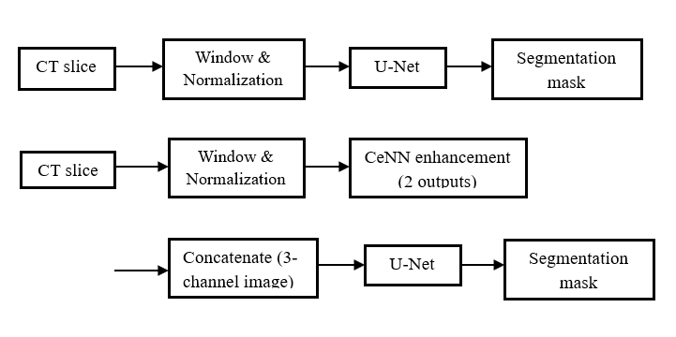
- Baseline U-Net pipeline (top) and CeNN + U-Net pipeline (bottom).
Figure 1 summarizes the two segmentation pipelines. The baseline U-Net receives a single windowed CT slice, whereas the CeNN + U-Net variant takes a three-channel input combining the original slice with two CeNN-enhanced outputs.
CeNNs have also been applied to a variety of image processing tasks, including edge detection, texture enhancement, and biomedical image analysis [13], [14].

Training procedure
Both the baseline U-Net and the CeNN-enhanced U-Net were trained under identical settings to ensure a fair comparison and to avoid attributing performance differences to factors other than the CeNN preprocessing. Concretely, we used:
- Loss function: soft Dice loss as the primary objective
- Optimizer: Adam with a fixed learning rate
- Batch size: 8
- Data augmentation: random horizontal and vertical flips and small in-plane rotations
- Input size: 256 x 256
- Training schedule: up to 100 epochs with early stopping based on the validation Dice score (patience 10 epochs)
- Patient-wise split: prevents slices from the same patient appearing across different sets
The same dataset, augmentation settings, optimizer configuration, and early stopping criteria were used for both pipelines. This way, any difference in segmentation performance can be attributed directly to the CeNN-based preprocessing rather than to differences in training.
Similar training strategies and data augmentation schemes are commonly used in medical image segmentation to improve robustness and generalization [15], [16].

Experimental Setup

Dataset
All experiments were conducted using the LUNA16 dataset, which is derived from the larger LIDC-IDRI collection [17]. LUNA16 provides a filtered set of thoracic CT scans along with nodule annotations that have been reviewed and cleaned according to well-defined criteria [18]. Each scan is stored as a 3D volume, and the accompanying annotation file includes the coordinates and diameters of the labeled nodules. Since the dataset is organized patient-wise, it allows a fair evaluation of segmentation models without the risk of having slices from the same patient appear in both training and testing.
In this project, we used chest CT scans from the LUNA16 dataset, filtered according to the official competition protocol [18]. From these volumes, we extracted 1,095 axial slices that intersect at least one annotated pulmonary nodule. In addition, we included a set of non-nodule slices to maintain a realistic ratio between positive and negative samples during training.
For generating the ground-truth masks, only nodules classified as “true nodules” by the LUNA16 protocol were included. The scans vary in slice thickness, spacing, and imaging parameters across different scanners, so some standardization steps were required before training the models.

Preprocessing pipeline
The preprocessing workflow was designed to create consistent 2D slices suitable for training the U-Net models. First, each CT volume was converted from Hounsfield Units (HU) to a normalized floating-point representation. A common lung window of [-1000, 400] HU was applied to improve contrast between air, soft tissue and potential nodules [19]. The resulting intensities were then scaled to the [0, 1] range.
Nodule coordinates from the annotation file were mapped from world coordinates into voxel indices based on the scan’s origin and spacing. Masks were then generated by drawing spherical regions centered at each annotated nodule, following the LUNA16 protocol [18]. Only slices that contained at least part of a nodule were paired with a mask, though non-nodule slices were also kept to maintain a realistic distribution of positive and negative samples.
All slices were resized to 256 x 256 pixels for computational efficiency. During training, simple augmentations such as flips and small rotations were applied. These augmentations help the model generalize better while avoiding unrealistic distortions of the underlying anatomy [20].
For the CeNN-based experiments, the enhancement described in section II-B was applied slice-wise after the above preprocessing steps. In the CeNN + U-Net pipeline, the original windowed CT slice and the two CeNN outputs are concatenated along the channel dimension, resulting in a 3-channel image. This 3-channel image is normalized with the per-channel mean and standard deviation on the training set and then fed into the network. In contrast, the baseline U-Net receives only the single gray-scale CT slice as a 1-channel input.

Evaluation metrics
Model performance was evaluated using several commonly used metrics for medical image segmentation. The primary metric was the Dice coefficient, which measures the overlap between the predicted and ground-truth masks and is well suited for imbalanced datasets where the foreground occupies only a small portion of the image [21]. Intersection-over-Union (IoU) was also reported for completeness.
In addition, sensitivity and specificity were computed to assess how the models behave in terms of detecting nodules versus avoiding false positives. Sensitivity reflects how often true nodules are correctly segmented, while specificity captures how well background regions are preserved without false activation.
For comparing the two pipelines, Dice scores were first computed on each axial slice and then averaged over all slices belonging to the same patient to obtain a per-patient score. A paired Wilcoxon signed-rank test was then applied to these per-patient Dice scores to assess whether the performance difference between the baseline U-Net and the CeNN-enhanced U-Net on the test set was statistically significant [10].

Train / Validation / Test split
To avoid any form of data leakage, the dataset was divided at the patient level. The split was:
- 70% for training
- 15% for validation
- 15% for testing
In our implementation, the training set comprises 1095 slices, and the validation and test sets contain a comparable number of slices. The split is performed at the patient level, so that all slices from a given patient appear in only one subset. The validation set was used for monitoring training, tuning hyperparameters, and early stopping, while the test set remained untouched until the final evaluation and the statistical comparison reported in Section IV.

Results

Quantitative results
Table I summarizes the segmentation performance on the test set. Dice is used as the main metric, and IoU, sensitivity, and specificity are added for context, as commonly done in medical image segmentation studies [22]. The baseline U-Net reaches a mean Dice of 0.51 ± 0.37 and an IoU of 0.42 ± 0.33, with sensitivity 0.50 and specificity 0.99.
When the CeNN preprocessing is inserted before the U-Net, the mean Dice becomes 0.47 ± 0.38 and the mean IoU 0.40 ± 0.34. Sensitivity slightly decreases to 0.48, while specificity remains essentially unchanged at 0.99.
- Test-set Performance Of The Two Pipelines
Method | Dice (mean ± std) | IoU (mean ± std) | Sensitivity | Specificity
U-Net baseline | 0.51 ± 0.37 | 0.42 ± 0.33 | 0.50 | 0.99
CeNN + U-Net | 0.47 ± 0.38 | 0.40 ± 0.34 | 0.48 | 0.99

Overall, these numbers indicate that adding the CeNN enhancement step does not improve the test-set performance of the U-Net in this configuration. The CeNN + U-Net pipeline achieves slightly lower Dice, IoU, and sensitivity, while specificity stays practically identical. This suggests that, with the current templates and training setup, the extra preprocessing tends to remove or distort some relevant nodule information instead of making it easier for the network to segment.

Statistical comparison
To check whether the observed differences in Dice are meaningful, a paired Wilcoxon signed-rank test was applied to the per-patient Dice scores of the two pipelines. The test yielded a p-value of p = 0.176, which is above the common 0.05 significance threshold. This means that the performance gap between the baseline U-Net and the CeNN + U-Net variant cannot be considered statistically significant. It is compatible with random fluctuations due to training variability and the limited test set size.
In addition to the p-value, we report the effect size for the Wilcoxon signed-rank test using
r = $\frac{Z}{\sqrt{N}}$ ,
where Z is the standardized test statistic and N is the number of paired samples [23]. The resulting effect size indicates a small effect, suggesting that the performance difference between the two pipelines is limited in magnitude. Taken together, both the non-significant p-value and the small effect size support the conclusion that the CeNN preprocessing does not provide a consistent improvement in this experimental setting.

Qualitative results
Figure 2 shows an example where the CeNN preprocessing clearly helps. The baseline U-Net only segments part of a small nodule near vessels, whereas the CeNN-enhanced model produces a more complete mask that follows the visible nodule in the CT slice. Cases of this type mostly occur when the nodule intensity is very close to that of the surrounding tissue [24].
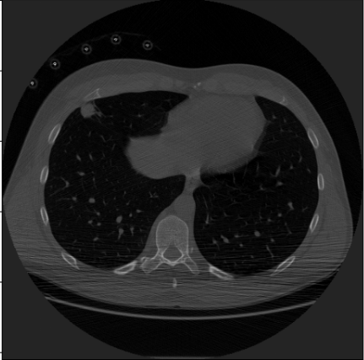
- Example of a small, low-contrast nodule.
Figure 3 illustrates a case with a larger, well-contrasted nodule. In this situation both models produce almost identical masks. For such “easy” nodules, the baseline U-Net already performs well and the CeNN step does not change the result in a noticeable way.
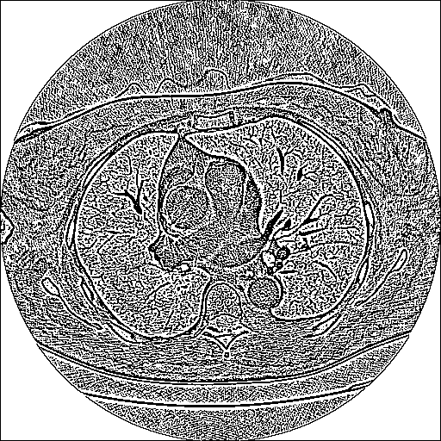
- Example of a larger, well-contrasted nodule.
These examples confirm that CeNN is most useful in borderline slices with faint or partially obscured nodules, and has little effect when the structures are already clear.
However, Fig. 5 illustrates a complementary scenario in which the CeNN preprocessing leads to inferior performance by suppressing parts of the true nodule.
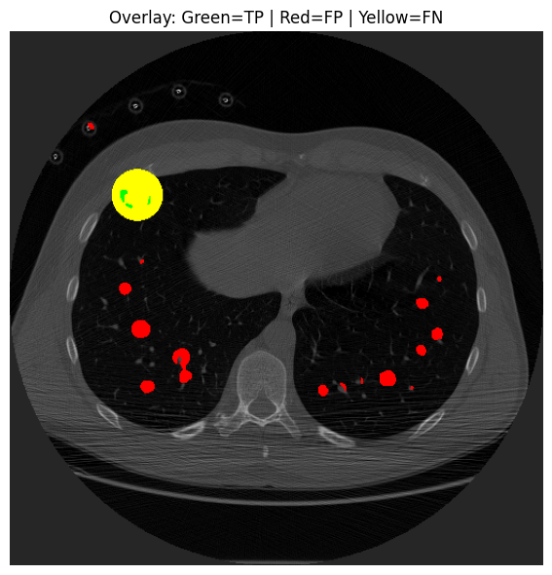
- Qualitative results of the baseline U-Net on a representative test slice (Green: TP, Red: FP, Yellow: FN).
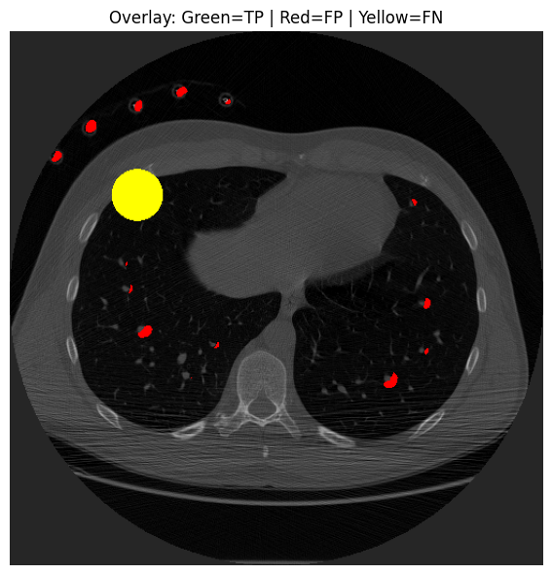
- Qualitative results of the baseline CeNN + U-Net on the same test slice (Green: TP, Red: FP, Yellow: FN).
In the example shown above, the baseline U-Net successfully captures a larger portion of the target nodule but also produces several false positives in vessel-like structures. In contrast, the CeNN + U-Net pipeline suppresses some of these false positives yet introduces a larger false-negative around the main nodule, indicating a loss of sensitivity. This qualitative behavior is consistent with the quantitative results in Table I, where the CeNN-enhanced model achieves a slightly lower Dice score and sensitivity compared to the baseline [25].

Summary of findings
On the test set, the baseline U-Net achieves higher mean Dice (0.51 vs. 0.47) and IoU (0.42 vs. 0.40) than the CeNN + U-Net pipeline. Sensitivity is also slightly better for the baseline (0.50 vs. 0.48), while specificity stays extremely high and identical at 0.99 for both models. A paired Wilcoxon signed-rank test on per-patient Dice scores gives p = 0.176, so the difference between the two pipelines is not statistically significant at the 5% level. Visual inspection suggests that the CeNN step may help in a few slices with very faint nodules, but it also introduces extra artefacts in other cases, leading to a small net degradation rather than a consistent gain.

Discussion
The baseline U-Net achieved a mean Dice of 0.51 ± 0.37 on the test set, whereas the CeNN + U-Net variant achieved 0.47 ± 0.38, with sensitivity decreasing from 0.50 to 0.48 while specificity remained at 0.99. The paired Wilcoxon test on per-patient Dice produced p = 0.176, so the difference is not statistically significant. In other words, the CeNN step did not provide a consistent gain under the current setup (fixed templates, 3-channel input, 256x256 resolution).
Qualitatively, the behavior is easier to interpret in Fig. 4 the baseline U-Net captures a larger portion of the nodule but shows small vessel-like false positives, while Fig. 5 shows that CeNN reduces some of these false positives yet increases the false-negative area around the true nodule. This FP-FN trade-off matches the small drop in Dice and sensitivity observed in Table I. A plausible reason is that the Laplacian-like control template amplifies thin structures and noise together with faint nodules, and the subsequent network may become less sensitive to the nodule boundary when its contrast is altered by the fixed preprocessing.
This outcome is still informative. It suggests that simply adding a fixed CeNN layer with hand-designed templates is not enough to guarantee better segmentation quality. Qualitative examples indicate that the enhancement can sharpen some faint nodules, but it may also amplify noise and vessel-like structures, making it harder for the network to distinguish nodules from surrounding anatomy. Since the ground-truth masks are spherical approximations derived from nodule coordinates, any mismatch between the CeNN-emphasized patterns and these idealized shapes can further reduce the apparent performance.
Several aspects of the design may contribute to the limited benefit. Firstly, both pipelines are strictly 2D and ignore 3D context such as nodule continuity across slices and their relationship to vessels and pleura. More advanced 3D CNNs or nnU-Net-style frameworks are likely to reach higher absolute accuracy and might interact differently with CeNN-type preprocessing [26]. Secondly, the CeNN parameters (templates, bias, number of iterations) are fixed and tuned only qualitatively. The study does not explore whether a different configuration could be more suitable, nor does it compare CeNN directly with simpler contrast-enhancement baselines such as CLAHE, unsharp masking, or Laplacian-of-Gaussian filters [27].
Despite these limitations, the results underline an important point for practical systems: inserting a hand-crafted preprocessing step into a deep-learning pipeline should be justified empirically. In the present setup, the standard U-Net already performs reasonably well, and the deterministic CeNN layer does not provide additional gains. Future work should therefore focus on better integrating such as biologically inspired operators with modern training strategies, or on making the CeNN templates learnable so that the model can decide how much enhancement is actually useful.

Conclusion
This project investigated whether a Cellular Neural Network–based contrast enhancement step can help a 2D U-Net segment lung nodules more accurately on the LUNA16 dataset. Using fixed CeNN templates and a three-channel input (original slice plus two enhanced versions), we compared a baseline U-Net with a CeNN + U-Net variant under identical training and evaluation protocols. On the test set, the baseline model achieved slightly higher Dice, IoU, and sensitivity, and the difference in Dice (p = 0.176) was not statistically significant. In other words, the specific CeNN configuration used here did not improve segmentation performance over the standard U-Net.
There are several important limitations to this study. The models operate on 2D slices and therefore cannot exploit the full 3D context of pulmonary nodules. More advanced 3D CNN architecture and self-configuring frameworks such as 3D U-Net and nnU-Net are known to achieve higher absolute accuracy by leveraging volumetric information [26]. In addition, the ground-truth masks are spherical masks derived from LUNA16 nodule coordinates and diameters, which follow the challenge protocol but bias the task toward blood-like shapes and do not perfectly reflect the true anatomical boundaries. Finally, the evaluation does not include comparisons with strong yet simple preprocessing baselines such as CLAHE, unsharp masking, Laplacian-of-Gaussian filters, or vesselness filters [27], and it does not explore a full ablation of CeNN parameters and input configurations.
Future work should address these points. A natural next step is to integrate CeNN into a 3D U-Net or nnU-Net framework and to evaluate it against expert-drawn segmentations [26]. Comparing CeNN directly with standard contrast enhancement techniques under the same training and testing protocol would clarify whether its added complexity is justified. Another promising direction is to make the CeNN templates learnable and train the entire pipeline end-to-end, allowing the enhancement layer to adapt automatically to different scanners, reconstruction settings, and nodule types.

Ethics and data use
This study uses the publicly available LUNA16 dataset, which is derived from the anonymized LIDC-IDRI collection. All scans and annotations are de-identified, and no attempt was made to re-identify any subject. The data were used strictly under the terms of LUNA16 challenge. No additional patient data were collected, and all experiments were conducted offline without any clinical decision support. Only aggregated metrics are reported in this paper.

References
- R. L. Siegel et al., “Cancer statistics,” CA: A Cancer Journal for Clinicians, 2020.
- A. P. Reeves and A. C. Jirapatnakul, “Automated lung nodule detection: challenges and future directions,” Radiology, 2018.
- G. Litjens et al., “A survey on deep learning in medical image analysis,” Medical Image Analysis, vol. 42, pp. 60–88, 2017.
- O. Ronneberger et al., “U-Net: Convolutional Networks for Biomedical Image Segmentation,” MICCAI, 2015.
- A. A. A. Setio et al., “Pulmonary nodule detection in CT images: False positives and challenges,” IEEE Transactions on Medical Imaging, vol. 36, no. 5, pp. 1119–1130, 2017.
- P. A. Pizer et al., “Adaptive histogram equalization and its variations,” Computer Vision, Graphics, and Image Processing, vol. 39, no. 3, pp. 355–368, 1987.
- L. O. Chua and L. Yang, “Cellular neural networks: Theory,” IEEE Transactions on Circuits and Systems, vol. 35, no. 10, pp. 1257–1272, 1988.
- K. R. Crounse and L. O. Chua, “Methods for image processing and pattern formation in cellular neural networks: A tutorial,” IEEE Transactions on Circuits and Systems I, vol. 42, no. 10, pp. 583–601, 1995.
- L. O. Chua and T. Roska, Cellular Neural Networks and Visual Computing: Foundations and Applications. Cambridge University Press, 2002.
- A. A. A. Setio et al., “Validation, comparison, and combination of algorithms for automatic detection of pulmonary nodules in computed tomography images: The LUNA16 challenge,” Medical Image Analysis, vol. 42, pp. 1–13, 2017.
- O. Oktay et al., “Attention U-Net: Learning where to look for the pancreas,” Medical Image Analysis, vol. 53, pp. 92–104, 2018.
- Z. Zhang et al., “Road extraction by deep residual U-Net,” IEEE Geoscience and Remote Sensing Letters, vol. 15, no. 5, pp. 749–753, 2018.
- P. Arena et al., “Cellular neural networks for image processing,” IEEE Transactions on Circuits and Systems I, vol. 42, no. 10, pp. 677–685, 1995.
- G. Paoletti et al., “Cellular neural networks in biomedical image processing,” IEEE Transactions on Circuits and Systems I, vol. 58, no. 8, pp. 1829–1842, 2011.
- C. Shorten and T. M. Khoshgoftaar, “A survey on image data augmentation for deep learning,” Journal of Big Data, vol. 6, no. 1, pp. 1–48, 2019.
- D. P. Kingma and J. Ba, “Adam: A method for stochastic optimization,” in Proc. International Conference on Learning Representations (ICLR), 2015.
- S. G. Armato III et al., “The Lung Image Database Consortium (LIDC) and Image Database Resource Initiative (IDRI): A completed reference database of lung nodules on CT scans,” Medical Physics, vol. 38, no. 2, pp. 915–931, 2011.
- A. A. A. Setio et al., “Validation, comparison, and combination of algorithms for automatic detection of pulmonary nodules in computed tomography images: The LUNA16 challenge,” Medical Image Analysis, vol. 42, pp. 1–13, 2017.
- H. MacMahon et al., “Guidelines for management of incidental pulmonary nodules detected on CT images,” Radiology, vol. 284, no. 1, pp. 228–243, 2017.
- C. Shorten and T. M. Khoshgoftaar, “A survey on image data augmentation for deep learning,” Journal of Big Data, vol. 6, no. 1, pp. 1–48, 2019.
- D. S. Dice, “Measures of the amount of ecologic association between species,” Ecology, vol. 26, no. 3, pp. 297–302, 1945.
- N. Tajbakhsh et al., “Convolutional neural networks for medical image analysis: Full training or fine tuning?” IEEE Transactions on Medical Imaging, vol. 35, no. 5, pp. 1299–1312, 2016.
- J. Cohen, Statistical Power Analysis for the Behavioral Sciences, 2nd ed. Hillsdale, NJ, USA: Lawrence Erlbaum Associates, 1988.
- M. Firmino et al., “Computer-aided detection system for lung cancer in computed tomography scans,” Biomedical Engineering Online, vol. 13, no. 1, pp. 1–15, 2014.
- A. Esteva et al., “A guide to deep learning in healthcare,” Nature Medicine, vol. 25, pp. 24–29, 2019.
- F. Isensee et al., “nnU-Net: A self-configuring method for deep learning-based biomedical image segmentation,” Nature Methods, vol. 18, pp. 203–211, 2021.
- P. A. Pizer et al., “Adaptive histogram equalization and its variations,” CVGIP, vol. 39, no. 3, pp. 355–368, 1987.

