DSCI-511

Phase 1

Jewel Cooper

Minh Nguyen

Quang Nguyen

1. Team Members

Member 1: Jewel Cooper
Current Skills:
Areas to grow into:

Member 2: Minh Vo
Current Skills:
Areas to grow into:

Member 3: Quang Nguyen
Current Skills: Python programming, APIs proficiency,
Areas to grow into: Web Scrapping

2. Topics and Motivation
Formula 1 is one of the most data-intensive sports in the world. During a single race weekend, a modern F1 car generates up to millions of data points per lap across hundreds of sensors measuring speed, throttle, brake pressure, tire degradation, fuel load, and aerodynamic forces. Every team employs dozens of data engineers whose sole job is to collect, pipeline, and analyze this data in real time to make race-winning decisions. This makes F-1 an interesting domain as the data is rich, structured, publicly accessible, and genuinely used at the professional level.
F1 performance data is scattered across multiple sources with varying levels of detail and accessibility. No single source provides a complete picture. The goal of this project is to collect F-1 telemetry and car performance data using APIs and web scraping.

3. Data Sources & Collection Methods

Method 1: OpenF1 APIs
Source: https://openf1.org
OpenF1 is a free, open REST API that provides real-time and historical F1 data with no authentication required.

Example Relevant endpoints:

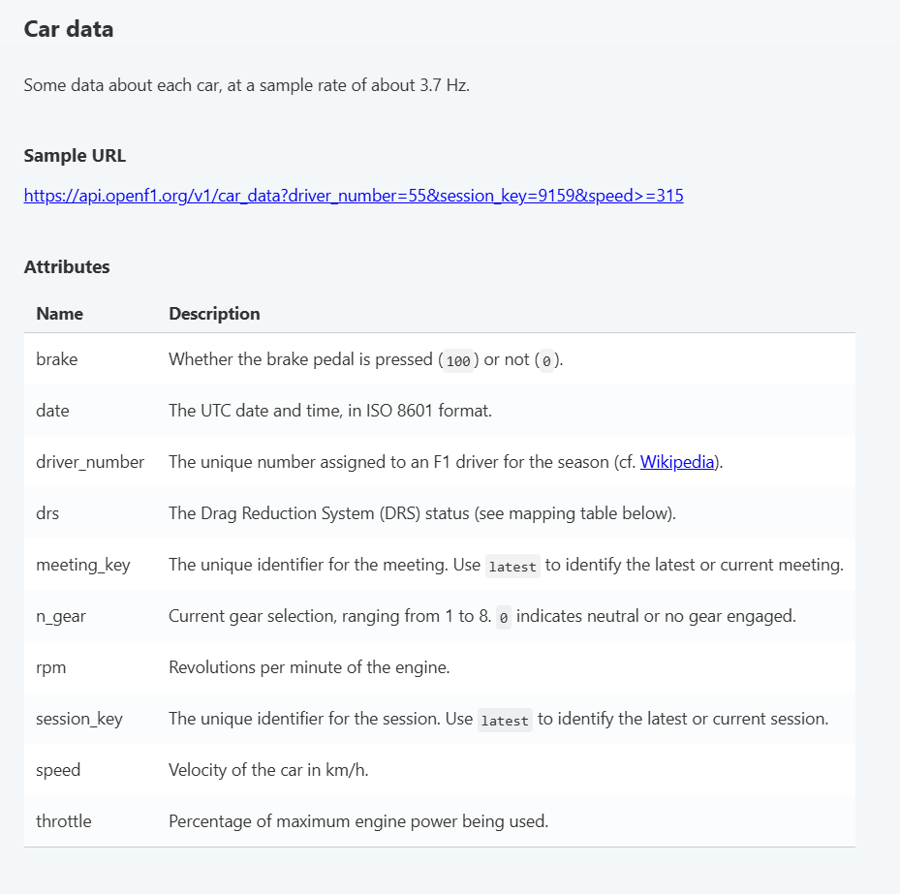

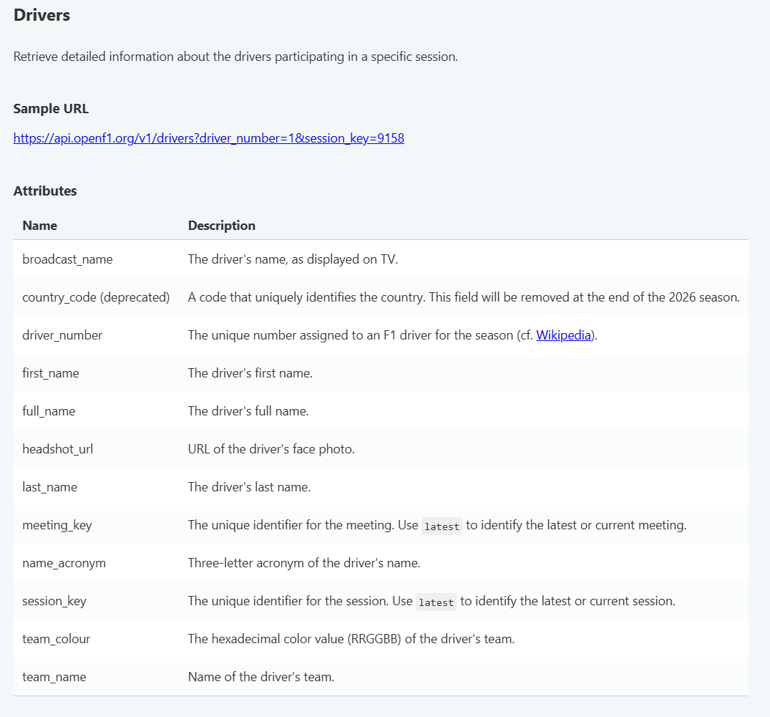
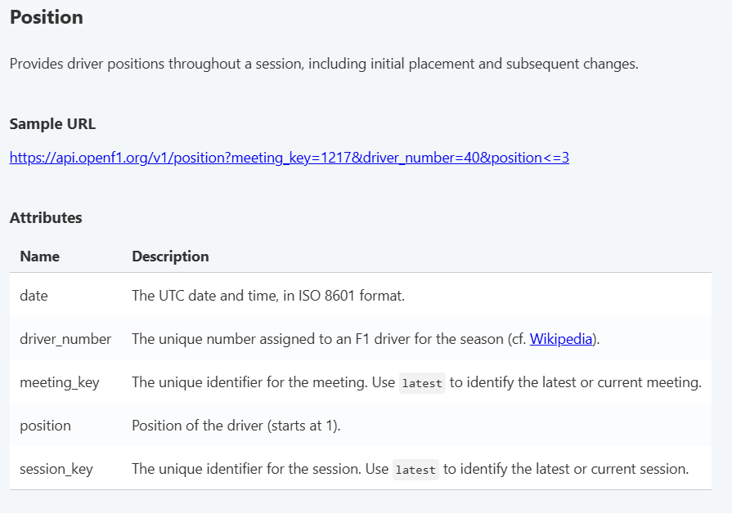

Sample Data

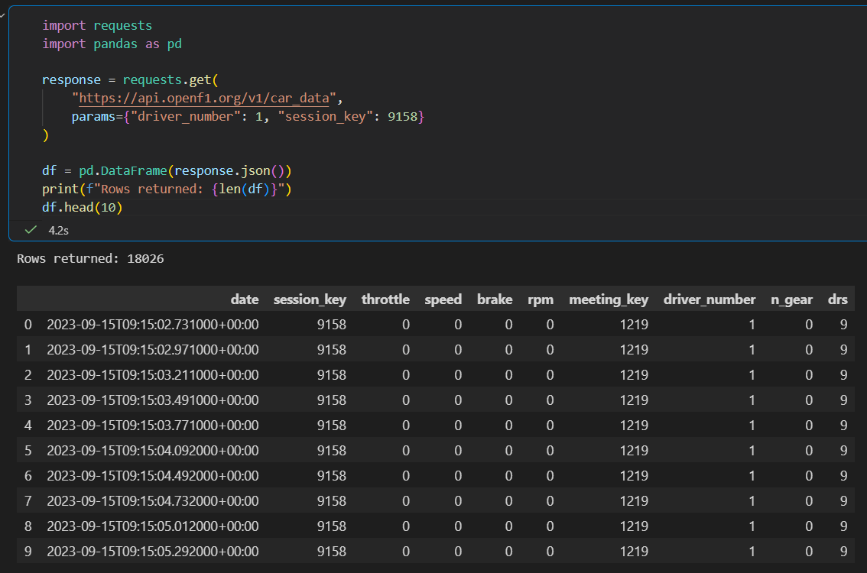

Method 2: Web Scraping
Source: Wikipedia race result tables, https://www.statsf1.com
Web scraping will be used to collect:
- Circuit metadata (length, number of corners, lap record)
- Race entry lists (driver, team, car number mappings)
- Constructor and chassis information per season

