**Data Labeling Process**

**VinHR project**

**1. Overview**

The purpose of this document is to record the process of “labeling video data”, in which we determine the exact start and end time for each action that HK staffs from VinPearl doing in their cleaning videos.

**2. Goals of Data Labeling Process**

- To create a dataset including the start and end times for specific actions in the videos from VinPearl HK staffs.

- To map this dataset with the signal dataset collected by signal-collecting-wristbands that HK staffs wore during their works

- To apply this process for further labeling purposes.

**3. Data and label description**

**3.1 Privacy concern**

Video distribution channels need to be carefully considered. Labelers cannot have permission to transfer or upload the videos to other platforms.

NDA is required to be signed by all participants of this project before accessing the data.

**3.2 Data collecting process description**

The data need to label is a set of videos filming HK employees cleaning the room for 3 days while wearing signal-collecting-wristbands.

Time and number of HK: 46 hours of 182 videos were recorded in 3 days, following 9 HK employees with different level of experience.

Dominant/Non-dominant hand: On the first 2 days, each HK employee wore one device on their dominant hands. On the last day, they all wore two devices on both hands while working.

Room types: The videos filming HK employees cleaning 3 types of room: Vacant, Checkout/Back2back, and Occupied; pushing trolley in the hallway, and did Others activities (adhoc tasks, lunch time,...).

Outroom/Inroom tasks: While cleaning rooms, HK employees will divide the workload with their colleagues, and either cleaned the outroom (bed room) or the inroom (WC room).

Volume of data:

218 sensorlog data files – 13GB

46 hours of 182 videos – 200GB

The total number of motion files collected by the devices and the number of videos are shown as below:

|  |  |  |  |  |  |  |  |  |  |
| --- | --- | --- | --- | --- | --- | --- | --- | --- | --- |
|  | |  |  |  |  |  |  |  | |
|  | | | | | | | |  | |  |  |  |  |  |  |

**3.3 Define and Describe label**

3.3.1 Define activities levels.

Based on actual observation trip to VinPearl and investigation of cleaning videos from HK staffs, we can identify 2 levels of activities that the staffs performed:

Level 1 – Main activities: A main activity is composed of a series of consecutive small actions, all belonging to a housekeeping task

For this project, the main activities are defined as above:

|  |  |
| --- | --- |
| Label | Name of main activities |
| TN | Collecting dirty items |
| DG | Making bed |
| LC | Cleaning furniture |
| FPN | Filling bedroom stuffs |
| HB | Vacuuming |
| LN | Cleaning the floor |
| CVS | Cleaning restroom |
| FVS | Filling restroom stuffs |
| DX | Pushing trolleys |

Level 2 – Sub-activities: Separated and smaller activities under a housekeeping task.

3.3.2 Describe activities

Every main activity and sub activity are clearly described by 3 questions:

- What did the staff do in this activity? List all the actions that the staff do in this activity.

- When should be the start time of this activity? The start time of an activity should be counted at the moment the staff touched the object to begin the action by her wearing-device hand.

- When should be the end time of this activity? The end time of an activity should be counted at the moment the staff left her wearing-device hand off the object to stop the action.

A sample video is also created for each main and sub activity for better understanding.

Specific description of each label/activity can be referred to Appendix 1

3.3.3 Intertwining activities

Level 1: Labeling main activities

Label case 1: If a staff stopped a main activity to do a different main activity, then came back to do the previous main activity: Label 2 separated main activities.

For example: During cleaning furniture - a main activity, the staff who was cleaning TV cabinet went to the trolley to take beverage and filled it in the minibar, then continued cleaning:

- Label LC from when she started cleaning until she stopped to go to trolley

- Label FPN from when she went to the trolley until she finished filling the minibar

- Label LC from when she came back to cleaning furniture

Label case 2: If a staff stopped a main activity to do a sub-activity that lasted less than 3s, then came back to do the previous main activity: ignore the sub-activity and label the whole process as the label of main activity.

For example: During cleaning restroom – a main activity, the staff who was cleaning the sink stopped to re-arrange the objects near the sink, then continued to clean the sink again.

Since the re-arrangement took less than 3 seconds, we temporally ignore this sub-activity and label the whole process as cleaning restroom.

This sub-activity will be later labeled as sub-activity FVS2 in level 2 – labeling sub activities.

Label case 3: If a staff stopped a main activity to do a sub-activity that lasted more than 3s, then came back to do the previous main activity: label the sub-activity using its main-activity’s label

For example: During making bed session – a main activity, the staff stopped making bed to take dirty bedding sets to the trolley, then came back to continued making bed. Because the sub-activity of taking dirty clothes to the trolley took more than 3s, we label as followings:

- Label DG from when she started making bed to when she stopped making bed to take items to the trolley

- Label TN when she brought items to the trolley – later in the labeling sub-activity round, this action will be labeled TN2

- Label the rest of the making bed process as DG

Level 2: Labeling sub-activity

While labeling sub-activity, in case the staffs did 2 actions at the same time, actions performed by wearing-wristband hand would determine the label.

**4. Data label process**

**4.1 Preparation**

4.1.1 Label vendors

Privacy concern: Ensure all participants to this project have to sign NDA before having access to the data.

Training: Ensure all labelers understand their jobs by providing training documents (including label description, video samples, tool tutorials) and on-the-job training.

Labor resource: Prepare 2 individual teams to label the same number of videos. Cross-checking between 2 teams will increase label quality.

4.1.2 Video processing tool

The tool for labelling team to process the video needs the following functions:

- Trim/cut videos

- Insert markers or subtitles

- Export markers and subtitles to csv. file, with start time and end time of each marker.

**4.2 Labeling Process**

4.2.1 Labeling levels

The labeling process will be proceeding in 2 levels:

In the first level, main activities will be labeled. Based on the label of this level, videos will be trimmed accordingly to each main label. These videos will be the input of level 2

In the second level, labelers will use the main-activity videos to label performed Sub-activities

4.2.2 The process

For each level, we apply the process as follows:

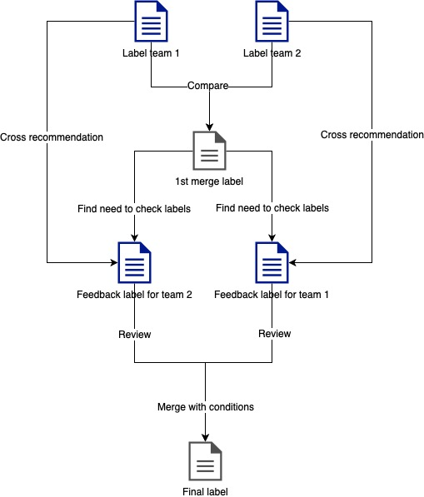

Step 1: Label round 1

- 2 teams will independently label all 182 videos at the same time.

- Labelers have to choose the exact start and end time of an activity, then insert the corresponding activity label for this period of time using the provided tool.

- After labeling a video, labelers have to export a csv file which has the following information: Label | Start time | End time.

Step 2: Quality control

- When 2 teams both finish their labeling works, a QC program will merge their works and compare with their prior individual works to detect any dissimilarities.

- The program will then provide recommendation for the two labelers team review their works again based on the suggested dissimilarities above.

Step 3: Label round 2 - Review

2 teams will individually edit their labels based on recommendation from QC program.

Step 4: Integrate and finalize labels

The reviewed works from 2 teams will then go through QC program again.

If the two files can meet all the criteria of QC program, they will be merged to become the finalized labels.

If the reviewed files cannot pass this quality checking process, QC program will give the recommendation back for both teams so that they can review their works until it is accepted by QC program.

Step 5: Gen video split for Team Labeling Round 2

Gen video split from video input and merge team file CSV. This video split is to do next Round 2 for Team Labeling.

**4.3 Quality control script:**

1. data: contains the data for Round 1 and 2
   1. In: input
      1. 1_labels(team_name/*.csv): collect team 1+2 work for first merge
      2. 2_labels(team_name/*.csv): collect team 1+2 work after reviewed for second merge
      3. videos(*.MOV): videos for labelling, formatted by ID
   2. Out: output
      1. 1_merged(*.csv): store merged csv file after run first merge
      2. 2_feedback(team_name/*.csv): store feedback csv file for each team after run first merge
      3. 2_merged(*.csv): store merged csv file after run second merge
      4. Videos(*.MP4): store the videos for round_2
2. src:
   1. mapping.py: Concatenate all the labels files and map with its original information from mapping file
   2. merge.py: given two csv files, the function’s output is a merged csv file
   3. gen_feedback.py: generate the feedback for both teams
   4. gen_label_data.py: generate labels for dataset
   5. utils.py: helper and reusable method such as convert string to delta time, read csv file, calculate xou value, …
3. test: contains unit test for script
4. config.py: contains all the directories and configurations.
5. All-in-One.ipynb: run the procedures for Round 1/2 on Python Notebook