

REPORT

HOMEWORK ASSIGNMENT 3

Professor: SHAW JIN-SIANG | Application Intelligent Control | 2017/04/06

Student: NGUYEN CONG MINH | Student ID: 105AG8409

# Problem

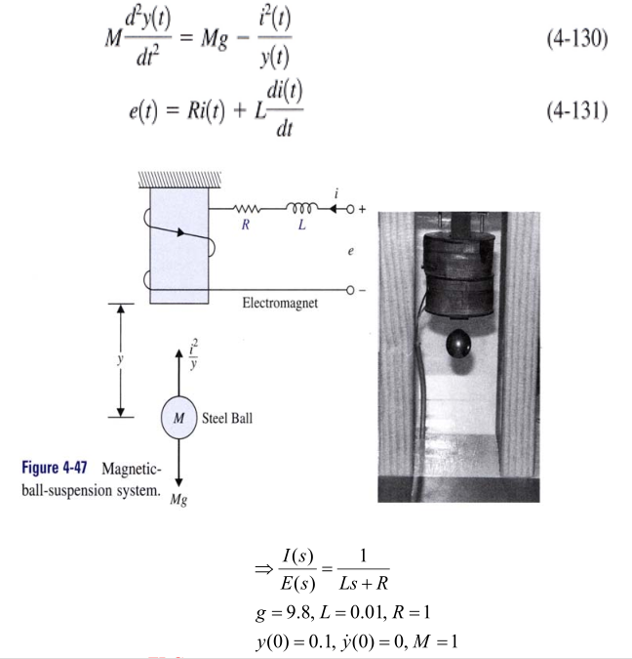

# Solution

System will have this form:

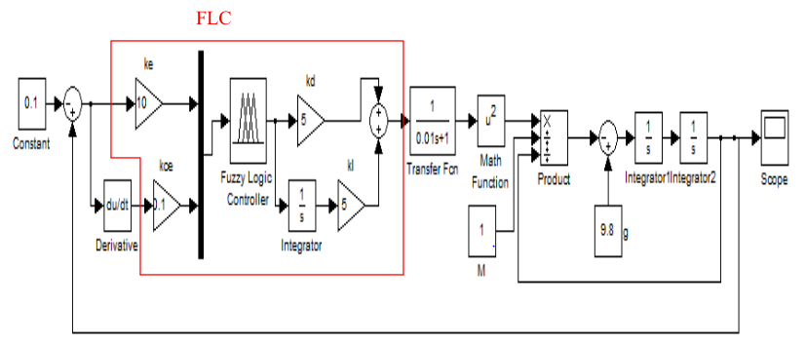

# Explain why command is negative and feedback is positive

The reason is: command/feedback is negative/positive, it depends on fuzzy logic set.

With this system, the bigger error, the bigger output the Fuzzy Logic set create.

Therefore:

|  |  |
| --- | --- |
|  |  |
| When Feedback > Command (for example: Feedback = 0.2) | |
| Error = 0.1 – 0.2 = -0.1<0  Force should be smaller and the ball will be pushed away the magnetic system, Feedback will be bigger => unstable | Error = 0.2 – 0.1 = 0.1>0  Force should be bigger and the ball will be pulled back the magnetic system, Feedback will be smaller => stable |
| When Feedback < Command (for example: Feedback = 0.05) | |
| Error = 0.1 – 0.05 = 005>0  Force should be bigger and the ball will be pulled back the magnetic system, Feedback will be smaller => unstable | Error = 0.05 – 0.1 = -0.05<0  Force should be smaller and the ball will be pushed away the magnetic system, Feedback will be bigger => stable |

There are 2 way to solve problem:

* Or change the fuzzy set(revert all rule of fuzzy set) to use positive command and negative feedback
* Or keep the fuzzy set original, just revert command to negative and feedback to to positive.

In this case, we chose the second method.

# Plot time response (is closed loop stable?)





Overshoot: 8%; Respond time: 0.6s

# What are parameters ke, kce, kd, and ki used?

System:

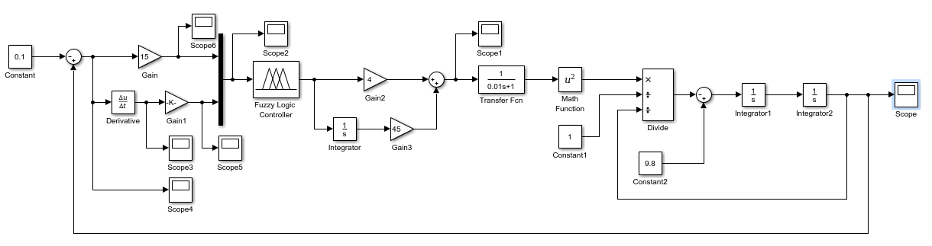

Fuzzy set:

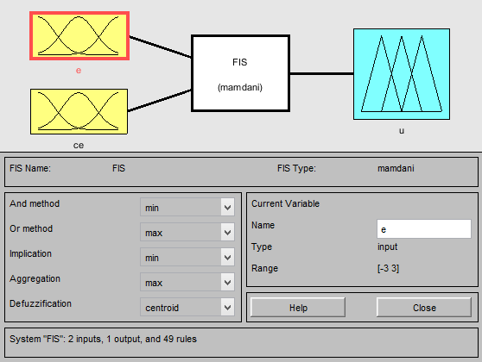 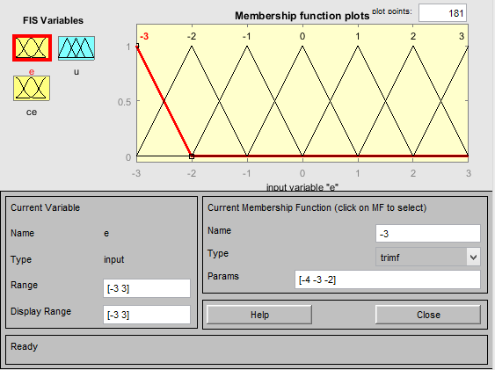

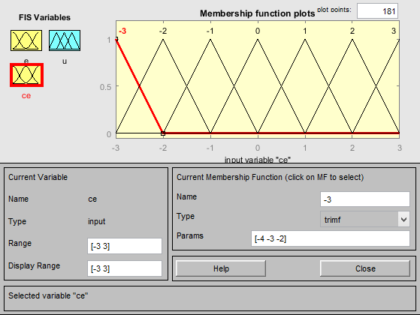 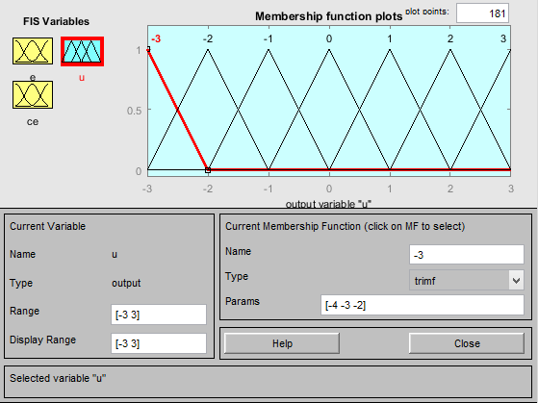

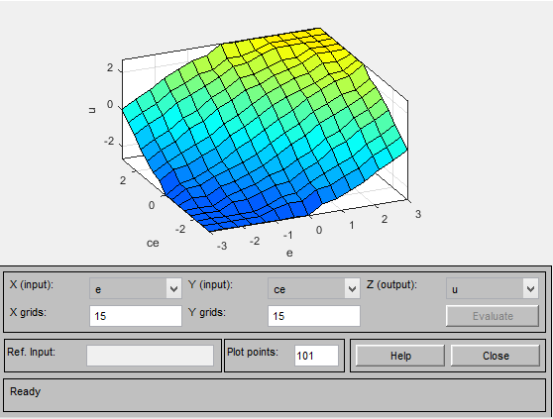

Ke, Kce Ratios:



Kp, Ki Ratios:



# Comments/Suggestion

* The designed fuzzy controller has great capability to stabilize the strong nonlinear system – the Magnetic ball-suspension system.
* In fact, the Magnetic ball-suspension is not only strong nonlinear, but also its parameters are uncertainty (especially is inductance of the circuit), so it is difficult to get the good performance by using the conventional PID controller, even PID-fuzzy logic.
* The fuzzy controller has 4 parameters to tune the response performance, so it seem to be more flexible than classical PID controller, however, due to there are more parameters needed to tune and fuzzy rules, so it leads to be more difficult and complicated.
* When design a fuzzy controller, we need to care about changing range of input, such as error and error rate, which will affect heavily to performance of the fuzzy controller.