ĐỀ THI TOEIC READING – ETS TEST 08 (ĐÃ GẮN TAG)
Sinh viên: 2380601458. File được chuyển từ đề Reading_v08.pdf. Phần này nằm trước [EXAM] nên chương trình import bỏ qua.
Part 5, 6: nội dung dạng chữ. Part 7: bài đọc được giữ nguyên dạng ảnh (biểu mẫu, bảng, trang web...) đặt sau tag [IMAGE]; câu hỏi dạng chữ.
Tag | Ý nghĩa
[EXAM] … [/EXAM] | Bao toàn bộ đề
[TITLE] / [DURATION] | Tên đề / thời gian (phút)
[PART n] … [/PART] | Một Part (5, 6, 7)
[GROUP a-b] … [/GROUP] | Nhóm câu chung bài đọc
[PASSAGE] … [/PASSAGE] | Một bài đọc
[BLANK n] | Chỗ trống Part 6
[IMAGE] | Ảnh dán ở dòng ngay sau
[Q n] … [/Q] | Một câu hỏi
(A) (B) (C) (D) | 4 đáp án
[ANSWER] X | Đáp án đúng
[HINT] … | Gợi ý đáp án
[SHUFFLE_Q] / [NO_SHUFFLE_Q] | Hoán vị câu hỏi (dòng PART/GROUP)
[SHUFFLE_A] / [NO_SHUFFLE_A] | Hoán vị đáp án (dòng Q)

[EXAM]
[TITLE] TOEIC Reading - ETS Test 08
[DURATION] 75

[PART 5] [SHUFFLE_Q]
[DIRECTIONS] A word or phrase is missing in each of the sentences below. Four answer choices are given below each sentence. Select the best answer to complete the sentence.

[Q 101] [SHUFFLE_A]
Ms. Villanueva has extensive experience in corporate ------- and budgeting.
(A) financially
(B) financed
(C) financial
(D) finance
[ANSWER] D
[HINT] Sau tính từ "corporate" và song song với danh từ "budgeting" cần một danh từ: corporate finance (tài chính doanh nghiệp).
[/Q]

[Q 102] [SHUFFLE_A]
Because Mr. Lewis works so -------, he was given a pay raise.
(A) bright
(B) hard
(C) tight
(D) sharp
[ANSWER] B
[HINT] "work hard" = làm việc chăm chỉ, là lý do được tăng lương.
[/Q]

[Q 103] [SHUFFLE_A]
Full of old-fashioned charm, the Bronstad Inn ------- offers modern conveniences.
(A) plus
(B) else
(C) also
(D) less
[ANSWER] C
[HINT] Cần trạng từ đứng trước động từ "offers" mang nghĩa "cũng": also.
[/Q]

[Q 104] [SHUFFLE_A]
Franklin Bookstore will be moving next month ------- a larger location on Queen Street.
(A) to
(B) at
(C) out
(D) over
[ANSWER] A
[HINT] "move to + địa điểm" = chuyển đến nơi nào đó.
[/Q]

[Q 105] [SHUFFLE_A]
Marina Hou ------- considered becoming an actor before deciding to write plays instead.
(A) briefly
(B) briefs
(C) briefing
(D) briefed
[ANSWER] A
[HINT] Bổ nghĩa cho động từ "considered" cần trạng từ: briefly (thoáng qua, trong thời gian ngắn).
[/Q]

[Q 106] [SHUFFLE_A]
On Fixit Time's Web site, homeowners will find economical solutions for ------- repairs.
(A) dark
(B) broken
(C) cleaning
(D) common
[ANSWER] D
[HINT] "common repairs" = các sửa chữa thường gặp; "broken repairs" không hợp nghĩa.
[/Q]

[Q 107] [SHUFFLE_A]
Walter Keegan was ------- hired as a salesperson, but he soon became head of the marketing department.
(A) originality
(B) original
(C) originals
(D) originally
[ANSWER] D
[HINT] Bổ nghĩa cho "was hired" cần trạng từ: originally (ban đầu), đối lập với "but he soon became...".
[/Q]

[Q 108] [SHUFFLE_A]
Durr Island has become popular with tourists ------- its rich culture of art and music.
(A) provided that
(B) because of
(C) even
(D) how
[ANSWER] B
[HINT] Phía sau là cụm danh từ "its rich culture" nên dùng giới từ "because of" (bởi vì).
[/Q]

[Q 109] [SHUFFLE_A]
While he is not enthusiastic about the suggestions, Mr. Shang ------- them.
(A) considering
(B) to consider
(C) will consider
(D) consider
[ANSWER] C
[HINT] Mệnh đề chính cần động từ chia theo chủ ngữ số ít Mr. Shang: will consider.
[/Q]

[Q 110] [SHUFFLE_A]
The design ------- of Tavalyo Toys has been relocated to the company's headquarters.
(A) division
(B) specification
(C) allowance
(D) construction
[ANSWER] A
[HINT] "design division" = bộ phận thiết kế, có thể được chuyển (relocated) về trụ sở.
[/Q]

[Q 111] [SHUFFLE_A]
The Merrick Travel Agency organizes tours of national monuments and other ------- sites in the St. Petersburg area.
(A) historian
(B) historic
(C) historically
(D) histories
[ANSWER] B
[HINT] Trước danh từ "sites" cần tính từ: historic sites (di tích lịch sử).
[/Q]

[Q 112] [SHUFFLE_A]
The MHS wireless speaker not only works with smartphones ------- is waterproof as well.
(A) but
(B) and
(C) however
(D) besides
[ANSWER] A
[HINT] Cấu trúc "not only ... but (also) ...".
[/Q]

[Q 113] [SHUFFLE_A]
Assistant managers are largely responsible for the day-to-day operations in ------- departments.
(A) theirs
(B) them
(C) their
(D) they
[ANSWER] C
[HINT] Trước danh từ "departments" cần tính từ sở hữu: their.
[/Q]

[Q 114] [SHUFFLE_A]
Customers must ------- review the terms of the fitness center's membership agreement before they sign it.
(A) smoothly
(B) probably
(C) legibly
(D) thoroughly
[ANSWER] D
[HINT] "review thoroughly" = xem xét kỹ lưỡng trước khi ký.
[/Q]

[Q 115] [SHUFFLE_A]
We made a ------- estimate of how many tourists to expect in the coming month.
(A) conservative
(B) conservation
(C) conservatism
(D) conservatively
[ANSWER] A
[HINT] Giữa mạo từ "a" và danh từ "estimate" cần tính từ: conservative estimate (ước tính thận trọng).
[/Q]

[Q 116] [SHUFFLE_A]
Once they have completed three years of employment, the workers at Loruja ------- additional vacation time.
(A) reserve
(B) earn
(C) continue
(D) find
[ANSWER] B
[HINT] "earn additional vacation time" = được hưởng thêm ngày nghỉ nhờ thâm niên.
[/Q]

[Q 117] [SHUFFLE_A]
------- has time at the end of the day should make sure that all of the file cabinets are locked.
(A) Whom
(B) Who
(C) Whoever
(D) Whose
[ANSWER] C
[HINT] Cần đại từ làm chủ ngữ cho cả mệnh đề "___ has time" và động từ "should make": Whoever (bất kỳ ai).
[/Q]

[Q 118] [SHUFFLE_A]
North River Linens promises next-day shipping ------- Asia.
(A) without
(B) between
(C) throughout
(D) along
[ANSWER] C
[HINT] "throughout Asia" = khắp châu Á.
[/Q]

[Q 119] [SHUFFLE_A]
------- last year, the unpublished novel by Martin Sim has attracted intense interest from several publishing companies.
(A) Discover
(B) Discovery
(C) Discovered
(D) Discovering
[ANSWER] C
[HINT] Rút gọn mệnh đề bị động: (The novel was) discovered last year → Discovered.
[/Q]

[Q 120] [SHUFFLE_A]
Hoonton Realty clients can search property listings in ------- neighborhood by using a special online database.
(A) other
(B) several
(C) all
(D) any
[ANSWER] D
[HINT] Danh từ số ít đếm được "neighborhood" đi với "any" (bất kỳ). other/several/all cần danh từ số nhiều.
[/Q]

[Q 121] [SHUFFLE_A]
Exceptional service is what sets our hotels apart from those of our -------.
(A) compete
(B) competing
(C) competitive
(D) competition
[ANSWER] D
[HINT] Sau tính từ sở hữu "our" cần danh từ: competition (đối thủ cạnh tranh).
[/Q]

[Q 122] [SHUFFLE_A]
The Internet connection will be closely monitored ------- the source of the slowdown can be confirmed.
(A) why
(B) until
(C) due to
(D) just as
[ANSWER] B
[HINT] "until" + mệnh đề = cho đến khi xác định được nguyên nhân.
[/Q]

[Q 123] [SHUFFLE_A]
Thank you for being one of Danton Transportation's most ------- customers over the past ten years.
(A) valuation
(B) valued
(C) value
(D) values
[ANSWER] B
[HINT] "most valued customers" = những khách hàng quý giá nhất.
[/Q]

[Q 124] [SHUFFLE_A]
Mr. Tang is a successful recruiter because he can quickly ------- talented sales agents from the rest.
(A) distinguish
(B) persuade
(C) alter
(D) assist
[ANSWER] A
[HINT] Cấu trúc "distinguish A from B" = phân biệt A với B.
[/Q]

[Q 125] [SHUFFLE_A]
Ms. Penner assured us that ------- work stopped during the power failure, production targets would be met.
(A) although
(B) at
(C) her
(D) never
[ANSWER] A
[HINT] Cần liên từ nối hai mệnh đề mang nghĩa nhượng bộ: although (mặc dù).
[/Q]

[Q 126] [SHUFFLE_A]
Please provide the exact dimensions of the custom fence you would like built, and your quote will be adjusted -------.
(A) namely
(B) accordingly
(C) frequently
(D) supposedly
[ANSWER] B
[HINT] "adjusted accordingly" = điều chỉnh tương ứng (theo kích thước được cung cấp).
[/Q]

[Q 127] [SHUFFLE_A]
The vice president of Chestonville Bank believes that ------- employees is vital to the company's success.
(A) empowered
(B) empower
(C) empowering
(D) empowers
[ANSWER] C
[HINT] Chủ ngữ của "is vital" là danh động từ: empowering employees (trao quyền cho nhân viên).
[/Q]

[Q 128] [SHUFFLE_A]
The ------- for the city council's Monday meeting is posted on the municipal Web site by 3:00 P.M. on the preceding Friday.
(A) catalog
(B) inventory
(C) agenda
(D) record
[ANSWER] C
[HINT] "agenda for the meeting" = chương trình nghị sự của cuộc họp.
[/Q]

[Q 129] [SHUFFLE_A]
The building inspector declared the new facility ------- sound and ready to open.
(A) structured
(B) structuring
(C) structural
(D) structurally
[ANSWER] D
[HINT] Bổ nghĩa cho tính từ "sound" cần trạng từ: structurally sound (vững chắc về kết cấu).
[/Q]

[Q 130] [SHUFFLE_A]
Dr. Huertas received the ------- Brighton Award for her groundbreaking work in plant biology.
(A) overwhelmed
(B) intentional
(C) prestigious
(D) deserving
[ANSWER] C
[HINT] "prestigious award" = giải thưởng danh giá.
[/Q]

[/PART]

[PART 6] [NO_SHUFFLE_Q]
[DIRECTIONS] Read the texts that follow. A word, phrase, or sentence is missing in parts of each text. Four answer choices for each question are given below the text. Select the best answer to complete the text.

[GROUP 131-134] [NO_SHUFFLE_Q]
[PASSAGE]
Questions 131-134 refer to the following e-mail.
To: All Staff
From: George Ruiz
Date: Wednesday, 18 July
Subject: Important guests
Food critics from two [BLANK 131] newspapers, the Toronto Day and Toronto Rising, are expected to dine here this week. Let's make a special effort to do our work flawlessly.
Photographs of the critics will be placed at our welcome station. Using these [BLANK 132], hosts will be responsible for identifying the critics and telling the wait staff, who should alert the kitchen.
Servers must strive to be prompt. They should also recommend our daily specials. [BLANK 133]
I am confident that everyone [BLANK 134] these critics with our great food and service.
Thank you,
George Ruiz
General Manager
[/PASSAGE]

[Q 131] [SHUFFLE_A]
(A) local
(B) locals
(C) locally
(D) more locally
[ANSWER] A
[HINT] Trước danh từ "newspapers" cần tính từ: local newspapers (báo địa phương).
[/Q]

[Q 132] [SHUFFLE_A]
(A) reviews
(B) issues
(C) menus
(D) images
[ANSWER] D
[HINT] "these images" thay cho "Photographs" ở câu trước.
[/Q]

[Q 133] [SHUFFLE_A]
(A) These are the most creative dishes we offer.
(B) We have already placed an advertisement.
(C) Work schedules are posted by the rear entrance.
(D) One of them was unhappy with the timing.
[ANSWER] A
[HINT] Câu trước nói về "our daily specials"; câu A tiếp ý: đây là những món sáng tạo nhất.
[/Q]

[Q 134] [SHUFFLE_A]
(A) impressed
(B) will impress
(C) is impressing
(D) has impressed
[ANSWER] B
[HINT] Các nhà phê bình sẽ đến trong tuần này nên dùng tương lai: will impress.
[/Q]

[/GROUP]

[GROUP 135-138] [NO_SHUFFLE_Q]
[PASSAGE]
Questions 135-138 refer to the following article.
Cherville Simplifies Local Tourism
10 May—The city of Cherville boasts charming architecture and a breathtaking countryside that has long been appreciated by residents. Thanks to the recent introduction of a train service, tourists are now able to [BLANK 135] the city as well. As a result of Cherville's rise in popularity, existing tourism-related businesses are booming. [BLANK 136]
To help tourists and businesses, the Cherville Commerce Bureau has debuted the Citycard. When swiped, the card automatically applies [BLANK 137] at local businesses and attractions. The Bureau believes that the Citycard will please tourists, who will benefit from lower prices. [BLANK 138], the card should encourage retail traffic, leading to increased profits for businesses.
[/PASSAGE]

[Q 135] [SHUFFLE_A]
(A) revisit
(B) enjoy
(C) depart
(D) bypass
[ANSWER] B
[HINT] Cư dân đã yêu thích thành phố từ lâu; nhờ có tàu, du khách giờ cũng có thể tận hưởng (enjoy) thành phố "as well".
[/Q]

[Q 136] [SHUFFLE_A]
(A) Furthermore, the architect will be building a tower.
(B) The mayor will be giving a welcome speech.
(C) The train allows locals to travel more easily.
(D) In fact, restaurants and hotels keep opening.
[ANSWER] D
[HINT] Câu trước: các doanh nghiệp du lịch đang bùng nổ → câu D minh hoạ: nhà hàng, khách sạn liên tục mở cửa.
[/Q]

[Q 137] [SHUFFLE_A]
(A) discounts
(B) discounted
(C) to discount
(D) discounting
[ANSWER] A
[HINT] Sau động từ "applies" cần danh từ làm tân ngữ: discounts; khớp với "lower prices" ở câu sau.
[/Q]

[Q 138] [SHUFFLE_A]
(A) Instead
(B) Until then
(C) At the same time
(D) Despite that
[ANSWER] C
[HINT] Thẻ vừa có lợi cho du khách, đồng thời (At the same time) có lợi cho doanh nghiệp.
[/Q]

[/GROUP]

[GROUP 139-142] [NO_SHUFFLE_Q]
[PASSAGE]
Questions 139-142 refer to the following memo.
To: All Macaw Store Managers
From: Mary Van Vliet, Chief Technology Officer
Date: 22 May
Re: Payment system upgrade
Next week new payment processing terminals will be installed at each sales register in Macaw stores located in St. Thomas. Payment System 4.0 [BLANK 139] in our stores in Puerto Rico for several months. So far, no issues with the system have been reported by [BLANK 140] customers or managers there.
[BLANK 141] It is faster and handles more transaction types than the current payment system. It also eliminates the need for [BLANK 142] verification of transactions under $25.00.
Please feel free to contact me with any questions about the installation.
[/PASSAGE]

[Q 139] [SHUFFLE_A]
(A) to operate
(B) will operate
(C) is operating
(D) has operated
[ANSWER] D
[HINT] "for several months" là dấu hiệu thì hiện tại hoàn thành: has operated.
[/Q]

[Q 140] [SHUFFLE_A]
(A) like
(B) extra
(C) either
(D) total
[ANSWER] C
[HINT] Cấu trúc "either ... or ...": either customers or managers.
[/Q]

[Q 141] [SHUFFLE_A]
(A) Payment System 4.0 offers a variety of benefits.
(B) New payroll software will be released soon.
(C) We are having a special sale in June.
(D) I will e-mail each of you the exact installation date.
[ANSWER] A
[HINT] Câu sau liệt kê ưu điểm (nhanh hơn, xử lý nhiều loại giao dịch) → câu A giới thiệu "nhiều lợi ích".
[/Q]

[Q 142] [SHUFFLE_A]
(A) available
(B) additional
(C) reserved
(D) economical
[ANSWER] B
[HINT] "eliminates the need for additional verification" = không cần xác minh bổ sung.
[/Q]

[/GROUP]

[GROUP 143-146] [NO_SHUFFLE_Q]
[PASSAGE]
Questions 143-146 refer to the following review.
App Review: Forward Path
In the world of [BLANK 143] apps, those developed by Arvedlon, Inc., stand out for their innovation and ease of use. The newly released Forward Path app [BLANK 144] tablets and smartphones is no exception. Forward Path connects with home exercise equipment such as stationary bicycles and rowing machines. Users can select video footage of dozens of real-world routes. Then they can choose from several speed options [BLANK 145] the video to the pace of their workouts.
[BLANK 146] While nothing can replace an outdoor workout, Forward Path comes closer than any other app currently on the market. Our testers highly recommend it.
[/PASSAGE]

[Q 143] [SHUFFLE_A]
(A) translation
(B) fitness
(C) landscaping
(D) navigation
[ANSWER] B
[HINT] Ứng dụng kết nối xe đạp tập, máy chèo thuyền → ứng dụng thể dục (fitness apps).
[/Q]

[Q 144] [SHUFFLE_A]
(A) into
(B) by
(C) near
(D) for
[ANSWER] D
[HINT] "app for tablets and smartphones" = ứng dụng dành cho máy tính bảng và điện thoại.
[/Q]

[Q 145] [SHUFFLE_A]
(A) to time
(B) time
(C) are timing
(D) timed
[ANSWER] A
[HINT] Chỉ mục đích dùng to-V: choose speed options to time the video (để căn tốc độ video).
[/Q]

[Q 146] [SHUFFLE_A]
(A) They can even specify the weather conditions and season.
(B) The choices are somewhat limited compared to other apps.
(C) At this price, it should be very popular.
(D) The minimum is 30 minutes a day.
[ANSWER] A
[HINT] Tiếp tục liệt kê tính năng (chọn tuyến đường, tốc độ, thậm chí thời tiết và mùa) trước khi kết luận app gần giống tập ngoài trời.
[/Q]

[/GROUP]

[/PART]

[PART 7] [SHUFFLE_Q]
[DIRECTIONS] In this part you will read a selection of texts, such as magazine and newspaper articles, e-mails, and instant messages. Each text or set of texts is followed by several questions. Select the best answer for each question.

[GROUP 147-148] [SHUFFLE_Q]
[PASSAGE]
Questions 147-148 refer to the following notice.
[IMAGE]
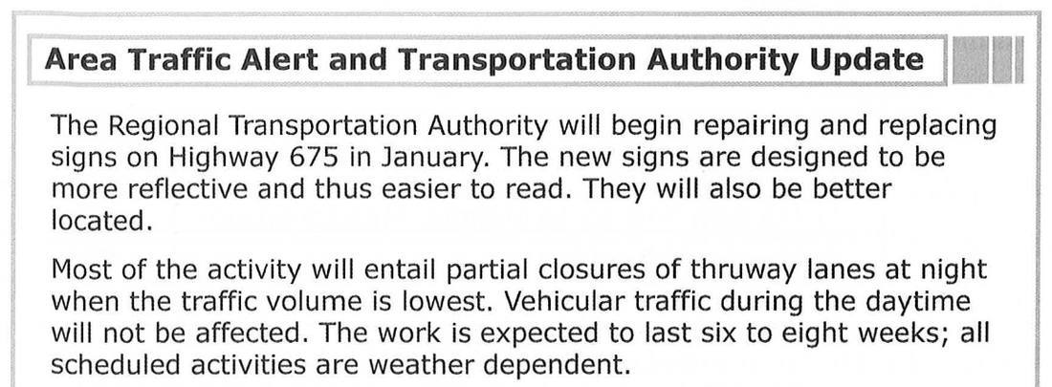
[/PASSAGE]

[Q 147] [SHUFFLE_A]
What is the purpose of the notice?
(A) To warn about increased traffic
(B) To outline work-zone safety tips
(C) To describe an improvement project
(D) To announce plans for a new highway
[ANSWER] C
[HINT] Thông báo về việc sửa chữa, thay mới biển báo trên Highway 675 → mô tả một dự án cải tạo.
[/Q]

[Q 148] [SHUFFLE_A]
What is a feature of the new signs?
(A) They will last much longer.
(B) They come in many colors.
(C) They are significantly larger.
(D) They offer improved readability.
[ANSWER] D
[HINT] Biển mới phản quang tốt hơn nên dễ đọc hơn (easier to read).
[/Q]

[/GROUP]

[GROUP 149-150] [SHUFFLE_Q]
[PASSAGE]
Questions 149-150 refer to the following form.
[IMAGE]
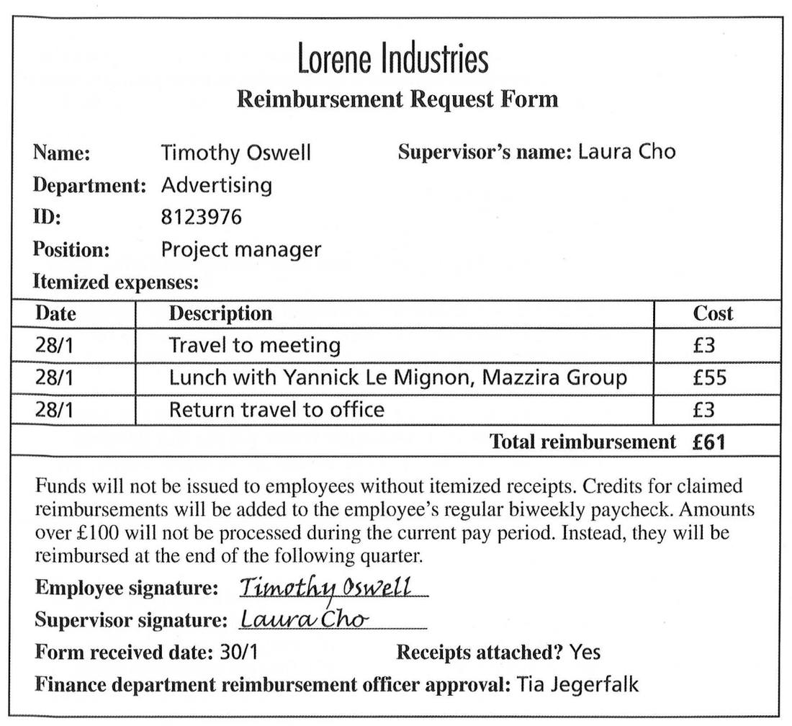
[/PASSAGE]

[Q 149] [SHUFFLE_A]
What can be reimbursed using the form?
(A) Only amounts less than £100
(B) Only transportation costs
(C) Only charges submitted with a receipt
(D) Only the expenses of senior staff members
[ANSWER] C
[HINT] "Funds will not be issued to employees without itemized receipts" → chỉ hoàn tiền khi có hoá đơn.
[/Q]

[Q 150] [SHUFFLE_A]
What is suggested about Mr. Oswell?
(A) He used a company credit card.
(B) He gets paid at the end of every week.
(C) He conducted business with a new client.
(D) He will receive a credit with his next paycheck.
[ANSWER] D
[HINT] Tổng £61 (dưới £100) nên được cộng vào kỳ lương hai tuần một lần tiếp theo.
[/Q]

[/GROUP]

[GROUP 151-153] [SHUFFLE_Q]
[PASSAGE]
Questions 151-153 refer to the following e-mail.
[IMAGE]
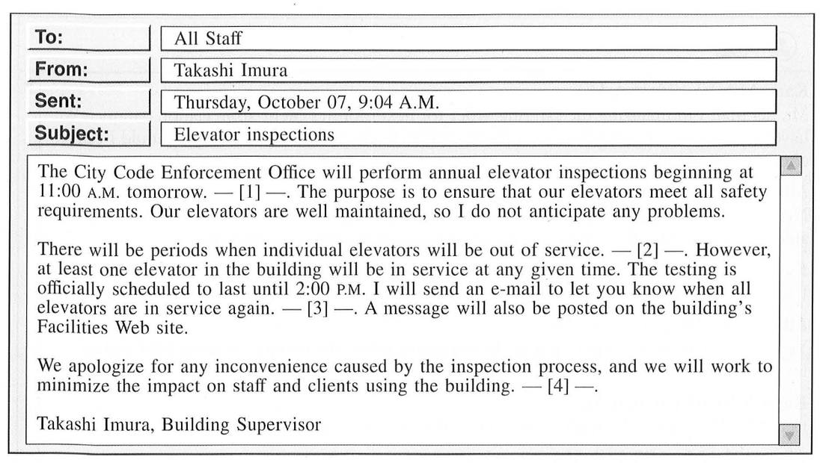
[/PASSAGE]

[Q 151] [SHUFFLE_A]
How often are the elevators inspected?
(A) Once a month
(B) Every six months
(C) Once a year
(D) Every two years
[ANSWER] C
[HINT] "annual elevator inspections" = kiểm tra hằng năm.
[/Q]

[Q 152] [SHUFFLE_A]
Why might the inspection be inconvenient for staff and clients?
(A) Offices on the top floor will be closed after 11:00 A.M.
(B) An elevator they often use may not be working.
(C) The elevators will be out of service until 2:00 P.M. Monday.
(D) Officials may have to operate some elevators for riders.
[ANSWER] B
[HINT] "individual elevators will be out of service" → thang máy họ hay dùng có thể tạm ngưng.
[/Q]

[Q 153] [NO_SHUFFLE_A]
In which of the positions marked [1], [2], [3], and [4] does the following sentence best belong?
"Thank you for your patience, and let me know if you have any questions."
(A) [1]
(B) [2]
(C) [3]
(D) [4]
[ANSWER] D
[HINT] Câu cảm ơn và mời đặt câu hỏi phù hợp ở cuối email, sau lời xin lỗi về sự bất tiện → vị trí [4].
[/Q]

[/GROUP]

[GROUP 154-155] [SHUFFLE_Q]
[PASSAGE]
Questions 154-155 refer to the following online chat discussion.
[IMAGE]
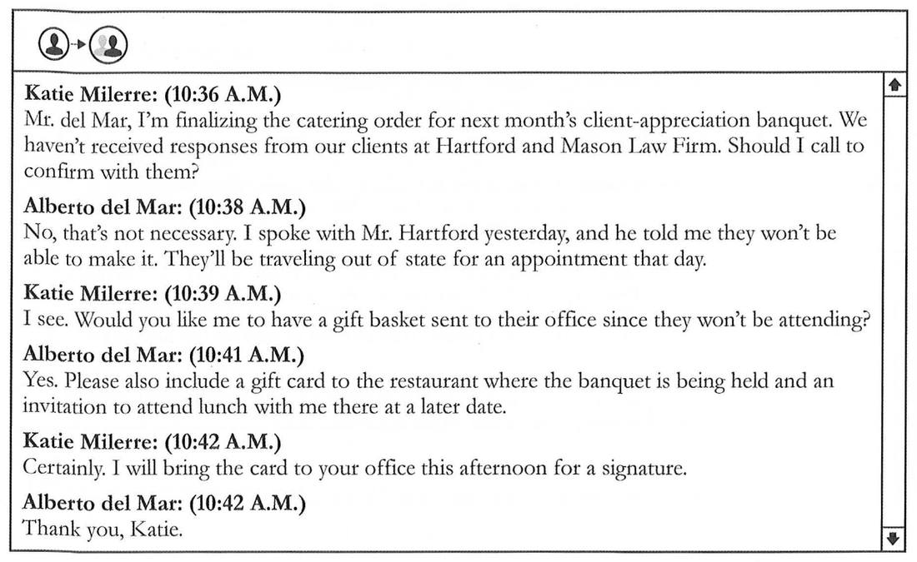
[/PASSAGE]

[Q 154] [SHUFFLE_A]
What is indicated about Mr. Hartford?
(A) He is unable to attend an upcoming event.
(B) He will contact Ms. Milerre in the afternoon.
(C) He is organizing a conference.
(D) He has not made travel plans yet.
[ANSWER] A
[HINT] Mr. Hartford nói họ "won't be able to make it" vì phải đi công tác ngoài bang.
[/Q]

[Q 155] [SHUFFLE_A]
At 10:39 A.M., what does Ms. Milerre most likely mean when she says, "I see"?
(A) She is looking at some information about a client.
(B) She understands an explanation provided by Mr. del Mar.
(C) She is currently viewing some photographs of gift baskets.
(D) She knows that Mr. del Mar wants her to purchase a card.
[ANSWER] B
[HINT] "I see" đáp lại lời giải thích của Mr. del Mar về việc khách không tham dự được → cô đã hiểu.
[/Q]

[/GROUP]

[GROUP 156-157] [SHUFFLE_Q]
[PASSAGE]
Questions 156-157 refer to the following information.
[IMAGE]

[/PASSAGE]

[Q 156] [SHUFFLE_A]
Where would the information most likely be found?
(A) Inside a package with a product
(B) Near a piece of art in a museum
(C) In an article in a nature magazine
(D) In an advertisement in a newspaper
[ANSWER] A
[HINT] Cuối thư: "Thank you for purchasing my products!" → tờ thông tin đi kèm sản phẩm.
[/Q]

[Q 157] [SHUFFLE_A]
According to the information, what can readers do on a Web site?
(A) Browse new items available for sale
(B) Compare the different types of wood
(C) Read detailed product-care instructions
(D) Learn about wood-carving techniques
[ANSWER] C
[HINT] "For more tips on how to best protect your natural wood product... visit www..." → hướng dẫn bảo quản sản phẩm.
[/Q]

[/GROUP]

[GROUP 158-160] [SHUFFLE_Q]
[PASSAGE]
Questions 158-160 refer to the following form.
[IMAGE]
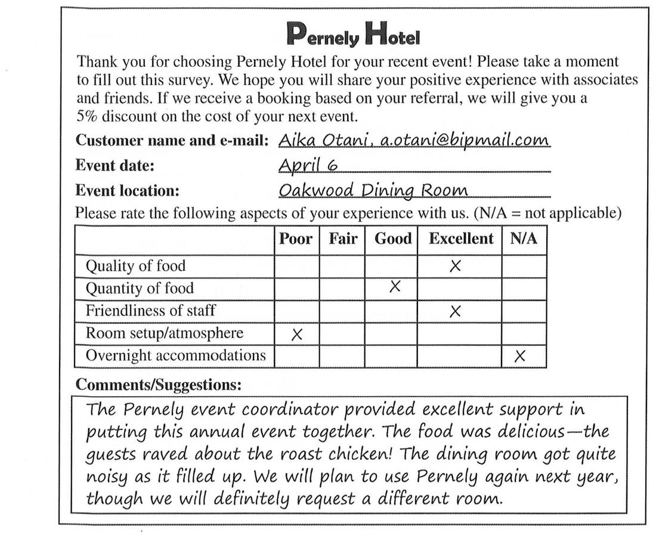
[/PASSAGE]

[Q 158] [SHUFFLE_A]
How can Ms. Otani become eligible for a discount?
(A) By booking an event before April 6
(B) By referring someone who books an event
(C) By reserving a block of hotel rooms
(D) By completing an online survey
[ANSWER] B
[HINT] "If we receive a booking based on your referral, we will give you a 5% discount".
[/Q]

[Q 159] [SHUFFLE_A]
What problem did Ms. Otani experience?
(A) There was too much noise.
(B) There was not enough food.
(C) The menu was limited.
(D) The room was small.
[ANSWER] A
[HINT] "The dining room got quite noisy as it filled up" → quá ồn.
[/Q]

[Q 160] [SHUFFLE_A]
What is NOT indicated on the form?
(A) The guests enjoyed the food.
(B) The event was held in the Oakwood Dining Room.
(C) Many of Ms. Otani's guests stayed overnight.
(D) A Pernely Hotel staff member helped with planning.
[ANSWER] C
[HINT] Mục "Overnight accommodations" được đánh N/A (không áp dụng) → không có khách ở lại qua đêm.
[/Q]

[/GROUP]

[GROUP 161-163] [SHUFFLE_Q]
[PASSAGE]
Questions 161-163 refer to the following article.
[IMAGE]

[/PASSAGE]

[Q 161] [SHUFFLE_A]
What is the purpose of the article?
(A) To critique new types of eyewear
(B) To report on the opening of a vision center
(C) To announce the uniting of two companies
(D) To discuss recent fashion trends
[ANSWER] C
[HINT] Roebling Vision "will be merging with Novianto Technology" → thông báo hai công ty sáp nhập.
[/Q]

[Q 162] [SHUFFLE_A]
What will Roebling Vision do soon?
(A) Increase its laboratory capacity
(B) Move its headquarters to Nairobi
(C) Discontinue a product line
(D) Hire a new CEO
[ANSWER] A
[HINT] Phòng thí nghiệm ở Johannesburg sẽ được mở rộng để chứa lực lượng lao động lớn hơn.
[/Q]

[Q 163] [SHUFFLE_A]
The phrase "devoted to" in paragraph 4, line 8, is closest in meaning to
(A) admiring of
(B) focused on
(C) elected to
(D) supported by
[ANSWER] B
[HINT] "a small division devoted to research" = bộ phận chuyên về nghiên cứu → focused on.
[/Q]

[/GROUP]

[GROUP 164-167] [SHUFFLE_Q]
[PASSAGE]
Questions 164-167 refer to the following online chat discussion.
[IMAGE]
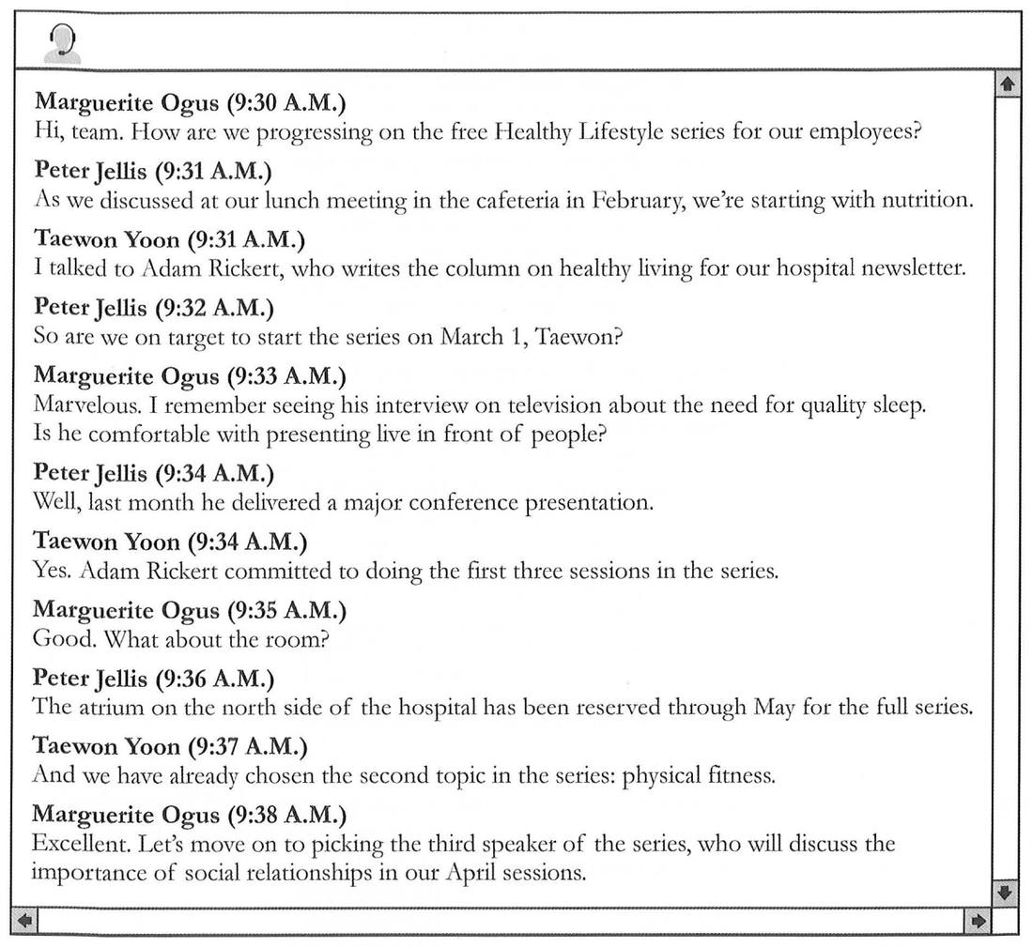
[/PASSAGE]

[Q 164] [SHUFFLE_A]
What is suggested about the speaker series?
(A) It will include lunch.
(B) It will be held in a hospital.
(C) It will be open to the public.
(D) It will be shown on television.
[ANSWER] B
[HINT] "The atrium on the north side of the hospital has been reserved... for the full series".
[/Q]

[Q 165] [SHUFFLE_A]
At 9:33 A.M., what does Ms. Ogus mean when she writes, "Marvelous"?
(A) She is satisfied with the latest newsletter.
(B) She is pleased that Mr. Jellis has joined the chat.
(C) She is happy with Mr. Yoon's choice of speaker.
(D) She is glad to speak as part of the series.
[ANSWER] C
[HINT] Mr. Yoon vừa cho biết đã liên hệ Adam Rickert; bà Ogus khen "Marvelous" và nhớ đã xem ông ấy trên TV → hài lòng với diễn giả.
[/Q]

[Q 166] [NO_SHUFFLE_A]
When is Mr. Rickert scheduled to speak?
(A) In February
(B) In March
(C) In April
(D) In May
[ANSWER] B
[HINT] Chuỗi bắt đầu ngày 1/3 và Rickert nhận ba buổi đầu tiên → tháng Ba.
[/Q]

[Q 167] [SHUFFLE_A]
According to the chat, what topic will most likely NOT be discussed in the speaker series?
(A) Physical exercise
(B) Eating well
(C) Sleep habits
(D) Healthy relationships
[ANSWER] C
[HINT] Các chủ đề: dinh dưỡng, thể chất, quan hệ xã hội. Giấc ngủ chỉ là chủ đề Rickert từng nói trên TV.
[/Q]

[/GROUP]

[GROUP 168-171] [SHUFFLE_Q]
[PASSAGE]
Questions 168-171 refer to the following report.
[IMAGE]
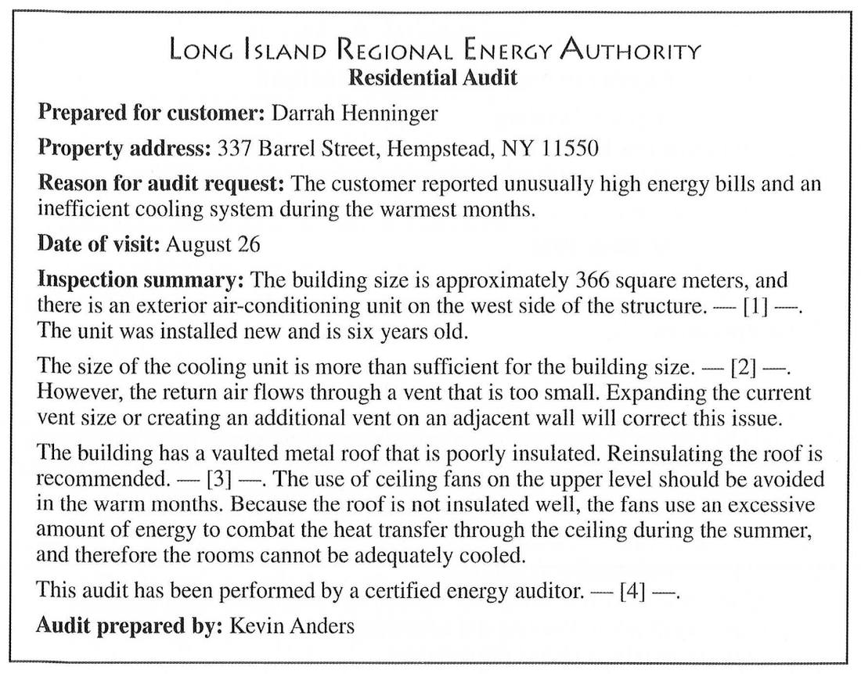
[/PASSAGE]

[Q 168] [SHUFFLE_A]
Why most likely did Ms. Henninger request the audit service?
(A) She would like to enlarge her living space.
(B) She needs some heating equipment repaired.
(C) She is interested in purchasing a property.
(D) She wants to lower her summer energy costs.
[ANSWER] D
[HINT] Lý do: hoá đơn năng lượng cao bất thường và hệ thống làm mát kém trong những tháng nóng.
[/Q]

[Q 169] [SHUFFLE_A]
What is indicated about the air-conditioning unit?
(A) It is an adequate size.
(B) It has a satisfactory venting system.
(C) It is a discontinued model.
(D) It has been producing warm air.
[ANSWER] A
[HINT] "The size of the cooling unit is more than sufficient for the building size".
[/Q]

[Q 170] [SHUFFLE_A]
What does Mr. Anders advise about the ceiling fans?
(A) They should be replaced.
(B) They should be reinstalled in other locations.
(C) They should be used instead of the air-conditioning unit.
(D) They should be turned off for part of the year.
[ANSWER] D
[HINT] "The use of ceiling fans on the upper level should be avoided in the warm months".
[/Q]

[Q 171] [NO_SHUFFLE_A]
In which of the positions marked [1], [2], [3], and [4] does the following sentence best belong?
"This should be a top priority."
(A) [1]
(B) [2]
(C) [3]
(D) [4]
[ANSWER] C
[HINT] Đứng ngay sau "Reinsulating the roof is recommended." để nhấn mạnh việc cách nhiệt lại mái → vị trí [3].
[/Q]

[/GROUP]

[GROUP 172-175] [SHUFFLE_Q]
[PASSAGE]
Questions 172-175 refer to the following conference schedule.
[IMAGE]
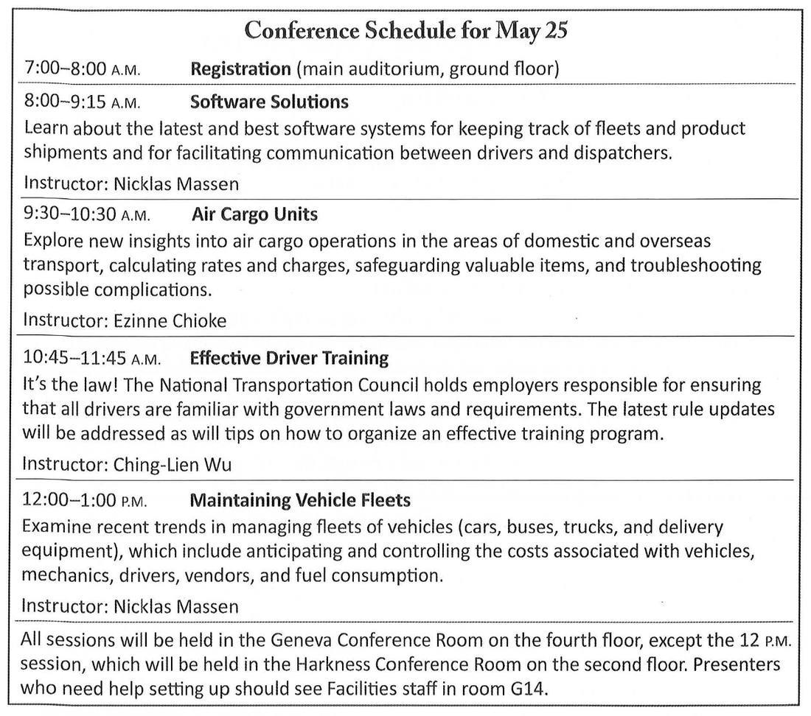
[/PASSAGE]

[Q 172] [SHUFFLE_A]
Who most likely would attend the conference?
(A) Transportation company owners
(B) Computer software programmers
(C) Truck and bus drivers
(D) Business management professors
[ANSWER] A
[HINT] Nội dung về quản lý đội xe, trách nhiệm của chủ doanh nghiệp vận tải (employers) → chủ công ty vận tải.
[/Q]

[Q 173] [SHUFFLE_A]
What is NOT a subject likely to be covered during the 9:30 A.M. session?
(A) Pricing
(B) International shipments
(C) Solving common difficulties
(D) Improving staff communication
[ANSWER] D
[HINT] Buổi Air Cargo Units: vận chuyển quốc tế, tính giá cước, xử lý sự cố. Không nói về giao tiếp nhân viên.
[/Q]

[Q 174] [NO_SHUFFLE_A]
When will the session on following regulations be held?
(A) At 8:00 A.M.
(B) At 9:30 A.M.
(C) At 10:45 A.M.
(D) At 12:00 P.M.
[ANSWER] C
[HINT] Buổi Effective Driver Training lúc 10:45 nói về luật và quy định mới nhất.
[/Q]

[Q 175] [SHUFFLE_A]
Where will Ms. Chioke lead her session?
(A) In the main auditorium
(B) In the Geneva Conference Room
(C) In the Harkness Conference Room
(D) In room G14
[ANSWER] B
[HINT] Bà Chioke dạy buổi 9:30; mọi buổi đều ở Geneva Conference Room trừ buổi 12 giờ trưa.
[/Q]

[/GROUP]

[GROUP 176-180] [SHUFFLE_Q]
[PASSAGE]
Questions 176-180 refer to the following sales report and e-mail.
[IMAGE]
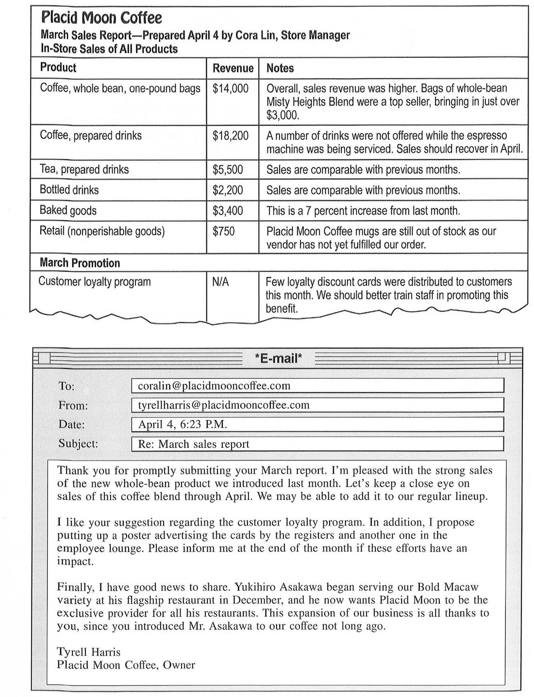
[/PASSAGE]

[Q 176] [SHUFFLE_A]
What product sold less than expected?
(A) Prepared coffee drinks
(B) Prepared tea drinks
(C) Bottled drinks
(D) Baked goods
[ANSWER] A
[HINT] Một số đồ uống không bán được khi máy espresso đang bảo dưỡng; "Sales should recover in April".
[/Q]

[Q 177] [SHUFFLE_A]
What problem does Ms. Lin have?
(A) Some desserts did not sell as desired.
(B) Some mugs have not been delivered.
(C) Some coffee beans are out of stock.
(D) Some posters have unclear information.
[ANSWER] B
[HINT] Cốc Placid Moon vẫn hết hàng vì nhà cung cấp chưa giao đơn hàng.
[/Q]

[Q 178] [SHUFFLE_A]
What does Ms. Lin recommend?
(A) A better espresso machine should be purchased.
(B) The customer loyalty program should be discontinued.
(C) Part-time staff should be hired on a permanent basis.
(D) Employees should receive additional training.
[ANSWER] D
[HINT] "We should better train staff in promoting this benefit".
[/Q]

[Q 179] [SHUFFLE_A]
What is suggested about the Misty Heights Blend?
(A) It was offered for the first time in March.
(B) It will no longer be sold by Placid Moon Coffee.
(C) It is more expensive than other types of coffee.
(D) It has a stronger flavor than other blends.
[ANSWER] A
[HINT] Kết hợp 2 bài: Misty Heights bán chạy nhất tháng 3; email (4/4) gọi đó là sản phẩm mới ra mắt tháng trước.
[/Q]

[Q 180] [SHUFFLE_A]
What is most likely true about Ms. Lin?
(A) She agreed to take on an added responsibility.
(B) She requested a new espresso maker from Mr. Harris.
(C) She recommended products to Mr. Asakawa.
(D) She renovated the employee lounge.
[ANSWER] C
[HINT] "you introduced Mr. Asakawa to our coffee not long ago" → cô đã giới thiệu sản phẩm cho ông Asakawa.
[/Q]

[/GROUP]

[GROUP 181-185] [SHUFFLE_Q]
[PASSAGE]
Questions 181-185 refer to the following article and online application.
[IMAGE]
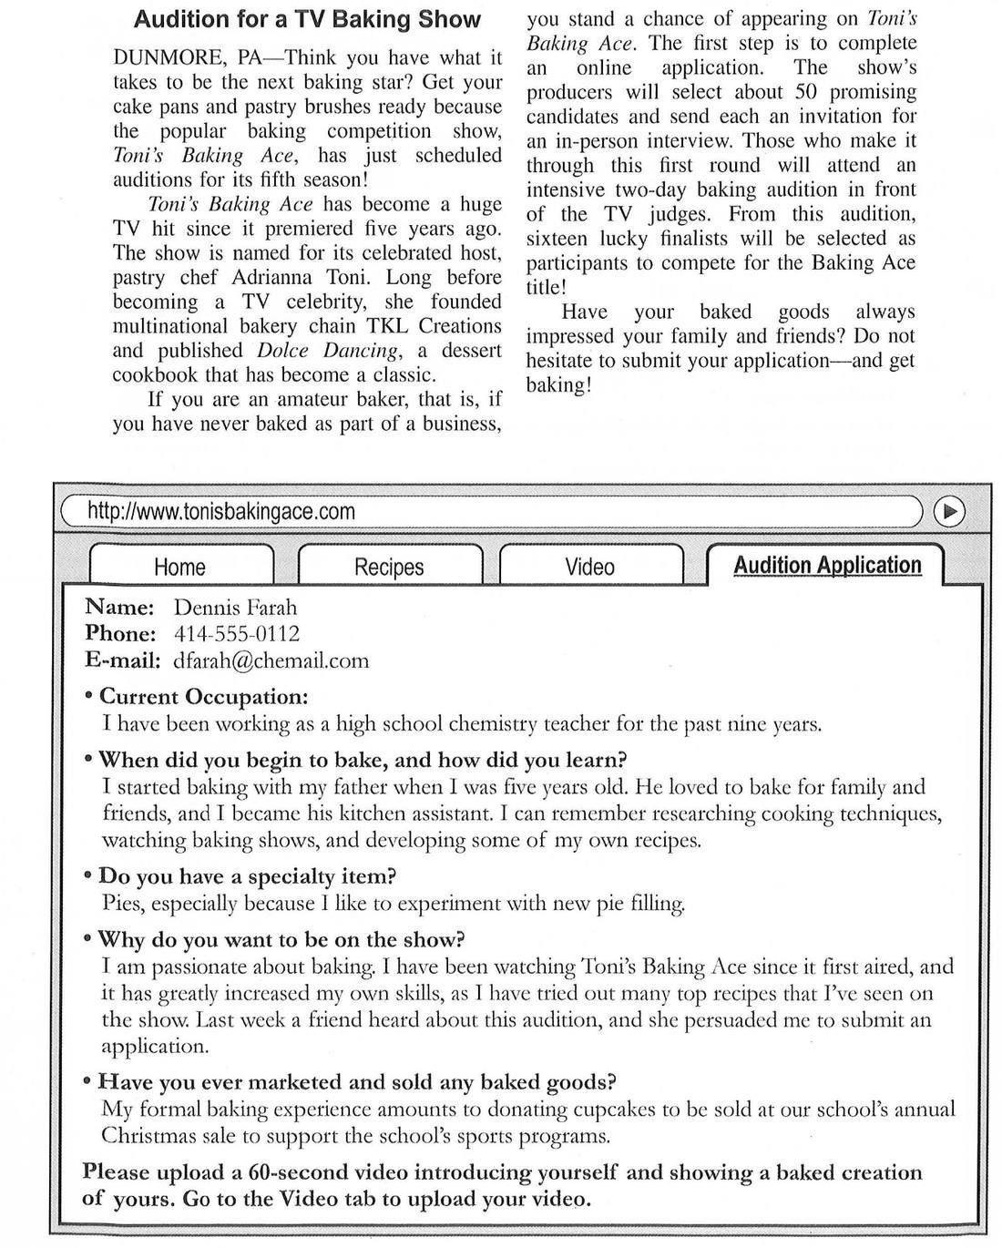
[/PASSAGE]

[Q 181] [SHUFFLE_A]
What does the article indicate about Toni's Baking Ace?
(A) It accepts teenagers as contestants.
(B) It often selects international participants.
(C) It awards prize money to winners.
(D) It is hosted by a famous author.
[ANSWER] D
[HINT] Người dẫn chương trình Adrianna Toni đã xuất bản cuốn sách nấu ăn kinh điển Dolce Dancing.
[/Q]

[Q 182] [SHUFFLE_A]
In the article, the word "hit" in paragraph 2, line 2, is closest in meaning to
(A) success
(B) impact
(C) expense
(D) encouragement
[ANSWER] A
[HINT] "a huge TV hit" = một chương trình truyền hình rất thành công.
[/Q]

[Q 183] [SHUFFLE_A]
What requirement is mentioned in the online application?
(A) Signing a contract
(B) Passing a baking speed competition
(C) Including an introductory video
(D) Participating in a past contest
[ANSWER] C
[HINT] "Please upload a 60-second video introducing yourself".
[/Q]

[Q 184] [SHUFFLE_A]
What does Mr. Farah state in his application?
(A) He has a kitchen assistant.
(B) He is an educator.
(C) He has never watched the show.
(D) His father will soon appear on the show.
[ANSWER] B
[HINT] Ông là giáo viên hoá học trung học trong 9 năm → nhà giáo dục.
[/Q]

[Q 185] [SHUFFLE_A]
Why most likely does Mr. Farah give details about an annual event?
(A) To show how popular his baking is
(B) To indicate he is familiar with contests
(C) To provide evidence that he is not a professional baker
(D) To prove he can bake with limited equipment
[ANSWER] C
[HINT] Bài báo yêu cầu thí sinh nghiệp dư (chưa từng làm bánh để kinh doanh); ông chỉ tặng bánh cho hội chợ trường.
[/Q]

[/GROUP]

[GROUP 186-190] [SHUFFLE_Q]
[PASSAGE]
Questions 186-190 refer to the following Web page, form, and e-mail.
[IMAGE]
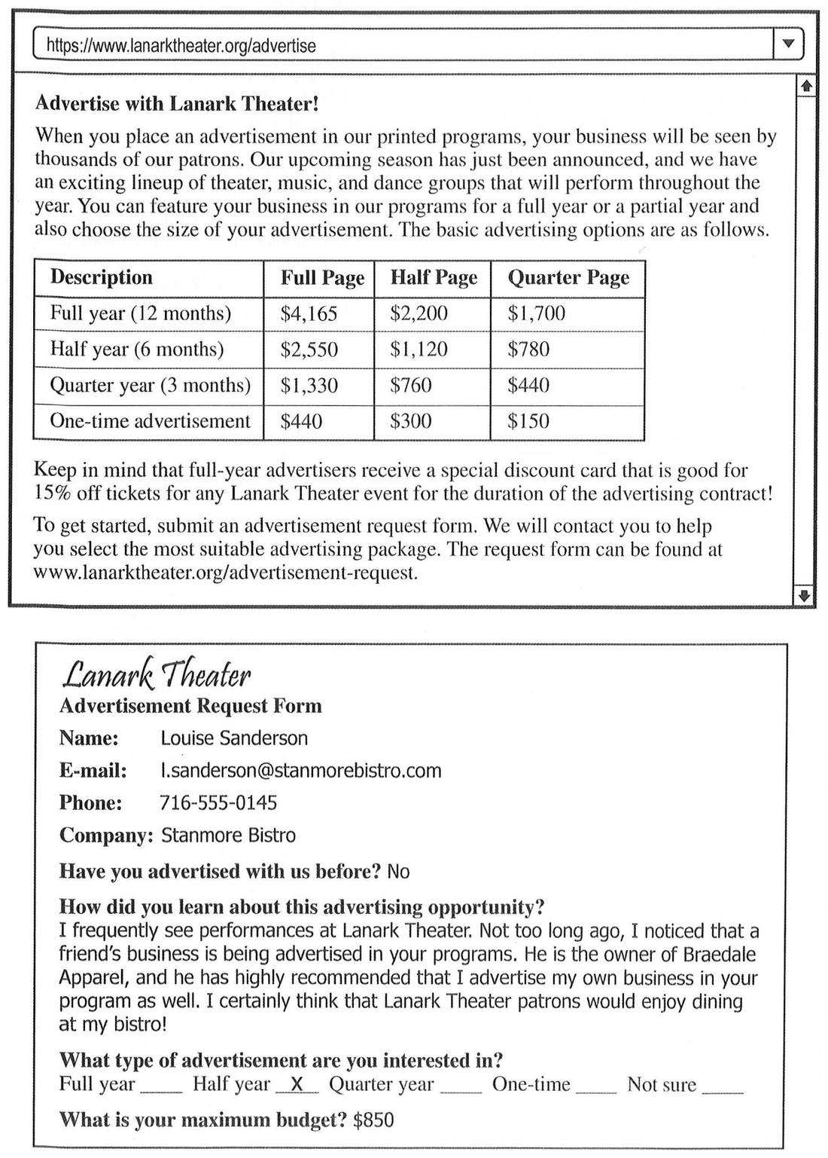
[/PASSAGE]
[PASSAGE]
[IMAGE]
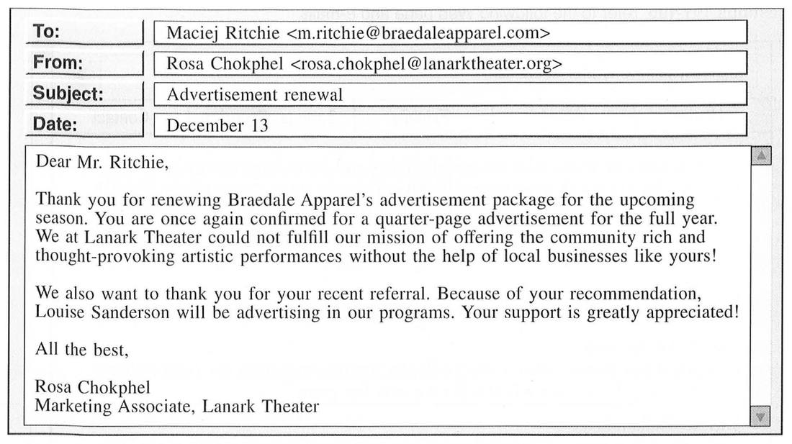
[/PASSAGE]

[Q 186] [SHUFFLE_A]
What is the purpose of the Web page?
(A) To promote upcoming shows
(B) To review recent performances
(C) To announce advertising opportunities
(D) To profile the lineup of performers
[ANSWER] C
[HINT] Tiêu đề "Advertise with Lanark Theater!" và bảng giá quảng cáo.
[/Q]

[Q 187] [SHUFFLE_A]
What is mentioned about Lanark Theater?
(A) It offers a variety of artistic performances.
(B) It advertises in a local newspaper.
(C) It has only recently opened.
(D) It features performances exclusively from local groups.
[ANSWER] A
[HINT] "an exciting lineup of theater, music, and dance groups" → nhiều loại hình nghệ thuật.
[/Q]

[Q 188] [SHUFFLE_A]
What type of business does Ms. Sanderson own?
(A) An advertising company
(B) A clothing store
(C) A theater
(D) A restaurant
[ANSWER] D
[HINT] Công ty Stanmore Bistro, "patrons would enjoy dining at my bistro" → nhà hàng.
[/Q]

[Q 189] [SHUFFLE_A]
What advertisement option will Ms. Sanderson most likely purchase?
(A) A full-page advertisement
(B) A half-page advertisement
(C) A quarter-page advertisement
(D) A one-time advertisement
[ANSWER] C
[HINT] Bà chọn gói Half year, ngân sách tối đa $850; trong gói nửa năm chỉ quarter page ($780) vừa ngân sách.
[/Q]

[Q 190] [SHUFFLE_A]
What is suggested about Mr. Ritchie?
(A) He is a co-owner at Stanmore Bistro.
(B) He will receive discounted tickets.
(C) He has upgraded his advertising package.
(D) He prefers music performances to dance performances.
[ANSWER] B
[HINT] Ông gia hạn quảng cáo cả năm; trang web cho biết khách quảng cáo cả năm được thẻ giảm 15% giá vé.
[/Q]

[/GROUP]

[GROUP 191-195] [SHUFFLE_Q]
[PASSAGE]
Questions 191-195 refer to the following Web page and e-mails.
[IMAGE]
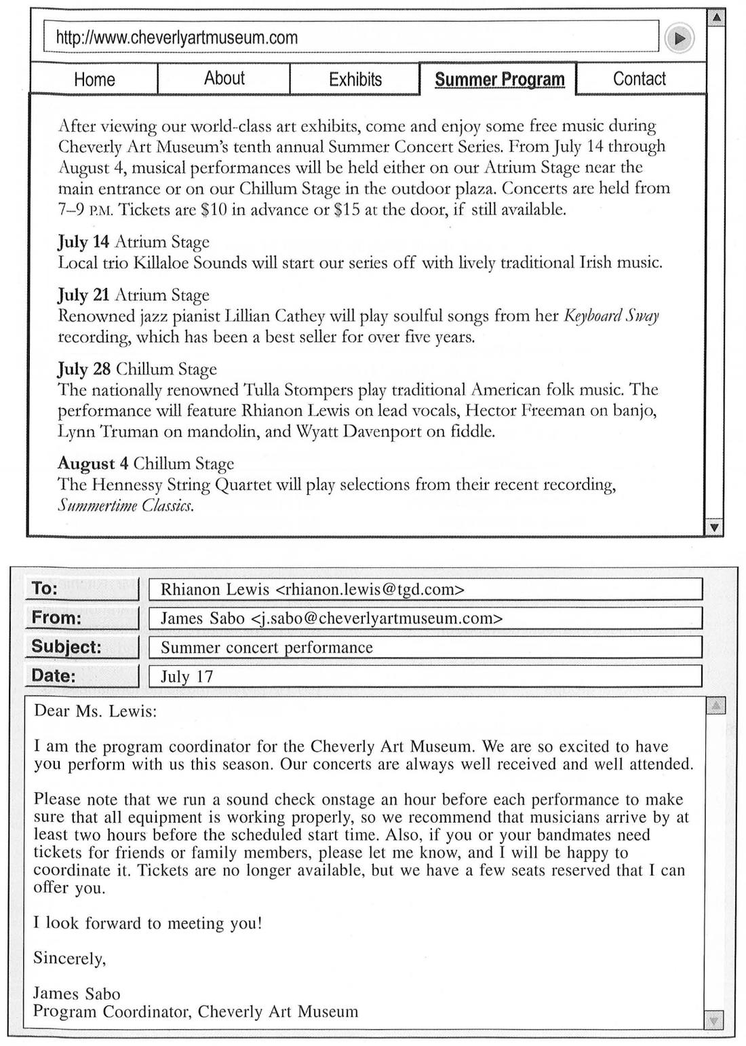
[/PASSAGE]
[PASSAGE]
[IMAGE]
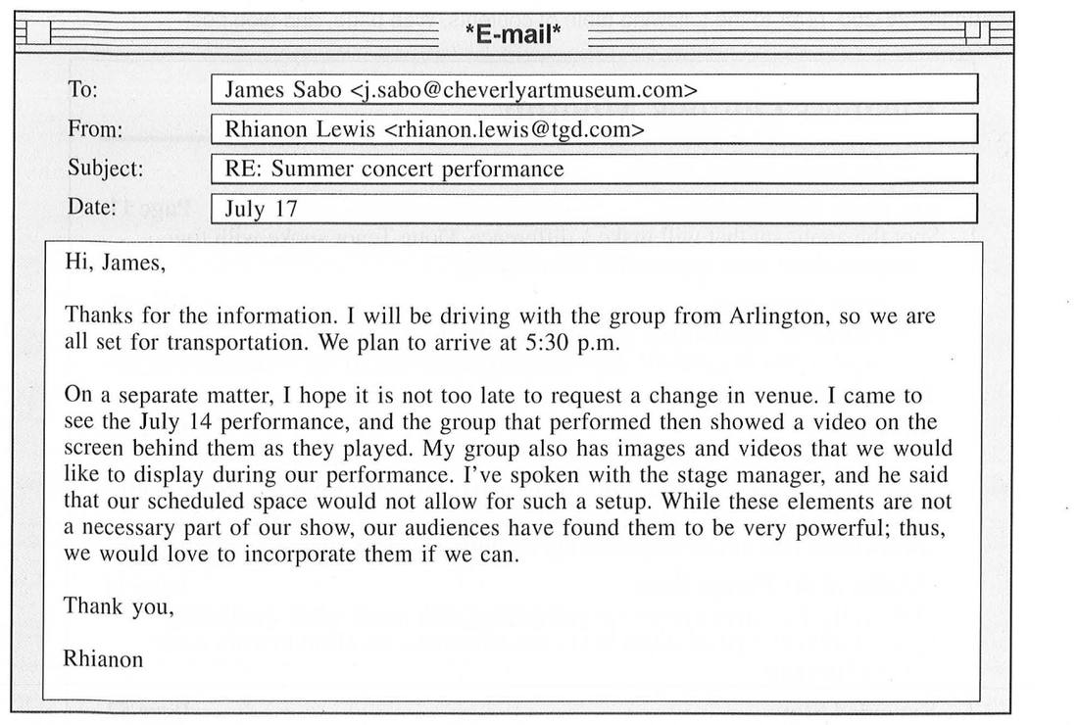
[/PASSAGE]

[Q 191] [SHUFFLE_A]
What does the Web page indicate about the concert series?
(A) It is held every year.
(B) It focuses on classical music.
(C) It is open only to museum members.
(D) It is organized by a well-known artist.
[ANSWER] A
[HINT] "tenth annual Summer Concert Series" → tổ chức hằng năm.
[/Q]

[Q 192] [SHUFFLE_A]
According to the Web page, what act has recently recorded music?
(A) Killaloe Sounds
(B) Lillian Cathey
(C) The Tulla Stompers
(D) The Hennessy String Quartet
[ANSWER] D
[HINT] Hennessy String Quartet chơi các bài trong bản thu gần đây "Summertime Classics". Album của Lillian Cathey đã hơn 5 năm.
[/Q]

[Q 193] [SHUFFLE_A]
What is suggested about the Tulla Stompers concert?
(A) It has already sold out.
(B) It will begin two hours early.
(C) It will feature a local guest musician.
(D) It has been moved to a different date.
[ANSWER] A
[HINT] Rhianon Lewis hát chính cho Tulla Stompers; email gửi cô viết "Tickets are no longer available".
[/Q]

[Q 194] [SHUFFLE_A]
According to the first e-mail, why should musicians arrive early?
(A) To find parking
(B) To sign a contract
(C) To test sound equipment
(D) To select a stage manager
[ANSWER] C
[HINT] Có buổi kiểm tra âm thanh (sound check) một giờ trước mỗi buổi diễn.
[/Q]

[Q 195] [SHUFFLE_A]
What is indicated about Ms. Lewis?
(A) She recorded a song with Lillian Cathey.
(B) She has requested transportation to Cheverly Art Museum.
(C) She has never used video in her performance before.
(D) She attended a performance by Killaloe Sounds.
[ANSWER] D
[HINT] Cô xem buổi diễn ngày 14/7; theo trang web, Killaloe Sounds biểu diễn ngày 14/7.
[/Q]

[/GROUP]

[GROUP 196-200] [SHUFFLE_Q]
[PASSAGE]
Questions 196-200 refer to the following table of contents, Web page, and blog post.
[IMAGE]
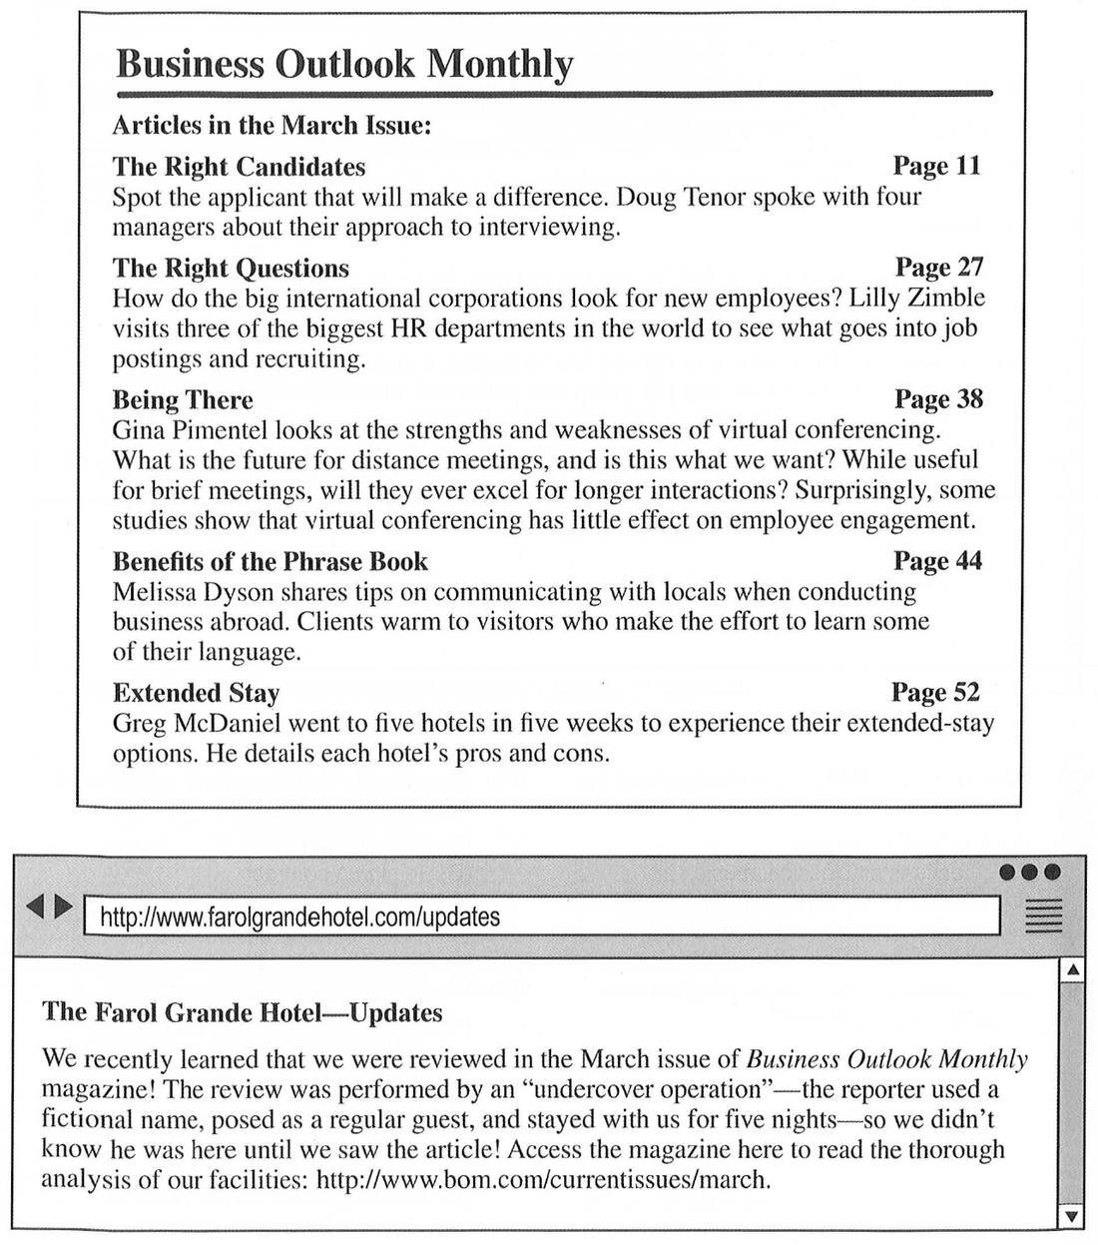
[/PASSAGE]
[PASSAGE]
[IMAGE]
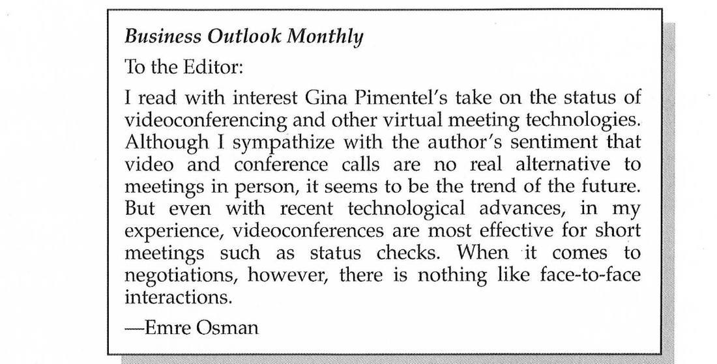
[/PASSAGE]

[Q 196] [SHUFFLE_A]
How are the first two articles in the magazine similar?
(A) Both discuss employee hiring practices.
(B) Both focus on new uses of technology.
(C) Both discuss how a new position is advertised.
(D) Both critique negative interview behaviors.
[ANSWER] A
[HINT] "The Right Candidates" (phỏng vấn ứng viên) và "The Right Questions" (tuyển dụng) đều nói về tuyển nhân viên.
[/Q]

[Q 197] [NO_SHUFFLE_A]
On what page is there advice for international travelers?
(A) Page 11
(B) Page 27
(C) Page 38
(D) Page 44
[ANSWER] D
[HINT] Trang 44 "Benefits of the Phrase Book": mẹo giao tiếp khi đi công tác nước ngoài.
[/Q]

[Q 198] [SHUFFLE_A]
According to the Web page, what did the reporter do?
(A) He visited the hotel in March.
(B) He hid his real identity.
(C) He canceled a reservation.
(D) He arrived late at night.
[ANSWER] B
[HINT] Phóng viên dùng tên giả và đóng vai khách thường ("undercover operation").
[/Q]

[Q 199] [SHUFFLE_A]
Who stayed at the Farol Grande Hotel?
(A) Mr. Tenor
(B) Ms. Zimble
(C) Ms. Dyson
(D) Mr. McDaniel
[ANSWER] D
[HINT] Bài "Extended Stay" của Greg McDaniel đánh giá khách sạn; khách sạn xác nhận được review trong số tháng 3.
[/Q]

[Q 200] [SHUFFLE_A]
On what do Ms. Pimentel and Mr. Osman agree about virtual meetings?
(A) They increase employee engagement.
(B) They should be phased out in the future.
(C) They should replace in-person meetings.
(D) They work well for quick exchanges of information.
[ANSWER] D
[HINT] Pimentel: hữu ích cho cuộc họp ngắn; Osman: hiệu quả nhất cho cuộc họp ngắn như kiểm tra tiến độ.
[/Q]

[/GROUP]

[/PART]

[/EXAM]

