BPMN – 01 Account Management

Purpose:
Allow travelers to securely access TravelMate securely and manage their personal account information.

Main Process:
Travelers access TravelMate and choose to register or log in. The system validates the provided information before creating a new account or authenticating the traveler. After successful authentication, the traveler is redirected to the Trip List page where they can access the application's features.

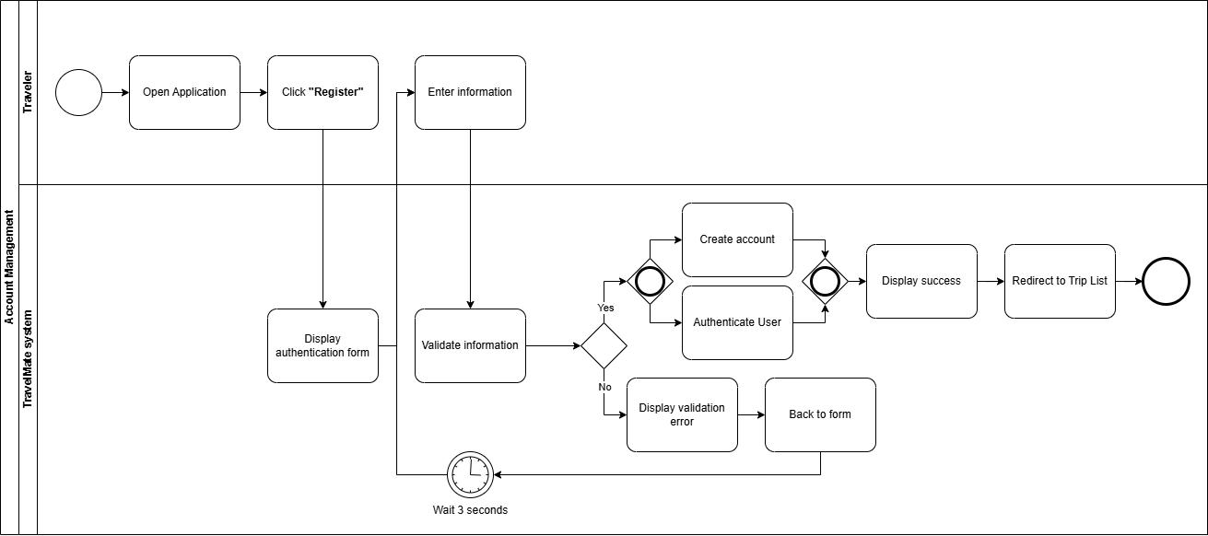

BPMN – 02 Trip Management

Purpose:
Allow travelers to create, update, organize, and manage their trips throughout the trip lifecycle.

Main Process:
Travelers access the Trip List and choose a trip management action, such as creating, editing, archiving, restoring, or deleting a trip. The system validates the request, updates the trip information accordingly, and refreshes the Trip List after the operation is completed successfully.
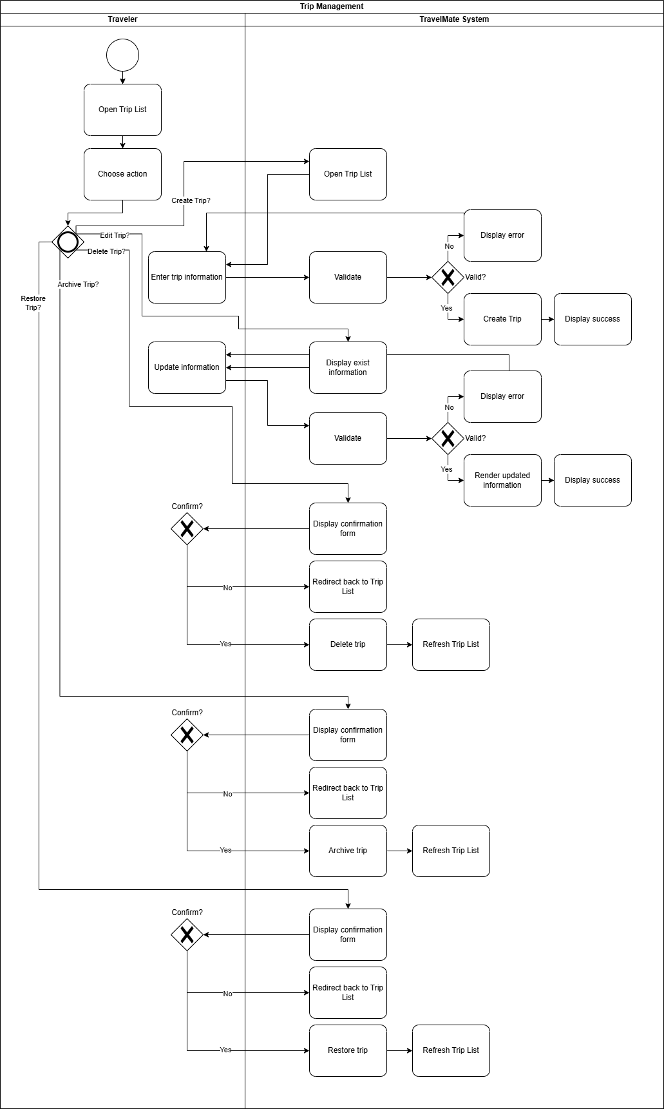

BPMN – 03 Collaboration

Purpose:
Allow trip owners and invited members to collaborate on shared trips through invitations and role-based access.

Main Process:
The trip owner enables collaboration, adds members by entering their email addresses, and assigns roles. The system validates the information, creates an invitation, and sends it via the email service. Invited travelers may accept or decline the invitation. If accepted, the system updates the trip member list and grants the assigned permissions.
