Biểu đồ scatter plot và boxplot cho nhóm Nam hút thuốc vs Nam không hút thuốc

Minh

2024-02-28

options(warn = -1)

## Load bộ số liệu và các packages

library(tidyverse)  
library(gtsummary)  
library(rstatix)  
library(readxl)  
library(boot)  
library(forestplot)  
d <- read_excel("C:/Users/Admin/OneDrive/NC_Quangpho/Data_regardless_sleep_18_03.xlsx")  
View(d)  
  
d$BMI_25_30 <- ifelse(d$BMI_index < 25, 1,   
 ifelse(d$BMI_index >= 25 & d$BMI_index < 30, 2, 3))  
d$Age_stage <- ifelse(d$Age <= 30, 1,   
 ifelse(d$Age >= 30 & d$Age < 40, 2, ifelse(d$Age >= 40 & d$Age < 50, 3,4)))  
d$Gender <- ifelse(d$Gender == 0, "female", ifelse(d$Gender == 1, "male", NA))  
d$Race <- d$`6. Race`  
d <- d %>%  
 mutate(Age_stage = case_when(  
 Age_stage == 1 ~ "Age <30",  
 Age_stage == 2 ~ "Age [30-40)",  
 Age_stage == 3 ~ "Age [40-50)",  
 Age_stage == 4 ~ "Age >=50",  
 TRUE ~ NA_character_ # This line handles any unexpected values  
 ))  
d$Hypertension <- ifelse(d$Hypertension == 0, "No", ifelse(d$Hypertension == 1, "Yes", NA))  
d$`Stress index` <- ifelse(d$`Stress index` == 0, "No", ifelse(d$`Stress index` == 1, "Yes", NA))  
d$Obesity <- ifelse(d$Obesity == 0, "No", ifelse(d$Obesity == 1, "Yes", NA))  
d <- d %>%  
 mutate(BMI_25_30 = case_when(  
 BMI_25_30 == 1 ~ "BMI <25",  
 BMI_25_30 == 2 ~ "BMI [25-30)",  
 BMI_25_30 == 3 ~ "BMI >=30",  
 TRUE ~ NA_character_ # This line handles any unexpected values  
 ))  
d$Smoking <- ifelse(d$Smoking == "Do not smoke", "Non smoker", ifelse(d$Smoking == "Cigarettes, pipe tobacco...", "Smoker", NA))  
d <- d %>% filter(Gender == "male")

## So sánh các chỉ số trung bình của nhóm Smoker vs Non smoker bằng Wilcox test

Tạo hàm tính 95%CI

library(dplyr)  
  
calculate_95CI <- function(data, variable) {  
 ci_lower <- quantile(data[[variable]], probs = 0.025, na.rm = TRUE)  
 ci_upper <- quantile(data[[variable]], probs = 0.975, na.rm = TRUE)  
   
 return(c(CI_lower = ci_lower, CI_upper = ci_upper))  
}

Tạo hàm so sánh trung bình bằng Wilcox.test nếu subgroup có 2 level

library(dplyr)  
  
compare_means <- function(data, subgroup, variable) {  
 # Split data into subgroups  
 subgroup_levels <- unique(data[[subgroup]])  
 results <- data.frame(Subgroup = subgroup_levels, n = NA, Mean = NA, CI_lower = NA, CI_upper = NA)  
   
 # Loop through each subgroup to calculate mean, n, and 95% CI  
 for (i in 1:length(subgroup_levels)) {  
 subgroup_data <- data[data[[subgroup]] == subgroup_levels[i], ]  
 n <- nrow(subgroup_data)  
 mean_value <- mean(subgroup_data[[variable]], na.rm = TRUE)  
 CI_lower <- quantile(subgroup_data[[variable]], probs = 0.025, na.rm = TRUE)  
 CI_upper <- quantile(data[[variable]], probs = 0.975, na.rm = TRUE)  
   
 results[i, "n"] <- n  
 results[i, "Mean"] <- mean_value  
 results[i, "CI_lower"] <- CI_lower  
 results[i, "CI_upper"] <- CI_upper  
 }  
   
 # Statistical comparison  
 if (length(subgroup_levels) > 2) {  
 results$P_Value <- NA # Not applicable for more than two subgroups  
 } else if (length(subgroup_levels) == 2) {  
 # If exactly two subgroups, perform Wilcoxon signed-rank test and add p-values to the results  
 test_result <- wilcox.test(data[[variable]] ~ data[[subgroup]], data = data)  
 results$P_Value <- rep(test_result$p.value, nrow(results))  
 } else {  
 # If only one subgroup, no comparison is needed  
 results$P_Value <- NA  
 message("Only one subgroup detected. No comparison needed.")  
 }  
   
 return(results)  
}

List_var <- c("M_mean", "Kv100_mean", "δ_mean", "T_mean", "A365_mean", "A460_mean", "Anadn_mean", "POM_mean", "A-E_mean", "A-N_mean", "A-M_mean", "A-R_mean", "A-C_mean", "F-E_mean", "F-N_mean", "F-M_mean", "F-R_mean", "F-C_mean")

# Initialize an empty list to store results  
results_list <- list()  
  
# Loop through each variable and apply compare_means  
for (var in List_var) {  
 result <- compare_means(data = d, subgroup = "Smoking", variable = var)  
 result$Variable <- var # Add a new column for the variable name  
 results_list[[var]] <- result  
}  
  
# Combine individual data frames into a final results table  
final_results <- do.call(rbind, results_list)  
  
# Reordering columns to make 'Variable' the first column  
final_results <- final_results[, c("Variable", setdiff(names(final_results), "Variable"))]  
  
# Reset row names to remove any potential duplicates  
rownames(final_results) <- NULL  
  
# View the final results  
final_results %>% knitr::kable()

| Variable | Subgroup | n | Mean | CI_lower | CI_upper | P_Value |
| --- | --- | --- | --- | --- | --- | --- |
| M_mean | Non smoker | 31 | 24.4826613 | 5.372500 | 37.353250 | 0.6893053 |
| M_mean | Smoker | 14 | 21.1096667 | 4.602750 | 37.353250 | 0.6893053 |
| Kv100_mean | Non smoker | 31 | 20.6321237 | 6.808125 | 40.097500 | 0.0795145 |
| Kv100_mean | Smoker | 14 | 14.4326905 | 7.875125 | 40.097500 | 0.0795145 |
| δ_mean | Non smoker | 31 | 4.1933333 | 1.848750 | 7.860000 | 0.0269689 |
| δ_mean | Smoker | 14 | 2.9509881 | 0.551750 | 7.860000 | 0.0269689 |
| T_mean | Non smoker | 31 | 31.5779301 | 24.133750 | 35.666000 | 0.5362906 |
| T_mean | Smoker | 14 | 29.9534405 | 21.912875 | 35.666000 | 0.5362906 |
| A365_mean | Non smoker | 31 | 87.4220430 | 19.625000 | 155.800000 | 0.7313942 |
| A365_mean | Smoker | 14 | 85.8571429 | 2.812500 | 155.800000 | 0.7313942 |
| A460_mean | Non smoker | 31 | 57.2473118 | 14.875000 | 106.950000 | 0.3451713 |
| A460_mean | Smoker | 14 | 65.9904762 | 13.650000 | 106.950000 | 0.3451713 |
| Anadn_mean | Non smoker | 31 | 0.7467742 | 0.436250 | 4.177500 | 0.0954619 |
| Anadn_mean | Smoker | 14 | 1.4245952 | 0.409375 | 4.177500 | 0.0954619 |
| POM_mean | Non smoker | 31 | 9.5858333 | 2.242500 | 18.402500 | 0.0839258 |
| POM_mean | Smoker | 14 | 7.8422738 | 1.097625 | 18.402500 | 0.0839258 |
| A-E_mean | Non smoker | 31 | 1.7288978 | 0.595000 | 3.462500 | 0.0107407 |
| A-E_mean | Smoker | 14 | 1.0282619 | 0.206750 | 3.462500 | 0.0107407 |
| A-N_mean | Non smoker | 31 | 1.6372043 | 0.611250 | 2.992833 | 0.0179084 |
| A-N_mean | Smoker | 14 | 1.1155238 | 0.158375 | 2.992833 | 0.0179084 |
| A-M_mean | Non smoker | 31 | 1.2960215 | 0.563750 | 2.382250 | 0.0166848 |
| A-M_mean | Smoker | 14 | 0.8810714 | 0.151875 | 2.382250 | 0.0166848 |
| A-R_mean | Non smoker | 31 | 0.7346237 | 0.223750 | 1.278500 | 0.0861069 |
| A-R_mean | Smoker | 14 | 0.5788095 | 0.125875 | 1.278500 | 0.0861069 |
| A-C_mean | Non smoker | 31 | 0.9783602 | 0.417500 | 1.642500 | 0.2111059 |
| A-C_mean | Smoker | 14 | 0.7811071 | 0.194250 | 1.642500 | 0.2111059 |
| F-E_mean | Non smoker | 31 | 0.0147742 | 0.010000 | 0.020000 | 0.3505025 |
| F-E_mean | Smoker | 14 | 0.0156702 | 0.012500 | 0.020000 | 0.3505025 |
| F-N_mean | Non smoker | 31 | 0.0340860 | 0.021750 | 0.047375 | 0.5155402 |
| F-N_mean | Smoker | 14 | 0.0353881 | 0.021000 | 0.047375 | 0.5155402 |
| F-M_mean | Non smoker | 31 | 0.0765242 | 0.061000 | 0.134350 | 0.1074320 |
| F-M_mean | Smoker | 14 | 0.0912810 | 0.061000 | 0.134350 | 0.1074320 |
| F-R_mean | Non smoker | 31 | 0.3239946 | 0.206000 | 0.507400 | 0.4312457 |
| F-R_mean | Smoker | 14 | 0.3495262 | 0.206000 | 0.507400 | 0.4312457 |
| F-C_mean | Non smoker | 31 | 1.1142957 | 0.851000 | 1.486000 | 0.2152527 |
| F-C_mean | Smoker | 14 | 1.2020857 | 1.016466 | 1.486000 | 0.2152527 |

## Vẽ đồ thị scatter plot và boxplot

### Subgroup Smoking

long_data_Smoking1 <- reshape2::melt(d, id.vars = "Smoking", measure.vars = c("M_mean", "A-E_mean", "A-N_mean", "A-M_mean", "A-R_mean", "A-C_mean"))  
  
# Plotting  
ggplot(long_data_Smoking1, aes(x = Smoking, y = value, fill = Smoking)) +  
 geom_jitter(aes(colour = Smoking), position = position_jitterdodge(jitter.width = 0.2, dodge.width = 0.75)) +  
 geom_boxplot(outlier.shape = NA, position = position_dodge(width = 0.1), alpha = 0.4) +  
 facet_wrap(~variable, scales = "free_y", nrow = 1) +  
 theme_minimal() +  
 theme(legend.position = "none") + # Hide the legend if not necessary  
 ylab("Index Value") +  
 xlab("Smoking") +  
 scale_color_manual(values = c("Smoker" = "blue", "Non smoker" = "red"))

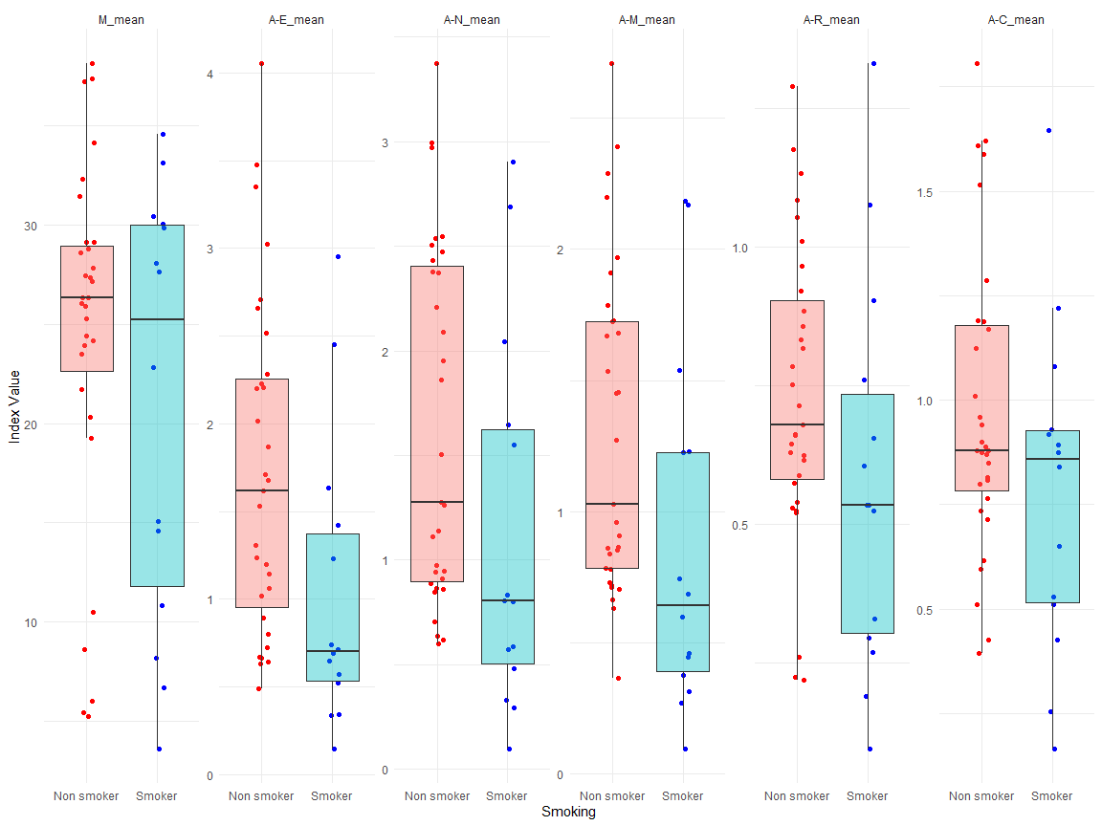

long_data_Smoking2 <- reshape2::melt(d, id.vars = "Smoking", measure.vars = c("Kv100_mean", "δ_mean", "T_mean", "A365_mean", "A460_mean", "Anadn_mean", "POM_mean"))  
  
# Plotting  
ggplot(long_data_Smoking2, aes(x = Smoking, y = value, fill = Smoking)) +  
 geom_jitter(aes(colour = Smoking), position = position_jitterdodge(jitter.width = 0.2, dodge.width = 0.75)) +  
 geom_boxplot(outlier.shape = NA, position = position_dodge(width = 0.1), alpha = 0.4) +  
 facet_wrap(~variable, scales = "free_y", nrow = 1) +  
 theme_minimal() +  
 theme(legend.position = "none") + # Hide the legend if not necessary  
 ylab("Index Value") +  
 xlab("Smoking") +  
 scale_color_manual(values = c("Smoker" = "blue", "Non smoker" = "red"))

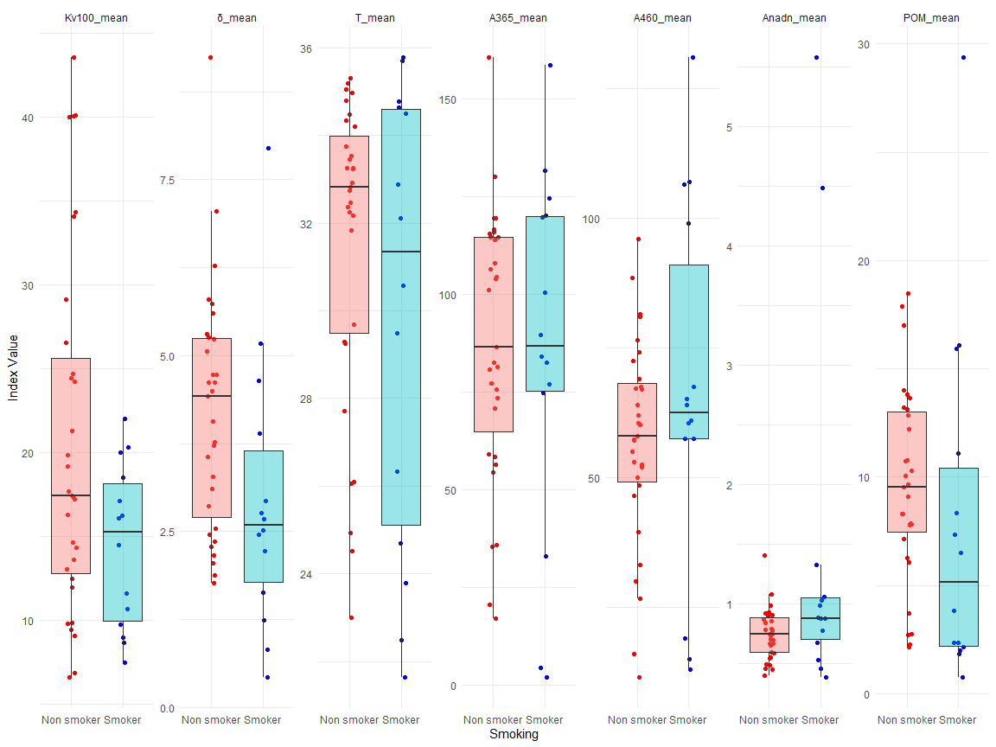

long_data_Smoking3 <- reshape2::melt(d, id.vars = "Smoking", measure.vars = c("F-E_mean", "F-N_mean", "F-M_mean", "F-R_mean", "F-C_mean"))  
  
# Plotting  
ggplot(long_data_Smoking3, aes(x = Smoking, y = value, fill = Smoking)) +  
 geom_jitter(aes(colour = Smoking), position = position_jitterdodge(jitter.width = 0.2, dodge.width = 0.75)) +  
 geom_boxplot(outlier.shape = NA, position = position_dodge(width = 0.1), alpha = 0.4) +  
 facet_wrap(~variable, scales = "free_y", nrow = 1) +  
 theme_minimal() +  
 theme(legend.position = "none") + # Hide the legend if not necessary  
 ylab("Index Value") +  
 xlab("Smoking") +  
 scale_color_manual(values = c("Smoker" = "blue", "Non smoker" = "red"))

