Phan tich Forest plot của right hand/left hand ratio

Minh

2024-02-28

## Load bộ số liệu và các packages

## ── Attaching core tidyverse packages ──────────────────────── tidyverse 2.0.0 ──  
## ✔ dplyr 1.1.2 ✔ readr 2.1.4  
## ✔ forcats 1.0.0 ✔ stringr 1.5.0  
## ✔ ggplot2 3.5.0 ✔ tibble 3.2.1  
## ✔ lubridate 1.9.2 ✔ tidyr 1.3.0  
## ✔ purrr 1.0.2   
## ── Conflicts ────────────────────────────────────────── tidyverse_conflicts() ──  
## ✖ dplyr::filter() masks stats::filter()  
## ✖ dplyr::lag() masks stats::lag()  
## ℹ Use the conflicted package (<http://conflicted.r-lib.org/>) to force all conflicts to become errors  
##   
## Attaching package: 'rstatix'  
##   
##   
## The following object is masked from 'package:stats':  
##   
## filter  
##   
##   
## Loading required package: grid  
##   
## Loading required package: checkmate  
##   
## Loading required package: abind

## So sánh khác biệt về ratio của chỉ số Right index/ Left index theo các biến

Hàm để so sánh lograrit(right/left) với 0 bằng Wilcox test

Hàm để tạo bảng tổng hợp kết quả và p-value

Hàm sắp xếp các cột theo thứ tự

Hàm vẽ Forest plot

Bảng All

| Variable | Subgroup | Subgroup_Level | Median_Ratio | CI_Lower | CI_Upper | P_Value |
| --- | --- | --- | --- | --- | --- | --- |
| M | All | 1 | 0.9765196 | 0.9471572 | 1.0525388 | 0.7899733 |
| Kv100 | All | 1 | 0.9908616 | 0.8138761 | 1.1437362 | 0.3777141 |
| δ | All | 1 | 0.9064935 | 0.7736486 | 1.0339367 | 0.1231051 |
| T | All | 1 | 1.0026902 | 0.9978960 | 1.0051843 | 0.3036074 |
| A365 | All | 1 | 0.9514563 | 0.9236948 | 1.0176991 | 0.5450711 |
| A460 | All | 1 | 0.7340426 | 0.6774194 | 0.8461538 | 0.0000002 |
| Anadn | All | 1 | 0.7294118 | 0.6460717 | 0.8664921 | 0.0000197 |
| POM | All | 1 | 1.3286094 | 1.1113300 | 1.6304781 | 0.0018061 |
| A-E | All | 1 | 0.9537612 | 0.7122302 | 1.1213307 | 0.1961384 |
| A-N | All | 1 | 0.9285714 | 0.7697368 | 1.0868056 | 0.1600116 |
| A-M | All | 1 | 0.9356984 | 0.7777778 | 1.1111111 | 0.1207467 |
| A-R | All | 1 | 1.0638298 | 0.9105691 | 1.2444444 | 0.5858161 |
| A-C | All | 1 | 0.9675325 | 0.8897059 | 1.0937190 | 0.2797757 |
| F-E | All | 1 | 1.0000000 | 0.9333333 | 1.0000000 | 0.4270740 |
| F-N | All | 1 | 1.0000000 | 0.9024390 | 1.0109890 | 0.1445894 |
| F-M | All | 1 | 1.0000000 | 1.0000000 | 1.0404858 | 0.2543253 |
| F-R | All | 1 | 1.0000000 | 0.9285409 | 1.0000000 | 0.5555405 |
| F-C | All | 1 | 1.0000000 | 1.0000000 | 1.0000000 | 0.4908955 |

Các đồ thị Forest plot theo dưới nhóm All

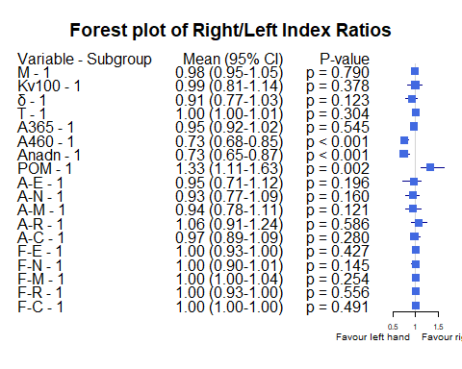

Bảng Gender

| Variable | Subgroup | Subgroup_Level | Median_Ratio | CI_Lower | CI_Upper | P_Value |
| --- | --- | --- | --- | --- | --- | --- |
| M | Gender | female | 1.0072381 | 0.9633986 | 1.1166499 | 0.4216649 |
| M | Gender | male | 0.9569698 | 0.9001016 | 1.0157001 | 0.3205616 |
| Kv100 | Gender | female | 0.8226067 | 0.6629494 | 0.9864312 | 0.0286438 |
| Kv100 | Gender | male | 1.1849202 | 0.9512922 | 1.2985723 | 0.5273196 |
| δ | Gender | female | 0.7649620 | 0.6760736 | 0.9064935 | 0.0062296 |
| δ | Gender | male | 1.0505051 | 0.8199654 | 1.2660550 | 0.7605460 |
| T | Gender | female | 1.0046228 | 0.9896768 | 1.0189589 | 0.3926476 |
| T | Gender | male | 1.0015279 | 0.9965577 | 1.0038079 | 0.5957550 |
| A365 | Gender | female | 0.9228671 | 0.8640777 | 0.9913793 | 0.3436414 |
| A365 | Gender | male | 0.9924242 | 0.9316239 | 1.1303987 | 0.9460043 |
| A460 | Gender | female | 0.7797538 | 0.6382979 | 0.8978102 | 0.0002020 |
| A460 | Gender | male | 0.7304348 | 0.6805556 | 0.8620690 | 0.0002252 |
| Anadn | Gender | female | 0.8185304 | 0.6458333 | 1.0129870 | 0.0221910 |
| Anadn | Gender | male | 0.7053191 | 0.5851064 | 0.8072289 | 0.0008011 |
| POM | Gender | female | 1.3651960 | 0.9989101 | 1.5989305 | 0.0340088 |
| POM | Gender | male | 1.3286094 | 1.1618084 | 1.8983834 | 0.0200594 |
| A-E | Gender | female | 0.6617844 | 0.5384390 | 1.0369662 | 0.0012325 |
| A-E | Gender | male | 1.0744186 | 0.8198052 | 1.4587156 | 0.4228908 |
| A-N | Gender | female | 0.7213096 | 0.6395904 | 0.9081913 | 0.0023409 |
| A-N | Gender | male | 1.0868056 | 0.9111111 | 1.4058824 | 0.5421747 |
| A-M | Gender | female | 0.7747157 | 0.6567568 | 0.9785695 | 0.0023409 |
| A-M | Gender | male | 1.0476190 | 0.9149997 | 1.2439024 | 0.6679764 |
| A-R | Gender | female | 0.9209804 | 0.7500000 | 1.1662790 | 0.3298077 |
| A-R | Gender | male | 1.1400000 | 0.9311927 | 1.2982456 | 0.0801900 |
| A-C | Gender | female | 0.9504329 | 0.7483070 | 1.1225342 | 0.2970004 |
| A-C | Gender | male | 0.9675325 | 0.9183673 | 1.1627907 | 0.5634839 |
| F-E | Gender | female | 1.0000000 | 0.9090909 | 1.0170953 | 0.4188084 |
| F-E | Gender | male | 1.0000000 | 0.9230769 | 1.0416667 | 0.7370000 |
| F-N | Gender | female | 1.0416667 | 0.9863939 | 1.1440467 | 0.4601156 |
| F-N | Gender | male | 0.9024390 | 0.6764706 | 1.0000000 | 0.0572904 |
| F-M | Gender | female | 1.0000000 | 0.9483843 | 1.0569849 | 0.7823196 |
| F-M | Gender | male | 1.0000000 | 1.0000000 | 1.0774648 | 0.1949058 |
| F-R | Gender | female | 1.0000000 | 1.0000000 | 1.0260664 | 0.8668808 |
| F-R | Gender | male | 1.0000000 | 0.7466528 | 1.0000000 | 0.3919448 |
| F-C | Gender | female | 1.0000000 | 1.0000000 | 1.0058218 | 0.5460472 |
| F-C | Gender | male | 1.0000000 | 1.0000000 | 1.0000000 | 0.7022383 |

Các đồ thị Forest plot theo dưới nhóm Gender

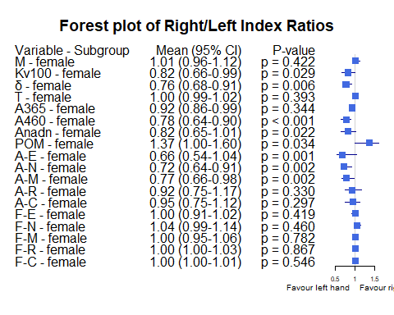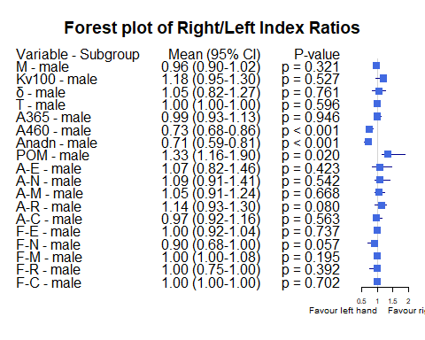

Bảng Age_stage

| Variable | Subgroup | Subgroup_Level | Median_Ratio | CI_Lower | CI_Upper | P_Value |
| --- | --- | --- | --- | --- | --- | --- |
| M | Age_stage | Age [30-40) | 1.0022222 | 0.9471572 | 1.0960071 | 0.6043417 |
| M | Age_stage | Age <30 | 0.9511744 | 0.8660547 | 1.0605868 | 0.6659118 |
| M | Age_stage | Age [40-50) | 0.9649541 | 0.8818049 | 1.0924511 | 0.3151744 |
| M | Age_stage | Age >=50 | 1.1520763 | 0.7184127 | 1.3837591 | 0.8339354 |
| Kv100 | Age_stage | Age [30-40) | 1.0061704 | 0.6979927 | 1.1849202 | 0.3346135 |
| Kv100 | Age_stage | Age <30 | 0.9489714 | 0.6838739 | 1.0971327 | 0.1477052 |
| Kv100 | Age_stage | Age [40-50) | 1.3653921 | 0.6377787 | 1.5677591 | 0.6603461 |
| Kv100 | Age_stage | Age >=50 | 1.2828551 | 0.8038773 | 1.8388742 | 0.1422132 |
| δ | Age_stage | Age [30-40) | 0.8242991 | 0.6285714 | 1.0991215 | 0.1744780 |
| δ | Age_stage | Age <30 | 0.9399116 | 0.7562753 | 1.0467800 | 0.1213152 |
| δ | Age_stage | Age [40-50) | 0.9017336 | 0.6735643 | 1.6476462 | 1.0000000 |
| δ | Age_stage | Age >=50 | 1.2664680 | 0.7696569 | 1.9075723 | 0.2945074 |
| T | Age_stage | Age [30-40) | 1.0042992 | 0.9978960 | 1.0140701 | 0.2454757 |
| T | Age_stage | Age <30 | 1.0010080 | 0.9885346 | 1.0051843 | 0.7799549 |
| T | Age_stage | Age [40-50) | 1.0037236 | 0.9951502 | 1.0224584 | 0.2092866 |
| T | Age_stage | Age >=50 | 0.9980195 | 0.9781445 | 1.0488077 | 0.8339354 |
| A365 | Age_stage | Age [30-40) | 0.9473684 | 0.8844622 | 1.0427350 | 0.4317594 |
| A365 | Age_stage | Age <30 | 0.9348105 | 0.8197446 | 1.1181818 | 0.5360093 |
| A365 | Age_stage | Age [40-50) | 0.9923563 | 0.8620962 | 1.1955962 | 0.9000858 |
| A365 | Age_stage | Age >=50 | 1.0324647 | 0.7019453 | 3.3143527 | 0.6749867 |
| A460 | Age_stage | Age [30-40) | 0.6811594 | 0.6640625 | 0.8048780 | 0.0000403 |
| A460 | Age_stage | Age <30 | 0.7797659 | 0.6428735 | 0.9569419 | 0.0350282 |
| A460 | Age_stage | Age [40-50) | 0.8009835 | 0.5699167 | 1.0000000 | 0.0426947 |
| A460 | Age_stage | Age >=50 | 0.7379706 | 0.6210399 | 0.8722784 | 0.0360317 |
| Anadn | Age_stage | Age [30-40) | 0.7244094 | 0.6296296 | 0.8958333 | 0.0267182 |
| Anadn | Age_stage | Age <30 | 0.7056150 | 0.6270945 | 0.9782609 | 0.0273583 |
| Anadn | Age_stage | Age [40-50) | 0.8816299 | 0.6234142 | 0.9395604 | 0.0120369 |
| Anadn | Age_stage | Age >=50 | 0.6195286 | 0.2563658 | 1.0086990 | 0.0934925 |
| POM | Age_stage | Age [30-40) | 1.3234501 | 1.0731970 | 1.7373806 | 0.0606385 |
| POM | Age_stage | Age <30 | 1.3552902 | 0.9895075 | 1.8653208 | 0.0796947 |
| POM | Age_stage | Age [40-50) | 1.2402574 | 0.7241379 | 2.0522712 | 0.3151744 |
| POM | Age_stage | Age >=50 | 2.0358275 | 0.7681371 | 4.9049052 | 0.1422132 |
| A-E | Age_stage | Age [30-40) | 0.9277108 | 0.6713948 | 1.1274298 | 0.1982743 |
| A-E | Age_stage | Age <30 | 0.7728238 | 0.5943775 | 1.1999246 | 0.1549264 |
| A-E | Age_stage | Age [40-50) | 1.3756683 | 0.5000000 | 1.8434783 | 0.5301580 |
| A-E | Age_stage | Age >=50 | 1.0071836 | 0.4618015 | 2.4840235 | 0.8339354 |
| A-N | Age_stage | Age [30-40) | 0.9285714 | 0.6796875 | 1.1148325 | 0.1921138 |
| A-N | Age_stage | Age <30 | 0.8716770 | 0.6401327 | 1.0941693 | 0.1477052 |
| A-N | Age_stage | Age [40-50) | 1.1734664 | 0.6776330 | 1.7142857 | 0.5720817 |
| A-N | Age_stage | Age >=50 | 1.0832456 | 0.6167555 | 2.0573182 | 0.8339354 |
| A-M | Age_stage | Age [30-40) | 0.8738739 | 0.7055118 | 1.1152203 | 0.0896128 |
| A-M | Age_stage | Age <30 | 0.8168889 | 0.6633647 | 1.1882353 | 0.1213152 |
| A-M | Age_stage | Age [40-50) | 1.1255556 | 0.7157198 | 1.5440415 | 0.7536104 |
| A-M | Age_stage | Age >=50 | 1.3052571 | 0.7210087 | 2.1530018 | 0.2945074 |
| A-R | Age_stage | Age [30-40) | 1.1400000 | 0.9019608 | 1.3061224 | 0.8024717 |
| A-R | Age_stage | Age <30 | 0.9478114 | 0.7592201 | 1.1908744 | 0.6844725 |
| A-R | Age_stage | Age [40-50) | 1.1837971 | 0.9052691 | 1.3632038 | 0.1486785 |
| A-R | Age_stage | Age >=50 | 1.1166228 | 0.5732625 | 2.7586762 | 0.6749867 |
| A-C | Age_stage | Age [30-40) | 0.9803922 | 0.8897059 | 1.1498258 | 0.4601450 |
| A-C | Age_stage | Age <30 | 0.9382413 | 0.6940789 | 1.1244950 | 0.2041207 |
| A-C | Age_stage | Age [40-50) | 0.9459981 | 0.8571429 | 1.1866606 | 1.0000000 |
| A-C | Age_stage | Age >=50 | 1.1391799 | 0.5148075 | 1.5135112 | 0.8339354 |
| F-E | Age_stage | Age [30-40) | 1.0000000 | 0.9081633 | 1.1818182 | 0.9808292 |
| F-E | Age_stage | Age <30 | 1.0000000 | 0.8125000 | 1.0344828 | 0.2393985 |
| F-E | Age_stage | Age [40-50) | 0.9302885 | 0.9087379 | 1.0000000 | 0.0828084 |
| F-E | Age_stage | Age >=50 | 1.1616352 | 0.9660918 | 1.5055453 | 0.1775299 |
| F-N | Age_stage | Age [30-40) | 1.0000000 | 0.7812500 | 1.0252101 | 0.3524618 |
| F-N | Age_stage | Age <30 | 1.0208333 | 0.8275862 | 1.2025998 | 1.0000000 |
| F-N | Age_stage | Age [40-50) | 0.9377060 | 0.6536170 | 1.0067002 | 0.0775562 |
| F-N | Age_stage | Age >=50 | 0.7887931 | 0.5262153 | 1.5396007 | 0.5293681 |
| F-M | Age_stage | Age [30-40) | 1.0245902 | 1.0000000 | 1.0491803 | 0.1331822 |
| F-M | Age_stage | Age <30 | 1.0000000 | 0.9638632 | 1.0745312 | 0.6012497 |
| F-M | Age_stage | Age [40-50) | 0.9765625 | 0.8816880 | 1.1550053 | 1.0000000 |
| F-M | Age_stage | Age >=50 | 0.9770476 | 0.7004168 | 1.9202033 | 1.0000000 |
| F-R | Age_stage | Age [30-40) | 1.0000000 | 0.7832700 | 1.1067961 | 0.7089421 |
| F-R | Age_stage | Age <30 | 1.0000000 | 1.0000000 | 1.0485437 | 0.3654364 |
| F-R | Age_stage | Age [40-50) | 0.6012348 | 0.4249586 | 1.0000000 | 0.0134354 |
| F-R | Age_stage | Age >=50 | 0.9409653 | 0.5575015 | 1.8646617 | 0.8339354 |
| F-C | Age_stage | Age [30-40) | 1.0000000 | 1.0000000 | 1.0116775 | 0.4079782 |
| F-C | Age_stage | Age <30 | 1.0000000 | 1.0000000 | 1.0000000 | 0.5046693 |
| F-C | Age_stage | Age [40-50) | 1.0000000 | 1.0000000 | 1.0229344 | 0.2945074 |
| F-C | Age_stage | Age >=50 | 1.0000000 | 0.9758117 | 1.3382722 | 0.4226781 |

Các đồ thị Forest plot dưới nhóm Age_stage 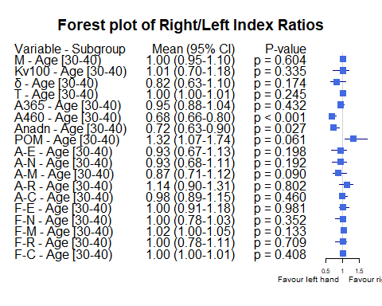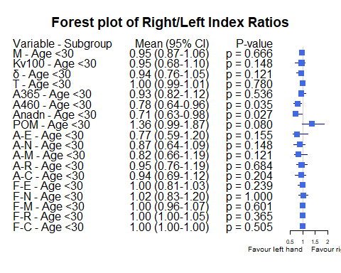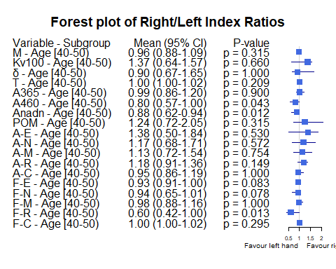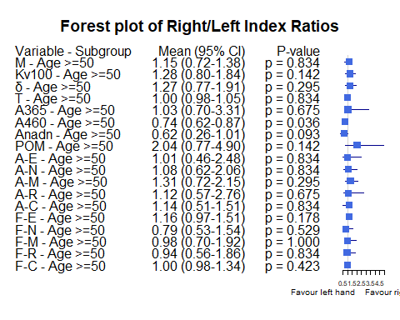

Bảng Race

| Variable | Subgroup | Subgroup_Level | Median_Ratio | CI_Lower | CI_Upper | P_Value |
| --- | --- | --- | --- | --- | --- | --- |
| M | Race | Asian or Asian British | 0.9853694 | 0.9403535 | 1.0836576 | 0.9713510 |
| M | Race | White | 0.9569698 | 0.8755584 | 1.0589121 | 0.4101983 |
| M | Race | Black | 0.9963380 | 0.8130631 | 1.4052863 | 1.0000000 |
| Kv100 | Race | Asian or Asian British | 1.0263425 | 0.8428833 | 1.1849202 | 0.6928040 |
| Kv100 | Race | White | 0.8091980 | 0.6237990 | 0.9512922 | 0.1322987 |
| Kv100 | Race | Black | 1.4130737 | 0.4880314 | 2.7556207 | 0.7892680 |
| δ | Race | Asian or Asian British | 0.9566929 | 0.7736486 | 1.0604651 | 0.3077502 |
| δ | Race | White | 0.8199654 | 0.6908386 | 0.9047994 | 0.0500580 |
| δ | Race | Black | 1.9944134 | 0.4859155 | 2.2463235 | 0.7892680 |
| T | Race | Asian or Asian British | 1.0032944 | 0.9965577 | 1.0067212 | 0.2780992 |
| T | Race | White | 1.0015279 | 0.9890372 | 1.0134267 | 0.9773446 |
| T | Race | Black | 1.0014013 | 0.9876106 | 1.0374283 | 0.7892680 |
| A365 | Race | Asian or Asian British | 0.9611650 | 0.8844622 | 1.0243902 | 0.4461042 |
| A365 | Race | White | 0.9342105 | 0.8934426 | 1.0921659 | 0.5136556 |
| A365 | Race | Black | 3.1000000 | 0.5000000 | 6.3333333 | 0.4226781 |
| A460 | Race | Asian or Asian British | 0.7142857 | 0.6640625 | 0.8461538 | 0.0000016 |
| A460 | Race | White | 0.7966102 | 0.6732026 | 0.9375000 | 0.0328100 |
| A460 | Race | Black | 0.8750000 | 0.6923077 | 1.6666667 | 1.0000000 |
| Anadn | Race | Asian or Asian British | 0.7053191 | 0.6458333 | 0.8526316 | 0.0003112 |
| Anadn | Race | White | 0.8604651 | 0.5909091 | 1.0658946 | 0.0686802 |
| Anadn | Race | Black | 0.5333333 | 0.1318681 | 1.0531915 | 0.4226781 |
| POM | Race | Asian or Asian British | 1.3819710 | 1.1618084 | 1.8274648 | 0.0087489 |
| POM | Race | White | 1.0731970 | 0.8923629 | 1.5325077 | 0.4432311 |
| POM | Race | Black | 2.7064935 | 0.9543147 | 10.2736842 | 0.4226781 |
| A-E | Race | Asian or Asian British | 1.0606061 | 0.7360115 | 1.3152174 | 0.7356710 |
| A-E | Race | White | 0.6713948 | 0.3088512 | 0.9537612 | 0.0134874 |
| A-E | Race | Black | 1.6587302 | 0.5943775 | 3.4687500 | 0.7892680 |
| A-N | Race | Asian or Asian British | 1.0040000 | 0.7837838 | 1.1770335 | 0.5226492 |
| A-N | Race | White | 0.7203472 | 0.5280612 | 0.9111111 | 0.0248679 |
| A-N | Race | Black | 2.3333333 | 0.5100000 | 2.6666667 | 0.4226781 |
| A-M | Race | Asian or Asian British | 0.9672131 | 0.7844311 | 1.1692308 | 0.3926894 |
| A-M | Race | White | 0.6826347 | 0.5670103 | 1.0958084 | 0.0331834 |
| A-M | Race | Black | 1.8541667 | 0.5555556 | 3.0975610 | 0.4226781 |
| A-R | Race | Asian or Asian British | 1.1206897 | 0.9311927 | 1.2892562 | 0.1108059 |
| A-R | Race | White | 0.8655462 | 0.5955056 | 1.1876796 | 0.0649102 |
| A-R | Race | Black | 1.2982456 | 0.5714286 | 1.9016393 | 0.7892680 |
| A-C | Race | Asian or Asian British | 1.0263158 | 0.9340659 | 1.1538462 | 0.9199007 |
| A-C | Race | White | 0.8897059 | 0.6089744 | 0.9870130 | 0.0280078 |
| A-C | Race | Black | 0.8571429 | 0.6262136 | 1.5735294 | 0.7892680 |
| F-E | Race | Asian or Asian British | 1.0000000 | 0.9090909 | 1.0000000 | 0.0799674 |
| F-E | Race | White | 1.0566038 | 0.9375000 | 1.4285714 | 0.0545205 |
| F-E | Race | Black | 0.7692308 | 0.7058824 | 1.0000000 | 0.3710934 |
| F-N | Race | Asian or Asian British | 1.0000000 | 0.8275862 | 1.0416667 | 0.2196366 |
| F-N | Race | White | 1.0000000 | 0.7365854 | 1.1034483 | 0.8445193 |
| F-N | Race | Black | 0.9024390 | 0.4655172 | 1.0000000 | 0.3710934 |
| F-M | Race | Asian or Asian British | 1.0000000 | 1.0000000 | 1.0447761 | 0.3382147 |
| F-M | Race | White | 1.0245902 | 0.9531250 | 1.2162162 | 0.5301580 |
| F-M | Race | Black | 1.0000000 | 0.9531250 | 1.1475410 | 1.0000000 |
| F-R | Race | Asian or Asian British | 1.0000000 | 0.9059233 | 1.0023256 | 0.5502308 |
| F-R | Race | White | 1.0000000 | 0.7706553 | 1.2187128 | 0.5408179 |
| F-R | Race | Black | 1.0000000 | 0.9533898 | 2.7864078 | 1.0000000 |
| F-C | Race | Asian or Asian British | 1.0000000 | 1.0000000 | 1.0000000 | 0.7823196 |
| F-C | Race | White | 1.0000000 | 1.0000000 | 1.1016043 | 0.3589514 |
| F-C | Race | Black | 1.0000000 | 0.9528754 | 1.0000000 | 1.0000000 |

Các đồ thị Forest plot theo dưới nhóm Race

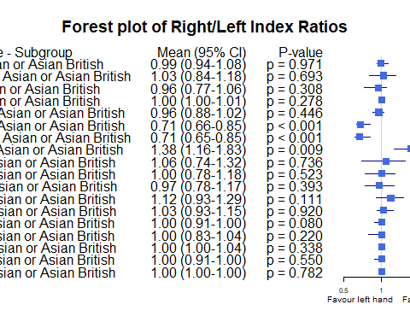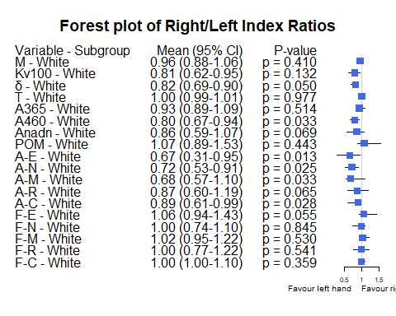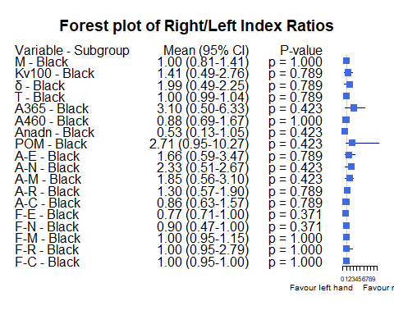

Bảng Skin

|  | Variable | Subgroup | Subgroup_Level | Median_Ratio | CI_Lower | CI_Upper | P_Value |
| --- | --- | --- | --- | --- | --- | --- | --- |
| Typer of skins_3_M | M | Typer of skins | 3 | 0.9699917 | 0.8988131 | 1.0491287 | 0.6428450 |
| Typer of skins_3_Kv100 | Kv100 | Typer of skins | 3 | 1.0071327 | 0.7044745 | 1.1958762 | 0.3786400 |
| Typer of skins_3_δ | δ | Typer of skins | 3 | 0.9096803 | 0.6965846 | 1.0628067 | 0.1522875 |
| Typer of skins_3_T | T | Typer of skins | 3 | 1.0029492 | 0.9931950 | 1.0091936 | 0.3502161 |
| Typer of skins_3_A365 | A365 | Typer of skins | 3 | 0.9729489 | 0.9126984 | 1.0335219 | 0.4142900 |
| Typer of skins_3_A460 | A460 | Typer of skins | 3 | 0.7063492 | 0.6557479 | 0.8412304 | 0.0001915 |
| Typer of skins_3_Anadn | Anadn | Typer of skins | 3 | 0.7732930 | 0.6617581 | 0.8902439 | 0.0003074 |
| Typer of skins_3_POM | POM | Typer of skins | 3 | 1.2938021 | 1.0620793 | 1.7080465 | 0.0152598 |
| Typer of skins_3_A-E | A-E | Typer of skins | 3 | 1.0779221 | 0.7612204 | 1.3820225 | 0.9090378 |
| Typer of skins_3_A-N | A-N | Typer of skins | 3 | 0.9301948 | 0.7030061 | 1.1388839 | 0.3231843 |
| Typer of skins_3_A-M | A-M | Typer of skins | 3 | 0.9324162 | 0.7777778 | 1.1132458 | 0.3298113 |
| Typer of skins_3_A-R | A-R | Typer of skins | 3 | 1.0339066 | 0.8843884 | 1.2407407 | 0.6332400 |
| Typer of skins_3_A-C | A-C | Typer of skins | 3 | 0.9782913 | 0.7996235 | 1.1428571 | 0.4316824 |
| Typer of skins_3_F-E | F-E | Typer of skins | 3 | 1.0000000 | 0.8892809 | 1.0000000 | 0.1441903 |
| Typer of skins_3_F-N | F-N | Typer of skins | 3 | 1.0000000 | 0.7654655 | 1.0682836 | 0.3090292 |
| Typer of skins_3_F-M | F-M | Typer of skins | 3 | 1.0000000 | 0.9122172 | 1.0672555 | 0.6735099 |
| Typer of skins_3_F-R | F-R | Typer of skins | 3 | 1.0000000 | 0.7986798 | 1.1317482 | 0.7678168 |
| Typer of skins_3_F-C | F-C | Typer of skins | 3 | 1.0000000 | 1.0000000 | 1.0000000 | 1.0000000 |
| Typer of skins_4_M | M | Typer of skins | 4 | 0.9713620 | 0.9030870 | 1.2265991 | 0.7556577 |
| Typer of skins_4_Kv100 | Kv100 | Typer of skins | 4 | 0.8138761 | 0.6608448 | 1.7388334 | 0.6890837 |
| Typer of skins_4_δ | δ | Typer of skins | 4 | 0.9260417 | 0.6760736 | 1.6751864 | 0.6248349 |
| Typer of skins_4_T | T | Typer of skins | 4 | 1.0140701 | 1.0036394 | 1.0215240 | 0.1000006 |
| Typer of skins_4_A365 | A365 | Typer of skins | 4 | 0.8453039 | 0.6235294 | 1.3770492 | 0.5048799 |
| Typer of skins_4_A460 | A460 | Typer of skins | 4 | 0.8350101 | 0.5438596 | 1.0000000 | 0.0755606 |
| Typer of skins_4_Anadn | Anadn | Typer of skins | 4 | 0.7747748 | 0.6190476 | 1.9400000 | 0.8939037 |
| Typer of skins_4_POM | POM | Typer of skins | 4 | 1.0259981 | 0.4361281 | 2.0532446 | 0.9645414 |
| Typer of skins_4_A-E | A-E | Typer of skins | 4 | 0.7122302 | 0.5817965 | 1.2549020 | 0.1197224 |
| Typer of skins_4_A-N | A-N | Typer of skins | 4 | 1.0637119 | 0.5761124 | 1.3333333 | 0.9645414 |
| Typer of skins_4_A-M | A-M | Typer of skins | 4 | 1.0118577 | 0.6237113 | 1.2105263 | 0.3983046 |
| Typer of skins_4_A-R | A-R | Typer of skins | 4 | 1.3418252 | 0.7155172 | 1.4000000 | 0.6890837 |
| Typer of skins_4_A-C | A-C | Typer of skins | 4 | 1.0701754 | 0.7543860 | 1.2995169 | 0.7556577 |
| Typer of skins_4_F-E | F-E | Typer of skins | 4 | 1.0433387 | 1.0000000 | 1.2142857 | 0.4069412 |
| Typer of skins_4_F-N | F-N | Typer of skins | 4 | 0.9729730 | 0.8148148 | 1.0434783 | 0.5633178 |
| Typer of skins_4_F-M | F-M | Typer of skins | 4 | 1.0245902 | 0.9481481 | 1.0945946 | 0.4771966 |
| Typer of skins_4_F-R | F-R | Typer of skins | 4 | 1.0000000 | 0.6445993 | 1.0504202 | 0.5541131 |
| Typer of skins_4_F-C | F-C | Typer of skins | 4 | 1.0000000 | 0.9402283 | 1.0501761 | 0.9326466 |
| Typer of skins_1_M | M | Typer of skins | 1 | 0.9765196 | 0.9020202 | 1.2097210 | 0.8888407 |
| Typer of skins_1_Kv100 | Kv100 | Typer of skins | 1 | 0.9377246 | 0.8023301 | 1.2578413 | 0.7267678 |
| Typer of skins_1_δ | δ | Typer of skins | 1 | 0.9003322 | 0.7554077 | 1.2048077 | 0.4846417 |
| Typer of skins_1_T | T | Typer of skins | 1 | 0.9980134 | 0.9802971 | 1.0020402 | 0.4420464 |
| Typer of skins_1_A365 | A365 | Typer of skins | 1 | 0.9333333 | 0.8934426 | 0.9618321 | 0.4846417 |
| Typer of skins_1_A460 | A460 | Typer of skins | 1 | 0.7546296 | 0.5522388 | 0.8695652 | 0.0107874 |
| Typer of skins_1_Anadn | Anadn | Typer of skins | 1 | 0.7655172 | 0.5882353 | 1.0000000 | 0.0206584 |
| Typer of skins_1_POM | POM | Typer of skins | 1 | 1.4070022 | 0.9989101 | 1.6304781 | 0.0934925 |
| Typer of skins_1_A-E | A-E | Typer of skins | 1 | 0.6904962 | 0.4600000 | 1.1182796 | 0.0692130 |
| Typer of skins_1_A-N | A-N | Typer of skins | 1 | 0.7321814 | 0.6366177 | 1.1713062 | 0.1241747 |
| Typer of skins_1_A-M | A-M | Typer of skins | 1 | 0.7953488 | 0.6567568 | 1.1460674 | 0.2348113 |
| Typer of skins_1_A-R | A-R | Typer of skins | 1 | 0.8864865 | 0.6134868 | 1.2457627 | 0.1842351 |
| Typer of skins_1_A-C | A-C | Typer of skins | 1 | 0.9134615 | 0.7551020 | 1.0000000 | 0.2895874 |
| Typer of skins_1_F-E | F-E | Typer of skins | 1 | 1.0566038 | 0.9375000 | 1.4468085 | 0.0998330 |
| Typer of skins_1_F-N | F-N | Typer of skins | 1 | 1.0000000 | 0.7500000 | 1.1034483 | 0.6890837 |
| Typer of skins_1_F-M | F-M | Typer of skins | 1 | 0.9722222 | 0.8714286 | 1.0826667 | 1.0000000 |
| Typer of skins_1_F-R | F-R | Typer of skins | 1 | 1.0000000 | 0.9285409 | 1.0023256 | 0.7262861 |
| Typer of skins_1_F-C | F-C | Typer of skins | 1 | 1.0000000 | 1.0000000 | 1.0499490 | 0.2361370 |
| Typer of skins_6_M | M | Typer of skins | 6 | 0.9264961 | 0.8130631 | 1.4052863 | 0.8551321 |
| Typer of skins_6_Kv100 | Kv100 | Typer of skins | 6 | 1.3244473 | 0.4880314 | 2.7556207 | 0.5838824 |
| Typer of skins_6_δ | δ | Typer of skins | 6 | 1.5274393 | 0.4859155 | 2.2463235 | 0.5838824 |
| Typer of skins_6_T | T | Typer of skins | 6 | 1.0033632 | 0.9876106 | 1.0374283 | 0.5838824 |
| Typer of skins_6_A365 | A365 | Typer of skins | 6 | 1.8000000 | 0.3333333 | 6.3333333 | 0.5838824 |
| Typer of skins_6_A460 | A460 | Typer of skins | 6 | 0.7836538 | 0.0833333 | 1.6666667 | 0.5838824 |
| Typer of skins_6_Anadn | Anadn | Typer of skins | 6 | 0.3921897 | 0.1318681 | 1.0531915 | 0.2012426 |
| Typer of skins_6_POM | POM | Typer of skins | 6 | 2.9105384 | 0.9543147 | 10.2736842 | 0.2012426 |
| Typer of skins_6_A-E | A-E | Typer of skins | 6 | 1.7543651 | 0.5943775 | 3.4687500 | 0.3613104 |
| Typer of skins_6_A-N | A-N | Typer of skins | 6 | 2.0000000 | 0.5100000 | 2.6666667 | 0.3613104 |
| Typer of skins_6_A-M | A-M | Typer of skins | 6 | 1.5490346 | 0.5555556 | 3.0975610 | 0.3613104 |
| Typer of skins_6_A-R | A-R | Typer of skins | 6 | 1.1991228 | 0.5714286 | 1.9016393 | 0.5838824 |
| Typer of skins_6_A-C | A-C | Typer of skins | 6 | 1.0302663 | 0.6262136 | 1.5735294 | 1.0000000 |
| Typer of skins_6_F-E | F-E | Typer of skins | 6 | 0.7375566 | 0.6111111 | 1.0000000 | 0.1814492 |
| Typer of skins_6_F-N | F-N | Typer of skins | 6 | 0.6839781 | 0.4655172 | 1.0000000 | 0.1735682 |
| Typer of skins_6_F-M | F-M | Typer of skins | 6 | 1.0737705 | 0.9531250 | 2.1777778 | 0.4226781 |
| Typer of skins_6_F-R | F-R | Typer of skins | 6 | 0.9766949 | 0.9059233 | 2.7864078 | 1.0000000 |
| Typer of skins_6_F-C | F-C | Typer of skins | 6 | 1.0000000 | 0.9528754 | 1.1030351 | 1.0000000 |
| Typer of skins_2_M | M | Typer of skins | 2 | 0.9853694 | 0.5925328 | 1.0525388 | 0.2807127 |
| Typer of skins_2_Kv100 | Kv100 | Typer of skins | 2 | 0.8229814 | 0.3249756 | 6.5467626 | 0.7874065 |
| Typer of skins_2_δ | δ | Typer of skins | 2 | 0.7736486 | 0.1927982 | 1.2485437 | 0.1775299 |
| Typer of skins_2_T | T | Typer of skins | 2 | 1.0089087 | 0.7320107 | 1.0184445 | 0.7874065 |
| Typer of skins_2_A365 | A365 | Typer of skins | 2 | 1.0176991 | 0.1966292 | 3.4285714 | 1.0000000 |
| Typer of skins_2_A460 | A460 | Typer of skins | 2 | 1.0370370 | 0.4646465 | 1.5000000 | 1.0000000 |
| Typer of skins_2_Anadn | Anadn | Typer of skins | 2 | 0.9298246 | 0.2935780 | 6.0000000 | 1.0000000 |
| Typer of skins_2_POM | POM | Typer of skins | 2 | 0.8923629 | 0.2356364 | 3.5702479 | 0.7874065 |
| Typer of skins_2_A-E | A-E | Typer of skins | 2 | 0.7235772 | 0.1542969 | 1.0744186 | 0.1056454 |
| Typer of skins_2_A-N | A-N | Typer of skins | 2 | 0.7027027 | 0.2061611 | 1.1148325 | 0.1775299 |
| Typer of skins_2_A-M | A-M | Typer of skins | 2 | 0.7716535 | 0.2875817 | 1.4125874 | 0.2807127 |
| Typer of skins_2_A-R | A-R | Typer of skins | 2 | 0.9908257 | 0.3219178 | 1.2444444 | 0.5896386 |
| Typer of skins_2_A-C | A-C | Typer of skins | 2 | 0.9183673 | 0.4969325 | 1.8000000 | 0.2807127 |
| Typer of skins_2_F-E | F-E | Typer of skins | 2 | 0.9000000 | 0.6250000 | 1.7272727 | 0.8551321 |
| Typer of skins_2_F-N | F-N | Typer of skins | 2 | 1.1428571 | 1.0000000 | 2.6363636 | 0.1003482 |
| Typer of skins_2_F-M | F-M | Typer of skins | 2 | 1.0491803 | 1.0000000 | 1.8000000 | 0.1735682 |
| Typer of skins_2_F-R | F-R | Typer of skins | 2 | 0.7832700 | 0.3588850 | 2.7864078 | 0.4982249 |
| Typer of skins_2_F-C | F-C | Typer of skins | 2 | 1.0000000 | 0.7468051 | 1.0501761 | 1.0000000 |
| Typer of skins_5_M | M | Typer of skins | 5 | 1.0864178 | 0.8928482 | 1.2922034 | 0.2945074 |
| Typer of skins_5_Kv100 | Kv100 | Typer of skins | 5 | 1.0529749 | 0.7021954 | 1.4094562 | 0.6749867 |
| Typer of skins_5_δ | δ | Typer of skins | 5 | 1.1653785 | 0.6178038 | 1.7338256 | 0.6749867 |
| Typer of skins_5_T | T | Typer of skins | 5 | 0.9962441 | 0.9407552 | 1.0137475 | 0.6749867 |
| Typer of skins_5_A365 | A365 | Typer of skins | 5 | 1.2961287 | 0.6380116 | 1.7269789 | 0.6749867 |
| Typer of skins_5_A460 | A460 | Typer of skins | 5 | 0.7430087 | 0.3743941 | 0.9607689 | 0.0591721 |
| Typer of skins_5_Anadn | Anadn | Typer of skins | 5 | 0.5799992 | 0.2571694 | 1.3271293 | 0.2945074 |
| Typer of skins_5_POM | POM | Typer of skins | 5 | 1.9167129 | 0.4998205 | 4.7355095 | 0.2945074 |
| Typer of skins_5_A-E | A-E | Typer of skins | 5 | 1.4179764 | 0.3415401 | 2.5966208 | 0.6749867 |
| Typer of skins_5_A-N | A-N | Typer of skins | 5 | 1.2369020 | 0.3616740 | 1.9934561 | 1.0000000 |
| Typer of skins_5_A-M | A-M | Typer of skins | 5 | 1.3514706 | 0.3429071 | 1.5341844 | 0.6749867 |
| Typer of skins_5_A-R | A-R | Typer of skins | 5 | 1.5058570 | 0.9285556 | 2.2209665 | 0.1422132 |
| Typer of skins_5_A-C | A-C | Typer of skins | 5 | 1.0233550 | 0.5629958 | 1.4985689 | 1.0000000 |
| Typer of skins_5_F-E | F-E | Typer of skins | 5 | 0.9848485 | 0.6684871 | 1.1447029 | 0.7874065 |
| Typer of skins_5_F-N | F-N | Typer of skins | 5 | 0.6079401 | 0.4640782 | 1.3460485 | 0.1422132 |
| Typer of skins_5_F-M | F-M | Typer of skins | 5 | 1.0000000 | 0.7027821 | 1.9314479 | 0.8551321 |
| Typer of skins_5_F-R | F-R | Typer of skins | 5 | 1.0242718 | 0.7371874 | 1.7561279 | 1.0000000 |
| Typer of skins_5_F-C | F-C | Typer of skins | 5 | 1.0000000 | 0.9646623 | 1.2014664 | 1.0000000 |

Các đồ thị Forest plot theo dưới nhóm Skin

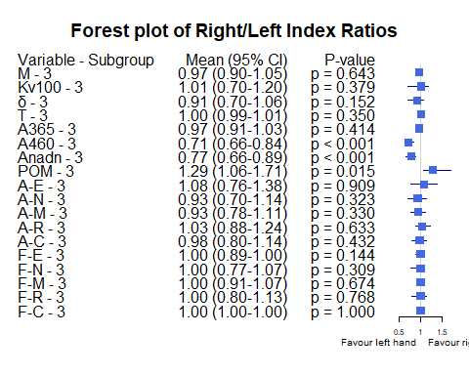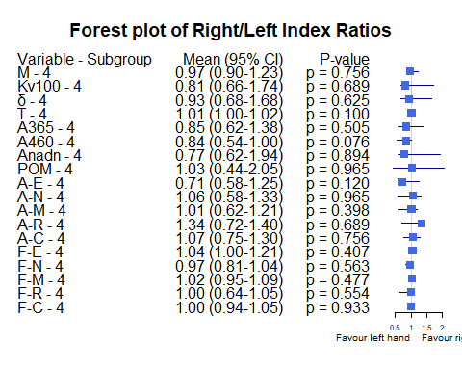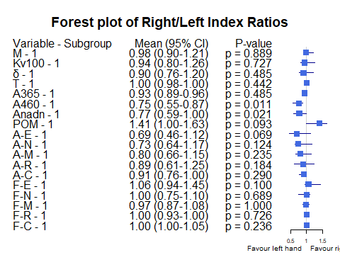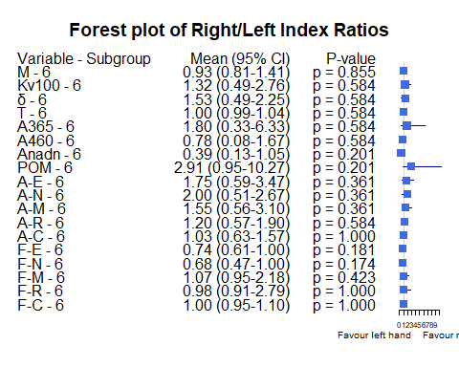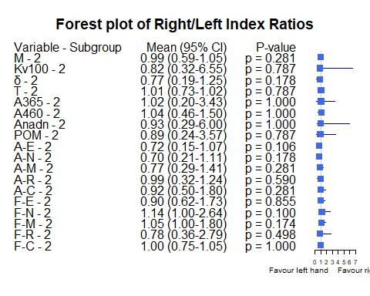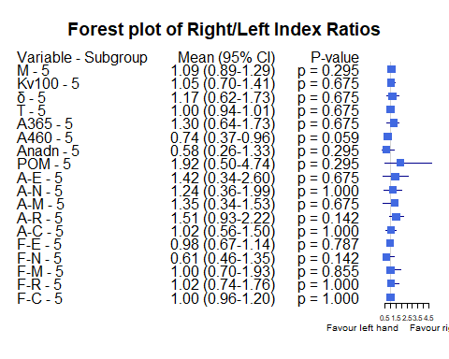

Bảng Stress

| Variable | Subgroup | Subgroup_Level | Median_Ratio | CI_Lower | CI_Upper | P_Value |
| --- | --- | --- | --- | --- | --- | --- |
| M | Stress index | No | 0.9651313 | 0.9206987 | 1.0715195 | 0.6911754 |
| M | Stress index | Yes | 1.0042960 | 0.9030870 | 1.1289638 | 0.8202219 |
| Kv100 | Stress index | No | 1.0263425 | 0.8054274 | 1.2194821 | 0.6794961 |
| Kv100 | Stress index | Yes | 0.9352172 | 0.6881430 | 1.1849202 | 0.2696660 |
| δ | Stress index | No | 0.9260417 | 0.7736486 | 1.0619792 | 0.2122517 |
| δ | Stress index | Yes | 0.8757868 | 0.7146406 | 1.1349338 | 0.3807189 |
| T | Stress index | No | 1.0026902 | 0.9980134 | 1.0051107 | 0.2460487 |
| T | Stress index | Yes | 1.0023048 | 0.9892483 | 1.0134267 | 0.9224112 |
| A365 | Stress index | No | 0.9900990 | 0.9333333 | 1.0921659 | 0.7349721 |
| A365 | Stress index | Yes | 0.8926099 | 0.7266054 | 0.9939086 | 0.0913702 |
| A460 | Stress index | No | 0.7304348 | 0.6640625 | 0.8461538 | 0.0000041 |
| A460 | Stress index | Yes | 0.8199441 | 0.6666667 | 0.9679974 | 0.0164724 |
| Anadn | Stress index | No | 0.6820809 | 0.6297717 | 0.8072289 | 0.0000043 |
| Anadn | Stress index | Yes | 0.8951448 | 0.6612690 | 1.0676692 | 0.5161361 |
| POM | Stress index | No | 1.5325077 | 1.2358871 | 1.8764045 | 0.0004320 |
| POM | Stress index | Yes | 1.0191910 | 0.9042375 | 1.3634318 | 0.8202219 |
| A-E | Stress index | No | 0.9537612 | 0.7235772 | 1.1274298 | 0.2942832 |
| A-E | Stress index | Yes | 1.0010647 | 0.6397775 | 1.3003425 | 0.3807189 |
| A-N | Stress index | No | 0.9318182 | 0.7027027 | 1.0868056 | 0.1952965 |
| A-N | Stress index | Yes | 0.9251553 | 0.7040600 | 1.2698864 | 0.6034467 |
| A-M | Stress index | No | 0.9589844 | 0.7777778 | 1.1153846 | 0.3525818 |
| A-M | Stress index | Yes | 0.8379786 | 0.6476572 | 1.2439024 | 0.1831589 |
| A-R | Stress index | No | 1.1268534 | 0.9259259 | 1.2686567 | 0.2592253 |
| A-R | Stress index | Yes | 1.0273277 | 0.7325558 | 1.1935484 | 0.4169975 |
| A-C | Stress index | No | 0.9518072 | 0.8209366 | 1.1192053 | 0.2385182 |
| A-C | Stress index | Yes | 0.9782913 | 0.8897059 | 1.1475701 | 0.6968414 |
| F-E | Stress index | No | 1.0000000 | 0.9230769 | 1.0000000 | 0.4587783 |
| F-E | Stress index | Yes | 1.0000000 | 0.8666667 | 1.1801776 | 0.6232614 |
| F-N | Stress index | No | 1.0000000 | 0.7777778 | 1.0109890 | 0.1219058 |
| F-N | Stress index | Yes | 1.0000000 | 0.9130435 | 1.1428571 | 0.9553348 |
| F-M | Stress index | No | 1.0000000 | 0.9536055 | 1.0245902 | 0.7179337 |
| F-M | Stress index | Yes | 1.0469782 | 1.0000000 | 1.1475410 | 0.0814698 |
| F-R | Stress index | No | 1.0000000 | 1.0000000 | 1.0485437 | 0.8477038 |
| F-R | Stress index | Yes | 0.9766949 | 0.8601421 | 1.0000000 | 0.1269030 |
| F-C | Stress index | No | 1.0000000 | 1.0000000 | 1.0000000 | 0.3891835 |
| F-C | Stress index | Yes | 1.0000000 | 1.0000000 | 1.0116775 | 0.9442847 |

Các đồ thị Forest plot theo dưới nhóm Stress

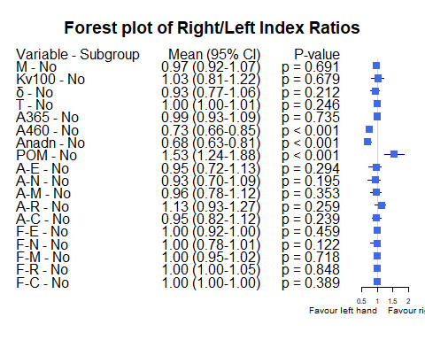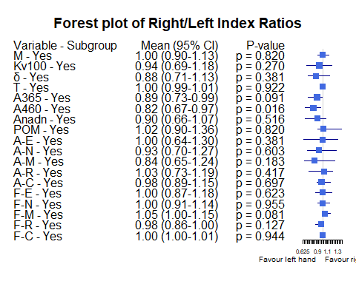

Bảng Smoking

| Variable | Subgroup | Subgroup_Level | Median_Ratio | CI_Lower | CI_Upper | P_Value |
| --- | --- | --- | --- | --- | --- | --- |
| M | Smoking | Non smoker | 0.9864477 | 0.9471572 | 1.0410736 | 0.8908461 |
| M | Smoking | Smoker | 0.9326164 | 0.8566542 | 1.1062100 | 0.3463733 |
| Kv100 | Smoking | Non smoker | 0.9512922 | 0.8023301 | 1.0796074 | 0.1956940 |
| Kv100 | Smoking | Smoker | 1.3137485 | 0.9208963 | 1.4662765 | 0.6155185 |
| δ | Smoking | Non smoker | 0.9047994 | 0.7562753 | 1.0092492 | 0.0821592 |
| δ | Smoking | Smoker | 1.0615927 | 0.7508647 | 1.5342020 | 0.9000858 |
| T | Smoking | Non smoker | 1.0020402 | 0.9954553 | 1.0050901 | 0.5920520 |
| T | Smoking | Smoker | 1.0043475 | 0.9955634 | 1.0213859 | 0.1672536 |
| A365 | Smoking | Non smoker | 0.9365854 | 0.8934426 | 1.0176991 | 0.4203326 |
| A365 | Smoking | Smoker | 0.9928788 | 0.8527391 | 1.3571429 | 0.8506184 |
| A460 | Smoking | Non smoker | 0.7543860 | 0.6805709 | 0.8620690 | 0.0000077 |
| A460 | Smoking | Smoker | 0.6792535 | 0.5316456 | 0.8714551 | 0.0069467 |
| Anadn | Smoking | Non smoker | 0.7655172 | 0.6481481 | 0.8902439 | 0.0006561 |
| Anadn | Smoking | Smoker | 0.6193262 | 0.4000000 | 0.9126214 | 0.0069467 |
| POM | Smoking | Non smoker | 1.3234501 | 1.0620793 | 1.5325077 | 0.0084490 |
| POM | Smoking | Smoker | 1.9260071 | 0.9520000 | 3.1145833 | 0.0686802 |
| A-E | Smoking | Non smoker | 0.7872928 | 0.6746988 | 1.1182796 | 0.0237534 |
| A-E | Smoking | Smoker | 1.5832689 | 0.9190950 | 2.1489362 | 0.1319041 |
| A-N | Smoking | Non smoker | 0.9111111 | 0.7027027 | 1.0144928 | 0.0455337 |
| A-N | Smoking | Smoker | 1.3629412 | 0.7837838 | 1.6666667 | 0.3151744 |
| A-M | Smoking | Non smoker | 0.8738739 | 0.7716535 | 1.1089331 | 0.0507076 |
| A-M | Smoking | Smoker | 1.0391621 | 0.7450980 | 1.4348247 | 0.5720817 |
| A-R | Smoking | Non smoker | 0.9830508 | 0.9019608 | 1.2457627 | 0.9271040 |
| A-R | Smoking | Smoker | 1.1334267 | 0.9000000 | 1.2982456 | 0.2328509 |
| A-C | Smoking | Non smoker | 0.9803922 | 0.9134615 | 1.0958904 | 0.3901506 |
| A-C | Smoking | Smoker | 0.9150327 | 0.7120886 | 1.1829161 | 0.4898538 |
| F-E | Smoking | Non smoker | 1.0000000 | 0.9333333 | 1.0357143 | 0.5589956 |
| F-E | Smoking | Smoker | 0.9848485 | 0.9087379 | 1.0000000 | 0.5405549 |
| F-N | Smoking | Non smoker | 1.0000000 | 0.9024390 | 1.0416667 | 0.3209112 |
| F-N | Smoking | Smoker | 0.9864865 | 0.5966680 | 1.0000000 | 0.4145199 |
| F-M | Smoking | Non smoker | 1.0000000 | 1.0000000 | 1.0403515 | 0.4338023 |
| F-M | Smoking | Smoker | 1.0245902 | 0.9045613 | 1.6976744 | 0.3266134 |
| F-R | Smoking | Non smoker | 1.0000000 | 1.0000000 | 1.0504202 | 0.4314759 |
| F-R | Smoking | Smoker | 0.6597044 | 0.4355401 | 0.9533898 | 0.0032162 |
| F-C | Smoking | Non smoker | 1.0000000 | 1.0000000 | 1.0000000 | 0.5614162 |
| F-C | Smoking | Smoker | 1.0000000 | 1.0000000 | 1.0000000 | 0.7874065 |

Các đồ thị Forest plot theo dưới nhóm Smoking

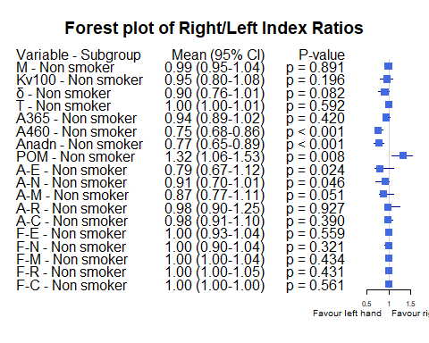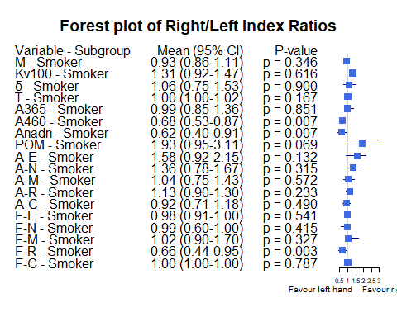

Bảng Hypertension

| Variable | Subgroup | Subgroup_Level | Median_Ratio | CI_Lower | CI_Upper | P_Value |
| --- | --- | --- | --- | --- | --- | --- |
| M | Hypertension | No | 0.9814837 | 0.9197064 | 1.0525388 | 0.6312092 |
| M | Hypertension | Yes | 0.9748521 | 0.8818049 | 1.1851155 | 0.8077703 |
| Kv100 | Hypertension | No | 0.9857016 | 0.8138761 | 1.1453596 | 0.4162487 |
| Kv100 | Hypertension | Yes | 0.9908616 | 0.7110165 | 1.2985723 | 0.7022135 |
| δ | Hypertension | No | 0.9025658 | 0.7649127 | 1.0122699 | 0.0588740 |
| δ | Hypertension | Yes | 0.9566929 | 0.6908386 | 1.4848485 | 1.0000000 |
| T | Hypertension | No | 1.0026242 | 0.9965577 | 1.0116720 | 0.3650128 |
| T | Hypertension | Yes | 1.0026902 | 0.9954553 | 1.0051843 | 0.8077703 |
| A365 | Hypertension | No | 0.9566442 | 0.9236948 | 1.0668886 | 0.9841526 |
| A365 | Hypertension | Yes | 0.9285714 | 0.8333333 | 1.1307190 | 0.1984315 |
| A460 | Hypertension | No | 0.8007441 | 0.6867109 | 0.8827409 | 0.0003003 |
| A460 | Hypertension | Yes | 0.5972222 | 0.4646465 | 0.7213115 | 0.0001973 |
| Anadn | Hypertension | No | 0.7678938 | 0.6610169 | 0.9126214 | 0.0022214 |
| Anadn | Hypertension | Yes | 0.6481481 | 0.5510204 | 0.8730159 | 0.0019786 |
| POM | Hypertension | No | 1.2713028 | 1.0620793 | 1.5325077 | 0.0301695 |
| POM | Hypertension | Yes | 1.9756098 | 0.9520000 | 2.3571429 | 0.0123302 |
| A-E | Hypertension | No | 0.9580127 | 0.7178813 | 1.1274298 | 0.2125743 |
| A-E | Hypertension | Yes | 0.8198052 | 0.6046512 | 1.3709924 | 0.7809654 |
| A-N | Hypertension | No | 0.9251553 | 0.7153753 | 1.0574279 | 0.1056301 |
| A-N | Hypertension | Yes | 1.0637119 | 0.5870966 | 1.4058824 | 1.0000000 |
| A-M | Hypertension | No | 0.8942540 | 0.7716535 | 1.0752106 | 0.0558300 |
| A-M | Hypertension | Yes | 1.1111111 | 0.6875000 | 1.3129973 | 0.8077703 |
| A-R | Hypertension | No | 0.9548950 | 0.8539602 | 1.1462607 | 0.4810880 |
| A-R | Hypertension | Yes | 1.2954545 | 0.9696970 | 1.4000000 | 0.0437899 |
| A-C | Hypertension | No | 0.9340817 | 0.8375725 | 1.0064726 | 0.0506396 |
| A-C | Hypertension | Yes | 1.1944444 | 0.9411765 | 1.4285714 | 0.3480098 |
| F-E | Hypertension | No | 1.0000000 | 0.9354143 | 1.0388958 | 0.5866697 |
| F-E | Hypertension | Yes | 1.0000000 | 0.9081633 | 1.0000000 | 0.7118861 |
| F-N | Hypertension | No | 1.0000000 | 0.9078605 | 1.0413787 | 0.1528671 |
| F-N | Hypertension | Yes | 1.0000000 | 0.7500000 | 1.0434783 | 0.7275066 |
| F-M | Hypertension | No | 1.0000000 | 0.9762812 | 1.0378452 | 0.7596693 |
| F-M | Hypertension | Yes | 1.0245902 | 1.0000000 | 1.2187500 | 0.1297644 |
| F-R | Hypertension | No | 1.0000000 | 0.9533898 | 1.0190625 | 0.9813519 |
| F-R | Hypertension | Yes | 1.0000000 | 0.6445993 | 1.0023256 | 0.2363671 |
| F-C | Hypertension | No | 1.0000000 | 1.0000000 | 1.0000000 | 0.3740089 |
| F-C | Hypertension | Yes | 1.0000000 | 1.0000000 | 1.0000000 | 0.8939037 |

Các đồ thị Forest plot theo dưới nhóm Hypertension

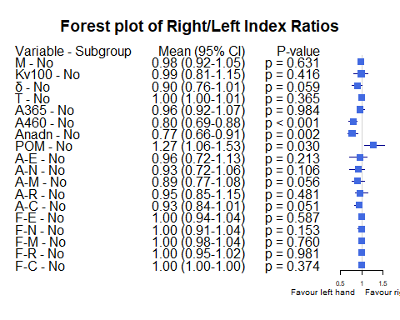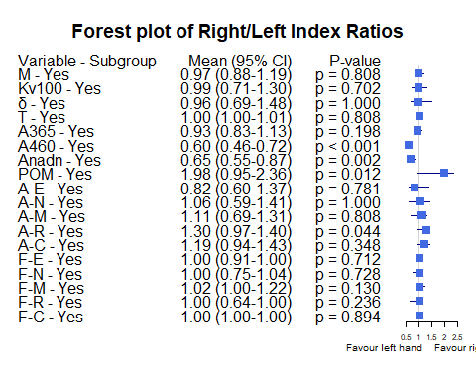

Bảng BMI_25_30

| Variable | Subgroup | Subgroup_Level | Median_Ratio | CI_Lower | CI_Upper | P_Value |
| --- | --- | --- | --- | --- | --- | --- |
| M | BMI_25_30 | BMI <25 | 0.9713620 | 0.9030870 | 1.0410736 | 0.4150384 |
| M | BMI_25_30 | BMI [25-30) | 0.9706483 | 0.9020202 | 1.0444500 | 0.5311745 |
| M | BMI_25_30 | BMI >=30 | 1.1974183 | 1.0102989 | 1.2464466 | 0.0587074 |
| Kv100 | BMI_25_30 | BMI <25 | 1.2194821 | 0.9652329 | 1.4018595 | 0.2852349 |
| Kv100 | BMI_25_30 | BMI [25-30) | 0.8081031 | 0.6306147 | 1.0861025 | 0.0118614 |
| Kv100 | BMI_25_30 | BMI >=30 | 0.8073127 | 0.6881430 | 1.2401994 | 0.2339528 |
| δ | BMI_25_30 | BMI <25 | 1.0092492 | 0.7736486 | 1.2048077 | 0.8991090 |
| δ | BMI_25_30 | BMI [25-30) | 0.8043626 | 0.6735537 | 0.9946828 | 0.0173308 |
| δ | BMI_25_30 | BMI >=30 | 0.9292904 | 0.7554077 | 1.4636429 | 0.7262861 |
| T | BMI_25_30 | BMI <25 | 1.0033698 | 0.9955634 | 1.0140701 | 0.1781873 |
| T | BMI_25_30 | BMI [25-30) | 1.0026673 | 0.9924357 | 1.0100684 | 0.6244272 |
| T | BMI_25_30 | BMI >=30 | 0.9967343 | 0.9890372 | 1.0020563 | 0.2339528 |
| A365 | BMI_25_30 | BMI <25 | 0.9611650 | 0.9126984 | 1.0427350 | 0.9950117 |
| A365 | BMI_25_30 | BMI [25-30) | 0.9890331 | 0.8504564 | 1.1454522 | 0.5614620 |
| A365 | BMI_25_30 | BMI >=30 | 0.9086197 | 0.7166667 | 0.9913793 | 0.1834306 |
| A460 | BMI_25_30 | BMI <25 | 0.6984127 | 0.6640625 | 0.8978102 | 0.0011006 |
| A460 | BMI_25_30 | BMI [25-30) | 0.7465112 | 0.6973034 | 0.8604561 | 0.0008764 |
| A460 | BMI_25_30 | BMI >=30 | 0.6003322 | 0.4455446 | 0.8365967 | 0.0224943 |
| Anadn | BMI_25_30 | BMI <25 | 0.7053191 | 0.6352459 | 0.8664921 | 0.0005584 |
| Anadn | BMI_25_30 | BMI [25-30) | 0.8401224 | 0.6471091 | 0.9755832 | 0.0488695 |
| Anadn | BMI_25_30 | BMI >=30 | 0.6036415 | 0.4987833 | 0.8604651 | 0.1834306 |
| POM | BMI_25_30 | BMI <25 | 1.2958153 | 1.0620793 | 1.6451613 | 0.0221257 |
| POM | BMI_25_30 | BMI [25-30) | 1.3879571 | 0.9681342 | 1.9830477 | 0.0897967 |
| POM | BMI_25_30 | BMI >=30 | 1.4207894 | 0.9989101 | 2.2350689 | 0.2339528 |
| A-E | BMI_25_30 | BMI <25 | 1.1182796 | 0.8108108 | 1.3333333 | 0.8610102 |
| A-E | BMI_25_30 | BMI [25-30) | 0.7471831 | 0.4733488 | 1.2303023 | 0.1135095 |
| A-E | BMI_25_30 | BMI >=30 | 0.6920495 | 0.6713948 | 1.0142855 | 0.0800579 |
| A-N | BMI_25_30 | BMI <25 | 0.9553571 | 0.7697368 | 1.2800000 | 0.7216825 |
| A-N | BMI_25_30 | BMI [25-30) | 0.8788012 | 0.5858586 | 1.0868056 | 0.1358229 |
| A-N | BMI_25_30 | BMI >=30 | 0.8790514 | 0.7203472 | 1.2698864 | 0.2936215 |
| A-M | BMI_25_30 | BMI <25 | 0.9291339 | 0.7777778 | 1.1460674 | 0.2538311 |
| A-M | BMI_25_30 | BMI [25-30) | 1.0256820 | 0.6117774 | 1.3416072 | 0.3806497 |
| A-M | BMI_25_30 | BMI >=30 | 0.8771666 | 0.6307692 | 1.1692308 | 0.2339528 |
| A-R | BMI_25_30 | BMI <25 | 1.0930233 | 0.9000000 | 1.2892562 | 0.6420103 |
| A-R | BMI_25_30 | BMI [25-30) | 1.0557577 | 0.8655462 | 1.2678025 | 0.7412597 |
| A-R | BMI_25_30 | BMI >=30 | 0.9994149 | 0.6753912 | 1.4000000 | 0.8336349 |
| A-C | BMI_25_30 | BMI <25 | 0.9803922 | 0.8571429 | 1.1627907 | 0.6947361 |
| A-C | BMI_25_30 | BMI [25-30) | 0.9293706 | 0.7767505 | 1.0251572 | 0.1746502 |
| A-C | BMI_25_30 | BMI >=30 | 1.0021364 | 0.6329966 | 1.5000000 | 0.9441825 |
| F-E | BMI_25_30 | BMI <25 | 1.0000000 | 0.9087379 | 1.0000000 | 0.1688085 |
| F-E | BMI_25_30 | BMI [25-30) | 1.0000000 | 0.8968544 | 1.0631480 | 0.8190792 |
| F-E | BMI_25_30 | BMI >=30 | 1.0283019 | 1.0000000 | 1.4468085 | 0.1775299 |
| F-N | BMI_25_30 | BMI <25 | 1.0000000 | 0.9024390 | 1.0109890 | 0.2386508 |
| F-N | BMI_25_30 | BMI [25-30) | 1.0000000 | 0.7500000 | 1.1593849 | 0.4351933 |
| F-N | BMI_25_30 | BMI >=30 | 0.9990915 | 0.7365854 | 1.1034483 | 0.7262861 |
| F-M | BMI_25_30 | BMI <25 | 1.0000000 | 0.9531250 | 1.0352113 | 0.7074657 |
| F-M | BMI_25_30 | BMI [25-30) | 1.0448331 | 1.0000000 | 1.1206665 | 0.1484923 |
| F-M | BMI_25_30 | BMI >=30 | 0.9861111 | 0.7877855 | 1.2479491 | 0.6726038 |
| F-R | BMI_25_30 | BMI <25 | 1.0000000 | 0.9533898 | 1.0000000 | 0.9016244 |
| F-R | BMI_25_30 | BMI [25-30) | 0.9642704 | 0.6782299 | 1.0894644 | 0.3963794 |
| F-R | BMI_25_30 | BMI >=30 | 1.0011628 | 0.7706553 | 1.3755020 | 0.6749867 |
| F-C | BMI_25_30 | BMI <25 | 1.0000000 | 1.0000000 | 1.0000000 | 0.4440812 |
| F-C | BMI_25_30 | BMI [25-30) | 1.0000000 | 1.0000000 | 1.0000000 | 0.2894019 |
| F-C | BMI_25_30 | BMI >=30 | 0.9886076 | 0.9077670 | 1.0115283 | 0.5293681 |

Các đồ thị Forest plot theo dưới nhóm BMI_25_30

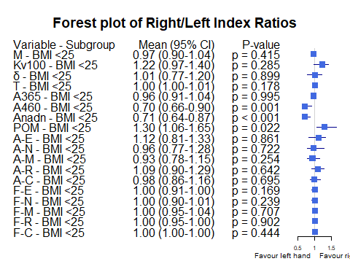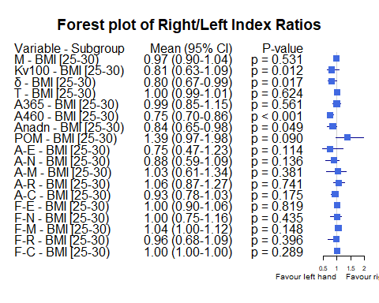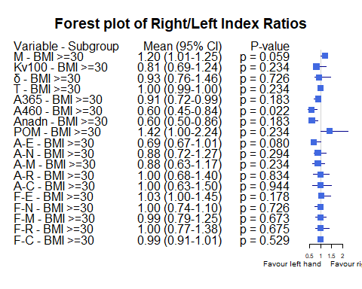

Bảng Obesity

| Variable | Subgroup | Subgroup_Level | Median_Ratio | CI_Lower | CI_Upper | P_Value |
| --- | --- | --- | --- | --- | --- | --- |
| M | Obesity | No | 0.9713620 | 0.9206987 | 1.0119979 | 0.3343058 |
| M | Obesity | Yes | 1.1974183 | 0.9650691 | 1.2464466 | 0.0587074 |
| Kv100 | Obesity | No | 1.0080951 | 0.8229814 | 1.1727273 | 0.5341476 |
| Kv100 | Obesity | Yes | 0.8073127 | 0.7338574 | 1.1427683 | 0.2339528 |
| δ | Obesity | No | 0.9064935 | 0.7680723 | 1.0505051 | 0.1131256 |
| δ | Obesity | Yes | 0.9292904 | 0.7561949 | 1.4636429 | 0.7262861 |
| T | Obesity | No | 1.0032944 | 1.0003156 | 1.0067212 | 0.1646853 |
| T | Obesity | Yes | 0.9967343 | 0.9890372 | 1.0036394 | 0.2339528 |
| A365 | Obesity | No | 0.9618321 | 0.9236948 | 1.0427350 | 0.7855243 |
| A365 | Obesity | Yes | 0.9086197 | 0.7252674 | 0.9913793 | 0.1834306 |
| A460 | Obesity | No | 0.7386364 | 0.6811594 | 0.8620690 | 0.0000030 |
| A460 | Obesity | Yes | 0.6003322 | 0.4876725 | 0.8695652 | 0.0224943 |
| Anadn | Obesity | No | 0.7702703 | 0.6610169 | 0.8902439 | 0.0000743 |
| Anadn | Obesity | Yes | 0.6036415 | 0.4984026 | 0.8604651 | 0.1834306 |
| POM | Obesity | No | 1.3234501 | 1.1113300 | 1.6447866 | 0.0042091 |
| POM | Obesity | Yes | 1.4207894 | 0.9989101 | 2.1914595 | 0.2339528 |
| A-E | Obesity | No | 1.0338983 | 0.7360115 | 1.1674208 | 0.3285993 |
| A-E | Obesity | Yes | 0.6920495 | 0.6713948 | 1.2549020 | 0.0800579 |
| A-N | Obesity | No | 0.9318182 | 0.7104377 | 1.1019709 | 0.2105811 |
| A-N | Obesity | Yes | 0.8790514 | 0.7203472 | 1.2698864 | 0.2936215 |
| A-M | Obesity | No | 0.9356984 | 0.7777778 | 1.1400000 | 0.2064342 |
| A-M | Obesity | Yes | 0.8771666 | 0.6436318 | 1.1670857 | 0.2339528 |
| A-R | Obesity | No | 1.0930233 | 0.9105691 | 1.2444444 | 0.5569959 |
| A-R | Obesity | Yes | 0.9994149 | 0.6753912 | 1.4000000 | 0.8336349 |
| A-C | Obesity | No | 0.9675325 | 0.8888889 | 1.0943396 | 0.2537969 |
| A-C | Obesity | Yes | 1.0021364 | 0.7360761 | 1.5000000 | 0.9441825 |
| F-E | Obesity | No | 1.0000000 | 0.9230769 | 1.0000000 | 0.2226398 |
| F-E | Obesity | Yes | 1.0283019 | 1.0000000 | 1.4468085 | 0.1775299 |
| F-N | Obesity | No | 1.0000000 | 0.9024390 | 1.0134454 | 0.1745929 |
| F-N | Obesity | Yes | 0.9990915 | 0.7365854 | 1.1034483 | 0.7262861 |
| F-M | Obesity | No | 1.0000000 | 1.0000000 | 1.0491803 | 0.2450636 |
| F-M | Obesity | Yes | 0.9861111 | 0.7890930 | 1.4197531 | 0.6726038 |
| F-R | Obesity | No | 1.0000000 | 0.9074890 | 1.0000000 | 0.5102433 |
| F-R | Obesity | Yes | 1.0011628 | 0.7706553 | 1.3755020 | 0.6749867 |
| F-C | Obesity | No | 1.0000000 | 1.0000000 | 1.0000000 | 0.3170991 |
| F-C | Obesity | Yes | 0.9886076 | 0.9077670 | 1.0116775 | 0.5293681 |

Các đồ thị Forest plot theo dưới nhóm Obesity

