Phan tich Forest plot các ratio của left hand

Minh

2024-02-28

## Load bộ số liệu và các packages

## ── Attaching core tidyverse packages ──────────────────────── tidyverse 2.0.0 ──  
## ✔ dplyr 1.1.3 ✔ readr 2.1.4  
## ✔ forcats 1.0.0 ✔ stringr 1.5.0  
## ✔ ggplot2 3.4.3 ✔ tibble 3.2.1  
## ✔ lubridate 1.9.2 ✔ tidyr 1.3.0  
## ✔ purrr 1.0.2   
## ── Conflicts ────────────────────────────────────────── tidyverse_conflicts() ──  
## ✖ dplyr::filter() masks stats::filter()  
## ✖ dplyr::lag() masks stats::lag()  
## ℹ Use the conflicted package (<http://conflicted.r-lib.org/>) to force all conflicts to become errors  
##   
## Attaching package: 'rstatix'  
##   
##   
## The following object is masked from 'package:stats':  
##   
## filter  
##   
##   
## Loading required package: grid  
##   
## Loading required package: checkmate  
##   
## Loading required package: abind

## So sánh khác biệt về ratio của chỉ số Stress vs non stress theo các biến

Hàm để tạo bảng tổng hợp kết quả và p-value

Hàm sắp xếp các cột theo thứ tự

Hàm vẽ Forest plot

Bảng Stress index Ratio, level1 = “Yes”, level2 = “No”

|  | Variable | Subgroup | Level1_Mean | Level2_Mean | Ratio | CI_Lower | CI_Upper | P_Value |
| --- | --- | --- | --- | --- | --- | --- | --- | --- |
| M_left | M_left | Stress index | 26.5329762 | 21.2249240 | 1.2500858 | 1.0290566 | 1.4946605 | 0.0381952 |
| Kv100_left | Kv100_left | Stress index | 23.2055952 | 21.6257018 | 1.0730563 | 0.7907431 | 1.4278222 | 0.4640325 |
| δ_left | δ_left | Stress index | 5.3633333 | 3.7370117 | 1.4351931 | 1.1163661 | 1.8589173 | 0.0151978 |
| T_left | T_left | Stress index | 33.2104762 | 30.5827836 | 1.0859206 | 1.0395076 | 1.1294787 | 0.0169317 |
| A365_left | A365_left | Stress index | 100.7261905 | 85.9859649 | 1.1714259 | 0.8880243 | 1.5160279 | 0.3052460 |
| A460_left | A460_left | Stress index | 61.7738095 | 70.6625731 | 0.8742083 | 0.6955414 | 1.0698438 | 0.3025230 |
| Anadn_left | Anadn_left | Stress index | 1.1186905 | 1.2238012 | 0.9141113 | 0.4640452 | 1.6032644 | 0.0292591 |
| POM_left | POM_left | Stress index | 12.1683333 | 6.5017719 | 1.8715411 | 1.2501404 | 2.8164132 | 0.0127902 |
| A-E_left | A-E_left | Stress index | 1.8000000 | 1.5716491 | 1.1452938 | 0.8164174 | 1.5646036 | 0.2413602 |
| A-N_left | A-N_left | Stress index | 1.7666667 | 1.5111930 | 1.1690543 | 0.8328698 | 1.5726834 | 0.3052889 |
| A-M_left | A-M_left | Stress index | 1.4585714 | 1.1838889 | 1.2320172 | 0.9543026 | 1.6115345 | 0.0954401 |
| A-R_left | A-R_left | Stress index | 0.8763095 | 0.6624971 | 1.3227372 | 1.0134597 | 1.7548737 | 0.0654807 |
| A-C_left | A-C_left | Stress index | 1.0400000 | 0.9168363 | 1.1343356 | 0.9100088 | 1.4118561 | 0.2622852 |
| F-E_left | F-E_left | Stress index | 0.0151071 | 0.0152474 | 0.9908033 | 0.8851936 | 1.1073776 | 0.8339029 |
| F-N_left | F-N_left | Stress index | 0.0375357 | 0.0351193 | 1.0688059 | 0.9076909 | 1.2570360 | 0.3755210 |
| F-M_left | F-M_left | Stress index | 0.0696786 | 0.0802784 | 0.8679620 | 0.7707290 | 0.9668329 | 0.3806790 |
| F-R_left | F-R_left | Stress index | 0.3379762 | 0.3281532 | 1.0299341 | 0.8211881 | 1.2847785 | 0.5365367 |
| F-C_left | F-C_left | Stress index | 1.1246310 | 1.1385450 | 0.9877791 | 0.9115077 | 1.0728286 | 0.8124961 |

Forest plot cho Stress index ratio

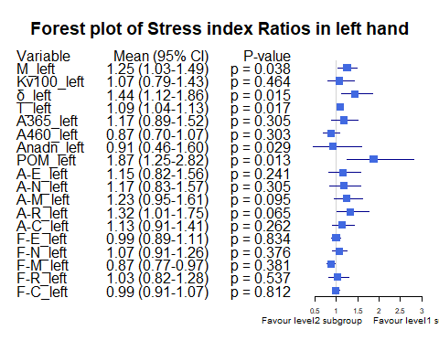

Bảng Gender Ratio, level1 = “male”, level2 = “female”

|  | Variable | Subgroup | Level1_Mean | Level2_Mean | Ratio | CI_Lower | CI_Upper | P_Value |
| --- | --- | --- | --- | --- | --- | --- | --- | --- |
| M_left | M_left | Gender | 23.9307185 | 20.9130556 | 1.1442957 | 0.9548920 | 1.4004465 | 0.1323960 |
| Kv100_left | Kv100_left | Gender | 18.3162593 | 27.1439646 | 0.6747820 | 0.5119965 | 0.8896884 | 0.0159219 |
| δ_left | δ_left | Gender | 3.8795852 | 4.5775253 | 0.8475290 | 0.6582021 | 1.0654907 | 0.1067077 |
| T_left | T_left | Gender | 31.0890074 | 31.5646465 | 0.9849313 | 0.9324762 | 1.0381332 | 0.9034010 |
| A365_left | A365_left | Gender | 89.1674074 | 91.0277778 | 0.9795626 | 0.7827859 | 1.2305824 | 0.8396801 |
| A460_left | A460_left | Gender | 69.3800000 | 66.7550505 | 1.0393221 | 0.8554552 | 1.2726924 | 0.7847379 |
| Anadn_left | Anadn_left | Gender | 1.2203704 | 1.1615909 | 1.0506025 | 0.6471369 | 1.8217441 | 0.2406712 |
| POM_left | POM_left | Gender | 8.4865037 | 7.4013131 | 1.1466214 | 0.7827538 | 1.7231412 | 0.7248776 |
| A-E_left | A-E_left | Gender | 1.5963481 | 1.6832828 | 0.9483541 | 0.7059869 | 1.2197158 | 0.0767323 |
| A-N_left | A-N_left | Gender | 1.5505111 | 1.6201515 | 0.9570161 | 0.7311884 | 1.2275632 | 0.1318052 |
| A-M_left | A-M_left | Gender | 1.2201111 | 1.3092929 | 0.9318855 | 0.7050141 | 1.1863717 | 0.1552813 |
| A-R_left | A-R_left | Gender | 0.6804222 | 0.7741162 | 0.8789666 | 0.6885862 | 1.1244985 | 0.3093852 |
| A-C_left | A-C_left | Gender | 0.9295111 | 0.9779293 | 0.9504891 | 0.7810541 | 1.1624575 | 0.9395281 |
| F-E_left | F-E_left | Gender | 0.0152319 | 0.0151793 | 1.0034625 | 0.9080628 | 1.1051242 | 0.9432091 |
| F-N_left | F-N_left | Gender | 0.0370881 | 0.0339722 | 1.0917198 | 0.9488905 | 1.2628693 | 0.3697338 |
| F-M_left | F-M_left | Gender | 0.0748526 | 0.0809318 | 0.9248846 | 0.7788877 | 1.0808997 | 0.3818398 |
| F-R_left | F-R_left | Gender | 0.3482274 | 0.3070303 | 1.1341793 | 0.9317028 | 1.3921506 | 0.2241786 |
| F-C_left | F-C_left | Gender | 1.1402311 | 1.1273914 | 1.0113889 | 0.9348173 | 1.0970863 | 0.7686839 |

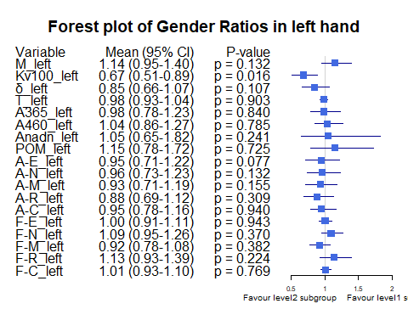

Bảng Smoking ratio, level1 = “Cigarettes, pipe tobacco…”, level2 = “Do not smoke”

|  | Variable | Subgroup | Level1_Mean | Level2_Mean | Ratio | CI_Lower | CI_Upper | P_Value |
| --- | --- | --- | --- | --- | --- | --- | --- | --- |
| M_left | M_left | Smoking | 21.8915476 | 22.8208047 | 0.9592803 | 0.7029646 | 1.2594015 | 0.9325537 |
| Kv100_left | Kv100_left | Smoking | 14.4630952 | 23.7109245 | 0.6099760 | 0.4463738 | 0.8216122 | 0.0187646 |
| δ_left | δ_left | Smoking | 3.2169048 | 4.3844219 | 0.7337124 | 0.4344863 | 1.1672382 | 0.0111169 |
| T_left | T_left | Smoking | 29.8427381 | 31.6068802 | 0.9441849 | 0.8562883 | 1.0283875 | 0.4385072 |
| A365_left | A365_left | Smoking | 84.9642857 | 91.0460938 | 0.9332008 | 0.6209322 | 1.2499778 | 0.7745059 |
| A460_left | A460_left | Smoking | 77.8095238 | 66.1825521 | 1.1756803 | 0.8439320 | 1.5283208 | 0.3972379 |
| Anadn_left | Anadn_left | Smoking | 2.0951190 | 0.9987109 | 2.0978233 | 0.9164134 | 3.7975406 | 0.0316690 |
| POM_left | POM_left | Smoking | 6.9844048 | 8.2555365 | 0.8460268 | 0.3152867 | 1.6569381 | 0.0332684 |
| A-E_left | A-E_left | Smoking | 1.0027381 | 1.7710260 | 0.5661905 | 0.3006627 | 1.0274727 | 0.0005204 |
| A-N_left | A-N_left | Smoking | 1.1322619 | 1.6779115 | 0.6748043 | 0.3574412 | 1.1140418 | 0.0082114 |
| A-M_left | A-M_left | Smoking | 0.8917857 | 1.3379167 | 0.6665480 | 0.3749382 | 1.0442776 | 0.0103100 |
| A-R_left | A-R_left | Smoking | 0.5769048 | 0.7513776 | 0.7677961 | 0.4853022 | 1.1465544 | 0.0598924 |
| A-C_left | A-C_left | Smoking | 0.7857143 | 0.9859323 | 0.7969252 | 0.6034651 | 1.0150793 | 0.1309024 |
| F-E_left | F-E_left | Smoking | 0.0161190 | 0.0150107 | 1.0738388 | 0.9491870 | 1.2013763 | 0.2383488 |
| F-N_left | F-N_left | Smoking | 0.0382262 | 0.0352326 | 1.0849680 | 0.8946613 | 1.3105779 | 0.4222905 |
| F-M_left | F-M_left | Smoking | 0.0796548 | 0.0769367 | 1.0353283 | 0.8515702 | 1.2944361 | 0.9156133 |
| F-R_left | F-R_left | Smoking | 0.4324524 | 0.3085609 | 1.4015137 | 1.1042028 | 1.7002574 | 0.0048527 |
| F-C_left | F-C_left | Smoking | 1.1975000 | 1.1210831 | 1.0681635 | 0.9871887 | 1.1707878 | 0.5181115 |

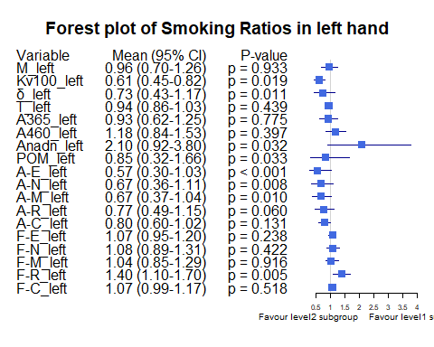

Bảng Smoking ratio, level1 = “Cigarettes, pipe tobacco…”, level2 = “Do not smoke”

|  | Variable | Subgroup | Level1_Mean | Level2_Mean | Ratio | CI_Lower | CI_Upper | P_Value |
| --- | --- | --- | --- | --- | --- | --- | --- | --- |
| M_left | M_left | Smoking | 21.8915476 | 22.8208047 | 0.9592803 | 0.7068370 | 1.2356346 | 0.9325537 |
| Kv100_left | Kv100_left | Smoking | 14.4630952 | 23.7109245 | 0.6099760 | 0.4370295 | 0.8301838 | 0.0187646 |
| δ_left | δ_left | Smoking | 3.2169048 | 4.3844219 | 0.7337124 | 0.4374966 | 1.1734319 | 0.0111169 |
| T_left | T_left | Smoking | 29.8427381 | 31.6068802 | 0.9441849 | 0.8531936 | 1.0350011 | 0.4385072 |
| A365_left | A365_left | Smoking | 84.9642857 | 91.0460938 | 0.9332008 | 0.6232549 | 1.2392015 | 0.7745059 |
| A460_left | A460_left | Smoking | 77.8095238 | 66.1825521 | 1.1756803 | 0.8323241 | 1.5344346 | 0.3972379 |
| Anadn_left | Anadn_left | Smoking | 2.0951190 | 0.9987109 | 2.0978233 | 0.9156231 | 3.9679097 | 0.0316690 |
| POM_left | POM_left | Smoking | 6.9844048 | 8.2555365 | 0.8460268 | 0.3000593 | 1.6738131 | 0.0332684 |
| A-E_left | A-E_left | Smoking | 1.0027381 | 1.7710260 | 0.5661905 | 0.2806676 | 0.9854820 | 0.0005204 |
| A-N_left | A-N_left | Smoking | 1.1322619 | 1.6779115 | 0.6748043 | 0.3587605 | 1.0822323 | 0.0082114 |
| A-M_left | A-M_left | Smoking | 0.8917857 | 1.3379167 | 0.6665480 | 0.3831730 | 1.0070350 | 0.0103100 |
| A-R_left | A-R_left | Smoking | 0.5769048 | 0.7513776 | 0.7677961 | 0.4728830 | 1.1459454 | 0.0598924 |
| A-C_left | A-C_left | Smoking | 0.7857143 | 0.9859323 | 0.7969252 | 0.5974526 | 1.0327423 | 0.1309024 |
| F-E_left | F-E_left | Smoking | 0.0161190 | 0.0150107 | 1.0738388 | 0.9440371 | 1.1917205 | 0.2383488 |
| F-N_left | F-N_left | Smoking | 0.0382262 | 0.0352326 | 1.0849680 | 0.8790205 | 1.3153010 | 0.4222905 |
| F-M_left | F-M_left | Smoking | 0.0796548 | 0.0769367 | 1.0353283 | 0.8607791 | 1.2691502 | 0.9156133 |
| F-R_left | F-R_left | Smoking | 0.4324524 | 0.3085609 | 1.4015137 | 1.1014055 | 1.7120295 | 0.0048527 |
| F-C_left | F-C_left | Smoking | 1.1975000 | 1.1210831 | 1.0681635 | 0.9799863 | 1.1646594 | 0.5181115 |

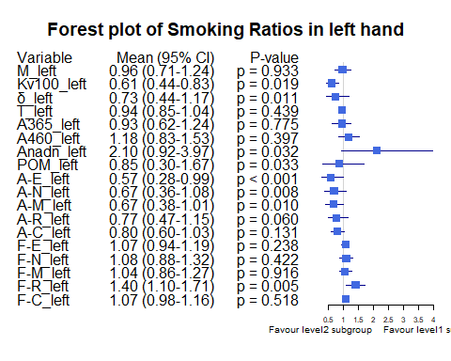

Bảng Hypertension ratio, level1 = “Yes”, level2 = “No”

|  | Variable | Subgroup | Level1_Mean | Level2_Mean | Ratio | CI_Lower | CI_Upper | P_Value |
| --- | --- | --- | --- | --- | --- | --- | --- | --- |
| M_left | M_left | Hypertension | 19.3701905 | 23.8638450 | 0.8116961 | 0.6225542 | 1.0088375 | 0.1525302 |
| Kv100_left | Kv100_left | Hypertension | 17.1088095 | 23.8718860 | 0.7166928 | 0.5352810 | 0.9365655 | 0.0788607 |
| δ_left | δ_left | Hypertension | 2.7376429 | 4.7043713 | 0.5819360 | 0.4304227 | 0.7609171 | 0.0001502 |
| T_left | T_left | Hypertension | 30.1820000 | 31.6985380 | 0.9521575 | 0.8818609 | 1.0165654 | 0.5848223 |
| A365_left | A365_left | Hypertension | 92.4023810 | 89.0526316 | 1.0376154 | 0.8355321 | 1.2862037 | 0.6975032 |
| A460_left | A460_left | Hypertension | 90.0523810 | 60.2441520 | 1.4947904 | 1.2212521 | 1.8257172 | 0.0005303 |
| Anadn_left | Anadn_left | Hypertension | 1.4952381 | 1.0850731 | 1.3780068 | 0.7562102 | 2.3227317 | 0.0238933 |
| POM_left | POM_left | Hypertension | 4.5186190 | 9.3200877 | 0.4848258 | 0.3220917 | 0.6824786 | 0.0046912 |
| A-E_left | A-E_left | Hypertension | 1.2172143 | 1.7863596 | 0.6813937 | 0.4463843 | 0.9597649 | 0.0107231 |
| A-N_left | A-N_left | Hypertension | 1.1918095 | 1.7229825 | 0.6917131 | 0.4541969 | 1.0340904 | 0.0073363 |
| A-M_left | A-M_left | Hypertension | 0.8741667 | 1.3991959 | 0.6247636 | 0.4179850 | 0.8983968 | 0.0013764 |
| A-R_left | A-R_left | Hypertension | 0.5069762 | 0.7985673 | 0.6348572 | 0.4684047 | 0.8609960 | 0.0008368 |
| A-C_left | A-C_left | Hypertension | 0.7010952 | 1.0416959 | 0.6730325 | 0.5227148 | 0.8413894 | 0.0013493 |
| F-E_left | F-E_left | Hypertension | 0.0150167 | 0.0152807 | 0.9827210 | 0.8797788 | 1.0917708 | 0.8162516 |
| F-N_left | F-N_left | Hypertension | 0.0342881 | 0.0363158 | 0.9441649 | 0.7791343 | 1.1398525 | 0.3096287 |
| F-M_left | F-M_left | Hypertension | 0.0767952 | 0.0776564 | 0.9889102 | 0.8442129 | 1.1831536 | 0.5862195 |
| F-R_left | F-R_left | Hypertension | 0.4015905 | 0.3047164 | 1.3179156 | 1.0580744 | 1.6145980 | 0.0145737 |
| F-C_left | F-C_left | Hypertension | 1.1843643 | 1.1165380 | 1.0607469 | 0.9694922 | 1.1546425 | 0.1203892 |

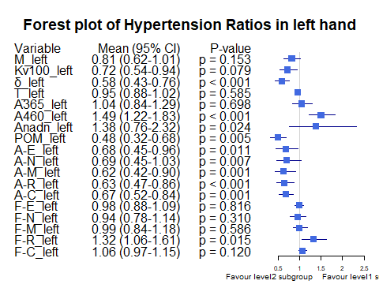

Bảng Obesity ratio, level1 = “Yes”, level2 = “No”

|  | Variable | Subgroup | Level1_Mean | Level2_Mean | Ratio | CI_Lower | CI_Upper | P_Value |
| --- | --- | --- | --- | --- | --- | --- | --- | --- |
| M_left | M_left | Obesity | 24.9205000 | 22.3949881 | 1.1127713 | 0.9465427 | 1.3062468 | 0.7985078 |
| Kv100_left | Kv100_left | Obesity | 18.3239583 | 22.4770119 | 0.8152311 | 0.5711718 | 1.0916878 | 0.6745039 |
| δ_left | δ_left | Obesity | 4.1008958 | 4.1833214 | 0.9802966 | 0.6980209 | 1.2983231 | 0.9934296 |
| T_left | T_left | Obesity | 33.8190000 | 31.0012381 | 1.0908919 | 1.0460469 | 1.1358838 | 0.0290921 |
| A365_left | A365_left | Obesity | 103.4937500 | 88.4071429 | 1.1706492 | 0.9781761 | 1.3989645 | 0.3871657 |
| A460_left | A460_left | Obesity | 79.4916667 | 66.9869048 | 1.1866747 | 0.9170082 | 1.4845765 | 0.2291222 |
| Anadn_left | Anadn_left | Obesity | 0.7810417 | 1.2428690 | 0.6284183 | 0.4460535 | 0.8929091 | 0.7543171 |
| POM_left | POM_left | Obesity | 9.0665833 | 7.9086190 | 1.1464180 | 0.7989885 | 1.6804031 | 0.1904215 |
| A-E_left | A-E_left | Obesity | 2.1062292 | 1.5790595 | 1.3338504 | 0.9110355 | 1.8683684 | 0.1176623 |
| A-N_left | A-N_left | Obesity | 1.9180833 | 1.5413333 | 1.2444312 | 0.8495330 | 1.7008727 | 0.1690470 |
| A-M_left | A-M_left | Obesity | 1.3817708 | 1.2436786 | 1.1110353 | 0.7520935 | 1.4857664 | 0.3782057 |
| A-R_left | A-R_left | Obesity | 0.8185208 | 0.7088095 | 1.1547825 | 0.7743841 | 1.7208709 | 0.7418405 |
| A-C_left | A-C_left | Obesity | 0.9882917 | 0.9456190 | 1.0451266 | 0.7872154 | 1.3573826 | 0.6446500 |
| F-E_left | F-E_left | Obesity | 0.0145021 | 0.0152905 | 0.9484390 | 0.8337718 | 1.0657611 | 0.5901680 |
| F-N_left | F-N_left | Obesity | 0.0346938 | 0.0358929 | 0.9665920 | 0.7907773 | 1.1972548 | 0.9539350 |
| F-M_left | F-M_left | Obesity | 0.0744625 | 0.0777631 | 0.9575558 | 0.8165716 | 1.1150237 | 0.6999858 |
| F-R_left | F-R_left | Obesity | 0.3489875 | 0.3287190 | 1.0616589 | 0.7690962 | 1.4005391 | 0.4750510 |
| F-C_left | F-C_left | Obesity | 1.1851437 | 1.1290452 | 1.0496867 | 0.8616014 | 1.2010296 | 0.2376917 |

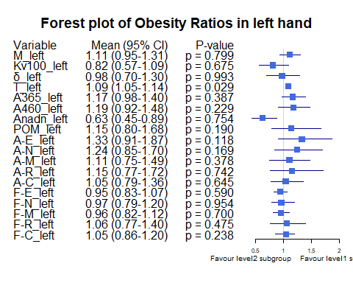

Bảng Race ratio, level1 = “White”, level2 = “Asian or Asian British”

|  | Variable | Subgroup | Level1_Mean | Level2_Mean | Ratio | CI_Lower | CI_Upper | P_Value |
| --- | --- | --- | --- | --- | --- | --- | --- | --- |
| M_left | M_left | Race | 27.8536190 | 21.1467623 | 1.3171576 | 1.1071130 | 1.5590936 | 0.0393984 |
| Kv100_left | Kv100_left | Race | 22.9898810 | 22.1756421 | 1.0367177 | 0.7620306 | 1.4216499 | 0.4504566 |
| δ_left | δ_left | Race | 5.9042619 | 3.7463934 | 1.5759855 | 1.2384460 | 2.0175371 | 0.0013638 |
| T_left | T_left | Race | 32.8872857 | 30.7787978 | 1.0685046 | 1.0174506 | 1.1170449 | 0.0674227 |
| A365_left | A365_left | Race | 109.9666667 | 89.4084699 | 1.2299357 | 1.0090472 | 1.4789804 | 0.1364576 |
| A460_left | A460_left | Race | 65.9476190 | 71.4877049 | 0.9225030 | 0.7714008 | 1.1020915 | 0.5957880 |
| Anadn_left | Anadn_left | Race | 0.6514286 | 1.2680191 | 0.5137372 | 0.3592148 | 0.7401569 | 0.0311295 |
| POM_left | POM_left | Race | 13.0690000 | 7.1229508 | 1.8347733 | 1.2265158 | 2.8873873 | 0.0010748 |
| A-E_left | A-E_left | Race | 2.6023095 | 1.4242896 | 1.8270930 | 1.3244335 | 2.4762332 | 0.0011545 |
| A-N_left | A-N_left | Race | 2.4465238 | 1.3666667 | 1.7901394 | 1.3340900 | 2.3457494 | 0.0005525 |
| A-M_left | A-M_left | Race | 1.8064286 | 1.1311749 | 1.5969490 | 1.2166065 | 2.0654656 | 0.0025372 |
| A-R_left | A-R_left | Race | 1.0215952 | 0.6497131 | 1.5723790 | 1.1530183 | 2.0978757 | 0.0183072 |
| A-C_left | A-C_left | Race | 1.2505714 | 0.8621585 | 1.4505123 | 1.1865075 | 1.7303553 | 0.0012988 |
| F-E_left | F-E_left | Race | 0.0144476 | 0.0153784 | 0.9394739 | 0.8341475 | 1.0487347 | 0.3484143 |
| F-N_left | F-N_left | Race | 0.0310214 | 0.0364713 | 0.8505707 | 0.7405610 | 0.9814291 | 0.2696869 |
| F-M_left | F-M_left | Race | 0.0700857 | 0.0798675 | 0.8775250 | 0.7764425 | 0.9964680 | 0.4436267 |
| F-R_left | F-R_left | Race | 0.2972786 | 0.3402678 | 0.8736607 | 0.6720201 | 1.1258926 | 0.5373888 |
| F-C_left | F-C_left | Race | 1.0605643 | 1.1524986 | 0.9202304 | 0.8164306 | 1.0274205 | 0.0896704 |

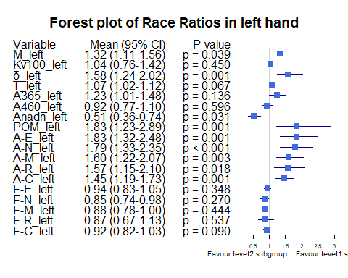

Bảng Race ratio, level1 = “Black, African, Caribbean or Black Bristish”, level2 = “Asian or Asian British”

|  | Variable | Subgroup | Level1_Mean | Level2_Mean | Ratio | CI_Lower | CI_Upper | P_Value |
| --- | --- | --- | --- | --- | --- | --- | --- | --- |
| M_left | M_left | Race | 29.0366667 | 21.1467623 | 1.3731022 | 1.1293818 | 1.7145257 | 0.2528587 |
| Kv100_left | Kv100_left | Race | 15.1366667 | 22.1756421 | 0.6825808 | 0.3271846 | 1.2115543 | 0.3738219 |
| δ_left | δ_left | Race | 4.8166667 | 3.7463934 | 1.2856809 | 0.4874584 | 2.5835484 | 0.9114818 |
| T_left | T_left | Race | 34.2366667 | 30.7787978 | 1.1123458 | 1.0644741 | 1.1726202 | 0.0834427 |
| A365_left | A365_left | Race | 7.6666667 | 89.4084699 | 0.0857488 | 0.0485040 | 0.1179648 | 0.0100790 |
| A460_left | A460_left | Race | 13.6666667 | 71.4877049 | 0.1911751 | 0.1597584 | 0.2290861 | 0.0051818 |
| Anadn_left | Anadn_left | Race | 2.2600000 | 1.2680191 | 1.7823075 | 0.9074413 | 3.1128787 | 0.0307771 |
| POM_left | POM_left | Race | 2.8900000 | 7.1229508 | 0.4057307 | 0.2729910 | 0.5957719 | 0.2039131 |
| A-E_left | A-E_left | Race | 1.3566667 | 1.4242896 | 0.9525216 | 0.2356739 | 1.7664656 | 0.8738127 |
| A-N_left | A-N_left | Race | 1.8733333 | 1.3666667 | 1.3707317 | 0.3527387 | 2.8317020 | 0.8738127 |
| A-M_left | A-M_left | Race | 1.2733333 | 1.1311749 | 1.1256733 | 0.4249169 | 2.1061886 | 1.0000000 |
| A-R_left | A-R_left | Race | 0.7433333 | 0.6497131 | 1.1440947 | 0.8263515 | 1.5990319 | 0.5047167 |
| A-C_left | A-C_left | Race | 1.3333333 | 0.8621585 | 1.5465061 | 0.8238613 | 2.3369934 | 0.1622014 |
| F-E_left | F-E_left | Race | 0.0153333 | 0.0153784 | 0.9970685 | 0.8431592 | 1.1326135 | 1.0000000 |
| F-N_left | F-N_left | Race | 0.0436667 | 0.0364713 | 1.1972881 | 0.8793834 | 1.5754203 | 0.2931407 |
| F-M_left | F-M_left | Race | 0.0620000 | 0.0798675 | 0.7762859 | 0.7009630 | 0.8483335 | 0.0957373 |
| F-R_left | F-R_left | Race | 0.2946667 | 0.3402678 | 0.8659847 | 0.5618337 | 1.3548612 | 0.4649379 |
| F-C_left | F-C_left | Race | 1.1213333 | 1.1524986 | 0.9729585 | 0.8849426 | 1.0851049 | 0.5239811 |

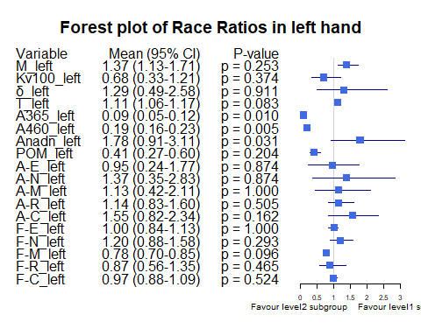

Bảng BMI ratio, level1 = “BMI <25”, level2 = “BMI [25-30)”

|  | Variable | Subgroup | Level1_Mean | Level2_Mean | Ratio | CI_Lower | CI_Upper | P_Value |
| --- | --- | --- | --- | --- | --- | --- | --- | --- |
| M_left | M_left | BMI_25_30 | 19.7088372 | 26.6729321 | 0.7389078 | 0.6069253 | 0.8935132 | 0.0102414 |
| Kv100_left | Kv100_left | BMI_25_30 | 23.9179457 | 20.1821914 | 1.1851015 | 0.8376705 | 1.6623017 | 0.2155310 |
| δ_left | δ_left | BMI_25_30 | 3.9666279 | 4.5284259 | 0.8759397 | 0.6685535 | 1.1538666 | 0.5030829 |
| T_left | T_left | BMI_25_30 | 30.1562016 | 32.3470370 | 0.9322709 | 0.8872641 | 0.9854886 | 0.0101706 |
| A365_left | A365_left | BMI_25_30 | 86.7713178 | 91.0123457 | 0.9534016 | 0.7413177 | 1.2287416 | 0.9711209 |
| A460_left | A460_left | BMI_25_30 | 66.6279070 | 67.5586420 | 0.9862233 | 0.7980486 | 1.2022416 | 0.6595313 |
| Anadn_left | Anadn_left | BMI_25_30 | 1.3906202 | 1.0075617 | 1.3801836 | 0.8163228 | 2.3037197 | 0.5422710 |
| POM_left | POM_left | BMI_25_30 | 6.8925581 | 9.5267901 | 0.7234922 | 0.4497048 | 1.1511027 | 0.0913001 |
| A-E_left | A-E_left | BMI_25_30 | 1.4784109 | 1.7393519 | 0.8499780 | 0.6253092 | 1.2081803 | 0.5423063 |
| A-N_left | A-N_left | BMI_25_30 | 1.4274806 | 1.7226543 | 0.8286518 | 0.6207992 | 1.1373015 | 0.5264218 |
| A-M_left | A-M_left | BMI_25_30 | 1.1816667 | 1.3424383 | 0.8802391 | 0.6603920 | 1.2270326 | 0.7491432 |
| A-R_left | A-R_left | BMI_25_30 | 0.6652326 | 0.7782099 | 0.8548241 | 0.6706320 | 1.0957841 | 0.2393953 |
| A-C_left | A-C_left | BMI_25_30 | 0.8831783 | 1.0450617 | 0.8450968 | 0.6830798 | 1.0404281 | 0.1409572 |
| F-E_left | F-E_left | BMI_25_30 | 0.0154380 | 0.0150556 | 1.0254012 | 0.9232279 | 1.1490638 | 0.6094959 |
| F-N_left | F-N_left | BMI_25_30 | 0.0354302 | 0.0366296 | 0.9672561 | 0.8199836 | 1.1233778 | 0.6986622 |
| F-M_left | F-M_left | BMI_25_30 | 0.0812132 | 0.0722685 | 1.1237698 | 0.9692652 | 1.3117783 | 0.6850343 |
| F-R_left | F-R_left | BMI_25_30 | 0.3131008 | 0.3535926 | 0.8854845 | 0.7110780 | 1.1231624 | 0.2698766 |
| F-C_left | F-C_left | BMI_25_30 | 1.1361202 | 1.1177778 | 1.0164097 | 0.9430646 | 1.1055277 | 0.9372716 |

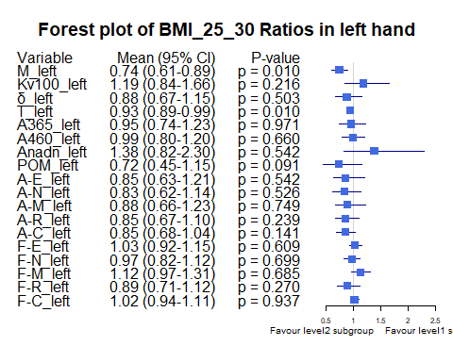

Bảng BMI ratio, level1 = “BMI >=30”, level2 = “BMI [25-30)”

|  | Variable | Subgroup | Level1_Mean | Level2_Mean | Ratio | CI_Lower | CI_Upper | P_Value |
| --- | --- | --- | --- | --- | --- | --- | --- | --- |
| M_left | M_left | BMI_25_30 | 24.9205000 | 26.6729321 | 0.9342992 | 0.7860697 | 1.132771 | 0.3631012 |
| Kv100_left | Kv100_left | BMI_25_30 | 18.3239583 | 20.1821914 | 0.9079271 | 0.6166685 | 1.307488 | 0.9539623 |
| δ_left | δ_left | BMI_25_30 | 4.1008958 | 4.5284259 | 0.9055897 | 0.6378800 | 1.280496 | 0.7433810 |
| T_left | T_left | BMI_25_30 | 33.8190000 | 32.3470370 | 1.0455053 | 1.0028914 | 1.096718 | 0.2207089 |
| A365_left | A365_left | BMI_25_30 | 103.4937500 | 91.0123457 | 1.1371397 | 0.9127386 | 1.428962 | 0.2977655 |
| A460_left | A460_left | BMI_25_30 | 79.4916667 | 67.5586420 | 1.1766321 | 0.8749948 | 1.514258 | 0.2625224 |
| Anadn_left | Anadn_left | BMI_25_30 | 0.7810417 | 1.0075617 | 0.7751800 | 0.5307212 | 1.157387 | 0.9530081 |
| POM_left | POM_left | BMI_25_30 | 9.0665833 | 9.5267901 | 0.9516934 | 0.6012001 | 1.483476 | 0.5760027 |
| A-E_left | A-E_left | BMI_25_30 | 2.1062292 | 1.7393519 | 1.2109276 | 0.8262676 | 1.834429 | 0.3070422 |
| A-N_left | A-N_left | BMI_25_30 | 1.9180833 | 1.7226543 | 1.1134464 | 0.7278018 | 1.727207 | 0.5425358 |
| A-M_left | A-M_left | BMI_25_30 | 1.3817708 | 1.3424383 | 1.0292993 | 0.6903457 | 1.503805 | 0.5556067 |
| A-R_left | A-R_left | BMI_25_30 | 0.8185208 | 0.7782099 | 1.0517996 | 0.6800609 | 1.650465 | 0.9217552 |
| A-C_left | A-C_left | BMI_25_30 | 0.9882917 | 1.0450617 | 0.9456778 | 0.6964059 | 1.227944 | 0.8751126 |
| F-E_left | F-E_left | BMI_25_30 | 0.0145021 | 0.0150556 | 0.9632380 | 0.8388946 | 1.122377 | 0.7975257 |
| F-N_left | F-N_left | BMI_25_30 | 0.0346938 | 0.0366296 | 0.9471499 | 0.7558912 | 1.210004 | 1.0000000 |
| F-M_left | F-M_left | BMI_25_30 | 0.0744625 | 0.0722685 | 1.0303587 | 0.8837604 | 1.195607 | 0.5373604 |
| F-R_left | F-R_left | BMI_25_30 | 0.3489875 | 0.3535926 | 0.9869763 | 0.7060704 | 1.381622 | 0.8874140 |
| F-C_left | F-C_left | BMI_25_30 | 1.1851437 | 1.1177778 | 1.0602678 | 0.8806220 | 1.226238 | 0.2145716 |

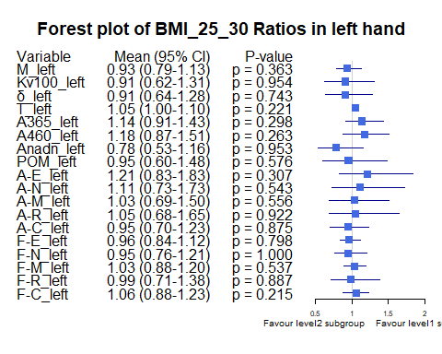

Bảng Age_stage ratio, level1 = “Age <30”, level2= “Age [30-40)”

|  | Variable | Subgroup | Level1_Mean | Level2_Mean | Ratio | CI_Lower | CI_Upper | P_Value |
| --- | --- | --- | --- | --- | --- | --- | --- | --- |
| M_left | M_left | Age_stage | 19.6532692 | 25.3512576 | 0.7752384 | 0.6014821 | 0.9842224 | 0.0947446 |
| Kv100_left | Kv100_left | Age_stage | 27.7751923 | 21.0282576 | 1.3208509 | 0.9695178 | 1.8103719 | 0.0831156 |
| δ_left | δ_left | Age_stage | 4.1582692 | 4.7532222 | 0.8748316 | 0.6758157 | 1.1175810 | 0.4619055 |
| T_left | T_left | Age_stage | 30.5000000 | 32.2822828 | 0.9447907 | 0.8888055 | 0.9936312 | 0.0225728 |
| A365_left | A365_left | Age_stage | 81.8461538 | 101.3772727 | 0.8073422 | 0.6027274 | 1.0534670 | 0.1533873 |
| A460_left | A460_left | Age_stage | 57.4038462 | 73.5106061 | 0.7808920 | 0.6129812 | 0.9623842 | 0.0573003 |
| Anadn_left | Anadn_left | Age_stage | 1.2288462 | 0.9086111 | 1.3524446 | 0.7737736 | 2.2628761 | 0.4271631 |
| POM_left | POM_left | Age_stage | 6.7784615 | 10.6032626 | 0.6392807 | 0.4106113 | 1.0016442 | 0.0440811 |
| A-E_left | A-E_left | Age_stage | 1.5325000 | 1.8803737 | 0.8149976 | 0.6218103 | 1.0930355 | 0.3247200 |
| A-N_left | A-N_left | Age_stage | 1.5180769 | 1.7583232 | 0.8633662 | 0.6550345 | 1.1502782 | 0.4636264 |
| A-M_left | A-M_left | Age_stage | 1.2450000 | 1.4193939 | 0.8771349 | 0.6629399 | 1.1559880 | 0.5669137 |
| A-R_left | A-R_left | Age_stage | 0.6946154 | 0.7821667 | 0.8880657 | 0.6906344 | 1.1460178 | 0.9939085 |
| A-C_left | A-C_left | Age_stage | 0.9665385 | 0.9807980 | 0.9854613 | 0.7754743 | 1.2173410 | 0.5824875 |
| F-E_left | F-E_left | Age_stage | 0.0154038 | 0.0150308 | 1.0248182 | 0.9078612 | 1.1607054 | 0.6434878 |
| F-N_left | F-N_left | Age_stage | 0.0377308 | 0.0336025 | 1.1228552 | 0.9441601 | 1.3386193 | 0.2383339 |
| F-M_left | F-M_left | Age_stage | 0.0802308 | 0.0736955 | 1.0886800 | 0.9139483 | 1.2983765 | 0.0731918 |
| F-R_left | F-R_left | Age_stage | 0.2706923 | 0.3277545 | 0.8258995 | 0.6632775 | 1.0415064 | 0.2601709 |
| F-C_left | F-C_left | Age_stage | 1.1316154 | 1.1591914 | 0.9762110 | 0.8915326 | 1.0655626 | 0.6903321 |

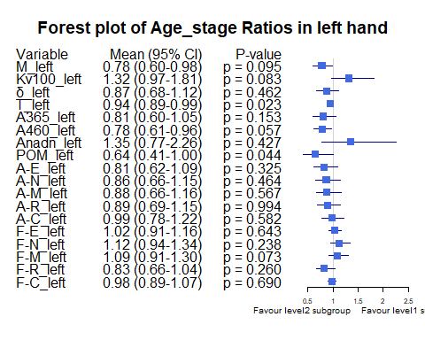

Bảng Age_stage ratio, level1 = “Age <30”, level2= “Age [40-50)”

|  | Variable | Subgroup | Level1_Mean | Level2_Mean | Ratio | CI_Lower | CI_Upper | P_Value |
| --- | --- | --- | --- | --- | --- | --- | --- | --- |
| M_left | M_left | Age_stage | 19.6532692 | 24.0101282 | 0.8185408 | 0.5917816 | 1.1296190 | 0.2428218 |
| Kv100_left | Kv100_left | Age_stage | 27.7751923 | 11.3402564 | 2.4492561 | 1.8176554 | 3.1630141 | 0.0000657 |
| δ_left | δ_left | Age_stage | 4.1582692 | 2.7820513 | 1.4946774 | 1.0592979 | 2.1499161 | 0.0356888 |
| T_left | T_left | Age_stage | 30.5000000 | 31.1891026 | 0.9779057 | 0.8967854 | 1.0783674 | 0.2809149 |
| A365_left | A365_left | Age_stage | 81.8461538 | 80.0384615 | 1.0225853 | 0.7005407 | 1.5223667 | 0.8464045 |
| A460_left | A460_left | Age_stage | 57.4038462 | 77.1794872 | 0.7437708 | 0.5316593 | 1.0566513 | 0.1524814 |
| Anadn_left | Anadn_left | Age_stage | 1.2288462 | 1.9470513 | 0.6311319 | 0.2957013 | 1.6267308 | 0.1285648 |
| POM_left | POM_left | Age_stage | 6.7784615 | 5.3755128 | 1.2609888 | 0.7336953 | 2.2338156 | 0.6066367 |
| A-E_left | A-E_left | Age_stage | 1.5325000 | 0.9714103 | 1.5776033 | 1.0706525 | 2.4729298 | 0.0226473 |
| A-N_left | A-N_left | Age_stage | 1.5180769 | 1.1316667 | 1.3414524 | 0.8297895 | 2.2424208 | 0.0762595 |
| A-M_left | A-M_left | Age_stage | 1.2450000 | 0.8626923 | 1.4431565 | 0.9627041 | 2.3952676 | 0.0584661 |
| A-R_left | A-R_left | Age_stage | 0.6946154 | 0.5543590 | 1.2530065 | 0.9054318 | 1.7495048 | 0.1526476 |
| A-C_left | A-C_left | Age_stage | 0.9665385 | 0.7846154 | 1.2318627 | 0.8971389 | 1.7373537 | 0.2702054 |
| F-E_left | F-E_left | Age_stage | 0.0154038 | 0.0156667 | 0.9832242 | 0.8667680 | 1.1188452 | 0.7523730 |
| F-N_left | F-N_left | Age_stage | 0.0377308 | 0.0356282 | 1.0590140 | 0.8671175 | 1.3112122 | 0.8578466 |
| F-M_left | F-M_left | Age_stage | 0.0802308 | 0.0798590 | 1.0046556 | 0.8055066 | 1.2611603 | 0.9759451 |
| F-R_left | F-R_left | Age_stage | 0.2706923 | 0.4342564 | 0.6233467 | 0.4952250 | 0.8030152 | 0.0015399 |
| F-C_left | F-C_left | Age_stage | 1.1316154 | 1.1445385 | 0.9887089 | 0.8847594 | 1.1022270 | 0.9048055 |

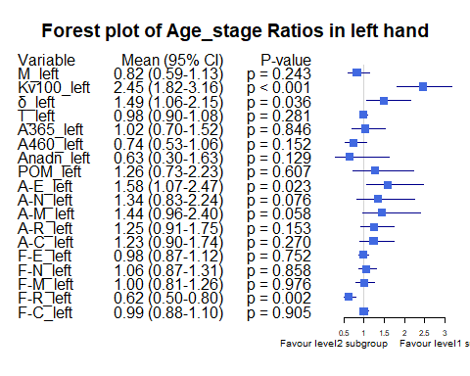

Bảng Age_stage ratio, level1 = “Age <30”, level2= “Age >=50”

|  | Variable | Subgroup | Level1_Mean | Level2_Mean | Ratio | CI_Lower | CI_Upper | P_Value |
| --- | --- | --- | --- | --- | --- | --- | --- | --- |
| M_left | M_left | Age_stage | 19.6532692 | 17.8841667 | 1.0989200 | 0.7114054 | 1.9918626 | 0.6890791 |
| Kv100_left | Kv100_left | Age_stage | 27.7751923 | 26.0786111 | 1.0650564 | 0.6345254 | 1.9957918 | 0.7597551 |
| δ_left | δ_left | Age_stage | 4.1582692 | 4.0836111 | 1.0182824 | 0.6493149 | 2.0203364 | 0.8468497 |
| T_left | T_left | Age_stage | 30.5000000 | 29.4775000 | 1.0346875 | 0.9069603 | 1.1955614 | 0.7353676 |
| A365_left | A365_left | Age_stage | 81.8461538 | 83.7500000 | 0.9772675 | 0.6304631 | 1.8343165 | 0.8468358 |
| A460_left | A460_left | Age_stage | 57.4038462 | 67.2222222 | 0.8539415 | 0.5789498 | 1.4130688 | 0.6119978 |
| Anadn_left | Anadn_left | Age_stage | 1.2288462 | 1.0005556 | 1.2281638 | 0.6929058 | 2.0122653 | 0.3587502 |
| POM_left | POM_left | Age_stage | 6.7784615 | 5.0177778 | 1.3508891 | 0.7733363 | 2.7577106 | 0.5878909 |
| A-E_left | A-E_left | Age_stage | 1.5325000 | 2.1430556 | 0.7151005 | 0.3944676 | 2.3050050 | 0.9422618 |
| A-N_left | A-N_left | Age_stage | 1.5180769 | 1.8386111 | 0.8256650 | 0.4786394 | 1.9169647 | 0.9812380 |
| A-M_left | A-M_left | Age_stage | 1.2450000 | 1.2811111 | 0.9718127 | 0.5779311 | 2.1064379 | 1.0000000 |
| A-R_left | A-R_left | Age_stage | 0.6946154 | 0.8477778 | 0.8193366 | 0.5264239 | 1.6313532 | 0.6814968 |
| A-C_left | A-C_left | Age_stage | 0.9665385 | 1.0672222 | 0.9056581 | 0.6762306 | 1.2283042 | 0.3222080 |
| F-E_left | F-E_left | Age_stage | 0.0154038 | 0.0143611 | 1.0726082 | 0.9226338 | 1.2744005 | 0.6086915 |
| F-N_left | F-N_left | Age_stage | 0.0377308 | 0.0395000 | 0.9552093 | 0.7104989 | 1.3356635 | 0.8653458 |
| F-M_left | F-M_left | Age_stage | 0.0802308 | 0.0805000 | 0.9966555 | 0.7593352 | 1.3092335 | 0.8636657 |
| F-R_left | F-R_left | Age_stage | 0.2706923 | 0.3838333 | 0.7052340 | 0.5321078 | 0.9712525 | 0.0116064 |
| F-C_left | F-C_left | Age_stage | 1.1316154 | 0.9933333 | 1.1392101 | 0.9376090 | 1.4224345 | 0.1830244 |

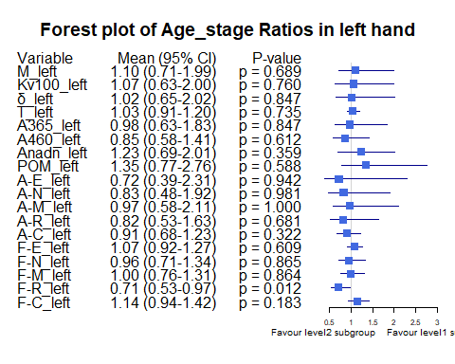

Bảng Age_stage ratio, level1 = “Age [30-40)”, level2= “Age >=50”

|  | Variable | Subgroup | Level1_Mean | Level2_Mean | Ratio | CI_Lower | CI_Upper | P_Value |
| --- | --- | --- | --- | --- | --- | --- | --- | --- |
| M_left | M_left | Age_stage | 25.3512576 | 17.8841667 | 1.4175252 | 0.9947061 | 2.510072 | 0.1167429 |
| Kv100_left | Kv100_left | Age_stage | 21.0282576 | 26.0786111 | 0.8063412 | 0.4827979 | 1.531024 | 0.6901766 |
| δ_left | δ_left | Age_stage | 4.7532222 | 4.0836111 | 1.1639752 | 0.7362761 | 2.348365 | 0.4576410 |
| T_left | T_left | Age_stage | 32.2822828 | 29.4775000 | 1.0951500 | 0.9688886 | 1.263946 | 0.3297433 |
| A365_left | A365_left | Age_stage | 101.3772727 | 83.7500000 | 1.2104749 | 0.8169402 | 2.169478 | 0.5991709 |
| A460_left | A460_left | Age_stage | 73.5106061 | 67.2222222 | 1.0935462 | 0.7629380 | 1.760434 | 0.6970625 |
| Anadn_left | Anadn_left | Age_stage | 0.9086111 | 1.0005556 | 0.9081066 | 0.5937762 | 1.367264 | 0.2931974 |
| POM_left | POM_left | Age_stage | 10.6032626 | 5.0177778 | 2.1131391 | 1.2026067 | 4.555948 | 0.0832962 |
| A-E_left | A-E_left | Age_stage | 1.8803737 | 2.1430556 | 0.8774265 | 0.4649831 | 2.756359 | 0.8052411 |
| A-N_left | A-N_left | Age_stage | 1.7583232 | 1.8386111 | 0.9563323 | 0.5572048 | 2.334219 | 0.5992264 |
| A-M_left | A-M_left | Age_stage | 1.4193939 | 1.2811111 | 1.1079398 | 0.6597756 | 2.530435 | 0.5080836 |
| A-R_left | A-R_left | Age_stage | 0.7821667 | 0.8477778 | 0.9226081 | 0.5635709 | 1.815533 | 0.7115133 |
| A-C_left | A-C_left | Age_stage | 0.9807980 | 1.0672222 | 0.9190195 | 0.7214710 | 1.271386 | 0.5205978 |
| F-E_left | F-E_left | Age_stage | 0.0150308 | 0.0143611 | 1.0466327 | 0.8973624 | 1.255472 | 0.7391402 |
| F-N_left | F-N_left | Age_stage | 0.0336025 | 0.0395000 | 0.8506968 | 0.6346123 | 1.156903 | 0.4238355 |
| F-M_left | F-M_left | Age_stage | 0.0736955 | 0.0805000 | 0.9154715 | 0.6961209 | 1.187408 | 0.6753826 |
| F-R_left | F-R_left | Age_stage | 0.3277545 | 0.3838333 | 0.8538981 | 0.6502023 | 1.126831 | 0.1674034 |
| F-C_left | F-C_left | Age_stage | 1.1591914 | 0.9933333 | 1.1669712 | 0.9689692 | 1.434288 | 0.1050057 |

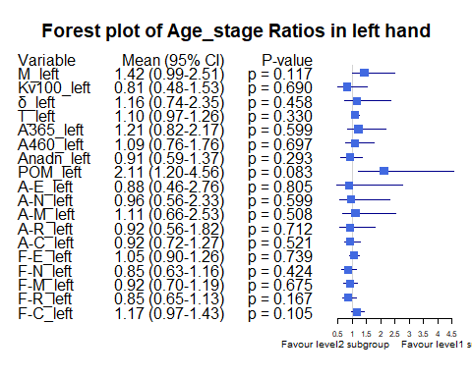

Bảng Age_stage ratio, level1 = “Age [30-40)”, level2= “Age [40-50)”

|  | Variable | Subgroup | Level1_Mean | Level2_Mean | Ratio | CI_Lower | CI_Upper | P_Value |
| --- | --- | --- | --- | --- | --- | --- | --- | --- |
| M_left | M_left | Age_stage | 25.3512576 | 24.0101282 | 1.0558568 | 0.8663448 | 1.3545782 | 1.0000000 |
| Kv100_left | Kv100_left | Age_stage | 21.0282576 | 11.3402564 | 1.8543018 | 1.4262177 | 2.3981251 | 0.0040611 |
| δ_left | δ_left | Age_stage | 4.7532222 | 2.7820513 | 1.7085315 | 1.2508558 | 2.5504052 | 0.0067689 |
| T_left | T_left | Age_stage | 32.2822828 | 31.1891026 | 1.0350501 | 0.9562146 | 1.1416225 | 0.8661278 |
| A365_left | A365_left | Age_stage | 101.3772727 | 80.0384615 | 1.2666070 | 0.9665538 | 1.8467411 | 0.2366468 |
| A460_left | A460_left | Age_stage | 73.5106061 | 77.1794872 | 0.9524630 | 0.7092340 | 1.3251981 | 0.8836011 |
| Anadn_left | Anadn_left | Age_stage | 0.9086111 | 1.9470513 | 0.4666601 | 0.2410926 | 1.1170906 | 0.0247976 |
| POM_left | POM_left | Age_stage | 10.6032626 | 5.3755128 | 1.9725118 | 1.2360827 | 3.2892600 | 0.0250855 |
| A-E_left | A-E_left | Age_stage | 1.8803737 | 0.9714103 | 1.9357153 | 1.3103440 | 3.0853095 | 0.0044793 |
| A-N_left | A-N_left | Age_stage | 1.7583232 | 1.1316667 | 1.5537466 | 1.0084070 | 2.6186782 | 0.0392494 |
| A-M_left | A-M_left | Age_stage | 1.4193939 | 0.8626923 | 1.6453073 | 1.1025126 | 2.6221307 | 0.0185526 |
| A-R_left | A-R_left | Age_stage | 0.7821667 | 0.5543590 | 1.4109389 | 1.0004191 | 2.0888645 | 0.1570192 |
| A-C_left | A-C_left | Age_stage | 0.9807980 | 0.7846154 | 1.2500366 | 0.9554390 | 1.7189202 | 0.1958968 |
| F-E_left | F-E_left | Age_stage | 0.0150308 | 0.0156667 | 0.9594133 | 0.8526317 | 1.0715079 | 0.5400278 |
| F-N_left | F-N_left | Age_stage | 0.0336025 | 0.0356282 | 0.9431439 | 0.7721586 | 1.1777334 | 0.4707260 |
| F-M_left | F-M_left | Age_stage | 0.0736955 | 0.0798590 | 0.9228199 | 0.7357275 | 1.1352785 | 0.2330594 |
| F-R_left | F-R_left | Age_stage | 0.3277545 | 0.4342564 | 0.7547489 | 0.6013140 | 0.9807947 | 0.0484207 |
| F-C_left | F-C_left | Age_stage | 1.1591914 | 1.1445385 | 1.0128025 | 0.9090965 | 1.1289753 | 0.4925891 |

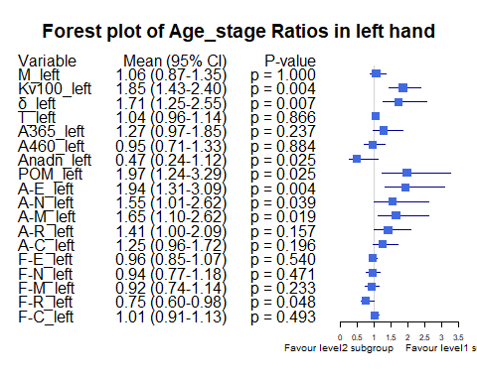

Bảng Age_stage ratio, level1 = “Age [40-50)”, level2= “Age >=50”

|  | Variable | Subgroup | Level1_Mean | Level2_Mean | Ratio | CI_Lower | CI_Upper | P_Value |
| --- | --- | --- | --- | --- | --- | --- | --- | --- |
| M_left | M_left | Age_stage | 24.0101282 | 17.8841667 | 1.3425355 | 0.9174771 | 2.5070479 | 0.1791243 |
| Kv100_left | Kv100_left | Age_stage | 11.3402564 | 26.0786111 | 0.4348489 | 0.2775767 | 0.8283467 | 0.0364883 |
| δ_left | δ_left | Age_stage | 2.7820513 | 4.0836111 | 0.6812723 | 0.4173356 | 1.4174174 | 0.6293843 |
| T_left | T_left | Age_stage | 31.1891026 | 29.4775000 | 1.0580647 | 0.9130920 | 1.2369371 | 0.7653693 |
| A365_left | A365_left | Age_stage | 80.0384615 | 83.7500000 | 0.9556831 | 0.5830238 | 1.7244153 | 0.9300493 |
| A460_left | A460_left | Age_stage | 77.1794872 | 67.2222222 | 1.1481246 | 0.7245880 | 1.8922189 | 0.4819372 |
| Anadn_left | Anadn_left | Age_stage | 1.9470513 | 1.0005556 | 1.9459702 | 0.8448902 | 4.0174236 | 0.8314168 |
| POM_left | POM_left | Age_stage | 5.3755128 | 5.0177778 | 1.0712935 | 0.5380209 | 2.2862659 | 0.9660917 |
| A-E_left | A-E_left | Age_stage | 0.9714103 | 2.1430556 | 0.4532828 | 0.2173711 | 1.4323867 | 0.6929541 |
| A-N_left | A-N_left | Age_stage | 1.1316667 | 1.8386111 | 0.6155008 | 0.3078355 | 1.6116219 | 0.6388029 |
| A-M_left | A-M_left | Age_stage | 0.8626923 | 1.2811111 | 0.6733938 | 0.3519138 | 1.7019909 | 0.5788737 |
| A-R_left | A-R_left | Age_stage | 0.5543590 | 0.8477778 | 0.6538966 | 0.3630610 | 1.3112035 | 0.2361962 |
| A-C_left | A-C_left | Age_stage | 0.7846154 | 1.0672222 | 0.7351940 | 0.5152388 | 1.0484918 | 0.1043795 |
| F-E_left | F-E_left | Age_stage | 0.0156667 | 0.0143611 | 1.0909091 | 0.9400710 | 1.2948104 | 0.2701890 |
| F-N_left | F-N_left | Age_stage | 0.0356282 | 0.0395000 | 0.9019799 | 0.6668128 | 1.2636968 | 0.5089936 |
| F-M_left | F-M_left | Age_stage | 0.0798590 | 0.0805000 | 0.9920369 | 0.7310658 | 1.3372817 | 0.8247722 |
| F-R_left | F-R_left | Age_stage | 0.4342564 | 0.3838333 | 1.1313671 | 0.8426439 | 1.5431005 | 0.4483050 |
| F-C_left | F-C_left | Age_stage | 1.1445385 | 0.9933333 | 1.1522199 | 0.9426093 | 1.4419441 | 0.1588750 |

