Phan tich Forest plot các ratio của trung bình 2 tay

Minh

2024-02-28

## Load bộ số liệu và các packages

## ── Attaching core tidyverse packages ──────────────────────── tidyverse 2.0.0 ──  
## ✔ dplyr 1.1.3 ✔ readr 2.1.4  
## ✔ forcats 1.0.0 ✔ stringr 1.5.0  
## ✔ ggplot2 3.4.3 ✔ tibble 3.2.1  
## ✔ lubridate 1.9.2 ✔ tidyr 1.3.0  
## ✔ purrr 1.0.2   
## ── Conflicts ────────────────────────────────────────── tidyverse_conflicts() ──  
## ✖ dplyr::filter() masks stats::filter()  
## ✖ dplyr::lag() masks stats::lag()  
## ℹ Use the conflicted package (<http://conflicted.r-lib.org/>) to force all conflicts to become errors  
##   
## Attaching package: 'rstatix'  
##   
##   
## The following object is masked from 'package:stats':  
##   
## filter  
##   
##   
## Loading required package: grid  
##   
## Loading required package: checkmate  
##   
## Loading required package: abind

## So sánh khác biệt về ratio của chỉ số Stress vs non stress theo các biến

Hàm để tạo bảng tổng hợp kết quả và p-value

Hàm sắp xếp các cột theo thứ tự

Hàm vẽ Forest plot

Bảng Stress index Ratio, level1 = “Yes”, level2 = “No”

|  | Variable | Subgroup | Level1_Mean | Level2_Mean | Ratio | CI_Lower | CI_Upper | P_Value |
| --- | --- | --- | --- | --- | --- | --- | --- | --- |
| M_mean | M_mean | Stress index | 26.5119643 | 21.0126988 | 1.2617115 | 1.0583687 | 1.472078 | 0.0177254 |
| Kv100_mean | Kv100_mean | Stress index | 21.4694444 | 21.0987047 | 1.0175717 | 0.7779231 | 1.314459 | 0.7100835 |
| δ_mean | δ_mean | Stress index | 4.9252579 | 3.6289561 | 1.3572107 | 1.1312616 | 1.667058 | 0.0031631 |
| T_mean | T_mean | Stress index | 33.1152976 | 30.6382661 | 1.0808476 | 1.0401896 | 1.125880 | 0.0280441 |
| A365_mean | A365_mean | Stress index | 92.5515873 | 85.3909357 | 1.0838573 | 0.8601446 | 1.316779 | 0.5355233 |
| A460_mean | A460_mean | Stress index | 55.2599206 | 60.7327485 | 0.9098867 | 0.7345305 | 1.083748 | 0.5317919 |
| Anadn_mean | Anadn_mean | Stress index | 0.9769246 | 1.0102076 | 0.9670533 | 0.5619222 | 1.613974 | 0.1477280 |
| POM_mean | POM_mean | Stress index | 11.8462103 | 7.6679971 | 1.5448898 | 1.1387130 | 2.049707 | 0.0050320 |
| A-E_mean | A-E_mean | Stress index | 1.6690476 | 1.4426404 | 1.1569395 | 0.9205912 | 1.429369 | 0.1134812 |
| A-N_mean | A-N_mean | Stress index | 1.6501984 | 1.4030380 | 1.1761609 | 0.9073426 | 1.476946 | 0.1990640 |
| A-M_mean | A-M_mean | Stress index | 1.3660913 | 1.1068275 | 1.2342405 | 0.9846187 | 1.566506 | 0.0943531 |
| A-R_mean | A-R_mean | Stress index | 0.8183929 | 0.6597339 | 1.2404893 | 1.0262018 | 1.493840 | 0.0576593 |
| A-C_mean | A-C_mean | Stress index | 1.0177778 | 0.8914532 | 1.1417063 | 0.9691401 | 1.350544 | 0.0714743 |
| F-E_mean | F-E_mean | Stress index | 0.0148710 | 0.0150453 | 0.9884157 | 0.9058850 | 1.079128 | 0.6157306 |
| F-N_mean | F-N_mean | Stress index | 0.0363194 | 0.0335980 | 1.0810017 | 0.9545686 | 1.218768 | 0.2322757 |
| F-M_mean | F-M_mean | Stress index | 0.0761091 | 0.0835038 | 0.9114451 | 0.8035341 | 1.030232 | 0.4389290 |
| F-R_mean | F-R_mean | Stress index | 0.3333472 | 0.3206640 | 1.0395529 | 0.8705501 | 1.234448 | 0.8207598 |
| F-C_mean | F-C_mean | Stress index | 1.1213274 | 1.1451889 | 0.9791637 | 0.9131134 | 1.051999 | 0.6158559 |

Forest plot cho Stress index ratio

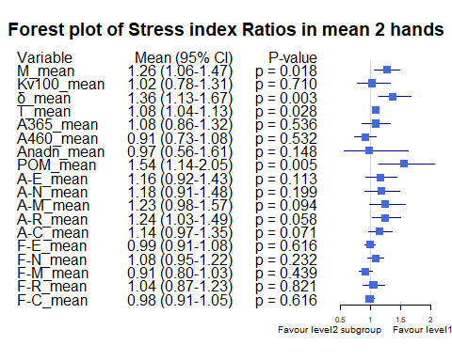

Bảng Gender Ratio, level1 = “male”, level2 = “female”

|  | Variable | Subgroup | Level1_Mean | Level2_Mean | Ratio | CI_Lower | CI_Upper | P_Value |
| --- | --- | --- | --- | --- | --- | --- | --- | --- |
| M_mean | M_mean | Gender | 23.4286778 | 21.2177146 | 1.1042036 | 0.9174647 | 1.329132 | 0.1705510 |
| Kv100_mean | Kv100_mean | Gender | 18.6726000 | 24.6429545 | 0.7577257 | 0.6033571 | 0.979935 | 0.0357702 |
| δ_mean | δ_mean | Gender | 3.7967889 | 4.2250126 | 0.8986456 | 0.7323106 | 1.115664 | 0.2632719 |
| T_mean | T_mean | Gender | 31.0624889 | 31.6360732 | 0.9818693 | 0.9349685 | 1.029261 | 0.8801301 |
| A365_mean | A365_mean | Gender | 86.8840741 | 87.9116162 | 0.9883116 | 0.8152695 | 1.207597 | 0.8121269 |
| A460_mean | A460_mean | Gender | 60.0837037 | 58.1351010 | 1.0335185 | 0.8652994 | 1.217301 | 0.8396841 |
| Anadn_mean | Anadn_mean | Gender | 0.9590407 | 1.0588005 | 0.9057804 | 0.5932570 | 1.517740 | 0.1305164 |
| POM_mean | POM_mean | Gender | 8.9979630 | 8.5132702 | 1.0569338 | 0.8021329 | 1.431953 | 0.6292548 |
| A-E_mean | A-E_mean | Gender | 1.5117148 | 1.4925253 | 1.0128571 | 0.8095886 | 1.245325 | 0.5012202 |
| A-N_mean | A-N_mean | Gender | 1.4748667 | 1.4623737 | 1.0085429 | 0.8009934 | 1.261871 | 0.6273444 |
| A-M_mean | A-M_mean | Gender | 1.1662963 | 1.1907197 | 0.9794885 | 0.7795980 | 1.227338 | 0.7385613 |
| A-R_mean | A-R_mean | Gender | 0.6840704 | 0.7275126 | 0.9402866 | 0.7783298 | 1.140610 | 0.8199758 |
| A-C_mean | A-C_mean | Gender | 0.9166741 | 0.9374495 | 0.9778384 | 0.8256126 | 1.166952 | 0.9838613 |
| F-E_mean | F-E_mean | Gender | 0.0150778 | 0.0148902 | 1.0126007 | 0.9424077 | 1.093948 | 0.6669287 |
| F-N_mean | F-N_mean | Gender | 0.0345296 | 0.0340593 | 1.0138078 | 0.9106391 | 1.124864 | 0.5238654 |
| F-M_mean | F-M_mean | Gender | 0.0811307 | 0.0820341 | 0.9889881 | 0.8698138 | 1.134307 | 0.7531540 |
| F-R_mean | F-R_mean | Gender | 0.3312411 | 0.3143119 | 1.0538613 | 0.9055343 | 1.223887 | 0.2654100 |
| F-C_mean | F-C_mean | Gender | 1.1428300 | 1.1332210 | 1.0084794 | 0.9427528 | 1.080920 | 0.9677019 |

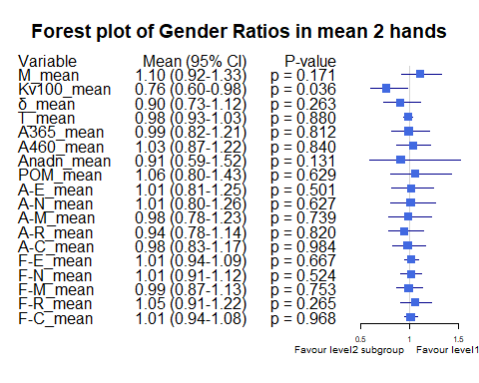

Bảng Smoking ratio, level1 = “Cigarettes, pipe tobacco…”, level2 = “Do not smoke”

|  | Variable | Subgroup | Level1_Mean | Level2_Mean | Ratio | CI_Lower | CI_Upper | P_Value |
| --- | --- | --- | --- | --- | --- | --- | --- | --- |
| M_mean | M_mean | Smoking | 21.1096667 | 22.7959336 | 0.9260277 | 0.6862594 | 1.1759816 | 0.8912557 |
| Kv100_mean | Kv100_mean | Smoking | 14.4326905 | 22.6785443 | 0.6364029 | 0.5141695 | 0.7922639 | 0.0168834 |
| δ_mean | δ_mean | Smoking | 2.9509881 | 4.2026107 | 0.7021797 | 0.4815188 | 0.9758188 | 0.0168834 |
| T_mean | T_mean | Smoking | 29.9534405 | 31.6008477 | 0.9478683 | 0.8604885 | 1.0355812 | 0.5025081 |
| A365_mean | A365_mean | Smoking | 85.8571429 | 87.6385417 | 0.9796733 | 0.7073665 | 1.2777541 | 0.8912529 |
| A460_mean | A460_mean | Smoking | 65.9904762 | 57.7868490 | 1.1419636 | 0.8308351 | 1.4766193 | 0.3829585 |
| Anadn_mean | Anadn_mean | Smoking | 1.4245952 | 0.9086393 | 1.5678336 | 0.7984442 | 2.6057947 | 0.0607923 |
| POM_mean | POM_mean | Smoking | 7.8422738 | 9.0008503 | 0.8712814 | 0.4524282 | 1.3674479 | 0.1502214 |
| A-E_mean | A-E_mean | Smoking | 1.0282619 | 1.6075755 | 0.6396352 | 0.3953924 | 0.9723492 | 0.0056602 |
| A-N_mean | A-N_mean | Smoking | 1.1155238 | 1.5470313 | 0.7210739 | 0.4402667 | 1.0668084 | 0.0215548 |
| A-M_mean | A-M_mean | Smoking | 0.8810714 | 1.2412826 | 0.7098073 | 0.4376306 | 1.0065155 | 0.0201167 |
| A-R_mean | A-R_mean | Smoking | 0.5788095 | 0.7294961 | 0.7934375 | 0.5462338 | 1.0692637 | 0.0833041 |
| A-C_mean | A-C_mean | Smoking | 0.7811071 | 0.9570417 | 0.8161684 | 0.6085396 | 1.0458408 | 0.2019428 |
| F-E_mean | F-E_mean | Smoking | 0.0156702 | 0.0148514 | 1.0551331 | 0.9772033 | 1.1439422 | 0.2850748 |
| F-N_mean | F-N_mean | Smoking | 0.0353881 | 0.0340993 | 1.0377939 | 0.8963761 | 1.1647883 | 0.4118863 |
| F-M_mean | F-M_mean | Smoking | 0.0912810 | 0.0793762 | 1.1499793 | 0.9789807 | 1.3605553 | 0.1871471 |
| F-R_mean | F-R_mean | Smoking | 0.3495262 | 0.3185121 | 1.0973717 | 0.9189400 | 1.2902338 | 0.2657248 |
| F-C_mean | F-C_mean | Smoking | 1.2020857 | 1.1249132 | 1.0686031 | 0.9906315 | 1.1559258 | 0.2514642 |

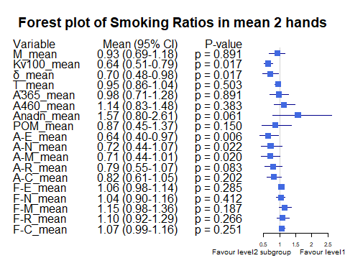

Bảng Smoking ratio, level1 = “Cigarettes, pipe tobacco…”, level2 = “Do not smoke”

|  | Variable | Subgroup | Level1_Mean | Level2_Mean | Ratio | CI_Lower | CI_Upper | P_Value |
| --- | --- | --- | --- | --- | --- | --- | --- | --- |
| M_mean | M_mean | Smoking | 21.1096667 | 22.7959336 | 0.9260277 | 0.6768928 | 1.1750150 | 0.8912557 |
| Kv100_mean | Kv100_mean | Smoking | 14.4326905 | 22.6785443 | 0.6364029 | 0.5043923 | 0.7926188 | 0.0168834 |
| δ_mean | δ_mean | Smoking | 2.9509881 | 4.2026107 | 0.7021797 | 0.4700515 | 0.9912269 | 0.0168834 |
| T_mean | T_mean | Smoking | 29.9534405 | 31.6008477 | 0.9478683 | 0.8565544 | 1.0303030 | 0.5025081 |
| A365_mean | A365_mean | Smoking | 85.8571429 | 87.6385417 | 0.9796733 | 0.7267986 | 1.2526155 | 0.8912529 |
| A460_mean | A460_mean | Smoking | 65.9904762 | 57.7868490 | 1.1419636 | 0.7977895 | 1.4737970 | 0.3829585 |
| Anadn_mean | Anadn_mean | Smoking | 1.4245952 | 0.9086393 | 1.5678336 | 0.8015571 | 2.6663286 | 0.0607923 |
| POM_mean | POM_mean | Smoking | 7.8422738 | 9.0008503 | 0.8712814 | 0.4462286 | 1.3928785 | 0.1502214 |
| A-E_mean | A-E_mean | Smoking | 1.0282619 | 1.6075755 | 0.6396352 | 0.3931174 | 0.9325279 | 0.0056602 |
| A-N_mean | A-N_mean | Smoking | 1.1155238 | 1.5470313 | 0.7210739 | 0.4365365 | 1.0651305 | 0.0215548 |
| A-M_mean | A-M_mean | Smoking | 0.8810714 | 1.2412826 | 0.7098073 | 0.4530257 | 1.0153894 | 0.0201167 |
| A-R_mean | A-R_mean | Smoking | 0.5788095 | 0.7294961 | 0.7934375 | 0.5576289 | 1.0713355 | 0.0833041 |
| A-C_mean | A-C_mean | Smoking | 0.7811071 | 0.9570417 | 0.8161684 | 0.6138096 | 1.0722032 | 0.2019428 |
| F-E_mean | F-E_mean | Smoking | 0.0156702 | 0.0148514 | 1.0551331 | 0.9735421 | 1.1529792 | 0.2850748 |
| F-N_mean | F-N_mean | Smoking | 0.0353881 | 0.0340993 | 1.0377939 | 0.9030324 | 1.1713213 | 0.4118863 |
| F-M_mean | F-M_mean | Smoking | 0.0912810 | 0.0793762 | 1.1499793 | 0.9649586 | 1.3633393 | 0.1871471 |
| F-R_mean | F-R_mean | Smoking | 0.3495262 | 0.3185121 | 1.0973717 | 0.9135717 | 1.2835606 | 0.2657248 |
| F-C_mean | F-C_mean | Smoking | 1.2020857 | 1.1249132 | 1.0686031 | 0.9872014 | 1.1696449 | 0.2514642 |

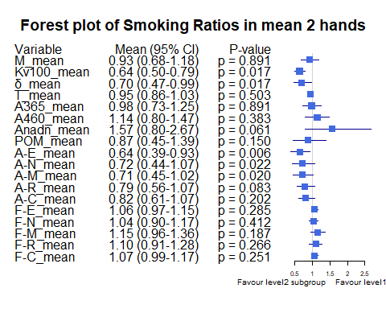

Bảng Hypertension ratio, level1 = “Yes”, level2 = “No”

|  | Variable | Subgroup | Level1_Mean | Level2_Mean | Ratio | CI_Lower | CI_Upper | P_Value |
| --- | --- | --- | --- | --- | --- | --- | --- | --- |
| M_mean | M_mean | Hypertension | 19.6236190 | 23.5505102 | 0.8332566 | 0.6418947 | 1.0367078 | 0.1893901 |
| Kv100_mean | Kv100_mean | Hypertension | 17.1374881 | 22.6946886 | 0.7551321 | 0.5698704 | 0.9956156 | 0.0513146 |
| δ_mean | δ_mean | Hypertension | 2.6955952 | 4.4504108 | 0.6056958 | 0.4828063 | 0.7509711 | 0.0000733 |
| T_mean | T_mean | Hypertension | 30.1469881 | 31.7318538 | 0.9500544 | 0.8847444 | 1.0150356 | 0.3919216 |
| A365_mean | A365_mean | Hypertension | 90.9857143 | 85.9678363 | 1.0583692 | 0.8526800 | 1.2750829 | 0.5244539 |
| A460_mean | A460_mean | Hypertension | 73.2928571 | 54.0890351 | 1.3550409 | 1.1221534 | 1.5930775 | 0.0014877 |
| Anadn_mean | Anadn_mean | Hypertension | 1.2385714 | 0.9138114 | 1.3553906 | 0.8065100 | 2.1742103 | 0.0392489 |
| POM_mean | POM_mean | Hypertension | 5.6123929 | 9.9646667 | 0.5632294 | 0.4051221 | 0.7495707 | 0.0026319 |
| A-E_mean | A-E_mean | Hypertension | 1.0953690 | 1.6539956 | 0.6622563 | 0.4825272 | 0.8745908 | 0.0048586 |
| A-N_mean | A-N_mean | Hypertension | 1.0941667 | 1.6078918 | 0.6804977 | 0.4906722 | 0.8965941 | 0.0045282 |
| A-M_mean | A-M_mean | Hypertension | 0.8270238 | 1.3054313 | 0.6335253 | 0.4705279 | 0.8210009 | 0.0017716 |
| A-R_mean | A-R_mean | Hypertension | 0.5481071 | 0.7593129 | 0.7218462 | 0.5628777 | 0.9005936 | 0.0033995 |
| A-C_mean | A-C_mean | Hypertension | 0.7406667 | 0.9935468 | 0.7454774 | 0.5885570 | 0.9225098 | 0.0012735 |
| F-E_mean | F-E_mean | Hypertension | 0.0148131 | 0.0150667 | 0.9831700 | 0.9013975 | 1.0746013 | 0.7736441 |
| F-N_mean | F-N_mean | Hypertension | 0.0336917 | 0.0345661 | 0.9747031 | 0.8558215 | 1.1067503 | 0.7141834 |
| F-M_mean | F-M_mean | Hypertension | 0.0871405 | 0.0794396 | 1.0969397 | 0.9169463 | 1.2661455 | 0.5049896 |
| F-R_mean | F-R_mean | Hypertension | 0.3734060 | 0.3059056 | 1.2206576 | 1.0284786 | 1.4074188 | 0.0135268 |
| F-C_mean | F-C_mean | Hypertension | 1.1755964 | 1.1251950 | 1.0447935 | 0.9600257 | 1.1292716 | 0.1366759 |

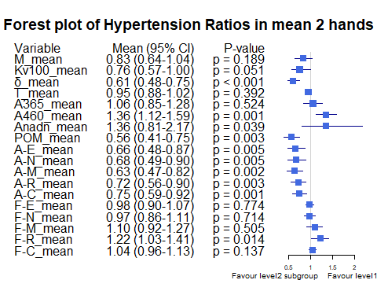

Bảng Obesity ratio, level1 = “Yes”, level2 = “No”

|  | Variable | Subgroup | Level1_Mean | Level2_Mean | Ratio | CI_Lower | CI_Upper | P_Value |
| --- | --- | --- | --- | --- | --- | --- | --- | --- |
| M_mean | M_mean | Obesity | 26.3489792 | 22.0526179 | 1.1948232 | 1.0405978 | 1.3527683 | 0.2734105 |
| Kv100_mean | Kv100_mean | Obesity | 17.4699688 | 21.6246393 | 0.8078733 | 0.5886284 | 1.0468472 | 0.4942983 |
| δ_mean | δ_mean | Obesity | 4.2083333 | 3.9516321 | 1.0649608 | 0.8239492 | 1.3265841 | 0.5924687 |
| T_mean | T_mean | Obesity | 33.5900104 | 31.0440333 | 1.0820118 | 1.0349669 | 1.1326502 | 0.0713221 |
| A365_mean | A365_mean | Obesity | 99.2645833 | 85.9535714 | 1.1548628 | 0.9887562 | 1.3471957 | 0.5314012 |
| A460_mean | A460_mean | Obesity | 63.7479167 | 58.7463095 | 1.0851391 | 0.8728651 | 1.3001619 | 0.5259844 |
| Anadn_mean | Anadn_mean | Obesity | 0.6855208 | 1.0373298 | 0.6608514 | 0.4803313 | 0.8872994 | 0.4942819 |
| POM_mean | POM_mean | Obesity | 10.5535729 | 8.5916810 | 1.2283479 | 0.9493369 | 1.6159296 | 0.1495592 |
| A-E_mean | A-E_mean | Obesity | 1.8947188 | 1.4588964 | 1.2987342 | 0.9090659 | 1.7604105 | 0.1119867 |
| A-N_mean | A-N_mean | Obesity | 1.8104167 | 1.4306286 | 1.2654694 | 0.9216952 | 1.6621143 | 0.1989163 |
| A-M_mean | A-M_mean | Obesity | 1.2695833 | 1.1660060 | 1.0888309 | 0.8029179 | 1.3945836 | 0.5532393 |
| A-R_mean | A-R_mean | Obesity | 0.7794063 | 0.6936548 | 1.1236227 | 0.8389763 | 1.5027378 | 0.6565292 |
| A-C_mean | A-C_mean | Obesity | 0.9855000 | 0.9186024 | 1.0728254 | 0.8423810 | 1.3101041 | 0.4340202 |
| F-E_mean | F-E_mean | Obesity | 0.0153740 | 0.0149555 | 1.0279819 | 0.9243635 | 1.1315579 | 0.6681135 |
| F-N_mean | F-N_mean | Obesity | 0.0332844 | 0.0344502 | 0.9661581 | 0.8193477 | 1.1464668 | 0.5258797 |
| F-M_mean | F-M_mean | Obesity | 0.0742125 | 0.0823473 | 0.9012139 | 0.7885743 | 1.0321279 | 0.7348688 |
| F-R_mean | F-R_mean | Obesity | 0.3571073 | 0.3203040 | 1.1149010 | 0.8901248 | 1.4010802 | 0.4029313 |
| F-C_mean | F-C_mean | Obesity | 1.1845344 | 1.1335338 | 1.0449925 | 0.9224942 | 1.1608885 | 0.3913493 |

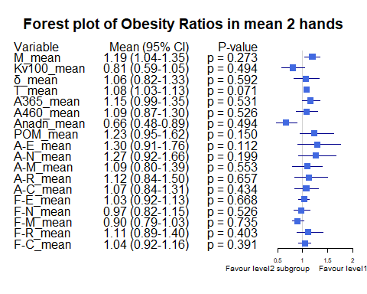

Bảng Race ratio, level1 = “White”, level2 = “Asian or Asian British”

|  | Variable | Subgroup | Level1_Mean | Level2_Mean | Ratio | CI_Lower | CI_Upper | P_Value |
| --- | --- | --- | --- | --- | --- | --- | --- | --- |
| M_mean | M_mean | Race | 26.9520952 | 21.1070615 | 1.2769231 | 1.0928651 | 1.4766173 | 0.0502243 |
| Kv100_mean | Kv100_mean | Race | 21.5091190 | 21.3712596 | 1.0064507 | 0.7476432 | 1.3785797 | 0.8119168 |
| δ_mean | δ_mean | Race | 5.2153571 | 3.6522281 | 1.4279933 | 1.1759600 | 1.7330308 | 0.0019788 |
| T_mean | T_mean | Race | 32.8789048 | 30.7926680 | 1.0677511 | 1.0230618 | 1.1150284 | 0.0737673 |
| A365_mean | A365_mean | Race | 107.2821429 | 86.1051913 | 1.2459428 | 1.0867718 | 1.4646129 | 0.0737550 |
| A460_mean | A460_mean | Race | 57.6476190 | 61.8550546 | 0.9319791 | 0.8017883 | 1.0689114 | 0.4965357 |
| Anadn_mean | Anadn_mean | Race | 0.5639881 | 1.0555970 | 0.5342835 | 0.4121966 | 0.7098159 | 0.0009755 |
| POM_mean | POM_mean | Race | 13.9496905 | 7.6299276 | 1.8282861 | 1.3968563 | 2.4117547 | 0.0002755 |
| A-E_mean | A-E_mean | Race | 2.0671905 | 1.3764727 | 1.5018028 | 1.1614066 | 1.9232445 | 0.0043903 |
| A-N_mean | A-N_mean | Race | 2.0586905 | 1.3097650 | 1.5718014 | 1.2688877 | 1.9271458 | 0.0016448 |
| A-M_mean | A-M_mean | Race | 1.5689881 | 1.0735451 | 1.4615018 | 1.1867787 | 1.7818737 | 0.0025965 |
| A-R_mean | A-R_mean | Race | 0.8769524 | 0.6581762 | 1.3323975 | 1.0872380 | 1.6341457 | 0.0183081 |
| A-C_mean | A-C_mean | Race | 1.1406429 | 0.8606093 | 1.3253899 | 1.0995386 | 1.5762127 | 0.0095872 |
| F-E_mean | F-E_mean | Race | 0.0161214 | 0.0147898 | 1.0900403 | 1.0110671 | 1.1732541 | 0.0701785 |
| F-N_mean | F-N_mean | Race | 0.0311000 | 0.0348999 | 0.8911210 | 0.7946673 | 0.9921097 | 0.1803419 |
| F-M_mean | F-M_mean | Race | 0.0761988 | 0.0836430 | 0.9110001 | 0.7998232 | 1.0630276 | 0.5485620 |
| F-R_mean | F-R_mean | Race | 0.2951833 | 0.3293209 | 0.8963395 | 0.7514947 | 1.0618516 | 0.1918141 |
| F-C_mean | F-C_mean | Race | 1.0804810 | 1.1534821 | 0.9367124 | 0.8584689 | 1.0233422 | 0.0927960 |

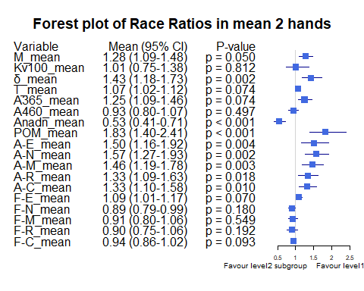

Bảng Race ratio, level1 = “Black, African, Caribbean or Black Bristish”, level2 = “Asian or Asian British”

|  | Variable | Subgroup | Level1_Mean | Level2_Mean | Ratio | CI_Lower | CI_Upper | P_Value |
| --- | --- | --- | --- | --- | --- | --- | --- | --- |
| M_mean | M_mean | Race | 29.8716667 | 21.1070615 | 1.4152452 | 1.1244187 | 1.7274567 | 0.1196230 |
| Kv100_mean | Kv100_mean | Race | 16.2366667 | 21.3712596 | 0.7597431 | 0.4167125 | 1.0418808 | 0.5675139 |
| δ_mean | δ_mean | Race | 4.8266667 | 3.6522281 | 1.3215677 | 0.7843807 | 1.9696786 | 0.3248092 |
| T_mean | T_mean | Race | 34.3816667 | 30.7926680 | 1.1165537 | 1.0690933 | 1.1680338 | 0.0654461 |
| A365_mean | A365_mean | Race | 18.8333333 | 86.1051913 | 0.2187247 | 0.0344477 | 0.3745605 | 0.0157774 |
| A460_mean | A460_mean | Race | 14.0000000 | 61.8550546 | 0.2263356 | 0.1835049 | 0.2693855 | 0.0057143 |
| Anadn_mean | Anadn_mean | Race | 1.9366667 | 1.0555970 | 1.8346648 | 0.7745603 | 3.6172315 | 0.0420663 |
| POM_mean | POM_mean | Race | 8.3750000 | 7.6299276 | 1.0976513 | 0.2591377 | 2.1220169 | 0.9240876 |
| A-E_mean | A-E_mean | Race | 1.4583333 | 1.3764727 | 1.0594713 | 0.5431519 | 1.5142583 | 0.6113142 |
| A-N_mean | A-N_mean | Race | 1.9700000 | 1.3097650 | 1.5040866 | 0.6155073 | 2.3396951 | 0.2662794 |
| A-M_mean | A-M_mean | Race | 1.4416667 | 1.0735451 | 1.3429028 | 0.6840866 | 1.9174468 | 0.3406493 |
| A-R_mean | A-R_mean | Race | 0.7883333 | 0.6581762 | 1.1977542 | 0.9863799 | 1.4153119 | 0.3406106 |
| A-C_mean | A-C_mean | Race | 1.2400000 | 0.8606093 | 1.4408397 | 1.0310867 | 1.9152722 | 0.1018773 |
| F-E_mean | F-E_mean | Race | 0.0140000 | 0.0147898 | 0.9466013 | 0.7800448 | 1.0900533 | 0.6676734 |
| F-N_mean | F-N_mean | Race | 0.0378333 | 0.0348999 | 1.0840539 | 0.9205221 | 1.2332347 | 0.4648688 |
| F-M_mean | F-M_mean | Race | 0.0630000 | 0.0836430 | 0.7532008 | 0.6936188 | 0.8198014 | 0.0715067 |
| F-R_mean | F-R_mean | Race | 0.3523333 | 0.3293209 | 1.0698784 | 0.6316592 | 1.4059872 | 0.8857982 |
| F-C_mean | F-C_mean | Race | 1.1115000 | 1.1534821 | 0.9636040 | 0.8872546 | 1.0425497 | 0.5778788 |

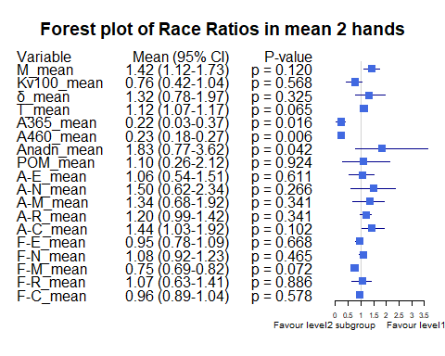

Bảng BMI ratio, level1 = “BMI <25”, level2 = “BMI [25-30)”

|  | Variable | Subgroup | Level1_Mean | Level2_Mean | Ratio | CI_Lower | CI_Upper | P_Value |
| --- | --- | --- | --- | --- | --- | --- | --- | --- |
| M_mean | M_mean | BMI_25_30 | 19.3407636 | 26.3714969 | 0.7333965 | 0.6042254 | 0.8877257 | 0.0014458 |
| Kv100_mean | Kv100_mean | BMI_25_30 | 24.0308760 | 17.7924846 | 1.3506195 | 1.0383910 | 1.7920114 | 0.0136159 |
| δ_mean | δ_mean | BMI_25_30 | 3.9597984 | 3.9386265 | 1.0053755 | 0.8190763 | 1.2543914 | 0.8951398 |
| T_mean | T_mean | BMI_25_30 | 30.2635233 | 32.2870679 | 0.9373265 | 0.8887375 | 0.9917642 | 0.0114094 |
| A365_mean | A365_mean | BMI_25_30 | 85.6666667 | 86.4104938 | 0.9913919 | 0.8057949 | 1.2210320 | 0.6994131 |
| A460_mean | A460_mean | BMI_25_30 | 59.0782946 | 58.2175926 | 1.0147842 | 0.8540529 | 1.2093424 | 0.9087310 |
| Anadn_mean | Anadn_mean | BMI_25_30 | 1.0973101 | 0.9418056 | 1.1651132 | 0.7284739 | 1.8018965 | 0.8611143 |
| POM_mean | POM_mean | BMI_25_30 | 7.4457597 | 10.4166667 | 0.7147929 | 0.5278532 | 0.9781442 | 0.0408807 |
| A-E_mean | A-E_mean | BMI_25_30 | 1.4580000 | 1.4603241 | 0.9984085 | 0.7613272 | 1.3036175 | 0.9663156 |
| A-N_mean | A-N_mean | BMI_25_30 | 1.3953062 | 1.4868827 | 0.9384104 | 0.7347634 | 1.2249176 | 0.7767616 |
| A-M_mean | A-M_mean | BMI_25_30 | 1.1317054 | 1.2206327 | 0.9271466 | 0.7155987 | 1.1828377 | 0.6994231 |
| A-R_mean | A-R_mean | BMI_25_30 | 0.6471512 | 0.7677160 | 0.8429564 | 0.6995811 | 1.0143514 | 0.1210187 |
| A-C_mean | A-C_mean | BMI_25_30 | 0.8748760 | 0.9882407 | 0.8852863 | 0.7375858 | 1.0771575 | 0.3283968 |
| F-E_mean | F-E_mean | BMI_25_30 | 0.0148849 | 0.0150679 | 0.9878538 | 0.8989001 | 1.0787654 | 0.8609215 |
| F-N_mean | F-N_mean | BMI_25_30 | 0.0338318 | 0.0354352 | 0.9547511 | 0.8531069 | 1.0858297 | 0.3402734 |
| F-M_mean | F-M_mean | BMI_25_30 | 0.0841380 | 0.0794954 | 1.0584011 | 0.9192316 | 1.2130504 | 0.3933794 |
| F-R_mean | F-R_mean | BMI_25_30 | 0.3081384 | 0.3396790 | 0.9071457 | 0.7835457 | 1.0523545 | 0.1244004 |
| F-C_mean | F-C_mean | BMI_25_30 | 1.1419368 | 1.1201512 | 1.0194488 | 0.9550126 | 1.1023406 | 0.9374227 |

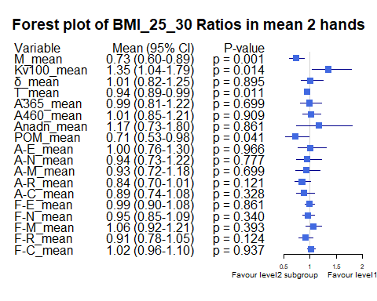

Bảng BMI ratio, level1 = “BMI >=30”, level2 = “BMI [25-30)”

|  | Variable | Subgroup | Level1_Mean | Level2_Mean | Ratio | CI_Lower | CI_Upper | P_Value |
| --- | --- | --- | --- | --- | --- | --- | --- | --- |
| M_mean | M_mean | BMI_25_30 | 26.3489792 | 26.3714969 | 0.9991461 | 0.8699610 | 1.158428 | 0.6299203 |
| Kv100_mean | Kv100_mean | BMI_25_30 | 17.4699688 | 17.7924846 | 0.9818735 | 0.6911787 | 1.395228 | 0.6027029 |
| δ_mean | δ_mean | BMI_25_30 | 4.2083333 | 3.9386265 | 1.0684774 | 0.8136782 | 1.373005 | 0.4993064 |
| T_mean | T_mean | BMI_25_30 | 33.5900104 | 32.2870679 | 1.0403549 | 0.9876848 | 1.100995 | 0.4057995 |
| A365_mean | A365_mean | BMI_25_30 | 99.2645833 | 86.4104938 | 1.1487561 | 0.9609416 | 1.383682 | 0.3457110 |
| A460_mean | A460_mean | BMI_25_30 | 63.7479167 | 58.2175926 | 1.0949940 | 0.8817118 | 1.317253 | 0.4917291 |
| Anadn_mean | Anadn_mean | BMI_25_30 | 0.6855208 | 0.9418056 | 0.7278794 | 0.4636751 | 1.057315 | 0.6299203 |
| POM_mean | POM_mean | BMI_25_30 | 10.5535729 | 10.4166667 | 1.0131430 | 0.7536352 | 1.373544 | 0.6576328 |
| A-E_mean | A-E_mean | BMI_25_30 | 1.8947188 | 1.4603241 | 1.2974646 | 0.8995513 | 1.830755 | 0.1789175 |
| A-N_mean | A-N_mean | BMI_25_30 | 1.8104167 | 1.4868827 | 1.2175921 | 0.8451405 | 1.689777 | 0.3874219 |
| A-M_mean | A-M_mean | BMI_25_30 | 1.2695833 | 1.2206327 | 1.0401027 | 0.7406686 | 1.378012 | 0.8136509 |
| A-R_mean | A-R_mean | BMI_25_30 | 0.7794063 | 0.7677160 | 1.0152272 | 0.7543493 | 1.415422 | 0.9217443 |
| A-C_mean | A-C_mean | BMI_25_30 | 0.9855000 | 0.9882407 | 0.9972266 | 0.7827654 | 1.263464 | 0.8596741 |
| F-E_mean | F-E_mean | BMI_25_30 | 0.0153740 | 0.0150679 | 1.0203119 | 0.9162915 | 1.140364 | 0.9216841 |
| F-N_mean | F-N_mean | BMI_25_30 | 0.0332844 | 0.0354352 | 0.9393030 | 0.7911914 | 1.137224 | 0.4204746 |
| F-M_mean | F-M_mean | BMI_25_30 | 0.0742125 | 0.0794954 | 0.9335449 | 0.8027642 | 1.097139 | 0.9371832 |
| F-R_mean | F-R_mean | BMI_25_30 | 0.3571073 | 0.3396790 | 1.0513081 | 0.8397107 | 1.337487 | 0.7679781 |
| F-C_mean | F-C_mean | BMI_25_30 | 1.1845344 | 1.1201512 | 1.0574772 | 0.9305447 | 1.174884 | 0.3159290 |

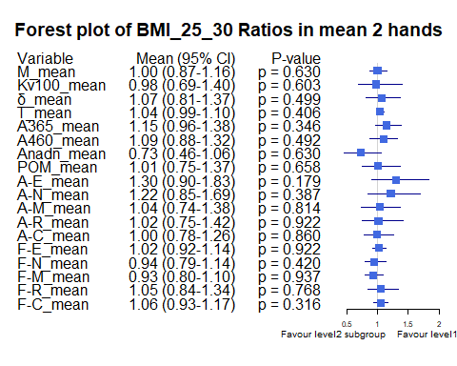

Bảng Age_stage ratio, level1 = “Age <30”, level2= “Age [30-40)”

|  | Variable | Subgroup | Level1_Mean | Level2_Mean | Ratio | CI_Lower | CI_Upper | P_Value |
| --- | --- | --- | --- | --- | --- | --- | --- | --- |
| M_mean | M_mean | Age_stage | 19.4150321 | 25.2926944 | 0.7676142 | 0.5875821 | 0.9465835 | 0.0778227 |
| Kv100_mean | Kv100_mean | Age_stage | 25.5942949 | 19.7702071 | 1.2945891 | 0.9948774 | 1.6585862 | 0.0549122 |
| δ_mean | δ_mean | Age_stage | 3.8714744 | 4.4582955 | 0.8683755 | 0.6955885 | 1.0693542 | 0.1730923 |
| T_mean | T_mean | Age_stage | 30.5252885 | 32.2174268 | 0.9474775 | 0.8939247 | 0.9972623 | 0.0702111 |
| A365_mean | A365_mean | Age_stage | 81.0320513 | 95.7939394 | 0.8458996 | 0.6553511 | 1.0317266 | 0.3438253 |
| A460_mean | A460_mean | Age_stage | 51.7467949 | 62.8012626 | 0.8239770 | 0.6714898 | 0.9880306 | 0.0930380 |
| Anadn_mean | Anadn_mean | Age_stage | 1.0597436 | 0.7796086 | 1.3593278 | 0.8596741 | 2.0686267 | 0.6359821 |
| POM_mean | POM_mean | Age_stage | 7.6075962 | 10.8500581 | 0.7011572 | 0.5094723 | 0.9475438 | 0.0276857 |
| A-E_mean | A-E_mean | Age_stage | 1.3982372 | 1.6922424 | 0.8262629 | 0.6511440 | 1.0552136 | 0.1106028 |
| A-N_mean | A-N_mean | Age_stage | 1.3865064 | 1.5968182 | 0.8682932 | 0.6755765 | 1.1080526 | 0.4053471 |
| A-M_mean | A-M_mean | Age_stage | 1.1463462 | 1.2777399 | 0.8971671 | 0.7117287 | 1.1689647 | 0.4452295 |
| A-R_mean | A-R_mean | Age_stage | 0.6820192 | 0.7322045 | 0.9314600 | 0.7731698 | 1.1410131 | 0.8069987 |
| A-C_mean | A-C_mean | Age_stage | 0.9086859 | 0.9473687 | 0.9591682 | 0.7761363 | 1.1749625 | 0.2490106 |
| F-E_mean | F-E_mean | Age_stage | 0.0148526 | 0.0149265 | 0.9950457 | 0.9140665 | 1.0844463 | 0.8784296 |
| F-N_mean | F-N_mean | Age_stage | 0.0374455 | 0.0325614 | 1.1499983 | 1.0187315 | 1.2989724 | 0.0385173 |
| F-M_mean | F-M_mean | Age_stage | 0.0849519 | 0.0780376 | 1.0886021 | 0.9389489 | 1.2669601 | 0.3779338 |
| F-R_mean | F-R_mean | Age_stage | 0.2850160 | 0.3289452 | 0.8664544 | 0.7315229 | 1.0429083 | 0.0581977 |
| F-C_mean | F-C_mean | Age_stage | 1.1218942 | 1.1690412 | 0.9596704 | 0.8903414 | 1.0323395 | 0.2743406 |

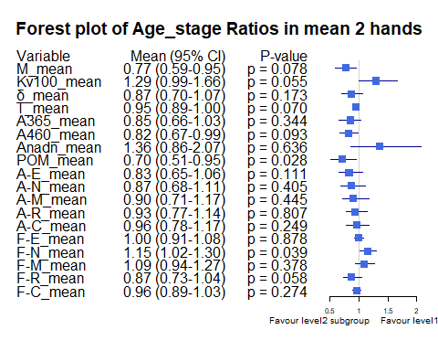

Bảng Age_stage ratio, level1 = “Age <30”, level2= “Age [40-50)”

|  | Variable | Subgroup | Level1_Mean | Level2_Mean | Ratio | CI_Lower | CI_Upper | P_Value |
| --- | --- | --- | --- | --- | --- | --- | --- | --- |
| M_mean | M_mean | Age_stage | 19.4150321 | 23.4781026 | 0.8269421 | 0.6116924 | 1.1236003 | 0.2162958 |
| Kv100_mean | Kv100_mean | Age_stage | 25.5942949 | 12.6213590 | 2.0278557 | 1.5640322 | 2.6035286 | 0.0002978 |
| δ_mean | δ_mean | Age_stage | 3.8714744 | 2.8460641 | 1.3602906 | 0.9826602 | 1.9593978 | 0.0760885 |
| T_mean | T_mean | Age_stage | 30.5252885 | 31.3444744 | 0.9738651 | 0.8879497 | 1.0761905 | 0.2678025 |
| A365_mean | A365_mean | Age_stage | 81.0320513 | 79.5384615 | 1.0187782 | 0.7354535 | 1.5101624 | 0.9524843 |
| A460_mean | A460_mean | Age_stage | 51.7467949 | 65.9512821 | 0.7846215 | 0.5854950 | 1.0692382 | 0.1177408 |
| Anadn_mean | Anadn_mean | Age_stage | 1.0597436 | 1.5545641 | 0.6816982 | 0.3419662 | 1.5737802 | 0.0923086 |
| POM_mean | POM_mean | Age_stage | 7.6075962 | 6.4109103 | 1.1866640 | 0.7691136 | 1.9003452 | 0.6066367 |
| A-E_mean | A-E_mean | Age_stage | 1.3982372 | 1.0862051 | 1.2872681 | 0.9021941 | 1.9587813 | 0.2084201 |
| A-N_mean | A-N_mean | Age_stage | 1.3865064 | 1.2163333 | 1.1399066 | 0.7831928 | 1.7537819 | 0.4705009 |
| A-M_mean | A-M_mean | Age_stage | 1.1463462 | 0.9415385 | 1.2175245 | 0.8496300 | 1.9062394 | 0.2944442 |
| A-R_mean | A-R_mean | Age_stage | 0.6820192 | 0.6160256 | 1.1071280 | 0.8373812 | 1.5765816 | 0.4125766 |
| A-C_mean | A-C_mean | Age_stage | 0.9086859 | 0.8335000 | 1.0902050 | 0.7878990 | 1.6072158 | 0.7885787 |
| F-E_mean | F-E_mean | Age_stage | 0.0148526 | 0.0151449 | 0.9806992 | 0.8665259 | 1.1102500 | 0.7655324 |
| F-N_mean | F-N_mean | Age_stage | 0.0374455 | 0.0315333 | 1.1874898 | 1.0242813 | 1.3892062 | 0.0382239 |
| F-M_mean | F-M_mean | Age_stage | 0.0849519 | 0.0810718 | 1.0478604 | 0.8636844 | 1.2389822 | 0.8690399 |
| F-R_mean | F-R_mean | Age_stage | 0.2850160 | 0.3626821 | 0.7858564 | 0.6359418 | 0.9808159 | 0.0456793 |
| F-C_mean | F-C_mean | Age_stage | 1.1218942 | 1.1472462 | 0.9779019 | 0.8838866 | 1.0929907 | 0.7093546 |

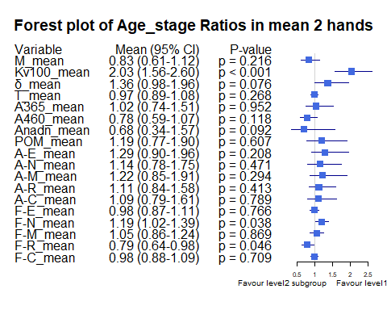

Bảng Age_stage ratio, level1 = “Age <30”, level2= “Age >=50”

|  | Variable | Subgroup | Level1_Mean | Level2_Mean | Ratio | CI_Lower | CI_Upper | P_Value |
| --- | --- | --- | --- | --- | --- | --- | --- | --- |
| M_mean | M_mean | Age_stage | 19.4150321 | 18.3016667 | 1.0608341 | 0.7072491 | 1.8606627 | 0.9807390 |
| Kv100_mean | Kv100_mean | Age_stage | 25.5942949 | 28.5897222 | 0.8952271 | 0.5720183 | 1.5691378 | 0.7241534 |
| δ_mean | δ_mean | Age_stage | 3.8714744 | 4.2500000 | 0.9109351 | 0.6118143 | 1.5925624 | 0.8323953 |
| T_mean | T_mean | Age_stage | 30.5252885 | 29.5819444 | 1.0318892 | 0.9026582 | 1.1911842 | 0.6546560 |
| A365_mean | A365_mean | Age_stage | 81.0320513 | 84.8055556 | 0.9555040 | 0.6814842 | 1.3861722 | 0.9437890 |
| A460_mean | A460_mean | Age_stage | 51.7467949 | 57.8333333 | 0.8947573 | 0.6273498 | 1.3961806 | 0.7905541 |
| Anadn_mean | Anadn_mean | Age_stage | 1.0597436 | 0.7679167 | 1.3800242 | 0.8810280 | 2.0065241 | 0.6121610 |
| POM_mean | POM_mean | Age_stage | 7.6075962 | 7.7758333 | 0.9783641 | 0.5669469 | 1.9526181 | 0.8692882 |
| A-E_mean | A-E_mean | Age_stage | 1.3982372 | 1.8269444 | 0.7653419 | 0.4755113 | 1.6794315 | 0.7597551 |
| A-N_mean | A-N_mean | Age_stage | 1.3865064 | 1.6784722 | 0.8260526 | 0.5001854 | 1.6509504 | 0.6890791 |
| A-M_mean | A-M_mean | Age_stage | 1.1463462 | 1.2611111 | 0.9089970 | 0.6209402 | 1.6251766 | 0.8692882 |
| A-R_mean | A-R_mean | Age_stage | 0.6820192 | 0.8145833 | 0.8372615 | 0.6156599 | 1.2613945 | 0.3813739 |
| A-C_mean | A-C_mean | Age_stage | 0.9086859 | 1.0769444 | 0.8437630 | 0.6168036 | 1.1523343 | 0.2565033 |
| F-E_mean | F-E_mean | Age_stage | 0.0148526 | 0.0157083 | 0.9455213 | 0.8310335 | 1.0824177 | 0.3840353 |
| F-N_mean | F-N_mean | Age_stage | 0.0374455 | 0.0366250 | 1.0224031 | 0.8653809 | 1.2522388 | 0.9614645 |
| F-M_mean | F-M_mean | Age_stage | 0.0849519 | 0.0866806 | 0.9800574 | 0.7635401 | 1.2799853 | 0.9419530 |
| F-R_mean | F-R_mean | Age_stage | 0.2850160 | 0.3829444 | 0.7442751 | 0.6225585 | 0.9023441 | 0.0236520 |
| F-C_mean | F-C_mean | Age_stage | 1.1218942 | 1.0269722 | 1.0924290 | 0.9328677 | 1.2838144 | 0.3843847 |

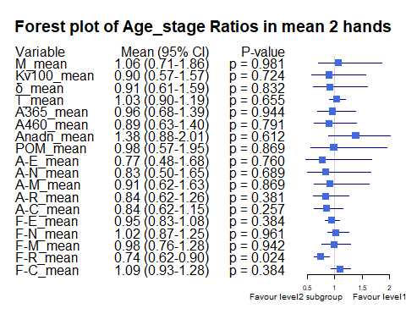

Bảng Age_stage ratio, level1 = “Age [30-40)”, level2= “Age >=50”

|  | Variable | Subgroup | Level1_Mean | Level2_Mean | Ratio | CI_Lower | CI_Upper | P_Value |
| --- | --- | --- | --- | --- | --- | --- | --- | --- |
| M_mean | M_mean | Age_stage | 25.2926944 | 18.3016667 | 1.3819886 | 0.9797360 | 2.543980 | 0.2058266 |
| Kv100_mean | Kv100_mean | Age_stage | 19.7702071 | 28.5897222 | 0.6915145 | 0.4497953 | 1.237466 | 0.3108094 |
| δ_mean | δ_mean | Age_stage | 4.4582955 | 4.2500000 | 1.0490107 | 0.7265449 | 1.768337 | 0.8944061 |
| T_mean | T_mean | Age_stage | 32.2174268 | 29.5819444 | 1.0890909 | 0.9614694 | 1.242836 | 0.3493784 |
| A365_mean | A365_mean | Age_stage | 95.7939394 | 84.8055556 | 1.1295715 | 0.8713275 | 1.570277 | 0.6901766 |
| A460_mean | A460_mean | Age_stage | 62.8012626 | 57.8333333 | 1.0859008 | 0.7775779 | 1.692552 | 0.5080622 |
| Anadn_mean | Anadn_mean | Age_stage | 0.7796086 | 0.7679167 | 1.0152255 | 0.7965078 | 1.307919 | 0.5054479 |
| POM_mean | POM_mean | Age_stage | 10.8500581 | 7.7758333 | 1.3953563 | 0.8841742 | 2.700446 | 0.1841702 |
| A-E_mean | A-E_mean | Age_stage | 1.6922424 | 1.8269444 | 0.9262692 | 0.5817245 | 2.114715 | 0.9844714 |
| A-N_mean | A-N_mean | Age_stage | 1.5968182 | 1.6784722 | 0.9513522 | 0.6164868 | 2.022356 | 0.9534353 |
| A-M_mean | A-M_mean | Age_stage | 1.2777399 | 1.2611111 | 1.0131858 | 0.6730349 | 1.824854 | 0.9848769 |
| A-R_mean | A-R_mean | Age_stage | 0.7322045 | 0.8145833 | 0.8988700 | 0.6622802 | 1.367443 | 0.4576410 |
| A-C_mean | A-C_mean | Age_stage | 0.9473687 | 1.0769444 | 0.8796820 | 0.6771402 | 1.156976 | 0.6128216 |
| F-E_mean | F-E_mean | Age_stage | 0.0149265 | 0.0157083 | 0.9502291 | 0.8545118 | 1.084009 | 0.3292650 |
| F-N_mean | F-N_mean | Age_stage | 0.0325614 | 0.0366250 | 0.8890475 | 0.7579522 | 1.069806 | 0.2507306 |
| F-M_mean | F-M_mean | Age_stage | 0.0780376 | 0.0866806 | 0.9002899 | 0.6997391 | 1.185551 | 0.4828790 |
| F-R_mean | F-R_mean | Age_stage | 0.3289452 | 0.3829444 | 0.8589894 | 0.7450149 | 1.013723 | 0.2645738 |
| F-C_mean | F-C_mean | Age_stage | 1.1690412 | 1.0269722 | 1.1383377 | 0.9817211 | 1.347599 | 0.0827614 |

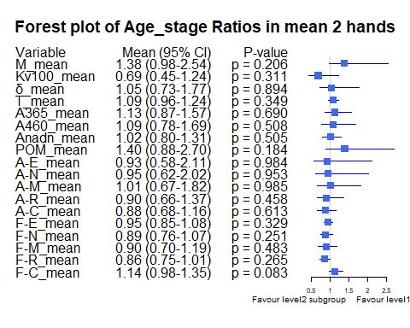

Bảng Age_stage ratio, level1 = “Age [30-40)”, level2= “Age [40-50)”

|  | Variable | Subgroup | Level1_Mean | Level2_Mean | Ratio | CI_Lower | CI_Upper | P_Value |
| --- | --- | --- | --- | --- | --- | --- | --- | --- |
| M_mean | M_mean | Age_stage | 25.2926944 | 23.4781026 | 1.0772887 | 0.8801162 | 1.436267 | 0.8452587 |
| Kv100_mean | Kv100_mean | Age_stage | 19.7702071 | 12.6213590 | 1.5664087 | 1.2229341 | 2.044420 | 0.0143726 |
| δ_mean | δ_mean | Age_stage | 4.4582955 | 2.8460641 | 1.5664775 | 1.1828141 | 2.209208 | 0.0056824 |
| T_mean | T_mean | Age_stage | 32.2174268 | 31.3444744 | 1.0278503 | 0.9509594 | 1.127382 | 0.6126951 |
| A365_mean | A365_mean | Age_stage | 95.7939394 | 79.5384615 | 1.2043725 | 0.9423676 | 1.693160 | 0.4207578 |
| A460_mean | A460_mean | Age_stage | 62.8012626 | 65.9512821 | 0.9522372 | 0.7736805 | 1.301868 | 0.5997795 |
| Anadn_mean | Anadn_mean | Age_stage | 0.7796086 | 1.5545641 | 0.5014966 | 0.2858229 | 1.039701 | 0.0392554 |
| POM_mean | POM_mean | Age_stage | 10.8500581 | 6.4109103 | 1.6924364 | 1.2190418 | 2.662626 | 0.0091690 |
| A-E_mean | A-E_mean | Age_stage | 1.6922424 | 1.0862051 | 1.5579400 | 1.0842626 | 2.386309 | 0.0168094 |
| A-N_mean | A-N_mean | Age_stage | 1.5968182 | 1.2163333 | 1.3128130 | 0.9026275 | 2.068244 | 0.0971140 |
| A-M_mean | A-M_mean | Age_stage | 1.2777399 | 0.9415385 | 1.3570767 | 0.9359476 | 2.133287 | 0.0769370 |
| A-R_mean | A-R_mean | Age_stage | 0.7322045 | 0.6160256 | 1.1885943 | 0.8856198 | 1.652625 | 0.2885488 |
| A-C_mean | A-C_mean | Age_stage | 0.9473687 | 0.8335000 | 1.1366151 | 0.8616014 | 1.592545 | 0.2550897 |
| F-E_mean | F-E_mean | Age_stage | 0.0149265 | 0.0151449 | 0.9855821 | 0.8772962 | 1.113757 | 0.9902548 |
| F-N_mean | F-N_mean | Age_stage | 0.0325614 | 0.0315333 | 1.0326014 | 0.8893995 | 1.204687 | 0.8356462 |
| F-M_mean | F-M_mean | Age_stage | 0.0780376 | 0.0810718 | 0.9625743 | 0.8091856 | 1.142592 | 0.3341712 |
| F-R_mean | F-R_mean | Age_stage | 0.3289452 | 0.3626821 | 0.9069795 | 0.7566172 | 1.089532 | 0.3202884 |
| F-C_mean | F-C_mean | Age_stage | 1.1690412 | 1.1472462 | 1.0189977 | 0.9290479 | 1.117027 | 0.5656505 |

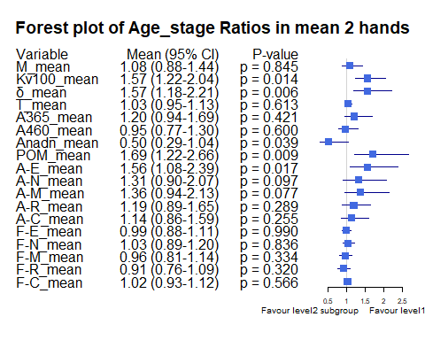

Bảng Age_stage ratio, level1 = “Age [40-50)”, level2= “Age >=50”

|  | Variable | Subgroup | Level1_Mean | Level2_Mean | Ratio | CI_Lower | CI_Upper | P_Value |
| --- | --- | --- | --- | --- | --- | --- | --- | --- |
| M_mean | M_mean | Age_stage | 23.4781026 | 18.3016667 | 1.2828396 | 0.8341484 | 2.2806911 | 0.3676102 |
| Kv100_mean | Kv100_mean | Age_stage | 12.6213590 | 28.5897222 | 0.4414649 | 0.2860299 | 0.7361162 | 0.0364883 |
| δ_mean | δ_mean | Age_stage | 2.8460641 | 4.2500000 | 0.6696621 | 0.4198547 | 1.1598439 | 0.1791243 |
| T_mean | T_mean | Age_stage | 31.3444744 | 29.5819444 | 1.0595813 | 0.9047830 | 1.2485065 | 0.7653693 |
| A365_mean | A365_mean | Age_stage | 79.5384615 | 84.8055556 | 0.9378921 | 0.6153570 | 1.4314931 | 0.9660917 |
| A460_mean | A460_mean | Age_stage | 65.9512821 | 57.8333333 | 1.1403680 | 0.7591811 | 1.8184076 | 0.2361962 |
| Anadn_mean | Anadn_mean | Age_stage | 1.5545641 | 0.7679167 | 2.0243917 | 0.9791110 | 3.5495601 | 0.3802461 |
| POM_mean | POM_mean | Age_stage | 6.4109103 | 7.7758333 | 0.8244660 | 0.4732678 | 1.7565631 | 0.4670500 |
| A-E_mean | A-E_mean | Age_stage | 1.0862051 | 1.8269444 | 0.5945474 | 0.3248520 | 1.4295620 | 0.2818075 |
| A-N_mean | A-N_mean | Age_stage | 1.2163333 | 1.6784722 | 0.7246669 | 0.4137504 | 1.5144455 | 0.3676102 |
| A-M_mean | A-M_mean | Age_stage | 0.9415385 | 1.2611111 | 0.7465944 | 0.4425677 | 1.3758743 | 0.3228660 |
| A-R_mean | A-R_mean | Age_stage | 0.6160256 | 0.8145833 | 0.7562463 | 0.5239597 | 1.1485683 | 0.2440660 |
| A-C_mean | A-C_mean | Age_stage | 0.8335000 | 1.0769444 | 0.7739489 | 0.4960634 | 1.0984078 | 0.2818075 |
| F-E_mean | F-E_mean | Age_stage | 0.0151449 | 0.0157083 | 0.9641298 | 0.8293309 | 1.1431356 | 0.7254898 |
| F-N_mean | F-N_mean | Age_stage | 0.0315333 | 0.0366250 | 0.8609784 | 0.7031339 | 1.0601660 | 0.1467885 |
| F-M_mean | F-M_mean | Age_stage | 0.0810718 | 0.0866806 | 0.9352939 | 0.7160692 | 1.2213066 | 0.8262940 |
| F-R_mean | F-R_mean | Age_stage | 0.3626821 | 0.3829444 | 0.9470879 | 0.7773135 | 1.1299434 | 0.8606352 |
| F-C_mean | F-C_mean | Age_stage | 1.1472462 | 1.0269722 | 1.1171151 | 0.9623795 | 1.3358693 | 0.1871481 |

