Phan tich Forest plot các ratio của right hand

Minh

2024-02-28

## Load bộ số liệu và các packages

## ── Attaching core tidyverse packages ──────────────────────── tidyverse 2.0.0 ──  
## ✔ dplyr 1.1.3 ✔ readr 2.1.4  
## ✔ forcats 1.0.0 ✔ stringr 1.5.0  
## ✔ ggplot2 3.4.3 ✔ tibble 3.2.1  
## ✔ lubridate 1.9.2 ✔ tidyr 1.3.0  
## ✔ purrr 1.0.2   
## ── Conflicts ────────────────────────────────────────── tidyverse_conflicts() ──  
## ✖ dplyr::filter() masks stats::filter()  
## ✖ dplyr::lag() masks stats::lag()  
## ℹ Use the conflicted package (<http://conflicted.r-lib.org/>) to force all conflicts to become errors  
##   
## Attaching package: 'rstatix'  
##   
##   
## The following object is masked from 'package:stats':  
##   
## filter  
##   
##   
## Loading required package: grid  
##   
## Loading required package: checkmate  
##   
## Loading required package: abind

## So sánh khác biệt về ratio của chỉ số Stress vs non stress theo các biến

Hàm để tạo bảng tổng hợp kết quả và p-value

Hàm sắp xếp các cột theo thứ tự

Hàm vẽ Forest plot

Bảng Stress index Ratio, level1 = “Yes”, level2 = “No”

|  | Variable | Subgroup | Level1_Mean | Level2_Mean | Ratio | CI_Lower | CI_Upper | P_Value |
| --- | --- | --- | --- | --- | --- | --- | --- | --- |
| M_right | M_right | Stress index | 26.4909524 | 20.8004737 | 1.2735745 | 1.0858754 | 1.498897 | 0.0140586 |
| Kv100_right | Kv100_right | Stress index | 19.7332937 | 20.5717076 | 0.9592443 | 0.7297329 | 1.275770 | 0.9013828 |
| δ_right | δ_right | Stress index | 4.4871825 | 3.5209006 | 1.2744417 | 1.0357870 | 1.568857 | 0.0235529 |
| T_right | T_right | Stress index | 33.0201190 | 30.6937485 | 1.0757930 | 1.0259145 | 1.126232 | 0.0443456 |
| A365_right | A365_right | Stress index | 84.3769841 | 84.7959064 | 0.9950596 | 0.7975016 | 1.211694 | 0.9461030 |
| A460_right | A460_right | Stress index | 48.7460317 | 50.8029240 | 0.9595123 | 0.7571729 | 1.185156 | 0.9326588 |
| Anadn_right | Anadn_right | Stress index | 0.8351587 | 0.7966140 | 1.0483857 | 0.6463067 | 1.650556 | 0.6521904 |
| POM_right | POM_right | Stress index | 11.5240873 | 8.8342222 | 1.3044824 | 0.9537721 | 1.768089 | 0.0769606 |
| A-E_right | A-E_right | Stress index | 1.5380952 | 1.3136316 | 1.1708726 | 0.9052903 | 1.517263 | 0.1493055 |
| A-N_right | A-N_right | Stress index | 1.5337302 | 1.2948830 | 1.1844546 | 0.9254886 | 1.529936 | 0.1384802 |
| A-M_right | A-M_right | Stress index | 1.2736111 | 1.0297661 | 1.2367965 | 0.9517373 | 1.598414 | 0.1240988 |
| A-R_right | A-R_right | Stress index | 0.7604762 | 0.6569708 | 1.1575495 | 0.9717402 | 1.389047 | 0.0797506 |
| A-C_right | A-C_right | Stress index | 0.9955556 | 0.8660702 | 1.1495091 | 0.9619566 | 1.376315 | 0.0547326 |
| F-E_right | F-E_right | Stress index | 0.0146349 | 0.0148433 | 0.9859631 | 0.8762664 | 1.101371 | 0.8032412 |
| F-N_right | F-N_right | Stress index | 0.0351032 | 0.0320766 | 1.0943543 | 0.9273391 | 1.272910 | 0.2683844 |
| F-M_right | F-M_right | Stress index | 0.0825397 | 0.0867292 | 0.9516938 | 0.7824917 | 1.157670 | 0.9864037 |
| F-R_right | F-R_right | Stress index | 0.3287183 | 0.3131749 | 1.0496317 | 0.8331559 | 1.308066 | 0.8815869 |
| F-C_right | F-C_right | Stress index | 1.1180238 | 1.1518327 | 0.9706477 | 0.8910558 | 1.048592 | 0.5308001 |

Forest plot cho Stress index ratio 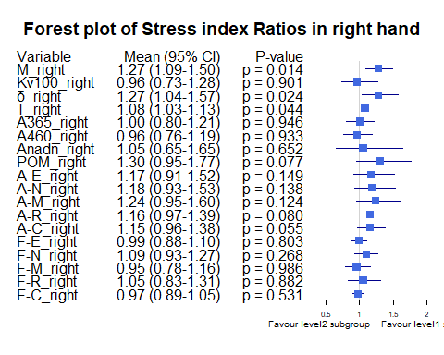 Bảng Gender Ratio, level1 = “male”, level2 = “female”

|  | Variable | Subgroup | Level1_Mean | Level2_Mean | Ratio | CI_Lower | CI_Upper | P_Value |
| --- | --- | --- | --- | --- | --- | --- | --- | --- |
| M_right | M_right | Gender | 22.9266370 | 21.5223737 | 1.0652467 | 0.8907248 | 1.279945 | 0.4090993 |
| Kv100_right | Kv100_right | Gender | 19.0289407 | 22.1419444 | 0.8594069 | 0.6713733 | 1.099948 | 0.2186232 |
| δ_right | δ_right | Gender | 3.7139926 | 3.8725000 | 0.9590685 | 0.7757477 | 1.207483 | 0.9154246 |
| T_right | T_right | Gender | 31.0359704 | 31.7075000 | 0.9788211 | 0.9335860 | 1.032398 | 0.9878959 |
| A365_right | A365_right | Gender | 84.6007407 | 84.7954545 | 0.9977037 | 0.8298871 | 1.195588 | 0.9717574 |
| A460_right | A460_right | Gender | 50.7874074 | 49.5151515 | 1.0256943 | 0.8475051 | 1.239497 | 0.7925518 |
| Anadn_right | Anadn_right | Gender | 0.6977111 | 0.9560101 | 0.7298156 | 0.4755139 | 1.177744 | 0.6598868 |
| POM_right | POM_right | Gender | 9.5094222 | 9.6252273 | 0.9879686 | 0.7204003 | 1.387696 | 0.6150265 |
| A-E_right | A-E_right | Gender | 1.4270815 | 1.3017677 | 1.0962643 | 0.8595950 | 1.411244 | 0.7500295 |
| A-N_right | A-N_right | Gender | 1.3992222 | 1.3045960 | 1.0725330 | 0.8435484 | 1.384471 | 0.7082233 |
| A-M_right | A-M_right | Gender | 1.1124815 | 1.0721465 | 1.0376208 | 0.7995413 | 1.332373 | 0.6094993 |
| A-R_right | A-R_right | Gender | 0.6877185 | 0.6809091 | 1.0100005 | 0.8285187 | 1.240496 | 0.4663857 |
| A-C_right | A-C_right | Gender | 0.9038370 | 0.8969697 | 1.0076562 | 0.8196101 | 1.239344 | 0.9959645 |
| F-E_right | F-E_right | Gender | 0.0149237 | 0.0146010 | 1.0221008 | 0.9204758 | 1.140174 | 0.6327286 |
| F-N_right | F-N_right | Gender | 0.0319711 | 0.0341465 | 0.9362934 | 0.8132861 | 1.080489 | 0.2068094 |
| F-M_right | F-M_right | Gender | 0.0874089 | 0.0831364 | 1.0513918 | 0.8687942 | 1.265885 | 0.9106660 |
| F-R_right | F-R_right | Gender | 0.3142548 | 0.3215934 | 0.9771804 | 0.8123787 | 1.186610 | 0.8652135 |
| F-C_right | F-C_right | Gender | 1.1454289 | 1.1390505 | 1.0055997 | 0.9349435 | 1.081649 | 0.6228906 |

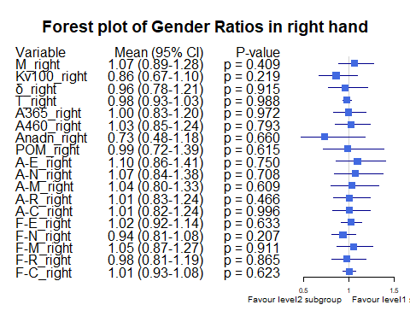

Bảng Smoking ratio, level1 = “Cigarettes, pipe tobacco…”, level2 = “Do not smoke”

|  | Variable | Subgroup | Level1_Mean | Level2_Mean | Ratio | CI_Lower | CI_Upper | P_Value |
| --- | --- | --- | --- | --- | --- | --- | --- | --- |
| M_right | M_right | Smoking | 20.3277857 | 22.7710625 | 0.8927026 | 0.6265555 | 1.1658594 | 0.5025081 |
| Kv100_right | Kv100_right | Smoking | 14.4022857 | 21.6461641 | 0.6653505 | 0.5293568 | 0.8305638 | 0.0943044 |
| δ_right | δ_right | Smoking | 2.6850714 | 4.0207995 | 0.6677954 | 0.4585452 | 0.9032939 | 0.0360505 |
| T_right | T_right | Smoking | 30.0641429 | 31.5948151 | 0.9515531 | 0.8564320 | 1.0391997 | 0.5277192 |
| A365_right | A365_right | Smoking | 86.7500000 | 84.2309896 | 1.0299060 | 0.7738127 | 1.2883827 | 0.6207002 |
| A460_right | A460_right | Smoking | 54.1714286 | 49.3911458 | 1.0967842 | 0.7721167 | 1.4219602 | 0.3191487 |
| Anadn_right | Anadn_right | Smoking | 0.7540714 | 0.8185677 | 0.9212084 | 0.6151888 | 1.3504384 | 0.4422434 |
| POM_right | POM_right | Smoking | 8.7001429 | 9.7461641 | 0.8926735 | 0.5207034 | 1.4047383 | 0.3320380 |
| A-E_right | A-E_right | Smoking | 1.0537857 | 1.4441250 | 0.7297053 | 0.4589848 | 1.0594075 | 0.0626022 |
| A-N_right | A-N_right | Smoking | 1.0987857 | 1.4161510 | 0.7758958 | 0.4695686 | 1.1104481 | 0.1181510 |
| A-M_right | A-M_right | Smoking | 0.8703571 | 1.1446484 | 0.7603707 | 0.4992760 | 1.0620880 | 0.1244087 |
| A-R_right | A-R_right | Smoking | 0.5807143 | 0.7076146 | 0.8206647 | 0.6017439 | 1.0505117 | 0.1819037 |
| A-C_right | A-C_right | Smoking | 0.7765000 | 0.9281510 | 0.8366095 | 0.5616557 | 1.1717127 | 0.1077741 |
| F-E_right | F-E_right | Smoking | 0.0152214 | 0.0146922 | 1.0360219 | 0.9144379 | 1.1753780 | 0.6610133 |
| F-N_right | F-N_right | Smoking | 0.0325500 | 0.0329661 | 0.9873766 | 0.8058407 | 1.2097569 | 0.6430740 |
| F-M_right | F-M_right | Smoking | 0.1029071 | 0.0818156 | 1.2577933 | 0.9594864 | 1.6462763 | 0.2587794 |
| F-R_right | F-R_right | Smoking | 0.2666000 | 0.3284633 | 0.8116585 | 0.6657909 | 1.0029449 | 0.1966093 |
| F-C_right | F-C_right | Smoking | 1.2066714 | 1.1287432 | 1.0690398 | 0.9792900 | 1.1651831 | 0.4183417 |

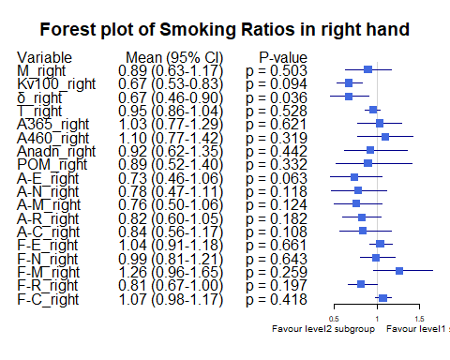

Bảng Smoking ratio, level1 = “Cigarettes, pipe tobacco…”, level2 = “Do not smoke”

|  | Variable | Subgroup | Level1_Mean | Level2_Mean | Ratio | CI_Lower | CI_Upper | P_Value |
| --- | --- | --- | --- | --- | --- | --- | --- | --- |
| M_right | M_right | Smoking | 20.3277857 | 22.7710625 | 0.8927026 | 0.6348352 | 1.1798588 | 0.5025081 |
| Kv100_right | Kv100_right | Smoking | 14.4022857 | 21.6461641 | 0.6653505 | 0.5136379 | 0.8336546 | 0.0943044 |
| δ_right | δ_right | Smoking | 2.6850714 | 4.0207995 | 0.6677954 | 0.4698518 | 0.8930302 | 0.0360505 |
| T_right | T_right | Smoking | 30.0641429 | 31.5948151 | 0.9515531 | 0.8657712 | 1.0376964 | 0.5277192 |
| A365_right | A365_right | Smoking | 86.7500000 | 84.2309896 | 1.0299060 | 0.7265030 | 1.2899629 | 0.6207002 |
| A460_right | A460_right | Smoking | 54.1714286 | 49.3911458 | 1.0967842 | 0.7467650 | 1.4186948 | 0.3191487 |
| Anadn_right | Anadn_right | Smoking | 0.7540714 | 0.8185677 | 0.9212084 | 0.6157702 | 1.3409902 | 0.4422434 |
| POM_right | POM_right | Smoking | 8.7001429 | 9.7461641 | 0.8926735 | 0.4760984 | 1.4085490 | 0.3320380 |
| A-E_right | A-E_right | Smoking | 1.0537857 | 1.4441250 | 0.7297053 | 0.4543633 | 1.0806125 | 0.0626022 |
| A-N_right | A-N_right | Smoking | 1.0987857 | 1.4161510 | 0.7758958 | 0.5075258 | 1.1196345 | 0.1181510 |
| A-M_right | A-M_right | Smoking | 0.8703571 | 1.1446484 | 0.7603707 | 0.4848849 | 1.0874817 | 0.1244087 |
| A-R_right | A-R_right | Smoking | 0.5807143 | 0.7076146 | 0.8206647 | 0.6020709 | 1.0568949 | 0.1819037 |
| A-C_right | A-C_right | Smoking | 0.7765000 | 0.9281510 | 0.8366095 | 0.5591980 | 1.1758578 | 0.1077741 |
| F-E_right | F-E_right | Smoking | 0.0152214 | 0.0146922 | 1.0360219 | 0.9104468 | 1.1678605 | 0.6610133 |
| F-N_right | F-N_right | Smoking | 0.0325500 | 0.0329661 | 0.9873766 | 0.8019692 | 1.2147592 | 0.6430740 |
| F-M_right | F-M_right | Smoking | 0.1029071 | 0.0818156 | 1.2577933 | 0.9233180 | 1.6752286 | 0.2587794 |
| F-R_right | F-R_right | Smoking | 0.2666000 | 0.3284633 | 0.8116585 | 0.6732558 | 1.0020401 | 0.1966093 |
| F-C_right | F-C_right | Smoking | 1.2066714 | 1.1287432 | 1.0690398 | 0.9849800 | 1.1727395 | 0.4183417 |

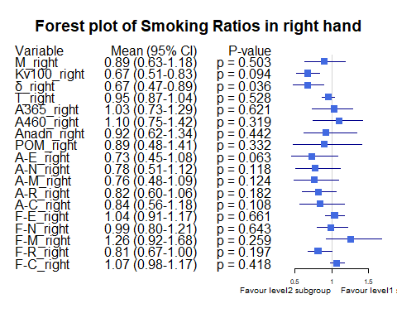

Bảng Hypertension ratio, level1 = “Yes”, level2 = “No”

|  | Variable | Subgroup | Level1_Mean | Level2_Mean | Ratio | CI_Lower | CI_Upper | P_Value |
| --- | --- | --- | --- | --- | --- | --- | --- | --- |
| M_right | M_right | Hypertension | 19.8770476 | 23.2371754 | 0.8553986 | 0.6559244 | 1.0472013 | 0.2745247 |
| Kv100_right | Kv100_right | Hypertension | 17.1661667 | 21.5174912 | 0.7977773 | 0.5842805 | 1.0876904 | 0.0847909 |
| δ_right | δ_right | Hypertension | 2.6535476 | 4.1964503 | 0.6323315 | 0.4866646 | 0.7958251 | 0.0020625 |
| T_right | T_right | Hypertension | 30.1119762 | 31.7651696 | 0.9479558 | 0.8850836 | 1.0145956 | 0.3795785 |
| A365_right | A365_right | Hypertension | 89.5690476 | 82.8830409 | 1.0806680 | 0.8692235 | 1.3050173 | 0.4848350 |
| A460_right | A460_right | Hypertension | 56.5333333 | 47.9339181 | 1.1794015 | 0.9854942 | 1.4021374 | 0.1147185 |
| Anadn_right | Anadn_right | Hypertension | 0.9819048 | 0.7425497 | 1.3223421 | 0.7859956 | 2.2217440 | 0.2009246 |
| POM_right | POM_right | Hypertension | 6.7061667 | 10.6092456 | 0.6321059 | 0.4459031 | 0.8649099 | 0.0222082 |
| A-E_right | A-E_right | Hypertension | 0.9735238 | 1.5216316 | 0.6397894 | 0.4711772 | 0.8393472 | 0.0056803 |
| A-N_right | A-N_right | Hypertension | 0.9965238 | 1.4928012 | 0.6675529 | 0.4829815 | 0.8966620 | 0.0102098 |
| A-M_right | A-M_right | Hypertension | 0.7798810 | 1.2116667 | 0.6436432 | 0.4927809 | 0.8200480 | 0.0105471 |
| A-R_right | A-R_right | Hypertension | 0.5892381 | 0.7200585 | 0.8183198 | 0.6538861 | 1.0148804 | 0.0976492 |
| A-C_right | A-C_right | Hypertension | 0.7802381 | 0.9453977 | 0.8253015 | 0.6072214 | 1.0622734 | 0.0138242 |
| F-E_right | F-E_right | Hypertension | 0.0146095 | 0.0148526 | 0.9836320 | 0.8787420 | 1.1070430 | 0.8384678 |
| F-N_right | F-N_right | Hypertension | 0.0330952 | 0.0328164 | 1.0084977 | 0.8408877 | 1.1995385 | 0.6352583 |
| F-M_right | F-M_right | Hypertension | 0.0974857 | 0.0812228 | 1.2002259 | 0.9359567 | 1.5285131 | 0.2907134 |
| F-R_right | F-R_right | Hypertension | 0.3452214 | 0.3070947 | 1.1241529 | 0.9036761 | 1.3941000 | 0.2713336 |
| F-C_right | F-C_right | Hypertension | 1.1668286 | 1.1338520 | 1.0290836 | 0.9346032 | 1.1250474 | 0.3399347 |

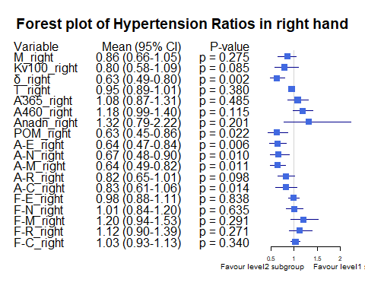

Bảng Obesity ratio, level1 = “Yes”, level2 = “No”

|  | Variable | Subgroup | Level1_Mean | Level2_Mean | Ratio | CI_Lower | CI_Upper | P_Value |
| --- | --- | --- | --- | --- | --- | --- | --- | --- |
| M_right | M_right | Obesity | 27.7774583 | 21.7102476 | 1.2794630 | 1.1351893 | 1.477561 | 0.0978850 |
| Kv100_right | Kv100_right | Obesity | 16.6159792 | 20.7722667 | 0.7999117 | 0.5669138 | 1.053263 | 0.5368324 |
| δ_right | δ_right | Obesity | 4.3157708 | 3.7199429 | 1.1601713 | 0.8935008 | 1.445694 | 0.2733984 |
| T_right | T_right | Obesity | 33.3610208 | 31.0868286 | 1.0731561 | 1.0205269 | 1.125439 | 0.0852356 |
| A365_right | A365_right | Obesity | 95.0354167 | 83.5000000 | 1.1381487 | 0.9575620 | 1.339069 | 0.5259582 |
| A460_right | A460_right | Obesity | 48.0041667 | 50.5057143 | 0.9504700 | 0.8098424 | 1.120629 | 0.6270190 |
| Anadn_right | Anadn_right | Obesity | 0.5900000 | 0.8317905 | 0.7093132 | 0.4727879 | 1.081649 | 0.1403658 |
| POM_right | POM_right | Obesity | 12.0405625 | 9.2747429 | 1.2982098 | 0.9413821 | 1.684928 | 0.0687756 |
| A-E_right | A-E_right | Obesity | 1.6832083 | 1.3387333 | 1.2573141 | 0.9191908 | 1.666701 | 0.1876260 |
| A-N_right | A-N_right | Obesity | 1.7027500 | 1.3199238 | 1.2900366 | 0.9159713 | 1.645590 | 0.1215550 |
| A-M_right | A-M_right | Obesity | 1.1573958 | 1.0883333 | 1.0634571 | 0.7829975 | 1.388693 | 0.5047251 |
| A-R_right | A-R_right | Obesity | 0.7402917 | 0.6785000 | 1.0910710 | 0.8923572 | 1.319201 | 0.4054541 |
| A-C_right | A-C_right | Obesity | 0.9827083 | 0.8915857 | 1.1022029 | 0.8534897 | 1.418165 | 0.4008592 |
| F-E_right | F-E_right | Obesity | 0.0162458 | 0.0146205 | 1.1111699 | 0.9844879 | 1.243962 | 0.2236085 |
| F-N_right | F-N_right | Obesity | 0.0318750 | 0.0330076 | 0.9656861 | 0.8017320 | 1.163949 | 0.9802403 |
| F-M_right | F-M_right | Obesity | 0.0739625 | 0.0869314 | 0.8508143 | 0.7015268 | 1.041734 | 0.3609602 |
| F-R_right | F-R_right | Obesity | 0.3652271 | 0.3118890 | 1.1710161 | 0.9226839 | 1.452889 | 0.1023965 |
| F-C_right | F-C_right | Obesity | 1.1839250 | 1.1380224 | 1.0403354 | 0.9277554 | 1.155407 | 0.5249842 |

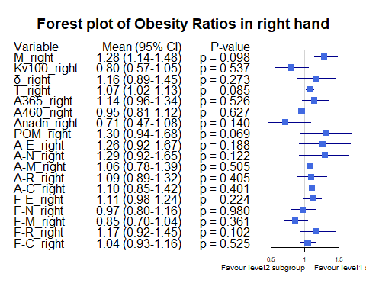

Bảng Race ratio, level1 = “White”, level2 = “Asian or Asian British”

|  | Variable | Subgroup | Level1_Mean | Level2_Mean | Ratio | CI_Lower | CI_Upper | P_Value |
| --- | --- | --- | --- | --- | --- | --- | --- | --- |
| M_right | M_right | Race | 26.0505714 | 21.0673607 | 1.2365370 | 1.0641557 | 1.4698535 | 0.1675457 |
| Kv100_right | Kv100_right | Race | 20.0283571 | 20.5668770 | 0.9738162 | 0.6680416 | 1.3780266 | 0.7390320 |
| δ_right | δ_right | Race | 4.5264524 | 3.5580628 | 1.2721676 | 0.9832557 | 1.6418038 | 0.0510207 |
| T_right | T_right | Race | 32.8705238 | 30.8065383 | 1.0669983 | 1.0226837 | 1.1139306 | 0.0917793 |
| A365_right | A365_right | Race | 104.5976190 | 82.8019126 | 1.2632271 | 1.1037293 | 1.4625782 | 0.0350312 |
| A460_right | A460_right | Race | 49.3476190 | 52.2224044 | 0.9449511 | 0.7922113 | 1.1089656 | 0.6244249 |
| Anadn_right | Anadn_right | Race | 0.4765476 | 0.8431749 | 0.5651824 | 0.4337876 | 0.7265639 | 0.0017184 |
| POM_right | POM_right | Race | 14.8303810 | 8.1369044 | 1.8226073 | 1.4033573 | 2.4137184 | 0.0002755 |
| A-E_right | A-E_right | Race | 1.5320714 | 1.3286557 | 1.1530989 | 0.8274959 | 1.5328099 | 0.2766641 |
| A-N_right | A-N_right | Race | 1.6708571 | 1.2528634 | 1.3336308 | 1.0129194 | 1.6918841 | 0.0350494 |
| A-M_right | A-M_right | Race | 1.3315476 | 1.0159153 | 1.3106876 | 1.0286336 | 1.6537968 | 0.0306042 |
| A-R_right | A-R_right | Race | 0.7323095 | 0.6666393 | 1.0985093 | 0.9480654 | 1.2913601 | 0.1513272 |
| A-C_right | A-C_right | Race | 1.0307143 | 0.8590601 | 1.1998163 | 0.9386943 | 1.5135704 | 0.1146684 |
| F-E_right | F-E_right | Race | 0.0177952 | 0.0142011 | 1.2530893 | 1.1281529 | 1.3759411 | 0.0007927 |
| F-N_right | F-N_right | Race | 0.0311786 | 0.0333284 | 0.9354952 | 0.7835081 | 1.1216467 | 0.7280646 |
| F-M_right | F-M_right | Race | 0.0823119 | 0.0874186 | 0.9415836 | 0.7443647 | 1.1954986 | 0.3807683 |
| F-R_right | F-R_right | Race | 0.2930881 | 0.3183740 | 0.9205779 | 0.7342943 | 1.1280000 | 0.4893476 |
| F-C_right | F-C_right | Race | 1.1003976 | 1.1544656 | 0.9531662 | 0.8866288 | 1.0330797 | 0.1338103 |

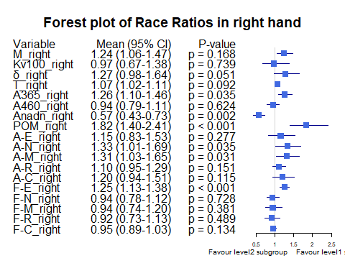

Bảng Race ratio, level1 = “Black, African, Caribbean or Black Bristish”, level2 = “Asian or Asian British”

|  | Variable | Subgroup | Level1_Mean | Level2_Mean | Ratio | CI_Lower | CI_Upper | P_Value |
| --- | --- | --- | --- | --- | --- | --- | --- | --- |
| M_right | M_right | Race | 30.7066667 | 21.0673607 | 1.4575469 | 1.0548245 | 1.8043164 | 0.1122633 |
| Kv100_right | Kv100_right | Race | 17.3366667 | 20.5668770 | 0.8429411 | 0.4984425 | 1.3480163 | 0.8240537 |
| δ_right | δ_right | Race | 4.8366667 | 3.5580628 | 1.3593539 | 1.0063772 | 1.7773245 | 0.1439869 |
| T_right | T_right | Race | 34.5266667 | 30.8065383 | 1.1207578 | 1.0746853 | 1.1692843 | 0.0654461 |
| A365_right | A365_right | Race | 30.0000000 | 82.8019126 | 0.3623105 | 0.0243584 | 0.6866430 | 0.0332960 |
| A460_right | A460_right | Race | 14.3333333 | 52.2224044 | 0.2744671 | 0.1734808 | 0.3789434 | 0.0083724 |
| Anadn_right | Anadn_right | Race | 1.6133333 | 0.8431749 | 1.9134030 | 0.2952009 | 4.4213257 | 0.9873261 |
| POM_right | POM_right | Race | 13.8600000 | 8.1369044 | 1.7033505 | 0.2252776 | 3.4858816 | 0.5461902 |
| A-E_right | A-E_right | Race | 1.5600000 | 1.3286557 | 1.1741190 | 0.8266053 | 1.6015700 | 0.3999214 |
| A-N_right | A-N_right | Race | 2.0666667 | 1.2528634 | 1.6495547 | 0.9345530 | 2.4054163 | 0.1234013 |
| A-M_right | A-M_right | Race | 1.6100000 | 1.0159153 | 1.5847778 | 0.9039659 | 2.5238232 | 0.1273121 |
| A-R_right | A-R_right | Race | 0.8333333 | 0.6666393 | 1.2500512 | 0.8966754 | 1.7085675 | 0.2730167 |
| A-C_right | A-C_right | Race | 1.1466667 | 0.8590601 | 1.3347921 | 1.1338614 | 1.5670821 | 0.0833720 |
| F-E_right | F-E_right | Race | 0.0126667 | 0.0142011 | 0.8919501 | 0.7085862 | 1.1145486 | 0.4149887 |
| F-N_right | F-N_right | Race | 0.0320000 | 0.0333284 | 0.9601417 | 0.8058053 | 1.1200537 | 0.8985214 |
| F-M_right | F-M_right | Race | 0.0640000 | 0.0874186 | 0.7321098 | 0.6450067 | 0.8365827 | 0.1060262 |
| F-R_right | F-R_right | Race | 0.4100000 | 0.3183740 | 1.2877934 | 0.6670656 | 1.8045970 | 0.5294299 |
| F-C_right | F-C_right | Race | 1.1016667 | 1.1544656 | 0.9542655 | 0.8814947 | 1.0335070 | 0.3984758 |

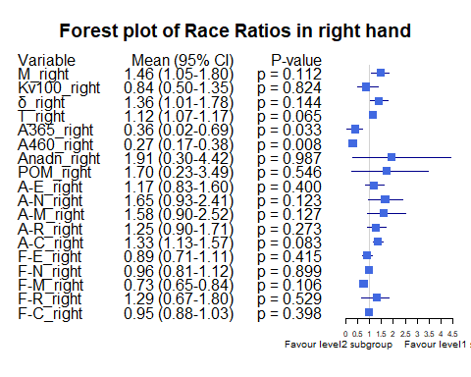

Bảng BMI ratio, level1 = “BMI <25”, level2 = “BMI [25-30)”

|  | Variable | Subgroup | Level1_Mean | Level2_Mean | Ratio | CI_Lower | CI_Upper | P_Value |
| --- | --- | --- | --- | --- | --- | --- | --- | --- |
| M_right | M_right | BMI_25_30 | 18.9726899 | 26.0700617 | 0.7277578 | 0.6063019 | 0.8703488 | 0.0003756 |
| Kv100_right | Kv100_right | BMI_25_30 | 24.1438062 | 15.4027778 | 1.5674969 | 1.1904772 | 2.1469033 | 0.0003068 |
| δ_right | δ_right | BMI_25_30 | 3.9529690 | 3.3488272 | 1.1804040 | 0.9589116 | 1.4817121 | 0.4435576 |
| T_right | T_right | BMI_25_30 | 30.3708450 | 32.2270988 | 0.9424008 | 0.8910478 | 0.9995119 | 0.0129364 |
| A365_right | A365_right | BMI_25_30 | 84.5620155 | 81.8086420 | 1.0336563 | 0.8353589 | 1.2650532 | 0.6465435 |
| A460_right | A460_right | BMI_25_30 | 51.5286822 | 48.8765432 | 1.0542620 | 0.8686369 | 1.2741643 | 0.4727354 |
| Anadn_right | Anadn_right | BMI_25_30 | 0.8040000 | 0.8760494 | 0.9177565 | 0.5552374 | 1.4931192 | 0.9374719 |
| POM_right | POM_right | BMI_25_30 | 7.9989612 | 11.3065432 | 0.7074630 | 0.5053450 | 0.9910896 | 0.0421134 |
| A-E_right | A-E_right | BMI_25_30 | 1.4375891 | 1.1812963 | 1.2169590 | 0.9296128 | 1.6269884 | 0.3559721 |
| A-N_right | A-N_right | BMI_25_30 | 1.3631318 | 1.2511111 | 1.0895369 | 0.8073704 | 1.4110643 | 0.7400108 |
| A-M_right | A-M_right | BMI_25_30 | 1.0817442 | 1.0988272 | 0.9844534 | 0.7481167 | 1.2740590 | 0.8092936 |
| A-R_right | A-R_right | BMI_25_30 | 0.6290698 | 0.7572222 | 0.8307598 | 0.6726277 | 1.0355321 | 0.1253215 |
| A-C_right | A-C_right | BMI_25_30 | 0.8665736 | 0.9314198 | 0.9303793 | 0.7435385 | 1.1562406 | 0.5788027 |
| F-E_right | F-E_right | BMI_25_30 | 0.0143318 | 0.0150802 | 0.9503679 | 0.8463872 | 1.0783168 | 0.6185658 |
| F-N_right | F-N_right | BMI_25_30 | 0.0322333 | 0.0342407 | 0.9413737 | 0.8029277 | 1.1146829 | 0.4605344 |
| F-M_right | F-M_right | BMI_25_30 | 0.0870628 | 0.0867222 | 1.0039271 | 0.8195136 | 1.2313374 | 0.9660366 |
| F-R_right | F-R_right | BMI_25_30 | 0.3031760 | 0.3257654 | 0.9306573 | 0.7474203 | 1.1397631 | 0.2089794 |
| F-C_right | F-C_right | BMI_25_30 | 1.1477535 | 1.1225247 | 1.0224750 | 0.9521682 | 1.0955493 | 0.4386276 |

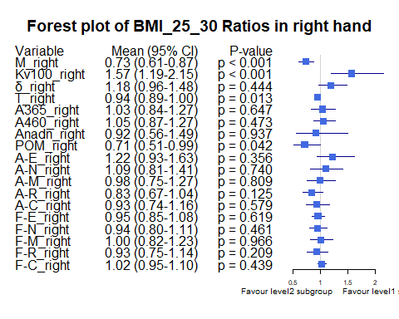

Bảng BMI ratio, level1 = “BMI >=30”, level2 = “BMI [25-30)”

|  | Variable | Subgroup | Level1_Mean | Level2_Mean | Ratio | CI_Lower | CI_Upper | P_Value |
| --- | --- | --- | --- | --- | --- | --- | --- | --- |
| M_right | M_right | BMI_25_30 | 27.7774583 | 26.0700617 | 1.0654926 | 0.9428981 | 1.221723 | 0.9539623 |
| Kv100_right | Kv100_right | BMI_25_30 | 16.6159792 | 15.4027778 | 1.0787651 | 0.7282987 | 1.545489 | 0.3428029 |
| δ_right | δ_right | BMI_25_30 | 4.3157708 | 3.3488272 | 1.2887410 | 0.9780117 | 1.660202 | 0.1515849 |
| T_right | T_right | BMI_25_30 | 33.3610208 | 32.2270988 | 1.0351854 | 0.9805935 | 1.102487 | 0.4281808 |
| A365_right | A365_right | BMI_25_30 | 95.0354167 | 81.8086420 | 1.1616794 | 0.9313904 | 1.441800 | 0.3456434 |
| A460_right | A460_right | BMI_25_30 | 48.0041667 | 48.8765432 | 0.9821514 | 0.8295733 | 1.189501 | 0.8288699 |
| Anadn_right | Anadn_right | BMI_25_30 | 0.5900000 | 0.8760494 | 0.6734780 | 0.3765020 | 1.176214 | 0.1457467 |
| POM_right | POM_right | BMI_25_30 | 12.0405625 | 11.3065432 | 1.0649199 | 0.7377426 | 1.457841 | 0.4281808 |
| A-E_right | A-E_right | BMI_25_30 | 1.6832083 | 1.1812963 | 1.4248824 | 1.0018848 | 1.921951 | 0.0955285 |
| A-N_right | A-N_right | BMI_25_30 | 1.7027500 | 1.2511111 | 1.3609902 | 0.9456384 | 1.830415 | 0.0737906 |
| A-M_right | A-M_right | BMI_25_30 | 1.1573958 | 1.0988272 | 1.0533011 | 0.7527114 | 1.442235 | 0.5760027 |
| A-R_right | A-R_right | BMI_25_30 | 0.7402917 | 0.7572222 | 0.9776412 | 0.7656080 | 1.224951 | 0.9217333 |
| A-C_right | A-C_right | BMI_25_30 | 0.9827083 | 0.9314198 | 1.0550649 | 0.8018823 | 1.370956 | 0.5168090 |
| F-E_right | F-E_right | BMI_25_30 | 0.0162458 | 0.0150802 | 1.0772923 | 0.9296863 | 1.242808 | 0.6355473 |
| F-N_right | F-N_right | BMI_25_30 | 0.0318750 | 0.0342407 | 0.9309086 | 0.7522568 | 1.161917 | 0.7679148 |
| F-M_right | F-M_right | BMI_25_30 | 0.0739625 | 0.0867222 | 0.8528668 | 0.6764286 | 1.072122 | 0.4385457 |
| F-R_right | F-R_right | BMI_25_30 | 0.3652271 | 0.3257654 | 1.1211352 | 0.8877673 | 1.439501 | 0.2521021 |
| F-C_right | F-C_right | BMI_25_30 | 1.1839250 | 1.1225247 | 1.0546984 | 0.9405714 | 1.170855 | 0.3445594 |

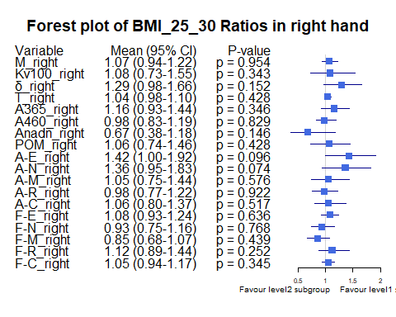

Bảng Age_stage ratio, level1 = “Age <30”, level2= “Age [30-40)”

|  | Variable | Subgroup | Level1_Mean | Level2_Mean | Ratio | CI_Lower | CI_Upper | P_Value |
| --- | --- | --- | --- | --- | --- | --- | --- | --- |
| M_right | M_right | Age_stage | 19.1767949 | 25.2341313 | 0.7599546 | 0.6033643 | 0.9401002 | 0.0424612 |
| Kv100_right | Kv100_right | Age_stage | 23.4133974 | 18.5121566 | 1.2647580 | 0.9739968 | 1.6704200 | 0.0947446 |
| δ_right | δ_right | Age_stage | 3.5846795 | 4.1633687 | 0.8610046 | 0.6659926 | 1.1133542 | 0.2585241 |
| T_right | T_right | Age_stage | 30.5505769 | 32.1525707 | 0.9501753 | 0.8985930 | 1.0014080 | 0.1110426 |
| A365_right | A365_right | Age_stage | 80.2179487 | 90.2106061 | 0.8892297 | 0.6931267 | 1.1047747 | 0.6523736 |
| A460_right | A460_right | Age_stage | 46.0897436 | 52.0919192 | 0.8847772 | 0.6999686 | 1.0767451 | 0.3676022 |
| Anadn_right | Anadn_right | Age_stage | 0.8906410 | 0.6506061 | 1.3689406 | 0.9128353 | 2.0055860 | 0.9269890 |
| POM_right | POM_right | Age_stage | 8.4367308 | 11.0968535 | 0.7602813 | 0.5160076 | 1.1016745 | 0.0182895 |
| A-E_right | A-E_right | Age_stage | 1.2639744 | 1.5041111 | 0.8403464 | 0.6015569 | 1.1249602 | 0.1427090 |
| A-N_right | A-N_right | Age_stage | 1.2549359 | 1.4353131 | 0.8743290 | 0.6690051 | 1.1375307 | 0.4010040 |
| A-M_right | A-M_right | Age_stage | 1.0476923 | 1.1360859 | 0.9221947 | 0.6883518 | 1.2066821 | 0.5114543 |
| A-R_right | A-R_right | Age_stage | 0.6694231 | 0.6822424 | 0.9812100 | 0.7757581 | 1.2305079 | 0.5772608 |
| A-C_right | A-C_right | Age_stage | 0.8508333 | 0.9139394 | 0.9309516 | 0.7335591 | 1.1471481 | 0.2335799 |
| F-E_right | F-E_right | Age_stage | 0.0143013 | 0.0148222 | 0.9648541 | 0.8563696 | 1.0988624 | 0.5242024 |
| F-N_right | F-N_right | Age_stage | 0.0371603 | 0.0315202 | 1.1789346 | 1.0114236 | 1.4014996 | 0.0333897 |
| F-M_right | F-M_right | Age_stage | 0.0896731 | 0.0823798 | 1.0885324 | 0.8673970 | 1.3406145 | 0.6055100 |
| F-R_right | F-R_right | Age_stage | 0.2993397 | 0.3301359 | 0.9067168 | 0.7249602 | 1.1483903 | 0.3097745 |
| F-C_right | F-C_right | Age_stage | 1.1121731 | 1.1788909 | 0.9434063 | 0.8571130 | 1.0254511 | 0.3868365 |

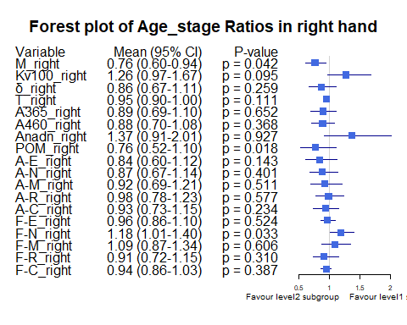

Bảng Age_stage ratio, level1 = “Age <30”, level2= “Age [40-50)”

|  | Variable | Subgroup | Level1_Mean | Level2_Mean | Ratio | CI_Lower | CI_Upper | P_Value |
| --- | --- | --- | --- | --- | --- | --- | --- | --- |
| M_right | M_right | Age_stage | 19.1767949 | 22.9460769 | 0.8357331 | 0.6197052 | 1.216830 | 0.2428218 |
| Kv100_right | Kv100_right | Age_stage | 23.4133974 | 13.9024615 | 1.6841188 | 1.2431406 | 2.399761 | 0.0114719 |
| δ_right | δ_right | Age_stage | 3.5846795 | 2.9100769 | 1.2318161 | 0.8499842 | 1.874025 | 0.2834385 |
| T_right | T_right | Age_stage | 30.5505769 | 31.4998462 | 0.9698643 | 0.8877424 | 1.065491 | 0.2678025 |
| A365_right | A365_right | Age_stage | 80.2179487 | 79.0384615 | 1.0149230 | 0.7407408 | 1.474059 | 0.7317482 |
| A460_right | A460_right | Age_stage | 46.0897436 | 54.7230769 | 0.8422360 | 0.6173392 | 1.153441 | 0.2969528 |
| Anadn_right | Anadn_right | Age_stage | 0.8906410 | 1.1620769 | 0.7664217 | 0.3859564 | 1.665829 | 0.1108180 |
| POM_right | POM_right | Age_stage | 8.4367308 | 7.4463077 | 1.1330086 | 0.7149874 | 1.892761 | 0.7800367 |
| A-E_right | A-E_right | Age_stage | 1.2639744 | 1.2010000 | 1.0524349 | 0.6656308 | 1.685095 | 0.6124748 |
| A-N_right | A-N_right | Age_stage | 1.2549359 | 1.3010000 | 0.9645933 | 0.6405692 | 1.525705 | 0.7771352 |
| A-M_right | A-M_right | Age_stage | 1.0476923 | 1.0203846 | 1.0267622 | 0.6884722 | 1.718620 | 0.6441561 |
| A-R_right | A-R_right | Age_stage | 0.6694231 | 0.6776923 | 0.9877980 | 0.7052315 | 1.413523 | 0.8815488 |
| A-C_right | A-C_right | Age_stage | 0.8508333 | 0.8823846 | 0.9642432 | 0.6459693 | 1.464486 | 1.0000000 |
| F-E_right | F-E_right | Age_stage | 0.0143013 | 0.0146231 | 0.9779940 | 0.8361557 | 1.137600 | 0.7407631 |
| F-N_right | F-N_right | Age_stage | 0.0371603 | 0.0274385 | 1.3543127 | 1.1481800 | 1.594683 | 0.0055101 |
| F-M_right | F-M_right | Age_stage | 0.0896731 | 0.0822846 | 1.0897915 | 0.8173588 | 1.432373 | 0.8804623 |
| F-R_right | F-R_right | Age_stage | 0.2993397 | 0.2911077 | 1.0282784 | 0.7666723 | 1.368209 | 0.9148398 |
| F-C_right | F-C_right | Age_stage | 1.1121731 | 1.1499538 | 0.9671458 | 0.8601223 | 1.078987 | 0.8577822 |

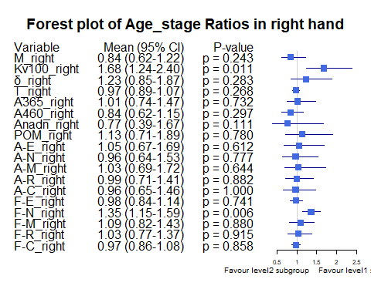

Bảng Age_stage ratio, level1 = “Age <30”, level2= “Age >=50”

|  | Variable | Subgroup | Level1_Mean | Level2_Mean | Ratio | CI_Lower | CI_Upper | P_Value |
| --- | --- | --- | --- | --- | --- | --- | --- | --- |
| M_right | M_right | Age_stage | 19.1767949 | 18.7191667 | 1.0244470 | 0.6423493 | 1.948732 | 0.8323953 |
| Kv100_right | Kv100_right | Age_stage | 23.4133974 | 31.1008333 | 0.7528222 | 0.5067119 | 1.352056 | 0.3312874 |
| δ_right | δ_right | Age_stage | 3.5846795 | 4.4163889 | 0.8116766 | 0.5508120 | 1.265601 | 0.3464204 |
| T_right | T_right | Age_stage | 30.5505769 | 29.6863889 | 1.0291106 | 0.9038546 | 1.190071 | 0.6292031 |
| A365_right | A365_right | Age_stage | 80.2179487 | 85.8611111 | 0.9342757 | 0.7081877 | 1.218208 | 0.9614821 |
| A460_right | A460_right | Age_stage | 46.0897436 | 48.4444444 | 0.9513938 | 0.6598717 | 1.568791 | 0.9807355 |
| Anadn_right | Anadn_right | Age_stage | 0.8906410 | 0.5352778 | 1.6638857 | 1.0477808 | 2.571747 | 0.4834445 |
| POM_right | POM_right | Age_stage | 8.4367308 | 10.5338889 | 0.8009132 | 0.4125483 | 1.945460 | 0.7958821 |
| A-E_right | A-E_right | Age_stage | 1.2639744 | 1.5108333 | 0.8366074 | 0.5476446 | 1.434669 | 0.4116500 |
| A-N_right | A-N_right | Age_stage | 1.2549359 | 1.5183333 | 0.8265220 | 0.5632365 | 1.402298 | 0.5144235 |
| A-M_right | A-M_right | Age_stage | 1.0476923 | 1.2411111 | 0.8441567 | 0.5873396 | 1.294901 | 0.4837655 |
| A-R_right | A-R_right | Age_stage | 0.6694231 | 0.7813889 | 0.8567092 | 0.6510909 | 1.112159 | 0.2179285 |
| A-C_right | A-C_right | Age_stage | 0.8508333 | 1.0866667 | 0.7829755 | 0.5115020 | 1.204379 | 0.3104137 |
| F-E_right | F-E_right | Age_stage | 0.0143013 | 0.0170556 | 0.8385117 | 0.7187294 | 1.014844 | 0.1581949 |
| F-N_right | F-N_right | Age_stage | 0.0371603 | 0.0337500 | 1.1010446 | 0.8197729 | 1.431676 | 0.2764155 |
| F-M_right | F-M_right | Age_stage | 0.0896731 | 0.0928611 | 0.9656688 | 0.6081114 | 1.433584 | 1.0000000 |
| F-R_right | F-R_right | Age_stage | 0.2993397 | 0.3820556 | 0.7834979 | 0.5988354 | 1.093635 | 0.0949007 |
| F-C_right | F-C_right | Age_stage | 1.1121731 | 1.0606111 | 1.0486153 | 0.9108634 | 1.208489 | 0.4973082 |

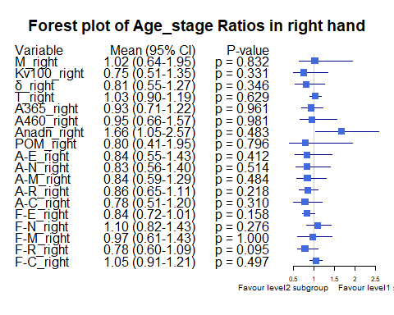

Bảng Age_stage ratio, level1 = “Age [30-40)”, level2= “Age >=50”

|  | Variable | Subgroup | Level1_Mean | Level2_Mean | Ratio | CI_Lower | CI_Upper | P_Value |
| --- | --- | --- | --- | --- | --- | --- | --- | --- |
| M_right | M_right | Age_stage | 25.2341313 | 18.7191667 | 1.3480371 | 0.8697371 | 2.532194 | 0.2925591 |
| Kv100_right | Kv100_right | Age_stage | 18.5121566 | 31.1008333 | 0.5952302 | 0.3920023 | 1.007319 | 0.0762056 |
| δ_right | δ_right | Age_stage | 4.1633687 | 4.4163889 | 0.9427088 | 0.6712429 | 1.491585 | 0.8347492 |
| T_right | T_right | Age_stage | 32.1525707 | 29.6863889 | 1.0830745 | 0.9581213 | 1.233388 | 0.3906906 |
| A365_right | A365_right | Age_stage | 90.2106061 | 85.8611111 | 1.0506573 | 0.8806761 | 1.292334 | 0.5723767 |
| A460_right | A460_right | Age_stage | 52.0919192 | 48.4444444 | 1.0752919 | 0.7626557 | 1.644870 | 0.6969604 |
| Anadn_right | Anadn_right | Age_stage | 0.6506061 | 0.5352778 | 1.2154550 | 0.9189542 | 1.651035 | 0.4476468 |
| POM_right | POM_right | Age_stage | 11.0968535 | 10.5338889 | 1.0534432 | 0.5884479 | 2.539794 | 0.5054479 |
| A-E_right | A-E_right | Age_stage | 1.5041111 | 1.5108333 | 0.9955507 | 0.6691681 | 1.723621 | 0.8456713 |
| A-N_right | A-N_right | Age_stage | 1.4353131 | 1.5183333 | 0.9453215 | 0.6503817 | 1.576989 | 0.5992079 |
| A-M_right | A-M_right | Age_stage | 1.1360859 | 1.2411111 | 0.9153780 | 0.6579399 | 1.368045 | 0.5206822 |
| A-R_right | A-R_right | Age_stage | 0.6822424 | 0.7813889 | 0.8731151 | 0.6947975 | 1.107236 | 0.3601599 |
| A-C_right | A-C_right | Age_stage | 0.9139394 | 1.0866667 | 0.8410485 | 0.5809335 | 1.286282 | 0.5205978 |
| F-E_right | F-E_right | Age_stage | 0.0148222 | 0.0170556 | 0.8690554 | 0.7565056 | 1.018096 | 0.1430748 |
| F-N_right | F-N_right | Age_stage | 0.0315202 | 0.0337500 | 0.9339319 | 0.7005974 | 1.213881 | 0.4460994 |
| F-M_right | F-M_right | Age_stage | 0.0823798 | 0.0928611 | 0.8871291 | 0.5942406 | 1.314537 | 0.6947331 |
| F-R_right | F-R_right | Age_stage | 0.3301359 | 0.3820556 | 0.8641043 | 0.6617542 | 1.137168 | 0.2878142 |
| F-C_right | F-C_right | Age_stage | 1.1788909 | 1.0606111 | 1.1115204 | 0.9940461 | 1.234424 | 0.0927925 |

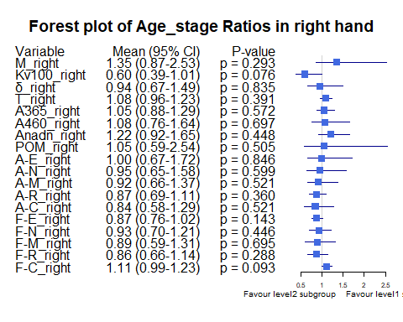

Bảng Age_stage ratio, level1 = “Age [30-40)”, level2= “Age [40-50)”

|  | Variable | Subgroup | Level1_Mean | Level2_Mean | Ratio | CI_Lower | CI_Upper | P_Value |
| --- | --- | --- | --- | --- | --- | --- | --- | --- |
| M_right | M_right | Age_stage | 25.2341313 | 22.9460769 | 1.0997144 | 0.8759098 | 1.493449 | 0.9424102 |
| Kv100_right | Kv100_right | Age_stage | 18.5121566 | 13.9024615 | 1.3315740 | 0.9691352 | 1.870327 | 0.1820064 |
| δ_right | δ_right | Age_stage | 4.1633687 | 2.9100769 | 1.4306731 | 1.0306291 | 2.171202 | 0.0668671 |
| T_right | T_right | Age_stage | 32.1525707 | 31.4998462 | 1.0207215 | 0.9467684 | 1.118498 | 0.6820626 |
| A365_right | A365_right | Age_stage | 90.2106061 | 79.0384615 | 1.1413507 | 0.8696340 | 1.616841 | 0.5337565 |
| A460_right | A460_right | Age_stage | 52.0919192 | 54.7230769 | 0.9519187 | 0.7615452 | 1.293780 | 0.4419862 |
| Anadn_right | Anadn_right | Age_stage | 0.6506061 | 1.1620769 | 0.5598649 | 0.3052049 | 1.043327 | 0.0852874 |
| POM_right | POM_right | Age_stage | 11.0968535 | 7.4463077 | 1.4902491 | 1.0417763 | 2.293026 | 0.0325751 |
| A-E_right | A-E_right | Age_stage | 1.5041111 | 1.2010000 | 1.2523823 | 0.8439817 | 1.959570 | 0.2089509 |
| A-N_right | A-N_right | Age_stage | 1.4353131 | 1.3010000 | 1.1032384 | 0.7628107 | 1.769553 | 0.5179132 |
| A-M_right | A-M_right | Age_stage | 1.1360859 | 1.0203846 | 1.1133898 | 0.7458065 | 1.760118 | 0.4349730 |
| A-R_right | A-R_right | Age_stage | 0.6822424 | 0.6776923 | 1.0067141 | 0.7478791 | 1.405232 | 0.9902636 |
| A-C_right | A-C_right | Age_stage | 0.9139394 | 0.8823846 | 1.0357608 | 0.7331568 | 1.580105 | 0.4716035 |
| F-E_right | F-E_right | Age_stage | 0.0148222 | 0.0146231 | 1.0136186 | 0.8780221 | 1.179009 | 0.7680968 |
| F-N_right | F-N_right | Age_stage | 0.0315202 | 0.0274385 | 1.1487598 | 0.9598845 | 1.355534 | 0.3769115 |
| F-M_right | F-M_right | Age_stage | 0.0823798 | 0.0822846 | 1.0011567 | 0.7660383 | 1.248128 | 0.7306285 |
| F-R_right | F-R_right | Age_stage | 0.3301359 | 0.2911077 | 1.1340678 | 0.8521066 | 1.479883 | 0.4130007 |
| F-C_right | F-C_right | Age_stage | 1.1788909 | 1.1499538 | 1.0251637 | 0.9370755 | 1.113390 | 0.3383131 |

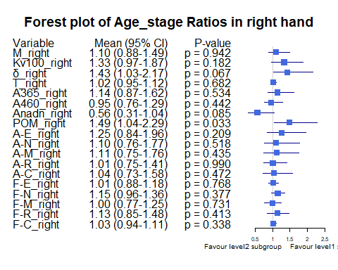

Bảng Age_stage ratio, level1 = “Age [40-50)”, level2= “Age >=50”

|  | Variable | Subgroup | Level1_Mean | Level2_Mean | Ratio | CI_Lower | CI_Upper | P_Value |
| --- | --- | --- | --- | --- | --- | --- | --- | --- |
| M_right | M_right | Age_stage | 22.9460769 | 18.7191667 | 1.2258065 | 0.7639913 | 2.3697476 | 0.8982751 |
| Kv100_right | Kv100_right | Age_stage | 13.9024615 | 31.1008333 | 0.4470125 | 0.2895888 | 0.7734282 | 0.0364883 |
| δ_right | δ_right | Age_stage | 2.9100769 | 4.4163889 | 0.6589268 | 0.3922265 | 1.1246238 | 0.1791243 |
| T_right | T_right | Age_stage | 31.4998462 | 29.6863889 | 1.0610872 | 0.9183193 | 1.2400206 | 0.7012384 |
| A365_right | A365_right | Age_stage | 79.0384615 | 85.8611111 | 0.9205385 | 0.6477242 | 1.2610908 | 0.9650063 |
| A460_right | A460_right | Age_stage | 54.7230769 | 48.4444444 | 1.1296048 | 0.7203304 | 1.7914907 | 0.4557722 |
| Anadn_right | Anadn_right | Age_stage | 1.1620769 | 0.5352778 | 2.1709792 | 1.1106683 | 4.0583864 | 0.0391224 |
| POM_right | POM_right | Age_stage | 7.4463077 | 10.5338889 | 0.7068907 | 0.3358460 | 1.6441272 | 0.7653693 |
| A-E_right | A-E_right | Age_stage | 1.2010000 | 1.5108333 | 0.7949255 | 0.4554258 | 1.5270392 | 0.4155241 |
| A-N_right | A-N_right | Age_stage | 1.3010000 | 1.5183333 | 0.8568606 | 0.4835234 | 1.5559577 | 0.6607237 |
| A-M_right | A-M_right | Age_stage | 1.0203846 | 1.2411111 | 0.8221541 | 0.4934739 | 1.3980479 | 0.4045229 |
| A-R_right | A-R_right | Age_stage | 0.6776923 | 0.7813889 | 0.8672920 | 0.5741381 | 1.1776902 | 0.7012384 |
| A-C_right | A-C_right | Age_stage | 0.8823846 | 1.0866667 | 0.8120104 | 0.4708534 | 1.3922552 | 0.3676102 |
| F-E_right | F-E_right | Age_stage | 0.0146231 | 0.0170556 | 0.8573791 | 0.7324935 | 1.0193301 | 0.2669821 |
| F-N_right | F-N_right | Age_stage | 0.0274385 | 0.0337500 | 0.8129915 | 0.5994053 | 1.0796093 | 0.2010800 |
| F-M_right | F-M_right | Age_stage | 0.0822846 | 0.0928611 | 0.8861041 | 0.5618854 | 1.4089306 | 1.0000000 |
| F-R_right | F-R_right | Age_stage | 0.2911077 | 0.3820556 | 0.7619512 | 0.5564855 | 1.0900563 | 0.1028555 |
| F-C_right | F-C_right | Age_stage | 1.1499538 | 1.0606111 | 1.0842370 | 0.9533166 | 1.2336549 | 0.2495928 |

