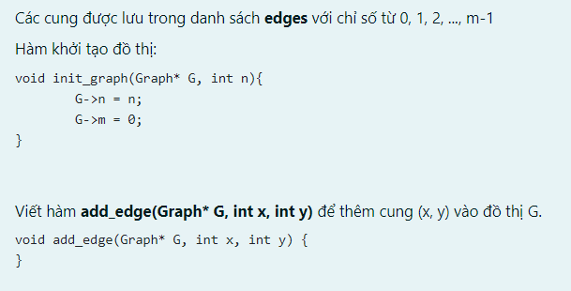

void add_edge(Graph* G, int x, int y) {

G->edges[G->m].x=x;

G->edges[G->m].y=y;

G->m++;

}

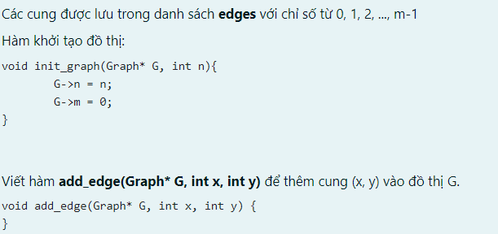

void add_edge(Graph* G, int x, int y) {

if( x>0 && x<=G->n && y>0 && y<=G->n){

G->edges[G->m].x=x;

G->edges[G->m].y=y;

G->m++;

}

}

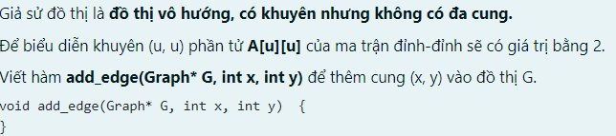

void add_edge(Graph* G, int x, int y) {

G->A[x][y]+=1;

G->A[y][x]+=1;

G->m++;

}



void add_edge(Graph *G,int e,int x,int y){

G->A[x][e]=1;

G->A[y][e]=1;

}

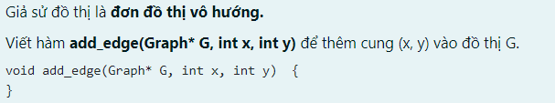

void add_edge(Graph* G, int x, int y) {

G->A[x][y]=1;

G->A[y][x]=1;

G->m++;

}

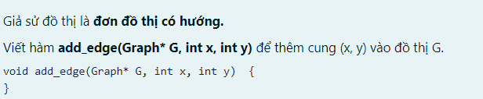

void add_edge(Graph* G, int x, int y) {

G->A[x][y]=1;

G->m++;

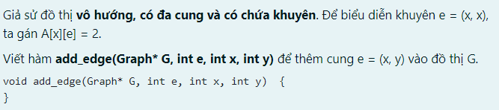}

void add_edge(Graph* G, int e, int x, int y) {

G->A[x][e]+=1;

G->A[y][e]+=1;

G->m++;

}

void add_edge(Graph* G, int x, int y) {

G->A[x][y]+=1;

G->A[y][x]+=1;

G->m++;

}

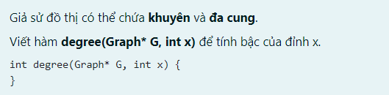

int degree(Graph* G, int x) {

int i,deg=0;

for(i=0;i<=G->m;i++){

if( (G->edges[i].x==x) || (G->edges[i].y==x)){

deg++;

}

}

return deg;

}



int deg(Graph *G,int x){

int i,deg=0;

for(i=1;i<=G->m;i++){

if(G->A[x][i]!=0){

deg++;

}

}return deg;

}

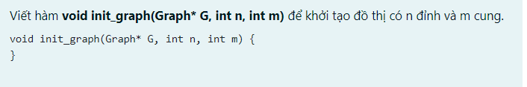

void init_graph(Graph* G, int n, int m) {

int i,j;

G->n=n;

G->m=m;

for(i=1;i<=G->n;i++){

for(j=1;j<=G->n;j++){

G->A[i][j]=0;

}

}

}



int deg(Graph* G, int x) {

int y,deg=0;

for(y=1;y<=G->n;y++){

if(G->A[x][y]!=0){

deg++;

}

}

return deg;

}



int edgeCount(Graph *G){

int u,v, dem=0;

for (u=1;u<=G->n;u++)

for(v=1;v<=u;v++)

if(G->A[u][v]!=0)

dem+=G->A[u][v];

return dem;

}

List neighbors(Graph* G, int x){

List l;

for(int i=1;i<=G->n;i++){

if(G->A[x][i]!=0){

push_back(&l,i);

}

}

return l;

}



void remove_edge(Graph* G, int x, int y) {

if(G->A[x][y]==0)

return ;

G->A[x][y]-=1;

G->A[y][x]-=1;

G->m--;

}