1. Choose Technologies
   1. Swift or Objective-C (iOS): These are the primary languages for iOS app development. Swift is the newer language introduced by Apple, which is gaining popularity due to its modern syntax and safety features. Objective-C is the older language traditionally used for iOS development.
   2. Java or Kotlin (Android): Java has been the traditional language for Android development. However, Kotlin, introduced by JetBrains and officially supported by Google, has gained significant traction due to its modern features, conciseness, and interoperability with Java.
   3. JavaScript (React Native, NativeScript): With frameworks like React Native and NativeScript, developers can build cross-platform mobile apps using JavaScript. These frameworks allow for code reusability across iOS and Android platforms while still providing native-like performance.
   4. Dart (Flutter): Flutter, developed by Google, uses Dart as its programming language. Flutter allows developers to create cross-platform mobile apps with a single codebase. It provides high-performance, customizable UI components, and hot reload for fast development.
2. Similar applications
   1. Edmodo:

Edmodo is a widely used flexible educational platform that helps teachers interact with students and implement lessons according to CCSS standards. With an easy-to-use interface, it facilitates communication and collaboration between teachers, students and parents. Edmodo also functions as a learning management system, providing online storage space for assignments and resources. Availability on multiple devices enables flexible learning and communication, supporting online learning and communication between teachers and students. Additionally, it also connects stakeholders in education, encouraging the exchange of ideas and resources. Edmodo not only improves the learning experience but also expands teachers' professional networks.

Edmodo offers a plethora of advantages that enhance the educational experience for both teachers and students. One of its standout features is team coordination, streamlining communication and collaboration among educators. The platform facilitates regular student check-ins, ensuring that no student feels left behind. It provides a safe and collaborative environment where teachers can share and store resources, fostering a culture of resource-sharing within the educational community. With engagement tools and assignment schedules, Edmodo promotes active learning and keeps both teachers and students organized. Its seamless Google integration, class discussions, and ease of access further contribute to its appeal. Notably, its aesthetically pleasing interface, reminiscent of popular social media platforms, coupled with strong customer support and robust formative assessment capabilities, make Edmodo a comprehensive solution for modern education.

Despite its many strengths, Edmodo does come with some drawbacks that users have noted. A significant concern is the lack of control over personal messaging features, making it challenging to maintain appropriate teacher-student communication boundaries. Additionally, users have expressed a desire for the return of features like Snapshots for formative assessments and improvements in the user interface for a smoother experience. The connection with Google Education could be more seamless, and users have reported occasional technical glitches, especially on the mobile version. There have also been isolated incidents of student responses disappearing and persistent notification issues. While Edmodo's mobile version doesn't quite match up to its web counterpart in terms of functionality, and occasional performance slowdowns occur, these challenges don't overshadow its overall utility in the educational landscape.

* 1. Canvas:

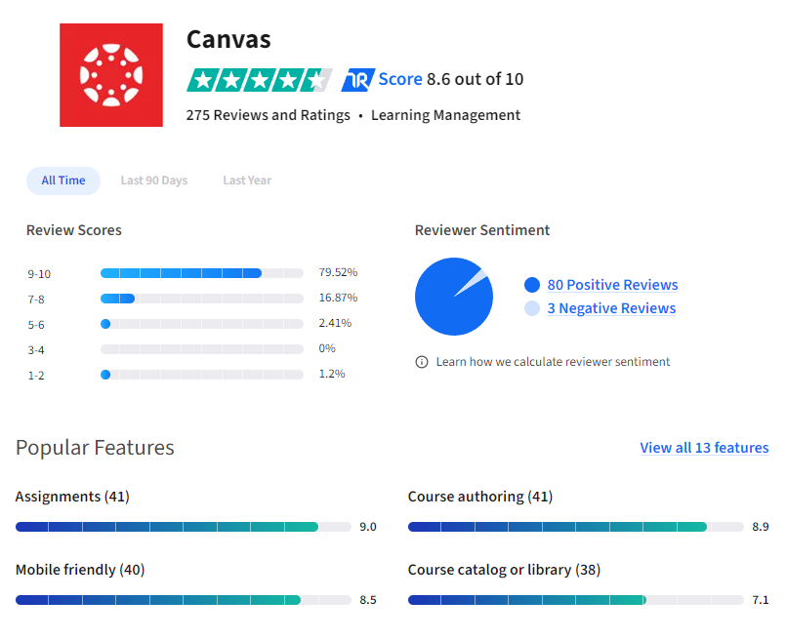

Canvas is a highly regarded learning management system adopted by universities, colleges, and schools for its user-friendly interface and effectiveness in managing both online and blended courses. It bridges communication between instructors and students, aiding in assignments, content sharing, and grade management. Beyond academics, Canvas serves HR for skill assessments, Student Services for club promotions, and libraries for information dissemination. Its mobile app enhances accessibility, and its frequent updates and robust features make it versatile for various course types. Overall, Canvas is essential for delivering quality education and promoting student engagement with its diverse features.

Canvas impresses users with its frequent updates, showcasing its commitment to improving the user experience and staying current. The mobile grading feature, Speed Grader, reduces grading time significantly, making it convenient for instructors to grade on the move. Additionally, Canvas's intuitive WYSIWYG editor simplifies content creation, allowing users to create engaging course materials easily, enhancing the learning experience for students.

While Canvas offers many features appreciated by users, there are areas of concern. Some find the navigation confusing and non-intuitive, making it challenging to find desired functionalities. Users also express dissatisfaction with the limited customization options for personalizing their experience. Additionally, there are concerns about the quality of customer support, with reports of delayed responses and availability issues.

* 1. Schoology

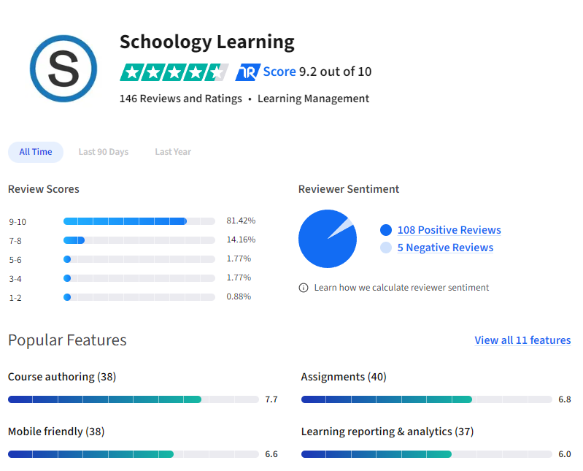

Schoology is a comprehensive Learning Management System popular among educators, students, and school districts for enhancing learning and communication. Teachers use it to share resources, post assignments, and assess students, while also coordinating school activities and fostering school culture. It facilitates easy communication between educators and families, manages events, assignments, and assessments, and encourages interactive class discussions. Students access course materials and assignments, benefiting from interactive learning. Parents receive regular updates on their child's progress. Schoology's user-friendly interface has led to its widespread adoption by school districts for addressing educational needs. Additionally, organizations use Schoology for professional development and training. Overall, Schoology simplifies the transition to digital classrooms, offering valuable tools for education and collaboration.

Pros of Schoology:

Schoology offers valuable integrations like Google Assignment App, which is especially beneficial for schools using Google and Chromebooks. It also integrates well with Microsoft OneDrive and Google Drive, facilitating seamless document sharing and assignments. Additionally, the platform provides options for assessment monitoring for schools and districts. The upcoming interface updates promise a cleaner look and an elementary version, aiming to enhance user experience. More question types, including labeling, have been introduced for assessments, broadening the scope of evaluation tools available to educators.

Cons of Schoology:

Despite its pros, Schoology has faced criticisms, primarily around unfulfilled promises regarding feature additions and improvements. Grading Google Drive Assignments can be cumbersome due to scrolling issues, and short answer/essay questions in assessments aren't readily visible for grading. Many teachers report that known pain points are never addressed by support, even after escalation. The focus of Schoology's roadmap appears to be more on integrating with other PowerSchool products rather than resolving existing platform issues. Additionally, the platform lacks some basic features like the ability to move and resize pop-up editing boxes, and settings and due dates for assessments are inconsistently located, leading to potential functionality issues.

1. Implementation
   1. Development tools

I used many tools to complete this application. Those tools are:

* + 1. Android Studio

Android Studio is the official Integrated Development Environment (IDE) for Android app development. Based on the powerful code editor and developer tools from IntelliJ IDEA , Android Studio offers even more features that enhance your productivity when building Android apps, such as:

A flexible Gradle-based build system

A fast and feature-rich emulator

A unified environment where you can develop for all Android devices

Live Edit to update composables in emulators and physical devices in real time

Code templates and GitHub integration to help you build common app features and import sample code

Extensive testing tools and frameworks

Lint tools to catch performance, usability, version compatibility, and other problems

C++ and NDK support

Built-in support for Google Cloud Platform, making it easy to integrate Google Cloud Messaging and App Engine

<https://developer.android.com/studio/intro>

* + 1. LDPlayer 9

LDPlayer 9 is an emulator for PC that lets you enjoy the Android 9 version. This way, you will be able to play all your favorite games in a fast environment with better quality and performance.

Whether you've already used a previous version of LDPlayer or another emulator, the LDPlayer 9 interface is simple, practical, and easy to understand and customize. In LDPlayer 9, you can install the APKs of your favorite games and apps. And, although the Google Play Store comes already installed, you can always add alternative stores, such as Uptodown.

LDPlayer 9 lets you map the controls to be able to use a mouse and keyboard in your games, meaning you can move more easily. The program also supports physical game controllers. There are many settings in LDPlayer 9 for improving your gaming experience. You can configure more than one virtual machine or select, for example, how many system resources you want to use.

In short, LDPlayer 9 is a good, smooth-working emulator with good performance and quality, perfect for players looking to play on PC. If you want to enjoy the latest Android games on your computer, don't hesitate to download LDPlayer 9.

<https://ldplayer-9.en.uptodown.com/windows#:~:text=LDPlayer%209%20is%20an%20emulator,with%20better%20quality%20and%20performance>.

* + 1. SamSung Galaxy J2 Prime

This is a mobile device using the Android operating system. I use this to run the application. The device is connected to the computer via a cable.

* + 1. Trello:

Trello is the visual work management tool that empowers teams to ideate, plan, manage, and celebrate their work together in a collaborative, productive, and organized way.

Whether you and your team are starting something new or trying to get more organized with your existing work, Trello adapts to any project. It helps you simplify and standardize your team’s work process in an intuitive way. But don’t let its simplicity fool you! Trello is user-friendly, yet still able to handle your team’s most robust projects.

This is a quick overview of the things you need to know when you are just getting started with your first project on Trello.

<https://trello.com/guide/trello-101>

* 1. Project Structure:

The project structure is shown in the figure below. Role of each folder:

+ Models: Stores the model source code of the entire application.

+ Student: Stores Student's functional source code in the application.

+ Tutor: Stores Tutor's functional source code in the application.

+ The remaining class in "com.example.tutorkit": Stores the source code for common features of both Student and Tutor.

+ Layout: Stores the user interface source code of the entire application.

+ Drawable: Stores images, icons,... used in the interface

* 1. Code snippets of important features:
     1. A
     2. B
     3. B
     4. C
     5. D
  2. Development plan

Phase 1: Requirements Gathering and Analysis.

+ Contact with stakeholders to identify project requirements.

+ Literature review about incoming domain as well as technologies and methodologies

and create Literature review document.

+ Identify project attributes (Objective, Aim, Scope, etc.).

+ Create System Requirement Specification (SRS).

+ Obtain user acceptance about the requirements documents.

Milestone: Requirements document approved

Phase 2: System Design and Architecture.

+ Design the system architecture.

+ Design Use Case Diagram.

+ Normalize and design database.

+ Design User Interfaces.

+ Obtain user acceptance about the design documents.

Milestone: Design document approved

Phase 3: Implementation

+ Project development based on the design and requirement documents.

+ Perform unit test during development process.

+ Integrated third-party services.

Milestone: Software completely developed.

Phase 4: Test and fix bugs.

+ Write test plan, include test scenario, test cases and test logs.

+ Perform test based on the test plan.

+ Contact with stakeholders to join in the testing process.

+ Report developers about bugs, prioritize low-difficulty and high-priority bugs.

Milestone: Complete test plan with data.

Phase 5: Create documents.

+ Gathering document from previous phases.

+ Create User Manual document.

+ Obtain user acceptance about documents.

Milestone: All document approved

1. Test case

|  |  |  |  |  |  |  |
| --- | --- | --- | --- | --- | --- | --- |
| Function | ID | Description | Data | Expected result | Actual result | Status |
| Register | R-001 | Not filling in the input and clicking the submit button. |  | Warning for filling in missing information. | Warning for filling in missing information. | Pass |
| R-002 | Verify the phone number according to the device's language (for example, if the phone is set to Vietnam, you must fill in the phone number according to Vietnam such as 036 XXX XXXX, 098 XXX XXXX,....) | 0367959940 | Success (qualification) | Don’t have notification | Pass |
| 0147859632 | Notification (Phone no. is not valid) and Re-enter | Notification (Phone no. is not valid) and Re-enter | Pass |
| R-003 | Check phone number have 10 numbers | 0367959940 | Success (qualification) | Don’t have notification | Pass |
| 0367954 | Notification (Phone no. is not valid) and Re-enter | Notification (Phone no. is not valid) and Re-enter | Pass |
| R-005 | Check email already exists | Enter : [minhnguyen010502@gmail.com](mailto:minhnguyen010502@gmail.com)  Email exists: [minhnguyen010502@gmail.com](mailto:minhnguyen010502@gmail.com) | Notify: enter another email | Notify: enter another email | Pass |
| R-004 | The password field must have a minimum of 6 | uiojkl | Success (qualification) | Don’t have notification | Pass |
| uio | Notification (password is too weak) and Re-enter | Notification (password is too weak) and Re-enter | Pass |
| R-005 | Verify user-added passwords must be protected, encrypted, and displayed with an asterisk (******). | uiojkl | Enter: uiojkl  Display : ****** | Enter: uiojkl  Display : ****** | Pass |
| R-006 | Verify if authentication is added for the password and confirm if the passwords are the same. | Password: uiojkl  Cf­-Password: uiojkl | Success (qualification) | Don’t have notification | Pass |
| Password: uiojklbnm  Cf­-Password: uiojkl | Notification (password confirm must be the same the password) | Notification (password confirm must be the same the password) | Pass |
| Password: uiojkl  Cf­-Password: uiojklbnm |
| R-007 | Verify the email verification link has been sent to the user's email address successfully. |  | Send a verification link to the email the person has registered with. | Send a verification link to the email the person has registered with. | Pass |
| Forgot password | FP-001 | Send link to email was enteted | minhnguyen010502@gmail.com | Send link reset password to email | Send link reset password to email | pass |
| FP-002 | Verify if authentication is added for the password and confirm if the passwords are the same. | Password: uiojkl  Cf­-Password: uiojkl | Success (qualification) | Don’t have notification | Pass |
| Password: uiojklbnm  Cf­-Password: uiojkl | Notification (password confirm must be the same the password) | Notification (password confirm must be the same the password) | Pass |
| Password: uiojkl  Cf­-Password: uiojklbnm |
| FP-003 | Login again with new password | uiojkl | Success (qualification) | Don’t have notification | Pass |
| Login | LI-001 | Verify that the user can log in by entering credentials and clicking the Log In button. | True:  Email: [minhnguyen010502@gmail.com](mailto:minhnguyen010502@gmail.com)  Password:  uiojkl | Login success | Login success | Pass |
| False:  Email:  [asdfasf@gmail.com](mailto:asdfasf@gmail.com)  Password:  uiojkl | Don’t login | Don’t login | Pass |
| LI-002 | Check verifies user’s email | Email was verified | Login success | Login success | Pass |
| Email wasn’t verified | Open dialog open email | Open dialog open email | Pass |
| LI-003 | Check device have app email | yes | Open app email | Open app email | Pass |
| no | Notify (don’t have app) | Notify (don’t have app) | Pass |
| LI-004 | Verify that the entered password is in encrypted form (******). | uiojkl | Display  ****** | Display  ****** | Pass |
| LI-005 | Verify that the user can see the password by clicking the eye icon. | Display ****** | Display:  uiojkl | Display:  uiojkl | Pass |
| LI-006 | Verify the error message that displays after leaving the passcode or password field blank. |  | Notify enter email and password | Notify enter email and password | Pass |
| LI-007 | Verify authorization when logging in by role. | Email Student | Open page Student home | Open page Student home | Pass |
| Email Tutor | Open page Tutor home | Open page Tutor home | Pass |
| Logout | Lo-001 | Logout |  | Return login page | Return login page | Pass |
| Function account user | FA-001 | View Profile | Data of account | Display information | Display information | Pass |
| FA-002 | Update profile | Data of account | View data before update | View data before update | Pass |
| FA-003 | Not filling in the input and clicking the submit button. |  | Warning for filling in missing information. | Warning for filling in missing information. | Pass |
| FA-004 | Verify the phone number according to the device's language (for example, if the phone is set to Vietnam, you must fill in the phone number according to Vietnam such as 036 XXX XXXX, 098 XXX XXXX, ....) | 0367959940 | Success (qualification) | Don’t have notification | Pass |
| 0147859632 | Notification (Phone no. is not valid) and Re-enter | Notification (Phone no. is not valid) and Re-enter | Pass |
| FA-005 | Check phone number have 10 numbers | 0367959940 | Success (qualification) | Don’t have notification | Pass |
| 0367954 | Notification (Phone no. is not valid) and Re-enter | Notification (Phone no. is not valid) and Re-enter | Pass |
| FA-006 | Update Email | Correct password | Button Authentication cannot be clicked and the new email input box and button Update are opened. | Button Authentication cannot be clicked and the new email input box and button Update are opened. | Pass |
| Incorrect password | Error and re-enter | Error and re-enter | Pass |
| FA-007 | Verify Email format. | asdasd | Notify enter valid email | Notify enter valid email | Pass |
| minhnguyen010502@gmail.com | Back to page login and notify “Verify new email” | Back to page login and notify “Verify new email” | Pass |
| FA-008 | Login with new email | New Email was verified | Login success | Login success | Pass |
| New Email wasn’t verified | Open dialog open email | Open dialog open email | Pass |
| FA-009 | Update password | Incorrect old password | Error and re-enter | Error and re-enter | Pass |
| Correct old password | Button Authentication cannot be clicked and the new password and confirm password input box and button Update are opened. | Button Authentication cannot be clicked and the new password and confirm password input box and button Update are opened. | Pass |
| New password: uiojkl  Old password : uiojkl | Notify: new password don’t have to be the same old password | Notify: new password don’t have to be the same old password | Pass |
| New password:jklbnm  Confirm password: jklbnmuio  Or  New password:jklbnmuio  Confirm password: jklbnm | Notify: confirm password must be the same new password | Notify: confirm password must be the same new password | Pass |
| New password:jklbnm  Confirm password: jklbnm | Update success and back to page login | Update success and back to page login | Pass |
| FA-010 | The new password field must have a minimum of 6 | New password:jkl | Notification (password is too weak) and Re-enter | Notification (password is too weak) and Re-enter | Pass |
| New password:jklbnm | Update success and back to page login | Update success and back to page login | pass |
| FA-011 | Login with new password | jklbnm | Login success | Login success | Pass |
| uiojkl | Login fail | Login fail | pass |
| Support | S-001 | View developer information | Email address, phone, fb, git, insta | Display email address, phone, fb, git, insta | Display email address, phone, fb, git, insta | Pass |
| S-002 | Send email | Email | Clicking on the email address will open the email application and the incoming email address is the developer's email | Clicking on the email address will open the email application and the incoming email address is the developer's email | Pass |
| S-003 | Call to developer | Phone no. | Clicking on the phone number will open the phone app and the developer's phone number will be displayed and just click call. | Clicking on the phone number will open the phone app and the developer's phone number will be displayed | Pass |
| S-004 | Connect fb with developer | Link fb | Clicking on the fb icon will lead to the developer's fb | Clicking on the fb icon will lead to the developer's fb | Pass |
| S-005 | Connect insta with developer | Link insta | Clicking on the insta icon will lead to the developer's insta | Clicking on the insta icon will lead to the developer's insta | Pass |
| S-006 | Open source code of project | Link git | Clicking on the git icon will open git which saves the project's source code. | Clicking on the git icon will open git which saves the project's source code. | Pass |
| Function Student | FS-001 | View list Tutors | All tutors | All tutors not approve in database display | Button choose the tutor was hired | Pass |
| FS-002 | Choose tutor |  | Information’s student display in page list Student in account Tutor who that student clicked choose | Information’s student display in page list Student in account Tutor who that student clicked choose | Pass |
| FS-003 | View list student’s tutors | List tutors approved | The list of approved tutors is displayed on the "Your tutor" page. | The list of approved tutors is displayed on the "Your tutor" page. | Pass |
| FS-004 | View student’s grade  (click to tutor created grade) | Grade (grade was created by tutor’s that student) | List student’s grades displayed | List student’s grades displayed | Pass |
| FS-005 | View list Assignments need to submit (all student’s tutors) | List Assignments | List Assignments displayed | List Assignments displayed | Pass |
| FS -006 | Verify that assignments past the deadline will not be submitted. | Dateline: 4/4/2024  Today: 7/4/2024 | Button Submit not working | Button Submit not working | Pass |
| FS-007 | Submit Assignment  (click button plus to choose image) | Image’s assignment | Display list image’s assignment when click button add in dialog | Display list image’s assignment | Pass |
| FS-008 | Tuition invoices need to be paid. | Tuition invoices | Displays the student's tuition invoice that needs to be paid. | Displays the student's tuition invoice that needs to be paid. | Pass |
| FS-009 | Payment |  | Payment with PayPal | Payment with PayPal | Pass |
| FS-010 | Take an exam | Id’s exam | Displays the test with the student id just entered | displays the test with the student id just entered | Pass |
| Id don’t exist | Box input was cleared | Box input was cleared | Pass |
| FS-011 | View solved quizzes | The exam was solved | Display the exam was solved and result | Display the exam was solved and result | Pass |
| FS-012 | View schedule | The schedule | Displays the day of the month and a list of class schedules | Displays the day of the month and a list of class schedules | Pass |
| FS-013 | Highlight the day have Schedule |  | The day have schedule change color | The day have schedule doesn’t change color | Fail |
| FS-014 | Chat with student’s tutors |  | Tutor and student chat together | Tutor and student chat together | Pass |
| FS-015 | Call with student’s tutors |  | Student call for tutor’s the student by phone number | Student call for tutor’s the student by phone number | Pass |
| Function tutor | FT-001 | Approve student |  | Display list students need to approve | Display list students need to approve | Pass |
| FT-002 | View list students approved |  | Display list students approved in Your student page | Display list students approved in Your student page | Pass |
| FT-002 | Add grade’s student.  Not filling in the input and clicking the ADD button. |  | Warning for filling in missing. | Warning for filling in missing. | Pass |
| FT-003 | Add grade’s student.  Garde >10 and <0 | Grade: 12  Or grade: -1 | Notify: grade must be less than 10 and greater than 0 | Notify: grade must be less than 10 and greater than 0 | Pass |
| FT-004 | Add grade’s student. | Type: Assignment or exam (using spiner)  Title: lesson 1  Grade: 7  Date: 4/4/2024 (picker) | Notify: done  And display list grade’s the student | Notify: done  And display list grade’s the student | Pass |
| FT-005 | Edit grade’s the student.  View before edit | Type: Assignment (using spiner)  Title: lesson 1  Grade: 7  Date: 4/4/2024 (picker) | Display that grade’s the student | Display that grade’s the student | Pass |
| FT-006 | Edit grade’s the student.  Not filling in the input and clicking the ADD button. |  | Warning for filling in missing. | Warning for filling in missing. | Pass |
| FT-007 | Edit grade’s the student.  Garde >10 and <0 | Grade: 12  Or grade: -1 | Notify: grade must be less than 10 and greater than 0 | Notify: grade must be less than 10 and greater than 0 | Pass |
| FT-008 | Edit grade’s the student. | New:  Type: Exam (using spiner)  Title: lesson 3  Grade: 8  Date: 8/4/2024 (picker) | Notify :update success and display:  Type: Exam (using spiner)  Title: lesson 3  Grade: 8  Date: 8/4/2024 (picker) | Notify :update success and display:  Type: Exam (using spiner)  Title: lesson 3  Grade: 8  Date: 8/4/2024 (picker) | Pass |
| FT-009 | Delete grade’s student | Type: Exam (using spinner)  Title: lesson 3  Grade: 8  Date: 8/4/2024 (picker) | That grade does not exist on screen nor on database | That grade does not exist on screen nor on database | Pass |
| FT-010 | Create an area to submit assignments.  Not filling in the input and clicking the ADD button. |  | Warning for filling in missing. | Warning for filling in missing. | Pass |
| FT-011 | Create an area to submit assignments.  Pick date in the past. | Date: 1/4/2024  Today: 4/4/2024 | Notify: please select the future date | Notify: please select the future date | Pass |
| FT-012 | Create an area to submit assignments. | Student: Salah(spinner with list tutor’s students)  Title: write a paragraph describing mother  Dateline: 7/4/2024 | Notify: done  And display list an areas to submit assignments | Notify: done  And display list an areas to submit assignments | Pass |
| FT-013 | Update an area to submit assignments.  View before edit | Student: Salah(spinner with list tutor’s students)  Title: write a paragraph describing mother  Dateline: 7/4/2024 | Display:  Student: Salah  Title: write a paragraph describing mother  Dateline: 7/4/2024 | Display:  Student: Salah  Title: write a paragraph describing mother  Dateline: 7/4/2024 | Pass |
| FT-014 | Update an area to submit assignments.  Not filling in the input and clicking the ADD button. |  | Warning for filling in missing. | Warning for filling in missing. | Pass |
| FT-015 | Update an area to submit assignments.  Pick date in the past. | Date: 1/4/2024  Today: 4/4/2024 | Notify: please select the future date | Notify: please select the future date | Pass |
| FT-016 | Update an area to submit assignments. | Student: Salah  (spinner with list tutor’s students)  Title: write a paragraph describing father  Dateline: 10/4/2024 | Display:  Student: Salah  Title: write a paragraph describing father  Dateline: 10/4/2024 | Display:  Student: Salah  Title: write a paragraph describing father  Dateline: 10/4/2024 | Pass |
| FT-017 | Delete an area to submit assignments. | Student: Salah  (spinner with list tutor’s students)  Title: write a paragraph describing father  Dateline: 10/4/2024 | That area to submit assignments does not exist on screen nor on database | That area to submit assignments does not exist on screen nor on database | Pass |
| FT-018 | Create tuition.  Not filling in the input and clicking the ADD button. |  | Warning for filling in missing. | Warning for filling in missing. | Pass |
| FT-019 | Create tuition.  Pick date in the past. | Date: 1/4/2024  Today: 4/4/2024 | Notify: please select the future date | Notify: please select the future date | Pass |
| FT-020 | Create tuition. | Student: nunez  (spinner with list tutor’s students)  Amount: 12  Price: 12  Dateline: 20/04/2024 (picker) | Notify: done  Display:  Student: nunez  Amount: 12  Price: 12  Dateline: 20/04/2024  Total: 144 (amount*price) | Notify: done  Display:  Student: nunez  Amount: 12  Price: 12  Dateline: 20/04/2024  Total: 144 | Pass |
| FT-021 | Update tuition.  View before edit | Student: Salah  Amount: 12  Price: 12  Dateline: 20/04/2024 | Student: Salah  Amount: 12  Price: 12  Dateline: 20/04/2024 | Student: Salah  Amount: 12  Price: 12  Dateline: 20/04/2024 | Pass |
| FT-021 | Update tuition.  Not filling in the input and clicking the ADD button. |  | Warning for filling in missing. | Warning for filling in missing. | Pass |
| FT-022 | Update tuition.  Pick date in the past. | Date: 1/4/2024  Today: 4/4/2024 | Notify: please select the future date | Notify: please select the future date | Pass |
| FT-023 | Update tuition. | Student: Salah  Amount: 14  Price: 16  Dateline: 20/04/2024 | Notify: update success  Display:  Student: Salah  Amount: 14  Price: 16  Dateline: 20/04/2024  Total: 224 | Notify: update success  Display:  Student: Salah  Amount: 14  Price: 16  Dateline: 20/04/2024  Total: 224 | Pass |
| FT-024 | Delete tuition | Student: Salah  Amount: 14  Price: 16  Dateline: 20/04/2024 | That tuition does not exist on screen nor on database | That tuition does not exist on screen nor on database | Pass |
| FT-025 | Create exam.  Not filling in the input and clicking the create button. |  | Notify :  Quiz title can not be empty | Notify :  Quiz title can not be empty | pass |
| FT-025 | Create exam. | Title: Math | Open page add question and answer (multiple choice) | Open page add question and answer (multiple choice) | Pass |
| FT-026 | Create questions and answers | Tick the missing number  [2, 3, 4, 5, ? , 7]:   1. 5 (b) 1 (c) 6 (d) 0   Tick the smallest number  (a) 85 (b) 76 (c) 89 (d) 65 | Notify: id of exam: 100001 | Notify: id of exam: 100001 | Pass |
| FT-027 | View result of exam |  | List Students take that exam and result’s that student | List Students take that exam and result’s that student | pass |
| FT-028 | Chat with tutor’s students |  | Tutor and student chat together | Tutor and student chat together | Pass |
| FT-029 | Call for tutor’s students or parent’ student |  | Tutor call for tutor’s students or parent’ student by phone number | Tutor call for tutor’s students or parent’ student by phone number | Pass |
| FT-030 | Create schedule.  Not filling in the input and clicking the create button. |  | Notify: enter time | Notify: enter time | Pass |
| FT-031 | Create schedule. | Student: nunez  Time: 1:30 CH | Notify: done  (save to database) | Notify: done  (save to database) | Pass |
| FT-032 | View schedule. |  | Display list schedule | Display list schedule | Pass |
| FT-033 | Update schedule:  Not filling in the input and clicking the create button. |  | Notify: enter time | Notify: enter time | Pass |
| FT-031 | Update schedule. | Student: nunez  Time: 5:30 CH | Notify: update success  Display:  Student: nunez  Time: 5:30 CH | Notify: update success  Display:  Student: nunez  Time: 5:30 CH | Pass |
| FT-031 | Update schedule.  View before update | Student: nunez  Time: 1:30 CH | Student: nunez  Time: 1:30 CH | Student: nunez  Time: 1:30 CH | Pass |
| FT-032 | Delete schedule: | Student: nunez  Time: 1:30 CH | That schedule does not exist on screen nor on database | That schedule does not exist on screen nor on database | Pass |

|  |  |  |  |  |  |
| --- | --- | --- | --- | --- | --- |
| Test | Number of test | Pass | Fail | Not yet | No test |
| Total | 82 | 81 | 1 | 0 | 0 |