

COMP1649 CW

Diving Clock



November 22, 2023

greenwich

Table of Contents

1 Introduction 3

2 Background literature: 3

2.1 HCI Research: 3

2.1.1 What Is HCI? 3

2.1.2 Importance of HCI 4

2.2 HCI Theory 4

2.2.1 Interaction design 4

2.2.2. Conceptual Models and Mental Models: 5

3 Design Process 5

3.1 Conceptual Design 5

3.2 Design principles 6

4 Prototype 7

4.1 Low-fidelity prototype 8

4.2 Hight-fidelity prototype 9

4.3 Mobile application 16

5 Research Study 24

5.1 Questions Research: 24

5.2 Analyze the following answer sheet 24

5.3 Participant recruitment: 25

6 Conclusion 25

7 Appendix 26

Context 26

Requirements 26

Design 27

Evaluation 27

Answer 27

Screens 30

References 31

Diving clock

<https://drive.google.com/file/d/1dHpy7OceDvFjPfnjp71CLwnpcGgVqgKk/view?usp=sharing>

Figure 1: Conceptual Design 6

Figure 2: The user-centered design process 7

Figure 3: low-fidelity prototype 8

Figure 4: watch charging dock 9

Figure 5: diving watch 10

Figure 6: Oxygen tank and diving mask 11

Figure 7: open device 12

Figure 8: using device 12

Figure 9: opening camera 13

Figure 10: display screen 14

Figure 11: taking a photo. 15

Figure 12: recording the video 15

Figure 13: mobile devices 16

Figure 14: Home Page 17

Figure 15:Album Page 18

Figure 16:Story Page 19

Figure 17: Diving Page 20

Figure 18: Diving Detail 21

Figure 19: Page Device 22

Figure 20: Connect with device 23

Table 1: answer 30

# Introduction

In the modern era, technology continues to develop rapidly, with regards to how individuals interact with the world. The rise of smart devices has become an indispensable part of many different aspects of daily life, meeting diverse needs and preferences. This paradigm shift has paved the way for innovative solutions that enhance convenience and deliver deeper emotional connections to users. In this project, my responsibility lies in creating a product that meets the unique requirements of both amateur and professional divers, to enhance their underwater experience. The goal is to contribute to the evolving landscape of smart devices by creating a product that not only serves a functional purpose but also fosters a deeper connection between divers and the world below. enchanting water.

# Background literature:

The diving device I have developed is a tool designed to enhance the underwater experience for professional and amateur divers, providing a seamless combination of information, position tracking and recording fun. capture the breathtaking moments beneath the surface. This innovative device is more than just a diving accessory; It's a comprehensive solution created to enrich the overall diving adventure. Through an intuitive interface, divers can conveniently view real-time data related to their dive, including depth, temperature, and remaining dive time. The device leverages advanced sensor technology to ensure accurate and reliable data, providing divers with the insights they need for a safe and enjoyable underwater journey. The device provides a compass display, allowing divers to plan and track their routes, discovering new dive locations.

## HCI Research:

### What Is HCI?

Human-Computer Interaction (HCI) is a dynamic and multidisciplinary field that places a paramount focus on refining the interaction between users and computers. At its core, HCI is driven by the objective of crafting interactive computer interfaces that are not only technically efficient but also seamlessly align with the diverse needs and preferences of users (Kanade, 2022). This field is characterized by its integration of insights from a spectrum of disciplines, reflecting its complex and multifaceted nature. Embracing elements of computer science, HCI draws on the technical aspects of software and hardware design to optimize the functionality and performance of interactive systems. Behavioral sciences contribute to the understanding of how users engage with technology, exploring patterns of user behavior and preferences.

### Importance of HCI

Human-Computer Interaction (HCI) plays a crucial role in optimizing the interaction between users and technology, leading to a multitude of benefits:

Enhancing User Experience: HCI places a strong emphasis on designing technology that is user-friendly and intuitive, aiming to create positive experiences that promote the adoption and effective utilization of the technology, ultimately leading to increased user satisfaction. (simplilearn, 2023).

User Satisfaction and Loyalty: Satisfactory user experiences cultivate loyalty and contentment. Users who are pleased are more likely to endorse products or services to others, playing a pivotal role in building brand reputation and facilitating growth. (simplilearn, 2023).

Cost Savings: Incorporating HCI principles into technology design results in cost savings by minimizing the need for customer support, reducing errors and the necessity for rework, and enhancing overall user efficiency. (simplilearn, 2023).

## HCI Theory

### Interaction design

Interaction design, put simply yet not oversimplified, involves crafting the interaction between users and products. While the focus often lies on software products such as applications or websites, interaction design aims to develop products that empower users to efficiently accomplish their objectives (Siang, 2020).

The five aspects of interaction design, as articulated by Gillian Crampton Smith and Kevin Silver, include language, visual elements, physical space or objects, time, and behavior. These dimensions underscore the significance of clear and meaningful language, the integration of visual elements such as images and typography for effective representation, and the consideration of physical space and objects, temporal aspects, and behavioral aspects in the design process. Physical objects or spatial considerations play a crucial role in shaping user-product interaction. Time encompasses dynamic media like animations and sounds, as well as the duration of user engagement. Lastly, behavior involves the mechanism of the product and user reactions, contributing significantly to the overall interactive experience (Siang, 2020).

### 2.2.2. Conceptual Models and Mental Models:

Exceptional interaction design ensures the provision of all necessary information for users to construct a solid conceptual model of the system. This, in turn, fosters understanding and a feeling of control. A well-developed conceptual model enhances both the discoverability of features and the evaluation of outcomes during system use (Philips, 2023).

Mental models, also known as cognitive maps, are the mental images users hold, shaping their expectations of interactions and real-world functionalities. These cognitive maps serve as internal representations linked to spatial relationships within our physical environment. By adeptly incorporating a user's mental model, interaction designers can craft systems that intuitively align with user expectations (Philips, 2023).

# Design Process

## Conceptual Design

Conceptual design serves as the foundational structure that establishes the intention and idea behind a visual plan. This crucial phase occurs early in the design process, preceding the detailed specification of techniques such as the illustration style and specific color choices. Conceptual design acts as the cornerstone of the project, determining whether the concept is prepared for production. It fundamentally shapes the realization of the final project (Relić, 2023).

Figure : Conceptual Design

In interaction with user:

* Button: turn on, turn off mobile phone, Switch screen on diving watch
* Touchscreen: Open the app on your mobile device, take photos and record videos on your diving watch.

## Design principles

"UCD" usually refers to User Centered Design. User-centered design is an iterative design process in which designers focus on end users and their needs throughout the development process. UCD's goal is to create products and systems that are not only functional and effective, but also user-friendly and enjoyable (interaction, 2023).

“First, as designers working in teams, we try to understand the *context in which users* may use a system. Then, we identify and *specify the users’ requirements*. A *design* phase follows, in which the design team develops solutions. The team then proceeds to an *evaluation* phase. ” (interaction, 2023)

Figure : The user-centered design process

# Prototype

A prototype serves as a preliminary model of a product, enabling you to investigate your concepts and demonstrate the purpose behind a feature or the overall design concept to users prior to committing resources to full-scale development. Prototypes can range from basic paper sketches (low-fidelity) to interactive models allowing users to navigate through content (high-fidelity) (usability, 2023).

Benefits of Prototypes

Modifying a product in the early stages of development is more cost-effective than making changes after the site is fully developed. Consequently, it is advisable to create prototypes early in the process. Prototyping enables you to collect user feedback during the planning and design phases of your website, facilitating adjustments based on valuable insights (usability, 2023).

## Low-fidelity prototype

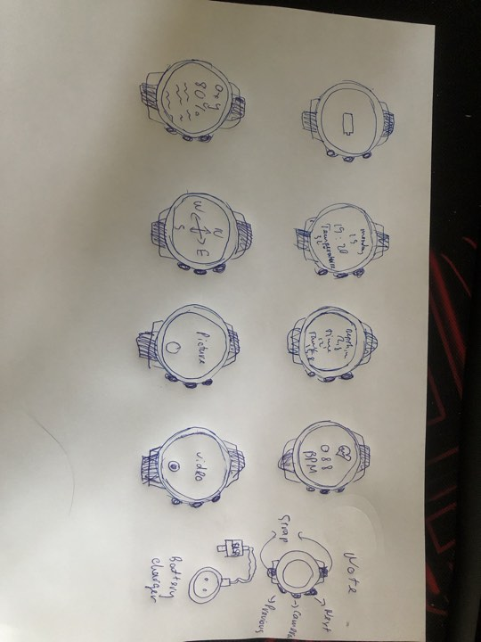

Figure : low-fidelity prototype

After coming up with the concepts and understanding of low fidelity, I designed a low fidelity diving watch. I use a pen to sketch the interface of the main functions of the machine. Includes a home screen that will display the watch's battery percentage. The next screens are Date and time screen, Oxygen parameters screen, Dive time and depth screen, Heart rate monitor screen, Compass screen. Screen records video and takes photos. Whether monitoring vital parameters, tracking time and depth, or capturing stunning images, the watch meets the diverse needs of underwater enthusiasts, enhancing both safety and performance. enjoyment of their diving efforts.

## Hight-fidelity prototype

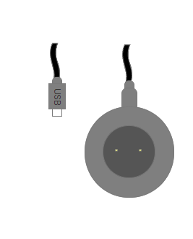

Figure : watch charging dock

The watch charging dock is designed in a circular shape to fit the back of the watch. When the watch runs out of battery, the user can place the back on it to charge the battery. The charging cord is designed with 2 ports: 1 type-C port for faster charging speed, the other port is USB to easily connect to chargers and devices with USB connection ports.

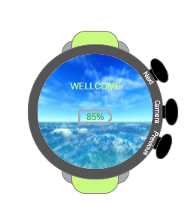

Figure : diving watch

The diving equipment I designed was a wristwatch. Color screen with LED backlight. Most importantly, I used MIP (memory in pixel) screen technology. MIP (memory in pixel) screen technology, in addition to helping the device save electricity, also has excellent visibility in many complex lighting conditions. Water resistant to 100 meters ~ 328 ft according to EN 13319-ISO 6425 standards for diving equipment. Wirelessly connect to oxygen tank to display pressure right on the watch. Alerts with both vibration and sound, 3D Digital Compass. The wire uses quick disassembly and can adapt to all wires with a width of 24mm. Battery life: 6-12 hours of continuous diving.

The watch is designed with 3 buttons: Next, Previous and Camera. Next and Previous are used to change the display on the watch. Camera pen is used to connect to the camera on the mask.

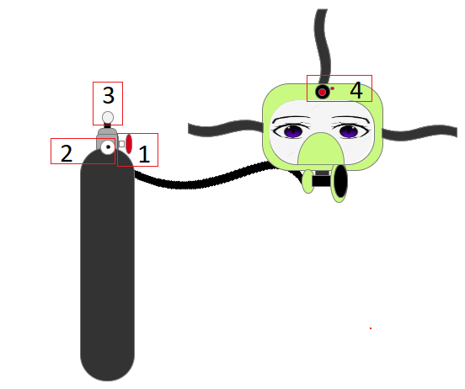

Figure : Oxygen tank and diving mask

Diver oxygen tanks are mainly used for divers from professional to amateur. With the use of providing oxygen to breathe underwater for long periods of time with other uses. An oxygen tank made of aluminum alloy has 21% oxygen compressed inside the tank for the purpose of supplying air to the mask for the user when diving. Used to provide air so you can breathe safely underwater for a period. There is a valve to open and close (1), a meter to measure the amount of oxygen in the tank (2), a signal light connected to the diving watch (3). The pressure a diving tank can withstand is higher than about Mpa (300 bar).

Scuba diving masks are designed with quality lenses, allowing for uninterrupted vision. Product size: 16 x 2 x 2cm, product weight: 7.2 grams. Furthermore, the mask strap is also very easy to adjust, creating the most comfortable feeling for the wearer. In addition, a camera is installed on the top of the mask and is wirelessly linked to the diving watch (4). The camera mounted on the mask is waterproof: up to 20 meters within 2 hours, shockproof: 2 meters, Rotation angle: 204 degrees and 151 degrees, Clear area: from 0.2 meters to infinity, Compute Electronic Image Stabilization (Movie SR), Photo format: JPEG ,Video format: MPEG-4 AVC/H.264 (MOV), Photo resolution: (4:3) 8M: 3264x2448, 5M: 2592x1944, (16:9) 6M: 3264x1840, 4M: 2592x1464, (1:1) 6M: 2448x2448, Video resolution: 3840x2160 @ 30fps, 1920x1080 @ 60fps/30fps, 1280x7 20 @ 120fps/60fps/30fps. and connected to the watch using the middle button on the watch.

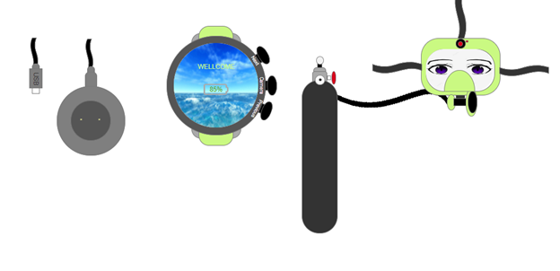

Figure : open device

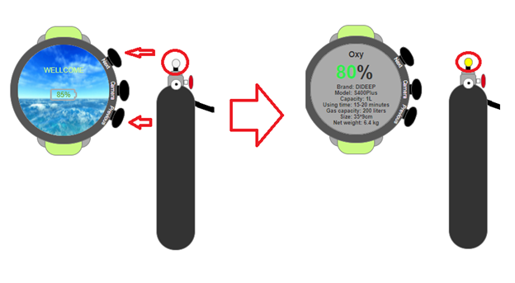

Figure : using device

When you start using it, the watch will automatically connect to the oxygen tank. When connected successfully, the indicator light will change to yellow

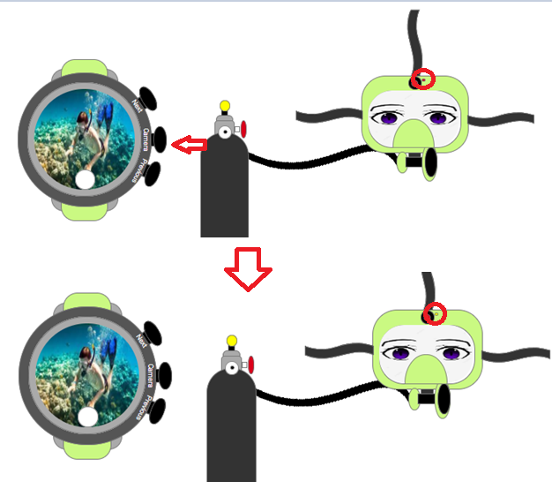

Figure : opening camera

On the left side of the watch there are 3 buttons. The 2 outside buttons will be used to change the clock screen (next, previous). The button held will be used to connect to the camera mounted on the top of the mask. When connected successfully, the indicator light will change to yellow

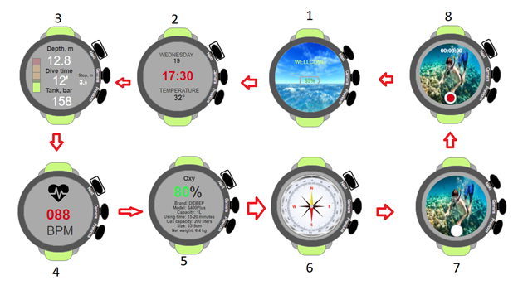

Figure : display screen

The multi-function diving watch boasts a user-friendly interface designed to meet the specific needs of divers. As you navigate through the different screens, each stage opens a wealth of important information for a safe and enjoyable diving experience. (8 screens)

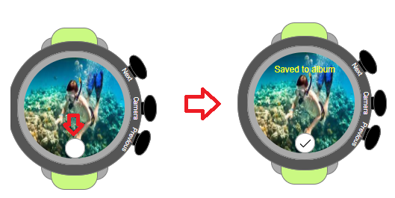

Figure : taking a photo.

The watch's capabilities of image capture and video recording redefine the way divers document their underwater experiences. The smooth operation, high-quality output, and integration with other features make this watch a reliable and versatile tool for capturing and preserving the wonders of the underwater world. Whether you are an avid underwater photographer or simply want to relive the magic of your dives, this watch stands as a testament to the convergence of technology and exploration.

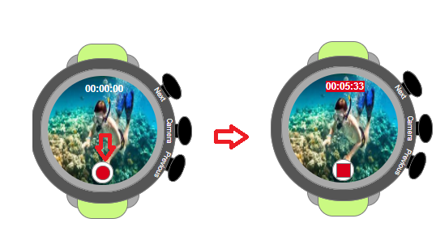

Figure : recording the video

## Mobile application

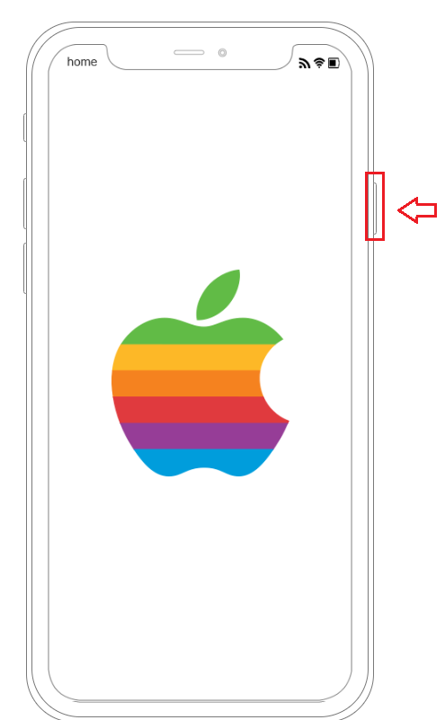

Figure : mobile devices

A mobile device is a smartphone whose main function is to save diving trip information, images, videos, and beautiful moments when the user goes scuba diving. When you press the open button on the right, the mobile device is started and the main screen is displayed.

Figure : Home Page

The main screen of a mobile device includes an application to help users easily share beautiful moments, store images, videos, etc.

The first is the album application, which helps users store images and videos recorded on the watch. The second is the Story application, which helps users share beautiful moments during their diving time. The third is the Diving application, which helps users save a list of sea areas and times they have explored. The fourth is the Device application, which helps users connect their mobile device to the diving watch.

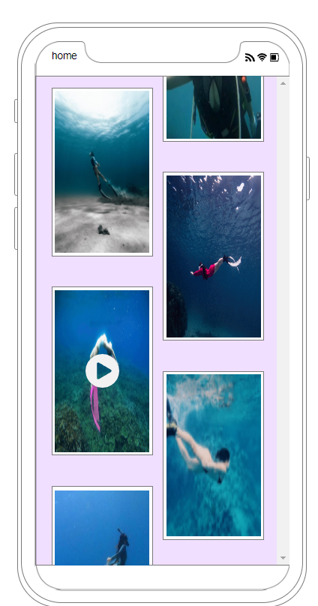

Figure :Album Page

Select the Album app on your mobile device, and the interface will seamlessly transition to a screen dedicated to your photo and video library. The design philosophy behind this interaction is rooted in user-centric principles, aiming to provide a clear and intuitive path for users to access and explore their media content. The design of this display is carefully crafted to present content in an organized and aesthetically pleasing manner. And press "home" in the upper left corner to return to the main screen.

Figure :Story Page

Choose the Story app to show off to your friends about your scuba diving trip. With the photo as the center to highlight the content the user wants to share, a small line of text describes the details of the posted photo, and below the photo is the time the article was posted. Above is the word "public" to notify that the article is in public mode and "ellipsis" helps users select many hidden functions such as editing the article, ... Below there is a trash can icon for users to use. Users can delete their posts, next to them is an emoticon so viewers can express their feelings about the post. And sharing icon so viewers can share with more people. And press "home" in the upper left corner to return to the main screen.

Figure : Diving Page

When selecting the Diving application, the screen switches to a screen containing a list of the user's diving trips. The centerpiece is a listing of each dive with name and date and featured photos. At the top is a search bar that helps users search for trips by name. Next to the search bar there is a trash icon that will delete trips that users no longer want to save. And press "home" in the upper left corner to return to the main screen.

Figure : Diving Detail

When clicking on any trip, detailed information of that trip will be displayed. Pressing the arrow in the upper left corner will return to the list of dive trips and the home button will return to the main screen.

Figure : Page Device

Connect to the watch, the user will click to select the Device application. The application will search for diving equipment and connect when clicking Connect.

Figure : Connect with device

When connecting successfully, a blue Connected Successfully message will appear and next to it is a Disconnect button when not in use anymore. The upper right corner will have the word "open device" to open the watch when connected successfully.

# Research Study

## Questions Research:

1. How do diving watch designs affect usability and readability underwater?
2. To what extent does the visibility of a diving watch affect a diver's safety in low-light or murky underwater conditions?
3. What are divers' preferences regarding the user interface and design of dive watches?
4. What factors contribute to the reliability of diving watches in different underwater environments?
5. How do environmental factors, such as exposure to salt water, affect the longevity of different dive watch materials?
6. How do the innovative features in newer dive watches compare to traditional models?

## Analyze the following answer sheet

The answer sheet provides detailed information on various aspects of diving watches, including design, visibility, user preferences, reliability factors, material selection and A comparison between innovative features in newer diving watches and traditional models. Here is a breakdown of the main points:

*Design and usability of diving watches:*

Feedback emphasized the importance of water resistance, sealing mechanisms, and anti-glare coating in enhancing the overall usability and longevity of dive watches.

*Visibility and diver safety:*

The response emphasized the role of improved visibility in ensuring diver safety, preventing miscalculation of dive times, aiding navigation and promoting safer diving practices.

*Diver options and user interface:*

Feedback related to divers' preference for backlit features in dark conditions and the value placed on intuitive and user-friendly controls.

*Material selection and saltwater exposure:*

The response compares the corrosion resistance and durability of different materials, noting that titanium is highly resistant to corrosion but is still subject to surface oxidation.

*Innovative features of newer diving watches compared to traditional diving watches:*

This analysis points out the differences between the design trends of newer dive watches, which feature contemporary aesthetics, larger case sizes, advanced materials, and traditional models that maintain classic designs and timeless.

## Participant recruitment:

The people I chose were people who had a lot of experience in scuba diving and were very suitable for my survey. I sent an invitation to participate in the dive watch survey via email to those on the list.

# Conclusion

In the development of the prototype, it has evolved into an underwater information tracking device designed to be compact and convenient for divers. The product design process reflects a deep understanding of user behavior towards the device. Additionally, its compact nature allows seamless connectivity to mobile devices through Bluetooth. The device has been tailored to accommodate all users, facilitating easy interaction with the underwater environment through three buttons on the left.

Thorough research on interactive design was conducted during the device's creation, ensuring user-friendly operation without the need for extensive documentation. The product boasts features enabling quick recognition of gas status, time, and depth during dives. The inclusion of a photo and video function enhances the diving experience, capturing memorable moments. Furthermore, the device aids underwater navigation, offering an overall solution to enhance the ease and enjoyment of diving, ensuring users don't miss out on the beauty beneath the waves.

While the current product is commendable, there is room for improvement to better serve users in the future. Proposed enhancements include the automatic determination of the user's location and alerts for potential hazards without the need to manually check each parameter. These additions aim to further elevate the device's functionality and contribute to a safer and more enjoyable diving experience.

# Appendix

## Context

The initial stage in the User-Centered Design (UCD) process involves conducting extensive research to gain valuable insights into the intended users and their interactions with the product. This phase is characterized by thorough UX research aimed at understanding the diverse demographics of potential users, discerning their objectives and motivations, identifying challenges they encounter, and comprehending their general needs and behaviors. This comprehensive research lays the groundwork for informed design decisions and ensures that the subsequent phases of the UCD process are grounded in a deep understanding of the user's perspective (BROWNE, 2021).

## Requirements

Once a comprehensive understanding of the product's intended users and their usage patterns is established, the next crucial step is to define company goals and the metrics that will be employed to gauge progress. This step is paramount in assessing the mutual benefits of the design for both users and the company. Without a clear delineation of goals and measurable metrics, it becomes challenging to ascertain the impact of the design and determine the point of achieving a successful final product. This strategic alignment ensures that the design process remains purposeful and contributes positively to both user satisfaction and the overarching objectives of the company (BROWNE, 2021).

## Design

Now that a comprehensive understanding of user needs and company goals has been established, the next phase involves the actual design of solutions. This is a familiar territory for most designers and encompasses the decision-making and construction of various product features and assets. During this phase, the focus is on translating the identified user requirements and business objectives into tangible design elements. Designers leverage their skills to create prototypes, wireframes, and other visual representations that align with the established goals, ensuring that the resulting product features effectively address user needs while contributing to the overall success of the company (BROWNE, 2021).

## Evaluation

After generating initial solutions, the next crucial step is to analyze and evaluate the designs to determine if they align with the goals established in the second phase. This involves taking a comprehensive look at the product and assessing its conformity with both user and business requirements. Usability testing with real users becomes an integral part of this evaluation process, providing valuable insights into how well the designs resonate with the intended audience. Through this testing, designers can identify strengths and areas for improvement, ensuring that the final product is not only aligned with user needs but also contributes effectively to the overarching objectives of the business (BROWNE, 2021).

## Answer

|  |  |  |  |
| --- | --- | --- | --- |
|  | Alex Nguyen | Tony Phung | Davis Tran |
| How do diving watch designs affect usability and readability underwater? | The water resistance of the watch and the effectiveness of its sealing mechanism impact overall usability and longevity, preventing water ingress and maintaining functionality underwater. | The intuitiveness of controls for adjusting settings underwater, as well as the design of buttons and crowns to facilitate ease of use with gloves, influences overall usability. | Incorporating anti-glare coatings on the crystal improves visibility in bright underwater conditions. |
| To what extent does the visibility of a diving watch affect a diver's safety in low-light or murky underwater conditions? | Improved visibility ensures quick and accurate time readings, preventing potential safety hazards associated with miscalculating dive duration. | A visible watch allows divers to track their position, maintain a sense of direction, and avoid disorientation in challenging underwater environments. | Divers may need to monitor other essential information on their watches, such as depth and ascent rate. Improved visibility ensures that divers can easily read and interpret these critical metrics, promoting safer dive practices. |
| What are divers' preferences regarding the user interface and design of dive watches? | Divers may appreciate watches with backlit features or displays, allowing them to read the time in dark conditions without relying solely on luminescence. | Divers value watches with user-friendly and intuitive controls, especially if adjustments need to be made underwater. | Straps that securely fasten to the wrist, often with adjustable features, are preferred for comfort and ensuring that the watch stays in place during dives. |
| What factors contribute to the reliability of diving watches in different underwater environments? | Diving watches should be able to withstand the potential impacts and shocks associated with underwater activities. Shock-resistant features protect the movement and internal components. | The watch's resistance to saltwater and corrosion is crucial for maintaining functionality over time. Corrosion-resistant materials and coatings contribute to the watch's longevity. | Diving watches should be designed to withstand variations in temperature that occur underwater. Extreme temperatures can impact the watch's accuracy and performance. |
| Environmental factors, such as exposure to salt water, affects the quality of the watch, so which material is best for diving watches? | Titanium is highly corrosion-resistant and lightweight. But it may still experience surface oxidation in extreme conditions. However, it is generally more durable in saltwater environments. | Rubber and silicone, often used in watch straps, are resistant to saltwater and comfortable to wear. But prolonged exposure may lead to degradation over time, but proper rinsing and maintenance can extend their lifespan. | High-quality plastics or resins are corrosion-resistant and lightweight. But they may be more susceptible to scratches and physical damage, but their resistance to corrosion makes them suitable for saltwater exposure. |
| How do the innovative features in newer dive watches compare to traditional models? | New Dive Watches: Embrace contemporary design trends, often featuring sleek profiles, larger case sizes, and a focus on modern aesthetics.  Traditional Models: May maintain classic and timeless designs, sometimes with smaller case sizes, appealing to those who prefer a more traditional or vintage look. | New Dive Watches: Some models integrate digital displays, dive computers, and smartwatch capabilities, providing additional functionalities like depth sensors, dive logs, and connectivity.  Traditional Models: Primarily analog in design, lacking digital or smart features found in more modern counterparts. | New Dive Watches: Utilize advanced materials like ceramics, carbon fiber, and lightweight alloys for improved durability, corrosion resistance, and reduced weight.  Traditional Models: Often feature stainless steel or, in some cases, titanium for the watch case, with fewer advancements in exotic materials. |

Table 1: answer

## Screens

1. Battery level screen:

Once activated, the watch will greet you with a clear indication of the battery level. This initial screen ensures that you start your dive confidently knowing the power status of your device.

2. Date, time and temperature screen:

With a simple press of the Next button, the watch will switch to a screen displaying the current date, time and temperature. This information is essential to coordinate diving and to be aware of external conditions.

3. Depth and dive time display:

The third screen of the watch interface provides data on the diver's elapsed diving depth and time. This important information assists divers in managing their underwater activities effectively and ensuring safety procedures are followed.

4. Heart rate control monitor:

Moving to the fourth screen, the watch introduces a feature intended to help divers regulate their heart rate. Monitoring this vital sign contributes to overall safety, allowing users to adjust their speed and activity accordingly.

5. Oxygen tank parameters and remaining air monitor:

The fifth screen delves into the specifics of the oxygen tank, showing the necessary parameters and the amount of air remaining. This data is indispensable for divers to plan their underwater activities, ensuring they have enough oxygen for the entire dive session.

6. Compass screen:

The sixth screen introduces a built-in compass, providing users with a reliable tool for underwater navigation. Ensuring that divers can maintain their bearings is important for a safe and enjoyable diving experience.

7. Screen capture:

Diving enthusiasts can capture the beauty of their underwater adventures with a seventh screen dedicated to photography. Users can capture stunning images directly from their dive sessions, creating lasting memories of the diverse marine environments they explore.

8. Video recording screen:

The final screen serves as a versatile tool to record the entire diving experience. With the video recording function, users can capture the vivid underwater world, creating vivid records of their adventures.

# References

BROWNE, C., 2021. *User-Centered Design: A How-To Guide.* [Online]   
Available at: https://careerfoundry.com/en/blog/ux-design/user-centered-design-how-to-guide/  
[Accessed 15 11 2023].

interaction, 2023. *User Centered Design.* [Online]   
Available at: https://www.interaction-design.org/literature/topics/user-centered-design  
[Accessed 15 11 2023].

Kanade, V., 2022. *What Is HCI (Human-Computer Interaction)? Meaning, Importance, Examples, and Goals.* [Online]   
Available at: https://www.spiceworks.com/tech/artificial-intelligence/articles/what-is-hci/#_004  
[Accessed 15 11 2023].

Philips, M., 2023. *Boost Your UX with These Successful Interaction Design Principles.* [Online]   
Available at: https://www.toptal.com/designers/interactive/interaction-design-principles  
[Accessed 15 11 2023].

Relić, J., 2023. *What is a Conceptual Design? Meaning, Uses, & Processes.* [Online]   
Available at: https://www.designrush.com/agency/product-design/trends/what-is-a-conceptual-design  
[Accessed 15 11 2023].

Siang, T. Y., 2020. *What is Interaction Design?.* [Online]   
Available at: https://www.interaction-design.org/literature/article/what-is-interaction-design#a_simple_and_useful_understanding_of_interaction_design-0  
[Accessed 15 11 2023].

simplilearn, 2023. *What is Human Computer Interaction? A Complete Guide to HCI.* [Online]   
Available at: https://www.simplilearn.com/what-is-human-computer-interaction-article  
[Accessed 15 11 2023].

usability, 2023. *Prototyping.* [Online]   
Available at: https://www.usability.gov/how-to-and-tools/methods/prototyping.html  
[Accessed 15 11 2023].

uxpin, 2023. *What is Interaction Design?.* [Online]   
Available at: https://www.uxpin.com/studio/blog/interaction-design-its-origin-and-principles/#:~:text=Interaction%20design%20is%20a%20process,or%20transition%20to%20another%20page.  
[Accessed 15 11 2023].