# 22125058 – Nguyen Huu Hoang Minh

# Task Name: Password Change and View Current Courses Enroll Feature

# Description: The password change and view current courses enroll feature is a part of the student management system that I have been working on for the last week. The password change feature allows students to change their existing password by entering their current password and setting up a new one. The view current courses enroll feature enables students to see the list of courses they are currently enrolled in.

# Start Date: 31th March 2023

# End Date: 5th April 2023

# Working Hours: I spent a total of 15 hours working on this task, which included analyzing the requirements, designing the system, and implementing the features. I also conducted testing and bug-fixing to ensure the features were working correctly.

# During the first few days of the week, I analyzed the requirements for these features, including the necessary security measures and user interface designs. I then worked on the front-end design and developed the functionality for the password change feature. Once the password change feature was completed, I implemented the view current courses enroll feature, which involved retrieving data from the database and displaying it on the student's dashboard.

# After the features were developed, I conducted extensive testing to ensure that they worked correctly and were secure. I also fixed any bugs that were discovered during the testing phase. Finally, I documented the entire process and created a user manual to help students understand how to use these new features.

# Overall, this task was challenging, but I am pleased with the final product. The password change and view current courses enroll features will make it easier for students to manage their accounts and stay on top of their coursework.

Below is demo image of my work.

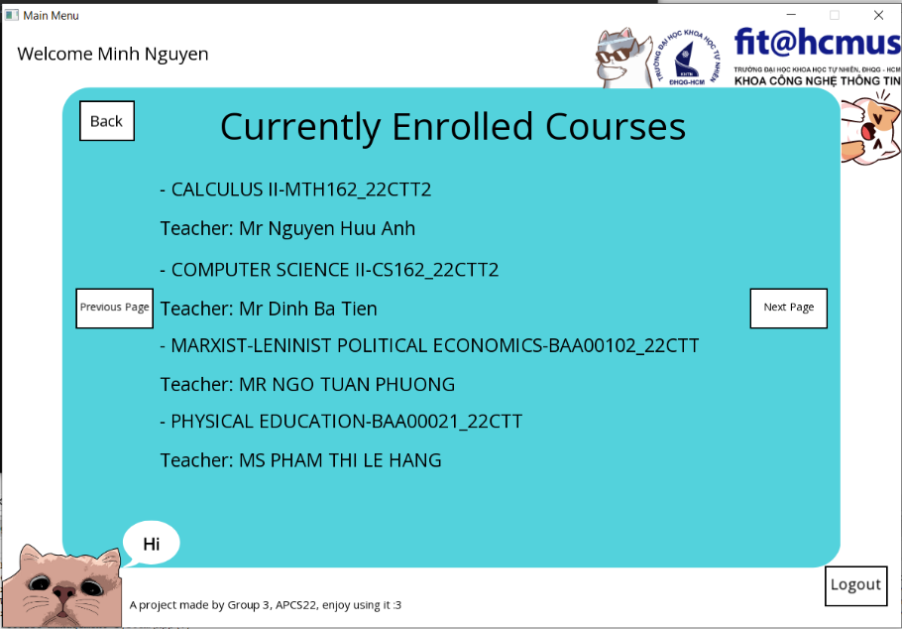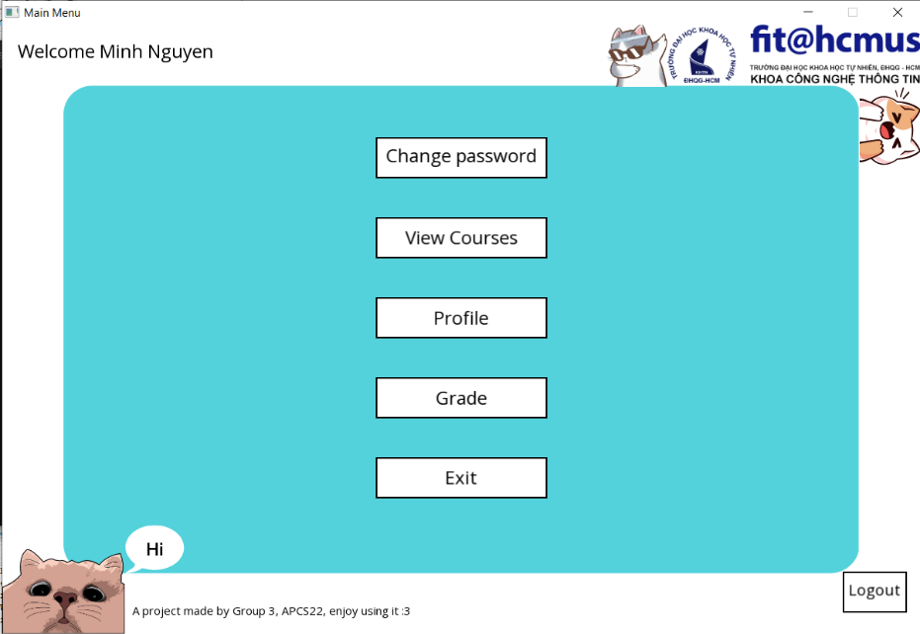

GitHub commits:

