# Assignment Red Black tree (Part 1)

## What is the properties of a Red Black tree? Give an example of Red Black tree.

The Red-Black tree satisfies all the properties of binary search tree in addition to that it satisfies following additional properties

1. Each tree node is colored either red or black.

2. The root node and the leaf node of the tree is always black.

3. Every path from the root to any of the leaf nodes must have the same number of black nodes. 4. Depth property: All the leaves have the same black depth.

4. No two red nodes can be adjacent, i.e., a red node cannot be the parent or the child of another red node. Given examples of Red Black trees, each of them violates one of the Red Black tree properties.

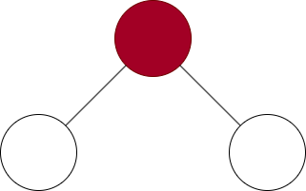Violation of Property 2: The root is black

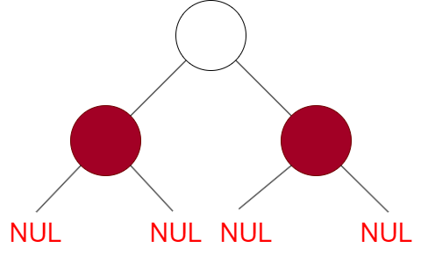Violation of Property 2 Every leaf is black in and Violation of Property 4 the children of a red node is black

Violation of Property 3 All the leaves has same black depth (number of black nodes in the path from root to leaf)

## Which trees are red black trees? If not, which property is violated?

This is not a red black tree because it violates property 3: every path from the root to the leaf has the same black nodes. In this cases there is a path with 2 black nodes and a path with 1 black node.

This is a red black tree

This is not a red black tree because it violates properties 3. There is a path with 2 black nodes and a path with 1 black node.

This is not a red black tree because it violates property 4. Children of a red node must be black.

This is a red black tree.

## Calculate the black heights of all nodes in the below red back trees.

Node 7: 1

Node 3: 2

Node 18: 1

Node 10: 2

Node 22: 2

Node 8: 2

Node 11: 2

Node 26: 2

## Is it possible to have all black nodes in a Red-Black tree? If yes, give an example. If no, give the reason.

**Yes**, a tree with all nodes black can be a red-black tree. The tree has to be a perfect binary tree (all leaves are at the same depth or same level, and in which every parent has two children) and so, it is the only tree whose Black height equals to its tree height.

First insert {1, 2, 3, 4, 5, 6, 7, 8, 9, 10} them delete {10, 9, 8}.