U.S Stock Market Analysis
Link to the dataset: https://www.kaggle.com/datasets/andrewmvd/sp-500-stocks?resource=download
- Data gathering and integration:
- The dataset I used is the S&P 500 Companies dataset from Kaggle. It contains financial and organizational information for 502 companies listed in the S&P 500 index.
- There are 502 rows, 15 columns, 11 sectors, and 6 numerical variables in this dataset.
- Numerical variables: Current Price, Market Cap, EBITDA, Revenue Growth, Full-time Employees, Index Weight.
- Categorical variables: Sector, Industry, Exchange, Country, State.
- The Longbusinesssummary column was dropped because it contained unstructured free text with no interesting information.
- Data Exploration:
- Technology is the most represented sector with 82 companies, followed by Industrials (70), Financial Services (67), and Healthcare (62). Energy, Communication Services, and Basic Materials each had only 22 companies. The majority of companies trade on the NYSE (NYQ, 348) or the NASDAQ (NMS, 152), with other companies on other exchanges.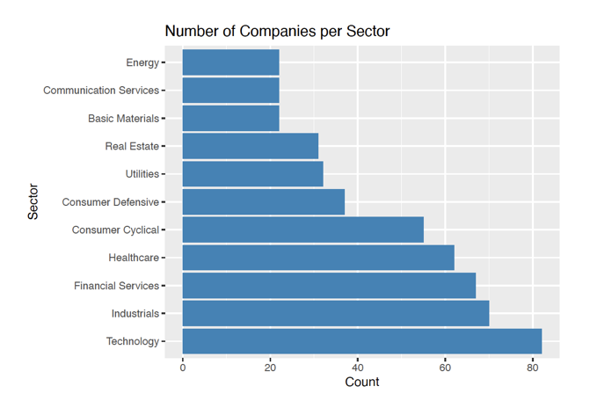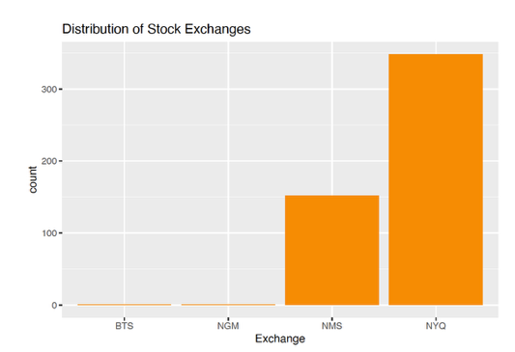
- All numerical variables showed strong right skew before transformation. Market cap, EBITDA, and employee count had extreme right tails. Log transformations revealed more interpretable distributions for market cap, price, and employee count. Revenue growth was centered near zero with a few large positive outliers. 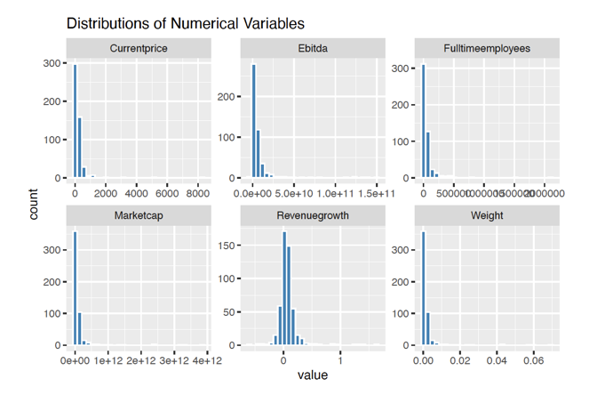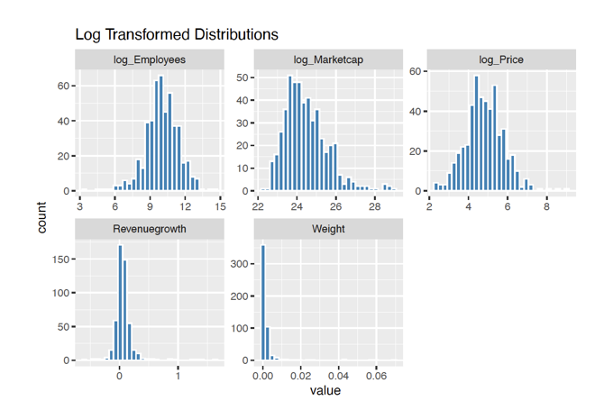
- As we can see, Market Cap vs EBITDA: r = 0.86, which means larger companies generate more operating profit.
- Market Cap vs Weight: r = 1.00, index weight is obtained from market cap
- Current Price: essentially uncorrelated with everything (all r < 0.05), confirming that stock price is not informative about company size
- Revenue Growth: weak correlations across the matrix. 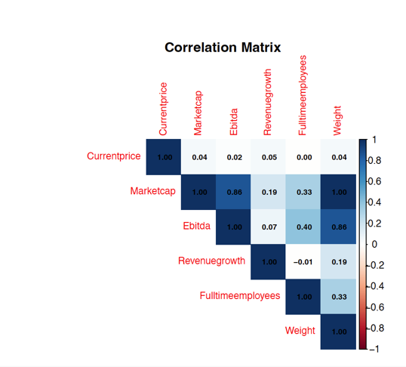
- Data Cleaning:
- Boxplots before cleaning showed extreme 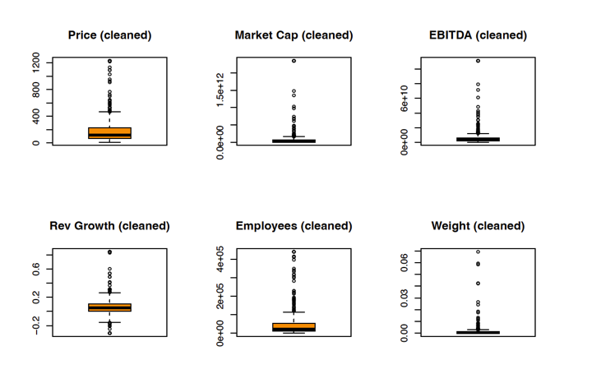outliers. Boxplots after cleaning confirmed substantially reduced spread.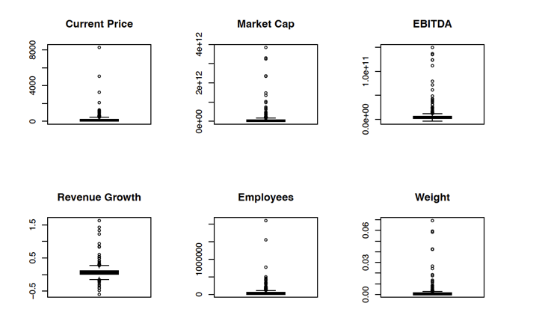
- Data Preprocessing:
- All six numerical variables were scaled to [0, 1]. 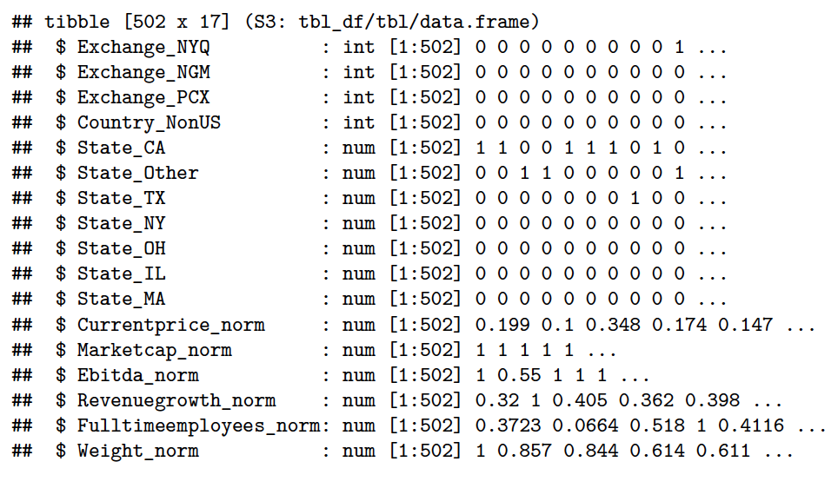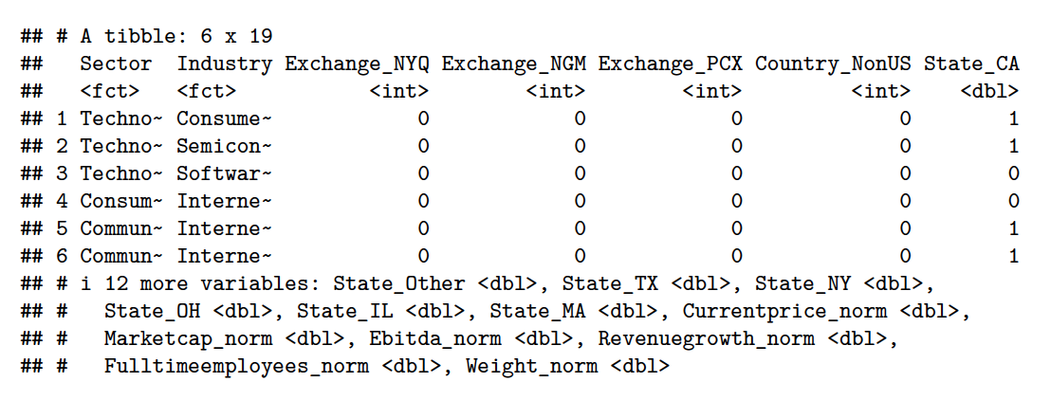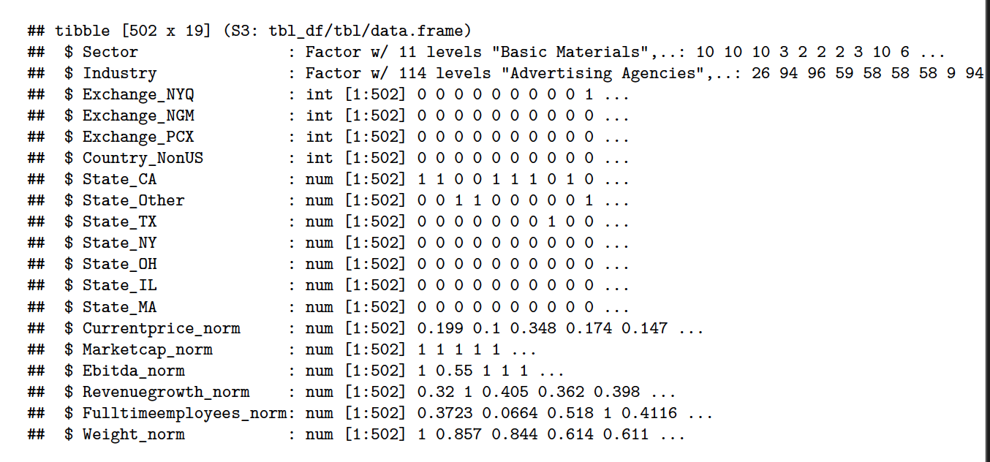
- Clustering:
- The elbow plot of total within cluster SS for k=1 through k=10 showed a gradual curve without a sharp bend. The rate of decrease visibly slowed after k=7. 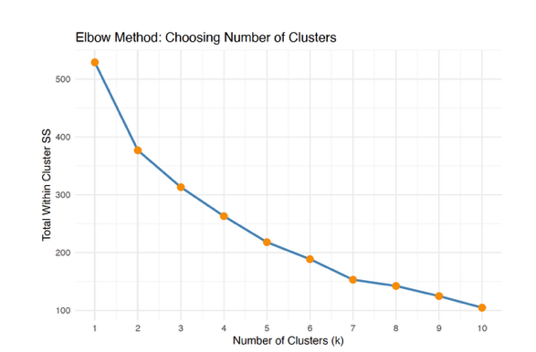
- PCA: The most visually distinct clusters in PCA space corresponded to mega cap companies, which stood apart due to their extreme market cap and EBITDA.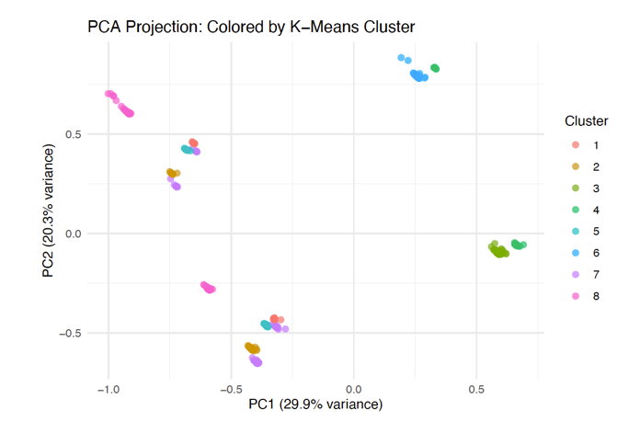
- Cluster 8: dominated by Technology (30 of 67 companies)
- Cluster 2: concentrated in Financial Services (21 of 49)
- Cluster 7: for Energy (16 of 70)
- Cluster 3: 180 companies that have Industrials, Healthcare, and Consumer sectors
- This shows that K-Means is created based on size grouping rather than sector based ones. Many sectors are financially indistinguishable using only market cap, EBITDA, and growth rate.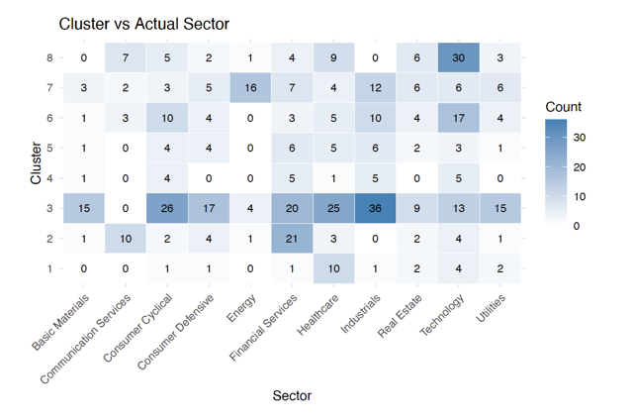
- Classification:
- Model 1 Decision Tree: The complexity parameter cp was searched across 0.001 - 0.05, best cp = 0.011. The tree primarily split on Fulltimeemployees_norm, State_CA, Marketcap_norm, and Revenuegrowth_norm.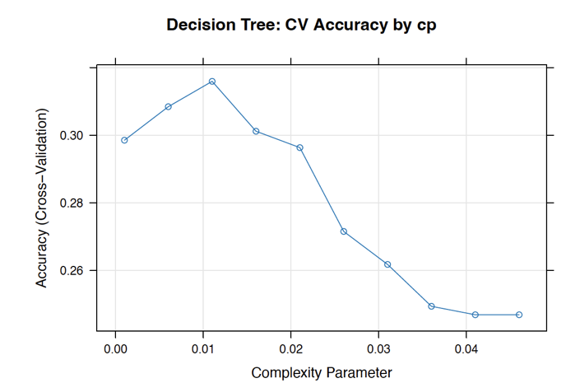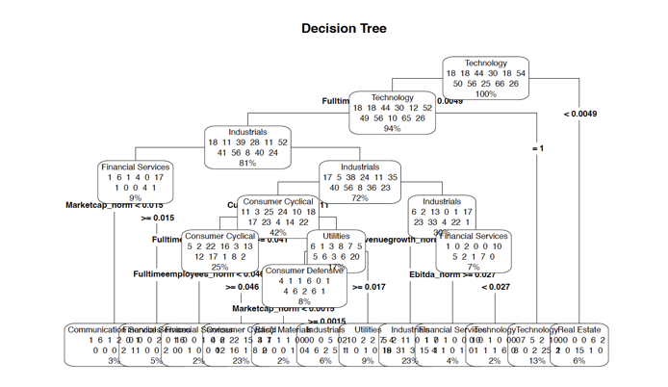
- Model 2 Random Forest: Best mtry = 4. Variable importance showed Fulltimeemployees_norm and Ebitda_norm as most predictive, followed by Revenuegrowth_norm and Currentprice_norm. Geographic features (State_CA, State_NY) contributed far less. 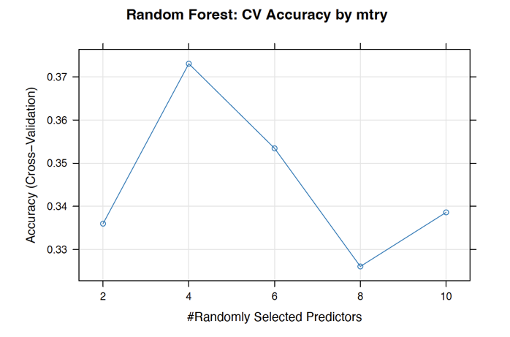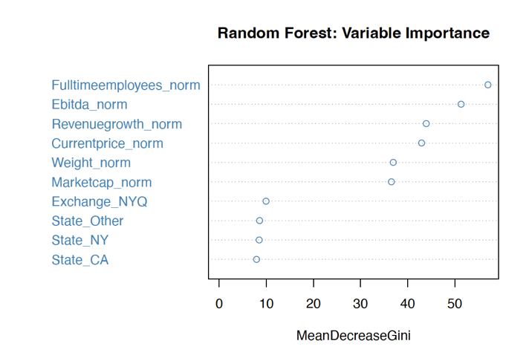
- Model comparison:
  - Decision Tree: cp = 0.011, CV Accuracy = 31.59%, Test Accuracy = 32.99%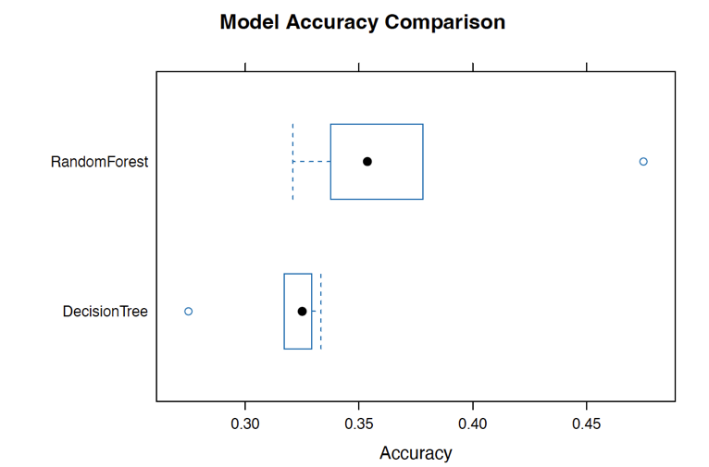
  - Random Forest: mtry = 4, CV Accuracy = 37.30%, Test Accuracy = 38.14%. Therefore, Random Forest performs better.
- Evaluation:
- Growth: Technology, Consumer Cyclical, Communication Services, Financial Services, and Industrials have 296 companies
- Defensive: Healthcare, Consumer Defensive, Utilities, Real Estate, Energy, Basic Materials have 206 companies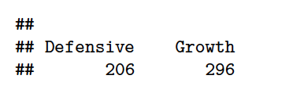
- Confusion Matrix: 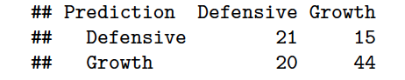
- Precision: TP / (TP + FP) = 44 / 64 = 0.6875
- Recall: TP / (TP + FN) = 44 / 59 = 0.7458
- F1 Score: 2 * (P * R) / (P + R) = 0.7154
- Accuracy: (TP + TN) / 100 = 65/100 = 0.65
- The ROC curve lies above the diagonal random baseline, confirming genuine discriminative ability. An AUC of 0.50 = random guessing, 1.0 = perfect. AUC of 0.66 indicates moderate but meaningful discrimination between Growth and Defensive sectors.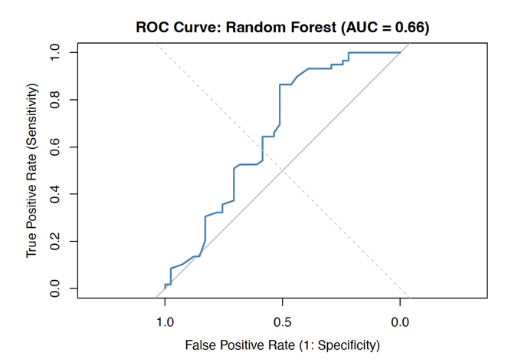
- Accuracy (65%) treats all errors equally and gives a single number. The model has higher recall (0.75) than precision (0.69), meaning it is better at catching actual Growth companies than avoiding false alarms. Of 59 true Growth companies, 44 were correctly caught, but 20 Defensive companies were falsely predicted as Growth.
- The AUC of 0.66: the model has a real predictive signal even though accuracy sits at only 65%.
- Report:
- Through this homework, I found out that the most striking finding was how difficult it is to predict a company's sector from financial metrics alone. While Random Forest achieved 38% accuracy across 11 classes. Sector membership is largely determined by what a company does, not merely its size or profitability.
- The cluster vs sector heatmap revealed that K-Means primarily created size based groupings rather than sector based ones. The most interpretable cluster was the mega-cap technology group, which stood clearly apart in PCA space due to extraordinary market cap and EBITDA. The remaining ~490 companies were far more difficult to separate.
- The plot from Random Forest was showing that full-time employee count and EBITDA were the most predictive features. This makes Consumer Cyclical and Industrials companies tend to be labor intensive, while Technology companies tend toward high EBITDA per employee.
- The AUC of 0.66 and the precision/recall breakdown showed that the model has real discriminative power that a single accuracy number obscures. The higher recall than precision reflects the class imbalance (296 Growth vs. 206 Defensive) and offers actionable insight about how the model errs.

