IIG Vietnam and International Exams
About IIG Vietnam
IIG Vietnam is a leading organization in educational testing and human resource assessment in Vietnam. As the official representative of ETS (Educational Testing Service), IIG provides international certifications such as TOEIC, TOEFL, and MOS. The company is committed to improving the quality of education and workforce standards in Vietnam and the region. IIG Vietnam offers comprehensive solutions for English proficiency, IT skills, and professional competency evaluation. With a network of branches across major cities, it ensures accessibility and high-quality services for individuals and organizations. IIG also partners with schools, universities, and businesses to enhance learning outcomes and recruitment efficiency. Through continuous innovation, IIG Vietnam contributes to building a more competitive and skilled workforce. Its vision is to become a trusted leader in education and competency assessment across Southeast Asia.

Popular Exams Organized by IIG
- IT Tests
  - IC3 – Digital Literacy Certification
  - MOS – Microsoft Office Specialist
  - ACA – Adobe Certified Associate
- English Tests
  - TOEIC – Test of English for International Communication
    - TOEFL – Institutional Testing Program

About IIG Academy
Smart Learning for Future Success!
Established in 2009, IIG Academy is an official member of IIG Vietnam – the leading organization in the field of Educational Testing and Accreditation in Vietnam and currently a provider of the biggest number of international tests including: TOEFL, TOEIC, GRE, SAT, TFI, MOS, ACA, IC3, IC3 Spark… After more than 10 years of establishment and development, IIG Academy has built an international standard training process for businesses, from basic English courses to intensive English courses. In 2015, the founders of IIG Academy identified the philosophy of “Smart Learning for Future Success” as the guiding principle for all orientations and actions. During the time, English was the universal key to open the door of human knowledge, international exchange and breakthrough.
Besides training products for corporate customers, IIG Academy builds a future education ecosystem, integrating technology in teaching for schools. Students with good English ability would possess a great advantage in development when Vietnam strives to strongly integrate with the world. It is from this educational philosophy that IIG Academy has determined that it is necessary to bring a modern, international quality English education model called School link.
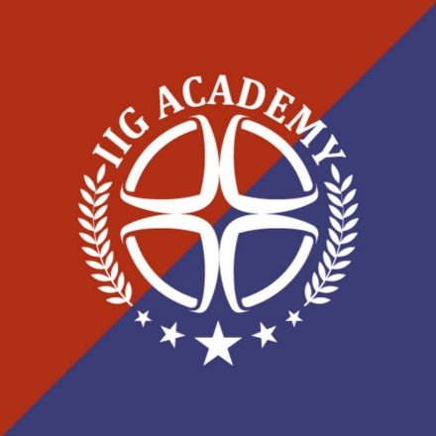
Contact us: Website IIG Academy

IIG Academy School Link?
IIG Academy, a member of IIG Vietnam, was established with the mission to provide high-quality training programs that meet international education standards. Inheriting IIG Vietnam’s strong foundation in assessment and educational excellence, the academy focuses on equipping learners with the knowledge, skills, and confidence needed to thrive in a global environment. Its goal is to bridge the gap between academic learning and real-world application, helping students unlock their full potential.
At IIG Academy, learners are immersed in a professional and engaging environment that promotes active learning and personal growth. The academy offers a wide range of programs, including English for communication, academic English, test preparation courses such as TOEIC and TOEFL, and corporate training. All courses are developed based on international standards and delivered by experienced instructors using innovative teaching methods and modern facilities.
Through its commitment to quality and continuous innovation, IIG Academy strives to nurture a generation of confident, competent, and globally minded individuals. By combining effective language training with essential soft skills development, the academy not only supports students in achieving their academic and career goals but also contributes to improving the overall quality of human resources in Vietnam and the region.
School Link fulfills that mission by:
- Developing self-learning skills and soft skills suitable for each age group
- Improving students’ foreign language proficiency.
- Consulting and providing educational solutions, advanced and personalized learning models for elementary, secondary and high school students.

Comprehensive methodology
IIG Academy’s School Link program uses active teaching model – active learning 6E (Engage – eLearn – Explore – Evaluate – Elaborate – Explain) combined with the project-based learning method which will provide the students with the most all-round and comprehensive experience

Learning environment with 100% native teachers
School Link is proud that we have successfully built a learning environment that helps students develop all 4 skills: Listening, Speaking, Reading and Writing comprehensively. IIG Academy has more than 100 native English teachers who possess not only Bachelor’s degrees from internationally recognized universities but also English teaching certificates such as TESOL, TEFL, CELTA.

Language proficiency assessment with international testing systems
Students will be assessed their language proficiency by taking part in international tests TOEFL PRIMARY, TOEFL JUNIOR, TOEFL ITP at the beginning and at the end of the school year.

A variety of extracurricular activities
School Link has a variety of extracurricular programs and events such as English Festival, Go English! Ring the golden bell, Fun English Day… which always aim to create unforgettable moments and memories for students.

