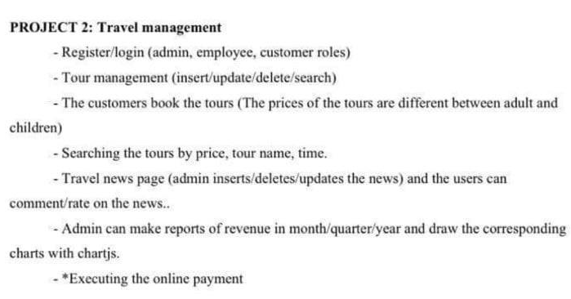

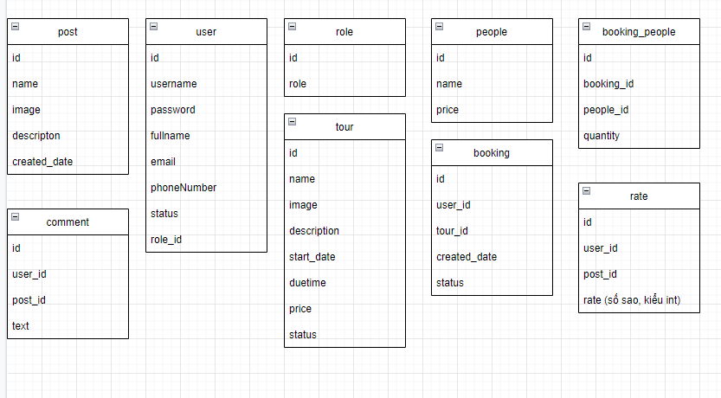

Link template : https://drive.google.com/file/d/19sRMrqBUGun6YEXP5HyWkoCClevZQOdj/view?usp=sharing