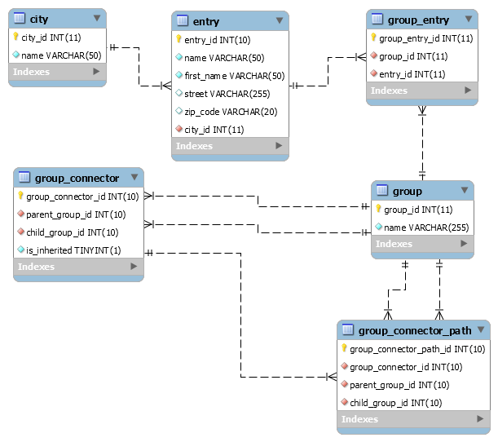

Figure Address Book database relationship model

1. **Tables**

- **entry**: storing Contacts info

- **city**: storing Cities info

- **group**: storing Group info

- **group_entry**: entries(Contacts) added directly to group will be stored in this table

- **group_connector**: storing relationship between group, it means group inheritance. Column **is_inherited** indicates whether a child group inherited directly from parent group.

***For example:***

We have groups A (id: 1), B (id: 2), C (id: 3), D (id: 4), E (id: 5).

Group B is child of group A

Group C is child of group B

Group E is child of group B

Group D is child of group C

Group D is child of group E (see image)

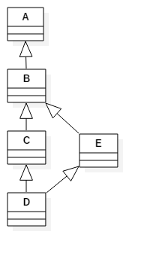

So, table **group_connector** will contains records as:

|  |  |  |  |
| --- | --- | --- | --- |
| group_connector_id | parent_group_id | child_group_id | is_inherited |
| 1 | 1 | 2 | 0 |
| 2 | 2 | 3 | 0 |
| 3 | 1 | 3 | 1 |
| 4 | 3 | 4 | 0 |
| 5 | 2 | 4 | 1 |
| 6 | 1 | 4 | 1 |
| 7 | 2 | 5 | 0 |
| 8 | 1 | 5 | 1 |
| 9 | 5 | 4 | 0 |
| 10 | 2 | 4 | 1 |
| 11 | 1 | 4 | 1 |

- **group_connector_path**: storing inheritance path of indirect group connection.

***For example:*** with group A, B, C, D, E above, table **group_connector_path** will contains records as:

|  |  |  |
| --- | --- | --- |
| group_connector_id | parent_group_id | child_group_id |
| 3 | 1 | 2 |
| 3 | 2 | 3 |
| 5 | 2 | 3 |
| 5 | 3 | 4 |
| 6 | 1 | 2 |
| 6 | 2 | 3 |
| 6 | 3 | 4 |
| 8 | 1 | 2 |
| 8 | 2 | 5 |
| 10 | 2 | 5 |
| 10 | 5 | 4 |
| 11 | 1 | 2 |
| 11 | 2 | 5 |
| 11 | 5 | 4 |

1. **Queries**
   1. **Getting all Contacts of one Group by group_id:**

Contacts are fetched from 2 sources: Contacts added directly to this group (table **group_entry**), and Contacts from parent groups (table **group_connector**).

SELECT DISTINCT `entry`.`entry_id`, `entry`.`name`, `entry`.`first_name`, `entry`.`street`, `entry`.`zip_code`, `entry`.`city_id`, MIN(`entry`.`is_inherited`) AS 'is_inherited'

FROM

(SELECT `entry`.*, 0 AS 'is_inherited'

FROM `entry` INNER JOIN `group_entry` ON `entry`.`entry_id` = `group_entry`.`entry_id`

WHERE `group_entry`.`group_id` = $group_id

UNION

SELECT DISTINCT `entry`.*, 1 AS 'is_inherited'

FROM `entry` INNER JOIN `group_entry` ON `entry`.`entry_id` = `group_entry`.`entry_id`

INNER JOIN `group_connector` ON `group_entry`.`group_id` = `group_connector`.`parent_group_id`

WHERE `group_connector`.`child_group_id` = $group_id) AS `entry`

GROUP BY `entry`.`entry_id`

ORDER BY `entry`.`is_inherited`, `entry`.`entry_id`

* 1. **Adding one new Group connection:**

For example: we want group D to be child of group C

B1. Add one new record to table **group_connector** to indicate that this group inherited directly from one parent group:

INSERT INTO `group_connector`(`parent_group_id`, `child_group_id`, `is_inherited`) VALUES (3, 4, 0)

B2. Find out all parent groups of group C:

SELECT * FROM `group_connector` WHERE `child_group_id` = 3

B3. Find out all child groups of group D:

SELECT * FROM `group_connector` WHERE `parent_group_id` = 4

B4. Add new records to table **group_connector** to indicate that groups step B3 + D inherited indirectly from groups step B2 + C:

foreach $parent_groups as $parent_group, $child_groups as $child_group

INSERT INTO `group_connector`(`parent_group_id`, `child_group_id`, `is_inherited`) VALUES ($parent_group->parent_group_id, $child_group->child_group_id, 1)

B5. Add new records to table **group_connector_path** to store path of each indirect group connection:

foreach $parent_groups as $parent_group, $child_groups as $child_group

// Add new record to table **group_connector** to indicate that this group inherited indirectly from parent group. $group_connector_id retrieved after step B4 done

if $parent_group->is_inherited = 1

// Path retrieved from $parent_group

INSERT INTO `group_connector_path`(`group_connector_id`, `parent_group_id`, `child_group_id`) SELECT $group_connector_id AS `group_connector_id`, `parent_group_id`, `child_group_id` FROM `group_connector_path` WHERE `group_connector_id` = $parent_group->group_connector_id

else

// Path from $parent_group->parent_group_id to $parent_group->child_group_id

INSERT INTO `group_connector_path`(`group_connector_id`, `parent_group_id`, `child_group_id`) VALUES ($group_connector_id, $parent_group->parent_group_id, $parent_group->child_group_id)

Endif

if $child_group->is_inherited = 1

// Path retrieved from $child_group

INSERT INTO `group_connector_path`(`group_connector_id`, `parent_group_id`, `child_group_id`) SELECT $group_connector_id AS `group_connector_id`, `parent_group_id`, `child_group_id` FROM `group_connector_path` WHERE `group_connector_id` = $child_group->group_connector_id

else

// Path from $ child_group->parent_group_id to $ child_group->child_group_id

INSERT INTO `group_connector_path`(`group_connector_id`, `parent_group_id`, `child_group_id`) VALUES ($group_connector_id, $child_group->parent_group_id, $child_group->child_group_id)

endif

// Path from $parent_group_id to $child_group_id

INSERT INTO `group_connector_path`(`group_connector_id`, `parent_group_id`, `child_group_id`) VALUES ($group_connector_id, 3, 4)

* 1. **Removing one Group connection**

For example: we want to remove connection between group A and group B

C1. Remove record that has `is_inherited`=0 from table **group_connector**:

DELETE FROM `group_connector` WHERE `parent_group_id` = 1 AND `child_group_id` = 2 AND `is_inherited` = 0

C2. Find out all indirect group connections from table **group_connector**:

SELECT `group_connector`.*

FROM `group_connector` INNER JOIN `group_connector_path` ON `group_connector`.`group_connector_id` = `group_connector_path`.`group_connector_id`

WHERE `group_connector_path`.`parent_group_id` = 1 AND `group_connector_path`.`child_group_id` = 2 AND `is_inherited` = 1

C3. Remove all indirect group connections from table **group_connector**, and matched records from table **group_connector_path**:

// Array $group_connector_ids retrieved from step C2

DELETE FROM `group_connector` WHERE `group_connector_id` IN ($group_connector_ids)

DELETE FROM `group_connector_path` WHERE `group_connector_id` IN ($group_connector_ids)

* 1. **Adding one Contact to one Group**

INSERT INTO `group_entry`(`group_id`, `entry_id`) VALUES ($group_id, $entry_id)

* 1. **Removing Contact from one Group**

DELETE FROM `group_entry` WHERE `group_id` = $group_id AND `entry_id` = $entry_id