Q: What caused no sparse?
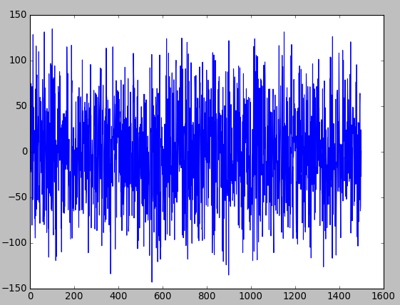
Experiments: Unsupervised training only
Change from 2 stacks → 1 stacks: no change
Disabled Batch normalization: no change. Also, from this exp batch normalization allow a big increase in learning rate ~ x100 old learning rate (not really)
Disabled Residual link: Big loss function around 20. Sparse went back. Also needed to decrease learning rate to 0.00001. Not sure the effect is from residue link or high learning rate. Decrease learning rate by 1/10 does not change much except coss function is lower around 5-6
Disabled Necklace link: No change
Disable Tied weight: No change

