

**PROJECT REPORT**

# Human Resources Management System

|  |  |
| --- | --- |
| **Semester:** | Programming Fundamentals |
| **Class:** | SE1302 |
| **Group:** | Group 1 |
| **Instructor** | Nguyen Duc Giang |
| **Team members:** | Nguyen Hoang Minh |

Index

Human Resources Management System 1

Project introduction 3

1. Proposed System 3

2. The scope of the project to be applied 3

3. System Name 3

4. Deployment Environment 3

5. Development Tools 3

6. Customer Requirements (System features) 3

I. Analyze System Requirements 4

1. Use Case 5

2. Activity Diagram: 14

II. Design Details 16

1. UI Design 16

2. Code Design (Class Diagram) 18

3. Sequence Diagram 19

4. Database Design 20

III. Test 21

IV. Installation Instructions 22

1. Deployment Diagram 22

2. Installation steps 23

Appendix 24

Document format 25

# Project introduction

The project was built for the purpose of managing information about personnel currently working in the enterprise and those applying for jobs. The system will improve time and performance when managing large amounts of personnel information, centralizing data for easier management.Proposed System

1. Proposed System

The project is built for the purpose of managing information about personnel working at the enterprise and those who are applying to work.

1. The scope of the project to be applied

The project aims to develop a system that will be applied to streamline and automate certain activities within the company. The system will improve efficiency, accuracy and productivity by automating manual processes and providing a centralized platform to manage various tasks.

1. System Name

Human Resources Management System

1. Deployment Environment

The system will be deployed on a personal computer platform, ready and easily accessible. And can only be accessed on 1 device.

1. Development Tools

System development will use programming languages, frameworks and tools. The program uses the C# language, and the database like MySQL. Specific tools and technologies will be determined based on the requirements and preferences of the development team.

1. Customer Requirements (System features)
   1. Functional Requirements: authenticate users, control function by role, control and track personal information of related people
   2. External Interface Requirements: Manually typed interface framework in C# programming language.
   3. System Features: Dashboard to visualize and access essential information, synchronize data and user permissions to the database in real time
   4. Nonfunctional Requirements

# Analyze System Requirements

< Specify the requirements of the system required to meet customer requirements. This is the content of the discussion presented in more detail >

1. Use Case

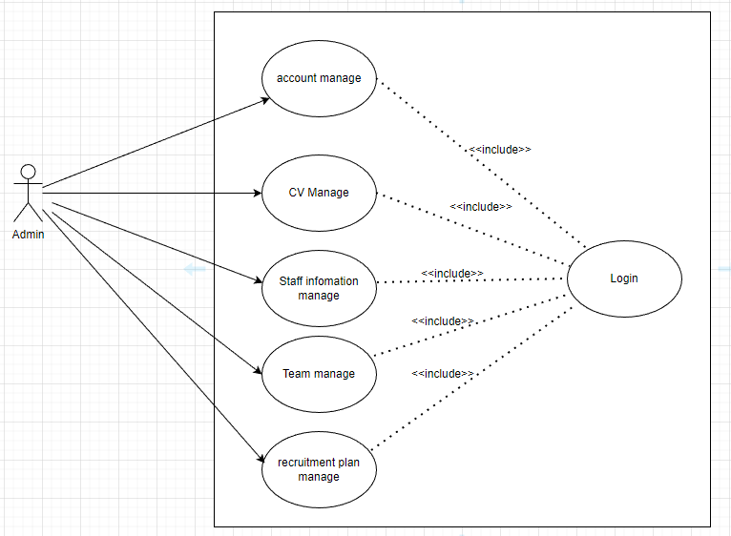

|  |  |
| --- | --- |
| Use Case Name | Use Case Manage function of the Admin |
| Use Case ID | UseCase1 |
| Description | Users can use all functions after the system approves and identifies with the position of administrator. |
| Actor | Admin |
| Organizational Benefits | Employee management, candidate testing and management, CV database |
| Preconditions | Have an account on the system |
| Postconditions | Any states that the system must be in or conditions that mus be met after the Use Case is completed successfully. These will be met if the Main Course or any Alternate Course are followed. Some Exceptions may result in failure to meet the Posconditions. |
| Main Course | The most common path of interaction between the user and the system  1. Step 1: Log in with an administrator account  2. Step 2: Use administrator rights to use all system functions |
| Alternate Courses | No replacement conditions |
| Exceptions | There are no exceptions |

|  |  |
| --- | --- |
| Use Case Name | Use Case Manage Employee |
| Use Case ID | UseCase2 |
| Description | In employee management, the administrator has the following functions:  + Update Employee  + Delete Employee  + Search Employee By ID  + Search Employee By Name  + Display Employee |
| Actor | Admin |
| Organizational Benefits | Administrators have the right to add, edit, and delete employee, search by ID , search by name , display a list of employees... |
| Preconditions | Have an account on the system |
| Postconditions | Moderated by the system in accordance with the administrator position |
| Main Course | The most common way of interaction between the administrator and the system  Step 1: Log in with an administrator account  Step 2: Use the position of administrator to use the functions with the full employee part of the system |
| Alternate Courses | No replacement conditions |
| Exceptions | There are no exceptions |

|  |  |
| --- | --- |
| Use Case Name | Use Case Manage User |
| Use Case ID | UseCase3 |
| Description | In user management, the administrator has the following functions:  + Add User  + Update User  + Delete User  + Search User  + Display User  + Account Review |
| Actor | Admin |
| Organizational Benefits | Administrators have the right to add, edit, and delete user accounts, display a list of user, and censor accounts registered by user... |
| Preconditions | Have an account on the system |
| Postconditions | Moderated by the system in accordance with the administrator position |
| Main Course | The most common way of interaction between the administrator and the system  Step 1: Log in with an administrator account  Step 2: Use the position of administrator to use the functions with the full user part of the system |
| Alternate Courses | No replacement conditions |
| Exceptions | There are no exceptions |

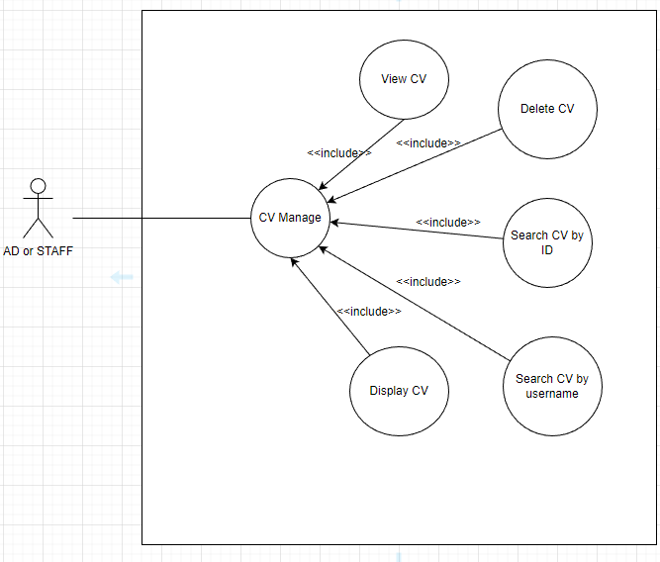

|  |  |
| --- | --- |
| Use Case Name | Use Case Manage CV |
| Use Case ID | UseCase4 |
| Description | In customer management, the administrator or staff has the following functions:  + Update CV  + Delete CV  + Search CV By ID  + Search Customer By Username  + Display CV |
| Actor | Admin or Staff |
| Organizational Benefits | Administrators or staff have the right to add, edit, and delete customer, display a list of customer,… |
| Preconditions | Have an account on the system |
| Postconditions | Moderated by the system in accordance with the administrator or staff position |
| Main Course | The most common way of interaction between the administrator and the system  Step 1: Log in with an administrator or staff account  Step 2: Use the position of administrator or staff to use the functions with the full user part of the system |
| Alternate Courses | No replacement conditions |
| Exceptions | There are no exceptions |

|  |  |
| --- | --- |
| Use Case Name | Use Case Manage CV |
| Use Case ID | UseCase5 |
| Description | In customer management, the administrator or staff has the following functions:  + Update candidate  + Delete candidate  + Search candidate By ID  + Search Customer By Username  + Display candidate |
| Actor | Admin or Staff |
| Organizational Benefits | Administrators or staff have the right to add, edit, and delete customer, display a list of customer,… |
| Preconditions | Have an account on the system |
| Postconditions | Moderated by the system in accordance with the administrator or staff position |
| Main Course | The most common way of interaction between the administrator and the system  Step 1: Log in with an administrator or staff account  Step 2: Use the position of administrator or staff to use the functions with the full user part of the system |
| Alternate Courses | No replacement conditions |
| Exceptions | There are no exceptions |

1. Activity Diagram:

# Design Details

1. UI Design

1. Code Design (Class Diagram)

1. Sequence Diagram

1. Database Design

|  |  |  |  |
| --- | --- | --- | --- |
| Users | | | |
| **Column Name** | **Data Type** | **Constraints** | **Description** |
| id | INT | Primary Key, Auto Increment, Not Null | User ID |
| username | VARCHAR(255) | Not Null | User's username |
| password | VARCHAR(255) | Not Null | User's password |
| email | VARCHAR(255) |  | User's email address |

|  |  |  |  |
| --- | --- | --- | --- |
| CV | | | |
| **Column Name** | **Data Type** | **Constraints** | **Description** |
| cv_id | INT | Primary Key, Auto Increment, Not Null | CV ID |
| username | VARCHAR(255) | Not Null | User's username (linked to Users) |
| cv_name | VARCHAR(255) | Not Null | CV name |
| cv_file_path | VARCHAR(255) | Not Null | Path to the CV file |

|  |  |  |  |
| --- | --- | --- | --- |
| Departments | | | |
| **Column Name** | **Data Type** | **Constraints** | **Description** |
| department_id | INT | Primary Key, Auto Increment, Not Null | Department ID |
| department_name | VARCHAR(255) | Not Null | Department name |

|  |  |  |  |
| --- | --- | --- | --- |
| Job Titles | | | |
| **Column Name** | **Data Type** | **Constraints** | **Description** |
| job_id | INT | Primary Key, Auto Increment, Not Null | Job Title ID |
| job_title | VARCHAR(255) | Not Null | Job title |

|  |  |  |  |
| --- | --- | --- | --- |
| Skills | | | |
| **Column Name** | **Data Type** | **Constraints** | **Description** |
| skill_id | INT | Primary Key, Auto Increment, Not Null | Skill ID |
| skill_name | VARCHAR(255) | Not Null | Skill name |

|  |  |  |  |
| --- | --- | --- | --- |
| **Column Name** | | | |
| employee_id | INT | Not Null | Employee ID (linked to Users) |
| department_id | INT | Not Null | Department ID (linked to Departments) |
| start_date | DATE |  | Start date of employment in the department |
| end_date | DATE |  | End date of employment in the department (if any) |

|  |  |  |  |
| --- | --- | --- | --- |
| Employee Job Titles | | | |
| **Column Name** | **Data Type** | **Constraints** | **Description** |
| employee_id | INT | Not Null | Employee ID (linked to Users) |
| job_id | INT | Not Null | Job Title ID (linked to Job Titles) |
| start_date | DATE |  | Start date of employment in the job title |
| end_date | DATE |  | End date of employment in the job title (if any) |

|  |  |  |  |
| --- | --- | --- | --- |
| Employee Skills | | | |
| **Column Name** | **Data Type** | **Constraints** | **Description** |
| employee_id | INT | Not Null | Employee ID (linked to Users) |
| skill_id | INT | Not Null | Skill ID (linked to Skills) |
| proficiency_level | VARCHAR(50) |  | Proficiency level in the skill |

|  |  |  |  |
| --- | --- | --- | --- |
| Awards | | | |
| **Column Name** | **Data Type** | **Constraints** | **Description** |
| award_id | INT | Primary Key, Auto Increment, Not Null | Award ID |
| employee_id | INT | Not Null | Employee ID (linked to Users) |
| award_name | VARCHAR(255) | Not Null | Name of the award |
| award_date | DATE |  | Date when the award was received |

|  |  |  |  |
| --- | --- | --- | --- |
| Disciplinary Actions | | | |
| **Column Name** | **Data Type** | **Constraints** | **Description** |
| action_id | INT | Primary Key, Auto Increment, Not Null | Action ID |
| employee_id | INT | Not Null | Employee ID (linked to Users) |
| action_type | VARCHAR(255) | Not Null | Type of disciplinary action |
| action_date | DATE |  | Date when the disciplinary action occurred |
| action_description | TEXT |  | Detailed description of the disciplinary action |

|  |  |  |  |
| --- | --- | --- | --- |
| Insurance | | | |
| **Column Name** | **Data Type** | **Constraints** | **Description** |
| insurance_id | INT | Primary Key, Auto Increment, Not Null | Insurance ID |
| employee_id | INT | Not Null | Employee ID (linked to Users) |
| insurance_type | VARCHAR(255) | Not Null | Type of insurance |
| insurance_start_date | DATE |  | 1. Start date of insurance coverage |
| insurance_end_date | DATE |  | 1. End date of insurance coverage |

|  |  |  |  |
| --- | --- | --- | --- |
| Salary | | | |
| **Column Name** | **Data Type** | **Constraints** | **Description** |
| salary_id | INT | Primary Key, Auto Increment, Not Null | Salary ID |
| employee_id | INT | Not Null | Employee ID (linked to Users) |
| salary_amount | DECIMAL(10, 2) | Not Null | Amount of the salary |
| salary_date | DATE |  | 1. Date when the salary was paid |

# Test

|  |  |
| --- | --- |
| Test Case Number | 001 |
| Test Case Name | LoginTest1() |
| Test Case Description | This test case checks username and password correct or not |
| Preconditions | Username and password must exist in the database |
| Test Case Input | Enter the wrong account password |
| Test Case Expected Output | You have entered the wrong account or password !! |
| Test Case Steps | 1.Call login method  2.Run test case |
| Default Value Preverving |  |

|  |  |
| --- | --- |
| Test Case Number | 002 |
| Test Case Name | LoginTest2() |
| Test Case Description | This test case checks username and password correct or not |
| Preconditions | Username and password must exist in the database |
| Test Case Input | Enter the correct account |
| Test Case Expected Output | Menu of functions when the system censors account positions |
| Test Case Steps | 1.Call login method  2.Run test case |
| Default Value Preverving |  |

|  |  |
| --- | --- |
| Test Case Number | 003 |
| Test Case Name | SearchCVByName() |
| Test Case Description | Search for CV in the system |
| Preconditions | Logged in correct |
| Test Case Input | Enter the name want to search : |
| Test Case Expected Output | Products with rhymes or names will show a list |
| Test Case Steps | Call GetByName method |
| Default Value Preverving |  |

|  |  |
| --- | --- |
| Test Case Number | 003 |
| Test Case Name | SearchCVByID() |
| Test Case Description | Search for products in the system |
| Preconditions | Logged in correct |
| Test Case Input | Enter the id want to search : |
| Test Case Expected Output | Display CV with id to search |
| Test Case Steps | Call GetByID method |
| Default Value Preverving |  |

# Installation Instructions

< Consistently listing conventions when installing software (Detailed instructions with pictures and notes)>

1. Deployment Diagram

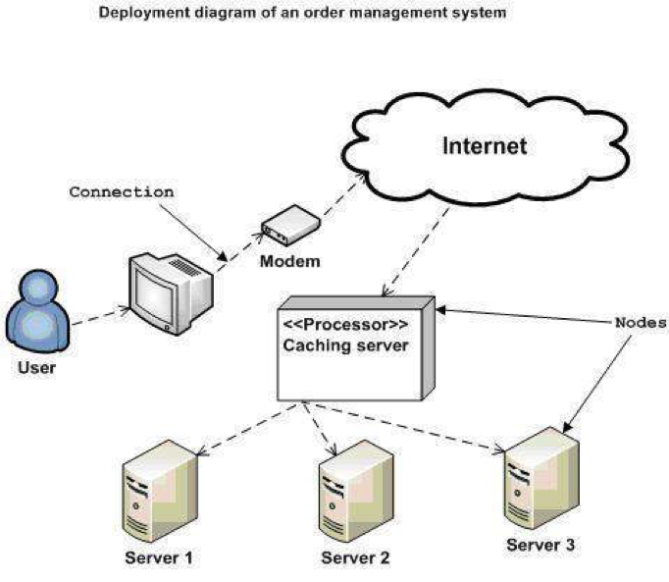

1. Installation steps
   * Database Install
   * Server install
   * Application install

# Appendix

Terms and abbreviations <if available>

<listing terms and abbreviations here>

References <if available >

<List of references here>

Some other issues <if available >

<Results, limitations, experiences, techniques, and other considerations when implementing a project>

# Document format

**Report corver:**

*The cover is printed in blue.*

*With the format as the first page of this document.*

**Paper Size:**

*The report is presented on A4 size paper (210 mm x 297 mm)*

**Top header**

*Left: Logo của VTC Academy*

*Right: Project Name*

*Font: Helvetica Neue (Light) or Arial*

*Font size: 12pt*

**Bottom header**

*Left: Class_Name –Project_Name*

*Right: Page_Number*

*Font: Helvetica Neue (Light) or Arial*

*Font size: 12pt*

**Report Content:**

*Font: Helvetica Neue (Light) or Arial*

*Font size: 12pt*

*Minimum 20 pages*

**Page margin (for A4 size paper)**

*Top: 20 - 25 mm;*

*Bottom: 20 - 25 mm;*

*Left: 30 - 35 mm;*

*Right: 15 - 20 mm;*