# **MINISTRY OF EDUCATION AND TRAINING**

**DISCOVERY**

This platform supports the online sale of components.

|  | |
| --- | --- |
| Project | Electronic components sales system |
| Group Member | Nguyễn Hoàng Lê Minh - SE140733  Lê Công Hưng - SE161248  Ngô Thanh Toàn - SE161573  Phan Hồng Trinh - SE170414  Trần Nhật Quang - SE171009 |
| Supervisor | Lâm Hữu Khánh Phương |

Ho Chi Minh City, Sep 11th 2024

**MINISTRY OF EDUCATION AND TRAINING** **1**

**1. Context** **2**

**2. Problem/Opportunities** **3**

**3. Proposed Solution** **3**

**4. Business Context Diagram** **3**

**5. Actors** **4**

**6. System Architecture Diagram** **4**

**7. ERD** **5**

**1. Use Case Diagram** **5**

**2. Use Case List** **5**

**3. Use Case Detail** **6**

UC-01: Sign in 6

UC-02: Sign up 8

UC-03: Sign out 11

UC-04: View profile 13

UC-05: Update profile 15

UC-06: View product 18

UC-07: Sign in 20

UC-08: Sign in 23

UC-09: Sign in 25

UC-10: Sign in 28

UC-11: Sign in 30

UC-12: Sign in 33

UC-13: Sign in 35

UC-14: Sign in 38

UC-15: Sign in 40

UC-20: Approve order of customer 43

UC-20: Approve order of customer 43

**4. Business Rules** **45**

**I.Business Requirements**

# 1. Context

In this project, we explore the world of electronic components, focusing on the application of LED lighting, Arduino microcontrollers, and core devices such as joystick modules. By integrating these components, we aim to build interactive systems that can be used in various applications, from simple LED displays to advanced robotics and automation solutions. The Arduino platform serves as the heart of the project, offering flexible control over the electronic components, while the LED and joystick devices enable intuitive user interaction. This project demonstrates how simple electronics can form the foundation of innovative, functional systems used in education, prototyping, and product development.

# 2. Problem/Opportunities

The growing demand for smart, interactive devices presents both challenges and opportunities in the field of electronics. Many enthusiasts and developers struggle with integrating various components like LEDs, Arduino microcontrollers, and joystick modules into cohesive systems. The complexity of designing and troubleshooting such systems often discourages beginners. However, these components, when correctly implemented, offer limitless potential for innovation, from home automation to robotics. This project addresses the need for accessible, easy-to-follow guidelines to help users build functional prototypes. By simplifying the integration process, it opens up opportunities for creative applications in education, product development, and personalized tech solutions.

# 3. Proposed Solution

The proposed solution is to develop a user-friendly platform that provides detailed guidance on working with electronic components such as LEDs, Arduino microcontrollers, and joystick modules. This platform will offer step-by-step tutorials, circuit diagrams, and coding examples to simplify the learning process for beginners and hobbyists. Additionally, it will feature troubleshooting tips and real-world applications to help users implement their projects more effectively. By making these resources accessible, the platform aims to bridge the gap between theory and practical application, encouraging creativity and innovation in electronics. Ultimately, it will empower users to build interactive, functional systems with confidence.

# 4. Business Context Diagram

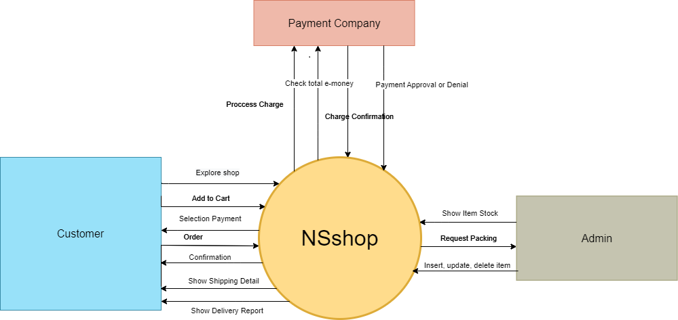

# 5. Actors

* Admin
* Customer
* Guest

# 6. System Architecture Diagram

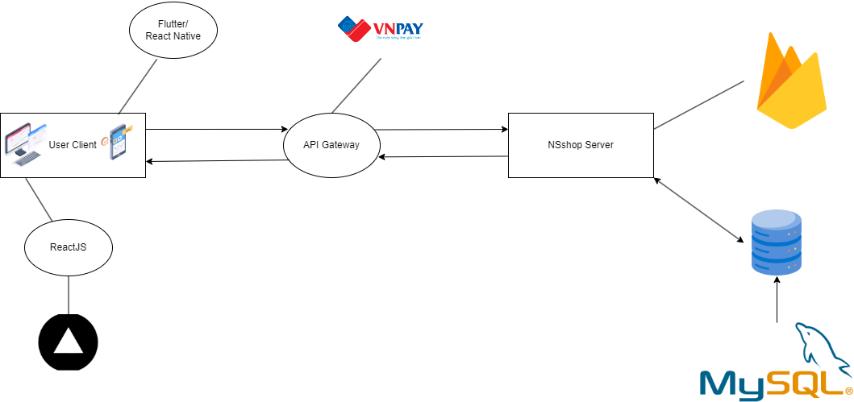

# 7. ERD

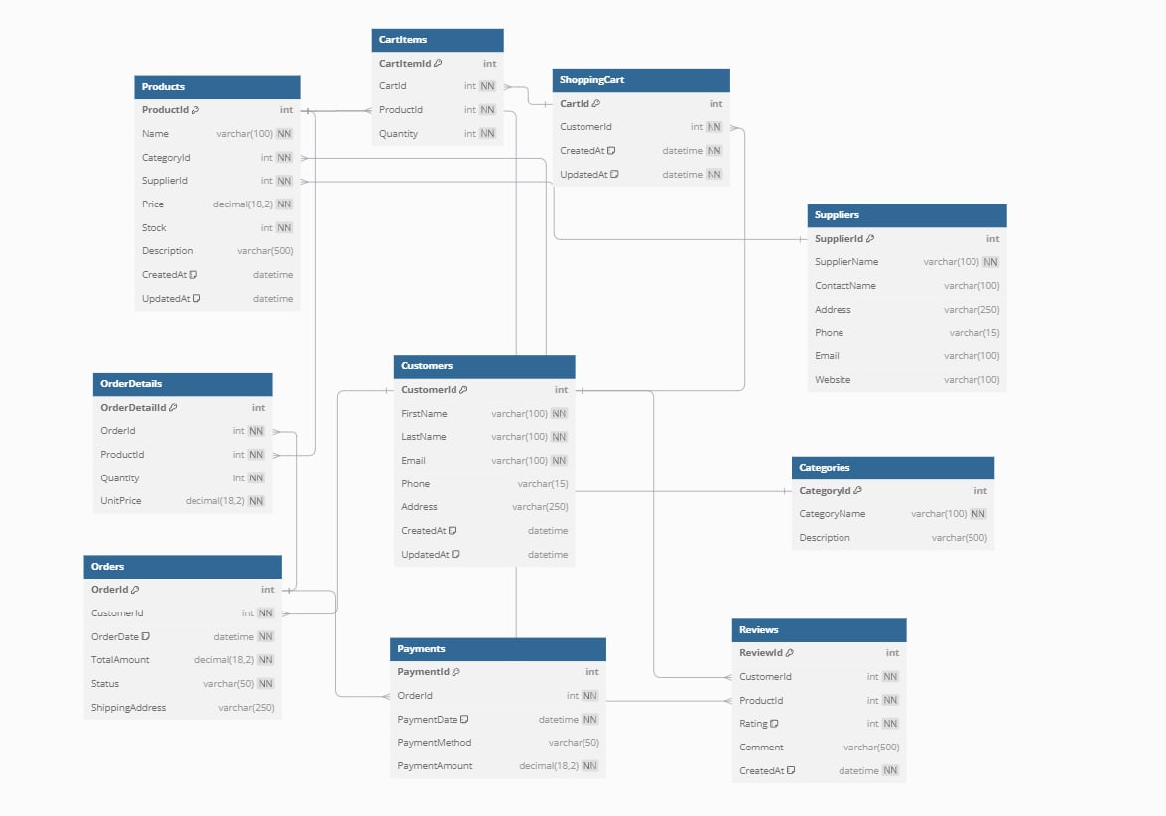

**II. Functional Requirements**

# 1. Use Case List

| ID | UseCase | Actor |
| --- | --- | --- |
| UC-01 | Sign in | Customer |
| UC-02 | Sign up | Customer |
| UC-03 | Sign out | Customer |
| UC-04 | View profile | Customer |
| UC-05 | Update profile | Customer |
| UC-06 | View product | Customer |
| UC-07 | Search product | Customer |
| UC-08 | View product detail | Customer |
| UC-09 | Add to cart | Customer |
| UC-10 | View cart detail | Customer |
| UC-11 | View order detail | Customer |
| UC-12 | Payment ( VNPay ) | Customer |
| UC-13 | View bill detail | Customer |
| UC-14 | View status detail | Customer |
| UC-15 | View revenue | Admin |
| UC-16 | View profile account | Admin |
| UC-17 | Delete account | Admin |
| UC-18 | Add product | Admin |
| UC-19 | Edit product | Admin |
| UC-20 | View order list | Admin |

# 2. Use Case Detail

### **UC-01: Sign in**

| **ID and Name:** | **UC-1: Sign in** | | |
| --- | --- | --- | --- |
| Created By: | MinhNHL | Date Created: | 12/09/2024 |
| Primary Actor: | Customer | Secondary Actors: | None |
| Priority: | High | Frequency of Use: | Always |
| Trigger: | The customer wants to log in to the web. | | |
| Description: | This feature allows users to log in to the system. | | |
| Preconditions: | Customer have previously registered accounts. | | |
| Post-conditions: | Success: Success: Redirect to home page.  Fail: The system shows an error message corresponding to error code. | | |
| Normal Flow: | | Step | Actor Action | System Response | | --- | --- | --- | | 1 | In sign in page, th the customer inputs accounts and passwords |  | | 2 | Actor clicks “sign in” | System redirects to the home page | | | |
| Alternative Flow: | | Step | Actor Action | System Response | | --- | --- | --- | | 1 | In sign in page, the customer clicks on the Google icon | System redirects to the Google interface and shows a confirmation message | | 2 | Customer clicks “yes” button | System redirects to the home page | | | |
| Exceptions: | | No | Cause | System Response | | --- | --- | --- | | 1 | The accounts or password is not correct format | System informs error message to remind user inputs correct format | | 2 | The accounts or password is not correct | System informs “accounts or password is incorrect” | | 3 | Incorrect OTP | System informs “OTP is incorrect” | | 4 | OTP number is expired | System shows error message: “Expired OTP” | | | |
| Business Rules: | * Password is not empty and at least 8 characters * If an customer provides incorrect username & password 5 times, they will have to wait at least 5 mins until their next try. | | |
| Assumptions: | * Customer’s internet connection is available * Customer has signed up by phone number before or has Google Account | | |

### **UC-02: Sign up**

| **ID and Name:** | **UC-2: Sign up** | | |
| --- | --- | --- | --- |
| Created By: | MinhNHL | Date Created: | 12/09/2024 |
| Primary Actor: | Customer | Secondary Actors: | None |
| Priority: | High | Frequency of Use: | Occasional |
| Trigger: | The customer wants to create an account on the web. | | |
| Description: | This feature allows new customers to register for an account on the system. | | |
| Preconditions: | Customer does not have a previously registered account. | | |
| Post-conditions: | Success: The customer is redirected to the account confirmation page.  Failure: The system shows an error message and prompts the customer to correct the form inputs. | | |
| Normal Flow: | | Step | Actor Action | System Response | | --- | --- | --- | | 1 | On the sign-up page, the customer inputs their details (name, email, phone number, password). | The system validates the input. | | 2 | Customer clicks "Sign Up". | System sends a confirmation email or SMS with OTP to verify the account. | | 3 | Customer enters the OTP and confirms. | System verifies the OTP and redirects to the account confirmation page. | | | |
| Alternative Flow: | | Step | Actor Action | System Response | | --- | --- | --- | | 1 | Customer signs up using Google by clicking the respective icon. | Customer signs up using Google by clicking the respective icon. | | 2 | Customer authorizes the app via Google. | System retrieves data from Google and completes the registration, then redirects to the account confirmation page. | | | |
| Exceptions: | | No | Cause | System Response | | --- | --- | --- | | 1 | Required details (email, phone, or password) are missing. | System prompts the customer to fill out missing details. | | 2 | The email or phone number is already registered. | System displays an error: "Email or phone number already in use." | | 3 | OTP entered is incorrect. | System informs the user: "OTP is incorrect." | | 4 | OTP has expired. | System displays an error: "OTP has expired." | | | |
| Business Rules: | * Password must be at least 8 characters long and not empty. * Email and phone number must be unique in the system. * The OTP is valid for 5 minutes after being sent. | | |
| Assumptions: | * Customer has a valid email address or phone number for OTP verification. * Customer has access to their Google or Facebook account for alternative sign-up. | | |

### **UC-03: Sign out**

| **ID and Name:** | **UC-3: Sign out** | | |
| --- | --- | --- | --- |
| Created By: | MinhNHL | Date Created: | 12/09/2024 |
| Primary Actor: | Customer | Secondary Actors: | None |
| Priority: | Medium | Frequency of Use: | Frequent |
| Trigger: | The customer wants to log out of the system. | | |
| Description: | This feature allows customers to securely log out of their accounts from the system. | | |
| Preconditions: | Customer is already signed in. | | |
| Post-conditions: | Success: Customer is redirected to the login page.  Failure: The system does not sign the customer out and shows an error message. | | |
| Normal Flow: | | Step | Actor Action | System Response | | --- | --- | --- | | 1 | Customer clicks the "Sign Out" button. | System logs out the customer and redirects them to the login page. | | | |
| Alternative Flow: | | Step | Actor Action | System Response | | --- | --- | --- | | 1 | Customer closes the browser without signing out. | System logs out the customer after a predefined timeout (e.g., 15 minutes of inactivity). | | | |
| Exceptions: | | No | Cause | System Responsel | | --- | --- | --- | | 1 | System encounters an error during sign-out. | System informs the customer: "Unable to sign out, please try again." | | | |
| Business Rules: | * Customers must be signed out of all active sessions on different devices when they click "Sign Out." * Session should time out after a specified period of inactivity (e.g., 15 minutes). | | |
| Assumptions: | * Customer has an active session. * Customer’s internet connection is stable. | | |

### **UC-04: View profile**

| **ID and Name:** | **UC-1: Sign in** | | |
| --- | --- | --- | --- |
| Created By: | MinhNHL | Date Created: | 12/09/2024 |
| Primary Actor: | Customer | Secondary Actors: | None |
| Priority: | High | Frequency of Use: | Always |
| Trigger: | The customer wants to log in to the web. | | |
| Description: | This feature allows users to log in to the system. | | |
| Preconditions: | Customer have previously registered accounts. | | |
| Post-conditions: | Success: Success: Redirect to home page.  Fail: The system shows an error message corresponding to error code. | | |
| Normal Flow: | | Step | Actor Action | System Response | | --- | --- | --- | | 1 | In sign in page, the customer inputs accounts and passwords |  | | 2 | Actor clicks “sign in” | System redirects to the home page | | | |
| Alternative Flow: | | Step | Actor Action | System Response | | --- | --- | --- | | 1 | In sign in page, the customer clicks on the Google icon | System redirects to the Google interface and shows a confirmation message | | 2 | Customer clicks “yes” button | System redirects to the home page | | | |
| Exceptions: | | No | Cause | System Response | | --- | --- | --- | | 1 | The accounts or password is not correct format | System informs error message to remind user inputs correct format | | 2 | The accounts or password is not correct | System informs “accounts or password is incorrect” | | 3 | Incorrect OTP | System informs “OTP is incorrect” | | 4 | OTP number is expired | System shows error message: “Expired OTP” | | | |
| Business Rules: | * Password is not empty and at least 8 characters * If an customer provides incorrect username & password 5 times, they will have to wait at least 5 mins until their next try. | | |
| Assumptions: | * Customer’s internet connection is available * Customer has signed up by phone number before or has Google Account | | |

### **UC-05: Update profile**

| ID and Name: | UC-5: Update profile | | |
| --- | --- | --- | --- |
| Created By: |  | Date Created: | 14/09/2024 |
| Primary Actor: | Admin | Secondary Actors: | None |
| Priority: | High | Frequency of Use: | Always |
| Trigger: | The admin wants to view the revenue of the system. | | |
| Description: | This feature allows admins to view the total and detailed revenue generated by the system. | | |
| Preconditions: | Customer have previously registered accounts. | | |
| Post-conditions: | Success: Success: Redirect to home page.  Fail: The system shows an error message corresponding to error code. | | |
| Normal Flow: | | Step | Actor Action | System Response | | --- | --- | --- | | 1 | In sign in page, th the customer inputs accounts and passwords |  | | 2 | Actor clicks “sign in” | System redirects to the home page | | | |
| Alternative Flow: | | Step | Actor Action | System Response | | --- | --- | --- | | 1 | In sign in page, the customer clicks on the Google icon | System redirects to the Google interface and shows a confirmation message | | 2 | Customer clicks “yes” button | System redirects to the home page | | | |
| Exceptions: | | No | Cause | System Response | | --- | --- | --- | | 1 | The accounts or password is not correct format | System informs error message to remind user inputs correct format | | 2 | The accounts or password is not correct | System informs “accounts or password is incorrect” | | 3 | Incorrect OTP | System informs “OTP is incorrect” | | 4 | OTP number is expired | System shows error message: “Expired OTP” | | | |
| Business Rules: | * Password is not empty and at least 8 characters * If an customer provides incorrect username & password 5 times, they will have to wait at least 5 mins until their next try. | | |
| Assumptions: | * Customer’s internet connection is available * Customer has signed up by phone number before or has Google Account | | |

### UC-06: View product

| ID and Name: | UC-1: Sign in | | |
| --- | --- | --- | --- |
| Created By: | MinhNHL | Date Created: | 12/09/2024 |
| Primary Actor: | Customer | Secondary Actors: | None |
| Priority: | High | Frequency of Use: | Always |
| Trigger: | The customer wants to log in to the web. | | |
| Description: | This feature allows users to log in to the system. | | |
| Preconditions: | Customer have previously registered accounts. | | |
| Post-conditions: | Success: Success: Redirect to home page.  Fail: The system shows an error message corresponding to error code. | | |
| Normal Flow: | | Step | Actor Action | System Response | | --- | --- | --- | | 1 | In sign in page, th the customer inputs accounts and passwords |  | | 2 | Actor clicks “sign in” | System redirects to the home page | | | |
| Alternative Flow: | | Step | Actor Action | System Response | | --- | --- | --- | | 1 | In sign in page, the customer clicks on the Google icon | System redirects to the Google interface and shows a confirmation message | | 2 | Customer clicks “yes” button | System redirects to the home page | | | |
| Exceptions: | | No | Cause | System Response | | --- | --- | --- | | 1 | The accounts or password is not correct format | System informs error message to remind user inputs correct format | | 2 | The accounts or password is not correct | System informs “accounts or password is incorrect” | | 3 | Incorrect OTP | System informs “OTP is incorrect” | | 4 | OTP number is expired | System shows error message: “Expired OTP” | | | |
| Business Rules: | * Password is not empty and at least 8 characters * If an customer provides incorrect username & password 5 times, they will have to wait at least 5 mins until their next try. | | |
| Assumptions: | * Customer’s internet connection is available * Customer has signed up by phone number before or has Google Account | | |

### **UC-07: Search product**

| **ID and Name:** | **UC-1: Sign in** | | |
| --- | --- | --- | --- |
| Created By: | MinhNHL | Date Created: | 12/09/2024 |
| Primary Actor: | Customer | Secondary Actors: | None |
| Priority: | High | Frequency of Use: | Always |
| Trigger: | The customer wants to log in to the web. | | |
| Description: | This feature allows users to log in to the system. | | |
| Preconditions: | Customer have previously registered accounts. | | |
| Post-conditions: | Success: Success: Redirect to home page.  Fail: The system shows an error message corresponding to error code. | | |
| Normal Flow: | | Step | Actor Action | System Response | | --- | --- | --- | | 1 | In sign in page, th the customer inputs accounts and passwords |  | | 2 | Actor clicks “sign in” | System redirects to the home page | | | |
| Alternative Flow: | | Step | Actor Action | System Response | | --- | --- | --- | | 1 | In sign in page, the customer clicks on the Google icon | System redirects to the Google interface and shows a confirmation message | | 2 | Customer clicks “yes” button | System redirects to the home page | | | |
| Exceptions: | | No | Cause | System Response | | --- | --- | --- | | 1 | The accounts or password is not correct format | System informs error message to remind user inputs correct format | | 2 | The accounts or password is not correct | System informs “accounts or password is incorrect” | | 3 | Incorrect OTP | System informs “OTP is incorrect” | | 4 | OTP number is expired | System shows error message: “Expired OTP” | | | |
| Business Rules: | * Password is not empty and at least 8 characters * If an customer provides incorrect username & password 5 times, they will have to wait at least 5 mins until their next try. | | |
| Assumptions: | * Customer’s internet connection is available * Customer has signed up by phone number before or has Google Account | | |

### **UC-08: View product detail**

| **ID and Name:** | **UC-1: Sign in** | | |
| --- | --- | --- | --- |
| Created By: | MinhNHL | Date Created: | 12/09/2024 |
| Primary Actor: | Customer | Secondary Actors: | None |
| Priority: | High | Frequency of Use: | Always |
| Trigger: | The customer wants to log in to the web. | | |
| Description: | This feature allows users to log in to the system. | | |
| Preconditions: | Customer have previously registered accounts. | | |
| Post-conditions: | Success: Success: Redirect to home page.  Fail: The system shows an error message corresponding to error code. | | |
| Normal Flow: | | Step | Actor Action | System Response | | --- | --- | --- | | 1 | In sign in page, th the customer inputs accounts and passwords |  | | 2 | Actor clicks “sign in” | System redirects to the home page | | | |
| Alternative Flow: | | Step | Actor Action | System Response | | --- | --- | --- | | 1 | In sign in page, the customer clicks on the Google icon | System redirects to the Google interface and shows a confirmation message | | 2 | Customer clicks “yes” button | System redirects to the home page | | | |
| Exceptions: | | No | Cause | System Response | | --- | --- | --- | | 1 | The accounts or password is not correct format | System informs error message to remind user inputs correct format | | 2 | The accounts or password is not correct | System informs “accounts or password is incorrect” | | 3 | Incorrect OTP | System informs “OTP is incorrect” | | 4 | OTP number is expired | System shows error message: “Expired OTP” | | | |
| Business Rules: | * Password is not empty and at least 8 characters * If an customer provides incorrect username & password 5 times, they will have to wait at least 5 mins until their next try. | | |
| Assumptions: | * Customer’s internet connection is available * Customer has signed up by phone number before or has Google Account | | |

### **UC-09: Add to cart**

| **ID and Name:** | **UC-09: Add to cart** | | |
| --- | --- | --- | --- |
| Created By: | HungLC | Date Created: | 12/09/2024 |
| Primary Actor: | Customer | Secondary Actors: | None |
| Priority: | High | Frequency of Use: | Frequently |
| Trigger: | The customer wants to purchase a product | | |
| Description: | This feature allows customers to add selected products to their shopping cart. | | |
| Preconditions: | The customer must be logged in, and the product must be available. | | |
| Post-conditions: | **Success:** Product is added to the shopping cart.  **Fail:** System shows an error message if the product cannot be added. | | |
| Normal Flow: | | Step | Actor Action | System Response | | --- | --- | --- | | 1 | The customer selects a product and clicks "Add to Cart" | The system checks if the product is in stock. | | 2 | The system adds the product to the shopping cart and shows confirmation. |  | | | |
| Alternative Flow: | | Step | Actor Action | System Response | | --- | --- | --- | | 1 | The customer clicks on "Buy Now" instead of "Add to Cart" | The system redirects the customer to the checkout page. | | | |
| Exceptions: | | No | Cause | System Response | | --- | --- | --- | | 1 | The product is out of stock. | Displays an "Out of stock" message. | | | |
| Business Rules: | * A customer can only add products that are in stock to their cart. * A product’s availability is checked before it is added to the cart. * The system updates the cart automatically when quantities of the same product are adjusted. * The cart is saved per session and linked to the customer’s account if logged in. | | |
| Assumptions: | * The customer is logged in or the cart is session-based for guest users. * The product added to the cart is in stock. * The system will persist the cart between sessions for logged-in customers. | | |

### **UC-10: View cart detail**

| **ID and Name:** | **UC-10: View cart detail** | | |
| --- | --- | --- | --- |
| Created By: | HungLC | Date Created: | 12/09/2024 |
| Primary Actor: | Customer | Secondary Actors: | None |
| Priority: | High | Frequency of Use: | Frequently |
| Trigger: | The customer wants to view the products in their cart | | |
| Description: | This feature allows customers to view the details of items added to their shopping cart. | | |
| Preconditions: | The customer must have items in the cart | | |
| Post-conditions: | **Success:** The system displays the cart details, including product names, quantities, and prices.  **Fail:** The system shows an error if the cart is empty or cannot be displayed. | | |
| Normal Flow: | | Step | Actor Action | System Response | | --- | --- | --- | | 1 | The customer navigates to the cart page. | The system retrieves the cart details, including product names, quantities, and prices. | | 2 | The system displays the cart details. |  | | | |
| Alternative Flow: | | Step | Actor Action | System Response | | --- | --- | --- | | 1 | The customer adds multiple products to the cart and clicks "View Cart" | The system retrieves and displays the full cart with a detailed price breakdown. | | | |
| Exceptions: | | No | Cause | System Response | | --- | --- | --- | | 1 | The cart is empty | The system shows a message "Your cart is empty." | | 2 | System cannot retrieve cart data | The system displays an error message. | | | |
| Business Rules: | * Only items that have been added to the cart will be displayed in the cart details. * The system should calculate total costs, including any applicable discounts and taxes. * The system should display an accurate total, including shipping fees. | | |
| Assumptions: | * The cart contents are retrieved correctly from the system database or session data. * The customer has added at least one product to their cart. | | |

### **UC-11: View order detail**

| **ID and Name:** | **UC-1: Sign in** | | |
| --- | --- | --- | --- |
| Created By: | MinhNHL | Date Created: | 12/09/2024 |
| Primary Actor: | Customer | Secondary Actors: | None |
| Priority: | High | Frequency of Use: | Occasionally |
| Trigger: | The customer wants to view details of a past order. | | |
| Description: | This use case allows the customer to view detailed information about a specific order. | | |
| Preconditions: | The customer has placed an order. | | |
| Post-conditions: | Success: Order details are displayed.  Fail: An error message is shown if the order details cannot be retrieved. | | |
| Normal Flow: | | Step | Actor Action | System Response | | --- | --- | --- | | 1 | The customer navigates to the order history page. | The system retrieves the list of past orders. | | 2 | The customer selects an order to view. | The system retrieves the details of the selected order. | | 3 | The system displays the order details, including itemized products and their statuses. |  | | | |
| Alternative Flow: | | Step | Actor Action | System Response | | --- | --- | --- | | 1 | The customer filters their orders by status (e.g., "Delivered") | The system displays an error message saying "Unable to retrieve order details." | | | |
| Exceptions: | | No | Cause | System Response | | --- | --- | --- | | 1 | Order details cannot be retrieved | System informs error message to remind user inputs correct format | | 2 | The customer tries to view an order that doesn't exist. | The system shows "Order not found." | | | |
| Business Rules: | * Only the orders that belong to the customer can be viewed. * The order details include itemized products, prices, and shipping information. * The system should show accurate order status (e.g., "Pending," "Shipped," "Delivered"). | | |
| Assumptions: | * The customer has previously placed orders. * The system can retrieve order history based on the customer’s account. | | |

### **UC-12: Payment (VNPay)**

| **ID and Name:** | **UC-12: Payment (VNPay)** | | |
| --- | --- | --- | --- |
| Created By: | HungLC | Date Created: | 12/09/2024 |
| Primary Actor: | Customer | Secondary Actors: | None |
| Priority: | High | Frequency of Use: | Always |
| Trigger: | The customer wants to make a payment using VNPay. | | |
| Description: | This use case allows the customer to pay for their order using the VNPay payment gateway. | | |
| Preconditions: | The customer has items in the cart and proceeds to checkout. | | |
| Post-conditions: | Success: Payment is completed, and the order status is updated to "Paid".  Fail: Payment fails, and the order remains unpaid. | | |
| Normal Flow: | | Step | Actor Action | System Response | | --- | --- | --- | | 1 | The customer selects "VNPay" as the payment method at checkout | The system redirects the customer to the VNPay payment gateway | | 2 | The customer completes the payment on VNPay | The system validates the payment and updates the order status to "Completed. | | 3 | The system redirects the customer to the order confirmation page |  | | | |
| Alternative Flow: | | Step | Actor Action | System Response | | --- | --- | --- | | 1 | The customer selects another payment method (e.g., credit card) | The system redirects to the corresponding payment gateway | | | |
| Exceptions: | | No | Cause | System Response | | --- | --- | --- | | 1 | Payment is declined by VNPay | The system shows "Payment declined" and prompts the customer to try again. | | 2 | Network issue during payment | The system informs the customer to try again or choose a different payment method. | | | |
| Business Rules: | * Payment can only be processed for orders that have been finalized. * VNPay will validate all payment information before processing the payment. * The system will only mark the order as "Paid" if the payment is successful. * Any failed transactions will not modify the order status and prompt the customer to retry payment. | | |
| Assumptions: | * The customer has an active internet connection. * The VNPay service is available and operational. * The system is integrated with VNPay for payment verification and processing. | | |

### **UC-13: View bill detail**

| **ID and Name:** | **UC-1: Sign in** | | |
| --- | --- | --- | --- |
| Created By: | HungLC | Date Created: | 12/09/2024 |
| Primary Actor: | Customer | Secondary Actors: | None |
| Priority: | High | Frequency of Use: | Occasionally |
| Trigger: | The customer wants to view the bill details for a specific order. | | |
| Description: | This use case allows the customer to view detailed billing information for a specific order. | | |
| Preconditions: | The customer has placed an order and it has been processed. | | |
| Post-conditions: | Success: Bill details are displayed.  Fail: An error message is shown if the bill cannot be retrieved. | | |
| Normal Flow: | | Step | Actor Action | System Response | | --- | --- | --- | | 1 | The customer selects an order from their order history | The system retrieves and displays the bill details for that order | | | |
| Alternative Flow: | | Step | Actor Action | System Response | | --- | --- | --- | | 1 | The customer requests a printable version of the bill | The system generates a printable version and provides an option to download or print. | | | |
| Exceptions: | | No | Cause | System Response | | --- | --- | --- | | 1 | Bill details cannot be retrieved | The system shows an error message "Unable to retrieve bill details." | | | |
| Business Rules: | * Only bills related to the customer’s orders are viewable. * The bill includes a breakdown of product costs, taxes, and any additional fees. * The system will allow the customer to download or print the bill. | | |
| Assumptions: | * The order associated with the bill has been successfully placed and processed. * The system can retrieve billing details from the database. | | |

### **UC-14: View status detail**

| **ID and Name:** | **UC-1: Sign in** | | |
| --- | --- | --- | --- |
| Created By: | MinhNHL | Date Created: | 12/09/2024 |
| Primary Actor: | Customer | Secondary Actors: | None |
| Priority: | High | Frequency of Use: | Always |
| Trigger: | The customer wants to log in to the web. | | |
| Description: | This feature allows users to log in to the system. | | |
| Preconditions: | Customer have previously registered accounts. | | |
| Post-conditions: | Success: Success: Redirect to home page.  Fail: The system shows an error message corresponding to error code. | | |
| Normal Flow: | | Step | Actor Action | System Response | | --- | --- | --- | | 1 | In sign in page, th the customer inputs accounts and passwords |  | | 2 | Actor clicks “sign in” | System redirects to the home page | | | |
| Alternative Flow: | | Step | Actor Action | System Response | | --- | --- | --- | | 1 | In sign in page, the customer clicks on the Google icon | System redirects to the Google interface and shows a confirmation message | | 2 | Customer clicks “yes” button | System redirects to the home page | | | |
| Exceptions: | | No | Cause | System Response | | --- | --- | --- | | 1 | The accounts or password is not correct format | System informs error message to remind user inputs correct format | | 2 | The accounts or password is not correct | System informs “accounts or password is incorrect” | | 3 | Incorrect OTP | System informs “OTP is incorrect” | | 4 | OTP number is expired | System shows error message: “Expired OTP” | | | |
| Business Rules: | * Password is not empty and at least 8 characters * If an customer provides incorrect username & password 5 times, they will have to wait at least 5 mins until their next try. | | |
| Assumptions: | * Customer’s internet connection is available * Customer has signed up by phone number before or has Google Account | | |

### **UC-15: View revenue**

| **ID and Name:** | **UC-15: View revenue** | | |
| --- | --- | --- | --- |
| Created By: | QuangTN | Date Created: | 14/09/2024 |
| Primary Actor: | Admin | Secondary Actors: | None |
| Priority: | High | Frequency of Use: | Often |
| Trigger: | The admin wants to view the revenue of the system. | | |
| Description: | This feature allows admins to view the total and detailed revenue generated by the system. | | |
| Preconditions: | The admin has the necessary permissions to view revenue data. | | |
| Post-conditions: | Success**:** The system displays a summary of total revenue and provides options to view detailed revenue reports (e.g., by product, category, time period).  Fail**:** The system shows an error message corresponding to the error code (e.g., insufficient permissions, data retrieval error). | | |
| Normal Flow: | | Step | Actor Action | System Response | | --- | --- | --- | | 1 | Admin navigates to the "Revenue" section or dashboard. | System displays a high-level overview of total revenue. | | 2 | Admin clicks on "View Revenue Details" or a similar button. | System presents a detailed revenue report. | | | |
| Alternative Flow: | No Alternative Flow. | | |
| Exceptions: | | No | Cause | System Response | | --- | --- | --- | | 1 | Invalid admin credentials (incorrect format, expired, or non-existent) | System displays an error message indicating that the credentials are invalid and prompts the admin to try again. | | 2 | Insufficient permissions to view revenue data | System displays an error message indicating that the admin does not have the necessary permissions to view revenue data. | | 3 | Data retrieval error (e.g., database connection issues, data corruption) | System displays an error message indicating that there was a problem retrieving the revenue data. | | 4 | Other unexpected errors | System displays a generic error message indicating that an unexpected error occurred and provides guidance on how to proceed (e.g., contact support). | | | |
| Business Rules: | * Admin must have valid credentials. * Data access may be restricted. * Revenue data is considered sensitive. | | |
| Assumptions: | * Admin has access to the system. * Data is accurate and available. * System is functioning properly. | | |

### **UC-16: View profile account**

| **ID and Name:** | **UC-16: View profile account** | | |
| --- | --- | --- | --- |
| Created By: | QuangTN | Date Created: | 14/09/2024 |
| Primary Actor: | Admin | Secondary Actors: | None |
| Priority: | High | Frequency of Use: | Often |
| Trigger: | The admin wants to view user profile information. | | |
| Description: | This feature allows admins to view detailed information about other user profiles within the system. | | |
| Preconditions: | The admin has the necessary permissions to view user profiles. | | |
| Post-conditions: | Success: The system displays the desired user profiles, including:   * Name * Email * Contact information * Role or permissions * Other relevant fields (e.g., profile picture, bio)   Fail: The system shows an error message corresponding to the error code (e.g., insufficient permissions, data retrieval error). | | |
| Normal Flow: | | Step | Actor Action | System Response | | --- | --- | --- | | 1 | Admin navigates to the "Users" or "User Management" section. | System displays a list of users or a search bar to find specific users. | | 2 | Admin selects a user profile to view. | System displays the user's profile information. | | | |
| Alternative Flow: | | Step | Actor Action | System Response | | --- | --- | --- | | 1 | Admin applies filters (e.g., by role, status, search term) to narrow down the list of users. | System displays the filtered results. | | | |
| Exceptions: | | No | Cause | System Response | | --- | --- | --- | | 1 | Insufficient permissions | System displays an error message indicating that the admin does not have the necessary permissions to view user profiles. | | 2 | Data retrieval error | System displays an error message indicating that there was a problem retrieving user data. | | | |
| Business Rules: | * Admins must have specific permissions to view user profiles. * There may be limitations on the types of information that can be viewed based on the admin's role or permissions. * User data may be subject to data privacy and security regulations. | | |
| Assumptions: | * Admin has access to the system and the "Users" or "User Management" section. * The system stores and retrieves user data accurately. * The system has appropriate validation rules in place to ensure data integrity. | | |

### **UC-17: Delete account**

| **ID and Name:** | **UC-17: Delete account** | | |
| --- | --- | --- | --- |
| Created By: | QuangTN | Date Created: | 14/09/2024 |
| Primary Actor: | Admin | Secondary Actors: | None |
| Priority: | High | Frequency of Use: | Occasionally |
| Trigger: | The admin wants to delete a user account. | | |
| Description: | This feature allows admins to delete user accounts from the system. | | |
| Preconditions: | The admin has the necessary permissions to delete user accounts. | | |
| Post-conditions: | Success: The system successfully deletes the specified user account.  Fail: The system shows an error message corresponding to the error code (e.g., insufficient permissions, data retrieval error, deletion restrictions). | | |
| Normal Flow: | | Step | Actor Action | System Response | | --- | --- | --- | | 1 | Admin navigates to the "Users" or "User Management" section. | System displays a list of users or a search bar to find specific users. | | 2 | Admin selects the user account to delete. | System prompts the admin to confirm the deletion. | | 3 | Admin confirms | System deletes the user account. | | | |
| Alternative Flow: | | Step | Actor Action | System Response | | --- | --- | --- | | 1 | Deletion restrictions | If there are restrictions on deleting the user account (e.g., active subscriptions, system administrators), the system displays an error message indicating the reason for the restriction. | | | |
| Exceptions: | | No | Cause | System Response | | --- | --- | --- | | 1 | Insufficient permissions | System displays an error message indicating that the admin does not have the necessary permissions to delete user accounts. | | 2 | Data retrieval error | System displays an error message indicating that there was a problem retrieving user data. | | 3 | Deletion restrictions | System displays an error message indicating that the user account cannot be deleted due to restrictions (e.g., active subscriptions, system administrators). | | | |
| Business Rules: | * Admins must have specific permissions to delete user accounts. * There may be restrictions on deleting certain user accounts (e.g., system administrators, users with active subscriptions). * User data may be subject to data privacy and security regulations. | | |
| Assumptions: | * Admin has access to the system and the "Users" or "User Management" section. * The system stores and retrieves user data accurately. * The system has appropriate validation rules in place to ensure data integrity. | | |

### **UC-18: Add product**

| **ID and Name:** | **UC-18: Add product** | | |
| --- | --- | --- | --- |
| Created By: | QuangTN | Date Created: | 14/09/2024 |
| Primary Actor: | Admin | Secondary Actors: | None |
| Priority: | High | Frequency of Use: | Often |
| Trigger: | The admin wants to add a new product to the system. | | |
| Description: | This feature allows admins to add new products to the system, including product information, pricing, and inventory. | | |
| Preconditions: | The admin has the necessary permissions to add products. | | |
| Post-conditions: | Success: The system successfully adds the new product to the database.  Fail: The system shows an error message corresponding to the error code (e.g., insufficient permissions, validation errors, data retrieval error). | | |
| Normal Flow: | | Step | Actor Action | System Response | | --- | --- | --- | | 1 | Admin navigates to the "Products" or "Product Management" section. | System displays a form for adding a new product. | | 2 | Admin fills out the product information and saves the new product | System validates the input data and adds the product to the database. | | | |
| Alternative Flow: | | Step | Actor Action | System Response | | --- | --- | --- | | 1 | Product validation | If the admin enters invalid data (e.g., duplicate product name, negative price), the system displays an error message and prompts the admin to correct the input. | | 2 | Image upload | Admin can upload product images as part of the product information.  System handles image upload and storage. | | | |
| Exceptions: | | No | Cause | System Response | | --- | --- | --- | | 1 | Insufficient permissions | System displays an error message indicating that the admin does not have the necessary permissions to add products. | | 2 | Data retrieval error | System displays an error message indicating that there was a problem retrieving product data (e.g., when checking for duplicate product names). | | 3 | Validation errors | System displays error messages for invalid input data (e.g., empty fields, incorrect formats). | | | |
| Business Rules: | * Admins must have specific permissions to add products. * There may be restrictions on the types of products that can be added (e.g., based on product categories or company policies). * Product information may be subject to data validation rules and formatting requirements. | | |
| Assumptions: | * Admin has access to the system and the "Products" or "Product Management" section. * The system has a database for storing product information. * The system has appropriate validation rules in place to ensure data integrity. | | |

### **UC-19: Edit product**

| **ID and Name:** | **UC-19: Edit product** | | |
| --- | --- | --- | --- |
| Created By: | QuangTN | Date Created: | 14/09/2024 |
| Primary Actor: | Admin | Secondary Actors: | None |
| Priority: | High | Frequency of Use: | Often |
| Trigger: | The admin wants to edit an existing product in the system. | | |
| Description: | This feature allows admins to modify product information, pricing, and inventory for existing products. | | |
| Preconditions: | The admin has the necessary permissions to edit products. | | |
| Post-conditions: | Success: The system successfully updates the product information.  Fail: The system shows an error message corresponding to the error code (e.g., insufficient permissions, validation errors, data retrieval error). | | |
| Normal Flow: | | Step | Actor Action | System Response | | --- | --- | --- | | 1 | Admin navigates to the "Products" or "Product Management" section. | System displays a list of products or a search bar to find specific products. | | 2 | Admin selects the product to edit. | System displays the product's details in an editable form. | | 3 | Admin modifies the desired fields (e.g., product name, description, price, quantity). Admin saves the changes. | System validates the input data and updates the product information. | | | |
| Alternative Flow: | | Step | Actor Action | System Response | | --- | --- | --- | | 1 | Product validation | If the admin enters invalid data (e.g., duplicate product name, negative price), the system displays an error message and prompts the admin to correct the input. | | 2 | Image upload | Admin can upload new product images or replace existing ones. | | | |
| Exceptions: | | No | Cause | System Response | | --- | --- | --- | | 1 | Insufficient permissions | System displays an error message indicating that the admin does not have the necessary permissions to edit products. | | 2 | Data retrieval error | System displays an error message indicating that there was a problem retrieving product data (e.g., when checking for duplicate product names). | | 3 | Validation errors | System displays error messages for invalid input data (e.g., empty fields, incorrect formats). | | 4 | Edit restrictions | If the product is associated with orders or other data, the system may restrict certain changes or require additional steps (e.g., removing the product from orders before editing). | | | |
| Business Rules: | * Admins must have specific permissions to edit products. * There may be restrictions on the types of changes that can be made to products (e.g., based on product status, company policies). * Product information may be subject to data validation rules and formatting requirements. | | |
| Assumptions: | * Admin has access to the system and the "Products" or "Product Management" section. * The system stores and retrieves product data accurately. * The system has appropriate validation rules in place to ensure data integrity. | | |

### **UC-20: View Order List**

| **ID and Name:** | **UC-20: View Order List** | | |
| --- | --- | --- | --- |
| Created By: | Trinhph | Date Created: | 14/09/2024 |
| Primary Actor: | Admin | Secondary Actors: | None |
| Priority: | High | Frequency of Use: | Always |
| Trigger: | The admin wants to view order list | | |
| Description: | This feature allows users to view order list | | |
| Preconditions: | Admin have previously logged in. | | |
| Post-conditions: | Success: Success: Redirect to home page.  Fail: The system shows an error message corresponding to error code. | | |
| Normal Flow: | | Step | Actor Action | System Response | | --- | --- | --- | | 1 | Admin login and go to order list page |  | | 2 | Actor selects a specific order | The system displays complete details for the selected order | | | |
| Alternative Flow: | N/A | | |
| Exceptions: | | No | Cause | System Response | | --- | --- | --- | | 1 | System Error While Loading Order List | The system encounters an error while retrieving the order list. | | | |
| Business Rules: | * Order Modification Restrictions | | |
| Assumptions: | * Admin’s internet connection is available * Admin has signed up by phone number before or has Google Account | | |

# 3. Business Rules

| **ID** | **Rule Definition** |
| --- | --- |
| BR-01 | Password cannot be blank and must be at least 8 characters. |
| BR-02 | If a customer enters the wrong username or password 5 times, they will have to wait at least 5 minutes before trying again. |
| BR-03 | Password must be at least 8 characters and cannot be blank. |
| BR-04 | Email address and phone number must be unique in the system. |
| BR-05 | Customers must be logged out of all active sessions on different devices when they click "Log Out". |
| BR-06 | Sessions will expire after a certain period of inactivity (e.g. 15 minutes). |
| BR-07 | The quantity of products in the cart will be updated automatically when customers adjust the quantity of the same product. |
| BR-08 | Only products that have been added to the cart will be displayed in the cart details. |
| BR-09 | Only orders belonging to the customer can be viewed. |
| BR-10 | Order details include the products listed, price, and shipping information. |
| BR-11 | Payments can only be processed for orders that have been completed. |
| BR-12 | Failed transactions will not change the order status and will ask the customer to retry the payment. |
| BR-13 | The system will only mark the order as "Paid" if the payment is successful. |
| BR-14 | Admin must have valid access to view user profile information. |
| BR-15 | There may be restrictions on the type of information that can be viewed based on the admin's role or permissions. |
| BR-16 | Admins must have valid access to delete user accounts. |
| BR-17 | There may be restrictions on deleting certain user accounts (e.g., system administrator accounts, users with active subscriptions). |
| BR-18 | User data may be subject to data privacy and security regulations. |
| BR-19 | Product information may be subject to data validation rules and formatting requirements. |
| BR-20 | Admins must have valid access to edit products. |
| BR-21 | There may be restrictions on the type of changes that can be made to products (e.g., based on product status, corporate policy). |
| BR-22 | Product information may be subject to data validation rules and formatting requirements. There are restrictions on order modifications. |

## 