4. Agent Orchestration
VeriBid — Evidence-Driven Bid Evaluation Engine | Version 0.1
Design statement. VeriBid is an evidence-verification pipeline, not a multi-agent voting system. Each Requirement × Vendor × Proposal work item is routed to the appropriate specialist, grounded in source evidence and deterministic tools, independently verified, and finally confirmed by a human reviewer.

1. Purpose
Agent Orchestration mô tả cách VeriBid điều phối một work item từ requirement đã chuẩn hóa đến kết quả đã được kiểm chứng và chuyển cho Human Review. Mục tiêu của topology là giữ ba ranh giới kiến trúc không bị trộn: semantic reasoning của Bedrock, deterministic computation của Python/Lambda, và final decision authority của human reviewer.
- Canonical flow: Requirement × Vendor × Proposal → Vendor-Scoped Retrieval → Router → Specialist Evaluator → Skeptical Verifier → Verified Evaluation → Human Review.
- Specialist agents là routing targets theo domain; không phải ba agent cùng bỏ phiếu để tạo consensus.
- Mọi user-visible factual assessment phải có resolvable SourcePointer hoặc explicit abstention bằng INSUFFICIENT_EVIDENCE.
- Boolean, numeric threshold, SLA, TCO, formula và weighted scoring là authoritative only khi đến từ deterministic tool.

2. Agent Orchestration Diagram
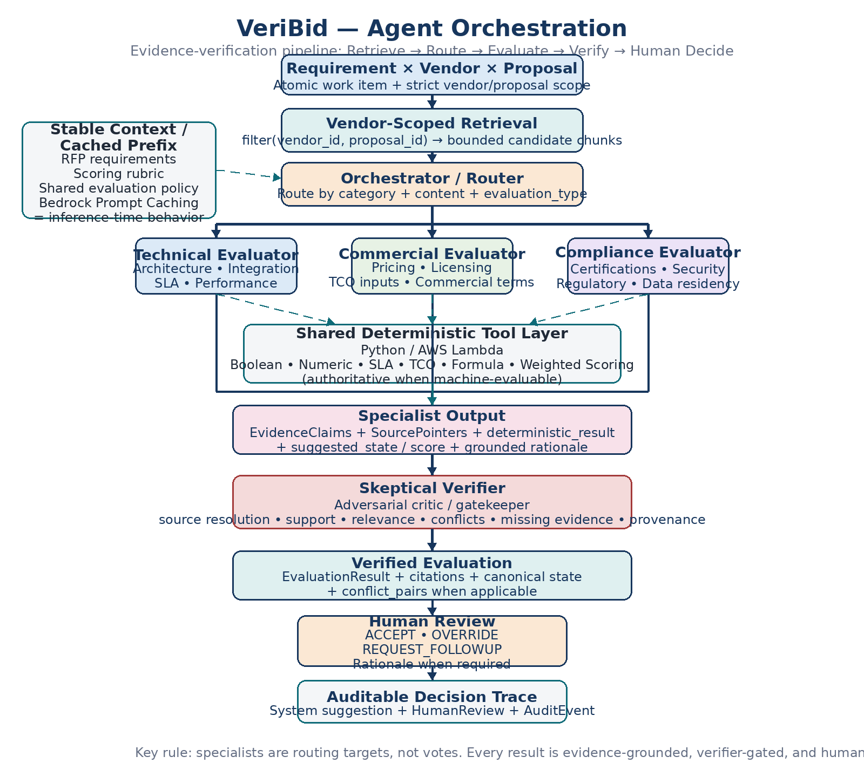
Figure 1. VeriBid Agent Orchestration — Router + Specialist + Critic with shared deterministic tools and human final authority.

3. Component Responsibilities

3.1 Requirement × Vendor × Proposal
Đây là atomic execution unit của evaluation runtime. Mọi retrieval, reasoning, deterministic check và verification phải giữ nguyên vendor_id + proposal_id để ngăn cross-vendor contamination.

3.2 Vendor-Scoped Retrieval
Runtime lọc theo vendor_id + proposal_id trước khi reasoning, sau đó chỉ chuyển một bounded set of candidate chunks vào specialist. Mỗi chunk phải giữ source metadata đủ mạnh để tạo SourcePointer mà không cần suy diễn lại vị trí nguồn.

3.3 Stable Context / Prompt Caching
Stable context gồm RFP requirements, scoring rubric và shared procurement/evaluation policy. Prefix này được giữ ổn định trước vendor-specific evidence để Amazon Bedrock Prompt Caching có thể tái sử dụng khi model/API hỗ trợ. Prompt caching là inference-time behavior, không phải một cache service/object riêng do ứng dụng khởi tạo.

3.4 Orchestrator / Router
Router chọn primary specialist dựa trên requirement category, nội dung và evaluation_type. MVP chỉ có ba specialist: Technical, Commercial và Compliance. Internal orchestration có thể dùng AWS Step Functions nhưng frontend/API không phụ thuộc trực tiếp vào topology này.

3.5 Technical Evaluator
Đánh giá functional/non-functional requirements, architecture, integration, SLA, latency, throughput, scalability và performance claims. Khi requirement là numeric/SLA threshold, agent chỉ extract raw values + citations rồi delegate comparison cho deterministic tool.

3.6 Commercial Evaluator
Đánh giá pricing, licensing model, implementation/support fees, usage-based assumptions và TCO inputs. AI không tự tính authoritative TCO hoặc weighted commercial arithmetic; các phép tính phải đi qua deterministic tool layer.

3.7 Compliance Evaluator
Đánh giá certifications, security controls, regulatory constraints, privacy, data residency và mandatory compliance criteria. Generic vendor assertions không được tự động chuyển thành SATISFIED; machine-evaluable compliance gates có thể delegate cho deterministic tools.

3.8 Shared Deterministic Tool Layer
Là tài nguyên dùng chung cho cả ba specialist khi criterion machine-evaluable. Các Lambda/Python tools xử lý boolean_rule_check, numeric_threshold_check, SLA comparison, TCO, formulas và weighted scoring. Tool result là authoritative; LLM rationale chỉ giải thích và trích dẫn input.

3.9 Specialist Output
Structured candidate gồm EvidenceClaims, SourcePointers, deterministic_result nếu có, suggested_state, suggested_score, grounded rationale và confidence metadata. Confidence chỉ phản ánh extraction/mapping quality; không thay thế evidence.

3.10 Skeptical Verifier
Independent adversarial critic/gatekeeper. Verifier kiểm tra source resolution, vendor/proposal ownership, actual support/relevance, contradiction, missing evidence, deterministic provenance và canonical state semantics. Result chưa qua verifier không được coi là verified assessment để hiển thị cho reviewer.

3.11 Verified Evaluation
Verifier phát hành EvaluationResult theo đúng một trong 5 canonical states: SATISFIED, PARTIALLY_SATISFIED, NOT_SATISFIED, CONFLICTING_EVIDENCE, INSUFFICIENT_EVIDENCE. Material contradiction phải giữ explicit conflict_pairs; missing/unresolvable evidence phải abstain.

3.12 Human Review & Audit Trace
Reviewer có thể ACCEPT, OVERRIDE hoặc REQUEST_FOLLOWUP. OVERRIDE bắt buộc có rationale và phải giữ system suggestion ban đầu. HumanReview cùng AuditEvent tạo append-only trace; VeriBid không tự động chọn hoặc tuyên bố vendor thắng cuộc.

4. Routing and Tool-Use Semantics
Requirement condition | Primary specialist | Deterministic delegation | Expected behavior
Architecture / integration / performance | Technical | When numeric/SLA/threshold | Extract cited facts → tool result → grounded specialist suggestion
Pricing / licensing / TCO | Commercial | Often required for TCO/formula/weighted arithmetic | Extract commercial facts → tool result → grounded specialist suggestion
Certification / security / residency / mandatory compliance | Compliance | When boolean/numeric hard gate is machine-evaluable | Assess source-backed compliance evidence; delegate explicit rules to tool
Material contradiction or missing/unresolvable evidence | Any specialist → Verifier | Not a replacement for verification | Verifier enforces CONFLICTING_EVIDENCE or INSUFFICIENT_EVIDENCE

5. Non-Negotiable Invariants
- No cross-vendor evidence: every retrieval/evaluation operation carries vendor_id + proposal_id.
- No source, no grounded claim: unsupported factual assertions cannot become user-visible facts.
- No silent averaging of contradictions: preserve both sources and explicit conflict_pairs.
- No arithmetic authority inside the LLM: deterministic tools own machine-evaluable calculations.
- No raw model output at the frontend boundary: agent output must pass typed schema validation and domain invariant checks.
- No autonomous award: final state/score and procurement decision remain human-controlled.
- No false cache claims: a warm run is counted only when runtime telemetry reports cached-input usage.

6. Coding Agent Implementation Notes
- Implement the workflow as contract-first. API clients should see run/job/result contracts, not raw Step Functions or Bedrock payloads.
- Use one specialist as the primary route per requirement; do not implement free-form multi-agent debate or voting for the MVP.
- Make deterministic tool calls optional and driven by evaluation_type / requirement semantics. All three specialists may use the shared tool layer.
- Persist the exact evidence IDs and SourcePointers used by the verifier so Evidence Matrix detail can render the reasoning trace without re-inference.
- Fail closed after bounded schema repair. Execution failure is not the same as INSUFFICIENT_EVIDENCE.
- Preserve prompt-cache telemetry (input/output/cache read/cache write tokens and latency) for controlled cold/warm benchmark runs.

7. Canonical Summary
Retrieve → Route → Evaluate → Verify → Human Decide
VeriBid does not use multi-agent voting or free-form consensus. It routes each requirement to the appropriate specialist, grounds the assessment in source evidence and deterministic tools, subjects the result to adversarial verification, and leaves the final decision to a human reviewer.

8. Project Alignment Sources
- VeriBid Product Brief / PRD v0.2 — Core Workflow, Dual-Path Separation, CAG, Adversarial Verifier Pattern, Traceable Evidence Graph.
- VeriBid Functional Requirements v0.1 — FR-4 Specialist Evaluation, FR-5 Skeptical Verification, vendor isolation, human review.
- VeriBid Data + Evidence Model v0.2 — EvidenceClaim, SourcePointer, EvaluationResult, conflict_pairs, canonical states, HumanReview, AuditEvent.
- VeriBid AI / Agent Specification v0.1 FINAL — routing topology, retrieval-before-evaluation, specialist contracts, verifier contract, abstention and schema safety.
- VeriBid API Contract v0.2 — run/result boundaries, deterministic_result DTO, matrix/detail split, human review, telemetry.
- VeriBid AWS System Architecture v0.1 — Step Functions baseline, Bedrock semantic path, shared deterministic Lambda tools, Prompt Caching telemetry.
- VeriBid Deployment + Test Checklist v0.2 — seeded contradiction, prompt-cache benchmark, end-to-end acceptance and submission proof.

