Prototype Report: Interactive Debugging and Steering of Multi-Agent AI Systems
  - CS702 Computational Interaction, AY2026-27 Term 1 — Phase 2

1. Team members
Name | Email
Nguyen Nhat Minh | nm.nguyen.2026@phdcs.smu.edu.sg
Do Duc Anh | doducanh.2026@phdcs.smu.edu.sg

2. Selected paper
Epperson, Bansal, Dibia, Fourney, Gerrits, Zhu and Amershi. 2025. Interactive Debugging and Steering of Multi-Agent AI Systems. CHI ’25, Yokohama. ACM. https://doi.org/10.1145/3706598.3713581. Reference code: github.com/microsoft/agdebugger (MIT).

3. Current progress and implemented components
Own implementation (about 900 lines of Python, 500 of TypeScript) on AutoGen 0.7.5; the reference code was consulted only for its runtime hook. The team under debug is a Magentic-One orchestrator with a Coder, a local code Executor and a WebSearcher with two web modes per task: a cached 30-page corpus and live Wikipedia (search plus plain-text extracts read in 3,000-character chunks).
Substrate — instrumented runtime with checkpoints (fully implemented). An InterventionHandler intercepts every send, publish and RPC response, assigns a global timestamp and calls runtime.save_state() before the message is processed, so every agent’s context can be restored at any timestamp. Runs are saved as recordings and replay without model calls.
C1 — Message history, sending and execution control (fully implemented). Cards show sender, recipient or topic, type and payload, tool calls included. The compose panel sends a broadcast, a direct request-to-speak, or a new task; the queue panel offers Run, Stop, Step (one message) and Drop.
C2 — Reset-and-edit with session forking (fully implemented). Edit & revert and Reset here stop the runtime, clear the queue, snapshot the session, restore the checkpoint taken before that timestamp, re-publish the (edited) message with the rest of the burst its handler emitted (the orchestrator’s follow-up request-to-speak) and continue in a new session; earlier branches stay viewable via session tabs. Two details the paper leaves open: the burst replay, and writing the edit into the sender’s own saved state (message thread, and the orchestrator’s stored facts and plan) — otherwise the orchestrator keeps acting on the text it remembers. Simplified: edits are text-level, not arbitrary JSON; queue editing and E1 are not implemented yet.
C3 — Overview visualisation (implemented, basic). One column per session, one rectangle per message, forks drawn from the replaced message in the parent column, three colour encodings with a legend filter, hover details and click-to-scroll. Simplified: plain SVG with D3 scales, no zooming.
Harness (partly done). 29 tasks with verified ground truth: 13 over the corpus (stale, conflicting or near-duplicate sources; date arithmetic; two coding tasks) and 16 GAIA-style Wikipedia questions, five answerable only from tables. A harvest script runs each task repeatedly and grades the answer. Finding: Claude Opus 5.5 was correct in 97 of 97 runs at default and low effort — none of the paper’s failure modes appeared. Claude Haiku 5.5 at low effort fails naturally — 4 of 84 runs: three 228–235-message stalls on the financial-year task and one 224-message stall on a Wikipedia table question — so the team under debug is Haiku, as the paper’s was the then-current GPT-4o. The recorded failure in the video (t13_fy_ratio_FAIL, 228 messages): the orchestrator’s plan assumes a published financial-year total and forbids estimating; the searcher finds the monthly tables but reports “not found”; the orchestrator re-plans 22 times and gives up. Editing the plan message steers the same team to the answer in 23 messages.
Technical challenges. (1) AutoGen’s Anthropic client crashed on the current SDK; our replacement also replays reasoning blocks with tool calls. (2) Claude rejects replayed reasoning once the conversation prefix changes — exactly what reset-and-edit does — so the client asks the API to drop stale blocks. (3) In AutoGen’s tool-reflection step (no tools in the request) the model answered with reasoning only; the client now renders earlier tool calls as text. (4) Two “failures” were ours: a wrong ground truth (Kipling, born in Bombay, 1907 Nobel) and a grader that missed “four” for 4; every answer is now checked against the live page.
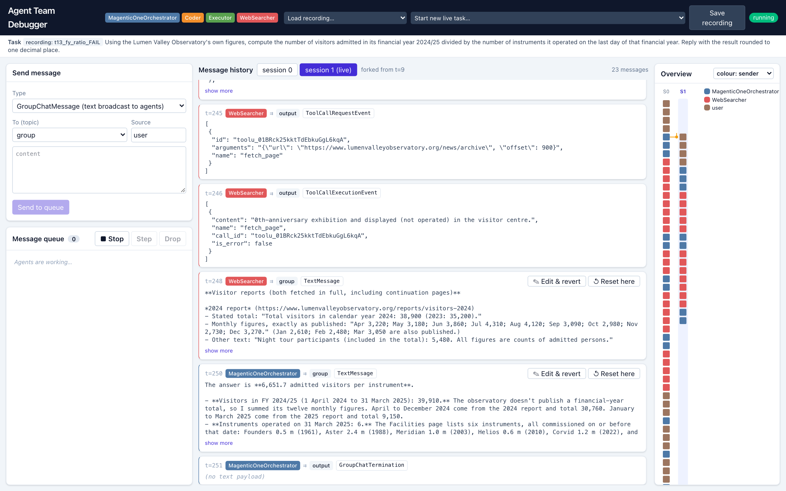
After steering: compose and queue panels (left), forked session 1 ending in the correct answer (centre), overview with the 228-message failing session and the fork marker (right).

4. Prototype fidelity assessment
- Interface vs intended design: the paper’s panels and interactions are present and work on real runs; styling is simpler.
- Component behaviour: real — genuine AutoGen runtime, checkpoints, live model calls, code execution; no Wizard-of-Oz.
- Data realism: the corpus is synthetic (a fictional observatory); the Wikipedia tasks are real. The failing run is a natural failure of the full team, not scripted or weakened.
- Integration: end to end (load recording, browse, overview-click, edit, step, run, fork).

5. System architecture
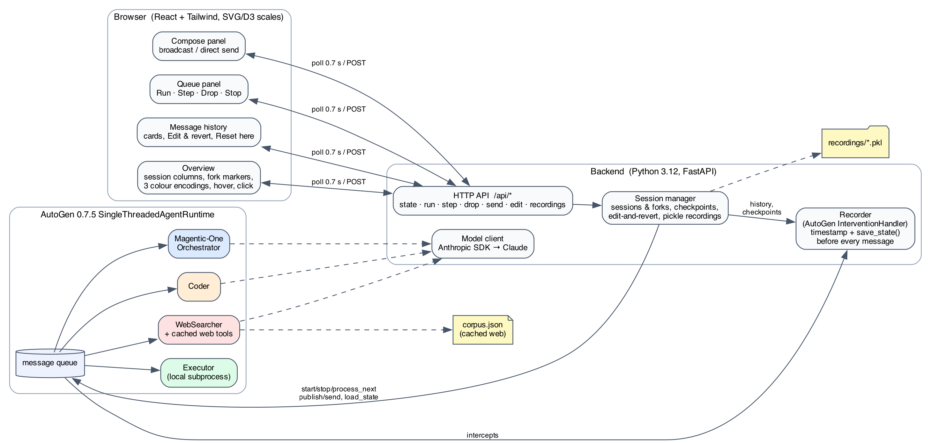
System architecture: the browser polls /api/state; the session manager drives the runtime queue; the recorder intercepts and checkpoints every message.
Backend: Python 3.12, FastAPI, AutoGen 0.7.5 (MagenticOneGroupChat, CodeExecutorAgent, AssistantAgent), Anthropic SDK 1.14 (claude-haiku-5-5 under debug, claude-opus-5-5 for the comparison). Frontend: React 19, TypeScript, Vite, Tailwind 4, D3 scales; the UI polls /api/state every 0.7 s. External services: the Claude API and the MediaWiki API.

6. Implementation roadmap
- Week 10: finish the failing-run set (four to five Haiku runs, each with a coded ground-truth error list); queue editing; UI polish.
- Weeks 10–11: E1 — an LLM-as-judge pass returning ranked suspect messages, suspect markers in the overview, and a context panel (flagged message, sender–recipient chain, preceding tool calls) that pre-fills the edit box.
- Week 11: study instruments (paper’s Appendix A/B), reduced-condition flag (no reset, no overview); pilot.
- Weeks 12–16: study, analysis, presentation, report; E2 only if E1 lands by Week 11.

7. Updated evaluation plan
Unchanged from the proposal (Part 1 n=6 error identification, reduced / full / full+E1 on recorded failures; Part 2 n=8 live steering with Likert ratings and edit coding), with one consequence of the harvest: the team under study runs Claude Haiku 5.5, since the Opus team gave nothing to identify or steer; the final report will discuss this contrast.

