**SOFTWARE DESIGN**

**FunixPricingChain**

**1. Architecture**

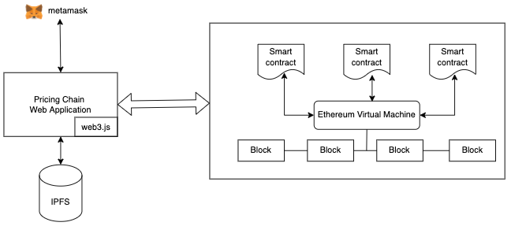

**2. Application Design**

|  |
| --- |
| *Main Contract* |
| *+ attribute* |
| *initSession*  *closeSession*  *getSession*  *submitPrice*  *signIn*  *signUp*  *createProduct*  *updateProduct*  *removeProduct*  *getUser*  *updateUser* |

|  |
| --- |
| *Session* |
| *+ attribute* |
|  |

|  |
| --- |
| *Product* |
| *+ attribute* |
|  |

**3. Functional Design**

/* *For each function in the smart contract, we need to define its signature, including the following:*

* *Function name*
* *Function purpose*
* *List of parameters (including name and data type for each parameter)*
* *Return type*

*/

*//TODO: define function signature for all functions in the Main and Session smart contract*