**Computer Organization 2020**

**HOMEWORK 3 RISC-V CPU**

**Due date:**

**Overview**

The goal of this homework is to help you understand how a RISC-V work and how to use Verilog hardware description language (Verilog HDL) to model electronic systems. In this homework, you need to implement ALU and decoder module and make your codes be able to execute *all RISC-V* instructions. You need to follow the instruction table in this homework and satisfy all the homework requirements. In addition, you need to verify your CPU by using Modelsim.

**General rules for deliverables**

* You need to complete this homework INDIVIDUALLY. You can discuss the homework with other students, but you need to do the homework by yourself. You should not copy anything from someone else, and you should not distribute your homework to someone else. If you violate any of these rules, you will get NEGATIVE scores, or even fail this course directly
* When submitting your homework, compress all files into a single **zip** file, and upload the compressed file to Moodle.
  + Please follow the file hierarchy shown in Figure 1.

**F740XXXXX ( your id ) (folder)**

**src ( folder ) * Store your source code**

**report.docx ( project report. The report template is already included. Follow the template to complete the report. )**

|  |
| --- |
|  |
| Figure 1. File hierarchy for homework submission |

* **Important!** DO NOT submit your homework in the last minute. Late submission is not accepted.
* You should finish all the requirements (shown below) in this homework and Project report.
* If your code can not be recompiled by TA successfully using modelsim, you will receive NO credit.
* Verilog and SystemVerilog generators aren’t allowed in this course.

**Instruction format:**

* **R-type**

|  |  |  |  |  |  |  |  |
| --- | --- | --- | --- | --- | --- | --- | --- |
| **31 25** | **24 20** | **19 15** | **14 12** | **11 7** | **6 0** |  |  |
| **funct7** | **rs2** | **rs1** | **funct3** | **rd** | **opcode** | **Mnemonic** | **Description** |
| 0000000 | rs2 | rs1 | 000 | rd | 0110011 | ADD | rd = rs1 + rs2 |
| 0100000 | rs2 | rs1 | 000 | rd | 0110011 | SUB | rd = rs1 - rs2 |
| 0000000 | rs2 | rs1 | 001 | rd | 0110011 | SLL | rd = rs1u << rs2[4:0] |
| 0000000 | rs2 | rs1 | 010 | rd | 0110011 | SLT | rd = rs1s < rs2s ? 1 : 0 |
| 0000000 | rs2 | rs1 | 011 | rd | 0110011 | SLTU | rd = rs1u < rs2u ? 1 : 0 |
| 0000000 | rs2 | rs1 | 100 | rd | 0110011 | XOR | rd = rs1 ^ rs2 |
| 0000000 | rs2 | rs1 | 101 | rd | 0110011 | SRL | rd = rs1u >> rs2[4:0] |
| 0100000 | rs2 | rs1 | 101 | rd | 0110011 | SRA | rd = rs1s >> rs2[4:0] |
| 0000000 | rs2 | rs1 | 110 | rd | 0110011 | OR | rd = rs1 | rs2 |
| 0000000 | rs2 | rs1 | 111 | rd | 0110011 | AND | rd = rs1 & rs2 |

* **I-type**

|  |  |  |  |  |  |  |  |
| --- | --- | --- | --- | --- | --- | --- | --- |
| **31 20** | | **19 15** | **14 12** | **11 7** | **6 0** |  |  |
| **imm[11:0]** | | **rs1** | **funct3** | **rd** | **opcode** | **Mnemonic** | **Description** |
| imm[11:0] | | rs1 | 010 | rd | 0000011 | LW | rd = M[rs1 + imm] |
| imm[11:0] | | rs1 | 000 | rd | 0000011 | LB | rd = ${M[rs1+ imm]}_{bs}$ |
| imm[11:0] | | rs1 | 001 | rd | 0000011 | LH | rd = ${M[rs1+ imm]}_{hs}$ |
| imm[11:0] | | rs1 | 100 | rd | 0000011 | LBU | rd = ${M[rs1+imm]}_{bu}$ |
| imm[11:0] | | rs1 | 101 | rd | 0000011 | LHU | rd = ${M[rs1+imm]}_{hu}$ |
| imm[11:0] | | rs1 | 000 | rd | 0010011 | ADDI | rd = rs1 + imm |
| imm[11:0] | | rs1 | 010 | rd | 0010011 | SLTI | rd = rs1s < imms? 1:0 |
| imm[11:0] | | rs1 | 011 | rd | 0010011 | SLTIU | rd = rs1u < immu? 1:0 |
| imm[11:0] | | rs1 | 100 | rd | 0010011 | XORI | rd = rs1 ^ imm |
| imm[11:0] | | rs1 | 110 | rd | 0010011 | ORI | rd = rs1 | imm |
| imm[11:0] | | rs1 | 111 | rd | 0010011 | ANDI | rd = rs1 & imm |
| 0000000 | shamt | rs1 | 001 | rd | 0010011 | SLLI | rd = rs1u << shamt |
| 0000000 | shamt | rs1 | 101 | rd | 0010011 | SRLI | rd = rs1u >> shamt |
| 0100000 | shamt | rs1 | 101 | rd | 0010011 | SRAI | rd = rs1s >> shamt |
| imm[11:0] | | rs1 | 000 | rd | 1100111 | JALR | rd = PC + 4  PC = imm + rs1  (Set LSB of PC to 0) |

1. **Byte = 8bits**
2. **Half-word=16bits**
3. **LBU and LHU means load byte/half-word unsigned data.**

* **S-type**

|  |  |  |  |  |  |  |  |
| --- | --- | --- | --- | --- | --- | --- | --- |
| **31 25** | **24 20** | **19 15** | **14 12** | **11 7** | **6 0** |  |  |
| **imm[11:5]** | **rs2** | **rs1** | **funct3** | **imm[4:0]** | **opcode** | **Mnemonic** | **Description** |
| imm[11:5] | rs2 | rs1 | 010 | imm[4:0] | 0100011 | SW | M[rs1 + imm] = rs2 |
| imm[11:5] | rs2 | rs1 | 000 | imm[4:0] | 0100011 | SB | ${M[rs1+imm]}_{b}$ = ${rs2}_{b}$ |
| imm[11:5] | rs2 | rs1 | 001 | imm[4:0] | 0100011 | SH | ${M[rs1+imm]}_{h}$ = ${rs2}_{h}$ |

**1.SB and SH means store lowest byte or half-word of rs2 to the memory**

* **B-type**

|  |  |  |  |  |  |  |  |
| --- | --- | --- | --- | --- | --- | --- | --- |
| **31 25** | **24 20** | **19 15** | **14 12** | **11 7** | **6 0** |  |  |
| **imm[12|10:5]** | **rs2** | **rs1** | **funct3** | **imm[4:1|11]** | **opcode** | **Mnemonic** | **Description** |
| imm[12|10:5] | rs2 | rs1 | 000 | imm[4:1|11] | 1100011 | BEQ | PC = (rs1 == rs2) ?  PC + imm : PC + 4 |
| imm[12|10:5] | rs2 | rs1 | 001 | imm[4:1|11] | 1100011 | BNE | PC = (rs1 != rs2) ?  PC + imm : PC + 4 |
| imm[12|10:5] | rs2 | rs1 | 100 | imm[4:1|11] | 1100011 | BLT | PC = (rs1s < rs2 s) ?  PC + imm : PC + 4 |
| imm[12|10:5] | rs2 | rs1 | 101 | imm[4:1|11] | 1100011 | BGE | PC = (rs1s ≧ rs2 s)?  PC + imm : PC + 4 |
| imm[12|10:5] | rs2 | rs1 | 110 | imm[4:1|11] | 1100011 | BLTU | PC = (rs1u < rs2 u) ?  PC + imm : PC + 4 |
| imm[12|10:5] | rs2 | rs1 | 111 | imm[4:1|11] | 1100011 | BGEU | PC = (rs1u ≧ rs2 u) ?  PC + imm : PC + 4 |

* **U-type**

|  |  |  |  |  |
| --- | --- | --- | --- | --- |
| **31 12** | **11 7** | **6 0** |  |  |
| **imm[31:12]** | **rd** | **opcode** | **Mnemonic** | **Description** |
| imm[31:12] | rd | 0010111 | AUIPC | rd = PC + imm |
| imm[31:12] | rd | 0110111 | LUI | rd = imm |

* **J-type**

|  |  |  |  |  |
| --- | --- | --- | --- | --- |
| **31 12** | **11 7** | **6 0** |  |  |
| **imm[20|10:1|11|19:12]** | **rd** | **opcode** | **Mnemonic** | **Description** |
| imm[20|10:1|11|19:12] | rd | 1101111 | JAL | rd = PC + 4  PC = PC + imm |

**Homework Description**

* **Module**

1. **top_tb module**
2. “top_tb” is not a part of CPU, it is a file that controls all the program and verify the correctness of our CPU. The main features are as follows: send periodical signal CLK to CPU, set the initial value of IM, print the value of DM, end the program.

※You do not need to modify this module.

1. **top module**

“top” is the outmost module. It is responsible for connecting wires between CPU, IM and DM.

Here are the wires:

* *instr_read* represents the signal whether the instruction should be read in IM.
* *instr_addr* represents the instruction address in IM.
* *instr_out* represents the instruction send from IM .
* *data_read* represents the signal whether the data should be read in DM.
* *data_write* has four signal , and every signal represents the byte of the data whether should be wrote in DM.
* *data_addr* represents the data address in DM.
* *data_in* represents the data which will be wrote into DM .
* *data_out* represents the data send from DM .

※You do not need to modify this module.

1. **SRAM module**

“SRAM” is the abbreviation of “Instruction Memory” (or “Data Memory”). This module saves all the instructions (or data) and send instruction (or data) to CPU according to request.



※You do not need to modify this module

1. **CPU module**

“CPU” is responsible for connecting wires between modules, please design a RISC-V CPU by yourself. You can write other modules in other files if you need, but remember to include those files in CPU.v.

※You should modify this module.

* **Reference Block Diagram**

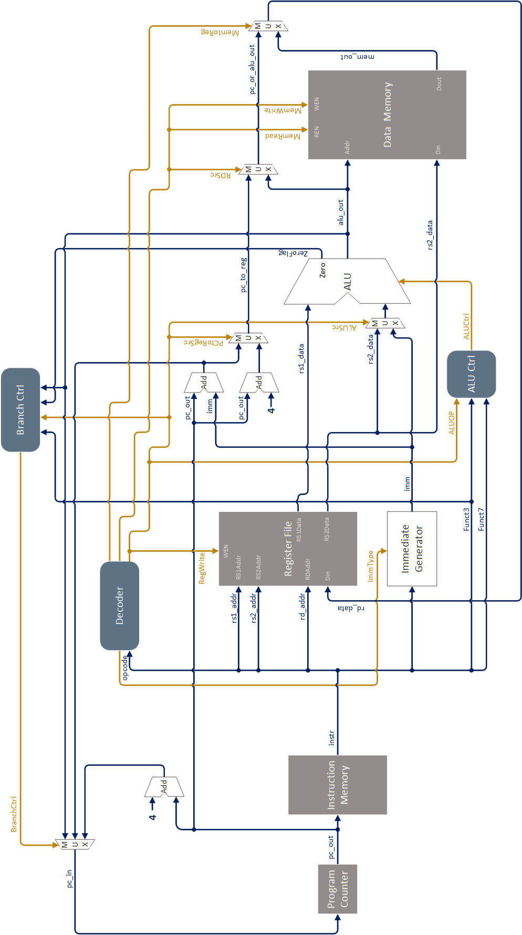

* **Register File**

|  |  |  |  |
| --- | --- | --- | --- |
| **Register** | **ABI Name** | **Description** | **Saver** |
| x0  x1  x2  x3  x4  x5  x6 – 7  x8  x9  x10 - 11  x12 - 17  x18 - 27  x28 - 31 | zero  ra  sp  gp  tp  t0  t1 - 2  s0/fp  s1  a0 - 1  a2 - 7  s2 - 11  t3 - 6 | Hard-wired zero  Return address  Stack pointer  Global pointer  Thread pointer  Temporary / alternate link register  Temporaries  Saved register / frame pointer  Saved register  Function arguments / return values  Function arguments  Saved registers  Temporaties | ---  Caller  Callee  ---  ---  Caller  Caller  Callee  Callee  Caller  Caller  Callee  Caller |

* **Test Instruction**

1. **Memory layout**

|  |
| --- |
|  |
| Figure 2. Memory layout |

* .text: Store instruction code.
* .init & .fini: Store instruction code for entering & leaving the process.
* .rodata: Store constant global variable.
* .bss & .sbss: Store uninitiated global variable or global variable initiated as zero.
* .data & .sdata: Store global variable initiated as non-zero
* .stack: Store local variables

1. **setup.S**

This program start at “PC = 0”, execute function as followings:

1. Reset register file
2. Initial stack pointer and sections
3. Call main function
4. Wait main function return, then terminate program
5. **main.S**

This program start after setup.S, it will verify all RISC-V instructions (31 instructions).

1. **main0.hex & main1.hex & main2.hex & main3.hex**

Using the cross compiler of RISC-V to compile test program, and write result in verilog format. So you do not need to compile above program again.

* **Simulation Result**

|  |  |
| --- | --- |
| **Register** | **Value (hex)** |
| DM[ 0]  DM[ 1]  DM[ 2]  DM[ 3]  DM[ 4]  DM[ 5]  DM[ 6]  DM[ 7]  DM[ 8]  DM[ 9]  DM[ 10]  DM[ 11]  DM[ 12]  DM[ 13]  DM[ 14]  DM[ 15]  DM[ 16]  DM[ 17]  DM[ 18]  DM[ 19]  DM[ 20]  DM[ 21]  DM[ 22]  DM[ 23]  DM[ 24]  DM[ 25]  DM[ 26]  DM[ 27]  DM[ 28]  DM[ 29]  DM[ 30]  DM[ 31]  DM[ 32]  DM[ 33]  DM[ 34]  DM[ 35]  DM[ 36]  DM[ 37]  DM[ 38]  DM[ 39]  DM[ 40]  DM[ 41]  DM[ 42]  DM[ 43]  DM[ 44] | **fffffff0**  **fffffff8**  **00000008**  **00000001**  **00000001**  **78787878**  **000091a2**  **00000003**  **fefcfefd**  **10305070**  **cccccccc**  **ffffffcc**  **ffffcccc**  **000000cc**  **0000cccc**  **00000d9d**  **00000004**  **00000003**  **000001a6**  **00000ec6**  **2468b7a8**  **5dbf9f00**  **00012b38**  **fa2817b7**  **ff000000**  **12345678**  **0000f000**  **00000f00**  **000000f0**  **0000000f**  **56780000**  **78000000**  **00005678**  **00000078**  **12345678**  **ce780000**  **fffff000**  **fffff000**  **fffff000**  **fffff000**  **fffff000**  **fffff000**  **1357a064**  **13578000**  **fffff004** |

**Homework Requirements**

1. Complete the CPU that can execute all instructions from the *RISC-V ISA* section.
2. Verify your CPU with the benchmark and take a snapshot (e.g. Figure 3)

|  |
| --- |
|  |
| Figure 3. **S**napshot of correct simulation |

* 1. Using **waveform** to verify the execute results.
  2. Please annotate the waveform

1. Finish the Project Report.
   1. Complete the project report. The report template is provided.

|  |
| --- |
| **Important**  When you upload your file, please make sure you have satisfied all the homework requirements, including the **File hierarchy**, **Requirement file** and **Report format**.  If you have any questions, please contact us. |