HOMEWORK 1

Student ID: P76087099 Name: Nguyen Vu Le Minh

Yutong’s thesis: A High-Performance VLSI Implementation of Local Binary Convolutional Neural Network

1. LBCNN Training:

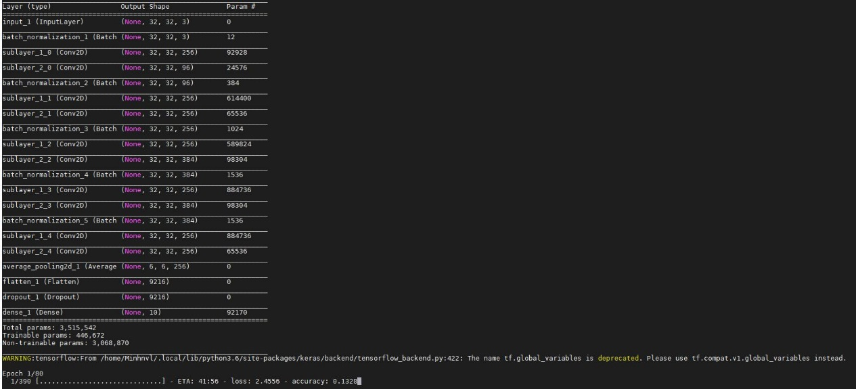

1. Transfer input and weight from floating-point into fixed-point

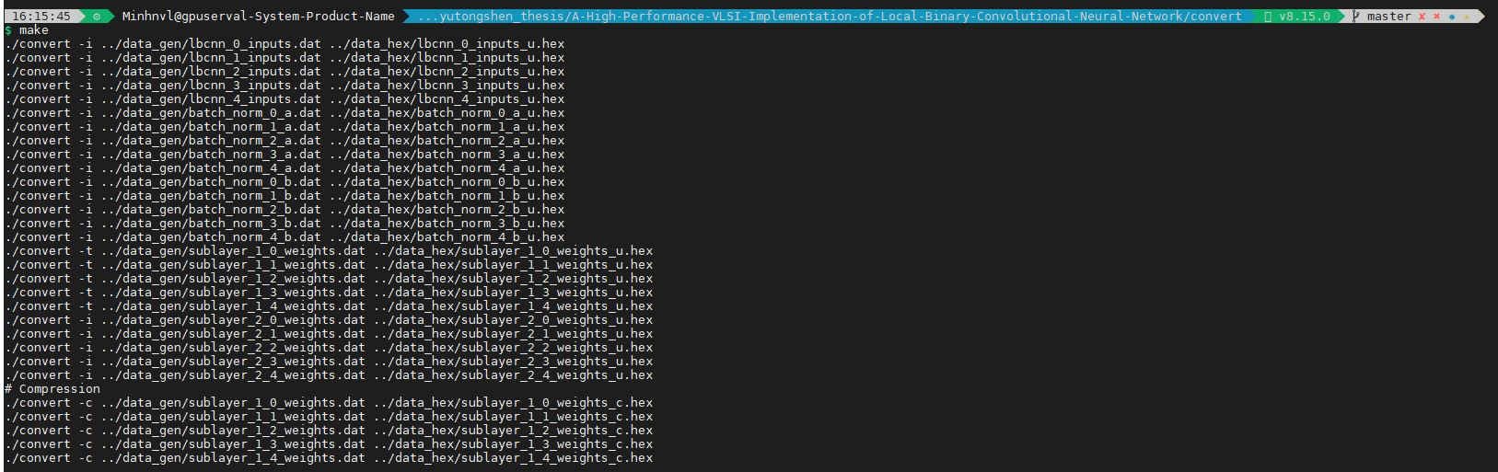

1. Generate Golden_data file



1. Execute pre-sim

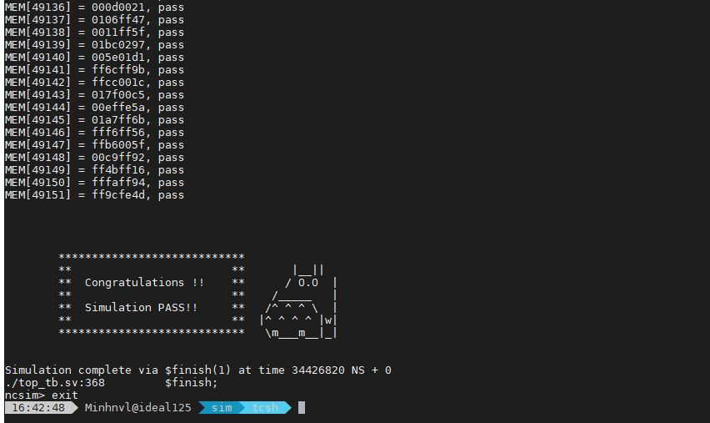

1. Execute post-sim

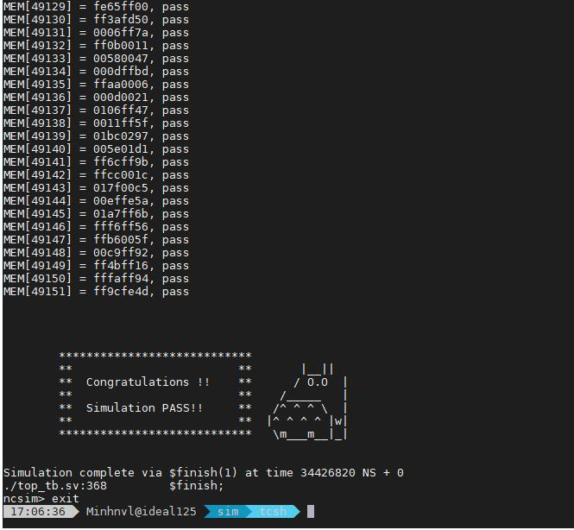

1. Use Jupyter Notebook to inference Cifar-10

