HOMEWORK 2

Student ID: P76087099 Name: Nguyen Vu Le Minh

The first step is an input pattern set of a random production circuit.

Execute command: gen_input_pattern.pl

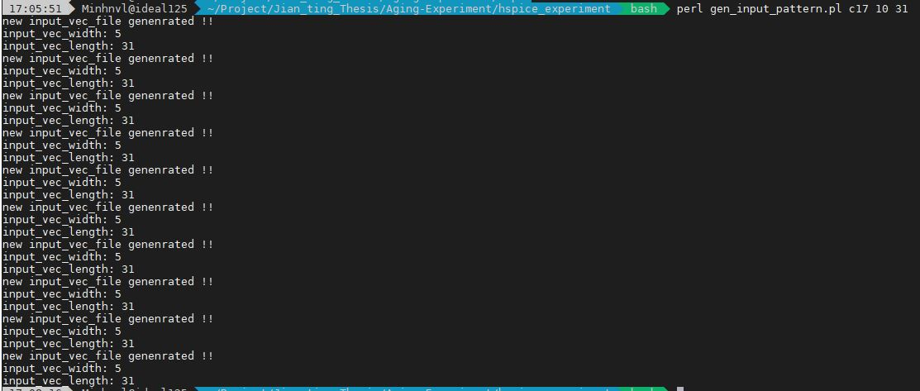

The following describes how to use ncverilog to simulate the output pattern of the circuit according to the input pattern.

Execute command run_ncverilog.pl

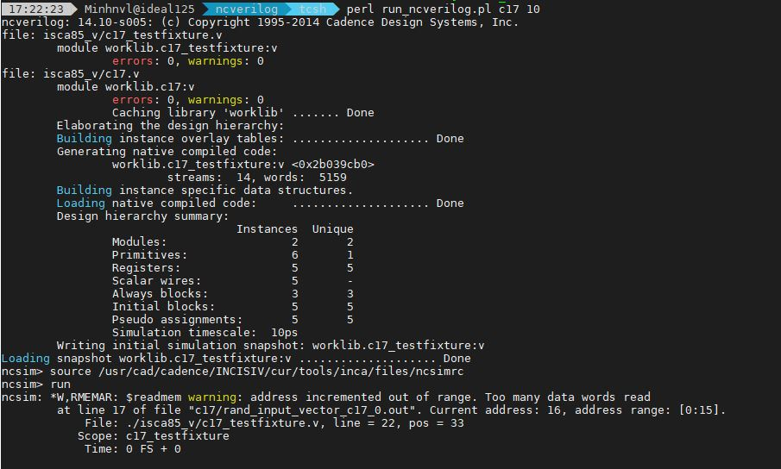

We will find that there are more files related to output pattern in the directory of input pattern.

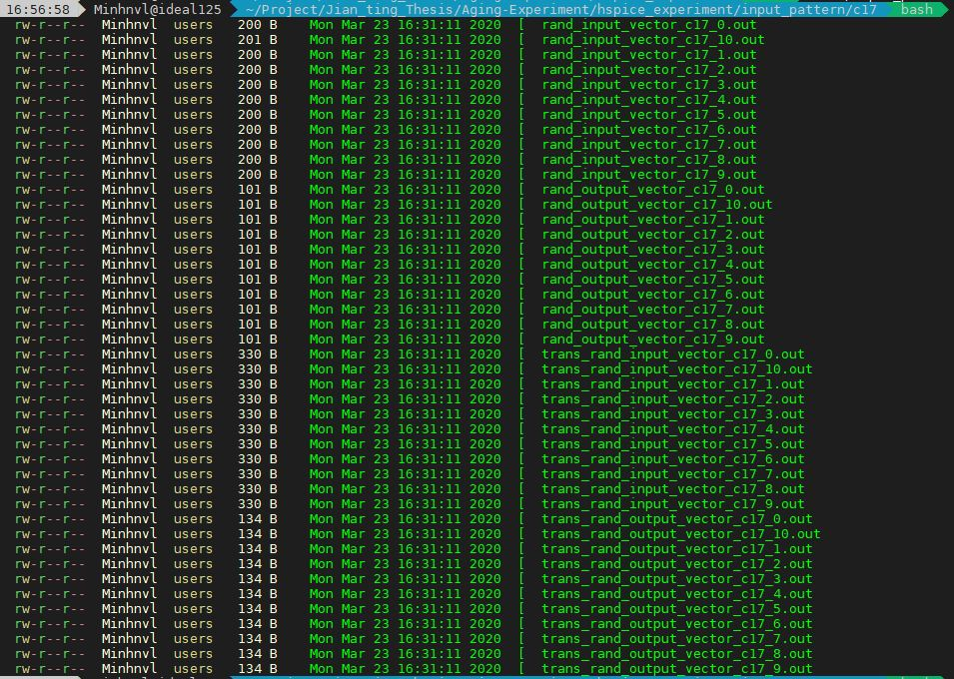

We go back to the folder “hspice_experiment” and execute command run_input_profile.pl

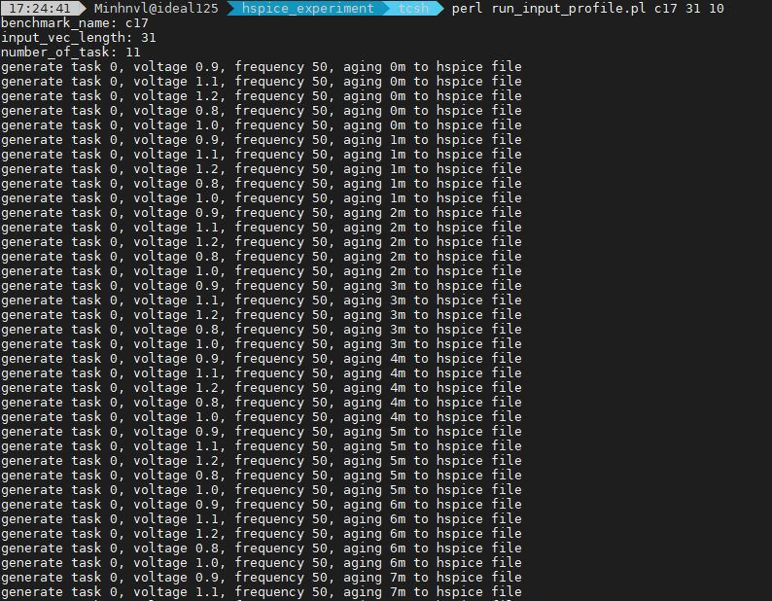

You will see file corresponding to the circuit in test_header directory

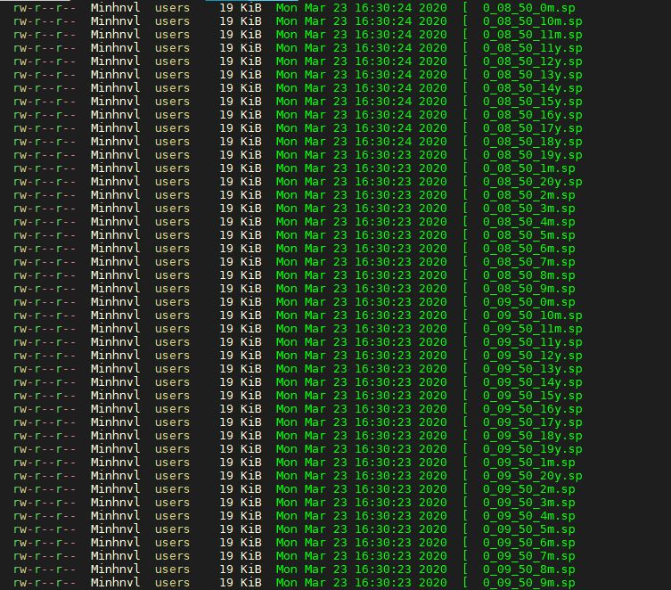

In hspice_experiment direction, execute run_hispice.pl

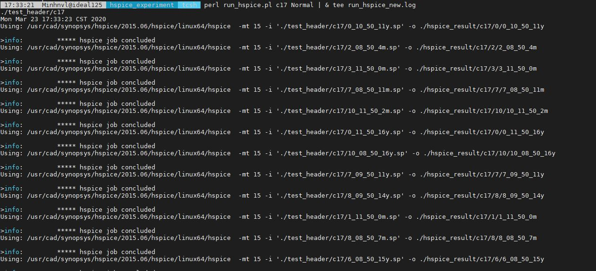

Finally, we run command run_simulate.pl the multicore lifetime and energy simulation results will be generated.

