00_Overview

Saturday, August 21, 2021

8:47 AM

**Syllabus**

App 
API 
Logic 
Data 
Auth 
DNS 
Cache 
Which Services Do We Need? 
Serve Static App (e.g. Angular App) 
REST API 
Execute Code on Demand 
Store & Retrieve Data (DB) 
Authenticate Users 
Translate URL 
Improve Performance (e.g. Caching) 
S3 (Simple Storage Service) 
API Gateway 
Lambda 
DynamoDB 
Cognito 
Route 53 
Cloudfront 
Optional Traditional Web Hosting - Apps 
Web App 
Mobile App 
Sends and receives Data (no HTML!) 
Issue: Re-invent 
the Wheel 
Issue: Servers are 
online even if not 
Serve' 
Runs PHP/Node/... 
required 
Runs PHP/Node 
Backend 
(REST API) 
Access Database 
Business Logic 
Issue: Keep OS & 
software updated 
Issue: Over- Oder 
underprovision 
AS PHP/Node/... Serverless Apps 
Web App 
Mobile App 
Sends and receives Data (no HTML!) 
Backend 
(REST API) 
Access Database 
Business Logic 
Forwards Request and receives Data 
Node.js 
Java 
On-Demand Code 
Python 

**App description**

Auth 
The "Compare Yourself" App 
Web App 
Your Data 
Submit 
API Gateway 
POST /compare-yourself 
Add Oata (Aqc. Helqtlt. Income) 
GET /compare-yourself/ 
Get Data - For Yau or Evervone 
DELETE /compare-yourself 
Remove Hours Entry 
Lambda 
DynamoDB 
CompareData 
Age 
Height 
Income "Traditional" vs "Serverless" 
"Traditional" Web Hosting 
Provision Capacity 
How much Server Capacity? 
CPU, RAM, Memory 
Scaling (Pay too much or Server Issues) 
Update OS & Software 
Prevent Security Issues by thoughtfully 
updating Software 
Lots of Overhead for SPA + API Apps 
Great Support for Fullstack Apps 
"Serverless" Web Hosting 
Runs On-Demand 
Unlimited Capacity 
Only Pay for Code Executions 
Scales Automatically (Pay what you Need) 
Runs on Managed AWS Infrastructure 
Code runs in up-to-date and secure 
Environment 
Great for SPA + API Apps 
Limited Support for Fullstack Apps 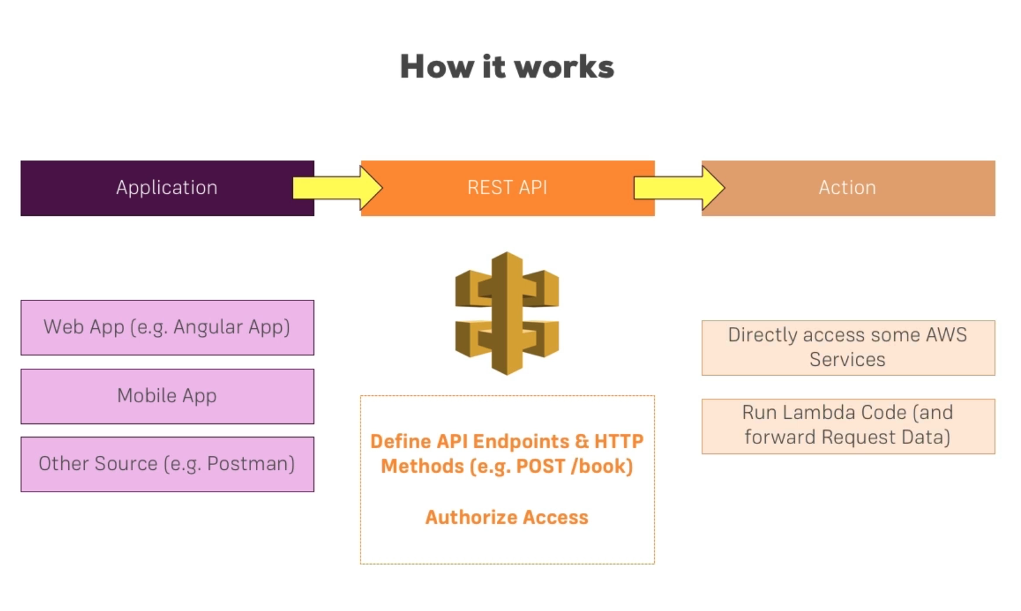Getting 
Started 
Content Delivery & 
Hosting with S3, 
CloudFront and 
Route53 
Course Structure 
Core Serverless 
Services 
Authentication 
with Cognito 
Beyond the 
Basics (Outlook) 
Business Logic with 
Lambda and API 
Gateway 
Data Storage with 
DynamoDB 
Roundup 

