CMPT 433

PROJECT ITERATION 2: FAN CONTROLLER

Group name: beaglebone cobalt

Minhoe Kim 301254082

Ken Ni 301267328

Gabriel Faulhaber 301291407

Our project is “Fan Controller” which uses sensor and fan to control room temperature. User set the temperature to users preferred level using potentiometer and the fan will move depending on the difference of room temperature and preferred temperature and we set up an website showing the state of any sensors/fans as well as a graph showing historical readings.

Accomplishments:

* Read room temperature from temperature sensor
* Nodejs Server
* Set user’s preferred temperature using potentiomater

We have successfully made the circuit and read the current temperature from temperature sensor. This program reads the room temperature each seconds and display it on terminal. For the final version current temperature will be displayed on the 14-seg display. The blue lead is connected to GND of the TMP 36 temperature sensor from P9-34 GNDA_ADC. The orange lead is connected to analog voltage output of the TMP 36 temperature sensor from P9-40 AIN1. The yellow lead is connected to positive supply of the TMP 36 temperature sensor from P9-3 VDD_3Y3. 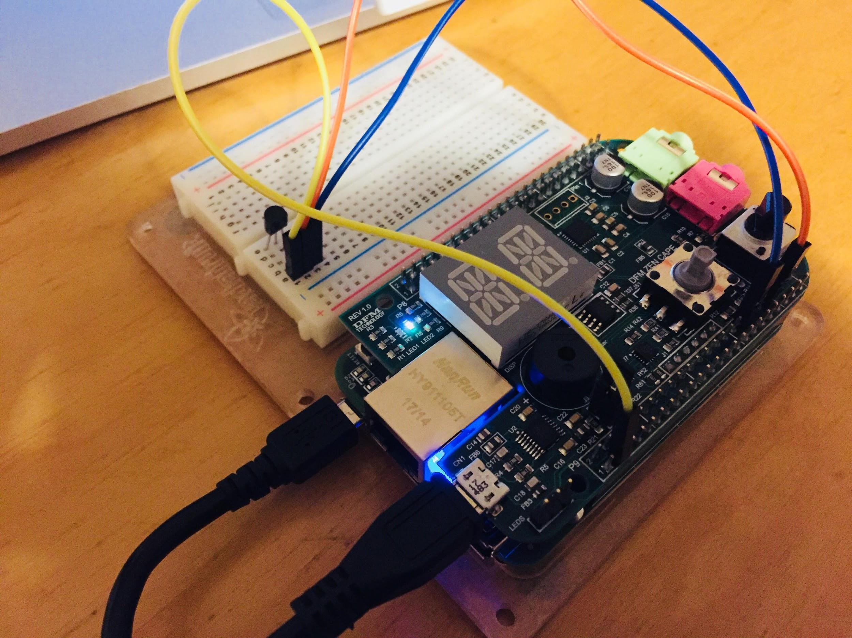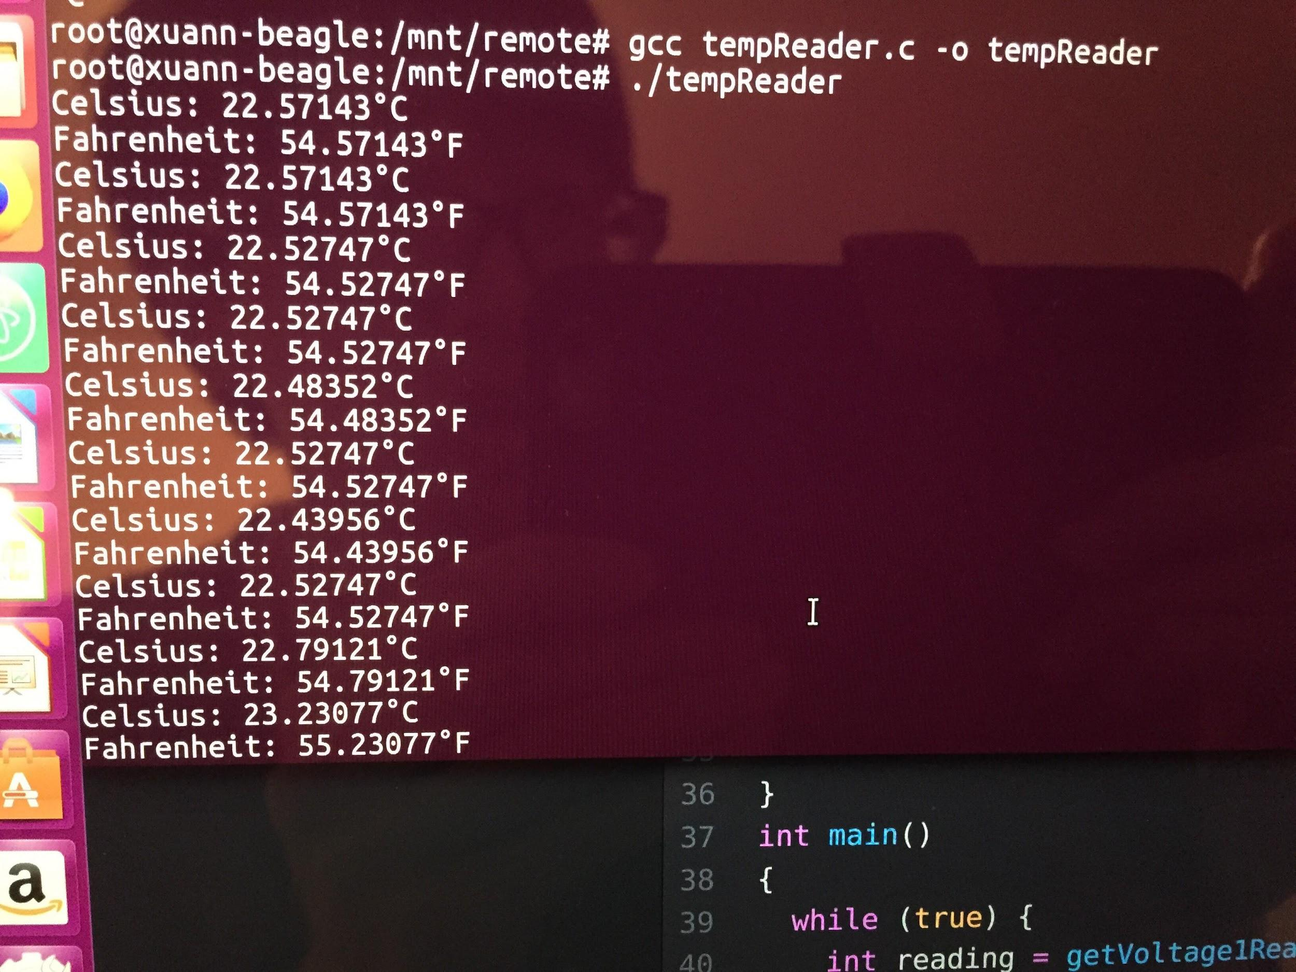

Nodejs Server

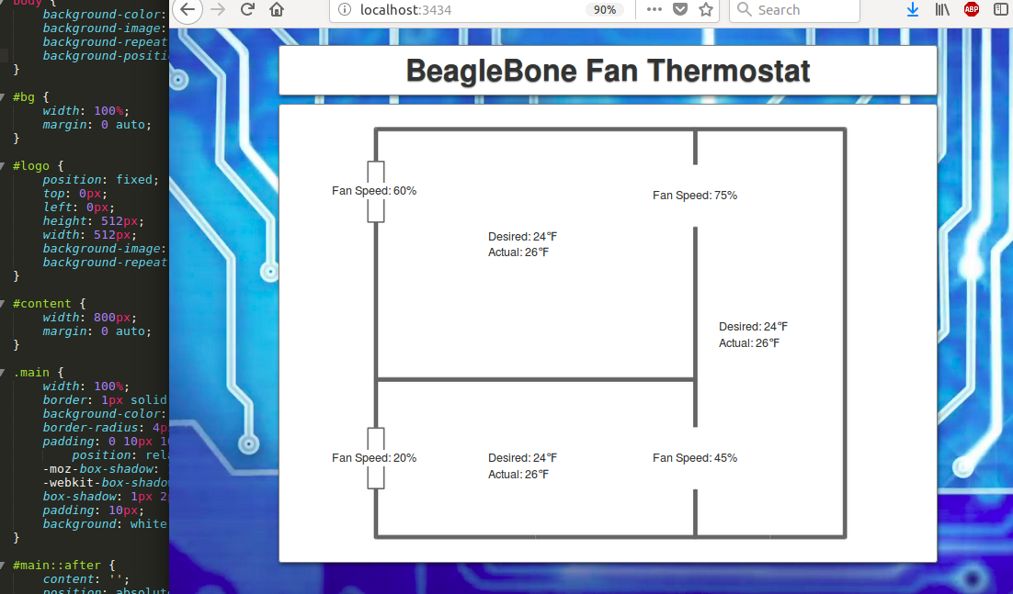

We have written this so that website will update the thermostat and fan speeds every second. To start with, this photo is just showing examples for 3 temperature readings and 4 fan outputs based on fixed values, but we will be updating this in real time once the rest of the project is complete. Furthermore, we will likely choose a different layout for the rooms, thermostat and fan locations. The website is already designed with unique ids for the 3 temperatures and the 4 fans, along with requests to pull from udp each of these values.

Potentiometer proof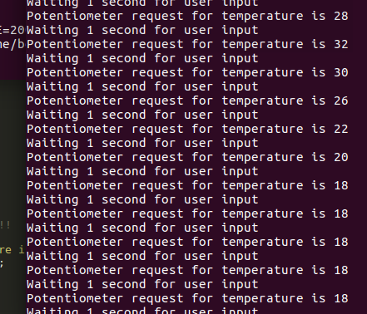

This shows that the potentiometer can take a request of temperature in the range of (0,50) degrees celsius. With the project, we will be polling for desired temperature each second, so this is close to the desired output. We will expand this functionality so that if there is more than one temperature sensor, then the joystick will cycle through thermostat locations.

What has fallen behind

* Turn the green LED on when the temperature is in moderate level
* Turn the red LED on when the temperature is higher than user preferred level
* UDP connection between webserver and C files
* Connect a fan to our board
* Turn the fan on when the current temperature is higher than users preferred level

Expected project changes

* features to be added
  + create website which can get access to database on beaglebone
  + show history of temperature and fan speed
  + based on history, display graph
  + finalize room/sensor/fan configuration