CMPT 433

PROJECT ITERATION 1: FAN CONTROLLER

Group name: beaglebone cobalt

Minhoe Kim 301254082

Ken Ni 301267328

Gabriel Faulhaber 301291407

Our project is “Fan Controller” which uses sensor and fan to control room temperature. User set the temperature to users preferred level using potentiometer and the fan will move depending on the difference of room temperature and preferred temperature.

What has been accomplished

We have now completed the potentiometer reading and the character display. We will later integrate these with the fan and sensor.

What has been fall behind

* Read the data from temperature sensor
* Turn the green LED on when the temperature is in moderate level
* Turn the red LED on when the temperature is higher than user preferred level

Expected project changes

* features to be added
  + show history of temperature and fan speed
  + based on history, display graph on website

CMPT 433

PROJECT MILESTONE 2: FAN CONTROLLER

Group name: beaglebone cobalt

Minhoe Kim 301254082

Ken Ni 301267328

Gabriel Faulhaber 301291407

Our project is “Fan Controller” which uses sensor and fan to control room temperature. User set the temperature to users preferred level using potentiometer and the fan will move depending on the difference of room temperature and preferred temperature.

What has been accomplished

We have now completed the potentiometer reading and the character display. We will later integrate these with the fan and sensor. We also have a nodejs server which has been setup but we have not yet programmed for a udp connection to feed data to the website.

What has been fall behind

* Read the data from temperature sensor
* Turn the green LED on when the temperature is in moderate level
* Turn the red LED on when the temperature is higher than user preferred level

Expected project changes

* features to be added
  + create website which can get access to database on beaglebone
  + show history of temperature and fan speed
  + based on history, display graph

Proof

Nodejs Server

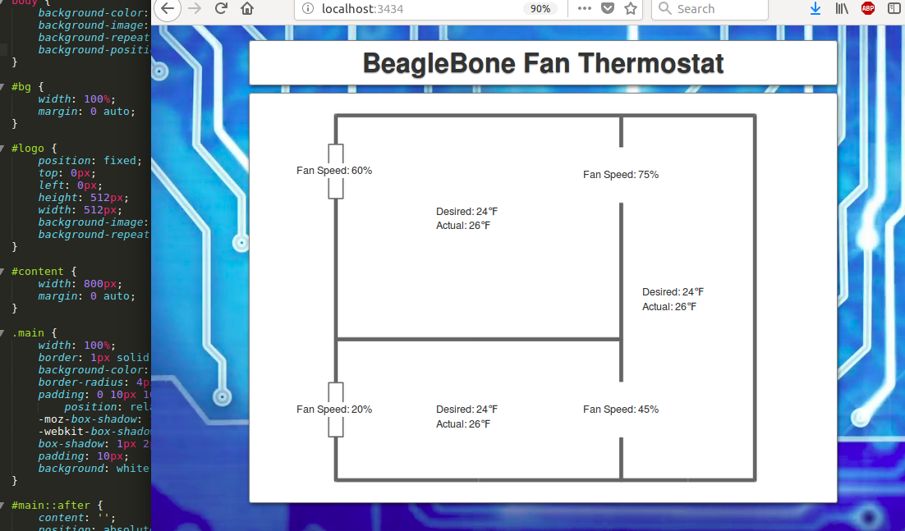

We have written this so that website will update the thermostat and fan speeds every second. To start with, this photo is just showing examples for the numbers but we will be updating this in real time once the rest of the project is complete. Furthermore, we will likely choose a different layout for the rooms, thermostat and fan locations.

Potentiometer proof

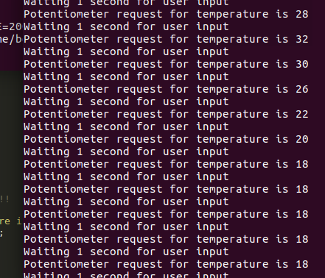

This shows that the potentiometer can take a request of temperature in the range of (0,50) degrees celsius.