Library use

from tensorflow.keras.layers import Dense, Dropout, Flatten, Conv2D, MaxPooling2D, LSTM

from tensorflow.keras.optimizers import Adam

from tensorflow.keras.preprocessing.image import ImageDataGenerator

from tensorflow.keras.callbacks import EarlyStopping, ModelCheckpoint

import matplotlib.pyplot as plt

import numpy as np

import pandas as pd

import tensorflow as tf

from tensorflow.keras.models import Sequential

G

Test and analyze the model 1. Display (plot) the Training Vs Validation Accuracy of the CNN Model as a line graph using matplotlib. Provide proper axis labels, title and a legend. Use different line color's for training and validation accuracy. Compare and analyze the training and validation accuracy in your report

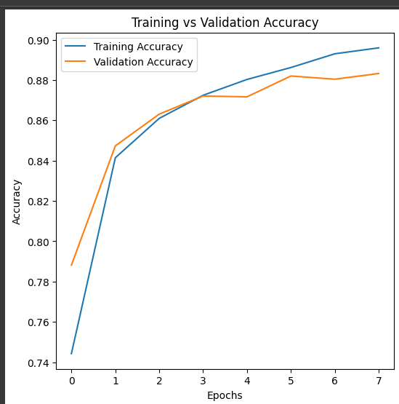

* **Training Accuracy**: Steadily increases from 0.74 to 0.90, indicating effective learning and model improvement.
* **Validation Accuracy**: Initially grows to around 0.84, but fluctuates around checkpoints (0.85, 0.88) with occasional drops and increases.

**Analysis**: The model effectively learns from training data, but fluctuations in validation accuracy suggest challenges in generalizing to new data, requiring further investigation for optimization.

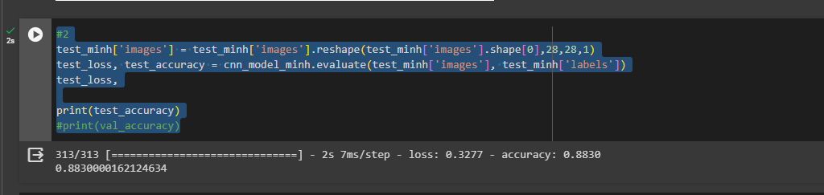

The test accuracy for the trained convolutional neural network (CNN) model is approximately 88.3%.

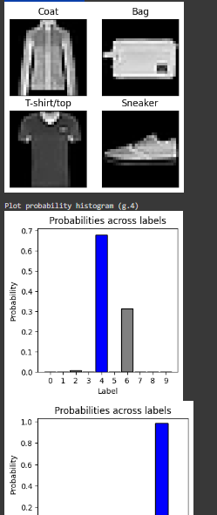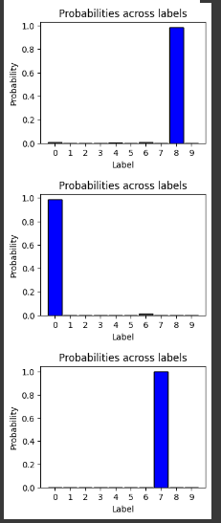

* The model accurately predicts the classes of the first 4 images from the test dataset:
  1. Image 24: Predicted as "Coat", True class: "Coat".
  2. Image 25: Predicted as "Bag", True class: "Bag".
  3. Image 26: Predicted as "T-shirt/top", True class: "T-shirt/top".
  4. Image 27: Predicted as "Sneaker", True class: "Sneaker".
* *The model's high prediction confidence levels suggest reliable classifications.*
* The model demonstrates accurate and confident predictions for fashion item classes, indicating its effectiveness in image classification tasks.

**Analysis**:

* **Test Accuracy**: The CNN model achieves a test accuracy of approximately 88.3%, indicating its ability to correctly classify images in the test dataset. So we could easily to identify each image

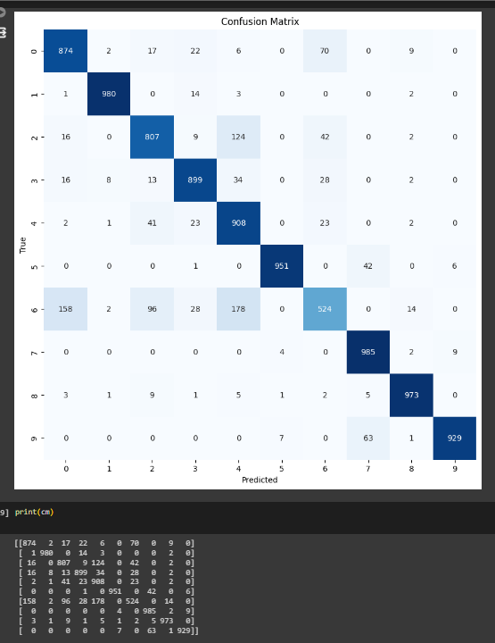

**Confusion Matrix**

the model demonstrates decent performance with notable accuracy in certain classes.

* The diagonal elements represent correct predictions for each class.
* Higher values along the diagonal indicate strong performance in certain classes.
* Some misclassifications are evident, particularly between classes 2, 3, and 4.