

Retail Chain Management System
Software Requirement Specification

– Hanoi, January 2026 –

Table of Contents
I. Record of Changes 3
II. Software Requirement Specification 4
1. Product Overview 4
2. User Requirements 5
2.1 Actors 5
2.2 Use Cases 5
3. Software Features 6
3.1 Functional Overview 6
3.2 <<Feature Name 1>> 8
3.3 <<Feature Name 2>> 10
4. Non-Functional Requirements 11
4.1 External Interfaces 11
4.2 Quality Attributes 11
5. Requirement Appendix 12
5.1 Business Rules 12
5.2 Common Requirements 12
5.3 Application Messages List 12
5.4 Other Requirements… 13

I. Record of Changes
Date | A*  M, D | In charge | Change Description
1/2 | A | All | Write the report specifications and draw diagrams.
*A - Added M - Modified D - Deleted

II. Software Requirement Specification

1. Product Overview
Retail Chain Management System (RCMS) is a mobile application developed using Flutter, aimed at replacing manual, fragmented, or paper-based sales management processes in current retail chains. The system leverages the power of Firebase to provide real-time inventory data synchronization, addressing the core challenge of multi-store management.
The system's goal is to provide a flexible point-of-sale (POS) tool for employees while delivering instant management reports to store managers and head office administrators.
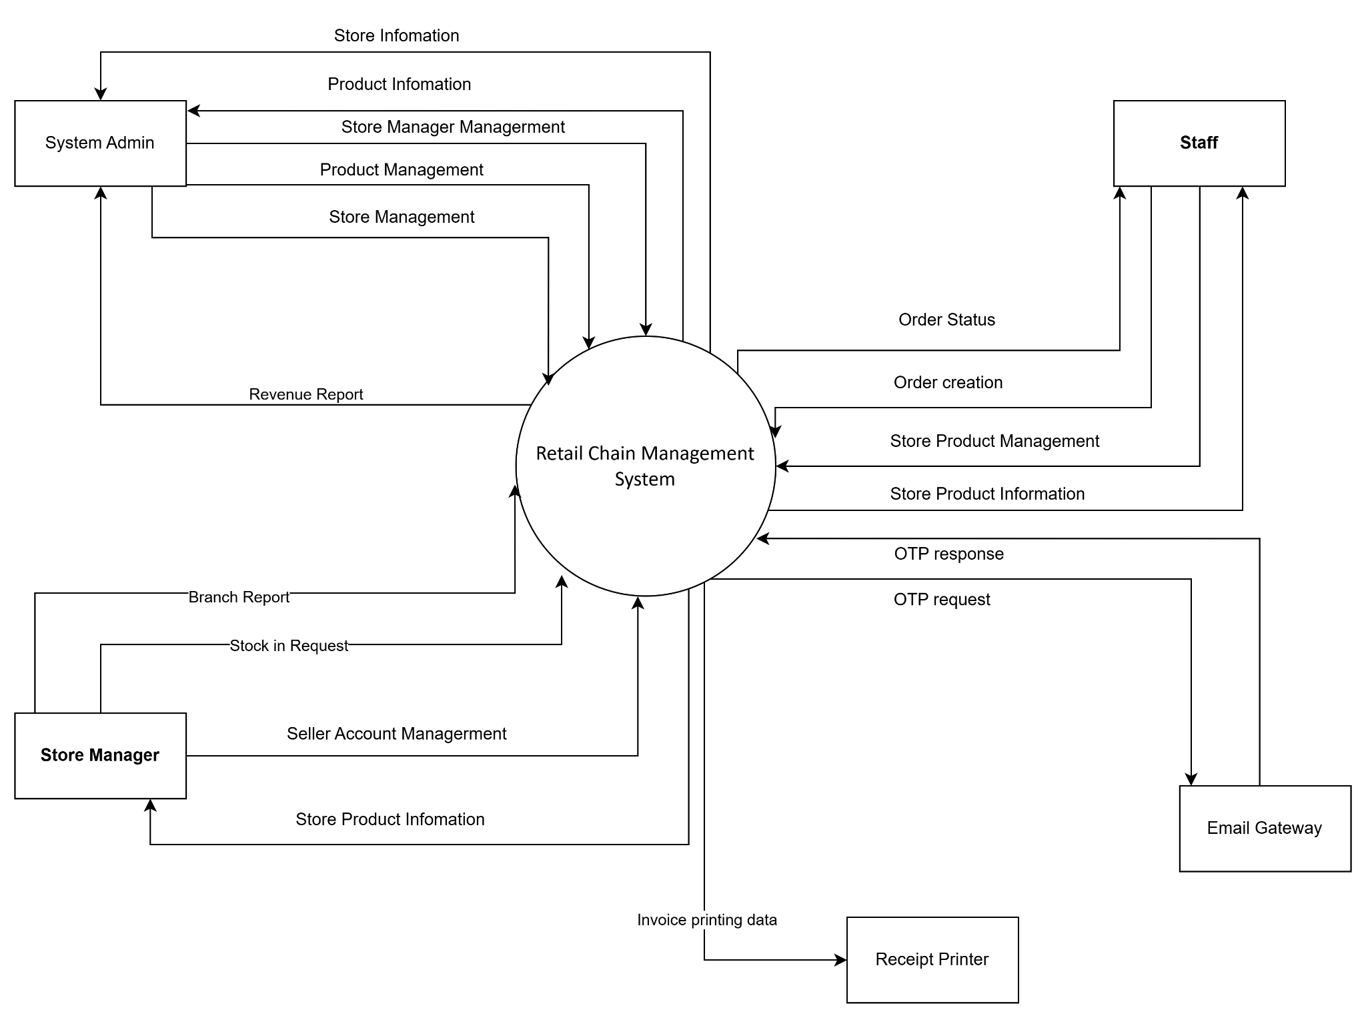
Figure 1: Context Diagram

2. User Requirements

2.1 Actors

# | Actor | Description
1 | System Admin | Represents head office administrators who are responsible for managing the entire retail chain. This actor manages store information, system-wide product data, user roles and permissions, and monitors overall business performance through consolidated revenue reports.
2 | Store Manager | Represents the manager of an individual store within the retail chain. This actor manages staff accounts, monitors inventory levels, submits stock replenishment requests, and reviews branch-level sales and performance reports.
3 | Staff | Represent store employees, such as cashiers or sales assistants, who directly operate the POS functions. This actor creates and processes customer orders, manages store-level product information, and tracks order status during daily sales operations.
4 | Receipt Printer | An external hardware device connected to the system for printing sales receipts. It receives invoice printing data from the RCM system and prints receipts for customers after successful transactions.
5 | Email Gateway | An external system responsible for handling email-based services. It receives OTP requests from the RCM system and sends OTP responses back to support user authentication and enhance system security.

2.2 Use Cases

2.2.1 Diagram(s)

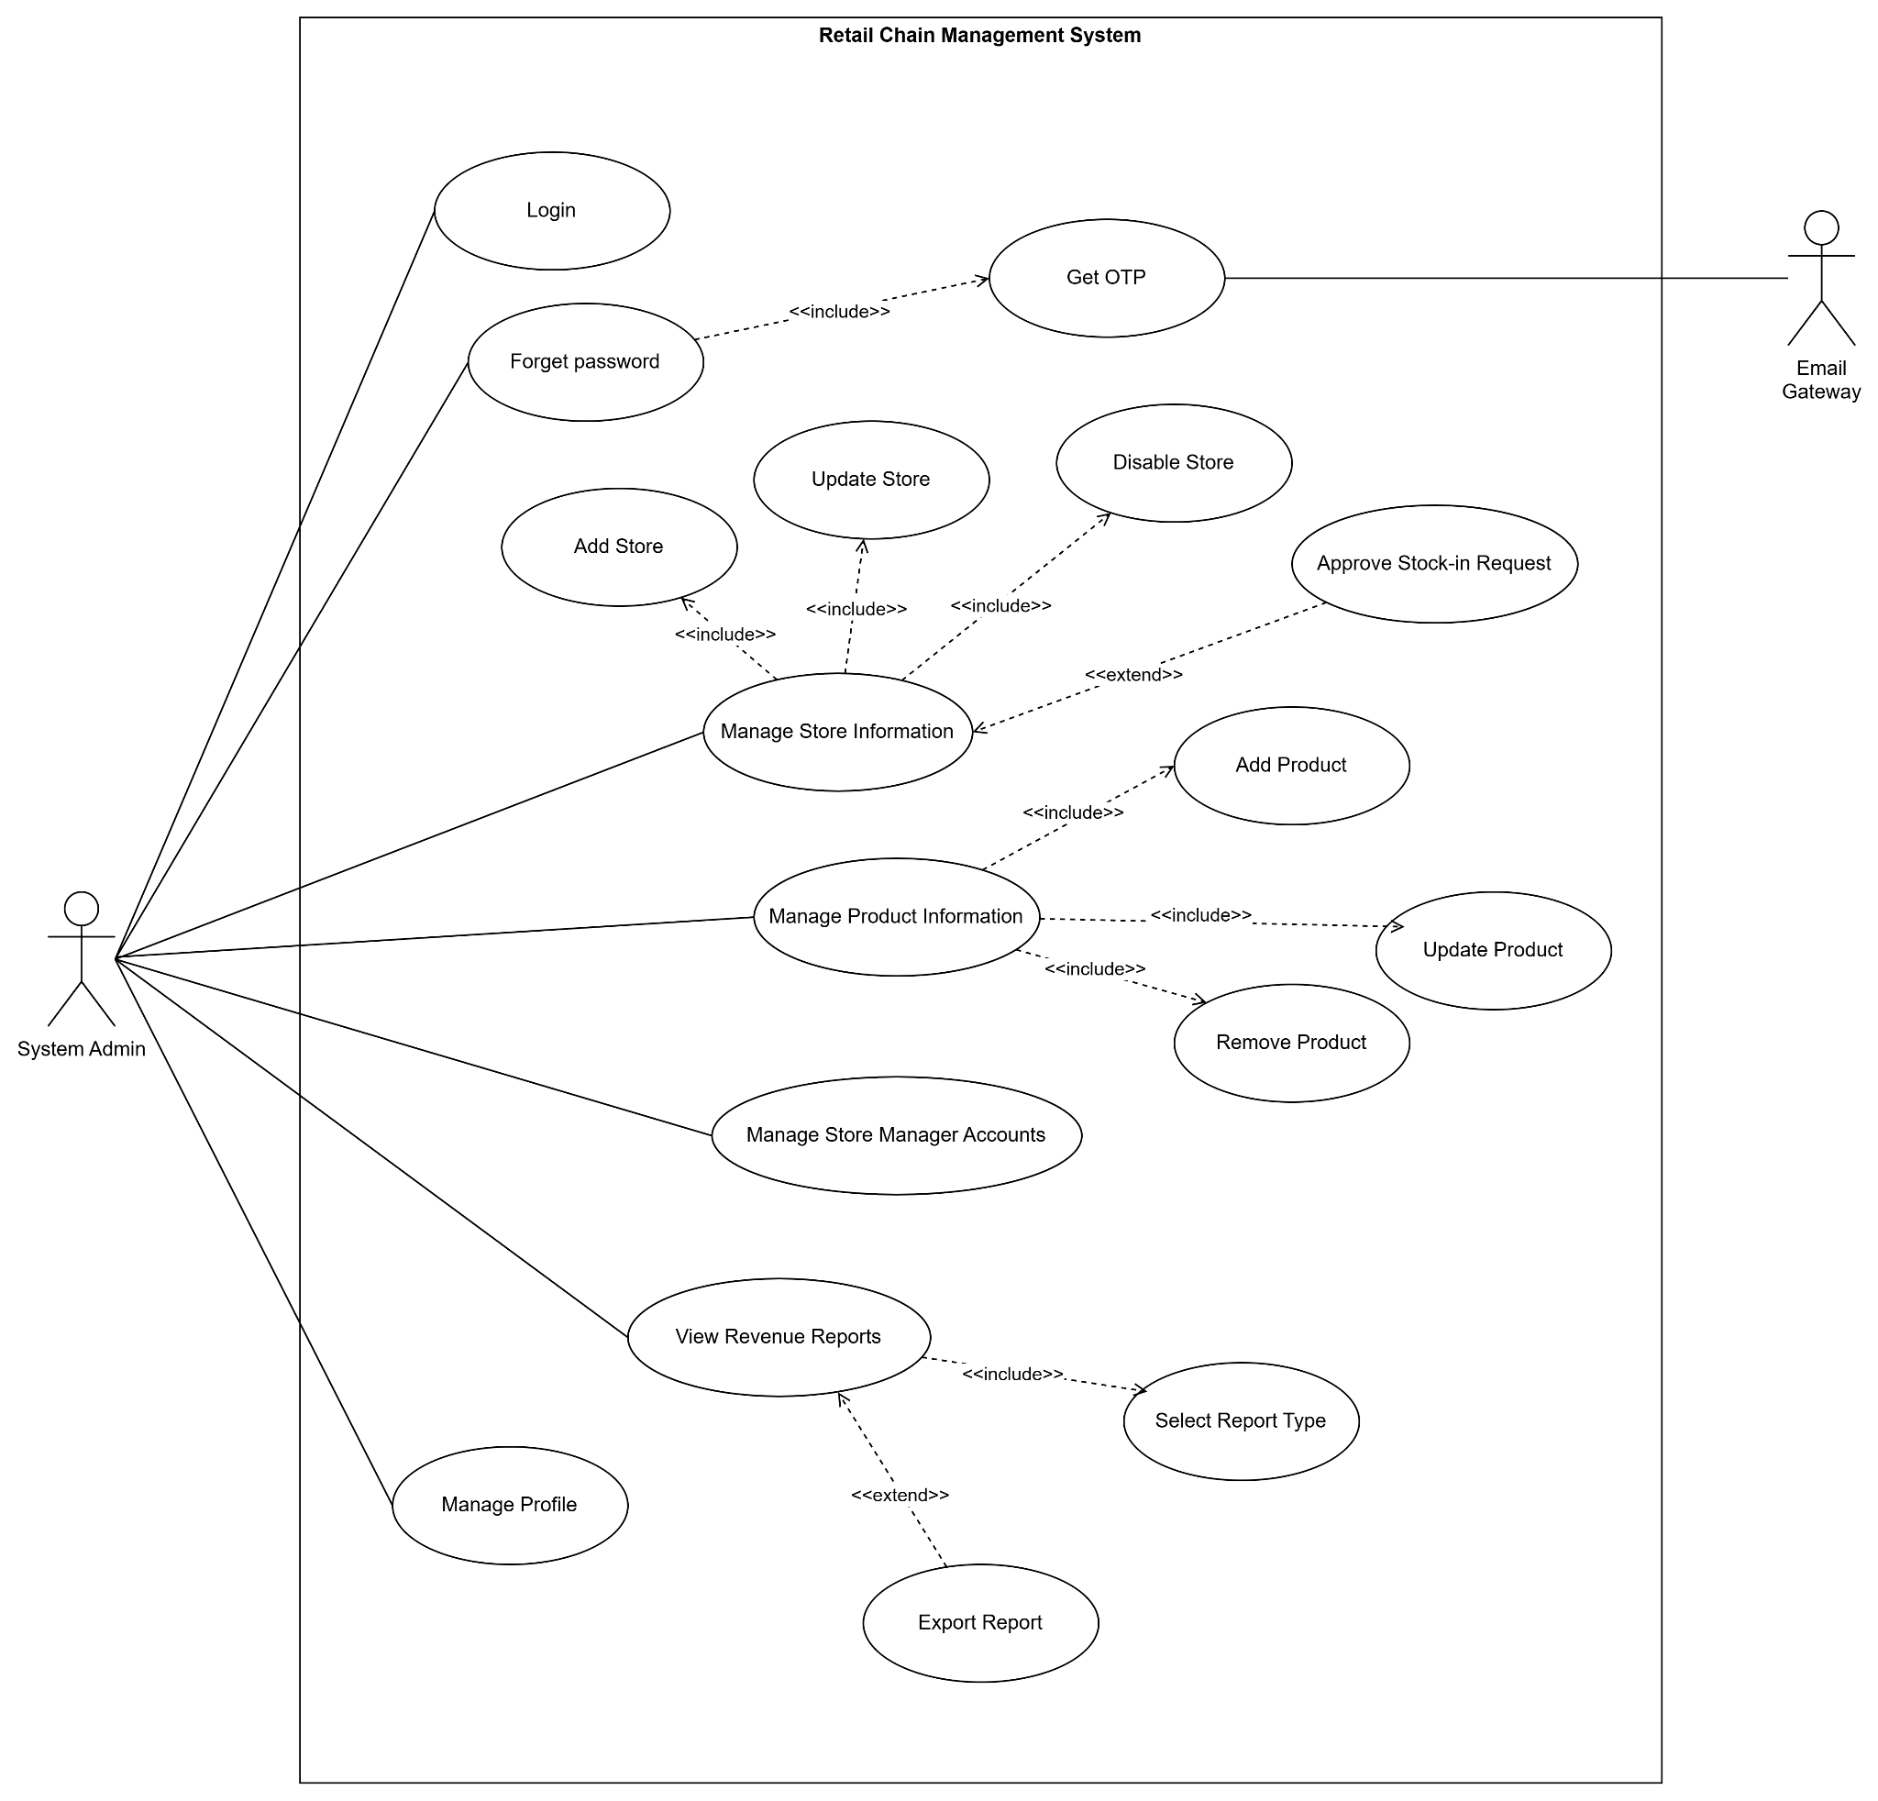
Figure 2.2.1-1: Use case diagram of actor System Admin
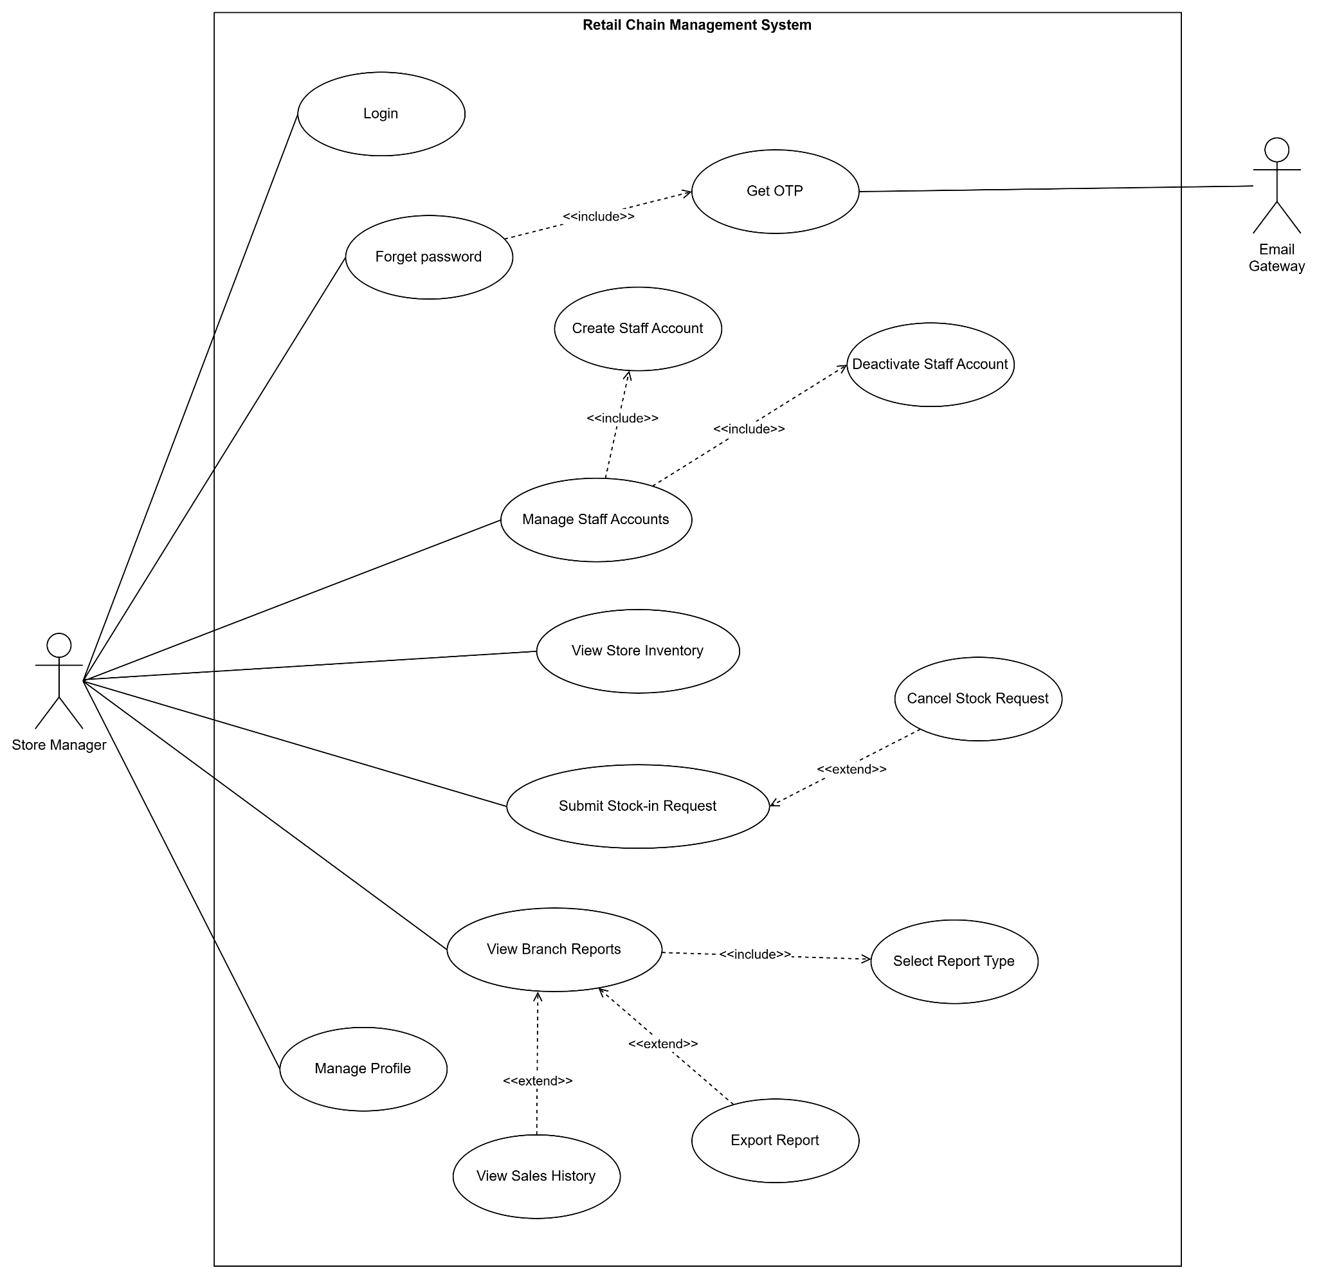
Figure 2.2.1-2: Use case diagram of actor Store Manager
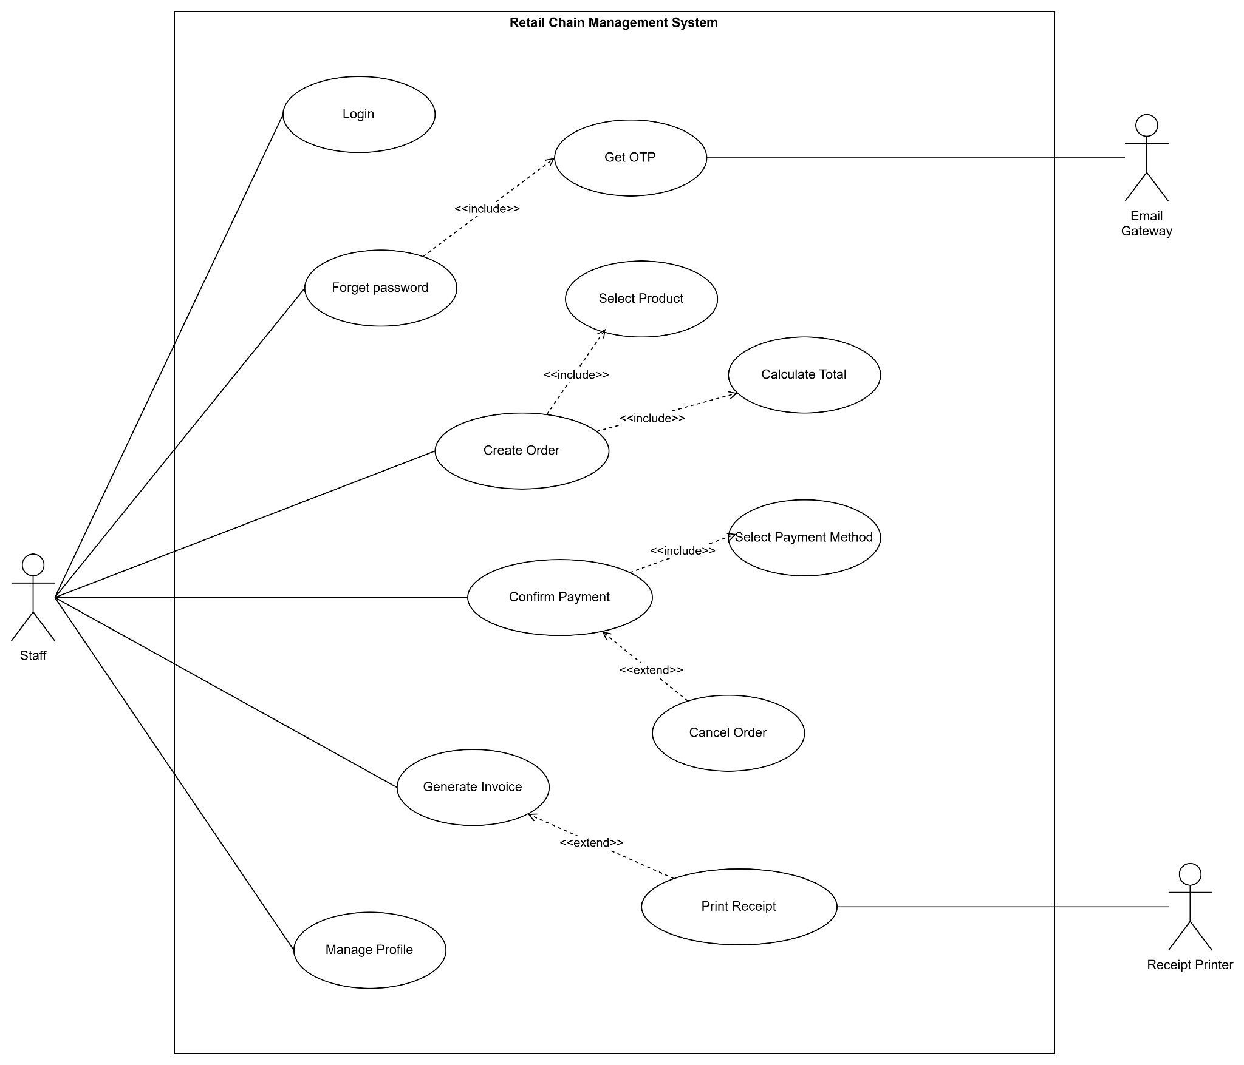
Figure 2.2.1-3: Use case diagram of actor Staff

2.2.2 Descriptions

ID | Group function | Use Case | Actors | Use Case Description & Main Flow
01 | Authentication | Login | System Admin, Store Manager, Staff | Description: The user logs into the RCM system.  Main Flow:  1. The user enters their username and password.  2. The system verifies the login information.  3. If valid, the system allows access to the system.
02 |  | Forget Password | System Admin, Store Manager, Staff | Description: Users reset their password when they forget it.  Main Flow:  1. The user selects the “Forget Password” function.  2. The user enters their email.  3. The system sends an OTP code via email.  4. The user enters a valid OTP.  5. The user enters their new password.  6. The system successfully updates the password.
03 | Profile Management | Manage Profile | System Admin, Store Manager, Staff | Description: Allows users to manage their personal information.  Main Flow:  1. Users access their personal profile page.  2. Views and edits personal information.  3. Saves changes.  4. The system updates the new information.
04 | Store Management | Manage Store Information | System Admin | Description: Manages all store information within a retail chain.  Main Flow:  1. System Admin accesses the store management function.  2. Views the list of existing stores.  3. Performs management operations (adds new stores, updates, disables stores).  4. The system saves changes and synchronizes data across the entire system.
05 | Product Management | Manage Product Information | System Admin | Description: Manages product information for the entire chain of stores.  Main Flow:  1. System Admin accesses the product management function.  2. Views the product list.  3. Performs product management (adds, edits, deletes).  4. The system updates product data in real time.
06 | User Management | Manage Store Manager Accounts | System Admin | Description: Manages the accounts of Store Managers in the system.  Main Flow:  1. System Admin accesses the Store Manager account management function.  2. Views the list of store manager accounts.  3. Adds, edits, or locks accounts as needed.  4. The system saves the information and applies the corresponding access permissions.
07 |  | Manage Staff Accounts | Store Manager | Description: Managing employee accounts in the store.  Main Flow:  1. The Store Manager accesses the employee management function.  2. Views the list of existing employees in the store.  3. Performs management actions (creates new accounts, updates account status).  4. The system saves changes and updates data.
08 | Inventory Management | View Store Inventory | Store Manager | Description: View the store's inventory status.  Main Flow:  1. The Store Manager accesses the inventory viewing function.  2. The system displays a list of products and their inventory quantities.  3. The Store Manager monitors and evaluates the inventory status.
09 |  | Submit Stock-in Request | Store Manager | Description: Submit a request to restock the store.  Main Flow:  1. Store Manager accesses the restock request function.  2. Selects the product and quantity to be restocked.  3. Submits the request to the system.  4. The system records the request and forwards it to the Admin for approval.
10 | Order Management | Create Order | Staff | Description: Create a new order for a customer at the sales counter.  Main Flow:  1. Staff selects the order creation function.  2. Selects the products the customer wants to buy.  3. The system displays a list of selected products and the total amount.  4. Staff confirms the order information.
11 |  | Confirm Payment | Staff | Description: Confirm payment for a created order.  Main Flow:  1. Staff selects the order to be paid for.  2. Selects a payment method.  3. The system processes and confirms successful payment.  4. The order status is updated to "Paid".
12 |  | Generate Invoice | Staff | Description: Creates a sales invoice after successful payment.  Main Flow:  1. After payment, staff requests invoice creation.  2. The system generates an invoice corresponding to the order.  3. The invoice is saved in the system.
13 |  | Print Receipt | Staff | Description: Allows staff to print invoices for customers after successful payment.  Main Flow:  1. Staff completes payment for the order.  2. Staff selects the Print Receipt function.  3. The system sends invoice data to the printer.  4. The printer prints the invoice for the customer.  5. The system records the invoice printing status as successful.
14 | Reporting | View Revenue Reports | System Admin | Description: View a consolidated sales report for the chain of stores.  Main Flow:  1. System Admin accesses the sales reporting function.  2. Selects the desired report type (by time period, by store, etc.).  3. The system aggregates sales data.  4. Displays the sales report to the System Admin.
15 |  | View Branch Reports | Store Manager | Description: View the store's business activity report.  Main Flow:  1. Store Manager accesses the branch reporting function.  2. Selects the desired report type.  3. The system aggregates the store's sales data.  4. Displays the report to the Store Manager.
16 |  | Export Report | System Admin | Description: Allows the Admin to export revenue/system activity reports to a file for storage or sharing.  Main Flow:  1. The Admin is viewing the revenue report on the system.  2. The Admin selects the Export Report function.  3. The system prompts for the selection of the export format (PDF / Excel / CSV).  4. The Admin confirms the report export.  5. The system creates the report file.  6. The file is successfully downloaded or saved.

3. Software Features

3.1 Functional Overview

3.1.1 Screens Flow
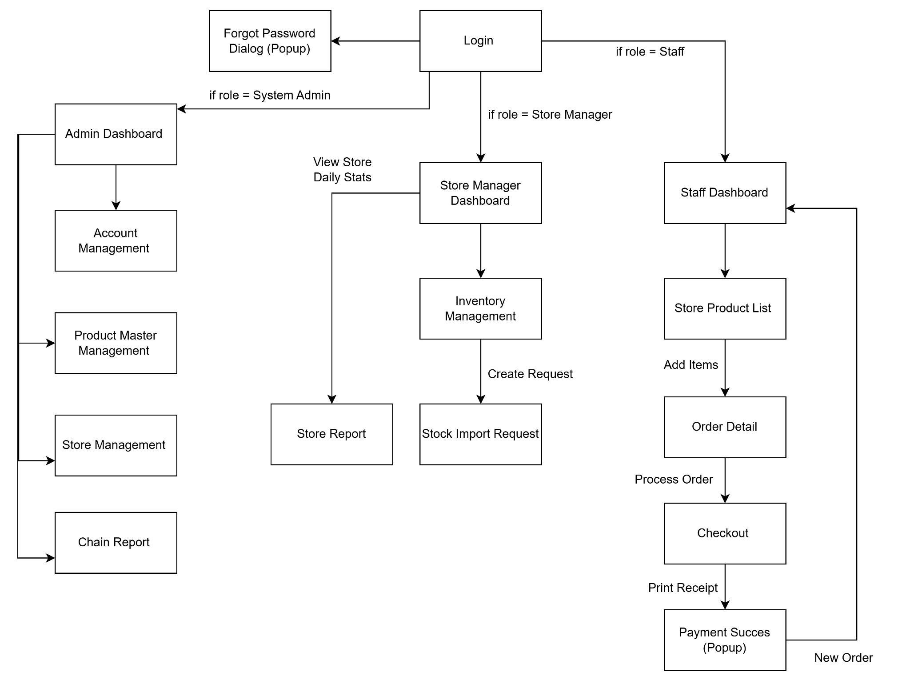

3.1.2 Screen Descriptions
# | Feature | Screen | Description
1 | Authentication | Login | The initial entry point of the application. It allows users (Admin, Manager, Staff) to authenticate using their credentials (email and password). Upon successful login, the system automatically redirects the user to their respective dashboard based on their assigned role.
2 |  | Forgot Password Dialog (Popup) | A pop-up dialog that appears when the user clicks "Forgot Password". It allows users to enter their registered email address to receive an OTP or reset link via the Email Gateway service to recover their account.
3 | System Administration | Admin Dashboard | The central hub for the System Admin. It provides high-level navigation to management features and displays an overview of the retail chain's performance (e.g., total revenue, total active stores).
4 |  | Account Management | Allows the Admin to create, update, deactivate, and manage user accounts for Store Managers and Staff. This screen includes functionality to assign users to specific store branches.
5 |  | Product Master Management | The interface for managing the "Master Data" of products. The Admin uses this screen to add new products, update prices, upload images, and manage categories. Changes here propagate to the store level.
6 |  | Store Management | Allows the Admin to manage the physical store network. Features include adding new store locations, updating store details (address, contact info), and assigning Store Managers to branches.
7 |  | Chain Report | Displays consolidated performance reports for the entire retail chain. It includes charts and metrics for total revenue, top-performing stores, and sales trends across all branches.
8 | Store Management | Store Manager Dashboard | The main dashboard for the Store Manager. It displays daily statistics specific to their assigned branch (e.g., today's sales, low stock alerts) and provides navigation to inventory and reporting features.
9 |  | Store Report | Provides detailed sales and performance reports for the specific store managed by the user. It allows filtering data by date range (daily, monthly) to analyze revenue and product performance.
10 |  | Inventory Management | Allows the Manager to view real-time stock levels of products at their store. It highlights items with low quantity and serves as the entry point for creating import requests.
11 |  | Stock Import Request | A form that allows the Store Manager to request additional stock from the central warehouse. The user selects products and inputs the required quantities to submit a replenishment request.
12 | Sales Operations (POS) | Staff Dashboard | The landing screen for Sales Staff. It provides quick access to the Point of Sale (POS) functions, customer lookup, and shows a summary of the staff member's shift performance.
13 |  | Store Product List | The primary sales interface. It displays a grid or list of products available at the current store. Staff can search, filter by category, and tap items to add them to the current order.
14 |  | Order Detail | Displays the list of items currently selected for purchase. Staff can review the order, adjust quantities, remove items, and see the subtotal before proceeding to payment.
15 |  | Checkout | The final step of the sales process. Staff selects the payment method (Cash, Transfer/QR), enters the amount received, and confirms the transaction to complete the order.
16 |  | Payment Success (Popup) | A confirmation pop-up displayed after a successful transaction. It provides options to print the receipt (via the connected hardware) or start a new order immediately.

3.1.3 Screen Authorization
[Provide the system roles authorization to the system features (down to screens, and event to the screen activities if applicable) in the table form as below – replace Role1, Role2,… with your specific system user role names]
# | Screen | System Admin | Store Manager | Staff
1 | Login | x | x | x
1.1 | Forgot Password (Popup) | x | x | x
2 | Admin Dashboard | x
2.1 | Account Management | x
 | Create New Account | x
 | Update/Block Account | x
2.2 | Product Master Management | x
 | Add New Product | x
 | Update Price/Info | x
2.3 | Store Management | x
 | View Store | x
 | Add New Store | x
3 | Chain Report |  | x
3.1 | Store Manager Dashboard |  | x
 | Store Report |  | x
3.2 | Inventory Management |  | x
 | View Stock Levels |  | x
3.3 | Stock Import Request |  | x
 | Submit Request |  | x
4 | Staff Dashboard |  |  | x
4.1 | Store Product List |  |  | x
 | Search/Filter Products |  |  | x
4.2 | Order Detail |  |  | x
4.3 | Checkout |  |  | x
 | Process Payment |  |  | x
4.5 | Payment Success (Popup) |  |  | x
 | Print Receipt |  |  | x

3.1.4 Non-Screen Functions
[Provide the descriptions for the non-screen system functions, i.e batch/cron job, service, API, etc.]
# | Feature | System Function | Description
1 | Data Management | Offline Data Synchronization | Utilizes the Firebase SDK's offline persistence capability. It automatically caches transaction data locally on the device when the internet connection is lost and synchronizes changes with the central Firestore database immediately upon reconnection, ensuring the POS can operate continuously.
2 | Inventory Management | Low Stock Monitor (Cloud Function) | A backend trigger (Cloud Function) that runs automatically whenever an order document is created. It checks the updated inventory level of purchased items. If the quantity falls below a defined threshold (e.g., 5 units), it sends a Push Notification (FCM) to the Store Manager's device.
3 | Reporting | Daily Revenue Aggregation Job | A scheduled task (Cloud Scheduler) running daily at 23:59 server time. It queries all orders generated during the day, calculates total revenue for each store and the entire chain, and saves the summary into a daily_reports collection to optimize report loading speed for Admins.
4 | Security | OTP Email Service | A backend API integration connecting the RCM system with the Email Gateway actor. When a user requests a password reset, this service generates a one-time code (OTP) and transmits it to the external gateway to be sent to the user's registered email address.
5 | Hardware Integration | Receipt Print Service | A background service running within the Flutter application. It listens for "Print" events from the Payment Success screen, converts the transaction data (JSON) into printer-specific commands (ESC/POS), and transmits them to the Receipt Printer via Bluetooth or LAN.

3.1.5 Entity Relationship Diagram
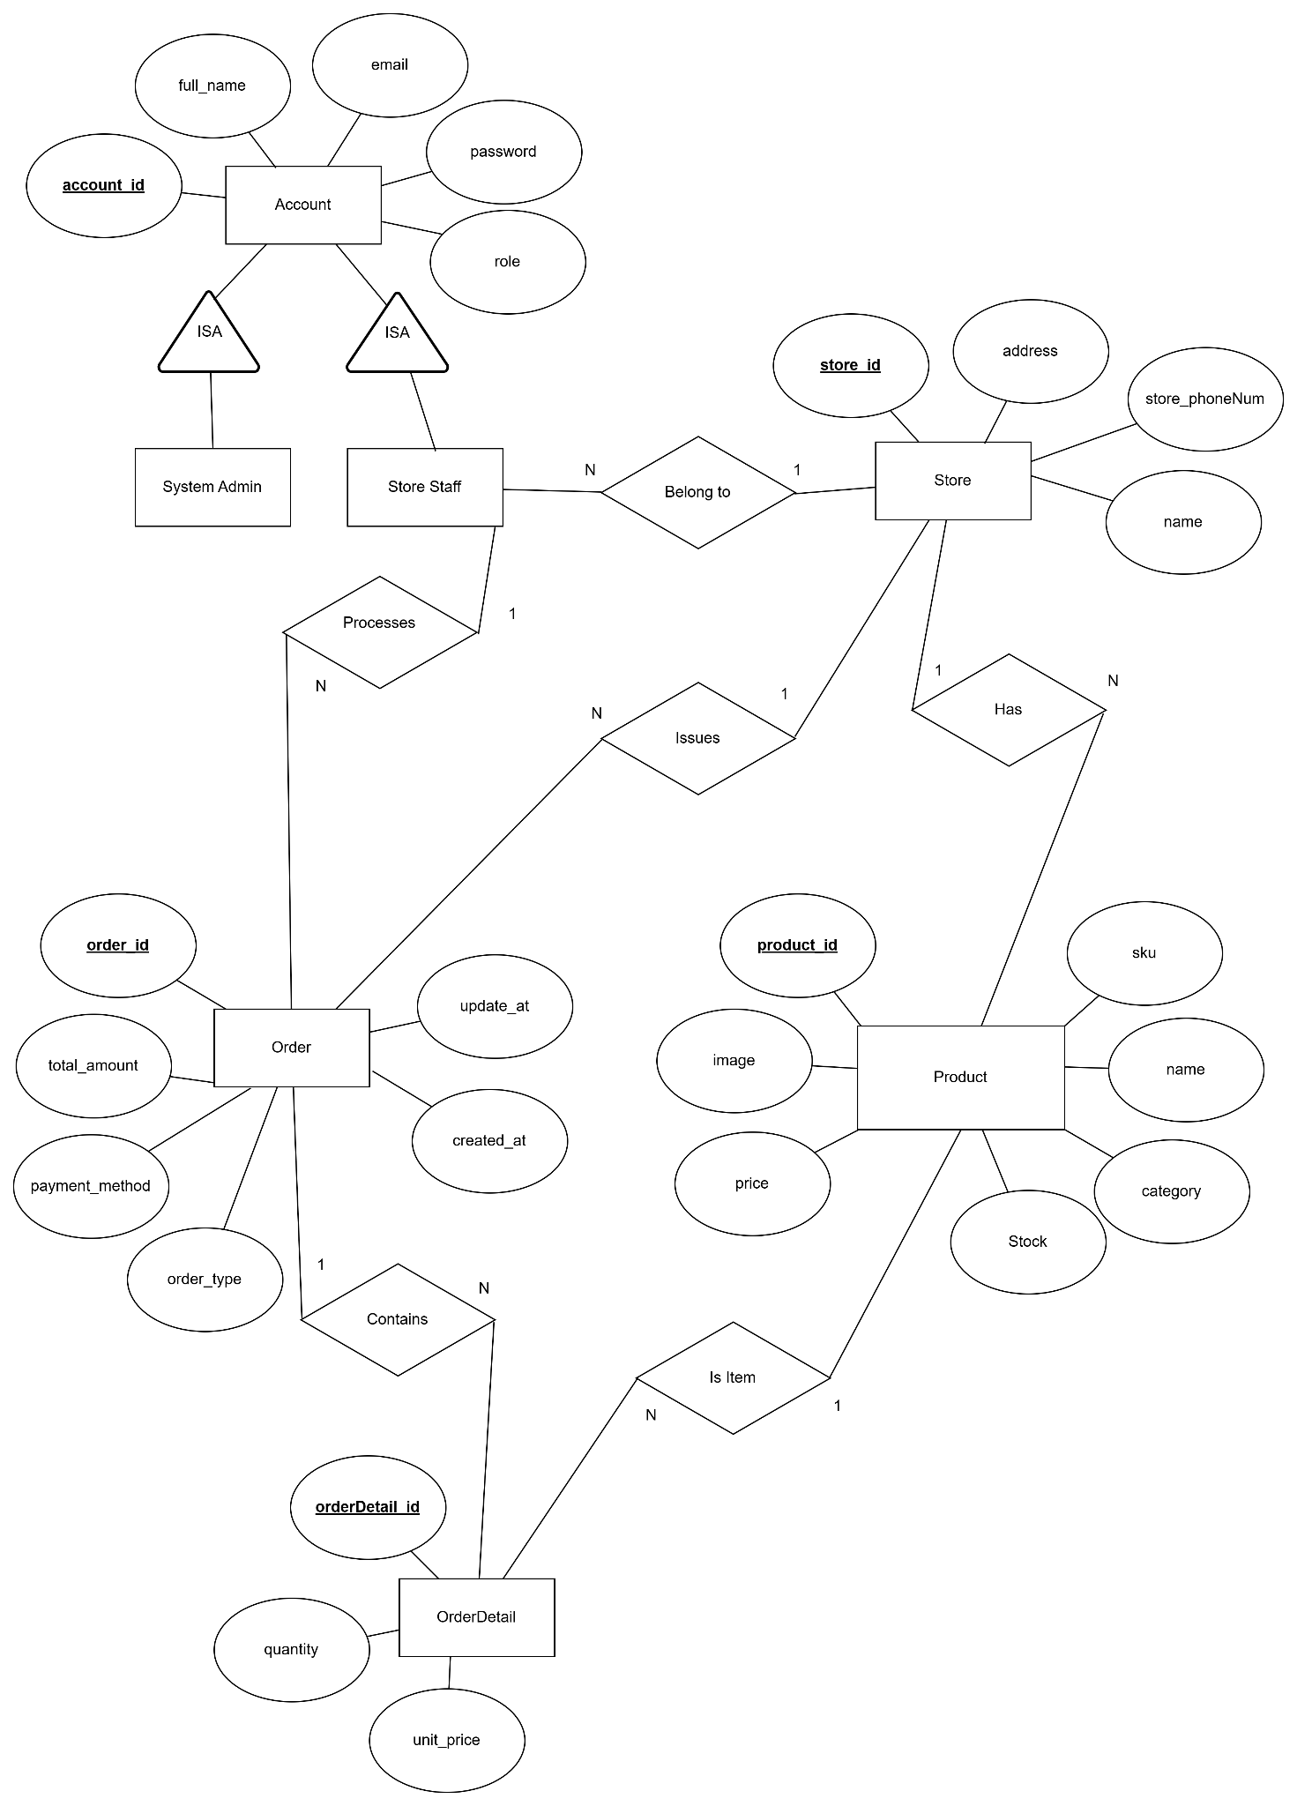
Entities Description
# | Entity | Description
1 | Account | The parent entity represents a generic user account in the system. It contains common login credentials (email, password) and personal information shared by all user roles.
2 | System Admin | A child entity inheriting from Account. Represents the head office administrator who manages the entire system and is not tied to any specific physical store.
3 | Store Staff | A child entity inheriting from Account. Represents employees working at a specific branch (including Store Managers and Sales Staff). This entity has a direct relationship with a Store.
4 | Store | Represents a physical retail branch. It serves as the central point for sales operations, inventory storage, and staff assignment.
5 | Product | Contains the "Master Data" for products, such as name, listing price, image, and SKU. This data is consistent across the entire chain.
6 | Order | Represents a sales transaction (invoice). It captures high-level transaction details such as total amount, creation date, and payment method.
7 | OrderDetail | Stores the specific items within an order, including the quantity and the unit price at the time of purchase.

3.1.6 Entity Details

Entity: Account
- Parent entity for user authentication.
# | Attribute name | PK | Type | Mandatory | Description
1 | account_id | x | String |  | Unique identifier for the account (Firebase UID).
2 | email |  | String |  | Email address used for system login.
3 | password |  | String |  | Encrypted user password.
4 | full_name |  | String |  | Full name of the user.
5 | role |  | String |  | Role of account

Entity: Store Staff
- Child entity (Inherits from Account) - Represents store employees.
# | Attribute name | PK | Type | FK | Description
1 | account_id | x | String | x | Inherits from the Account table.
2 | store_id |  | String | x | Foreign key referencing the Store table (Relationship: "Belongs to").

Entity: System Admin
- Child entity (Inherits from Account) - Represents head office admins.
# | Attribute name | PK | Type | FK | Description
1 | account_id | x | String | x | Inherits from the Account table.

Entity: Store
- Physical retail branches.
# | Attribute name | PK | Type | Mandatory | Description
1 | store_id | x | String |  | Unique identifier for the store.
2 | name |  | String |  | Display name of the store (e.g., "Cau Giay Branch").
3 | address |  | String |  | Physical address of the store.
4 | store_phoneNum |  | Num |  | Store phone number

Entity: Product
- Global product catalog (Master Data).
# | Attribute name | PK | Type | Mandatory | Description
1 | product_id | x | String |  | Unique identifier for the product.
2 | sku |  | String |  | Stock Keeping Unit (Barcode).
3 | name |  | String |  | Product name.
4 | category |  | String |  | Product category (e.g., Food, Drink).
5 | price |  | String |  | Standard listing price.
6 | image |  | String |  | URL to the product image.
7 | stock |  | Number |  | Stock of product

Entity: Order
- Sales transaction header.
# | Attribute name | PK | Type | FK | Description
1 | order_id | x | String |  | Unique identifier for the order.
2 | staff_id |  | String | x | Foreign key referencing Store Staff (Relationship: "Processes").
3 | customer_id |  | String | x | Foreign key referencing Customer (Relationship: "Places").
4 | store_id |  | String | x | Foreign key referencing Store (Relationship: "Issues").
5 | total_amount |  | Double |  | Total monetary value of the order.
6 | payment_method |  | Spring |  | Payment method used (e.g., 'Cash', 'Transfer').
7 | created_at |  | Date |  | Order creation timestamp.
8 | update_at |  | Date |  | Last status update timestamp.
9 | order_type |  | String |  | To distinguish between a purchase request and a sales order.

Entity: OrderDetail
- Line items within an order.
# | Attribute name | PK | Type | FK | Description
1 | orderDetail_id | x | String |  | Unique identifier for the order line item.
2 | order_id |  | String | x | Foreign key referencing Order (Relationship: "Contains").
3 | product_id |  | String | x | Foreign key referencing Product (Relationship: "Is Item").
4 | quantity |  | Int |  | Quantity of the product purchased.
5 | unit_price |  | Double |  | Unit price at the time of purchase.

3.2 <<Feature Name 1>>

3.2.1 <<FID - Function Name 1 / UC-ID Use Case Name >>
[A function can be a screen or a non-screen function (listed in the part 3.1.5 above). In this part, you need to provide the details on the related function, focus on mentioning below information.
]
3.2.1.1 Screen Mock-up
<<Provide basic (concept) design of screen –include screen mock-up and screen definition>>

Login
User name
Password
Login
Figure 3-1: Screen Design of Login

Table 3-1: Screen Definition
# | Field Name | Type | Mandatory | Max Length | Description
1 | User Name | Text | Yes | 20
2 | Password | Text | Yes | 20 | Display "*" instead of clear character
3 | Login | Button |  |  | Go to home page
4 | Close | Button

3.2.1.2 Use Case Description
<Provide detailed description for Use case>
Use Case ID |  | UC01 | Use Case Name |  | Login
Author |  | HungNV | Version | 1.0 | Date | 11/05/2013
Actor |  | LMS User
Description |  | The function allows a user to be able to login in the software when he/she have registered an account and his/her account is still active.
Precondition |  | PRE-01:  PRE-02:
Trigger |  | TRG-01:
Post-Condition |  | POS-01:
Main flows
Step | Actor | Action
1 | User | Type URL into location field of internet browser and then press enter
2 | LMS | Display Login screen with the following fields:  - User Name  - Password  - Login and Close button
3 | User | Enter user name & password into User Name & Password fields on the Login screen, then click on Login button.
4 | LMS | Validate the entered user name & password and then display Home screen

Alternative flows
AT1 | At step 2 in the main flows, if there is an internal error in the system,
Sub step | Actor | Action
2.1 | LMS | Display "Error" page with message "Internal System Error, please contact the administrator."

Business Rules
# | Rule Description
BR-01
BR-02

3.2.2 <<Function Name 2>>
…

3.3 <<Feature Name 2>>
…

4. Non-Functional Requirements

4.1 External Interfaces

4.1.1 User Interfaces
- Mobile Interface: The application is built using Flutter, adhering to Material Design standards to ensure a consistent user experience across Android platforms.
- Responsiveness: The interface must display clearly without layout breakage on mobile devices with screen sizes of 5.5 inches or larger.
- Notifications: The system uses Toast Messages or Dialog Popups to notify users of status (success/error) as defined in the "Application Messages List" (MSG01 - MSG09).

4.1.2 Hardware Interfaces
- Receipt Printer: The system communicates with thermal printers via Bluetooth or LAN connections. The application must convert invoice data (JSON) into standard ESC/POS commands so the printer can interpret and print the receipt.
- Mobile Device Sensors: The system requires access to the device's local storage to cache data for the "Offline Data Synchronization" feature.

4.1.3 Software Interfaces
- Firebase Platform:
  - Firestore Database: Serves as the primary data storage interface, supporting real-time synchronization between stores and the head office.
  - Firebase Authentication: Used to manage user sessions and secure authentication.
  - Cloud Functions: Interface for executing automated backend tasks, such as the "Low Stock Monitor".
- Email Gateway: The system connects to a third-party Email service via API to send OTP codes for the "Forget Password" function.

4.2 Quality Attributes

4.2.1 Usability
- Training Time:
  - For Staff: The Point of Sale (POS) interface must be intuitive enough for a new employee to proficiently perform basic functions (Create Order, Payment, Print Receipt) after no more than 30 minutes of training.
  - For Store Managers/Admins: Users should be able to proficiently use reporting and inventory management functions after no more than 2 hours of training.
- Efficiency:
  - The Checkout process must be optimized so that a staff member can complete a standard order (3 items) within under 45 seconds (including product selection and receipt printing).
  - Error messages (e.g., incorrect password, missing mandatory fields) must be clearly displayed in red or via popups for immediate user recognition.

4.2.2 Reliability
- Availability:
  - The system must ensure 24/7 continuous operation for sales functions (POS).
  - Offline Mode: Leveraging the Firebase SDK's offline persistence, the Staff application must continue to operate (create orders, save transactions) even when the Internet connection is lost. Data must automatically synchronize with the server immediately upon reconnection without data loss.
- Accuracy:
  - Inventory Data: Must ensure real-time accuracy to prevent "Overselling" scenarios where stock is insufficient.
  - Financial Calculations: Total order amounts and revenue reports must be absolutely accurate to the monetary unit.
- Mean Time To Repair (MTTR):
  - In the event of a Critical Bug that halts sales operations, the maximum time for resolution is 4 hours.

4.2.3 Performance
- Response Time:
  - Login: < 5 seconds under stable network conditions.
  - Product Search: Search results must display within < 10 second when staff interact with the "Store Product List" screen.
  - Payment Processing: The time to process payment logic and transition to the "Payment Success" screen must not exceed 20 seconds.
  - Data Synchronization: When changes occur (e.g., price updates from Admin), the Staff terminal must receive the new data within < 30 seconds due to Firestore's Real-time mechanism.
- Throughput:
  - The system must support processing a minimum of 50 concurrent transactions per second across the entire retail chain without significant latency.
- Optimization:
  - Revenue Reports: Must load within < 1 minutes. To achieve this, the system uses a "Daily Revenue Aggregation Job" scheduled at 23:59 daily to pre-calculate data, reducing the load of direct queries during peak hours.

5. Requirement Appendix
[Provide business rules, common requirements, or other extra requirements information here]

5.1 Business Rules
[Provide common business rules that you must follow. The information can be provided in the table format as the sample below]
ID | Rule Definition
BR-01 | Only System Admin can create, update, or deactivate user accounts for Store Managers and Staff.
BR-02 | Password reset requires OTP verification sent to the registered email address via Email Gateway.
BR-03 | Only System Admin can add, update, or remove products from the Master Product catalog.
BR-04 | Product prices in the Master catalog automatically propagate to all store branches.
BR-05 | When inventory quantity falls below 5 units, a low stock notification is sent to the Store Manager.
BR-06 | Order total amount is calculated as: sum of (unit_price × quantity) for all order items.
BR-07 | Payment methods are restricted to Cash or Transfer/QR only.
BR-08 | When an order is completed, inventory quantities for purchased products are automatically decremented.
BR-09 | The system operates in offline mode when internet connection is unavailable, using locally cached data.
BR-10 | When connectivity is restored, all offline transactions are automatically synchronized to Firebase.
BR-11 | Daily revenue aggregation runs at 23:59 server time to calculate total sales for each store and the chain.
BR-12 | Receipt printing is triggered only after successful payment confirmation.

5.2 Common Requirements

5.2.1 Performance Requirements
- The system shall load screens within 3 seconds on standard mobile devices.
- Order checkout shall complete within 5 seconds under normal network conditions.
- Firebase data synchronization shall complete within 10 seconds after connectivity is restored.

5.2.2 Security Requirements
- All user passwords must be encrypted using Firebase Authentication.
- OTP codes for password reset shall expire after 5 minutes.
- All network communication must use HTTPS/TLS encryption.

5.2.3 Reliability and Availability Requirements
- The POS system shall function offline for up to 24 hours using locally cached data.
- No data loss shall occur when connectivity is restored.
- The system shall automatically retry failed synchronization up to 3 times.

5.2.4 Usability Requirements
- The mobile interface shall be optimized for touchscreen devices (minimum 5-inch screen).
- Error messages shall be displayed in clear, user-friendly language.

5.2.5 Compatibility Requirements
- The mobile application shall use Flutter framework (version 3.0+).
- Compatible with Android 8.0 (Oreo) or higher.
- Integrates with Firebase: Authentication, Firestore, Cloud Functions, Cloud Scheduler.
- Receipt printers must support ESC/POS protocol via Bluetooth or LAN.
- Email Gateway shall use SMTP or REST API for OTP delivery.

5.3 Application Messages List
# | Message code | Message Type | Context | Content
1 | MSG01 | In line | No search results found | No results found.
2 | MSG02 | In red, under the text box | Input-required fields are empty | The * field is required.
3 | MSG03 | In red, under the text box | Input value length > max length | Exceed max length of {max_length}.
4 | MSG04 | In red, under the text box | Login credentials are incorrect | Incorrect email or password. Please try again.
5 | MSG05 | Toast message | OTP email sent successfully | An OTP has been sent to {email_address}.
6 | MSG06 | Toast message | CRUD operation successful (Create/Update/Delete) | {Action} successfully.
7 | MSG07 | Toast message | Low stock alert triggered | Low stock alert: {product_name} has {quantity} units left.
8 | MSG08 | Toast message | Payment confirmed successfully | Payment confirmed. Thank you!
9 | MSG09 | Toast message | Receipt printing failed | Failed to print receipt. Please check printer.
10 | MSG10 | Toast message | System offline mode activated | Offline mode. Data will sync when connected.
11 | MSG11 | Toast message | Data synchronized after reconnection | Data synchronized successfully.
12 | MSG12 | Popup dialog | Network connection error | Unable to connect. Please check your internet.
13 | MSG13 | Popup dialog | Confirm deletion | Are you sure you want to delete this item?
14 | MSG14 | In red, under the text box | Product out of stock | This product is out of stock.

5.4 Other Requirements

5.4.1 Constraints
- The system is dependent on Firebase infrastructure (Authentication, Firestore, Cloud Functions, Cloud Scheduler).
- Offline mode is limited to 24 hours before synchronization is required.
- Receipt printers must support ESC/POS protocol via Bluetooth or LAN.

5.4.2 Assumptions
- Store locations have stable internet connectivity during business hours.
- All users have valid email addresses for account creation and password recovery.
- The Email Gateway service is available for OTP delivery.

5.4.3 Legal and Compliance
- Customer personal data must be stored securely and comply with data protection regulations.
- All financial transactions must be recorded with timestamps for audit purposes.

