**ASSIGNMENT 2 FRONT SHEET**

|  |  |  |  |
| --- | --- | --- | --- |
| **Qualification** | **BTEC Level 5 HND Diploma in Computing** | | |
| **Unit number and title** | Unit 14: Business Intelligence | | |
| **Submission date** |  | **Date Received 1st submission** |  |
| **Re-submission Date** |  | **Date Received 2nd submission** |  |
| **Student Name** | Duong Duc Son | **Student ID** | GCH18524 |
| **Class** | GCH0715 | **Assessor name** | Doan Trung Tung |
| **Student declaration**  I certify that the assignment submission is entirely my own work and I fully understand the consequences of plagiarism. I understand that making a false declaration is a form of malpractice. | | | |
|  |  | **Student’s signature** |  |

**Grading grid**

|  |  |  |  |  |  |  |  |
| --- | --- | --- | --- | --- | --- | --- | --- |
| P3 | P4 | P5 | P6 | M3 | M4 | D3 | D4 |
|  |  |  |  |  |  |  |  |

|  |  |  |
| --- | --- | --- |
| **❒ Summative Feedback: ❒ Resubmission Feedback:** | | |
| **Grade:** | **Assessor Signature:** | **Date:** |
| **IV Signature:** | | |

**Table of Contents**

I. Review feedbacks 3

II. The legal issues 6

III. References 8

**Table of Figures :**

Figure 1: Question 1 4

Figure 2:Question 2 4

Figure 3:Question 3 5

Figure 4:Question 4 5

Figure 5: Question 5 6

Figure 6:feedbacks 6

# Review feedbacks

To take feedbacks and comments from viewers, I create Google Form to survey them.

Base on the data that was taken from Survey Online ( Google form ), I have analysis:

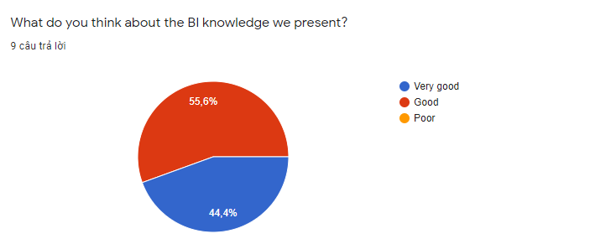

Figure 1: Question 1

55.6% of people think the BI knowledge we present is very good and 44.4% think it is good.

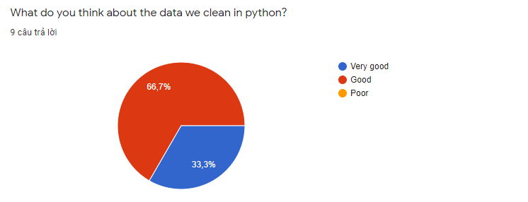

Figure 2:Question 2

33.3% of people think the data we clean up in python is very good and 66.7% think it is good.

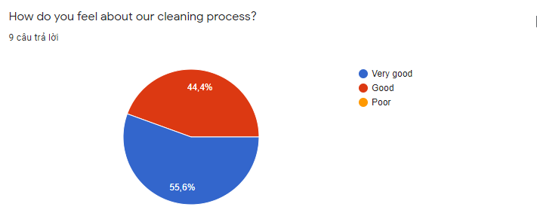

Figure 3:Question 3

55.6% of people think our cleaning process is very good and 44.4% think it is good.

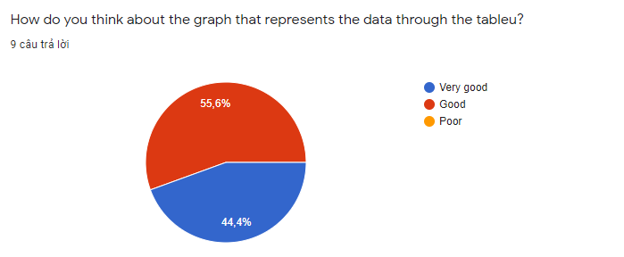

Figure 4:Question 4

44.4% of people think that the graph that represents the data through the tableu is very good and 55.6% think it is good.

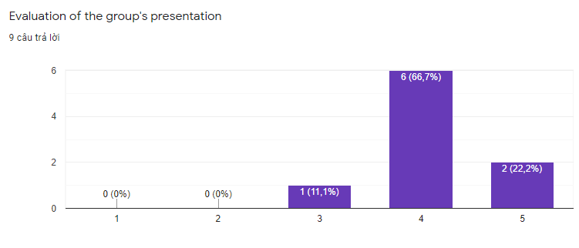

Figure 5: Question 5

11.1% rated the group presentation as 3/5, 66.7% rated the group presentation as 4/5, and 22.2% rated the group presentation as 5/5.

Through surveys we found we gave a successful presentation.

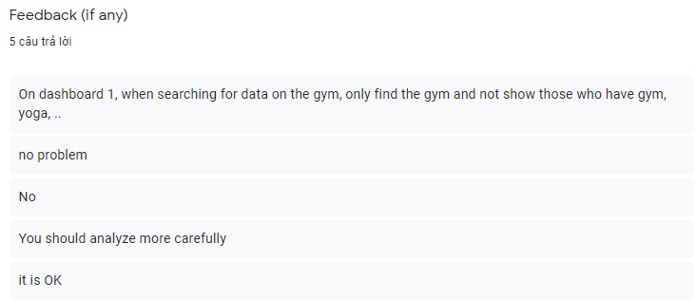

Figure 6:feedbacks

**Problems:**

On dashboard 1, when searching data about gym, only gym-only people are found, and not those who have exercised, yoga, etc.

There are some data that have not been applied yet, so they need to be included in the table for further analysis.

**Solution problems:**

We will use filter method in column (What form (s) of exercise do you currently participate in?) with the word gym in the answer all print out.

We will research more on this issue.

**Improvements in the future:**

- We will find more relationships between data to be able to open a new fitness related to increase revenue.

- We add questions about the customer's buying frequency so that we can find potential customers.

- We will create more charts of best-selling products to increase the revenue of best-selling products

# The legal issues

Corporate legal departments have reclaimed from their law firms control of legal matters. As legal departments institute increasingly creative alternative fee arrangements to predict and control costs, they need objective data in order to negotiate rates. On the flip side of the coin, so too must law firms tap into actionable BI in order to assess factors such as trends in their historical billing rates, hours billed, etc. While legal departments may hold the reins in this relationship, firms must still engage in rational calculus to determine at which levels of service and compensation they can afford to be engaged, if at all.

Actionable BI leads to strategic decisions. Legal departments are better able to assess and manage risky matters. They can compare how effective individual attorneys are compared to colleagues in the same firm, as well as on an inter-firm basis. To the most effective go future spoils.

Legal departments have found that putting an e-billing and matter management system in place can save between five to 15 percent in legal fees solely by pre-screening invoices for accuracy and compliance with performance guidelines. As they learn to capitalize on the data-driven business intelligence solutions, legal departments have been able to drive savings of as much as 50 percent by making fully informed decisions data-driven outcomes.

(Kerschberg, 2011)

General Counsel or chief legal officers increasingly play a strategic role in advising board decisions, proactively managing information governance and compliance, and managing legal risk. As in-house legal teams assume greater responsibility for their dockets and remove that authority from their outside counsel, they need to find faster ways to improve data transparency to support decisions. Just as their own corporations implement innovative IT solutions to manage business more effectively, many chief legal officers are taking on the role of change agent, innovating with technology solutions in legal operations.

The flexible, high-performance legal operations they envision require a data-driven approach to decision-making, increasing demand for more complete solutions from law firms and other service providers. Corporate legal goals include greater use of technology tools, collection and analysis of management metrics, and project management training. (CHI, 2017)

# Analysis Datasets_Design Dashboard

## 3.1 Dashboard 1

### 3.1.1 Customer personal information.

This chart shows personal information for both men and women at all on the list. In the chart:

* •Blue color represents the female gender
* •Orange represents the male gender

Through this chart, we can identify the client's name, gender, and age, besides we can also identify how that person participates in sports activities. From there, it is possible to filter and identify those who intend to go to the gym

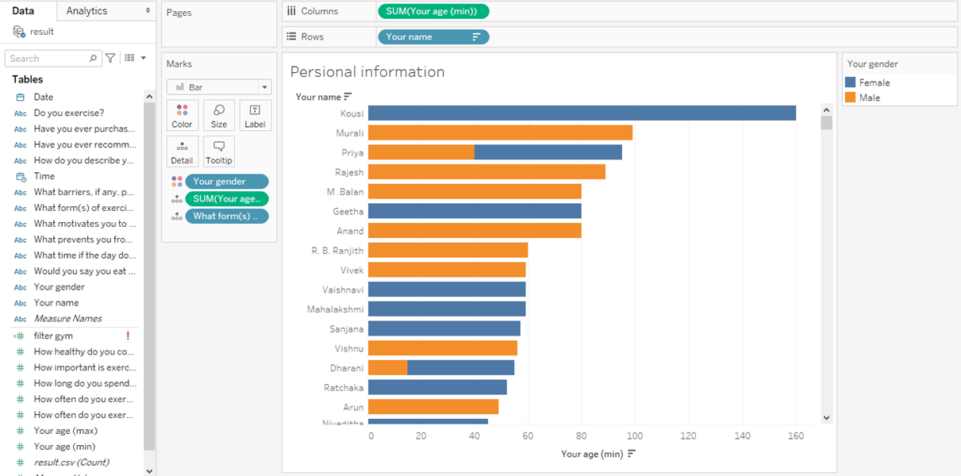

Figure 7: Customer personal information.

### 3.1.2 Health status of customers

This chart shows the health status of clients including male and female.

* Blue represents “No” answer to a healthy diet
* Orange represents the “Not always” answer to having a healthy diet
* Green represents the answer to “Yes” in having a healthy diet

Through this chart, we can determine the health status of the customer to see how much they are in addition to how they are physically able to show the information. news needed

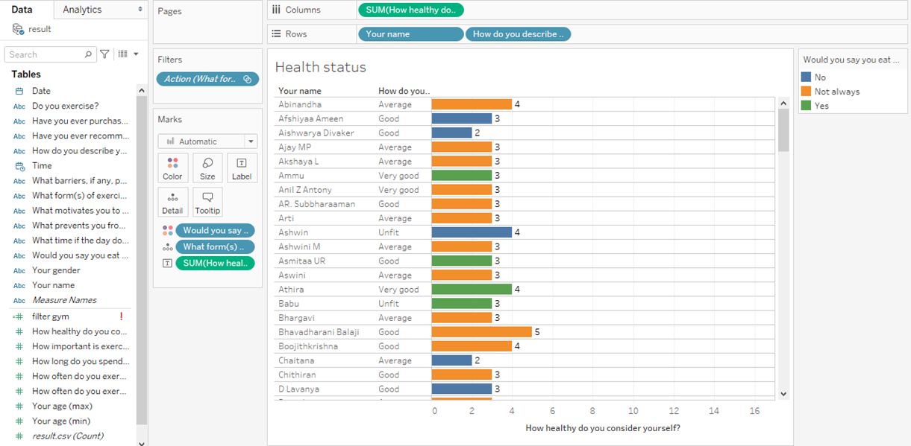

Figure 8: Health status of customers

### 3.1.3 Exercise habits of customers

In this chart, it will be more complicated because it will show 2 diagrams as "how often do you exercise?" with bar chart and “How long do you spend exercising per day?” with line chart style.

* The brown color represents those who have an afternoon workout routine
* Orange represents those who have an early morning routine
* Pink represents people who have a habit of practicing at night
* The blue line represents how long each household practices

Through this chart, one can look at their training history and how intense a client's exercise intensity will lead to many company-changing decisions.

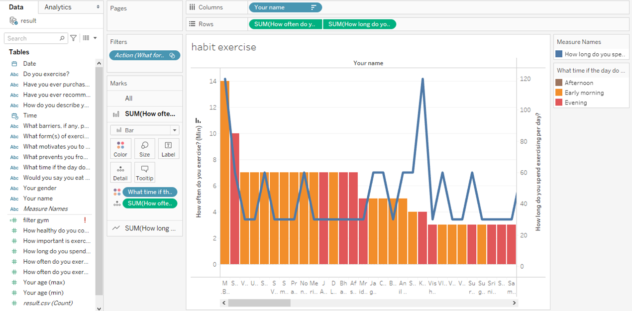

Figure 9: Exercise habits of customers

### 3.1.4 Evaluation Dashboard

The dashboard aggregates everyone's data related to sports training and focus on those who work out. Besides, it will show information about each person, how they are in health and their training progress. From there, it is possible to come up with business strategies for the company and it motivates our company to take measures for those in need.

From this information, we can filter those with the same gym format to the same table to be able to track and provide analysis that affects the company.

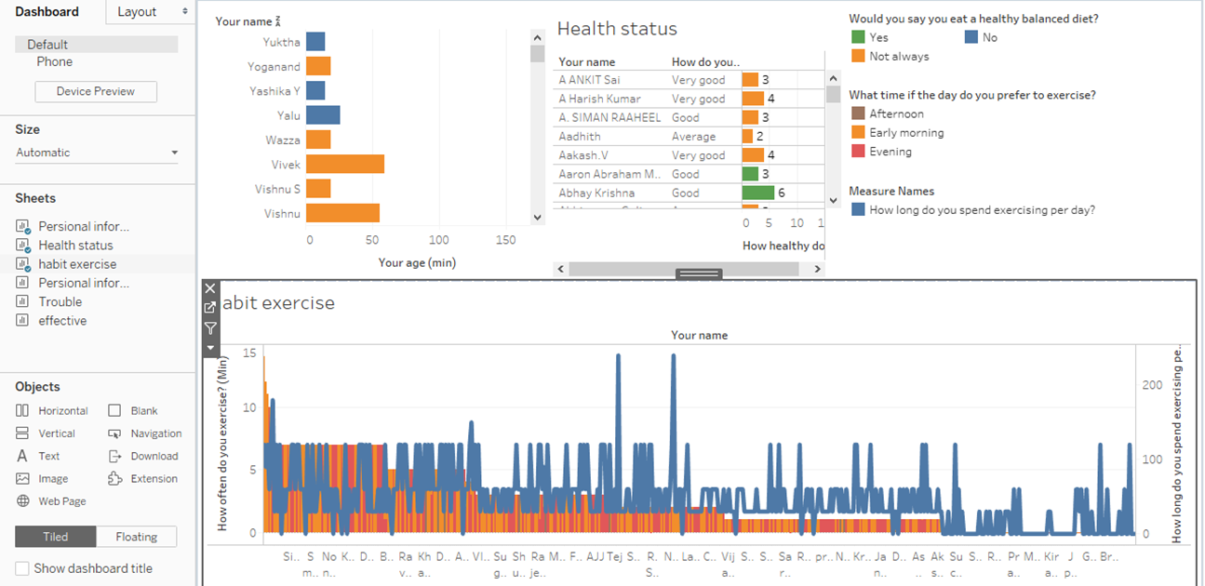

Figure 10: Dashboard 1

# References

CHI, S., 2017. *LawPay.* [Online]   
Available at: https://www.lawpracticetoday.org/article/business-intelligence-better-legal-business-model/

Kerschberg, B., 2011. *Forbes.* [Online]   
Available at: https://www.forbes.com/sites/benkerschberg/2011/04/26/business-intelligence-and-legal-matter-management/?sh=771cbec22d3c