create id
- auto increment : tang dan
- uuid v4 : ngau nhien 36 ky tu
- snowflake id : thoi gian + id pod + so dem
- uuid v7 : thoi gian + ky tu index : full text scan , can use when offline , migrate or work with multi database , security
Index
- unique index
- composite index
-prefix index
-full scan text
-
Explain database
kafka
Partition
1 topic 1 worker
1 partition – 1 worker ,
1 key partition -> 1 worker
2. Bẫy Rebalance Storm (Worker xử lý quá lâu): Nếu Worker kéo 500 tin về một lúc và xử lý quá lâu (quá max.poll.interval.ms, mặc định 5 phút), Kafka tưởng Worker đã chết nên đá ra và chia lại làn đường (Rebalance), làm cả hệ thống đứng hình. (Cá

kafka hash key de chia partition, can chon key hop li tranh viec hash key roi het vao 1 partition
2. Reliability / Fault Tolerance (Độ tin cậy / Chịu lỗi): Chết 1 máy chủ (Broker/Pod) hệ thống vẫn chạy đúng bình thường.
3. High Availability (Tính Sẵn sàng cao): Hệ thống hoạt động 24/7, nâng cấp hoặc migrate không cần tắt máy (Zero-Downtime).
4. Scalability (Khả năng Mở rộng): Khi khách tăng đột biến (Flash Sale), thêm Pod hoặc thêm Partition là gánh được tải.
5. Performance (Hiệu năng): Tốc độ phản hồi nhanh (Latency / P95 thấp) và xử lý được nhiều request/giây (Throughput cao).

Rebalitive balnce
Ig balance kafka

Consumer group
Routrobin

Define consumer
Co che consumer join a consumer group

Rabbit mq : get message , publish message , header payload in message , exchange , consumer , queue , bind , routing key , serilizaer
Message : header , body , basic.publish
-header
+ content type : data structure can be consume by another language because data selft describing their format
Example in python you could serialization type from content type header , it could auto deserialize into dict, tuple ,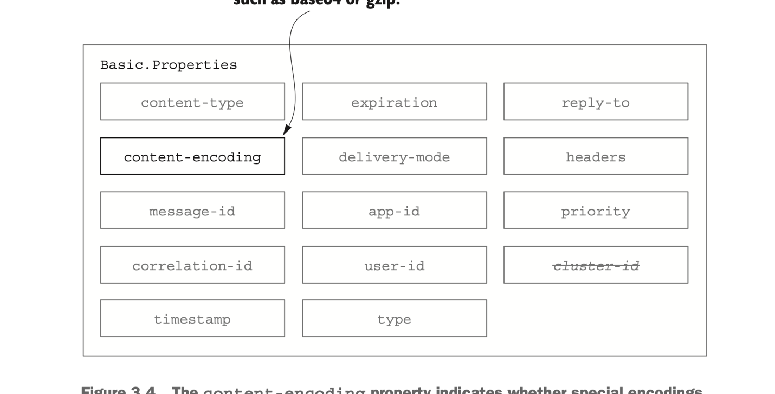

Delivery mode : persisting message , can be config here , if set to “ 2 “ the delivery-mode will tell rabbit mq to persist the message to disk
Correlation id : relation throught many layer, woker , message
Expiration : TTL message
User id , app id use for authentication
Type : in case you have 2 message version like order1 , order2, publish message can publish in type : order2, and handle in worker as : onMessage : type : order2
Reply – to : use for special routing key for replies this message
Priority : 0 -9 , 0 will be get by consumber before 9
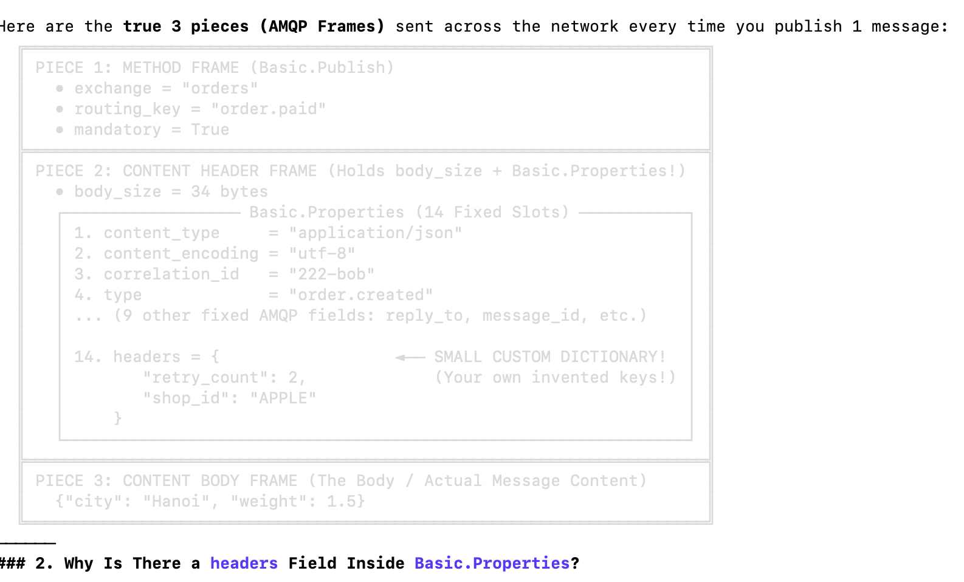

Database
Acid
Isolation level: read uncommit ,read committed, repeatable read , serializable,
Profiling 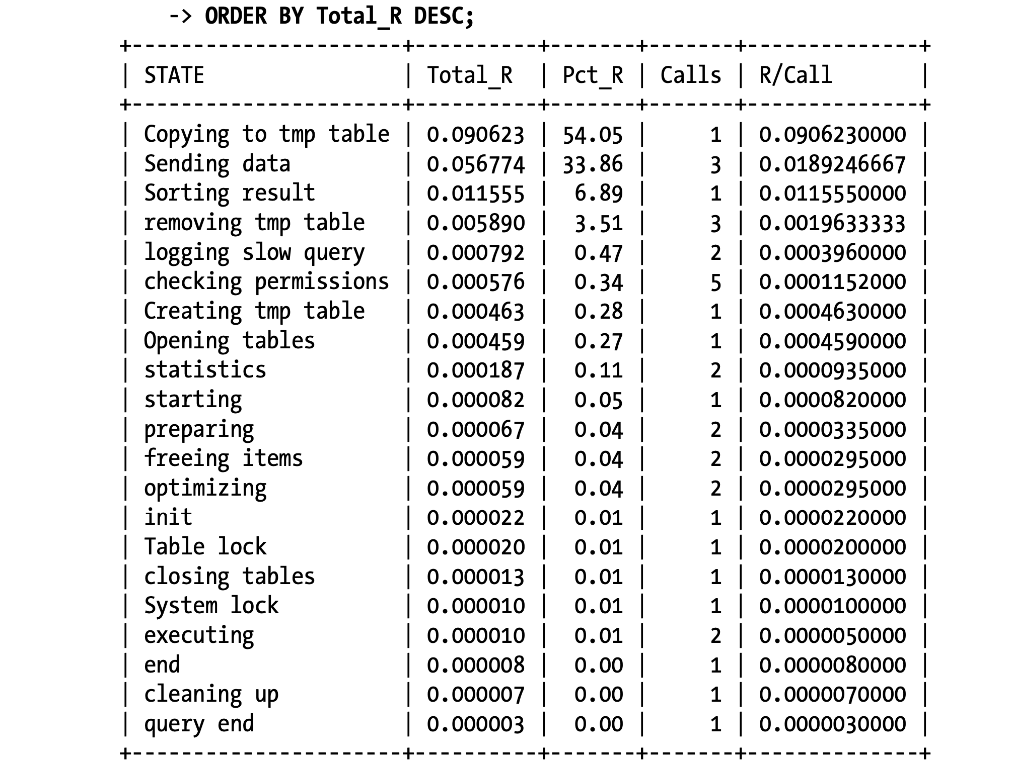
write lock , read lock , write a head log , redo log write to disk but senquential IO not random IO
Show profiling
Show status : what database doing in physic 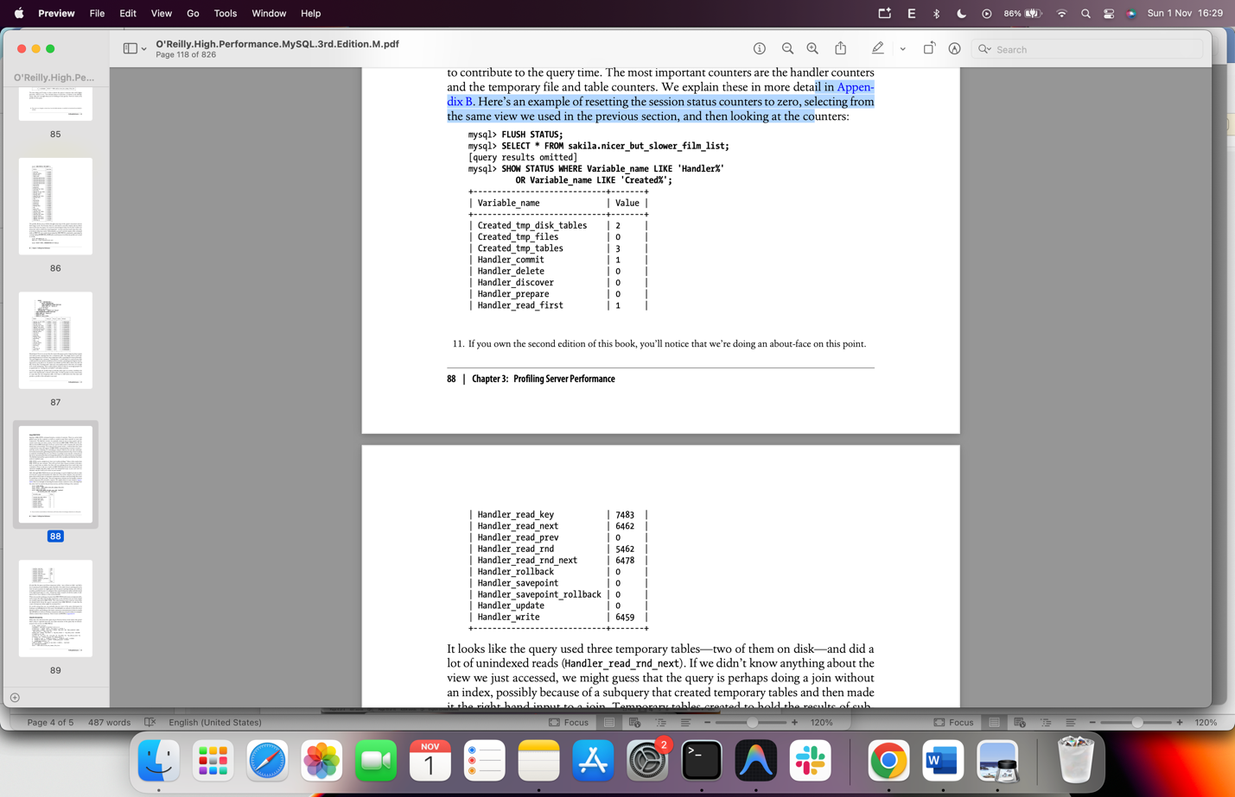
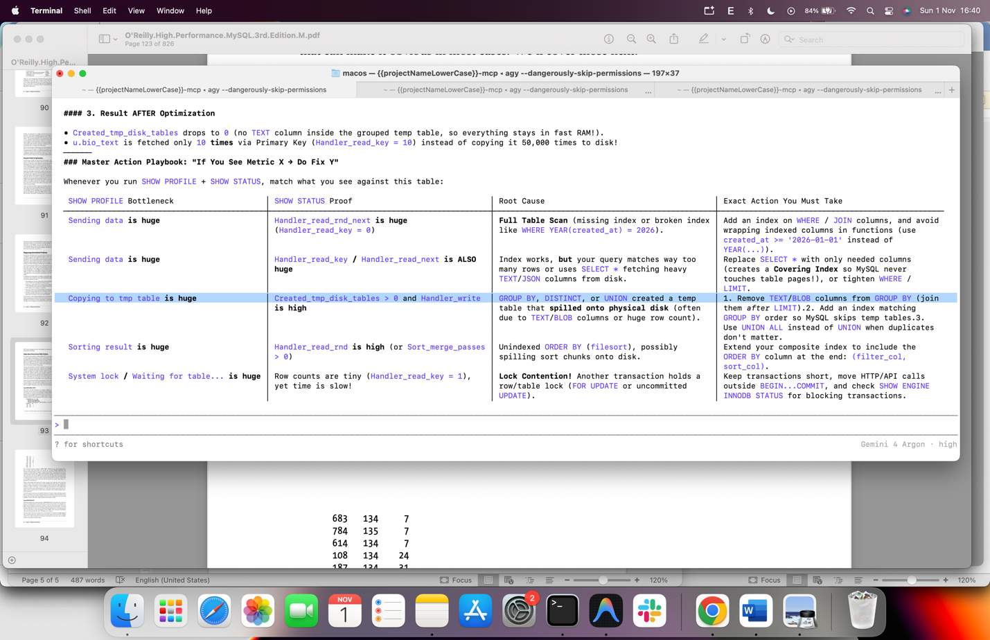

Slow querry logging , show process list , show global status
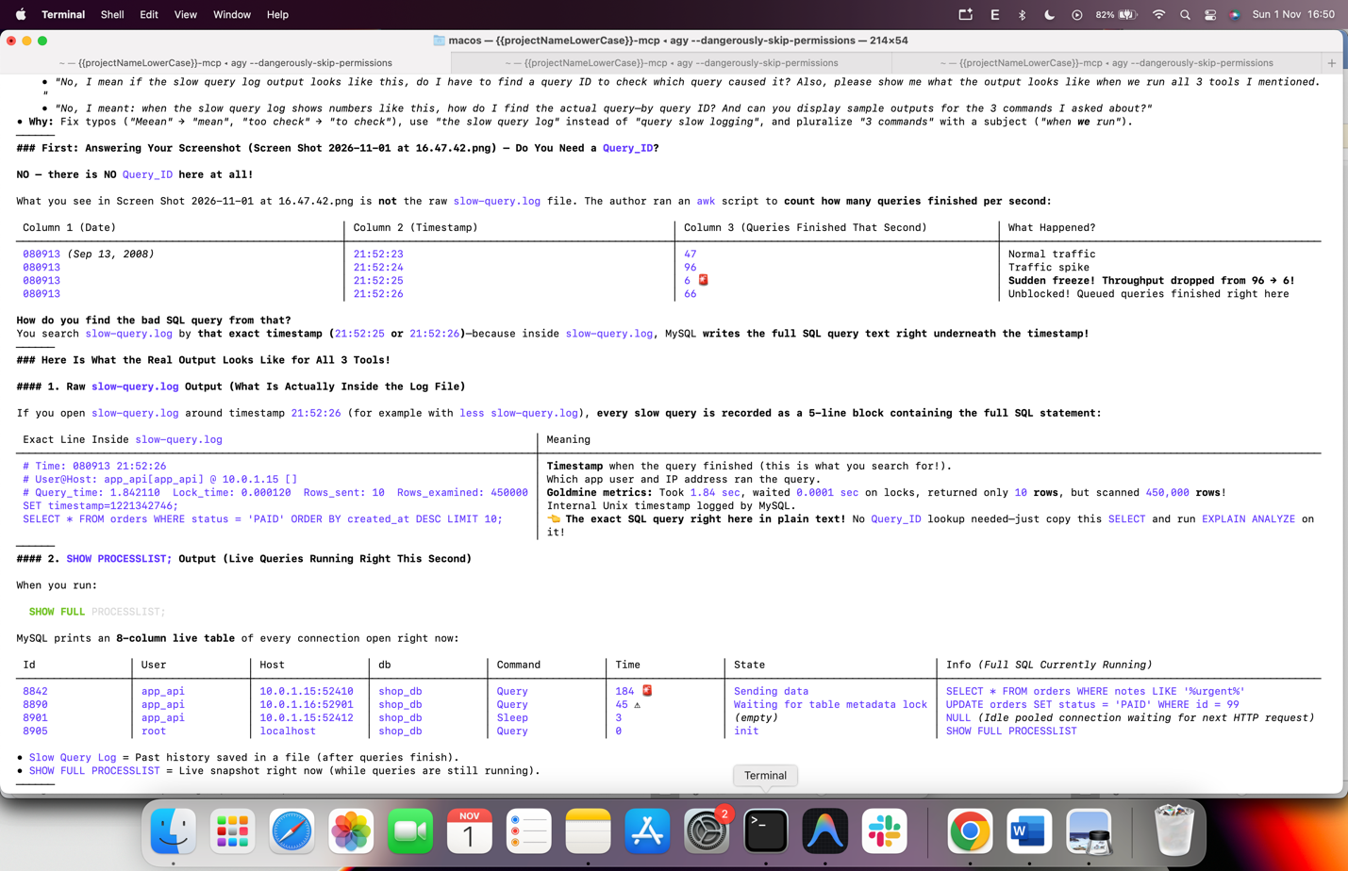
Using static table to see what each table show up metrics fetch , latency, inserted,updated
Or unuseful index
SELECT object_schema, object_name, index_name
FROM sys.schema_unused_indexes
WHERE object_schema = 'shop_db';

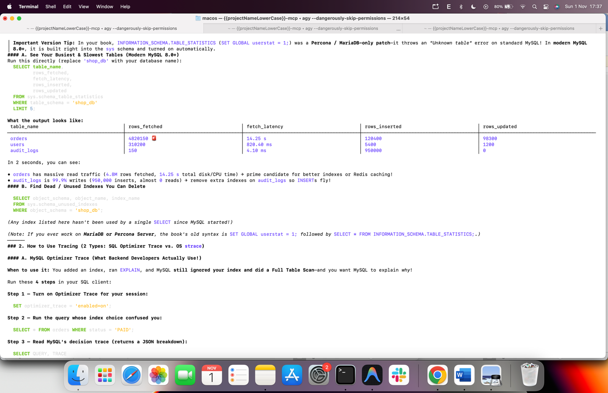

### Step 1: Turn ON Optimizer Trace
SET optimizer_trace = 'enabled=on';
### Step 2: Run Your Slow Query
SELECT * FROM orders WHERE status = 'PAID';
### Step 3: Print the Trace Vertically (Use \G Instead of ;)
(In mysql> terminal, \G prints vertically with zero broken borders. In DBeaver/TablePlus, run with ; and double-click the TRACE cell to format the JSON.)
SELECT QUERY, TRACE
FROM INFORMATION_SCHEMA.OPTIMIZER_TRACE\G
──────
### Step 4: What Data Shows Up on Your Screen

MySQL outputs QUERY (your SQL string) and TRACE (this JSON):

{
"steps": [
{
"join_optimization": {
"steps": [
{
"rows_estimation": [
{
"table": "orders",
"range_analysis": {
"table_scan": {
"rows": 100000,
"cost": 10247.35
},
"potential_range_indexes": [
{
"index": "PRIMARY",
"usable": false,
"cause": "not_applicable"
},
{
"index": "idx_status",
"usable": true
}
],
"analyzing_range_alternatives": {
"range_scan_alternatives": [
{
"index": "idx_status",
"index_only": false,
"rows": 85000,
"cost": 29751.01,
"chosen": false,
"cause": "cost"
}
]
}
}
}
]
}
]
}
}
]
}
──────
### Step 5: How to Read Those 3 JSON Blocks (In 10 Seconds)

1. Check "table_scan" first (The Price to Beat):

• "rows": 100000, "cost": 10247.35
• Meaning: A Full Table Scan with no index costs 10,247. Any index must cost less than 10,247 to be picked!

2. Check "potential_range_indexes" second (Can Your Index Run?):

• "index": "idx_status", "usable": true
• If "usable" is false: Your SQL WHERE syntax broke the index!
• If "usable" is true: Your SQL syntax is valid—move to #3 to check its cost.

3. Check "range_scan_alternatives" third (Why Your Index Won or Lost):
• "index_only": false → Because you wrote SELECT *, the index alone isn't enough; MySQL must jump back to the full table rows.
• "rows": 85000 → 'PAID' matched 85,000 out of 100,000 rows!
• "cost": 29751.01 → Jumping 85,000 times costs 29,751 (almost 3x slower than 10,247!).
• "chosen": false, "cause": "cost" → Proof: MySQL rejected idx_status because its cost was too high!
──────

Char and var char
Char : password, country code , fixed byte size , don’t add 1 more byte because the size is fixed, Y N field with user input , country code VN US UK ,…
Varchar : frequently update like text user, add more byte space, add 1 more byte for type length,
• "Walk me through this JSON example line by line:"
• Why: In English, "explain" normally needs a direct object ("Explain it using this example", or "Walk me through this example").
──────
Let's walk top-to-bottom through every single block and number in the exact JSON you just pasted!
Remember the query that produced this JSON was:
SELECT * FROM orders WHERE status = 'PAID';
──────
### Block 1: "table_scan" (No-Index Score)

"table_scan": {
"rows": 100000,
"cost": 10247.35
}
• "rows": 100000 → Your orders table has 100,000 rows total.
• "cost": 10247.35 → How MySQL calculated this score:
• Checking 100,000 rows in CPU (0.1 point per row) = 10,000 points
• Reading all table disk pages straight in order = 247.35 points
• Total No-Index Score = 10247.35 points (Lower score = Faster! Any index must beat 10247.35 to win.)

──────
### Block 2: "potential_range_indexes" (Which Indexes Exist on orders?)

"potential_range_indexes": [
{
"index": "PRIMARY",
"usable": false,
"cause": "not_applicable"
},
{
"index": "idx_status",
"usable": true
}
]
MySQL checks every index on the orders table:

1. "index": "PRIMARY" (the index on id):
• "usable": false, "cause": "not_applicable" → Your WHERE clause only says WHERE status = 'PAID'. It does not filter by id, so the PRIMARY index cannot be used here.
2. "index": "idx_status" (your index on status):
• "usable": true → Your WHERE clause filters on status, so this index can run! Now MySQL moves to Block 3 to calculate its cost score.
──────
### Block 3: "range_scan_alternatives" (Why idx_status Got 29751.01 and Lost!)

"range_scan_alternatives": [
{
"index": "idx_status",
"index_only": false,
"rows": 85000,
"cost": 29751.01,
"chosen": false,
"cause": "cost"
}
]

Look at where every single one of those 6 lines comes from:

1. "index": "idx_status" → Testing your idx_status index.
2. "index_only": false → Because you wrote SELECT *, idx_status (which only holds status and id) does not have the other columns (amount, address, created_at). So for every match, MySQL must jump from the
index over to a page in the main orders table!
3. "rows": 85000 → MySQL peeked at idx_status and saw 85,000 rows out of 100,000 have status = 'PAID'.
4. "cost": 29751.01 → Look at MySQL's exact math for why this number is huge:
• 85,000 extra jumps from index → main table (0.25 points per jump) = 21,250 points!
• Checking 85,000 rows in CPU (0.1 point per row) = 8,500 points (+ 1.01 lookup)
• Total Index Score = 29751.01 points!
5. "chosen": false → MySQL compares the two scores:
• Block 1 (table_scan, no index): 10247.35 points
• Block 3 (idx_status, with 85,000 jumps): 29751.01 points (29,751 ÷ 10,247 = 2.9x, almost 3x more work / 3x slower!)
• Since 29751.01 is worse than 10247.35, MySQL sets "chosen": false (do NOT use idx_status).
6. "cause": "cost" → MySQL writes down the reason it set "chosen": false: "Rejected because its cost (29751.01) was higher than table_scan (10247.35)."
──────
### Now Watch How Block 3 Changes When You Fix the Query!

#### Fix 1: Replace SELECT * with SELECT id, status (Zero Table Jumps!)

Because id and status both live inside idx_status, those 21,250 jump points disappear:

"range_scan_alternatives": [
{
"index": "idx_status",
"index_only": true,
"rows": 85000,
"cost": 8651.25,
"chosen": true
}
]

• "index_only" flipped from false → true!
• "cost" dropped from 29751.01 → 8651.25 (now lower than table_scan's 10247.35!).
• "chosen" flipped to true, and "cause": "cost" disappeared!

#### Fix 2: Keep SELECT *, But Filter a Rare Status (WHERE status = 'REFUNDED', Only 500 Rows)

"range_scan_alternatives": [
{
"index": "idx_status",
"index_only": false,
"rows": 500,
"cost": 176.01,
"chosen": true
}
]

• Only 500 jumps (500 × 0.25 = 125 points + 50 CPU points = 176.01 points).
• 176.01 easily beats table_scan (10247.35) → "chosen": true!

• In MySQL: TIMESTAMP is only 4 bytes (32-bit), so it breaks in 2038 → MySQL developers prefer DATETIME (and save UTC from backend code).
• In PostgreSQL: TIMESTAMPTZ is 8 bytes (64-bit), so it auto-handles time zones and works until year 294,276 (Postgres doesn't even have a DATETIME keyword!).

rabbit mq : AMQP, tx = transaction , write message to disk – delivery mode 2 tion, notifying a client that its connection has been blocked. Connection.Blocked and Connection.Unblocked are asynchronous methods that can be sent at any time to notify the client when RabbitMQ has blocked the publishing client and when that , Qos , prefetch , basic.reject flag requeue, basic.unack, controlling queue, temporary queue , allow single queue , automatically expired queues , queue durability , durable flag , exclude flag , auto delete , content – type ( header message )
Loại Exchange │ Cách phân loại tin nhắn │ Ví dụ thực tế
─────────────────────────────────────┼─────────────────────────────────────────────────────────────────────────────────────┼─────────────────────────────────────────────────────────────────────────────────────
1. direct(Đích danh) │ So sánh routing_key phải giống hệt 100% với binding_key. │ Gửi key "pay" → chỉ vào đúng Queue nối bằng "pay".
2. fanout(Loa phóng thanh) │ Bỏ qua hoàn toàn routing_key! Cứ có bao nhiêu Queue nối vào là nhân bản gửi cho TẤT │ User vừa đăng ký tài khoản → bắn cùng lúc cho cả 3 Queue: Gửi Email, Tặng Voucher,
│ CẢ. │ Tạo Ví.
3. topic(Phân loại theo mẫu * và #) │ So khớp theo từng từ cách nhau bởi dấu chấm . bằng ký tự đại diện:• * = Đúng 1 từ │ • vn.order.* khớp với vn.order.created, vn.order.paid• vn.# khớp với mọi tin bắt
│ bất kỳ• # = 0 hoặc nhiều từ bất kỳ │ đầu bằng vn.
4. headers(Phân loại theo Header) │ Bỏ qua routing_key, chỉ kiểm tra các cặp key: value bên trong thuộc tính headers │ Kiểm tra headers: { format: 'pdf', type: 'report' }. (Loại này thực tế ít dùng hơn
│ của tin nhắn. │ 3 loại trên).

Exchange to exchange , database to rabbit mq

