Week-6 Practical

CP2410: Algorithm and Data Structure

Nguyen Quoc Minh Quan

13740328

GitHub: <https://github.com/minhquan0902/CP2410--Practicals.git>

Task 1: (R-8.1) The following questions refer to the tree of Figure 8.3.

a. Which node is the root?

b. What are the internal nodes?

c. How many descendants does node cs016/ have?

d. How many ancestors does node cs016/ have?

e. What are the siblings of node homeworks/?

f. Which nodes are in the subtree rooted at node projects/?

g. What is the depth of node papers/?

h. What is the height of the tree?

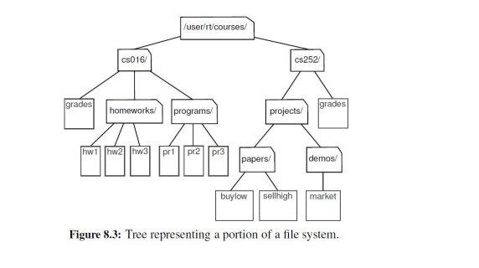

1. The root node is /uses/rt/courses
2. The Internal nodes are: /uses/rt/courses, cs016/, cs252/, homeworks/, programs/, projects, papers/, demos/
3. Node cs016/ have 9 descendants
4. Node cs016/ have 1 ancestor
5. Siblings of node homeworks/ are grades and programs/
6. Papers/, buylow, sellhigh, demos/, market
7. Depth of node papers/ is 3
8. Height of the tree is 4

Task 2: For the following tree, demonstrate (by hand) the output of:

a. Inorder traversal

b. Preorder traversal

c. Postorder traversal

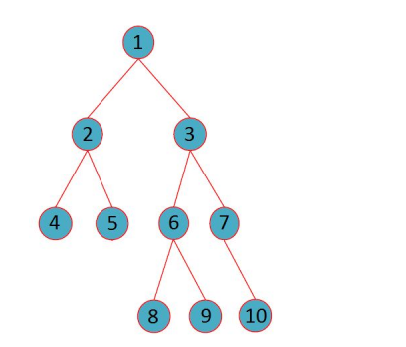

1. Inorder traversal 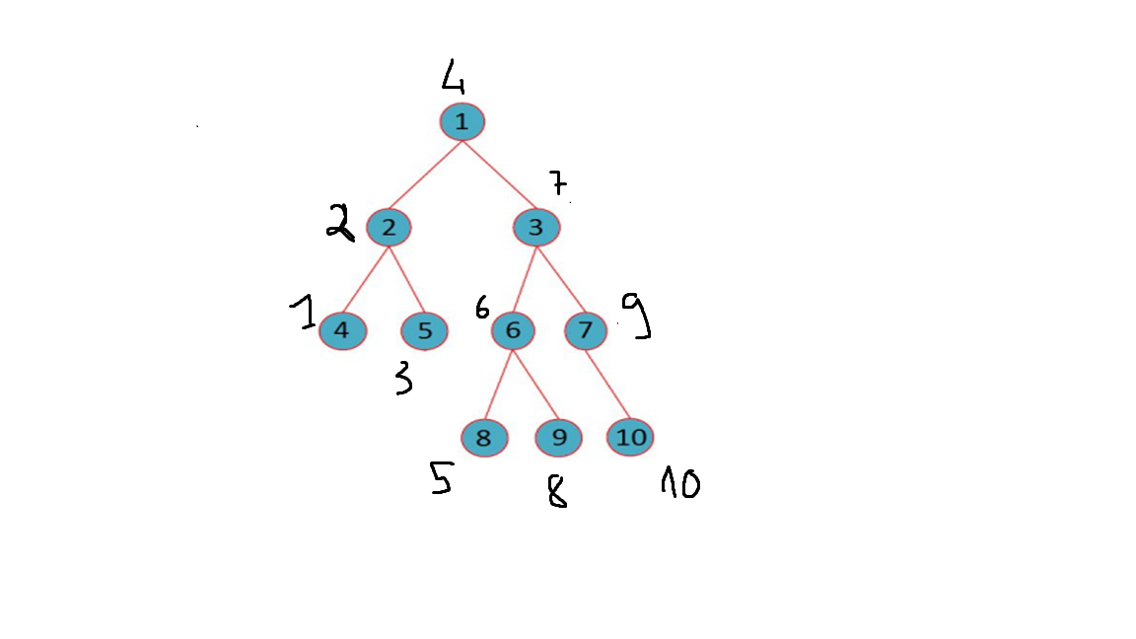
2. Preorder traversal

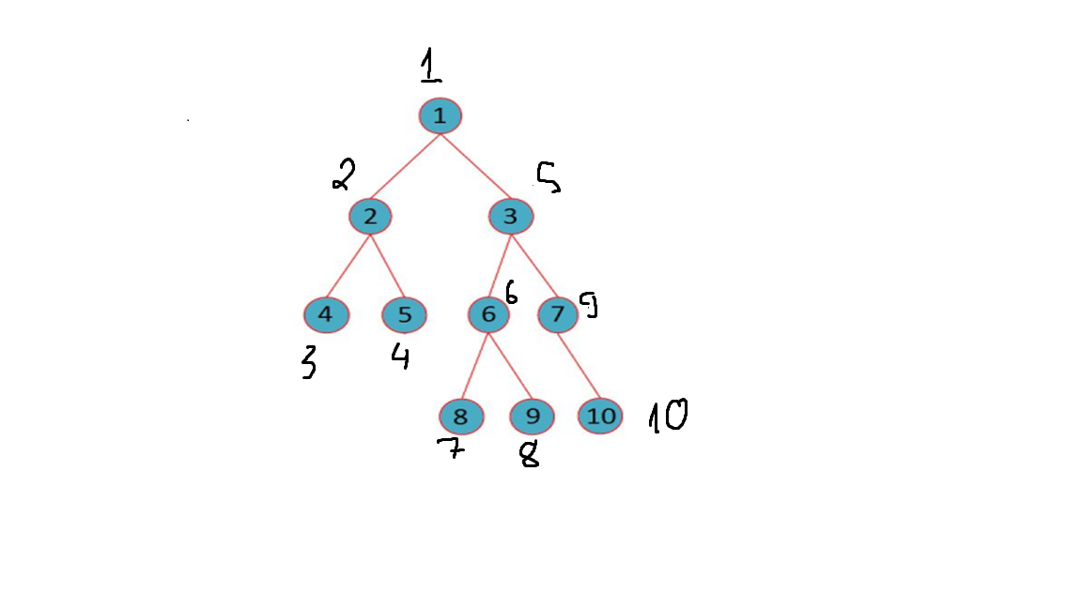

1. Postorder

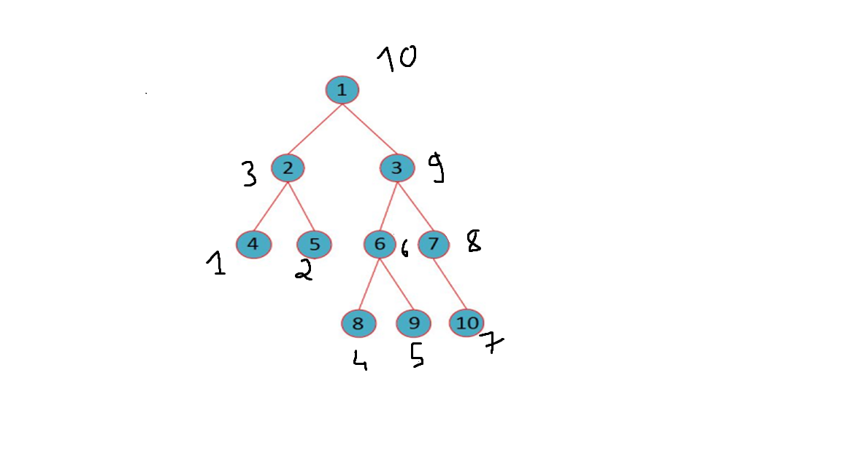

Task 3: Using LinkedBinaryTree (ch08/linked_binary_tree.py), recreate the tree above, and use the various traversals to check that your outputs for question 2 were correct.

Raise Empty class

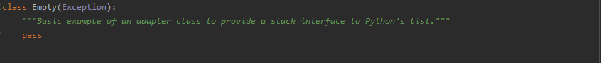

Initialize a LinkQueue Class

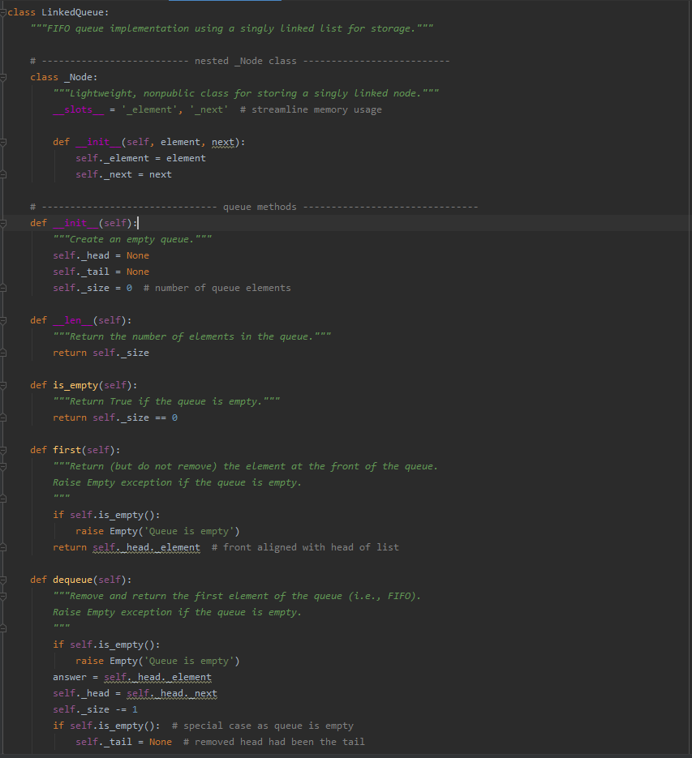

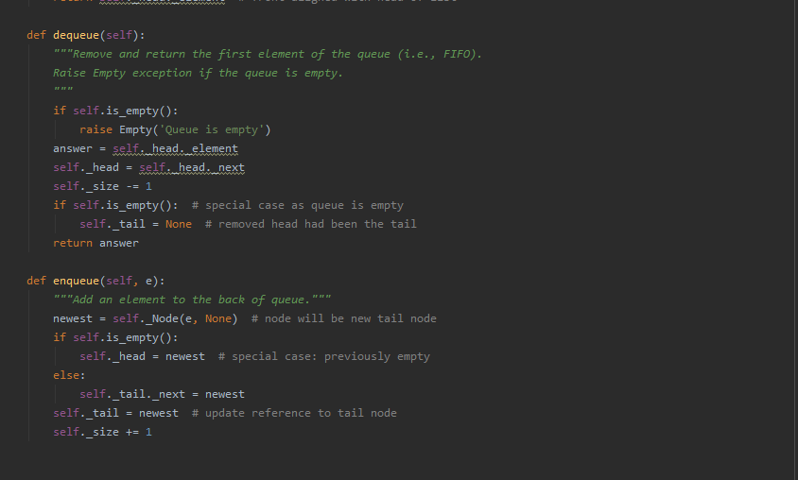

Initialized the Tree

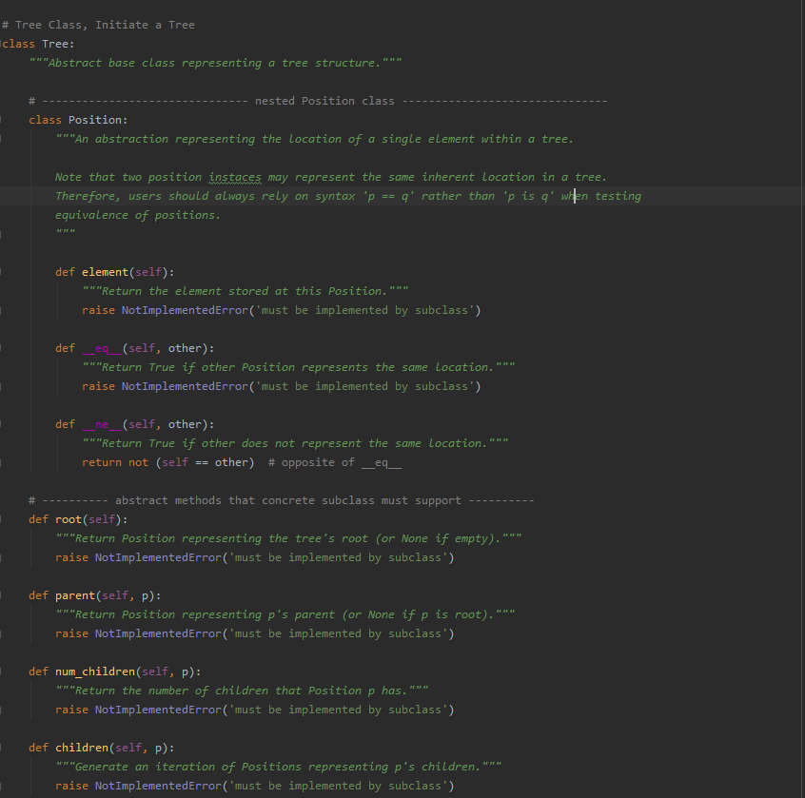

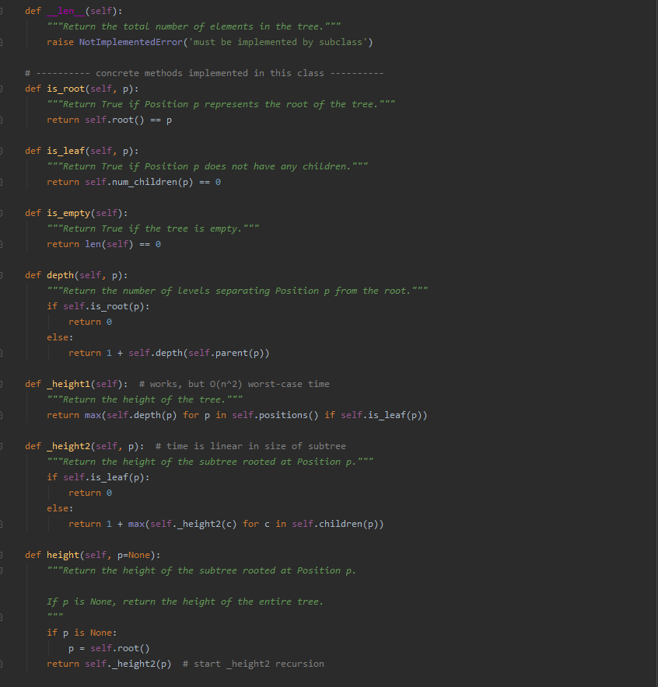

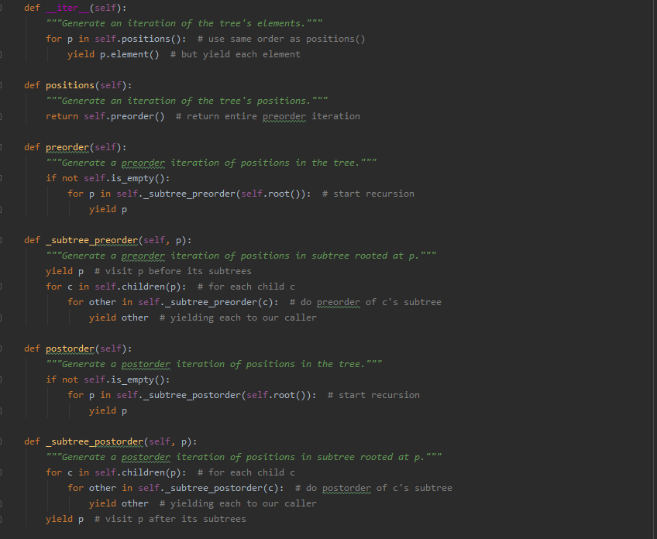

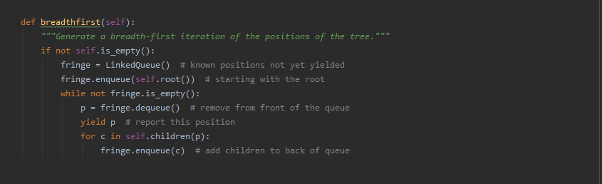

Initialized a Binary Tree Class:

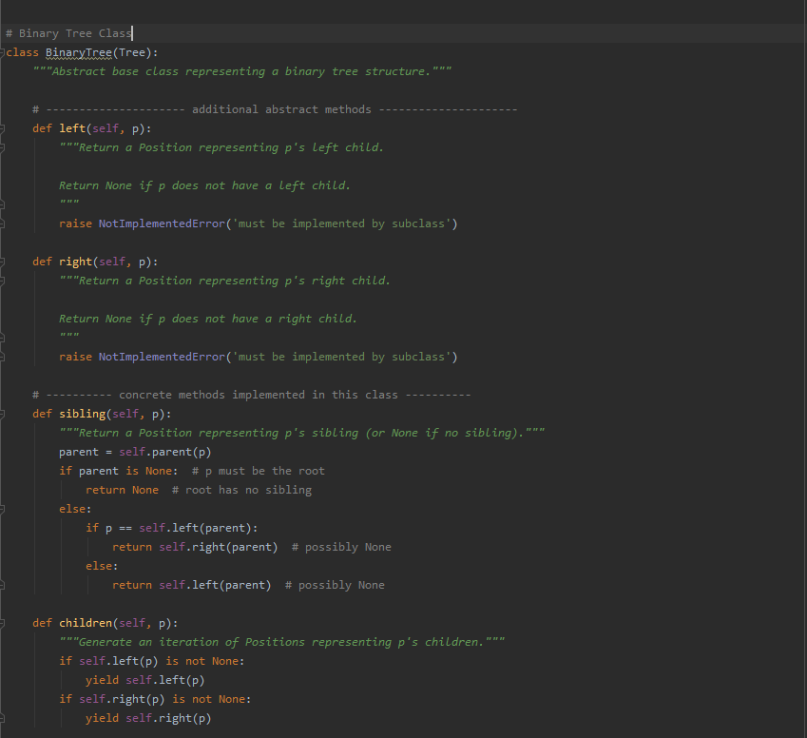

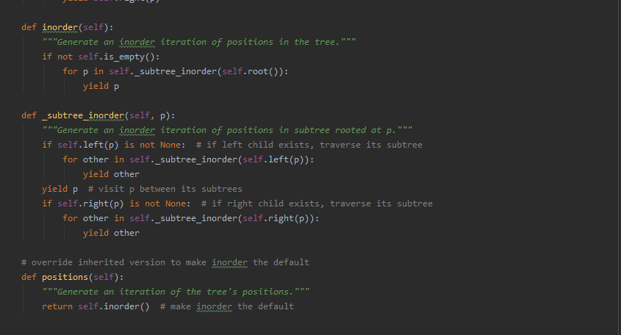

Linked Binary Tree Class:

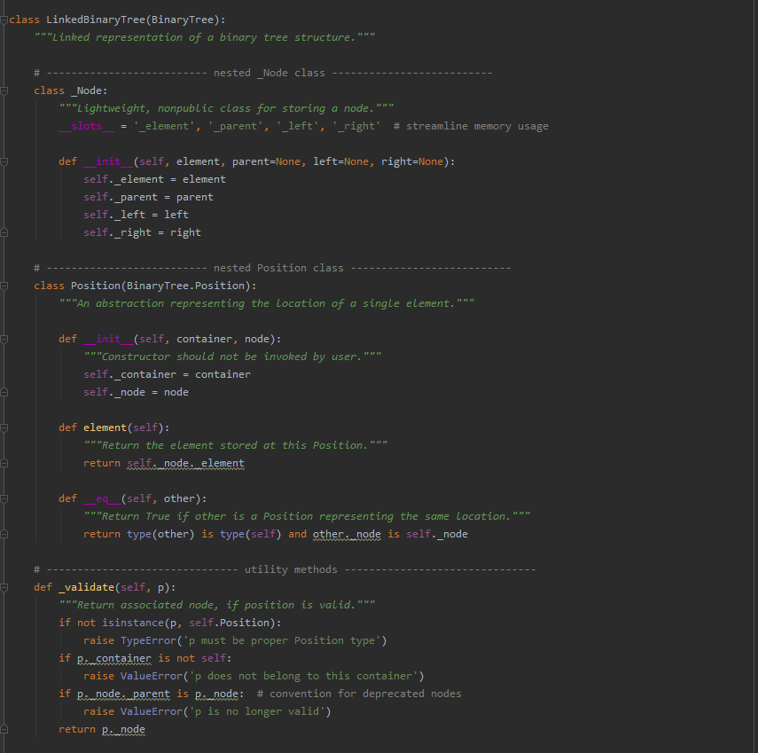

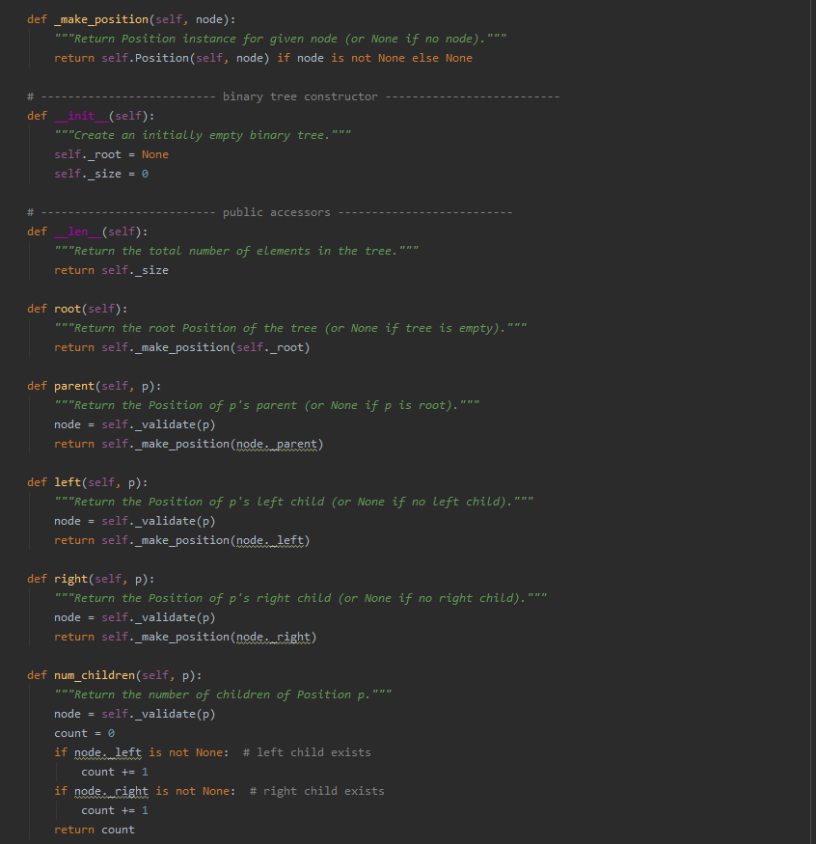

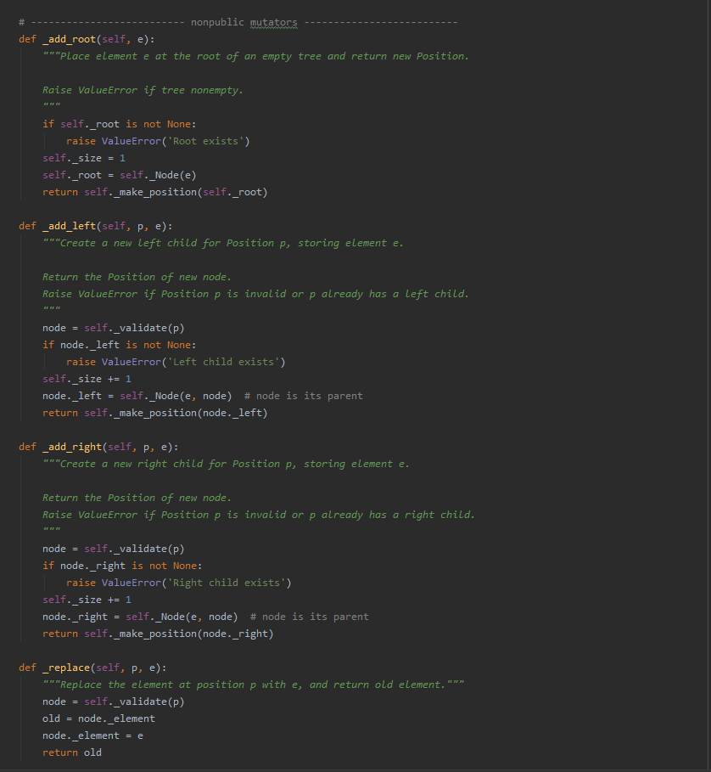

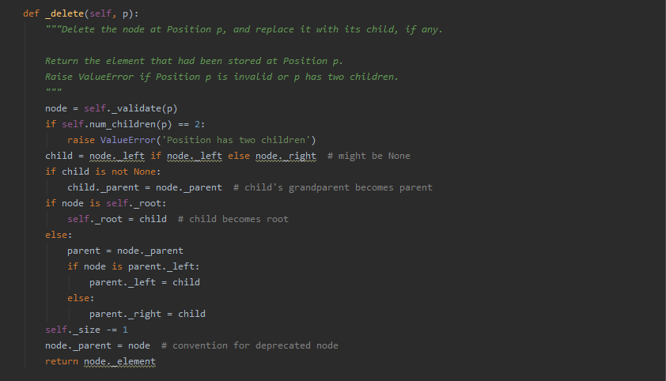

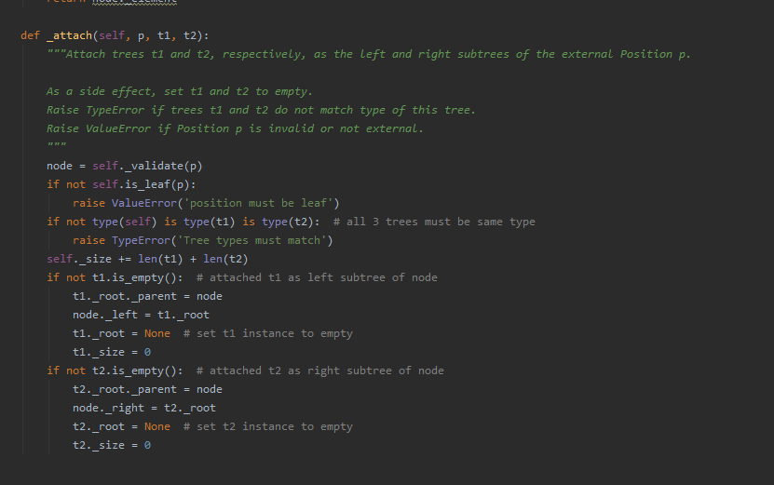

Execute code to recreate the tree above, and use the various traversals to check for outputs:

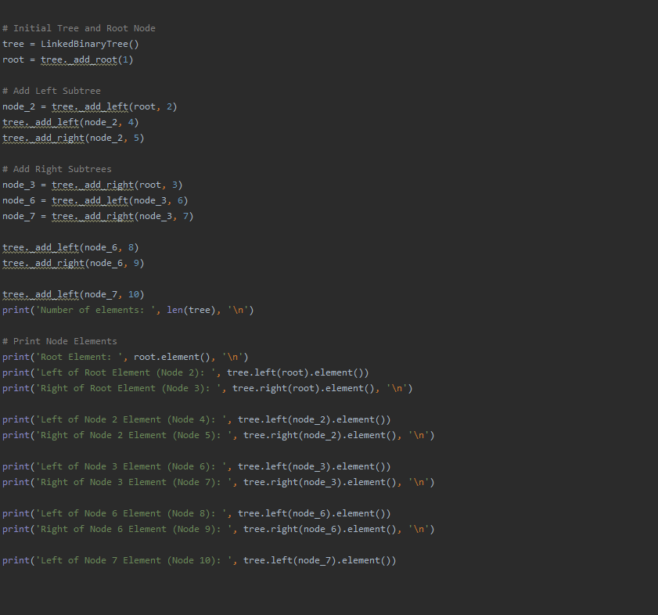

Result:

