ASSIGNMENT 1_OPT 1: Student Management

- Exercise 1:
employees(ssn, salary, phone),
departments(dno, dname, budget),
children of employee(name /*unique key*/, age).
- Draw an ER diagram that captures this information

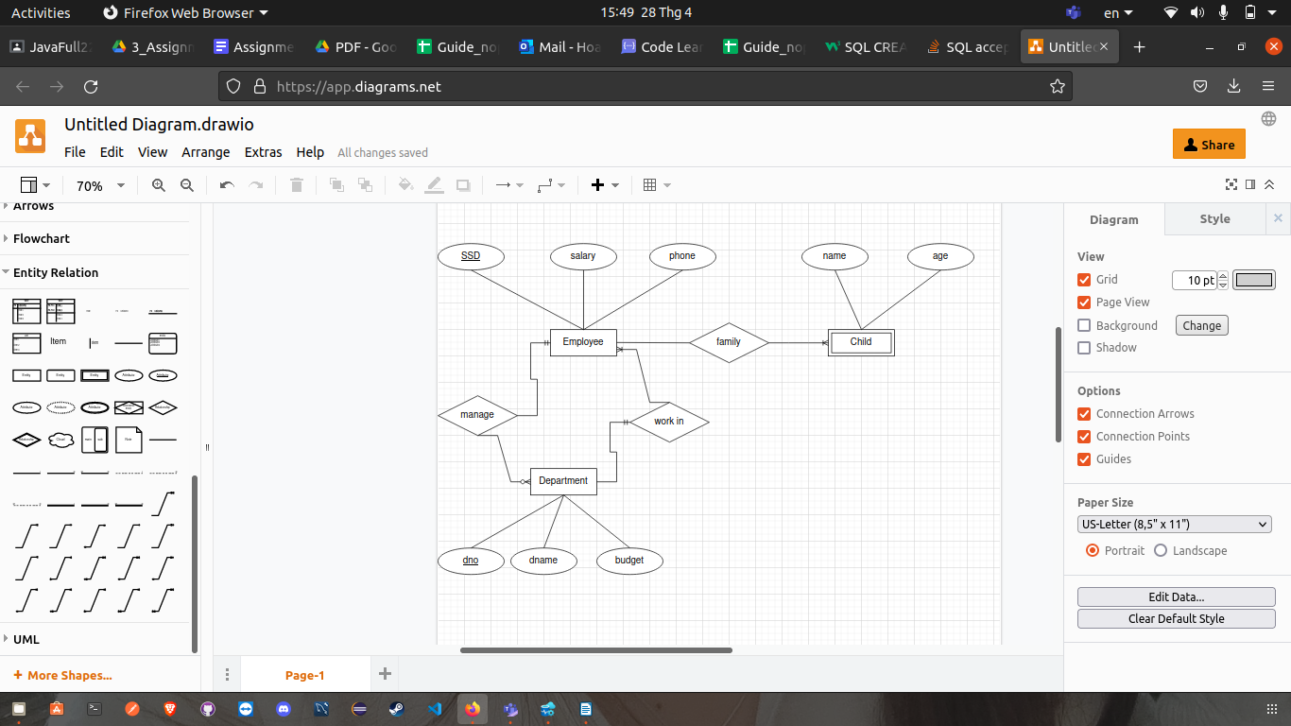

- Convert from ER diagram to relational schema: primary key(#), foreign key(~)

Children
#name | age | ~parent_id

Employee
#SSN | salary | phone | ~department_id

Department
#dno | dname | budget | ~manager_id
- Exercise 2:
STUDENT(#SSN, Name, Major, Bdate),
COURSE(#Course, Cname, Dept),
ENROLL(#SSN, #Course, Quarter, Grade),
BOOK_ADOPTION(#Course, Quarter, #Book_ISBN),
TEXT(#BOOK_ISBN, Book_Title, Publisher, Author)

Draw a relational schema diagram specifying the foreign keys of this schema

#: primary key
~: foregin key
Text
#BOOK_ISBN | Book_Title | Publisher | Author

Book_Adoption
~Course | Quarter | ~BOOK_ISBN

Course
#Course | Cname | Dept

Enroll
~SSN | ~Course | Quarter | Grade

Student
#SSN | Name | Major | Bdate

