WEEK 5

* Assignment 1: Create a new project to implement the program in Home Assignment 1. Compile and upload to simulator. Run and observe the result. Go to data memory section, check how test string are stored and packed in memory.

#Laboratory Exercise 5**,** Home Assignment 1

.data

**test:** .asciiz "Hello World"

**.text** li $v0**,** 4

la $a0**,** **test**

**syscall**

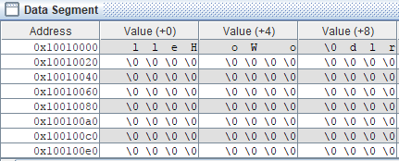

* Assignment 2: Create a new project to print the sum of two register $s0 and $s1 according to this format: “The sum of (s0) and (s1) is (result)”

.data

t1**:** .asciiz "\nThe sum of ("

t2**:** .asciiz ") and ("

t3**:** .asciiz ") is ("

t4**:** .asciiz ")\n"

**.text**

li $s0**,** 8000 # $s0 **=** 8000

li $s1**,** 3 # $s1 **=** 3

**add** $s2**,** $s0**,** $s1 # $s2 **=** $s1 **+** $s0

li $v0**,** 4

la $a0**,** t1

**syscall**

li $v0**,** 1

**add** $a0**,**$zero**,** $s0

**syscall** # print $s0

li $v0**,** 4

la $a0**,** t2

**syscall**

li $v0**,** 1

**add** $a0**,**$zero**,** $s1

**syscall** # print $s1

li $v0**,** 4

la $a0**,** t3

**syscall**

li $v0**,** 1

**add** $a0**,**$zero**,** $s2

**syscall** # print $s2

li $v0**,** 4

la $a0**,** t4

**syscall**

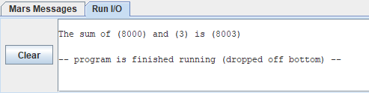

* Assignment 3: Create a new project to implement the program in Home Assignment 2. Add more instructions to assign a test string for y variable, and implement strcpy function. Compile and upload to simulator. Run and observe the result.

#Laboratory Exercise 5**,** Home Assignment 2

.data

y**:** .asciiz "Hello" # source string y

x**:** .space 1000 # destination string x**,** empty

**.text**

la $a1**,** y

la $a0**,** x

strcpy**:**

**add** $s0**,**$zero**,**$zero #s0 **=** i**=**0

L1**:**

**add** $t1**,**$s0**,**$a1 #t1 **=** s0 **+** a1 **=** i **+** y**[**0**]**

# **=** address of y**[**i**]**

lb $t2**,**0**(**$t1**)** #t2 **=** value at t1 **=** y**[**i**]**

**add** $t3**,**$s0**,**$a0 #t3 **=** s0 **+** a0 **=** i **+** x**[**0**]**

# **=** address of x**[**i**]**

sb $t2**,**0**(**$t3**)** #x**[**i**]=** t2 **=** y**[**i**]**

beq $t2**,**$zero**,**end_of_strcpy #if y**[**i**]==**0**,** exit

**nop**

addi $s0**,**$s0**,**1 #s0**=**s0 **+** 1 **<->** i**=**i**+**1

j L1 #next character

**nop**

end_of_strcpy**:**

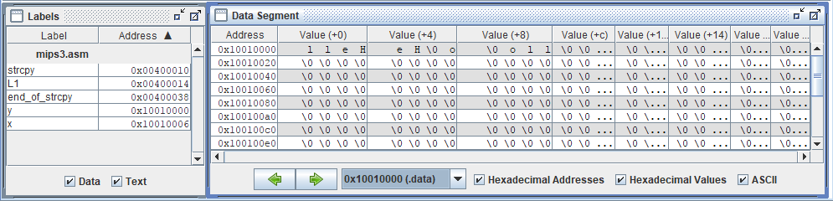

* Assignment 4: Accomplish the Home Assignment 3 with syscall function to get a string from dialog, and show the length to message dialog.

#Laboratory Exercise 5**,** Home Assignment 3

.data

string**:** .space 50

Message1**:** .asciiz "Nhap xau:"

Message2**:** .asciiz "Do dai la "

**.text**

main**:**

get_string**:**

la $a0**,** Message1

la $a1**,** string

la $a2**,** 49

li $v0**,** 54

**syscall**

get_length**:**

la $a0**,** string # a0 **=** Address**(**string**[**0**])**

**xor** $v0**,** $zero**,** $zero # v0 **=** length **=** 0

**xor** $t0**,** $zero**,** $zero # t0 **=** i **=** 0

check_char**:**

**add** $t1**,** $a0**,** $t0 # t1 **=** a0 **+** t0

#**=** Address**(**string**[**0**]+**i**)**

lb $t2**,** 0**(**$t1**)** # t2 **=** string**[**i**]**

beq $t2**,**$zero**,**end_of_str # Is null char?

addi $v0**,** $v0**,** 1 # v0**=**v0**+**1**->**length**=**length**+**1

addi $t0**,** $t0**,** 1 # t0**=**t0**+**1**->**i **=** i **+** 1

j check_char

end_of_str**:**

addi $v0**,** $v0**,** **-**1

end_of_get_length**:**

print_length**:**

la $a0**,** Message2

**add** $a1**,** $zero**,** $v0

li $v0**,** 56

**syscall**

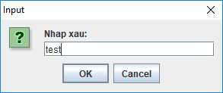 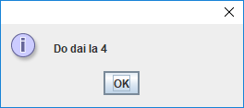

* Assignment 5: Write a program that let user input a string. Input process will be terminated when user press Enter or then length of the string exceed 20 characters. Print the reverse string.

.data

buffer**:** .space 50

**.text**

li $s6**,** 20 # Max length

li $s7**,** 10 # ASCII code of '\n'

la $s0**,** buffer # Load buffer

li $s1**,** 0 # index **=** 0

li $s3**,** 0 # i **=** 0

start_read_char**:**

li $v0**,** 12

**syscall** # Read char

**add** $s1**,** $s0**,** $s3 # Load buffer**[**i**]**

addi $s3**,** $s3**,** 1 # i**++**

beq $s3**,** $s6**,** end_read_char # exit when max length

beq $v0**,** $s7**,** end_read_char # exit when **enter**

sb $v0**,** 0**(**$s1**)**

j start_read_char

end_read_char**:**

Print_the_reverse_string**:**

li $v0**,** 11

lb $a0**,** 0**(**$s1**)**

**syscall**

beq $s1**,** $s0**,** exit

addi $s1**,** $s1**,** **-**1

j Print_the_reverse_string

exit**:**

* Conclusions: Before you pass the laboratory exercise, think about the questions below:

1. *What the difference between the string in C and Java?*

* String in C is Array terminated with a NUL (\0) character. But, in Java strings are instances (objects) of the *java.lang.String* class, you can not use them as array.

1. *In C, with 8 bytes, how many characters that we can store?*

* Chars in C are typically (not always) 8-bit

1. *In Java, with 8 bytes, how many characters that we can store?*

* Java chars are 16-bits (always).