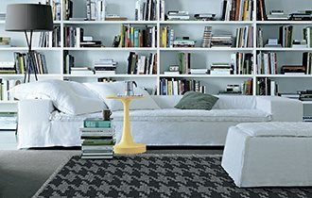

ID: mersofa1

Size: 250x150x90

Pre– cover: polyester fibre

Color: white