CP2406 Programming 3 Assignment 1

Phan Nguyen Minh Quan

**User Stories**

User Story 1: As a user, I want to see the simulator app as a single main window with menu bar and status bar.

User Story 2: As a user, when I click on the menu bar, it shows the menu items for 2 modes: city editing and simulation.

User Story 3: As a user, when I click on the city editing mode, I should be able to create, edit, open or save a city.

User Story 4: As a user, when I click on the simulation mode, I should be able to set the update rate, run the simulator, stop the simulator, set the vehicle spawn rate.

User Story 5: As a user, I want to have a simulator app which allows me to input information about vehicles, roads and traffic lights to see them interacting with each other.

User Story 6: As a user, I want to save my simulator histories with names so that I can go back to view them later.

User Story 7: As a user, I want to be able to resume/reload simulators that I saved before as histories .

User Story 8: As a user, I want to update vehicle rate to accelerate or decelerate vehicles in the simulator app.

User Story 9: As a user, I want to stop the simulator at any time.

User Story 10: As a user, I want vehicles to keep a safe distance or at least not to crash to each other while running in the simulator.

User Story 11: As a user, I want only 3 vehicle types on my simulator app: Motorbike, Car and Bus in which Motorbike’s length is only half of the length of a Car, Bus’s length is 3 times the length of a Car and the Car breadth is half of its length.

User Story 12: As a user, I want my simulator to have no roundabouts or pedestrians.

User Story 13: As a user, I want vehicles to stick to Australian rules and these specific rules when travelling on any road or interacting with each other:

1. A road is at least 2 times and at most 5 times the length of a bus.
2. A road can contain a limited number of vehicles based on the road’s length.
3. A road can only have traffic lights either at its start or end.
4. A road can have 2 lanes: right and left lanes
5. Roads can have intersections of which shapes are straight, 4-way and 3-way

User Story 14: As a user, when I am in the city editing mode, I should see the main window with city, a set of road shapes, traffic lights that can be selected and placed on the city

User Story 15: As a user, when I am in simulation mode, I should see the currently active city, current statistics about the number of vehicles and traffic lights, roads, the average speed of vehicles.

|  |  |  |
| --- | --- | --- |
| **User story number** | **Priority** | **Estimation in days** |
| **1** | **High** | **2** |
| **2** | **High** | **1** |
| **3** | **High** | **1** |
| **4** | **High** | **1** |
| **5** | **High** | **2** |
| **6** | **Low** | **1** |
| **7** | **Medium** | **2** |
| **8** | **Medium** | **1** |
| **9** | **Medium** | **2** |
| **10** | **High** | **2** |
| **11** | **High** | **2** |
| **12** | **Medium** | **1** |
| **13** | **High** | **1** |
| **14** | **High** | **1** |
| **15** | **High** | **1** |

## UML Diagram

(next page)

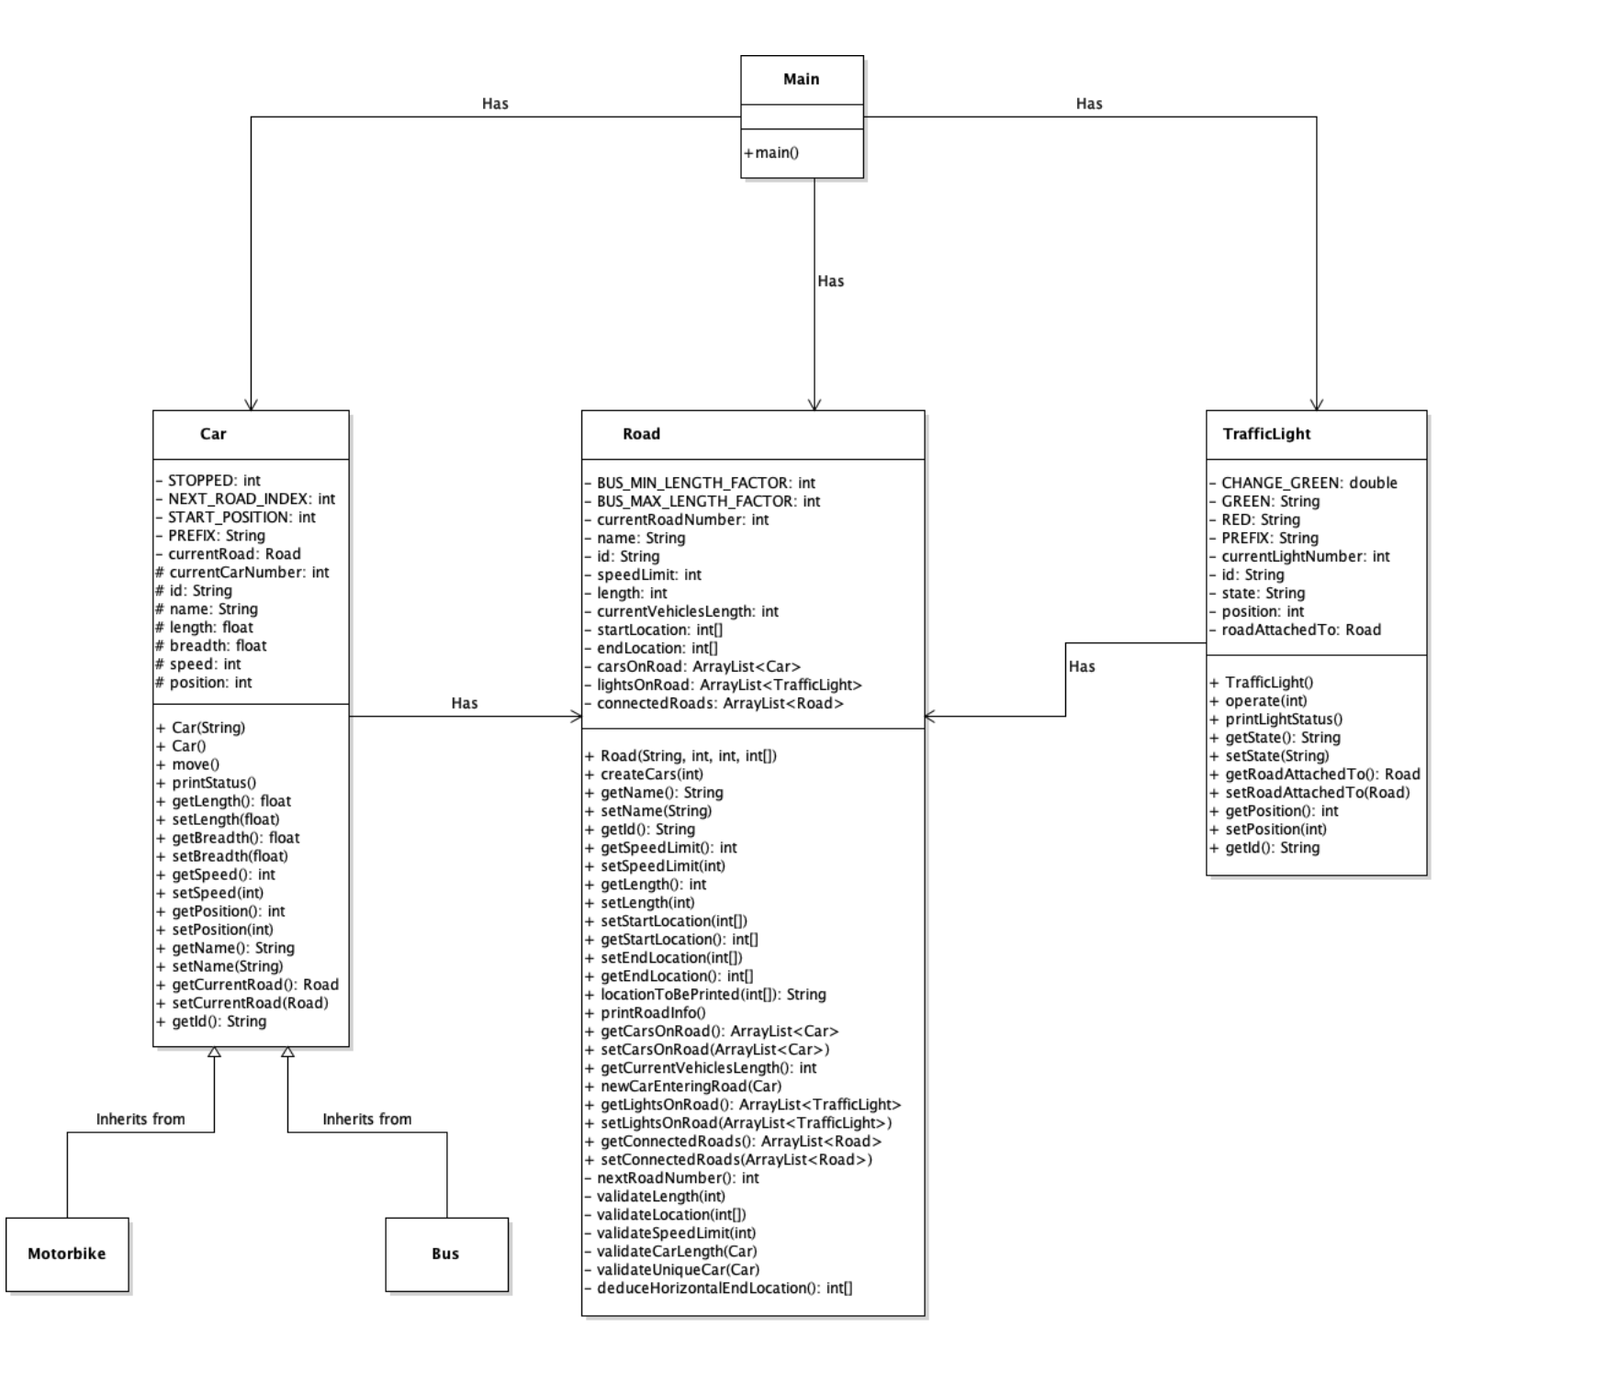

Github screenshots: