**翔鑫堡工業股份有限公司**

**報　　　告**

部　門： 編號：

報告人： 日期： 年 月 日

|  |  |
| --- | --- |
| 主  題 | APS訂單排序程式 |
| 董事長 |  |
| 執  行  副  總 |  |
| 管  理  本  部 |  |
| 會  簽  部  門  意  見 |  |
| 部  門  主  管 |  |

sw7048



APS訂單排序程式

規格書V1.0

APS Sales Order Scheduling System – Specification

資訊本部－系統整合一部

2023/02/11

李怡諴 製

目錄

1. Version update instructions 版本更新說明 2

2. Explanation remarks備註說明 3

2.1. Issues to be clarified 待釐清問題 3

3. Meeting minutes 會議記錄 4

3.1. Meeting minutes會議記錄 4

4. Introduction 引言 5

4.1. System overview系統概述 5

5. System flow chart系統流程圖 6

6. System design method系統設計方法 7

6.1. Input/Output Design I/O設計圖 7

6.2. External sources外部資料來源 7

6.2.1. 訂單資料來源為SAP資料庫拋轉至MS SQL－APS中介資料庫之訂單資料。The order data is sourced from the SAP database and dumped into the MS SQL-APS intermediate database as order data. 7

6.3. Functional architectire diagram 功能架構圖 7

6.4. System and function description 系統程式與功能說明 8

6.4.1. Article Group Setting－Search | Article Group 設定檔－查詢 8

6.4.2. Article Group Setting－Add/Edit | Article Group 設定檔－新增/修改 12

6.4.3. Class Code Setting－Search | Class Code 設定檔－查詢 21

6.4.4. Class Code Setting－Add/Edit | Class Code 設定檔－新增/修改 23

6.4.5. Destination Setting－Search | Destination 設定檔 – 查詢 26

6.4.6. Destination Setting－Add/Edit | Destination 設定檔 – 新增/修改 28

6.4.7. Order Type Setting－Search | Order Type設定檔 – 查詢 30

6.4.8. Order Type Setting－Add/Edit | Order Type 設定檔 – 新增/修改 32

6.4.9. Sales Order Scheduling | Sales Order 排序程式 36

7. Appendix 附錄 45

1. Version update instructions 版本更新說明

|  |  |  |  |  |
| --- | --- | --- | --- | --- |
| **版本 Version** | **日期**  **Date** | **更修者**  **Update By** | **描述**  **Description** | **備註**  **Remark** |
| V1.0 | 2023/02/11 | 李怡諴 Eddy | * 依使用者需求新增 Additions based on user needs. |  |

1. Explanation remarks備註說明
   1. Issues to be clarified 待釐清問題

|  |  |  |  |
| --- | --- | --- | --- |
| **No.** | **日期**  **Date** | **內容**  **Content** | **備註**  **Remark** |
| 1 |  |  |  |
| 2 |  |  |  |
| 3 |  |  |  |
| 4 |  |  |  |
|  |  |  |  |
|  |  | * + ­ |  |
|  |  |  |  |
|  |  |  |  |

1. Meeting minutes 會議記錄
   1. Meeting minutes會議記錄

|  |  |  |  |  |  |  |
| --- | --- | --- | --- | --- | --- | --- |
| **會議名稱** | APS訂單排序程式討論 | **主席** |  | **記錄** | Eddy | |
| **會議時間** | 2023/03/28 9:00 – 10:00 AM | | | **地點** | B301 | |
| **出席人員** | Panda/Ray/Morris/Hikari/Eddy | | | | | |
| **項次** | **議 事 內 容** | | | **負責人** | | **完成期限** |
| 1 | 規格書說明 | | |  | |  |
| 2 | DB存放位置：10.4.0.90 | | |  | |  |
| 3 | 程式存放位置：10.4.0.91 | | |  | |  |

1. Introduction 引言
   1. System overview系統概述

因應生管業務需求，接單後須進行訂單排序，排序完成後將訂單傳送至APS供後續生產排程使用。

In response to the needs of production management, after receiving an order, it is necessary to sort the order and send it to the Advanced Planning and Scheduling (APS) system for subsequent production scheduling.

Đáp ứng nhu cầu quản lý sản xuất, sau khi nhận được đơn hàng cần phân loại đơn hàng và gửi lên hệ thống Advanced Planning and Scheduling (APS) để lập kế hoạch sản xuất tiếp theo

1. System flow chart系統流程圖

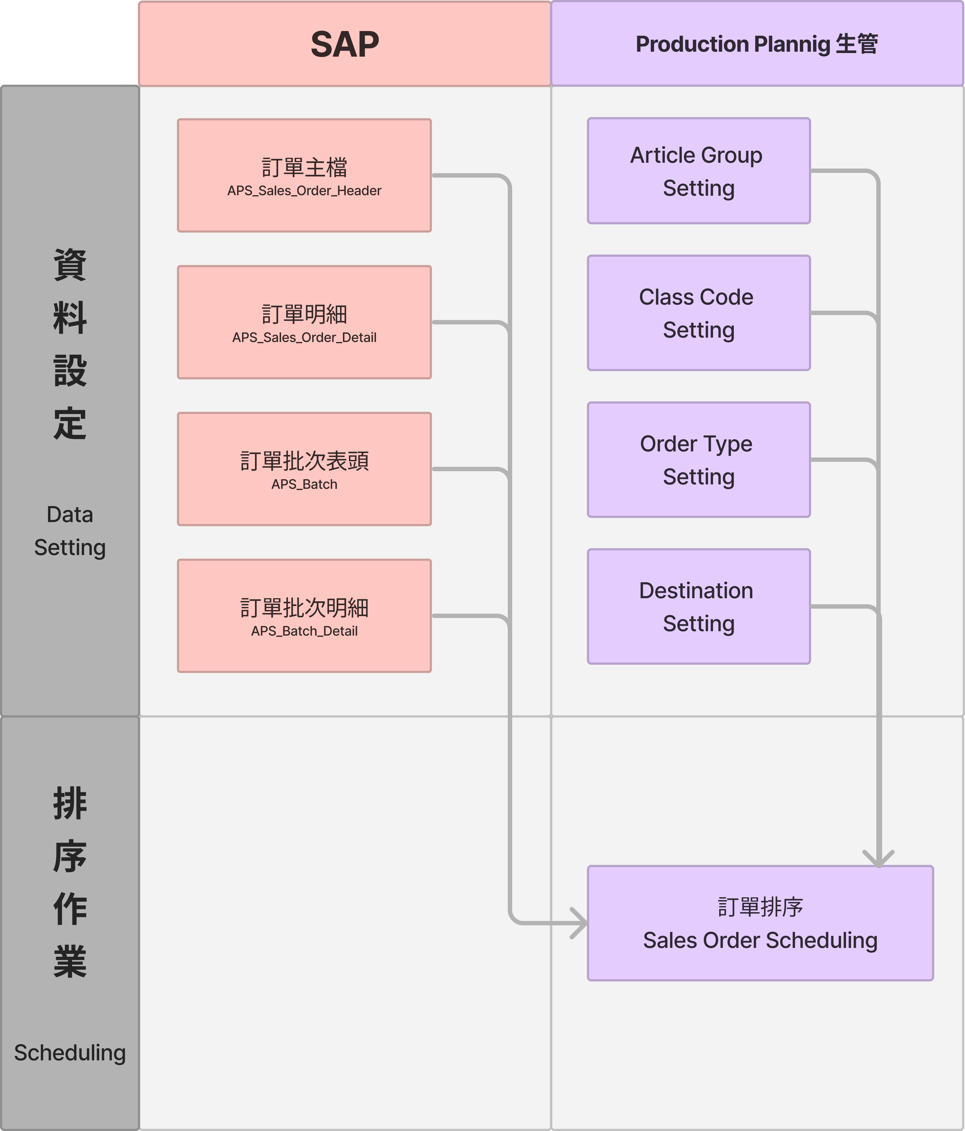

1. System design method系統設計方法




7. 1. Input/Output Design I/O設計圖

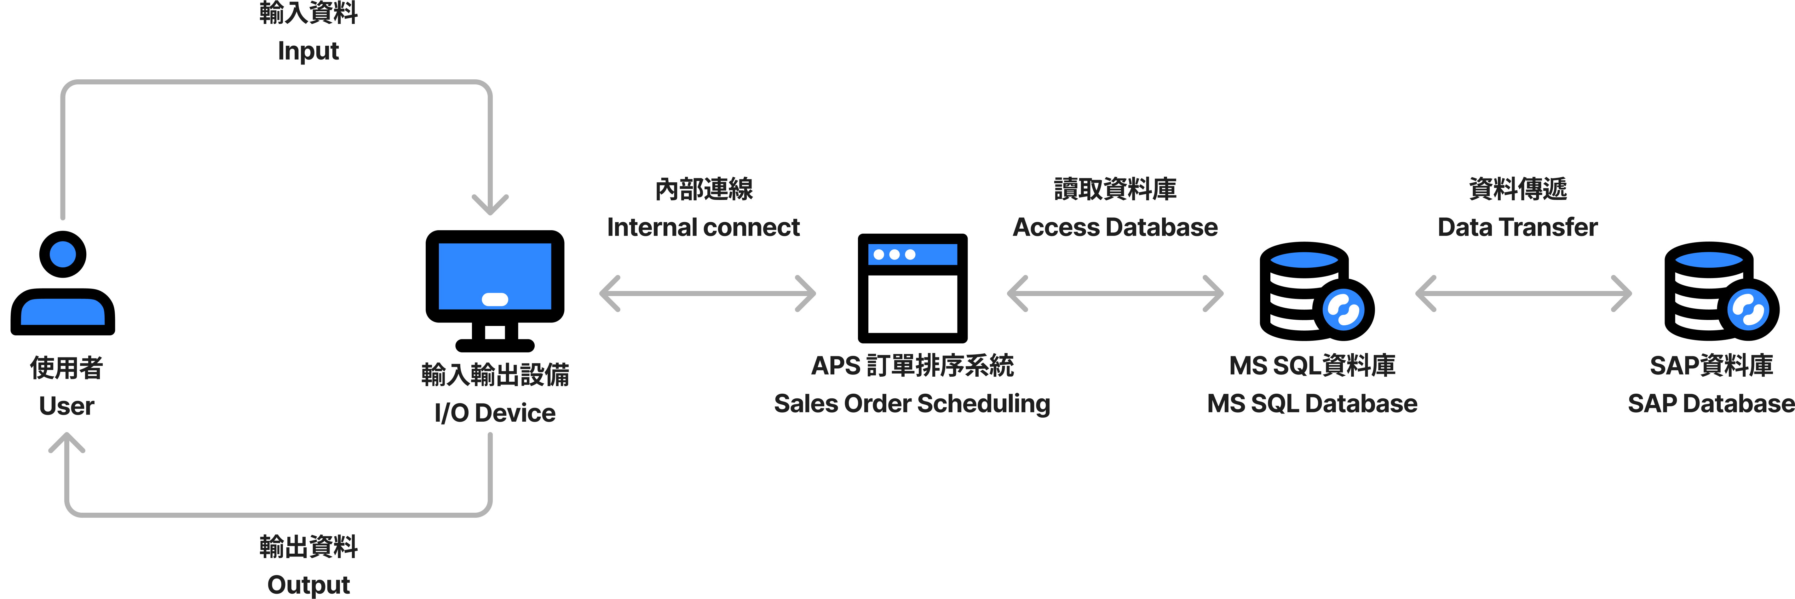

* 1. External sources外部資料來源
     1. 訂單資料來源為SAP資料庫拋轉至MS SQL－APS中介資料庫之訂單資料。The order data is sourced from the SAP database and dumped into the MS SQL-APS intermediate database as order data.
  2. Functional architectire diagram 功能架構圖

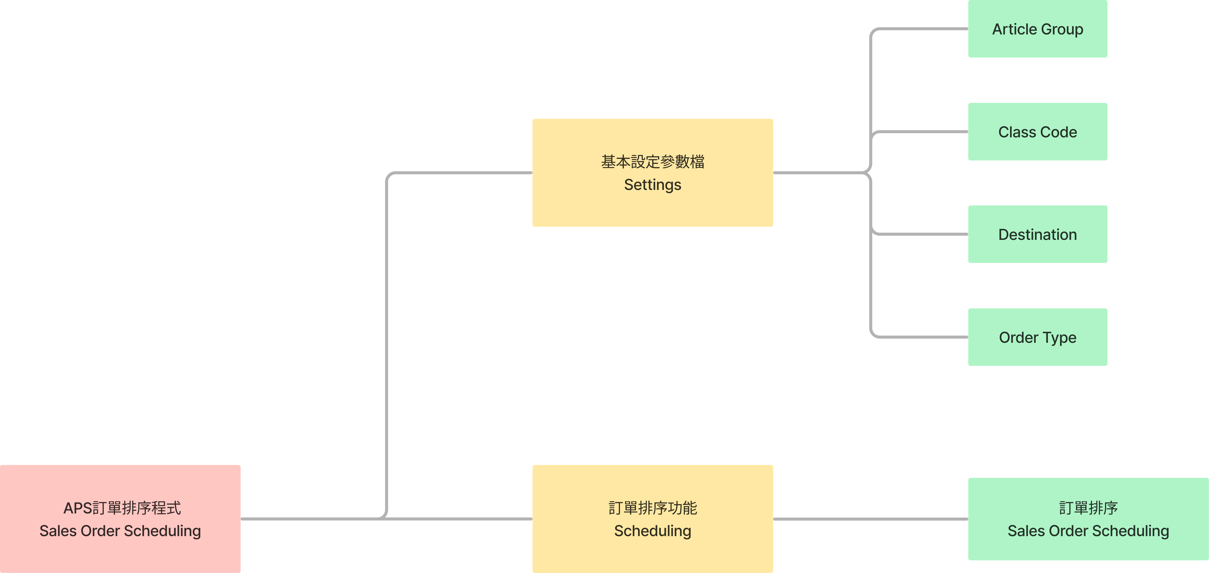

* 1. System and function description 系統程式與功能說明
     1. Article Group Setting－Search | Article Group 設定檔－查詢

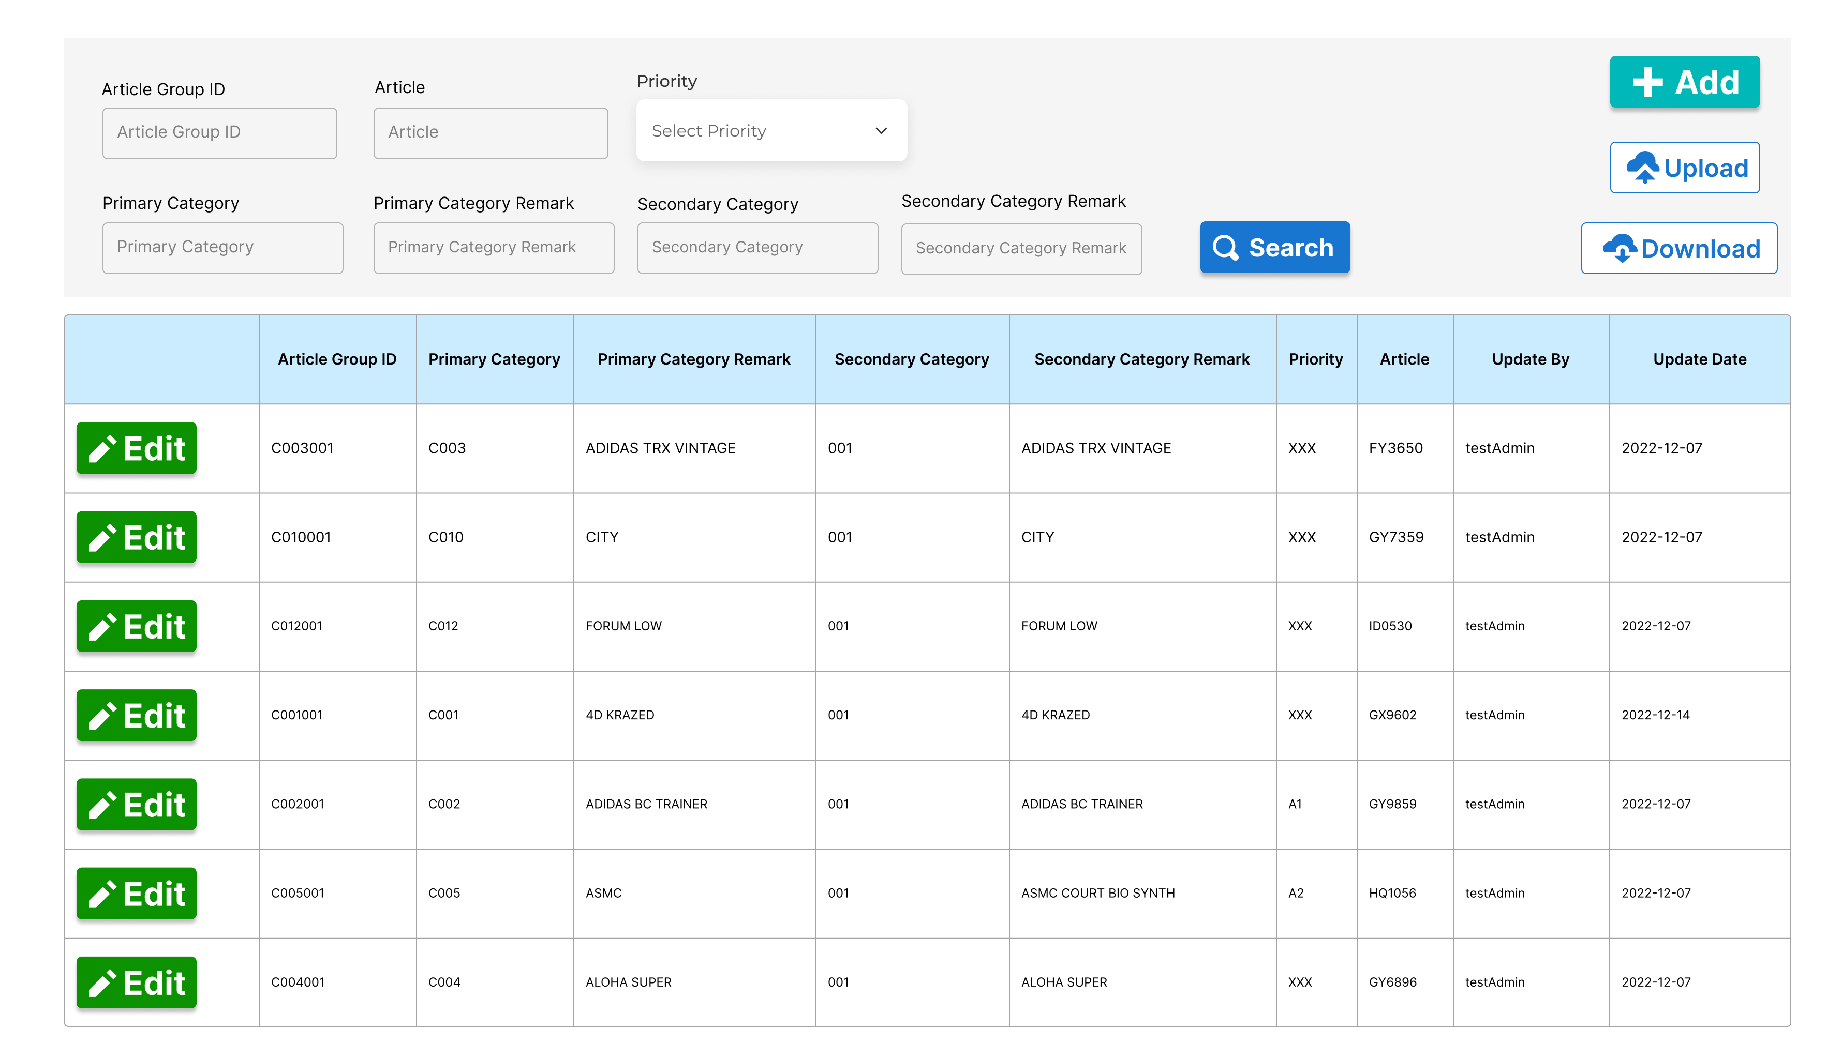

Article Group 設定檔畫面 1 - Article Group查詢

Search Article Group

* + - 1. Form Type表單種類：Article Group Data Searching Article Group資料查詢。
      2. Purpose功能目的：Search Article Group Info 查詢Article Group資訊。
      3. User使用部門：Production Planning 生管部門。
      4. Description欄位說明：

|  |  |  |  |  |  |  |
| --- | --- | --- | --- | --- | --- | --- |
| **Article Group查詢表頭 Article Group Searching Header** | | | | | | |
| **NO** | **顯示名稱**  **Name** | **必輸**  **Required** | **唯讀**  **ReadOnly** | **存改**  **Editable** | **對應欄位**  **Column** | **欄位型態 Type**  **欄位說明 Description** |
| 1 | Add 新增 |  |  |  |  | Button 按鈕  新增一筆Article Group資訊  (點擊後進入Article Group新增/修改畫面)  Add an Article Group information  (Click to enter Article Group add/modify screen) |
| 2 | Search 查詢 |  |  |  |  | Button按鈕  輸入查詢條件後，按下按鈕進行查詢篩選  After entering the query conditions, press the button to query |
| 3 | Excel Upload  Excel上傳 |  |  |  |  | Button 按鈕  點選後選擇Excel文件進行上傳，系統抓取Excel中的欄位進行多筆新增  (Excel上傳格式請參照：Article Group 上傳格式)  After clicking, select an Excel file to upload, and the system will grab the columns in Excel to add multiple entries  (For Excel upload format, please refer to: Article Group upload format) |
| 4 | Excel Download  Excel 下載 |  |  |  |  | Button 按鈕  下載系統中的Article Group資料  (Excel下載格式請參照：Article Group 上傳格式)  Download the Article Group data in the system  (For Excel download format, please refer to: Article Group upload format) |
| 5 | Article Group ID  Article Group 代碼 | N | Y | N | SOS_Article_Group_Setting.  Article_Group_ID | Input Field 輸入框  輸入Article Group代碼作為查詢條件(模糊查詢)  Enter the Article Group ID as the query condition (fuzzy query) |
| 6 | Article | N | Y | N | SOS_Article_Group_Setting.  Article | Input Field 輸入框  輸入Article作為查詢條件(模糊查詢)  Enter Article as the query condition (fuzzy query) |
| 7 | Priority  Article Group優先等級 | N | Y | N | SOS_Article_Group_Setting.  Priority | Drop-down Menu 下拉式選單  選擇 Article Group優先等級作為查詢條件  Select Article Group priority level as the query condition |
| 8 | Primary Category ID  Article Group 大分類代碼 | N | Y | N | SOS_Article_Group_Setting.  Primary_Category_ID | Input Field 輸入框  輸入Article Group大分類代碼作為查詢條件  Enter the Primary Category ID as the query condition |
| 9 | Primary Category Name  Article Group 大分類名稱 | N | Y | N | SOS_Article_Group_Setting.  Primary_Category_Name | Input Field 輸入框  輸入Article Group大分類名稱作為查詢條件  Enter the Primary Category Name as the query condition |
| 10 | Secondary Category ID  Article Group 中分類代碼 | N | Y | N | SOS_Article_Group_Setting.  Secondary_Category_ID | Input Field 輸入框  輸入Article Group中分類代碼作為查詢條件  Enter the Secondary Category ID as the query condition |
| 11 | Secondary Category Name  Article Group 中分類名稱 | N | Y | N | SOS_Article_Group_Setting.  Secondary_Category_Name | Input Field 輸入框  輸入Article Group中分類名稱作為查詢條件  Enter the Secondary Category Name as the query condition |

|  |  |  |  |  |  |  |
| --- | --- | --- | --- | --- | --- | --- |
| **Article Group查詢結果明細 Article Group Searching Result Detail** | | | | | | |
| **NO** | **顯示名稱**  **Name** | **必輸**  **Required** | **唯讀**  **ReadOnly** | **存改**  **Editable** | **對應欄位**  **Column** | **欄位型態 Type**  **欄位說明 Description** |
| 1 | Edit 更改 |  |  |  |  | Button 按鈕  修改該筆Article Group資訊  (點擊後進入Article Group新增/修改畫面)  Edit the Article Group  (Click to enter Article Group Add/Edit screen) |
| 2 | Article Group ID  Article Group 代碼 | N | Y | N | SOS_Article_Group_Setting.  Article_Group_ID | nvarchar(50)  顯示Article Group ID  Display Article Group ID |
| 3 | Primary Category ID  Article Group 大分類 | N | Y | N | SOS_Article_Group_Setting.  Primary_Category_ID | 顯示Article Group大分類  Display Primary Category ID |
| ~~4~~ | Primary Category Name  Article Group 大分類名稱 | N | Y | N | SOS_Article_Group_Setting.  Primary_Category_Name | nvarchar(50)  顯示Article Group大分類名稱  Display Primary Category Name |
| 5 | Secondary Category ID  Article Group 中分類 | N | Y | N | SOS_Article_Group_Setting.  Secondary_Category_ID | nvarchar(50)  顯示Article Group中分類  Display Secondary Category ID |
| 6 | Secondary Category Name  Article Group 中分類名稱 | N | Y | N | SOS_Article_Group_Setting.  Secondary_Category_Name | nvarchar(50)  顯示Article Group中分類名稱  Display Secondary Category Name |
| 7 | Priority  Article Group優先等級 | N | Y | N | SOS_Article_Group_Setting.  Priority | varchar(3)  顯示Article Group優先等級  Display Priority |
| 8 | Article | N | Y | N | Article _Setting.  Article | nvarchar(50)  顯示Article  Display Article |
| 9 | Special Article  是否為特殊型體 | N | Y | N | SOS_Article_Setting.  Special_Article | nvarchar(50)  顯示是否為特殊型體  Display Special Article |
| 10 | Update By  更新者 | N | Y | N | SOS_Article_Group_Setting.  Update_By | nvarchar(50)  顯示更新者  Display Update By |
| 11 | Update Date  更新日期 | N | Y | N | SOS_Article_Group_Setting.  Update_Date | Date  顯示更新日期  Display Update Date |

* + - 1. Operation Method操作方式

1. Query header查詢表頭：
2. 查詢條件輸入框：輸入查詢條件後，點擊Search按鈕進行查找及篩選。若無輸入查詢條件，則帶出全部Article Group資料。

Query condition input box: Enter the query conditions and click the Search button to search and filter. If no query condition is entered, all Article Group data will be displayed.

1. Query result body查詢結果表身：
2. 進入查詢畫面時：預設帶出全部Article Group資料。

When entering the query screen: All Article Group data is displayed by default.

1. 點擊Search 按鈕後：系統依據查詢表頭輸入之條件進行查詢，並刷新查詢結果表身，帶出符合查詢條件之Article Group資料。

After clicking the Search button: The system queries according to the input conditions in the query header, and refreshes the query result body to display the Article Group data that meets the query conditions.

1. Add Article Group in the page 在頁面中新增Article Group：
   1. 點選Add按鈕，進入Article Group新增/修改畫面

Click the Add button to enter the Article Group add/edit screen.

1. Upload Excel to add Article Group上傳Excel新增Article Group：
   1. 使用附錄中的Article Group Excel格式進行上傳，系統讀取之後檢核

Use the Article Group Excel format in the appendix for uploading. After the system reads it, it will perform the following checks：

* + 1. Article資料不可重複，一個Article只能存在於一個Article Group中

Article data cannot be duplicated. An Article can only exist in one Article Group.

* + 1. Excel中的Article資料與資料庫中的Article Table相互比對，若Article table中已存在該Article，更新該Article資料。若是該Article不存在於Article table，則在Article table insert該筆資料。

The Article data in the Excel is compared with the Article Table in the database. If the Article already exists in the Article table, update the Article data. If the Article does not exist in the Article table, insert the data into the Article table.

* + 1. 上傳Excel時檢核Excel欄位不可為空

Check that the Excel fields cannot be empty when uploading.

* 1. 檢核完畢後，將舊資料(上一版資料)備份於Temp Data Table並將Excel中的資料直接覆蓋Article table and Article Group table

After the check is completed, backup the old data (previous version data) in the Temp Data Table and directly overwrite the data in the Article table and Article Group table with the data in the Excel.

1. Download Article Group Excel 下載Article Group Excel
   1. 點擊Download按鈕，下載系統中現存Article Group資料

Click the Download button to download the current Article Group data in the system

* + 1. Article Group Setting－Add/Edit | Article Group 設定檔－新增/修改

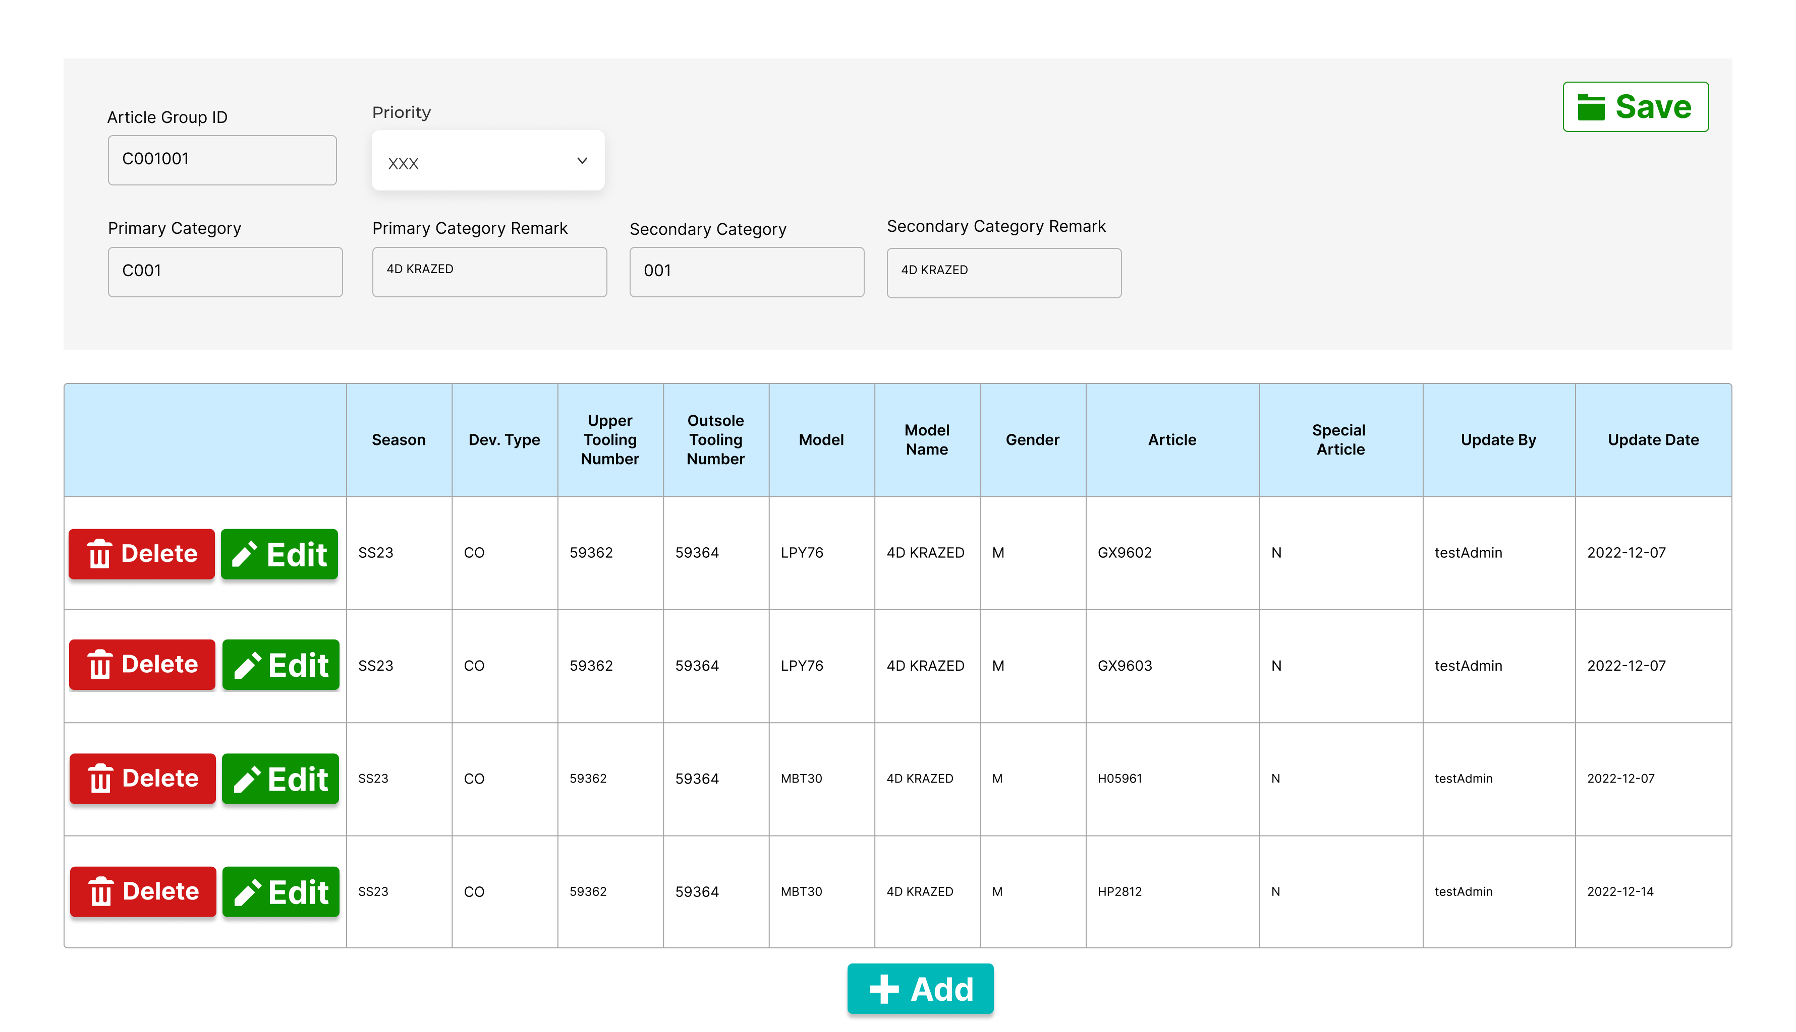

Article Group 設定檔畫面 2 - 新增/修改Article Group

Add/Edit Article Group Screen

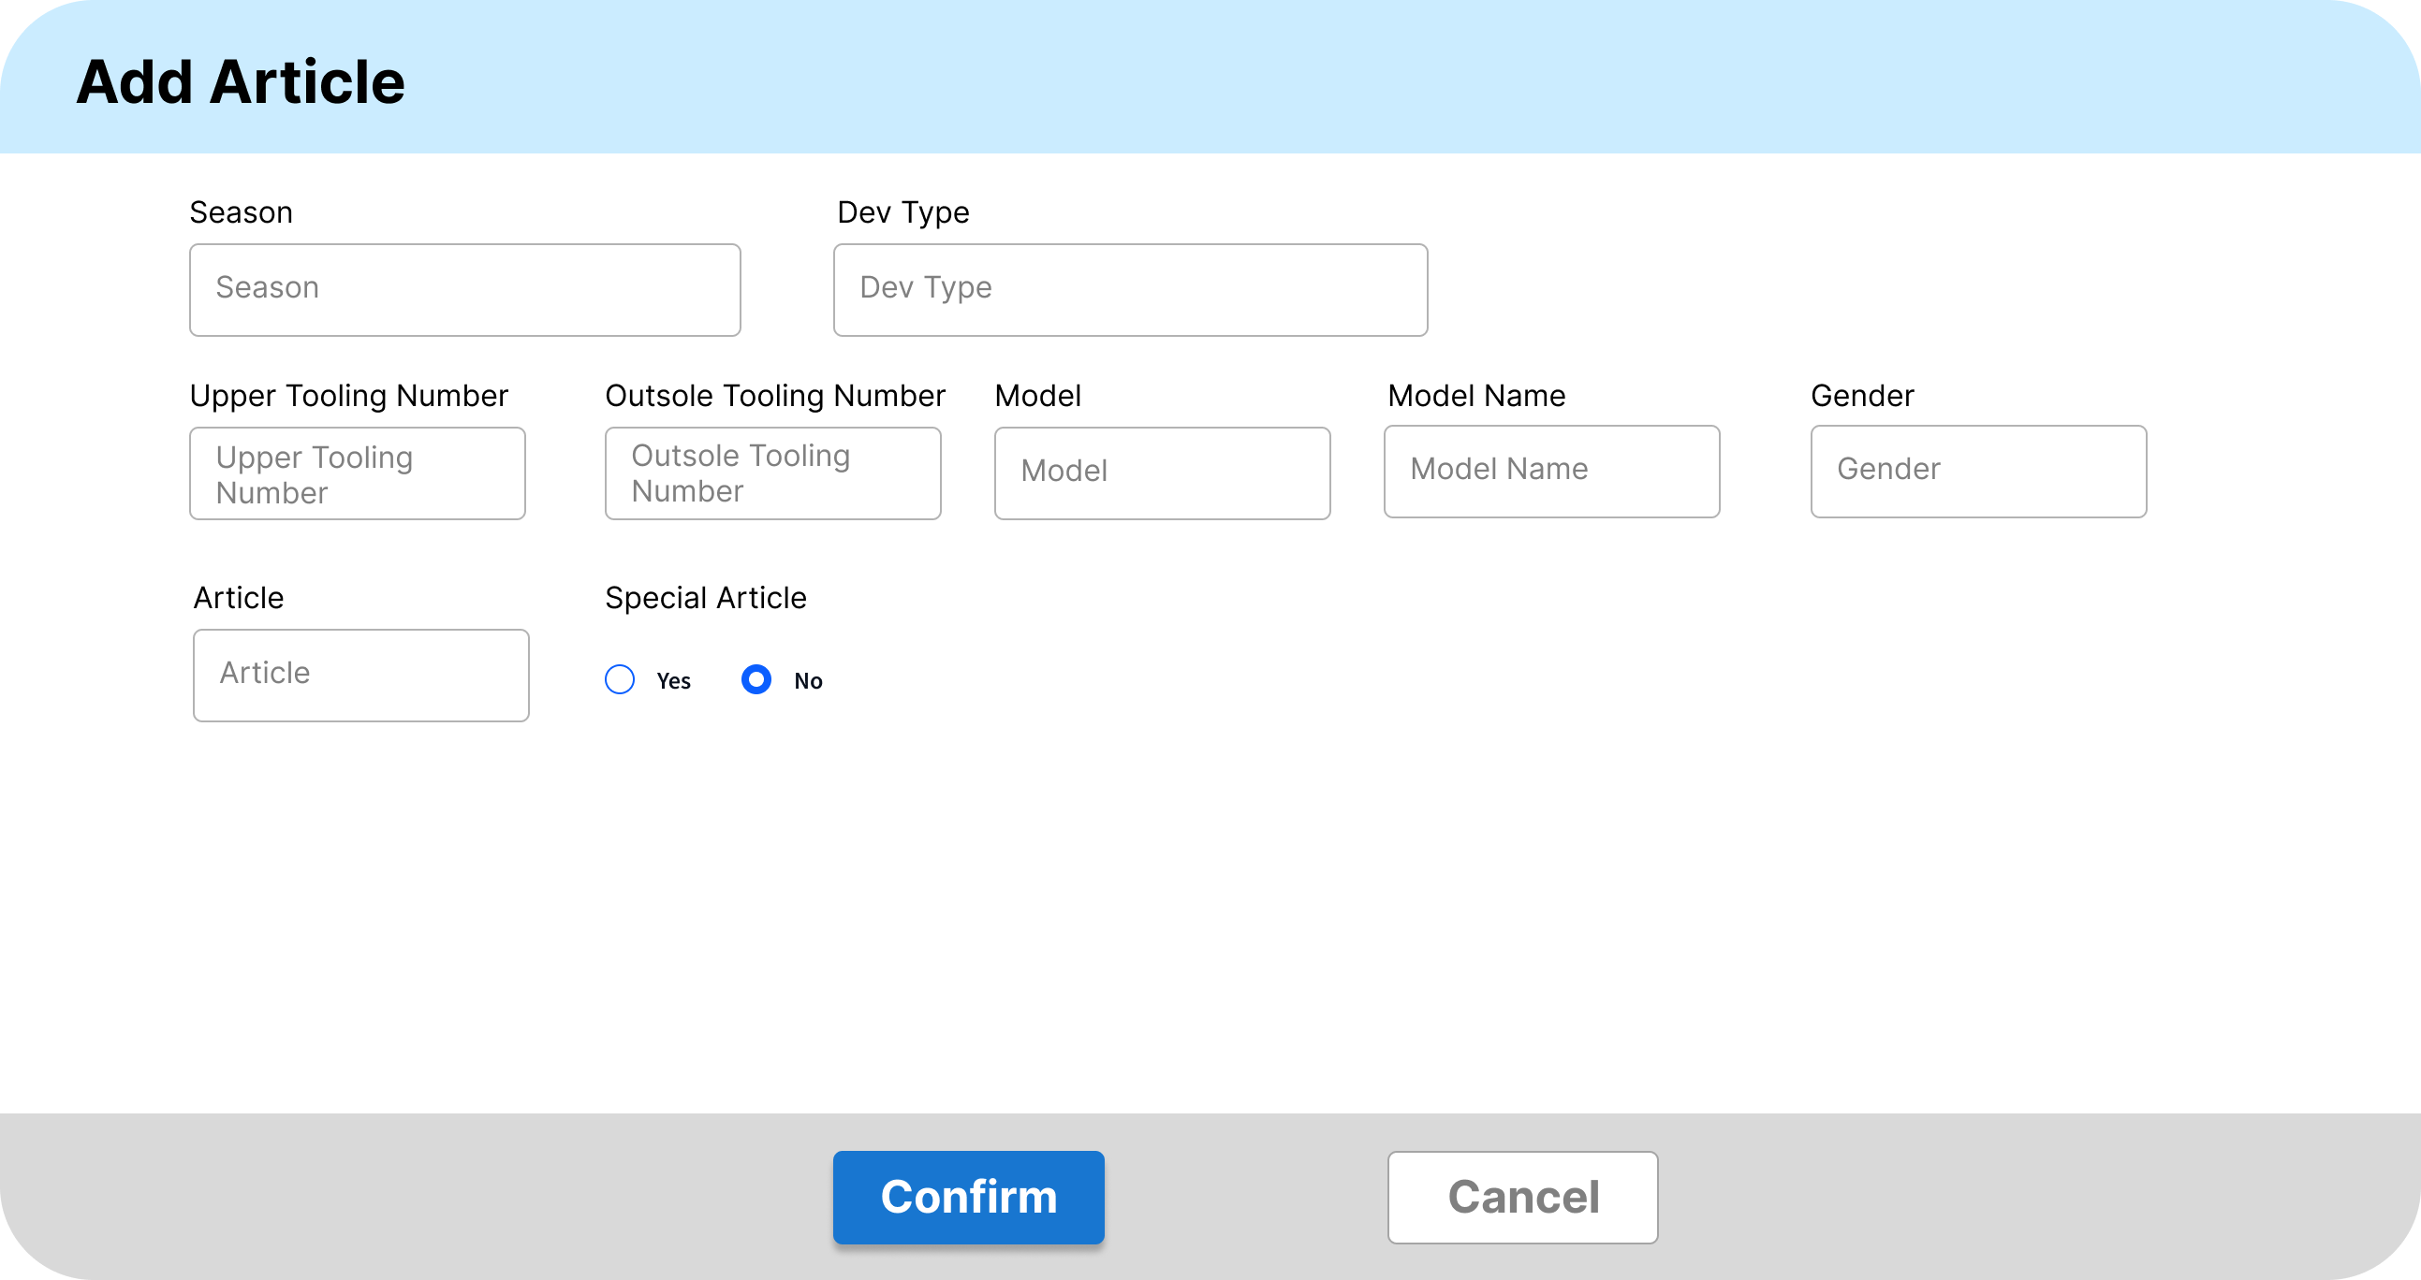

Article Group 設定檔畫面 3 - 新增Article

Add Article Popup Window

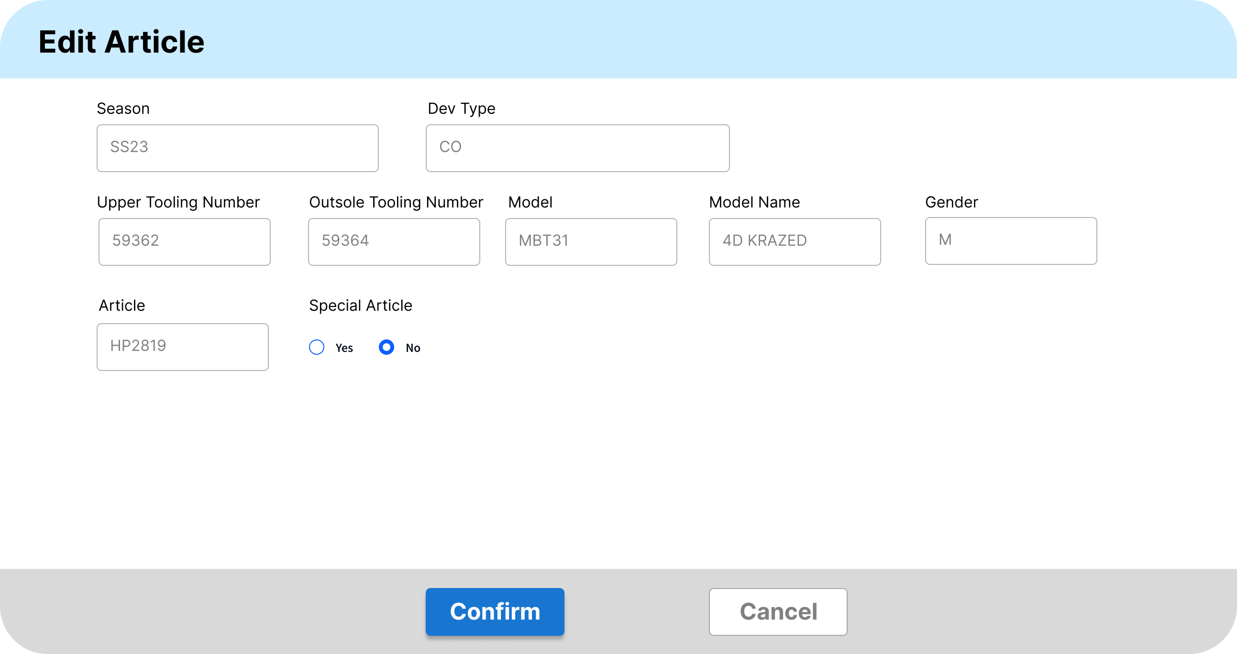

Article Group 設定檔畫面 4 – 修改Article

Edit Article Popup Window

* + - 1. Form Type 表單種類：Maintain Article Group Article Group資料維護
      2. Purpose 功能目的：Add/Save/Edit Article Group新增/存檔/修改 Article Group資訊。
      3. User 使用部門：Production Planning生管部門。
      4. Description 欄位說明：

|  |  |  |  |  |  |  |
| --- | --- | --- | --- | --- | --- | --- |
| **新增/修改Article Group表頭 Add/Edit Article Group Header** | | | | | | |
| **NO** | **顯示名稱**  **Name** | **必輸**  **Required** | **唯讀**  **ReadOnly** | **存改**  **Editable** | **對應欄位**  **Column** | **欄位型態 Type**  **欄位說明 Description** |
| 1 | Save存檔 |  |  |  |  | Button按鈕  新增/修改完畢後，按下按鈕進行存儲  After adding/editing, press the button to save |
| 2 | Article Group ID  Article Group 代碼 | Y | Y | N | SOS_Article_Group_Setting.  Article_Group_ID | Input Field 輸入框   * Add新增：輸入Article Group 代碼   Enter Article Group ID   * Edit修改：顯示Article Group 代碼，唯讀不可改   Display Article Group ID, read only and cannot be changed |
| 3 | Priority  Article Group優先等級 | Y | N | Y | SOS_Article_Group_Setting.  Priority | Drop-down Menu 下拉式選單   * Add 新增：下拉式選單選取Article Group優先等級   Select the Article Group priority level from the drop-down menu   * Edit修改：下拉式選單選取Article Group優先等級   Select the Article Group priority level from the drop-down menu |
| ~~4~~ | Primary Category ID  Article Group 大分類 | Y | Y | N | SOS_Article_Group_Setting.  Primary_Category_ID | Input Field 輸入框   * Add 新增：輸入Article Group 大分類   Enter Primary Category ID   * Edit 修改：顯示Article Group 大分類，唯讀不可改   Display Primary Category ID, read only and cannot be changed |
| 5 | Primary Category Name  Article Group 大分類名稱 | Y | Y | N | SOS_Article_Group_Setting.  Primary_Category_Name | Input Field 輸入框   * 新增：輸入Article Group 大分類名稱   Enter Primary Category Name   * Edit 修改：顯示Article Group 大分類名稱，唯讀不可改   Display Primary Category Name, read only and cannot be changed |
| 6 | Secondary Category ID  Article Group 中分類 | Y | Y | N | SOS_Article_Group_Setting.  Secondary_Category_ID | Input Field 輸入框   * Add 新增：輸入Article Group 中分類   Enter Secondary Category ID   * Edit修改：顯示Article Group 中分類，唯讀不可改   Display Secondary 7Category ID, read only and cannot be changed |
| 7 | Secondary Category Name  Article Group 中分類名稱 | Y | Y | N | SOS_Article_Group_Setting.  Secondary_Category_Name | Input Field 輸入框   * Add新增：輸入Article Group 中分類名稱   Enter Secondary Category Name   * Edit修改：顯示Article Group 中分類名稱，唯讀不可改   Display Secondary Category Name, read only and cannot be changed |

|  |  |  |  |  |  |  |
| --- | --- | --- | --- | --- | --- | --- |
| **新增/修改 Article Group表身明細 Add/Edit Article Group Detail** | | | | | | |
| **NO** | **顯示名稱**  **Name** | **必輸**  **Required** | **唯讀**  **ReadOnly** | **存改**  **Editable** | **對應欄位**  **Column** | **欄位型態 Type**  **欄位說明 Description** |
| 1 | Delete刪除 |  |  |  |  | Button按鈕  移除Article Group中的Article  Remove Article from Article Group |
| 2 | Edit修改 |  |  |  |  | Button按鈕  修改Article Group中的Article  (畫面顯示：修改Article視窗)  Edit Article in Article Group  (Screen display: Edit Article popup window) |
| 3 | Add新增 |  |  |  |  | Button按鈕  新增Article至Article Group  (畫面顯示：新增Article視窗)  Add Article to Article Group  (Screen display: Add Article popup window) |
| 4 | Season  季度 | Y | Y | N | SOS_Article_Setting.  Season | char(4)  顯示季度  Display Season |
| 5 | Dev Type | Y | Y | N | SOS_Article_Setting.  Dev_Type | varchar(2)  顯示開發類型  Display DevType |
| 6 | Upper Tooling Number  面部工具號 | Y | Y | N | SOS_Article_Setting.  Upper_Tooling_Number | nvarchar(10)  顯示面部工具號  Display Upper Tooling Number |
| 7 | Outsole Tooling Number  底部工具號 | Y | Y | N | SOS_Article_Setting.  Outsole_Tooling_Number | nvarchar(10)  顯示底部工具號  Display Outsole Tooling Number |
| 8 | Model  鞋型 | Y | Y | N | SOS_Article_Setting.  Model | char(5)  顯示Model No  Display Model No |
| 9 | Model Name  鞋型名稱 | Y | Y | N | SOS_Article_Setting.  Model_Name | nvarchar(50)  顯示Model 名稱  Display Model Name |
| 10 | Gender | Y | Y | N | SOS_Article_Setting.  Gender | char(1)  顯示Gender  Display Gender |
| 11 | Article | Y | Y | N | SOS_Article_Setting.  Article | nvarchar(50)  顯示Article  Display Article |
| 12 | Special Article  是否為特殊型體 | Y | Y | N | SOS_Article_Setting.  Special_Article | char(1)  顯示是否為特殊型體  Display Special Article |
| 13 | Update By  更新者 | Y | Y | N | SOS_Article_Setting.  Update_By | nvarchar(50)  顯示更新者  Display Update By |
| 14 | Update Date  更新日期 | Y | Y | N | SOS_Article_Setting.  Update_Date | date  顯示更新日期  Display Update Date |

|  |  |  |  |  |  |  |
| --- | --- | --- | --- | --- | --- | --- |
| **新增/修改 Article視窗 Add/Edit Article Popup Window** | | | | | | |
| **NO** | **顯示名稱**  **Name** | **必輸**  **Required** | **唯讀**  **ReadOnly** | **存改**  **Editable** | **對應欄位**  **Column** | **欄位型態 Type**  **欄位說明 Description** |
| 1 | Confirm確定 |  |  |  |  | Button 按鈕  輸入欲新增的Article資料後，點擊按紐新增至Article Group中，並關閉視窗  After entering the Article information to be added, click the button to add to the Article Group and close the window |
| 2 | Cancel放棄 |  |  |  |  | Button 按鈕  放棄編輯，返回畫面並關閉視窗  Abort editing, return to the screen and close the window |
| 3 | Season  季度 | Y | Y | N | SOS_Article_Setting.  Season | Input Field 輸入框   * Add新增：輸入季度   Enter Season   * Edit修改：顯示季度，唯讀不可改   Display Season, read only and cannot be changed |
| 4 | Dev Type | Y | Y | N | SOS_Article_Setting.  Dev_Type | Input Field 輸入框   * Add新增：輸入Dev Type   Enter Dev Type   * Edit修改：顯示Dev Type，唯讀不可改   Display Dev Type, read only and cannot be changed |
| 5 | Upper Tooling Number  面部工具號 | Y | Y | N | SOS_Article_Setting.  Upper_Tooling_Number | Input Field 輸入框   * Add新增：輸入Upper Tooling Number   Enter Upper Tooling Number   * Edit修改：顯示Upper Tooling Number，唯讀不可改   Display Upper Tooling Number, read only and cannot be changed |
| 6 | Outsole Tooling Number  底部工具號 | Y | Y | N | SOS_Article_Setting.  Outsole_Tooling_Number | Input Field 輸入框   * Add新增：輸入Outsole Tooling Number   Enter Outsole Tooling Number   * Edit修改：顯示Outsole Tooling Number，唯讀不可改   Display Outsole Tooling Number, read only and cannot be changed |
| 7 | Model  鞋型 | Y | Y | N | SOS_Article_Setting.  Model | Input Field 輸入框   * Add新增：輸入Model No   Enter Model No   * Edit修改：顯示Model No，唯讀不可改   Display Model No, read only and cannot be changed |
| 8 | Model Name  鞋型名稱 | Y | Y | N | SOS_Article_Setting.  Model_Name | Input Field 輸入框   * Add新增：輸入Model 名稱   Enter Model Name   * Edit修改：顯示Model 名稱，唯讀不可改   Display Model Name, read only and cannot be changed |
| 9 | Gender | Y | Y | N | SOS_Article_Setting.  Gender | Input Field 輸入框   * Add新增：輸入Gender   Enter Gender   * Edit修改：顯示Gender，唯讀不可改顯示   Display Gender, read only and cannot be changed |
| 10 | Article | Y | Y | N | SOS_Article_Setting.  Article | Input Field 輸入框   * Add新增：輸入Article   Enter Article   * Edit修改：顯示Article，唯讀不可改   Display Article, read only and cannot be changed |
| 11 | Special Article  是否為特殊型體 | Y | N | Y | SOS_Article_Setting.  Special_Article | Radio Button 單選按鈕   * Add新增：選擇是否為特殊型體   Choose whether to be a Special Article   * Edit修改：選擇是否為特殊型體   Choose whether to be a Special Article |
| 12 | Update By  更新者 | Y | N | Y | SOS_Article_Setting.  Update_By | No Display不顯示   * Add新增：系統自動帶入   The system automatically brings in   * Edit修改：系統自動帶入   The system automatically brings in |
| 13 | Update Date  更新日期 | Y | N | Y | SOS_Article_Setting.  Update_Date | No Display不顯示   * Add新增：系統自動帶入   The system automatically brings in   * Edit修改：系統自動帶入   The system automatically brings in |

* + - 1. Operation Method操作方式

1. Add Article新增Article
   1. 點擊Add按鈕，開啟Add Article視窗

Click the Add button to open the Add Article window.

* 1. 輸入Article詳細資料，輸入完畢後點擊Confirm，將Article新增至Article Group

Enter the detailed information of the Article, and click Confirm after completion to add the Article to the Article Group.

* 1. 新增完畢後，點擊Save按鈕進行存儲

After the addition is completed, click the Save button to store the changes.

1. Edit Article 修改Article
2. 在Article Group明細表身中，在欲修改的Article行中點選首欄的Edit修改按紐，點擊後開啟Edit Article視窗進行修改。

In the Article Group detail body, click the Edit button in the first column of the row that you want to modify, and then open the Edit Article window to make the modification.

1. 修改Article，修改完畢後點擊Confirm確認此修改並關閉視窗。

Modify the Article, and click Confirm after completion to confirm the modification and close the window.

1. 點擊Save按鈕進行儲存

Click the Save button to save the changes.

1. Delete Article刪除Article
   1. 在Article Group明細表身中，在欲刪除的Article行中點選首欄的Delete修改按紐，移除Article。

In the Article Group details, click the Delete modify button in the first column of the row of the Article to be deleted to remove the Article.

* 1. 移除完畢後，點擊Save按鈕進行存儲。

After removal is completed, click the Save button to store the changes.

* + 1. Class Code Setting－Search | Class Code 設定檔－查詢

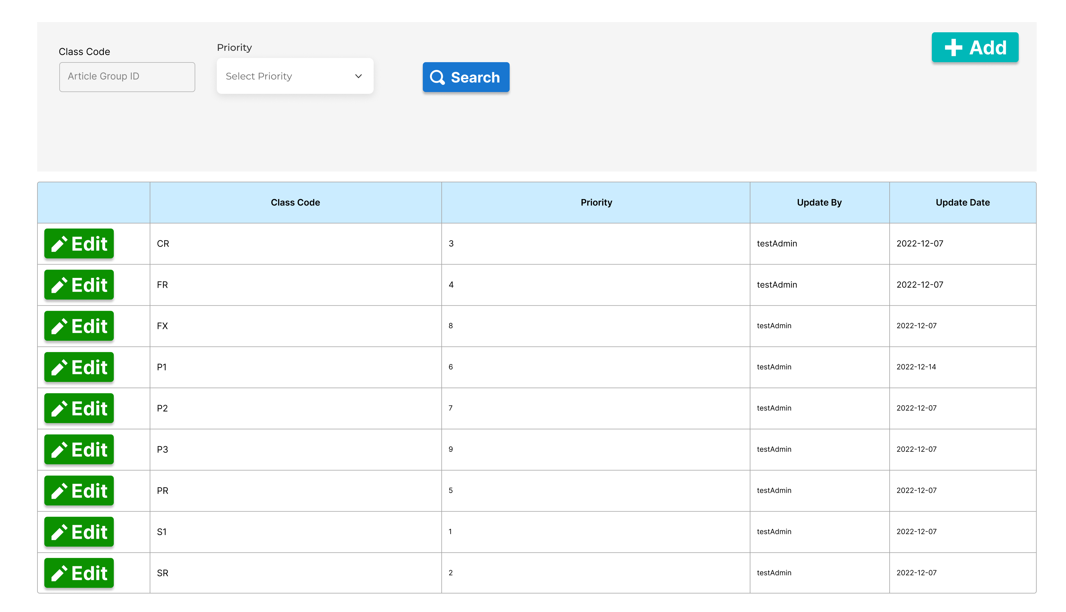

Class Code 設定檔畫面 1 – Class Code查詢

Search Class Code

* + - 1. Form Type 表單種類：Class Code Searching Class Code查詢
      2. Purpose 功能目的：Search Class Code 查詢 Class Code。
      3. User 使用部門：Production Planning 生管部門。
      4. Description 欄位說明：

|  |  |  |  |  |  |  |
| --- | --- | --- | --- | --- | --- | --- |
| **Class Code 查詢表頭 Class Code Searching Header** | | | | | | |
| **NO** | **顯示名稱**  **Name** | **必輸**  **Required** | **唯讀**  **ReadOnly** | **存改**  **Editable** | **對應欄位**  **Column** | **欄位型態 Type**  **欄位說明 Description** |
| 1 | Search查詢 |  |  |  |  | Button 按鈕  輸入查詢條件後，按下按鈕進行查詢篩選  After entering the query conditions, press the button to query |
| 2 | Add新增 |  |  |  |  | Button按鈕  新增Class Code  (點擊後開啟Class Code新增視窗)  Add Class Code  (Click to open the Add Class Code popup window) |
| 3 | Class Code | Y | N | Y | SOS_Class_Code_Setting.  Class_Code | Input Field輸入框  輸入Class Code作為查詢條件(模糊查詢)  Enter Class Code as query condition (fuzzy query) |
| 4 | Priority  Class Code優先等級 | Y | Y | N | SOS_Class_Code_Setting.  Priority | Input Field (Number) 輸入框(數字)  輸入Class Code優先等級作為查詢條件  Enter the Class Code priority level as the query condition |

|  |  |  |  |  |  |  |
| --- | --- | --- | --- | --- | --- | --- |
| **Class Code 查詢表身 Class Code Searching Detail** | | | | | | |
| **NO** | **顯示名稱**  **Name** | **必輸**  **Required** | **唯讀**  **ReadOnly** | **存改**  **Editable** | **對應欄位**  **Column** | **欄位型態 Type**  **欄位說明 Description** |
| 1 | Edit修改 |  |  |  |  | Button按鈕  修改Class Code  (點擊後開啟Class Code修改視窗)  Edit Class Code  (Click to open the Edit Class Code popup window) |
| 2 | Class Code | Y | Y | N | SOS_Class_Code_Setting.  Class_Code | char(2)  顯示Class Code  Display Class Code |
| 3 | Priority  Class Code優先等級 | Y | Y | N | SOS_Class_Code_Setting.  Priority | int  顯示Class Code優先等級  Display Class Code Priority |
| 4 | Update By  更新者 | Y | Y | N | SOS_Class_Code_Setting.  Update_By | nvarchar(50)  顯示更新者  Display Update By |
| 5 | Update Date  更新日期 | Y | Y | N | SOS_Class_Code_Setting.  Update_Date | date  顯示更新日期  Display Update Date |

* + - 1. Operation Method操作方式

1. Search Class Code 查詢Class Code
   1. 查詢條件輸入框輸入查詢條件後，點擊Search按鈕進行查找及篩選。若無輸入查詢條件，則帶出全部Class Code資料

Enter the query conditions in the input box, and click the Search button to search and filter. If no query conditions are entered, all Class Code data will be displayed.

1. Add Class Code 新增Class Code
   1. 點擊Add按鈕，開啟Add Class Code視窗

Click the Add button to open the Add Class Code popup window.

1. Edit Class Code 修改Class Code
   1. 在Class Code明細表身中，在欲修改的Class Code行中點選首欄的Edit修改按紐，點擊後開啟Edit Class Code視窗進行修改。

In the Class Code details, click the Edit button in the first column of the row of the Class Code to be modified, and click to open the Edit Class Code popup window for modification.

* + 1. Class Code Setting－Add/Edit | Class Code 設定檔－新增/修改

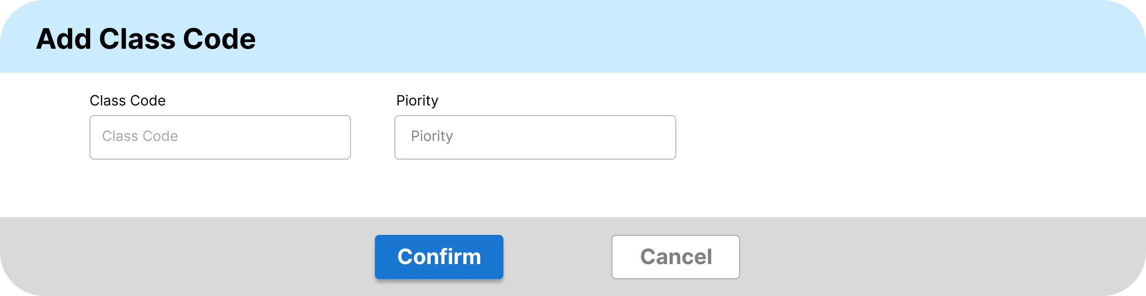

Class Code 設定檔畫面 2 – 新增Class Code

Add Class Code Popup Window

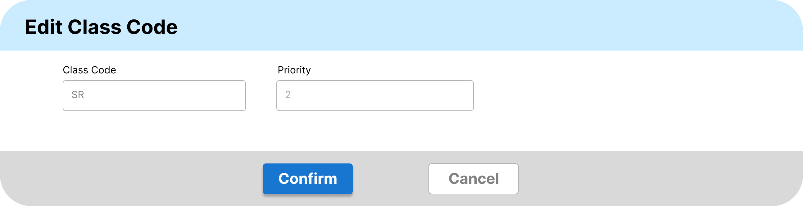

Class Code 設定檔畫面 3 – 修改Class Code Edit Class Code Popup Window

* + - 1. Form Type 表單種類：Maintain Class Code Class Code維護
      2. Purpose 功能目的：Add/Edit Class Code 新增/修改Class Code
      3. User 使用部門：Production Planning生管部門。
      4. Description 欄位說明：

|  |  |  |  |  |  |  |
| --- | --- | --- | --- | --- | --- | --- |
| **新增/修改Class Code視窗 Add/Edit Class Code Popup Window** | | | | | | |
| **NO** | **顯示名稱**  **Name** | **必輸**  **Required** | **唯讀**  **ReadOnly** | **存改**  **Editable** | **對應欄位**  **Column** | **欄位型態 Type**  **欄位說明 Description** |
| 1 | Confirm確認 |  |  |  |  | Button 按鈕  輸入欲新增/修改的Class Code資料後，點擊按紐儲存Class Code資料，並關閉視窗  After entering the Class Code information to be added, click the button to add and close the window |
| 2 | Cancel取消 |  |  |  |  | Button 按鈕  放棄編輯，返回畫面並關閉視窗  Abort editing, return to the screen and close the window |
| 3 | Class Code | Y | Y | N | SOS_Class_Code_Setting.  Class_Code | Input Field 輸入框   * Add新增：輸入Class Code   Enter Class Code   * Edit修改：顯示Class Code，唯讀不可改   Display Class Code, read only and cannot be changed |
| 4 | Priority  Class Code優先等級 | Y | N | Y | SOS_Class_Code_Setting.  Priority | Input Field (Number) 輸入框(數字)   * Add新增：輸入Class Code優先等級   Enter Class Code Priority   * Edit修改：輸入Class Code優先等級   Enter Class Code Priority |
| 5 | Update By  更新者 | Y | N | Y | SOS_Class_Code_Setting.  Update_By | 不顯示 No display   * Add新增：系統自動帶入   The system automatically brings in   * Edit修改：系統自動帶入   The system automatically brings in |
| 6 | Update Date  更新日期 | Y | N | Y | SOS_Class_Code_Setting.  Update_Date | 不顯示 No display   * Add新增：系統自動帶入   The system automatically brings in   * Edit修改：系統自動帶入   The system automatically brings in |

* + - 1. Operation Method操作方式

1. Add Class Code 新增Class Code
   1. 輸入Class Code以及 Priority，輸入完畢後點擊Confirm按鈕儲存

Enter the Class Code and Priority, and click the Confirm button to save after completion.

1. Edit Class Code 修改Class Code
   1. 修改Class Code的Priority，修改完畢後點擊Confirm按鈕儲存

Modify the Priority of the Class Code, and click the Confirm button to save after modification.

* + 1. Destination Setting－Search | Destination 設定檔 – 查詢

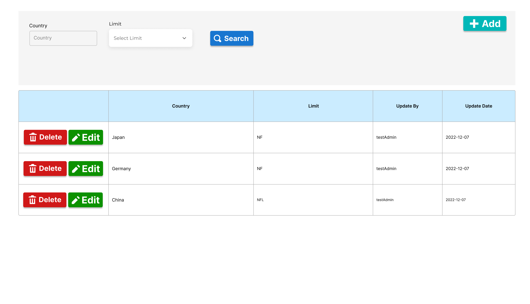

Destination 設定檔畫面 1 – 查詢

Search Destination

* + - 1. Form Type 表單種類：Destination Searching Destination設定檔查詢
      2. Purpose 功能目的：Search Destination 查詢Destination設定檔
      3. User 使用部門：Production Planning 生管部門。
      4. Description 欄位說明：

|  |  |  |  |  |  |  |
| --- | --- | --- | --- | --- | --- | --- |
| **Destination查詢表頭 Destination Setting－Searching Header** | | | | | | |
| **NO** | **顯示名稱**  **Name** | **必輸**  **Required** | **唯讀**  **ReadOnly** | **存改**  **Editable** | **對應欄位**  **Column** | **欄位型態 Type**  **欄位說明 Description** |
| 1 | Search查詢 |  |  |  |  | Button 按鈕  輸入查詢條件後，按下按鈕進行查詢篩選  After entering the query conditions, press the button to query |
| 2 | Add新增 |  |  |  |  | Button按鈕  新增Destination  (點擊後進入Destination新增畫面)  Add Destination  (Click to open the Add Destination popup window) |
| 3 | Country  國家 | N | N | N | SOS_Destination_Setting.  Country | Input Field輸入框  輸入國家作為查詢條件(模糊查詢)  Enter Country as the query condition (fuzzy query) |
| 4 | Limit  排序限制 | N | N | N | SOS_Destination_Setting.  Limit | Drop-down Menu 下拉式選單  選取排序限制作為查詢條件  Select Limit as query condition |

|  |  |  |  |  |  |  |
| --- | --- | --- | --- | --- | --- | --- |
| **Destination查詢表身 Destination Setting Searching Detail** | | | | | | |
| **NO** | **顯示名稱**  **Name** | **必輸**  **Required** | **唯讀**  **ReadOnly** | **存改**  **Editable** | **對應欄位**  **Column** | **欄位型態 Type**  **欄位說明 Description** |
| **1** | Edit修改 |  |  |  |  | Button按鈕  修改Destination  (點擊後進入Destination修改畫面)  Edit Destination  (Click to open the Edit Destination popup window) |
| 2 | Country  國家 | Y | Y | N | SOS_Destination_Setting.  Country | nvarchar(50)  顯示國家  Display Country |
| 3 | Limit  排序限制 | Y | Y | N | SOS_Destination_Setting.  Limit | varchar(3)  顯示排序限制  Display Limit |
| 4 | Update By  更新者 | Y | Y | N | SOS_Destination_Setting.  Update_By | nvarchar(50)  顯示更新者  Display Update By |
| 5 | Update Date  更新日期 | Y | Y | N | SOS_Destination_Setting.  Update_Date | date  顯示更新日期  Display Update Date |

* + - 1. Operation Method操作方式

1. Search Destination 查詢Destination
   1. 查詢條件輸入框：輸入查詢條件後，點擊Search按鈕進行查找及篩選。若無輸入查詢條件，則帶出全部Destination資料

Query Condition Input Box: Enter the query conditions and click the Search button to search and filter. If no query conditions are entered, all Destination data will be displayed.

1. Add Destination 新增Destination
   1. 點擊Add按鈕，開啟Add Destination視窗

Click the Add button to open the Add Destination popup window.

1. Edit Destination 修改Destination
   1. 在Destination明細表身中，在欲修改的Destination行中點選首欄的Edit修改按紐，點擊後開啟Edit Destination視窗進行修改

In the Destination details, click the Edit button in the first column of the row of the Destination to be modified, and then click to open the Edit Destination popup window for modification.

* + 1. Destination Setting－Add/Edit | Destination 設定檔 – 新增/修改



Destination 設定檔畫面 2 – 新增Destination視窗

Add Destination Popup Window



Destination 設定檔畫面 3 – 修改Destination視窗

Edit Destination Popup Window

* + - 1. Form Type 表單種類：Maintain Destination Destination 設定檔維護
      2. Purpose 功能目的：Add/Edit Destination 新增/修改Destination
      3. User 使用部門：Production Planning生管部門
      4. Description 欄位說明：

|  |  |  |  |  |  |  |
| --- | --- | --- | --- | --- | --- | --- |
| **新增/修改Destination視窗 Add/Edit Destination Popup Window** | | | | | | |
| **NO** | **顯示名稱**  **Name** | **必輸**  **Required** | **唯讀**  **ReadOnly** | **存改**  **Editable** | **對應欄位**  **Column** | **欄位型態 Type**  **欄位說明 Description** |
| 1 | 確認 |  |  |  |  | Button 按鈕  輸入欲新增/修改的Destination資料後，點擊按紐儲存Destination資料，並關閉視窗  After entering the Destination information to be added, click the button to add and close the window |
| 2 | 取消 |  |  |  |  | Button 按鈕  放棄編輯，返回畫面並關閉視窗  Abort editing, return to the screen and close the window |
| 3 | Country  目的地國家 | Y | Y | N | SOS_Destination_Setting.  Country | Input Field 輸入框   * Add新增：輸入目的地國家   Enter Country   * Edit修改：顯示目的地國家，唯讀不可改   Display Country, read only and cannot be changed |
| 4 | Limit  排序限制 | Y | N | Y | SOS_Destination_Setting.  Limit | Drop-down Menu 下拉式選單   * Add新增：選取排序限制   Select Limit   * Edit修改：選取排序限制   Select Limit |
| 5 | Update By  更新者 | Y | N | Y | SOS_Destination_Setting.  Update_By | 不顯示 No display   * Add新增：系統自動帶入   The system automatically brings in   * Edit修改：系統自動帶入   The system automatically brings in |
| 6 | Update Date  更新日期 | Y | N | Y | SOS_Destination_Setting.  Update_Date | 不顯示 No display   * Add新增：系統自動帶入   The system automatically brings in   * Edit修改：系統自動帶入   The system automatically brings in |

* + - 1. Operation Method操作方式

1. Add Destination 新增Destination
   1. 輸入Country以及 選擇Limit，輸入完畢後點擊Confirm按鈕儲存

Enter the Country and select the Limit, then click the Confirm button to save.

1. Edit Destination 修改Destination
   1. 修改Destination，修改完畢後點擊Confirm按鈕儲存

Edit the destination and click the Confirm button to save after completing the changes.

* + 1. Order Type Setting－Search | Order Type設定檔 – 查詢

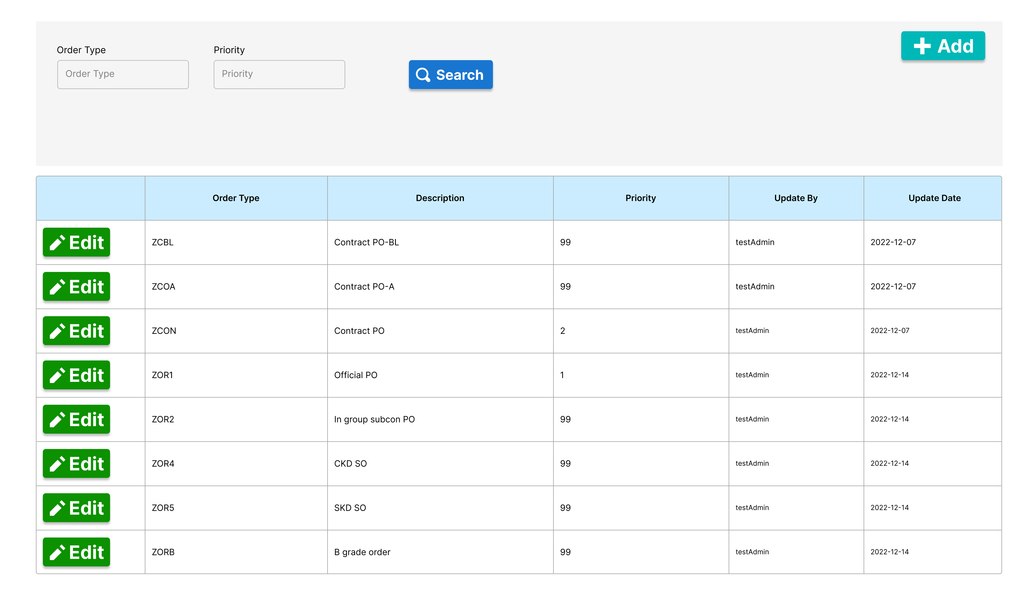

Order Type 設定檔畫面 1 – 查詢

Search Order Type

* + - 1. Form Type 表單種類：Order Type Searching Order Type 查詢。
      2. Purpose 功能目的：Search Order Type 查詢Order Type。
      3. User 使用部門：Production Planning 生管部門
      4. Description 欄位說明：

|  |  |  |  |  |  |  |
| --- | --- | --- | --- | --- | --- | --- |
| **Order Type查詢表頭 Order Type Searching Header** | | | | | | |
| **NO** | **顯示名稱**  **Name** | **必輸**  **Required** | **唯讀**  **ReadOnly** | **存改**  **Editable** | **對應欄位**  **Column** | **欄位型態 Type**  **欄位說明 Description** |
| 1 | Search查詢 |  |  |  |  | Button 按鈕  輸入查詢條件後，按下按鈕進行查詢篩選  After entering the query conditions, press the button to query |
| 2 | Add新增 |  |  |  |  | Button按鈕  新增Order Type  (點擊後進入Order Type新增畫面)  Add Order Type  (Click to open the Add Order Type popup window) |
| 3 | Order Type  訂單類型 | N | N | N | SOS_Order_Type_Setting.  Order_Type | Input Field輸入框  輸入訂單類型作為查詢條件(模糊查詢)  Enter Order Type as the query condition (fuzzy query) |
| 4 | Priority  訂單類型優先等級 | N | N | N | SOS_Order_Type_Setting.  Priority | Input Field (Number) 輸入框(數字)  輸入訂單類型優先等級作為查詢條件  Enter Priority as the query condition |

|  |  |  |  |  |  |  |
| --- | --- | --- | --- | --- | --- | --- |
| **Order Type查詢表身明細 Order Type Searching Detail** | | | | | | |
| **NO** | **顯示名稱**  **Name** | **必輸**  **Required** | **唯讀**  **ReadOnly** | **存改**  **Editable** | **對應欄位**  **Column** | **欄位型態 Type**  **欄位說明 Description** |
| 1 | 修改 |  |  |  |  | Button按鈕  修改Order Type  (點擊後進入Order Type修改畫面)  Edit Order Type  (Click to enter the Edit Order Type popup window) |
| 2 | Order Type  訂單類型 | Y | Y | N | SOS_Order_Type_Setting.  Order_Type | char(4)  顯示訂單類型  Display Order Type |
| 3 | Description  訂單類型說明 | Y | Y | N | SOS_Order_Type_Setting.  Description | nvarchar(50)  顯示訂單類型說明  Display Description |
| 4 | Priority  訂單類型優先等級 | Y | Y | N | SOS_Order_Type_Setting.  Priority | int  顯示訂單類型優先等級  Display Priority |
| 5 | Update By  更新者 | Y | Y | N | SOS_Order_Type_Setting.  Update_By | nvarchar(50)  顯示更新者  Display Update By |
| 6 | Update Date  更新日期 | Y | Y | N | SOS_Order_Type_Setting.  Update_Date | date  顯示更新日期  Display Update Date |

* + - 1. Operation Method操作方式

1. Search Order Type 查詢Order Type
2. 查詢條件輸入框：輸入查詢條件後，點擊Search按鈕進行查找及篩選。若無輸入查詢條件，則帶出全部Order Type資料

Query Condition Input Box: Enter the query conditions and click the Search button to search and filter. If no query conditions are entered, all Order Type data will be displayed.

1. Add Order Type 新增Order Type
   1. 點擊Add按鈕，開啟Add Order Type視窗

Click the Add button to open the Add OrderType popup window.

1. Edit Order Typr 修改Order Type
   1. 在Order Type明細表身中，在欲修改的Order Type行中點選首欄的Edit修改按紐，點擊後開啟Edit Order Type視窗進行修改

In the Order Type details, click the Edit button in the first column of the row of the Order Type to be modified, and then click to open the Edit Order Type popup window for modification.

* + 1. Order Type Setting－Add/Edit | Order Type 設定檔 – 新增/修改

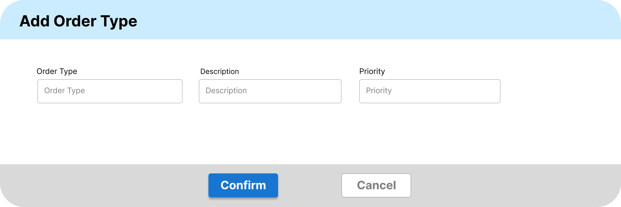

Order Type 設定檔畫面 2 – 新增

Add Order Type Popup Window

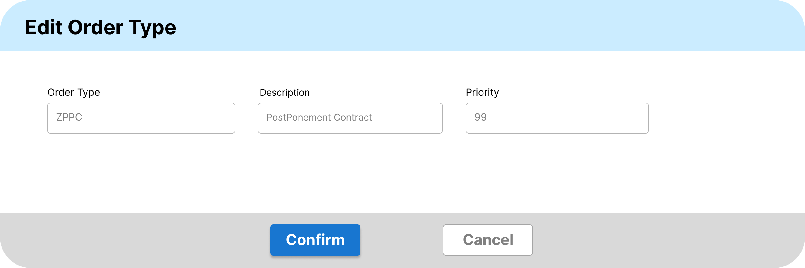

Order Type 設定檔畫面 3 – 修改

Edit Order Type Popup Window

* + - 1. Form Type 表單種類：Maintain Order Type Order Type資料維護
      2. Purpose 功能目的：Add/Edit Order Type 新增/修改Order Type。
      3. User 使用部門：Production Planning 生管部門
      4. Description 欄位說明：

|  |  |  |  |  |  |  |
| --- | --- | --- | --- | --- | --- | --- |
| **新增/修改Order Type 視窗 Add/Edit Order Type Popup Window** | | | | | | |
| **NO** | **顯示名稱**  **Name** | **必輸**  **Required** | **唯讀**  **ReadOnly** | **存改**  **Editable** | **對應欄位**  **Column** | **欄位型態 Type**  **欄位說明 Description** |
| 1 | 確認 |  |  |  |  | Button 按鈕  輸入欲新增/修改的Order Type資料後，點擊按紐儲存Order Type資料，並關閉視窗  After entering the Order Type information to be added, click the button to add and close the window |
| 2 | 取消 |  |  |  |  | Button 按鈕  放棄編輯，返回畫面並關閉視窗  Abort editing, return to the screen and close the window |
| 3 | Order Type  訂單類型 | Y | Y | N | SOS_Order_Type_Setting.  Order_Type | Input Field 輸入框   * Add新增：輸入訂單類型   Enter Order Type   * Edit修改：顯示訂單類型，唯讀不可改   Display Order Type, read only and cannot be changed |
| 4 | Description  訂單類型說明 | Y | N | Y | SOS_Order_Type_Setting.  Description | Input Field 輸入框   * Add新增：輸入訂單類型說明   Enter Description   * Edit修改：輸入訂單類型說明   Display Description, read only and cannot be changed |
| 5 | Priority  訂單類型優先等級 | Y | N | Y | SOS_Order_Type_Setting.  Priority | Input Field (Number) 輸入框(數字)   * Add新增：輸入訂單類型優先等級   Enter Priority   * Edit修改：輸入訂單類型優先等級   Enter Priority |
| 6 | Update By  更新者 | Y | N | Y | SOS_Order_Type_Setting.  Update_By | 不顯示 No display   * Add新增：系統自動帶入   The system automatically brings in   * Edit修改：系統自動帶入   The system automatically brings in |
| 7 | Update Date  更新日期 | Y | N | Y | SOS_Order_Type_Setting.  Update_Date | 不顯示 No display   * Add新增：系統自動帶入   The system automatically brings in   * Edit修改：系統自動帶入   The system automatically brings in |

* + - 1. Operation Method操作方式

1. Add Order Type 新增Order Type
   1. 輸入Order Type、Description以及 選擇Priority，輸入完畢後點擊Confirm按鈕儲存

Enter the Order Type and Description, then click the Confirm button to save.

1. Edit Order Type 修改Order Type
   1. 修改Order Type，修改完畢後點擊Confirm按鈕儲存

Edit the Order Type and click the Confirm button to save after completing the changes.

* + 1. Sales Order Scheduling | Sales Order 排序程式

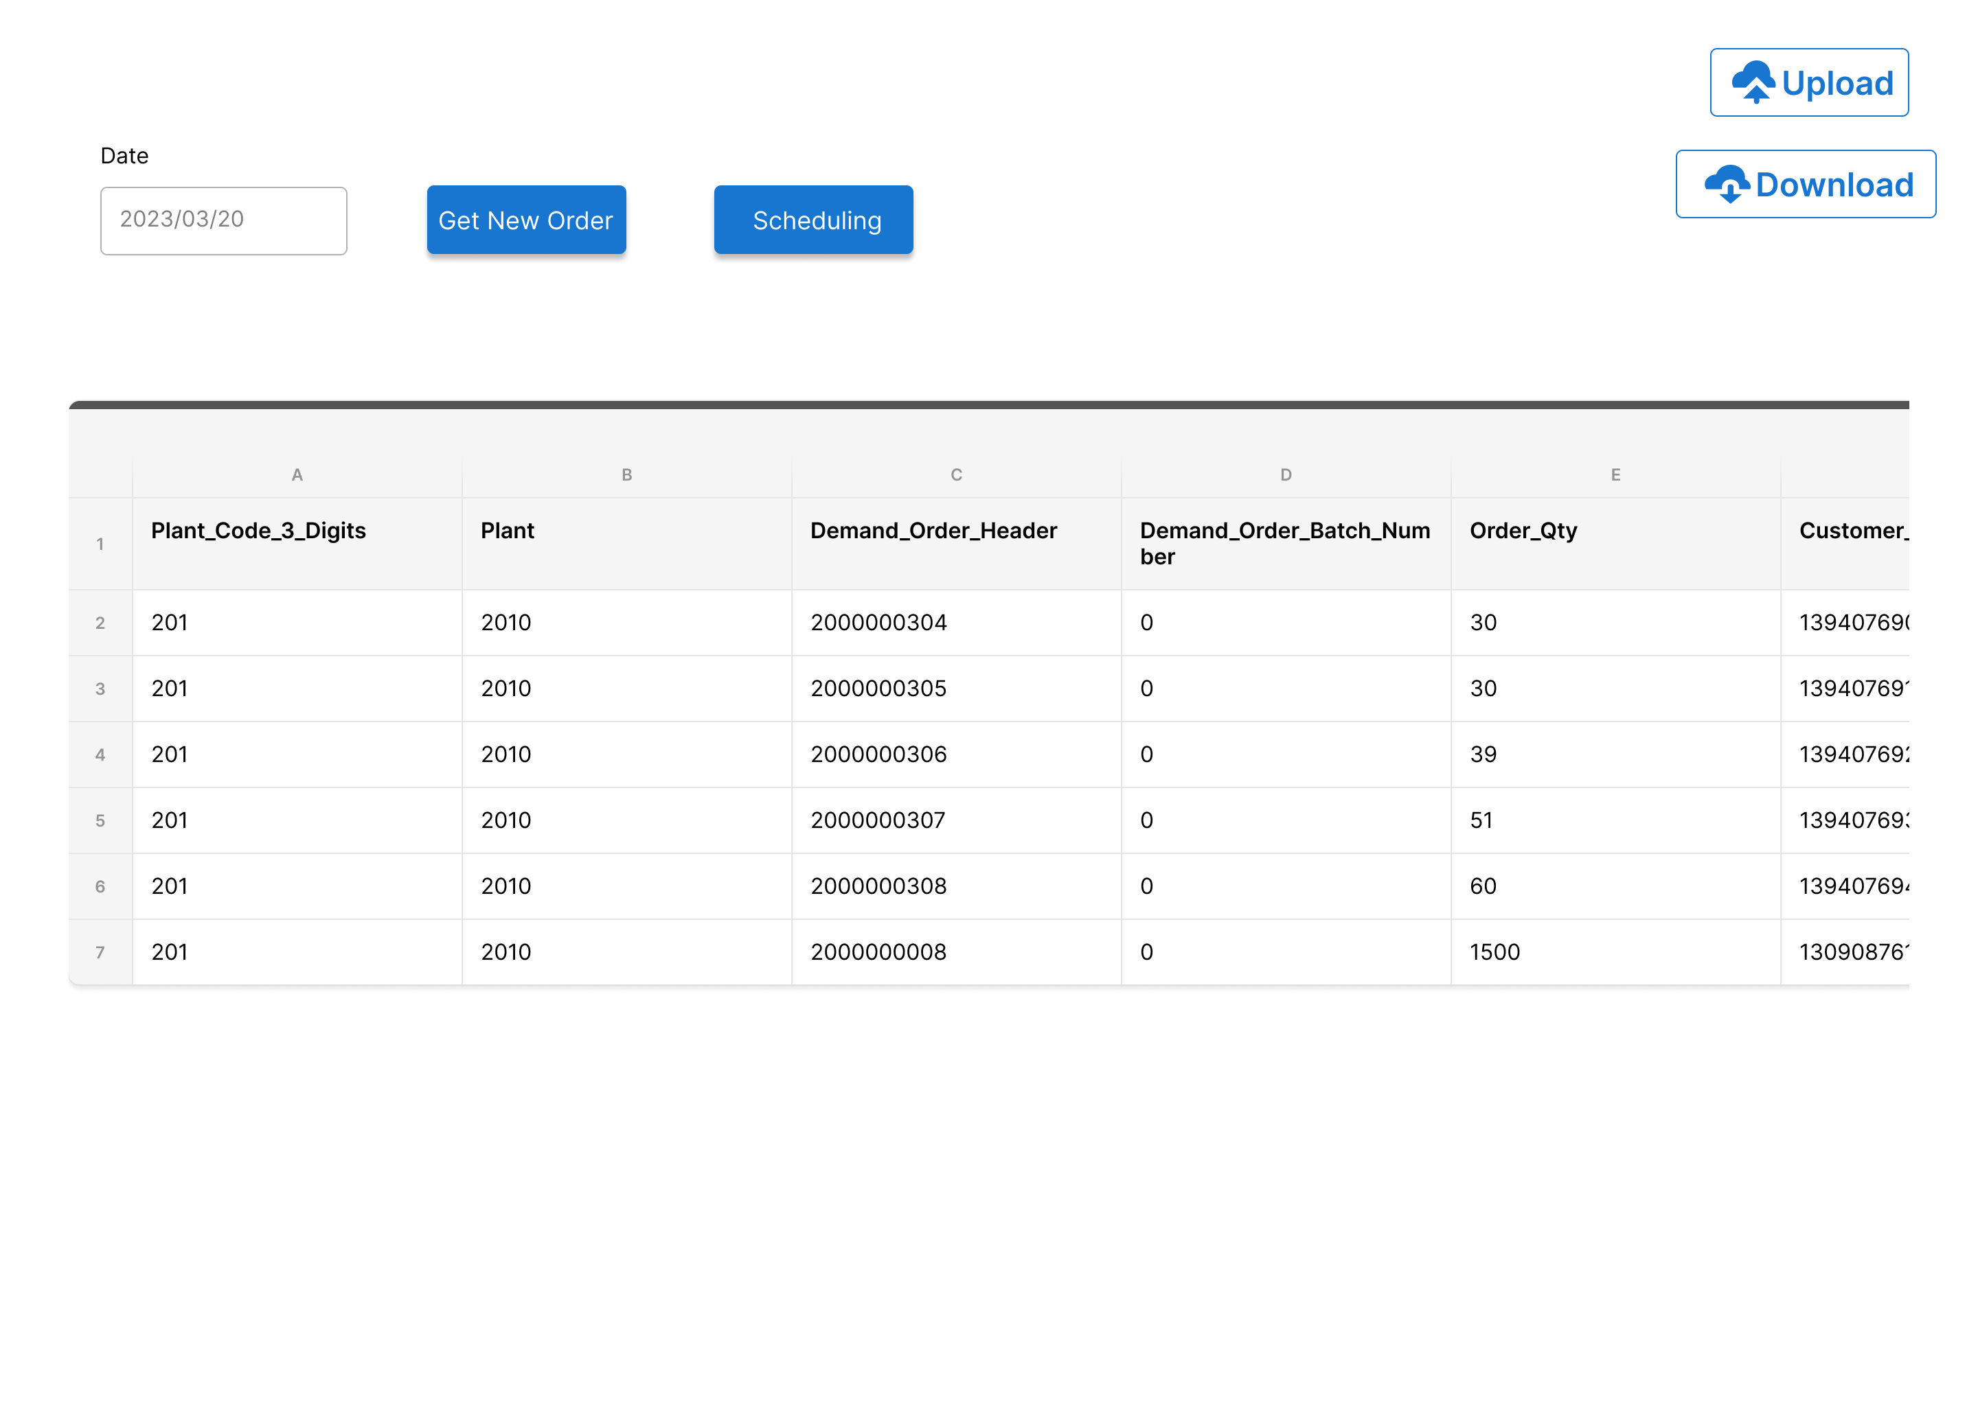

Sales Order 排序畫面 1

Sales Order Scheduling Screen

* + - 1. Form Type 表單種類：Sales Order Scheduling Sales Order排序
      2. Purpose 功能目的：According to the principle of order scheduling, perform Sales Order Scheduling. 根據訂單排序原則，進行Sales Order排序。
      3. User 使用部門：Prodution Planning 生管部門
      4. Description 欄位說明：

|  |  |  |  |  |  |  |
| --- | --- | --- | --- | --- | --- | --- |
| **Sales Order排序程式表頭 Sales Order Scheduling Header** | | | | | | |
| **NO** | **顯示名稱**  **Name** | **必輸**  **Required** | **唯讀**  **ReadOnly** | **存改**  **Editable** | **對應欄位**  **Column** | **欄位型態 Type**  **欄位說明 Description** |
| 1 | Scheduling Date  訂單排序日期 | Y | N | Y | SOS_Sales_Order_Scheduling_Result.Sorting_Date | Input Field 輸入框  預設代入今天日期  Default to today's date. |
| 2 | Get New Order  取得新訂單資料 |  |  |  |  | Button按鈕  點擊後系統抓取最新訂單資訊  Clicking will allow the system to retrieve the latest sales order information. |
| 3 | Scheduling  開始排序 |  |  |  |  | Button按鈕  點擊後系統開始訂單排序  Clicking will initiate the system to start scheduling sales orders. |
| 4 | Upload上傳 |  |  |  |  | Button按鈕  點擊後上傳生管手動調整後的訂單排序結果  Click to upload the manually adjusted sales order scheduling result by the user. |
| 5 | Download下載 |  |  |  |  | Button 按鈕  點擊後下載訂單排序結果  Click to download the sales order scheduling result. |

|  |  |  |  |  |  |  |
| --- | --- | --- | --- | --- | --- | --- |
| **Sales Order排序程式表身明細 Sales Order Scheduling Detail** | | | | | | |
| **NO** | **顯示名稱**  **Name** | **必輸**  **Required** | **唯讀**  **ReadOnly** | **存改**  **Editable** | **對應欄位**  **Column** | **欄位型態 Type**  **欄位說明 Description** |
| 1 | Scheduling Seq  訂單順序 | N | Y | N | SOS_Sales_Order_Scheduling_Result.Scheduling _Seq | int  顯示訂單順序  Display Scheduling Seq |
| 2 | Scheduling Date  訂單排序日期 | N | Y | N | SOS_Sales_Order_Scheduling_Result.Scheduling_Date | date  顯示訂單排序日期  Display Scheduling Date |
| 3 | Plant Code 3 Digits  工廠前三碼 | N | Y | N | SOS_Sales_Order_Scheduling_Result.Plant_Code_3_Digits | nvarchar(60)  顯示工廠前三碼  Display Plant Code 3 Digits |
| 4 | Plant  工廠代碼 | N | Y | N | SOS_Sales_Order_Scheduling_Result.Plant | nvarchar(60)  顯示工廠  Display Plant |
| 5 | Demand Order Header  銷售訂單號碼 | N | Y | N | SOS_Sales_Order_Scheduling_Result.Demand_Order_Header | nvarchar(60)  顯示銷售訂單號碼  Display Demand Order Header |
| 6 | Demand Order Batch Number  批次 | N | Y | N | SOS_Sales_Order_Scheduling_Result.Demand_Order_Batch_Number | nvarchar(60)  顯示批次  Display Demand Order Batch Number |
| 7 | Order Qty  訂單批次數量 | N | Y | N | SOS_Sales_Order_Scheduling_Result.Order_Qty | numeric(17, 4)  顯示訂單批次數量  Display Order Qty |
| 8 | Customer Order ID  客戶採購單號碼 | N | Y | N | SOS_Sales_Order_Scheduling_Result.Customer_Order_ID | nvarchar(60)  顯示客戶採購單號碼  Display Customer Order ID |
| 9 | Predict Deliver Date  PODD實際出貨日 | N | Y | N | SOS_Sales_Order_Scheduling_Result.Predict_Deliver_Date | nvarchar(8)  顯示PODD  Display Predict Deliver Date(PODD) |
| 10 | Promise Deliver Date  POSDD承諾出貨日 | N | Y | N | SOS_Sales_Order_Scheduling_Result.Promise_Deliver_Date | nvarchar(8)  顯示POSDD  Display Promise Deliver Date(POSDD) |
| 11 | Due Date  CRD 客戶需求日 | N | Y | N | SOS_Sales_Order_Scheduling_Result.Due_Date | nvarchar(8)  顯示CRD  Display Due Date(CRD) |
| 12 | Order Date  Document Date | N | Y | N | SOS_Sales_Order_Scheduling_Result.Order_Date | nvarchar(8)  顯示Document Date  Display Order Date  (Document Date) |
| 13 | Generic Material  料號 | N | Y | N | SOS_Sales_Order_Scheduling_Result.Generic_Material | nvarchar(60)  顯示料號  Display Generic Material |
| 14 | Model NO | N | Y | N | SOS_Sales_Order_Scheduling_Result.Model_NO | nvarchar(200)  顯示Model No  Display Model No |
| 15 | Article | N | Y | N | SOS_Sales_Order_Scheduling_Result.Article | nvarchar(200)  顯示Article  Display Article |
| 16 | Demand Order Type  銷售訂單類型 | N | Y | N | SOS_Sales_Order_Scheduling_Result.Demand_Order_Type | nvarchar(60)  顯示銷售訂單類型  Display Demand Order Type |
| 17 | Order Type Priority  銷售訂單優先等級 | N | Y | N | SOS_Sales_Order_Scheduling_Result.Order_Type_Priority | int  顯示銷售訂單優先等級  Display Order Type Priority |
| 18 | Demand Order Remark  銷售訂單類型說明 | N | Y | N | SOS_Sales_Order_Scheduling_Result.Demand_Order_Remark | nvarchar(60)  顯示銷售訂單類型說明  Display Demand Order Remark |
| 19 | Customer ID  買方客戶 | N | Y | N | SOS_Sales_Order_Scheduling_Result.Customer_ID | nvarchar(60)  顯示買方客戶  Display Customer ID |
| 20 | Customer Name  買方客戶名稱 | N | Y | N | SOS_Sales_Order_Scheduling_Result.Customer_Name | nvarchar(100)  顯示買方客戶名稱  Display Customer Name |
| 21 | Ship To Customer ID  收貨方客戶代碼 | N | Y | N | SOS_Sales_Order_Scheduling_Result.Ship_To_Customer_ID | nvarchar(60)  顯示收貨方客戶代碼  Display Ship To Customer ID |
| 22 | Ship To Customer Name  收貨方客戶名稱 | N | Y | N | SOS_Sales_Order_Scheduling_Result.Ship_To_Customer_Name | nvarchar(100)  顯示收貨方客戶名稱  Display Ship To Customer Name |
| 23 | Ship To Customer Country  收貨方客戶國家 | N | Y | N | SOS_Sales_Order_Scheduling_Result.Ship_To_Customer_Country | nvarchar(100)  顯示收貨方客戶國家  Display Ship To Customer Country |
| 24 | Destination Limit  收貨方客戶國家排單限制 | N | Y | N | SOS_Sales_Order_Scheduling_Result.Destination_Limit | varchar(3)  顯示收貨方客戶國家排單限制  Display Destination Limit |
| 25 | Class Code | N | Y | N | SOS_Sales_Order_Scheduling_Result.Class_Code | nvarchar(60)  顯示Class Code  Display Class Code |
| 26 | Class Code Priority  Class Code優先等級 | N | Y | N | SOS_Sales_Order_Scheduling_Result.Class_Code_Priority | int  顯示Class Code優先等級  Display Class Code Priority |
| 27 | Hold Shipment | N | Y | N | SOS_Sales_Order_Scheduling_Result.Hold_Shipment | datetime  顯示Hold Shipment  Display Hold Shipment |

* + - 1. Prerequisites for Sales Order Scheduling 訂單排序前置條件

1. 生管需要先於設定檔設定Article Group、Article、Class Code、Destination優先序

User needs to set the priority sequence of Article Group, Article, Class Code, and Destination in the setting file beforehand.

1. 執行訂單排序前，系統須獲得最新訂單資料

Before executing sales order scheduling, the system needs to get the latest sales order data.

1. Sales Order data retrieval instructions 訂單資料抓取說明：
   1. SAP會於每天12:15/19:15兩個時段拋轉新增及異動的訂單資料，位於以下四個table SAP will transfer new and modified order data twice a day at 12:15 and 19:15, which are located in the following four tables：
   * APS_Sales_Order_Header (Sales order master data訂單主檔)
   * APS_Sales_Order_Detail (Sales order detail訂單明細)
   * APS_Batch (Sales order batch訂單批次)
   * APS_Batch_Detail (Sales order batch detail訂單批次明細)
   1. 按下取得新訂單資料按鈕後，抓取新訂單資料，每次抓取SID最新的資料，並比對APS_Sales_Order_Detail中Order Qty 是否等於 Shipped Qty，若是相等則表示該訂單已出貨，不須進入訂單排序；若不相等，則列入本次訂單排序；若訂單數量等於0，代表該訂單已刪除，不進行訂單排序。

After clicking the "Get New Order Data" button, retrieve the new sales order data. Each time, retrieve the latest data based on SID and compare the Order Qty in APS_Sales_Order_Detail with the Shipped Qty. If they are equal, the order has already been shipped and does not need to be scheduled. If they are not equal, include the order in the current order scheduling. If the Order Qty is zero, it means that the order has been deleted and will not be scheduled.

* 1. 訂單排序使用的是訂單的總數，將訂單主檔與訂單明細對應後加總訂單數量後進行訂單排序。

The order scheduling uses the total number of orders. After matching the order master data with the order details and summing the Order Qty, the order scheduling is performed.

1. 按下訂單排序按鈕後，會先將上次排序的結果全數刪除，進行完排序後再將本次排序的結果存入 SOS_Sales_Order_Scheduling_Result table中

After clicking the "Scheduling" button, all the results of the previous scheduling will be deleted first. After the scheduling is completed, the results of the current scheduling will be stored in the SOS_Sales_Order_Scheduling_Result table.

* + - 1. Explanation of order scheduling principles 訂單排序原則說明

每當接新單時，生管會先將訂單進行排序，排序完成後再將訂單匯入APS進行後續生產排程。

Whenever a new order is received, the user will first schedule the orders before importing them into APS for subsequent production scheduling.

訂單排序可以分為以下五個層級 Order scheduling can be divided into the following five levels：

1. Level 0：CRD與排單日相距超過125天的訂單，暫不進入訂單排序

CRD that are more than 125 days away from the scheduling date are not sorted.

1. Level 1：Article Group
   1. 將訂單按照Article Group分群 Orders are grouped by Article Group.

生管會在系統上設定Article Group設定檔，系統會跟據設定檔將訂單分群

The user sets up an Article Group setting file in the system, and the system groups the orders based on this file.

* 1. 特殊形體 (Order By Article Group Priority)

Special Article (Order By Article Group Priority)

Article Group分群之後，特殊形體會根據Article Group Priority排序，Priority等級越高越優先(Article_Group_Priority 數字越小，Priority等級越高)。不考慮特殊形體Article Group中的總數量，直接放在所有排序中的最前面

After grouping the orders by Article Group, special article are scheduled by Article Group Priority, with higher priority levels given to lower Article_Group_Priority numbers. Regardless of the total quantity of special article in the Article Group, they are placed at the very beginning of all orders.

* 1. 訂單數量 (Group By Article Group Order By Qty DESC)

Order quantity (Group By Article Group Order By Qty DESC)

除特殊形體之外的Article Group，將Article Group中的訂單數量加總，加總後的總數量，從大到小排序，總數量大的優先排序

Orders in Article Groups other than special article are summed by quantity, and the total quantity is scheduled from largest to smallest, with higher quantity orders given priority.

1. Level 2：Model No
   1. 訂單數量 (Group By Model No Order By Qty ASC)

Order quantity (Group By Model No Order By Qty ASC)

在Article Group中，將同一個Model No的訂單數量加總，加總後的總數量，從小到大排序，總數量小的優先排序

Within an Article Group, orders with the same Model No are summed by quantity, and the total quantity is scheduled from smallest to largest, with lower quantity orders given priority.

1. Level 3：Article
   1. 客人要求重點形體

Customer-requested special article

同Model Name(Article Group)、同Model No的Article，判斷Article是否為客人要求重點形體。若是，將訂單優先排序；若否，則按照下方訂單數量規則排序。

For Articles with the same Model Name (Article Group) and Model No, it is determined whether the Article is a customer-requested special article. If it is, the order is given priority. If not, it is sorted according to the order quantity rules below.

* 1. 訂單數量

Order quantity

同Model Name(Article Group)、同Model No且並非客人要求重點形體的Article，將訂單數量加總，加總後的數量，從小到大排序，總數量小的優先排序

For Articles with the same Model Name (Article Group) and Model No that are not customer-requested special article, the orders are summed by quantity, and the total quantity is sorted from smallest to largest, with lower quantity orders given priority.

1. Level 4：Sales Order
   1. CRD

同Model Name(Article Group)、同Model No、同Article的訂單，依照CRD排序，由先到後，日期越近的訂單優先

Orders with the same Model Name (Article Group), Model No, and Article will be scheduled by CRD (Customer Request Date), with priority given to orders with earlier dates.

* 1. Class Code

同Model Name(Article Group)、同Model No、同Article的訂單、同CRD的訂單，依照訂單Class Code排序，Class_Code等級越重要越優先(Class_Code_Priority數字越小，等級越重要)

Orders with the same Model Name (Article Group), Model No, Article, and CRD will be scheduled by Class Code, with higher priority given to orders with lower Class_Code_Priority numbers (i.e., higher importance level).

* 1. 訂單數量

Order Quantity

同Model Name(Article Group)、同Model No、同Article的訂單、同CRD且同Class Code的訂單，依照訂單數量，從大到小排序，數量大的優先

Orders with the same Model Name (Article Group), Model No, Article, CRD, and Class Code will be scheduled by order quantity, with priority given to orders with larger quantities.

* 1. 訂單類型

Order Type

上述排序完成後，比對訂單類型，Priority等級越高越優先(Sales_Order_Type_Priority數字越小，等級越高)

After the above scheduling is completed, the order type will be compared, with higher priority given to orders with lower Sales_Order_Type_Priority numbers (i.e., higher priority level).

* 1. 客戶方目的地

Customer Destination

上述排序完成後，比對客戶方目的地，依據客戶方目的地設定檔，將順序調整。

例如：目的地為日本的訂單不排在第一張，因此與第二張訂單對調順序 (能不能上顏色就好?)

After the above scheduling is completed, the customer destination will be compared and the order sequence adjusted according to the customer Destination setting file. For example, orders with a destination of Japan will not be ranked first and will be swapped with the second order.

1. 訂單排序結束之後，需要進行拆批，拆批動作已在SAP中完成，在訂單排序程式中將訂單表頭與批次明細join，即可獲得拆批後的數量。

After the order scheduling is completed, the orders need to be batched. This batch process is completed in SAP. By joining the order header and batch details in the order scheduling program, the batch order quantities can be obtained.

* + - 1. Operation Method操作方式

1. Execute order scheduling執行訂單排序
   1. 點擊Get Sales Order按鈕，獲取最新的訂單 (資料來源：SAP)

Click the Get Sales Order button to get the latest order (Source: SAP)

* 1. 點擊Scheduling按鈕，系統執行訂單排序

Click the Scheduling button, the system executes order scheduling

* 1. 排序執行完畢，系統顯示結果

After the scheduling is completed, the system displays the results

1. Adjust order scheduling調整訂單排序
   1. 訂單排序執行完畢後，生管可於頁面上手動調整訂單排序結果

After the order scheduling is completed, the user can manually adjust the order scheduling results on the page

1. Download order scheduling results下載訂單排序結果
   1. 點擊Download按鈕，可下載訂單排序結果Excel

Click the Download button to download the order scheduling results in Excel

1. Upload order scheduling results 上傳訂單排序結果
   1. 點擊Upload按鈕，可讓生管將手調之後的訂單排序結果上傳

Click the Upload button to let the user upload the order scheduling results after manual adjustment

1. Appendix 附錄

