Name: DAO MINH QUY
Student ID: 2026512818
Step 1 — Create GitHub Repository
First, create a GitHub repository for the application.
The repository is used as the source code repository for the Render deployment.
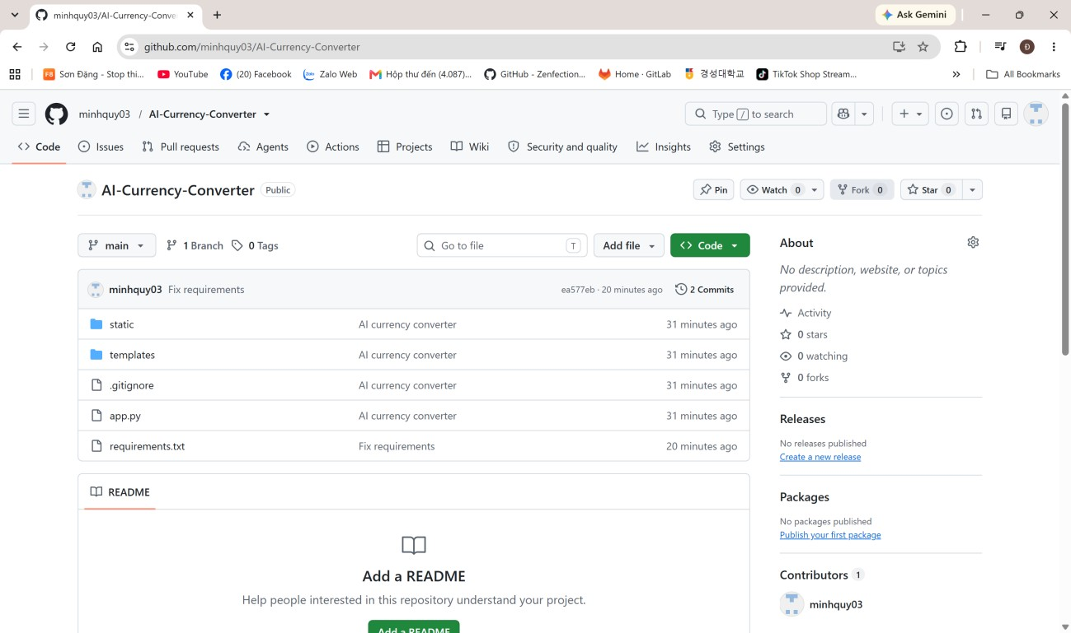
Step 2: Upload Project to GitHub git add .
git commit -m "AI currency converter" git push
Step 3 — Log in to Render
Open Render and log in using the GitHub account connected to the project.
Select New → Web Service to create a new web service.
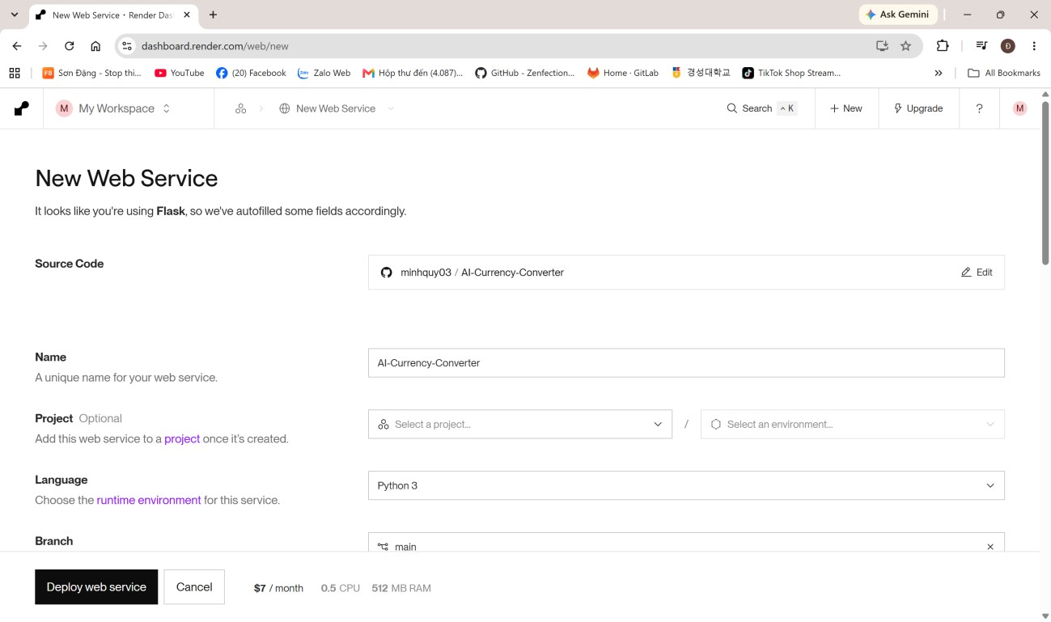
Step 4 — Connect GitHub and Select the Repository
Connect GitHub to Render and select the repository containing the application.
Step 5: Configure the Web Service
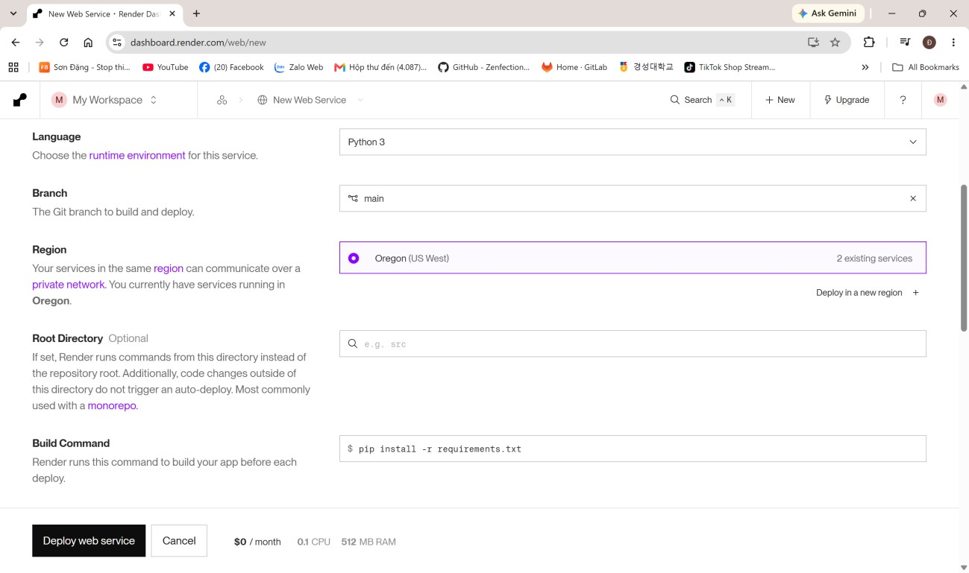
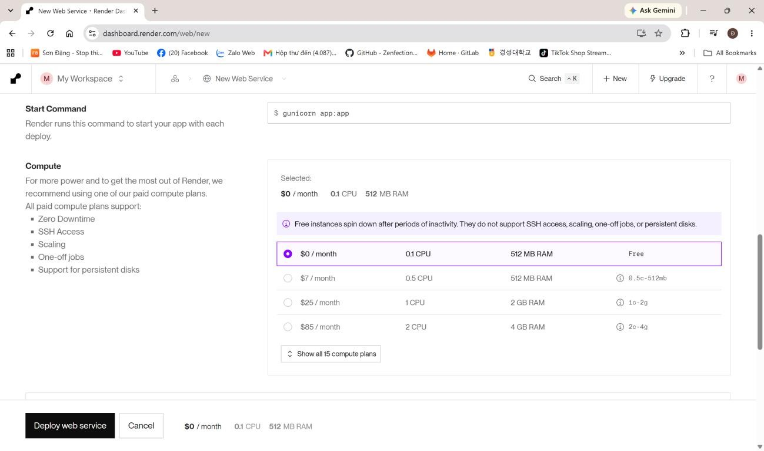
Step 6 — Add the Gemini API Key
The application uses the Gemini API, so the API key must be added as an environment variable on Render.
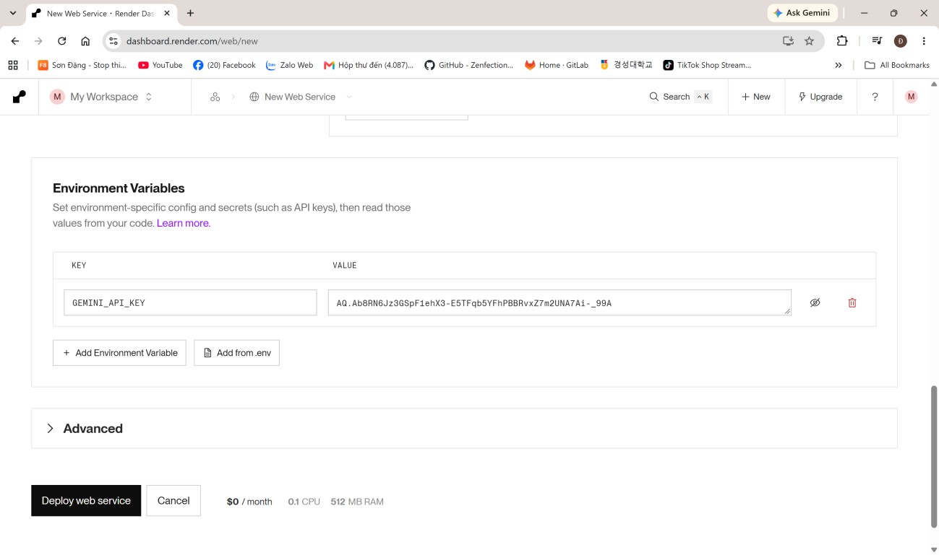
Step 7 — Deploy the Application
Click Deploy Web Service to start the deployment
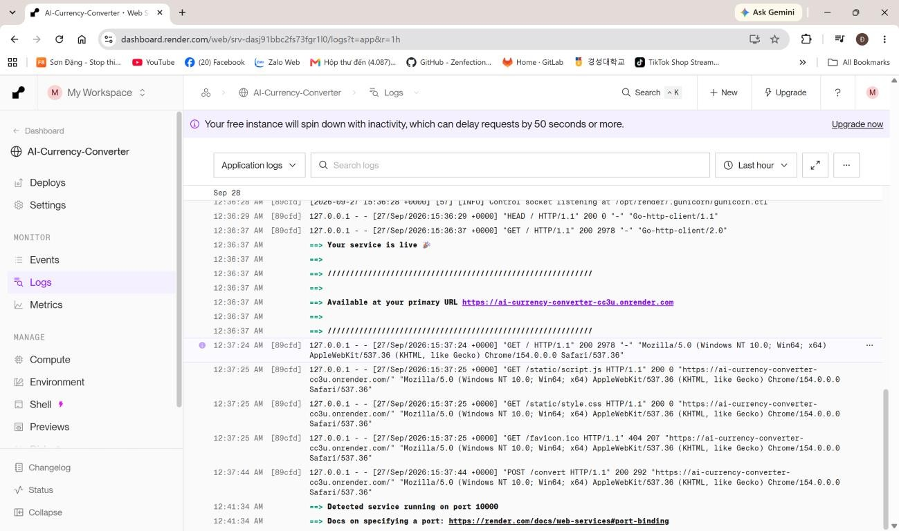
Step 8: Test the Application
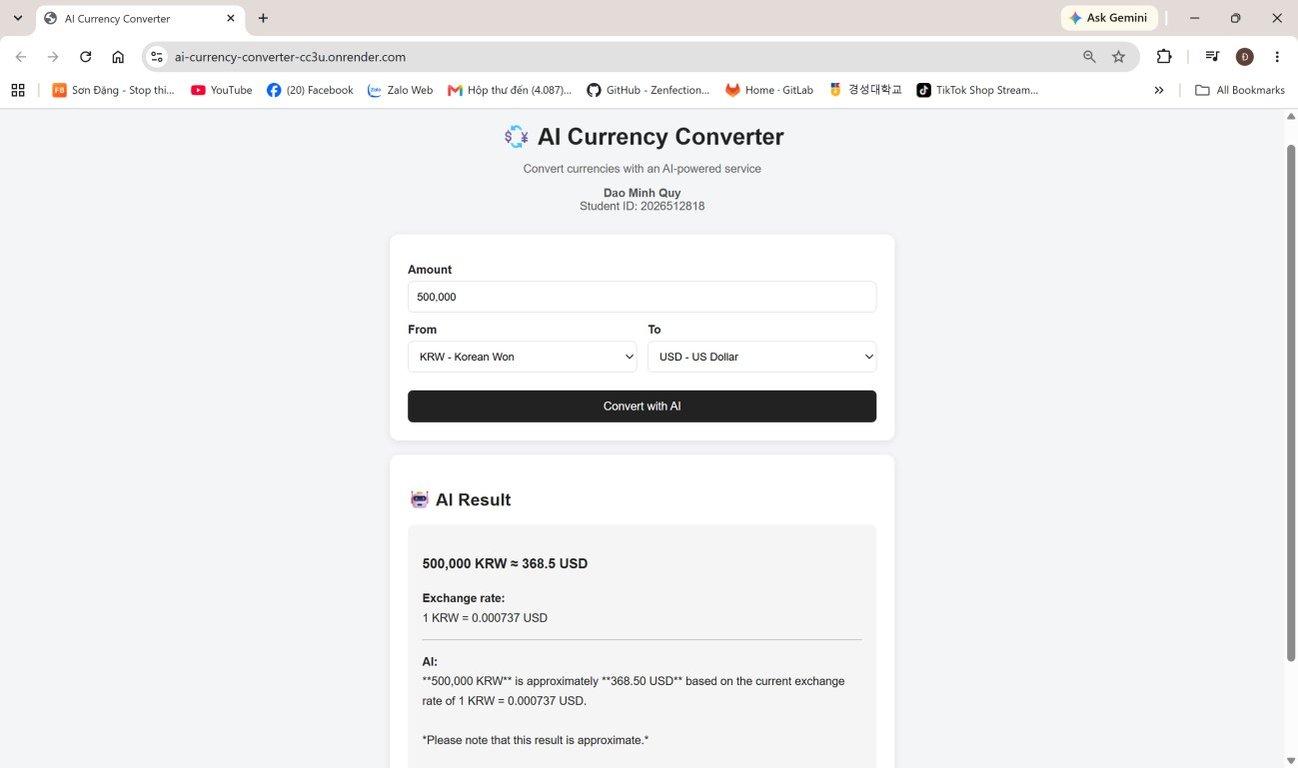

https://ai-currency-converter-cc3u.onrender.com

