Lab 2: Installing ProDiscover Basic Edition

What You Need for This Project
- A virtual machine running Windows 10. Other operating systems might work, but the procedure will be different.

Downloading ProDiscover Basic Edition
- Download installation for ProDiscover Basic. It's a free product and about ~75 MB in size.
Installing ProDiscover
- Run the ProDiscover Basic 7.0.msi (or .exe) file (remember if you are using Windows 7, right-click it and click "Run as Administrator").
- Click through the installer, accepting the default options.
Downloading a Simple Test Image
- In your Windows machine, in a Web browser, download this file:
Link
This is an image of a 32 MB SD card which has photographs on it. The file is 30 MB in size.
- Save the file on your desktop.
Starting ProDiscover
- On your desktop, double-click the "ProDiscover Basic" icon.
- In the "Launch Dialog" box, enter a "Project Number" of 5 and a "Project File Name" of 5-YOURNAME, replacing "YOURNAME" with your own name, as shown below: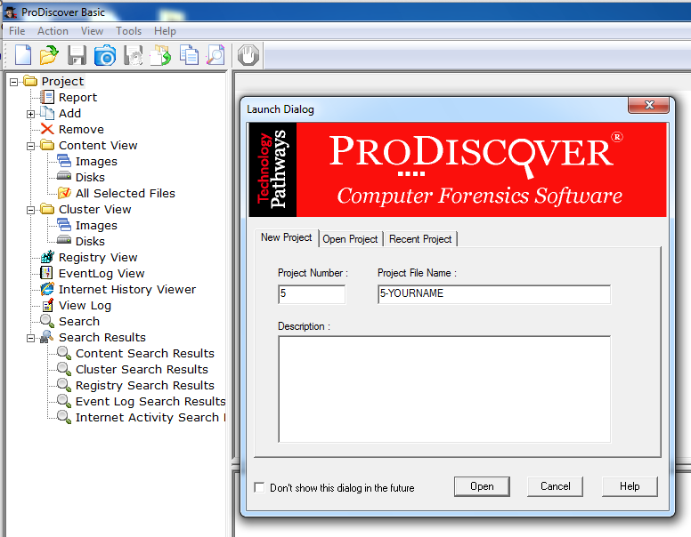
- Click Open.
- This creates a Project, but so far the Project has no evidence in it.
Adding an Image File
- From the ProDiscover menu bar, click Action, Add, "Image File...", as shown below.
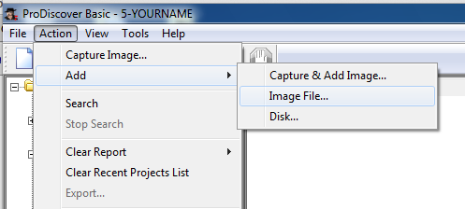
- Navigate to your desktop and double-click the nps-2009-canon2-gen6.dd file.
Viewing the SD Card Image
- In the left pane of ProDiscover, in the "Content View" section, click the plus sign to expand Images.
- Expand C:\Users\username\Desktop\nps-2009-canon2-gen6.dd. username should be your current Windows username.
- Click C. Expand C:
- Expand DCIM
- Click 100CANON to select it.
- A list of IMG files appears in the upper right pane, as shown below.
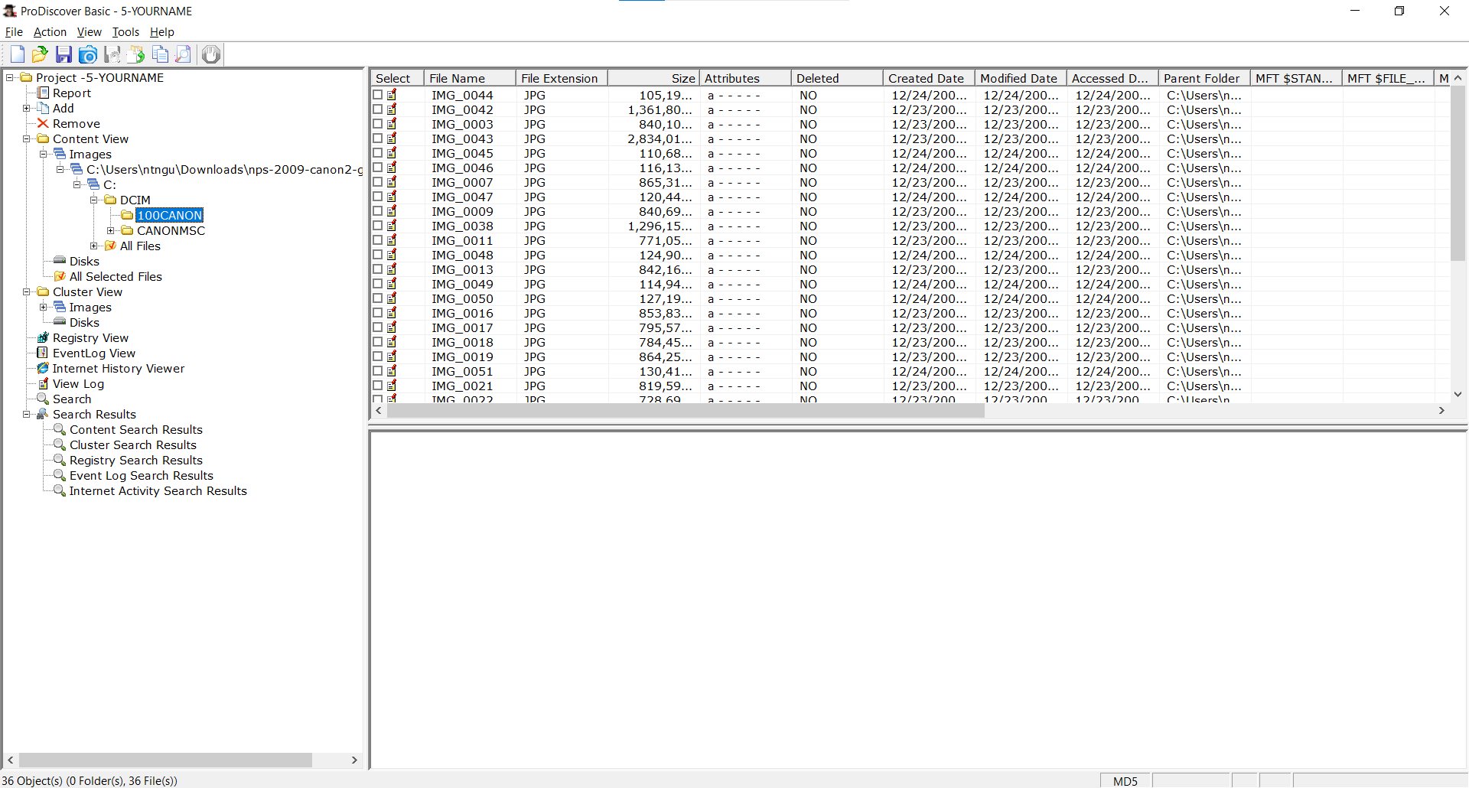
Using ASCII View
- In the upper right pane, click one of the IMG files to select it.
- The lower right pane shows the contents of this file in ASCII, as shown below. This isn't a very useful way to view a photographic image, but it does show the EXIF metadata which shows the model of camera used, and the time the photograph was taken.
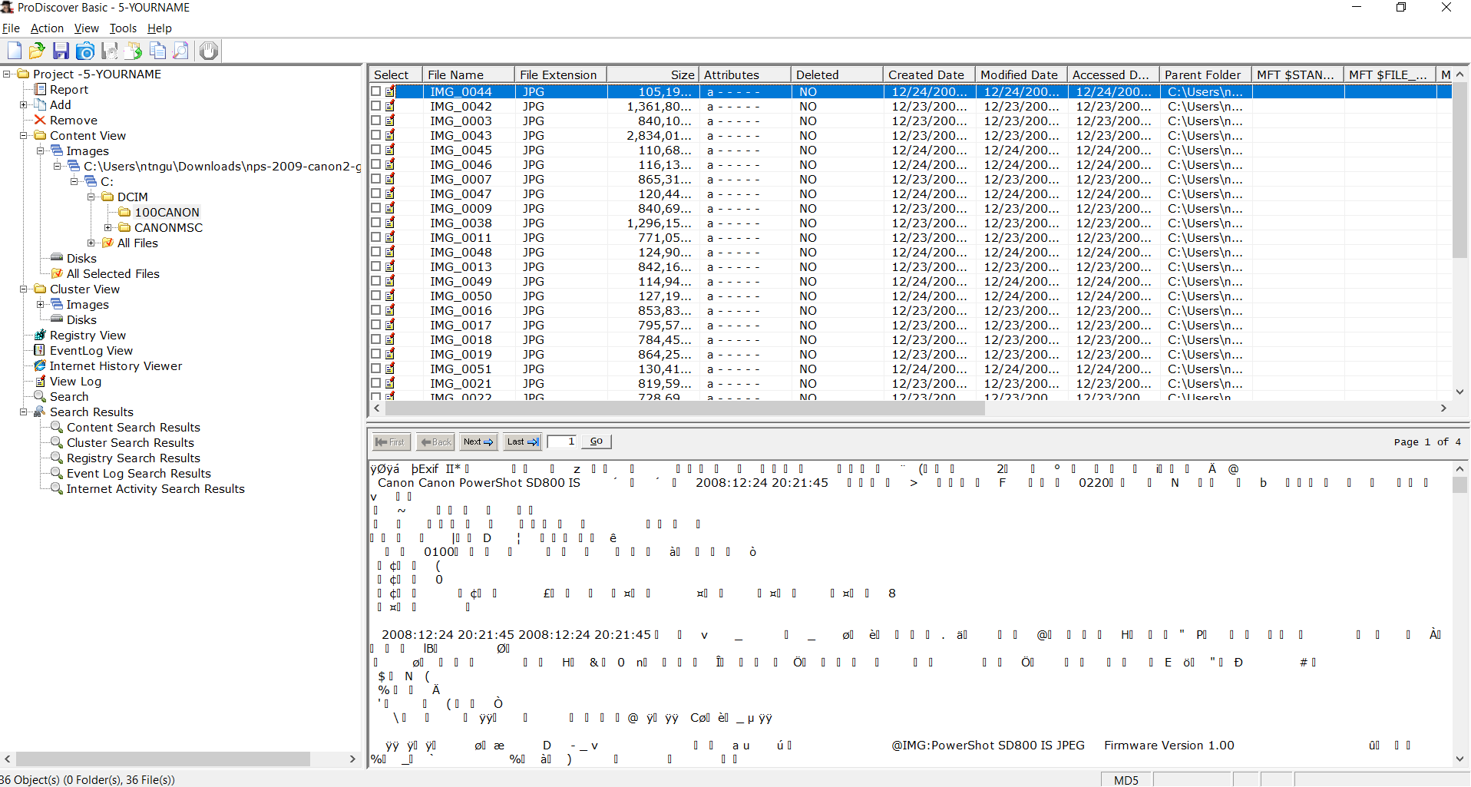
Using Photo Viewer
- In the upper right pane, double-click one of the IMG files.
- Now it opens in an image viewer so you can see the photograph, as shown below.
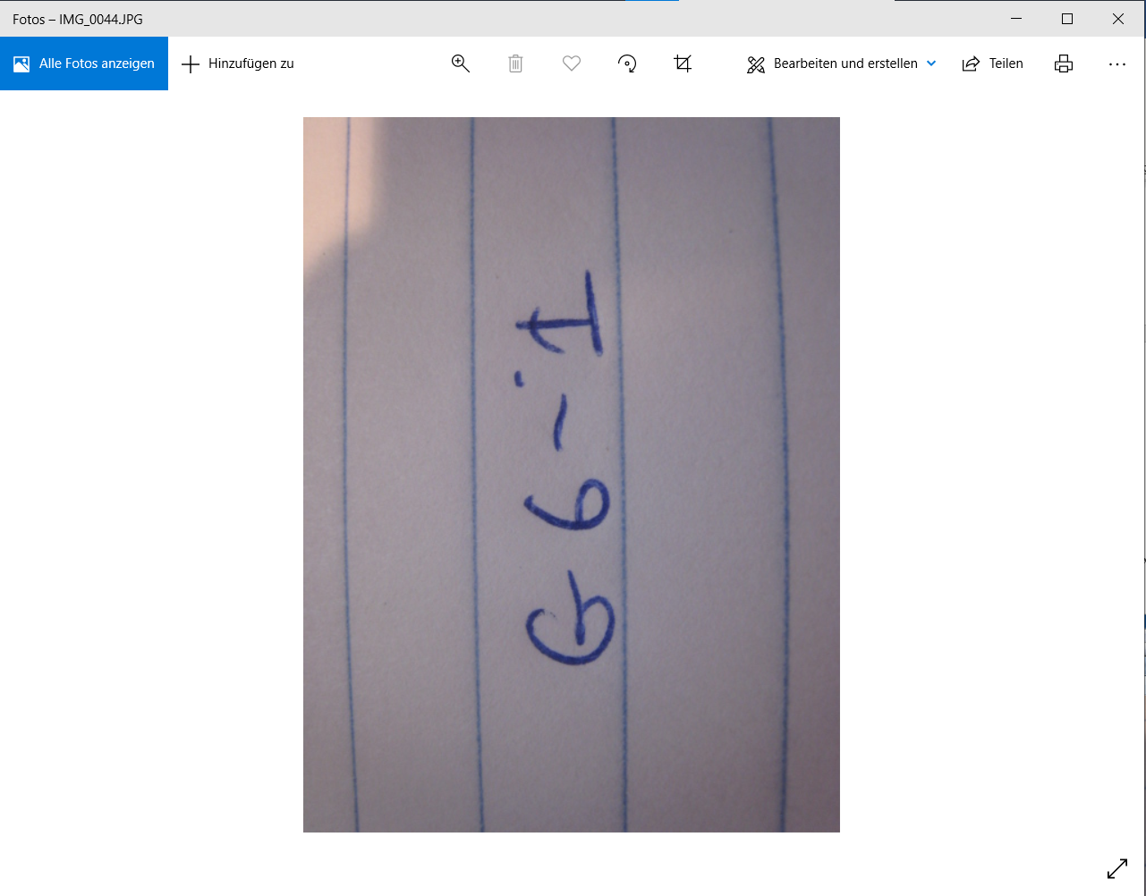
- Close the "Windows Photo Viewer" window.
Viewing a Deleted Photograph
- In the upper right pane of ProDiscover, scroll down till you find the image below IMG_0025 (or 0030 or 0035).
- Click the image to select it, as shown below.
- This is a deleted file, which has been recovered by ProDiscover. It's only partially recovered at this point, however. We'll do file carving in a later project.
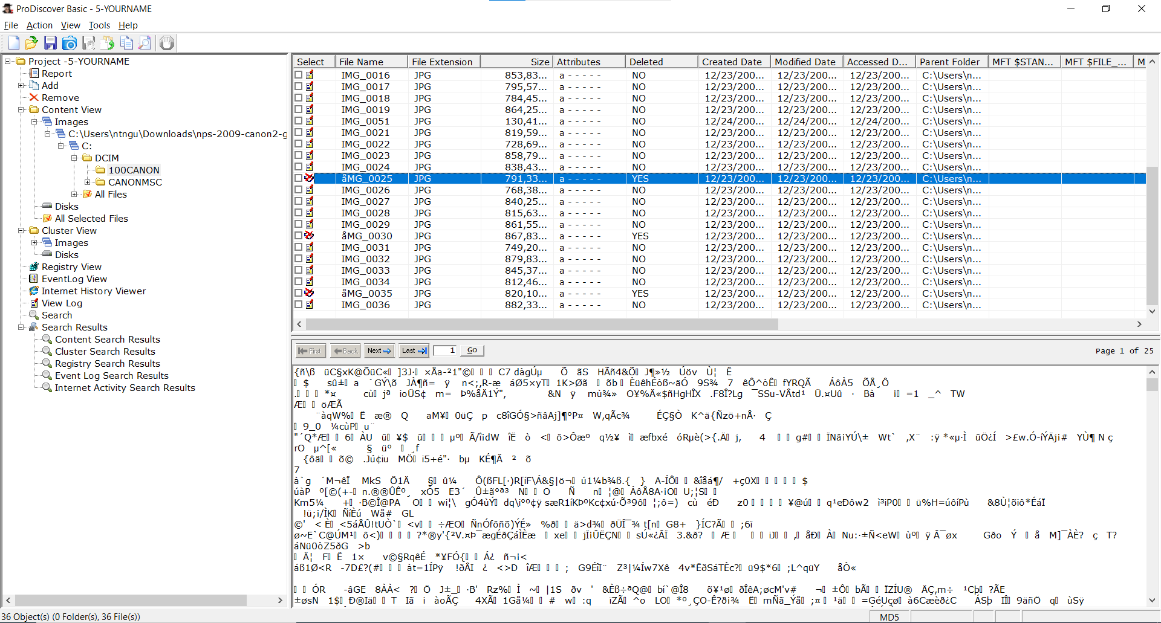
Saving a Screen Image
- Make sure your screen shows a Deleted file (Deleted of "YES") and the contents of that file in the lower right, as shown above.
- Press Alt + PrintScrn. That will copy the whole desktop to the clipboard.
- Open Paint and paste in the image.
- Save the image with the filename "Your Name Lab 2". Use your real name, not the literal text YOURNAME.
How to Save Your ProDiscover Project
- In ProDiscover, click File, "Save Project".
- Save it on your desktop with the default filename, which should be 5-YOURNAME.dft
- Close ProDiscover.

Turning in your Project
- Submit it to: cms with a subject line of "Lab 2 From Your Name", replacing "Your Name" with your own first and last name.
Bonus: Which data are contained in the IMG_0025, IMG_0030, IMG_0035?
