Lab-Project 13-1: Using Zeek
What You Need for this Project
- A virtual Linux machine
Purpose
- To install, configure, and apply Zeek for to detect common attacks.
Installing Zeek
Below you should make a right choice for your Linux machine from here in order to install Zeek successfully. Execute the following commands:
sudo apt update
sudo apt install cmake make gcc g++ flex bison -y
sudo apt install libpcap-dev libssl-dev python-dev swig zlib1g-dev -y
sudo apt install zlib1g-dev wget curl -y
echo 'deb http://download.opensuse.org/repositories/security:/zeek/Debian_10/ /' \ | sudo tee /etc/apt/sources.list.d/security:zeek.list
sudo wget -nv https://download.opensuse.org/repositories/security:zeek/Debian_10/Release.key \ -O "/etc/apt/trusted.gpg.d/security:zeek.asc"
sudo apt update
sudo apt install zeek-lts -y
cd
echo "export PATH=/opt/zeek/bin:$PATH" >> .bashrc
source .bashrc
Starting Zeek
In Terminal, execute this command (you should modify as well here for your Linux machine):
sudo /opt/zeek/bin/zeek -i ens4 -C &
Press Enter to get a fresh command prompt.
Creating DNS Traffic
In Terminal, execute these commands:
ping -c 1 -W 1 msn.com
ping -c 1 -W 1 kittenwar.com
ls
Several log files have appeared, e.g. as shown below.
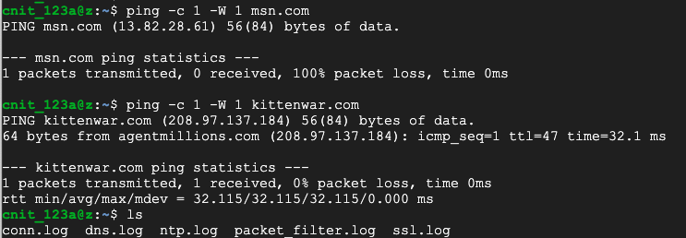
Viewing the DNS Log
On your Linux, execute this command:
cat dns.log
You see log entries for the domains you pinged, as shown below.
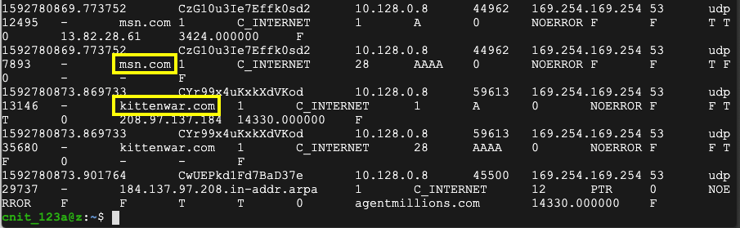
Creating HTTP Traffic
In Terminal, execute this command:
wget http://ad.samsclass.info
cat http.log
The flag is covered by a green box in the image below.
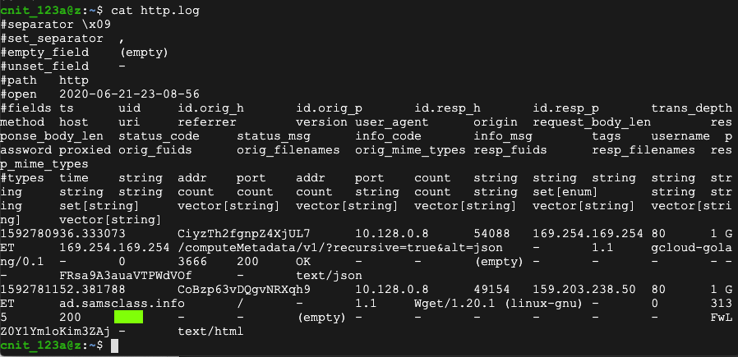

Saving a screen image
Make sure the flag is visible.
Save the image with filename Lab-Proj13-1a-YOURNAME.png. Use your real name, not the literal text YOURNAME.
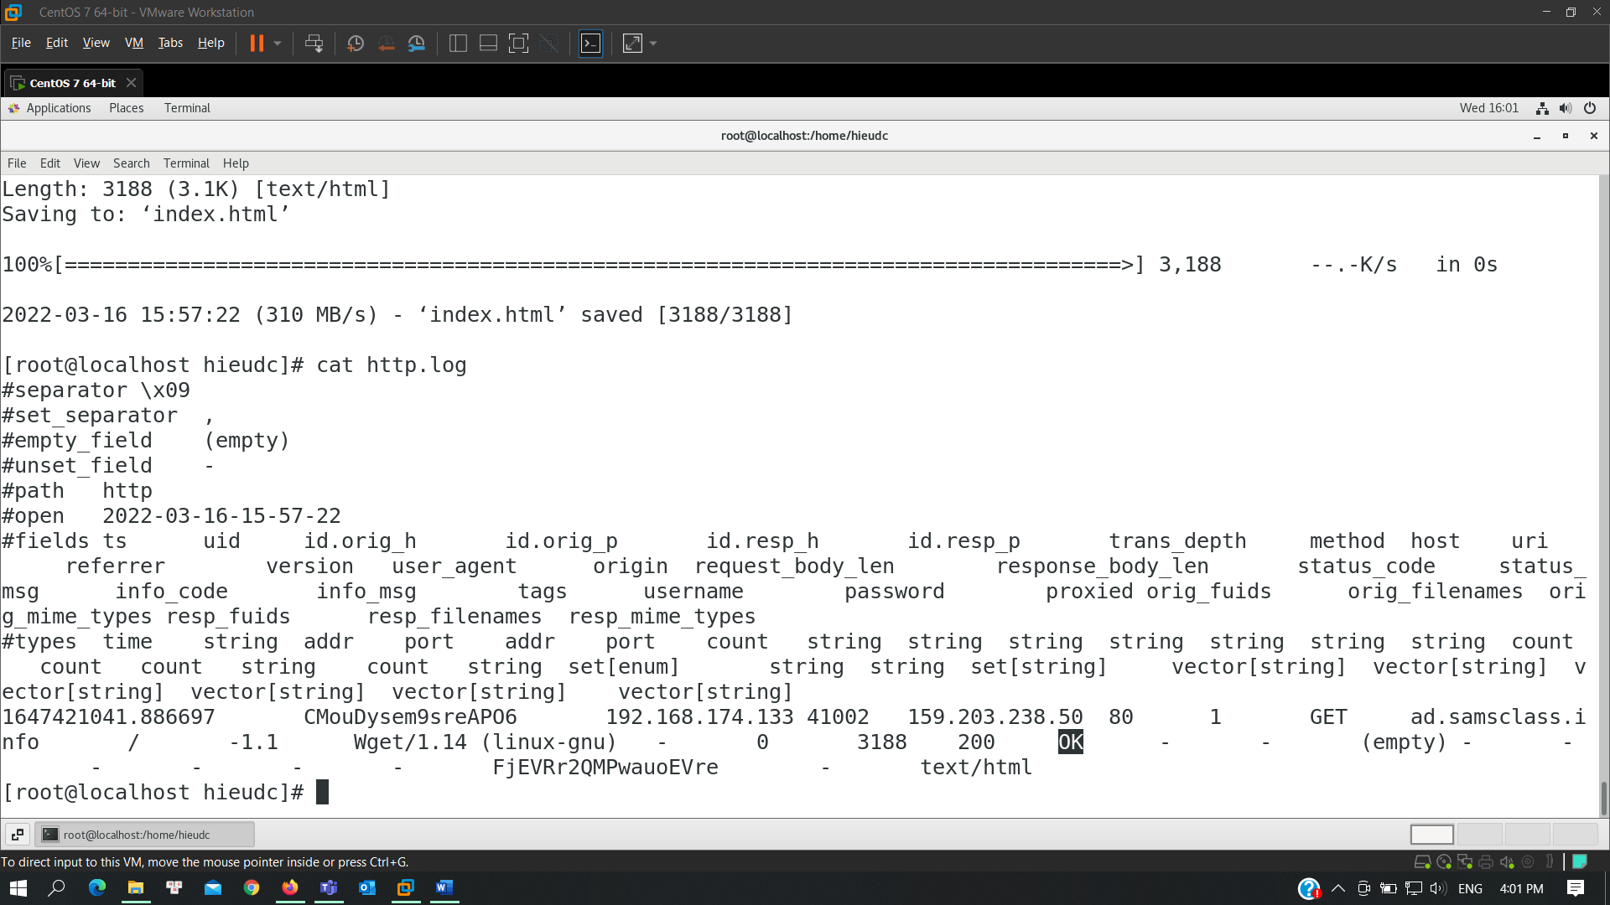
HTTP Basic Authentication
By default, Zeek doesn't log passwords. To fix that, on your Linux machine, execute this command:
sudo nano /opt/zeek/share/zeek/base/protocols/http/main.zeek
Change default_capture_password to T as shown below
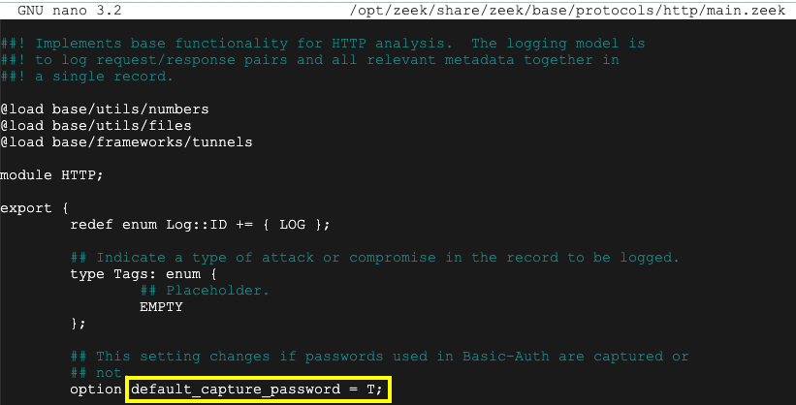
Press Ctrl+X, Y, Enter to save the file.
In Terminal, execute these commands to download a PCAP file to examine and process it with Zeek:
sudo rm http.log
wget https://samsclass.info/152/proj/http-basic.pcap
sudo /opt/zeek/bin/zeek -r http-basic.pcap -C
head -n 7 http.log
There are a lot of fields, but the ones of interest to us are:
username password status_code status_msg
as shown below.
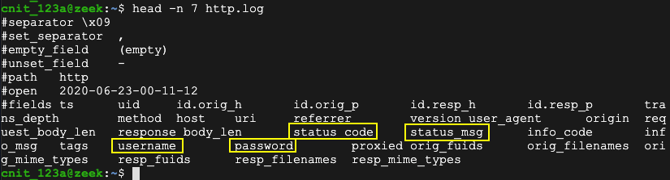
Zeek provides a zeek-cut utility to make it easier to pick out fields like that.
HTTP Password
In Terminal, execute this command:
cat http.log | zeek-cut username password status_code status_msg
The flag is the password for the successful login, covered by a green box in the image below.
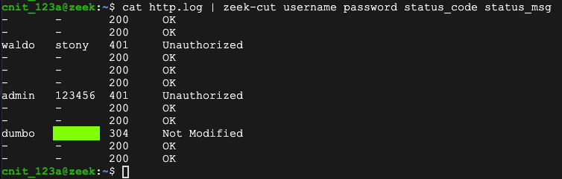

Saving a screen image
Make sure the flag is visible.
Save the image with filename Lab-Proj13-1b-YOURNAME.png. Use your real name, not the literal text YOURNAME.
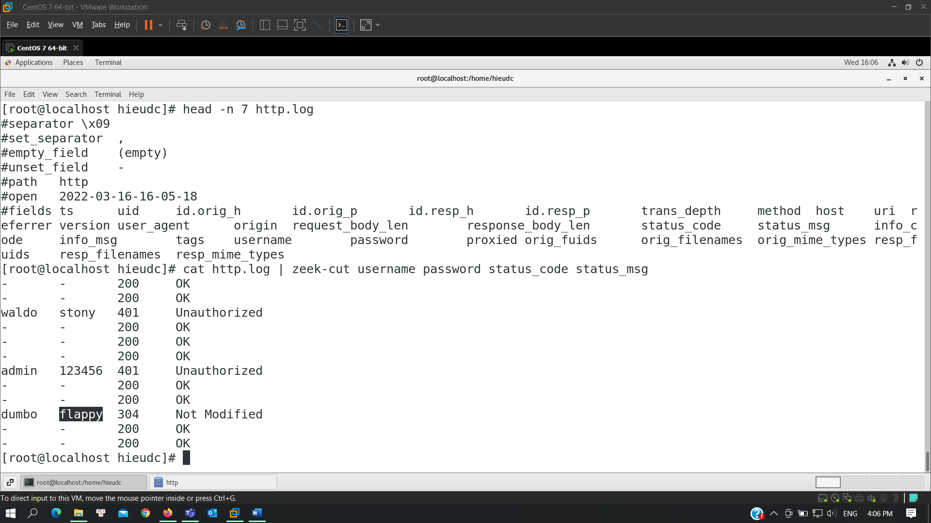
HTTP PIN
In Terminal, execute this command:
wget https://samsclass.info/152/proj/http-basic2.pcap
The flag is the password for the successful login.

Saving a screen image
Make sure the flag is visible.
Save the image with filename Lab-Proj13-1c-YOURNAME.png. Use your real name, not the literal text YOURNAME.
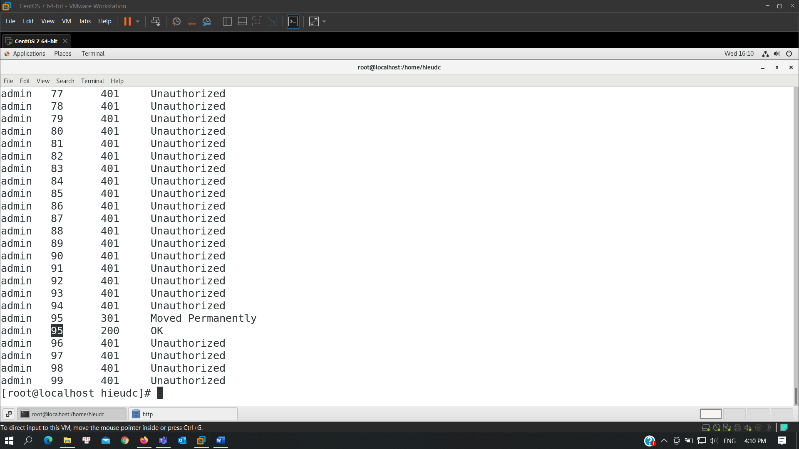
Detecting SSH Brute-Force Attacks
In Terminal, execute this command:
nano notice_ssh_guesser.zeek
Enter the following code:
@load protocols/ssh/detect-bruteforcing
redef SSH::password_guesses_limit=10;
hook Notice::policy(n: Notice::Info)
{
if ( n$note == SSH::Password_Guessing )
add n$actions[Notice::ACTION_EMAIL];
}
Press Ctrl+X, Y, Enter to save the file.
In Terminal, execute these commands:
wget https://samsclass.info/152/proj/ssh-brute.pcap
sudo /opt/zeek/bin/zeek -r ssh-brute.pcap -C notice_ssh_guesser.zeek
cat notice.log
The flag is covered by a green box in the image below.
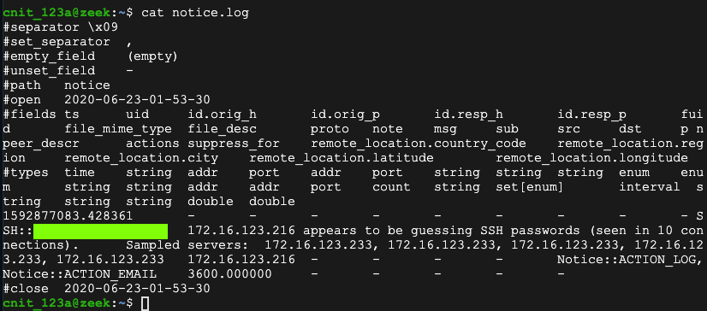

Saving a screen image
Make sure the flag is visible.
Save the image with filename Lab-Proj13-1d-YOURNAME.png. Use your real name, not the literal text YOURNAME.
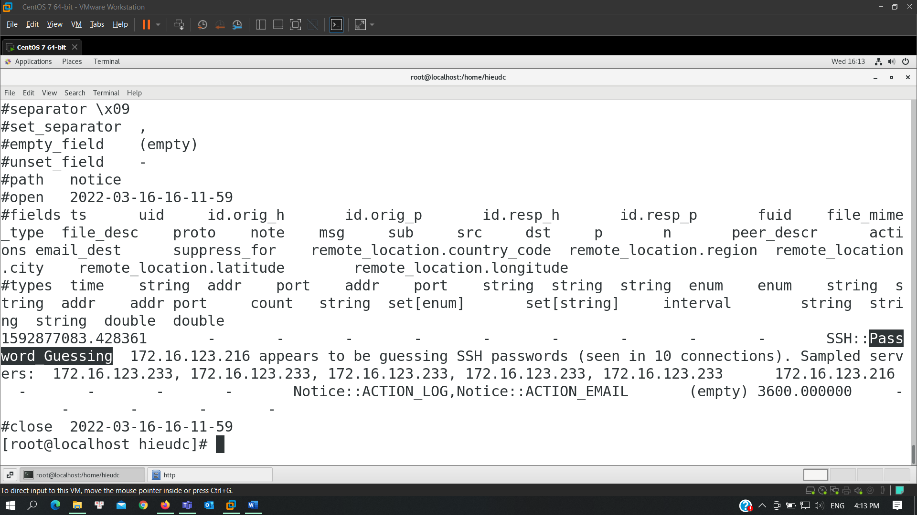

Turning in your Project
Submit the images you save in the steps Saving a Screen Image to: cms with a subject line of Lab-Proj13-1-YOURNAME, replacing YOURNAME with your real name.

