Lab-Project 6: Viewing Forensically Important Registry Keys with Regedit

What You Need for This Project
- Any Windows computer, real or virtual
- The computer must have had at least one USB storage device connected to it previously
- The instructions below are for a Windows 7 computer. Students should do the Lab with Windows 10.

Introduction to the Registry
The Registry has thousands of values that are used to control every detail of the Windows OS, and as a by-product, these keys record a lot of information about what has been happening on the computer.
Regedit is the primary tool used to examine and modify the Registry on Windows machines. IN later projects you will capture the registry from evidence machines, and examine captured registry files. But in this project you will examine the live Registry of a machine directly, just to learn about the most important keys.

Creating a Restore Point on the Windows 7 Machine
- Regedit is a dangerous tool to use. If you make mistakes with it, you can damage your Windows OS. So to be safe, the first thing is to create a restore point, which backs up the Registry and other system files.
- On the Windows 7 machine, Click Start, and type RESTORE into the Search box.
- Click "Create a Restore Point".
- In the "System Properties" box, click "Create".
- In the "Create a restore point" box, enter a name of "Your Name - Before registry edits" and click the Create button. Wait while the restore point is created.
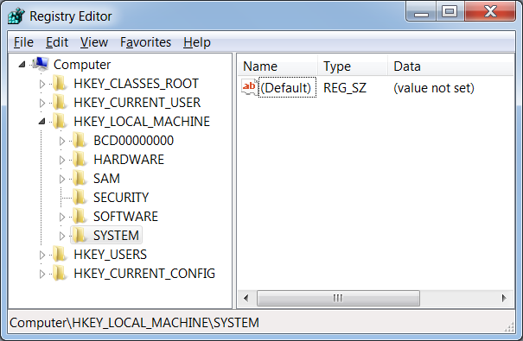
- A box appears saying "The restore point was created successfully". Click Close.
- Close "System Properties".

Starting Regedit
- Click Start. In the search box, type REGEDIT and then press the Enter key.
- Regedit opens, as shown to the right on this page.
- The registry has of five root keys named:
  - HKEY_CLASSES_ROOT
  - HKEY_CURRENT_USER
  - HKEY_LOCAL_MACHINE
  - HKEY_USERS
  - HKEY_CURRENT_CONFIG
- The root keys are often abbreviated as HKCR, HKCU, HKLM, HKU, and HKCC
- The other "folders" in the left pane are called subkeys, such as HARDWARE, SAM, and SECURITY. And the items shown in the right pane are called values, such as Default.
- You navigate the Registry the same way you navigate your folder structure with Windows Explorer.

USB Devices
- This is a good place to start, because you may find devices here which your client needs to request from the other party, because they may contain further evidence.
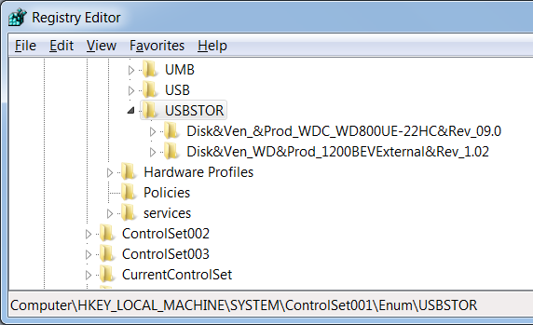
- Navigate to HKLM\SYSTEM\ControlSet001\Enum\USBSTOR. In the left pane of Regedit, click the triangle to expand USBSTOR. If there is no USBSTOR key, perhaps you have never connected a USB device to this computer--plug in a USB drive and click View, Refresh.
- You should see a list of USB devices that have been connected to this computer. In the example shown to the right on this page, there are only two devices.
- To see the details about these devices, expand their keys, and click the first subkey. In my example below, I expanded the first USB device's key, and clicked the subkey with the long name beginning with "6&2df.."--this is the device's serial number. The right pane shows several values that will help identify these devices, including a "FriendlyName" which gives you the USB device's manufacturer and model number.
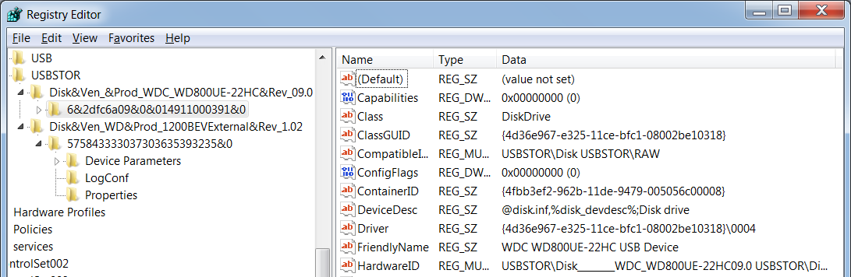



Saving a Screen Image
- Make sure your screen shows a USB device's FriendlyName.
- Press the PrintScrn key. Open Paint and paste in the image. Save it with the filename Your Name Lab-Proj 6a.

Understanding Control Sets
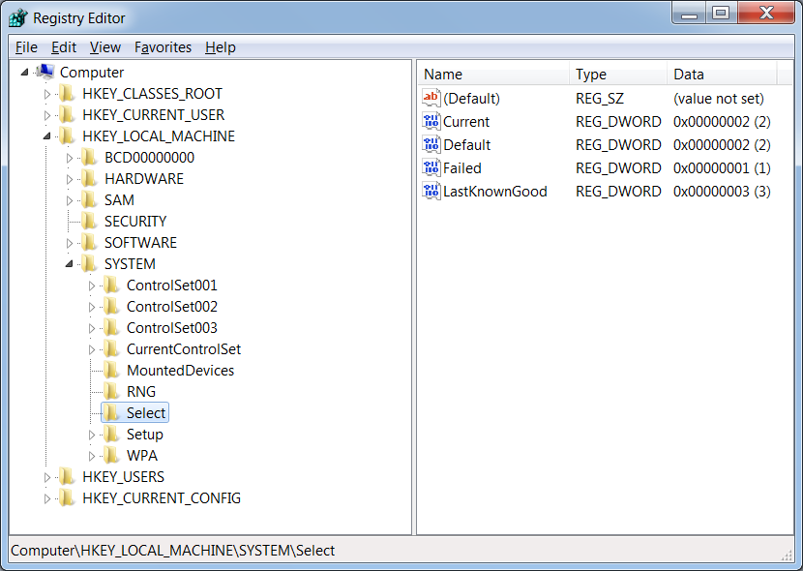
- You may have noticed that there are several Control Set keys, ControlSet001, ControlSet002, etc. To understand them, navigate to HKLM\SYSTEM\Select, as shown below on this page. The values here explain what the various control sets are--look at the Name and Data values in the right pane. You can see that the control set actually being used (Current) is ControlSet002, and ControlSet001 is actually a Failed set on my system.

UserAssist
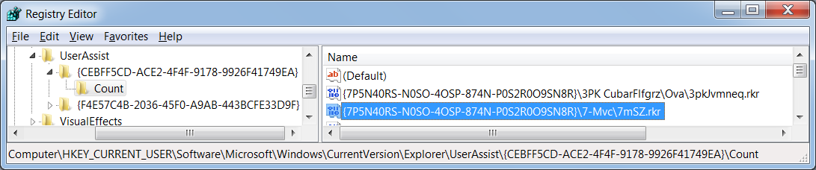
- Navigate to HCU\Software\Microsoft\Windows\CurrentVersion\Explorer\UserAssist. In the left pane, expand the UserAssist key. It has two or more subkeys with long names, as shown below on this page. Expand one of those subkeys, and select the Count subkey.

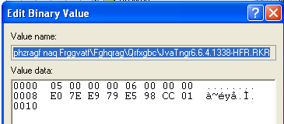
- On the right side, there are many values with long names. Double-click one of them, to open the "Edit Binary Value" box, as shown to the right on this page. The Value Name contains the name of an executable the current user has run, obfuscated with the ROT-13 method. Try to find a value with some backslashes in it, so it contains a complete path and filename.
- To deobfuscate the data, highlight the whole Value Name in the "Edit Binary Value" box, right-click it, and click Copy.
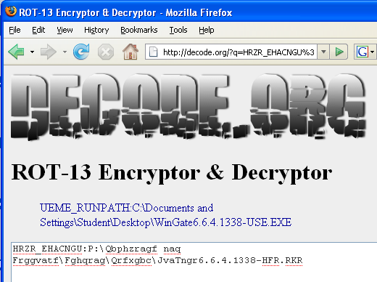
- Open Firefox and go to decode.org (if that page is down, just Google for "ROT13 Decoder and use another one).
- Paste the text into the box and click the Encrypt/Decrypt button.
- ROT13 encoder/decoded page and click the "Encode / Decode button".
- You should see a path, which may contain readable folder names as shown to the right on this page, or a long number (it's a GUID) in curly braces and an executable the user ran--in my example, it was WinGate.

Saving a Screen Image
- Make sure your screen shows a readable executable's path in the ROT13 Encryptor & Decryptor.
- Press the PrintScrn key. Open Paint and paste in the image. Save it with the filename Your Name Lab-Proj 6b.

Internet Explorer TypedURLs
- Navigate to HKCU\Software\Microsoft\ Internet Explorer\TypedURLs. The values here named url1, url10, etc. contain the Web addresses typed into Internet Explorer.
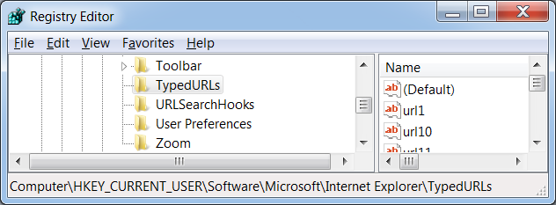

- On the right side, double-click one of the url values.
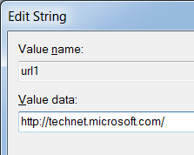
- An "Edit String" box opens, as shown to the right on this page. The Value data contains a URL in plain text.

Saving a Screen Image
- Make sure your screen shows a readable Web address in the "Value data" box.
- Press the PrintScrn key. Open Paint and paste in the image. Save it with the filename Your Name Proj 6c.

Turning in your Project
- Submit the images to: cms with a subject line of "Lab-Proj 6 From Your Name", replacing Your Name with your own first and last name.

Source:
"A Forensic Analysis Of The Windows Registry", http://www.forensicfocus.com/a-forensic-analysis-of-the-windows-registry

