Lab-Project 7: Thumbnail cache
What You Need for This Project
- A Windows Vista, or Windows 7 machine, real or virtual. It is better to use a Windows 7 VM. It is possible to do this project on Windows XP, but the thumbnail file is different and these instructions won't work.
- Students should do the Lab with Windows 10.
Purpose
You will create two images and delete one. Then you will recover evidence of both images from the Thumbnail Cache.
Creating Two Test Images
Open Paint. Click the pencil icon, and set the line width to the widest possible setting, as shown, e.g. below:
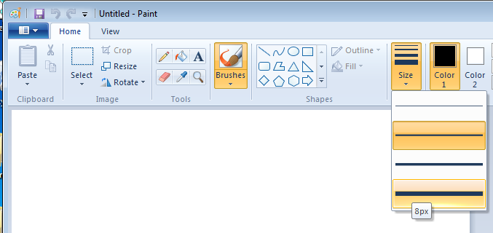
Write your name using the mouse, as shown, e.g. below. Use your own name.
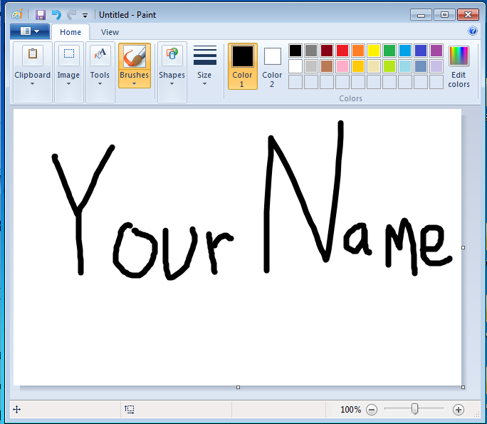
Save the file in your Pictures folder with the name "YOURNAME-p13a". Use your own name. Use a File Type of PNG.
Click the bucket tool, click any color, and paint the background some other color, as shown below. Make sure your name is still readable.
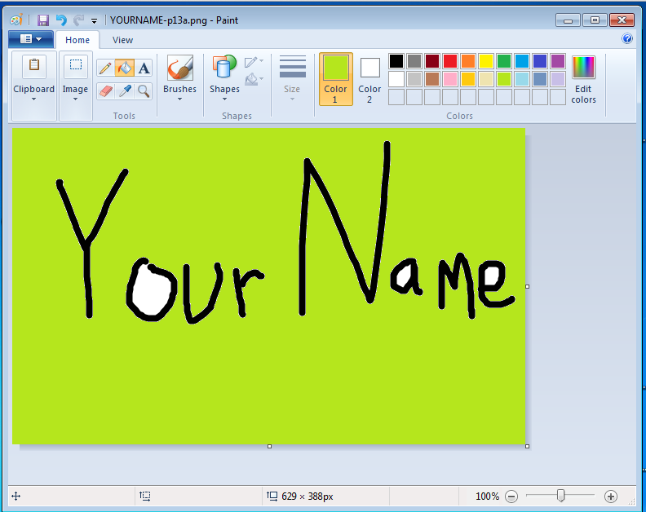
Save the file in your Pictures folder, or any other folder you can find, with the name "YOURNAME-p13b". Use a File Type of PNG.
Close Paint.
Click Start, Pictures.
You should see two thumbnail images of the two files you just made, as shown, e.g. below:
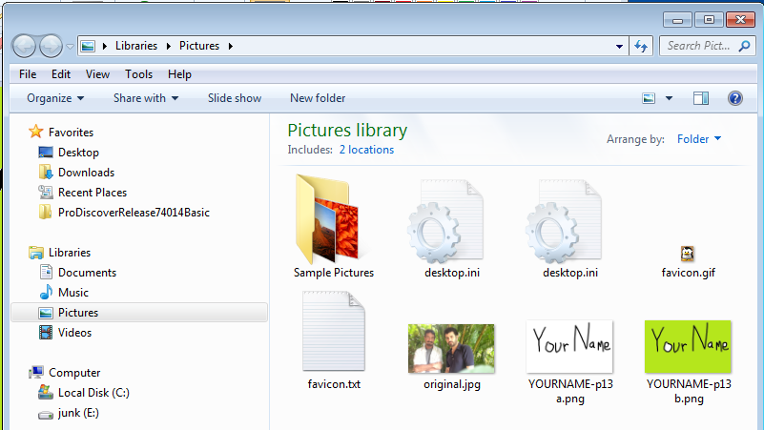
Drag the "YOURNAME-p13b" file into the Recycle Bin
Right-click the Recycle Bin and click "Empty recycle bin". Click Yes to confirm the deletion.
Viewing the Thumbcache Files
Click Start. In the upper right of the Start menu, click your logon name.
In your window, click Organize, "Folder and search options".
Click the View tab.
Make these two adjustments, as shown, e.g. below:
- Click the "Show hidden files, folders, or drives" button
- Clear the "Hide protected operating system files (Recommended)" box.
Click OK.
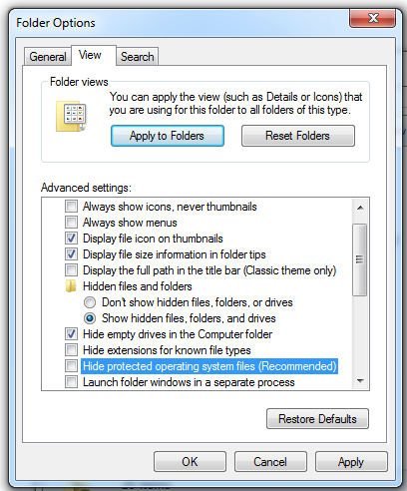
In your window, double-click AppData, Local, Microsoft, Windows, and Explorer.
You should see several "thumbcache" files, as shown, e.g. below.
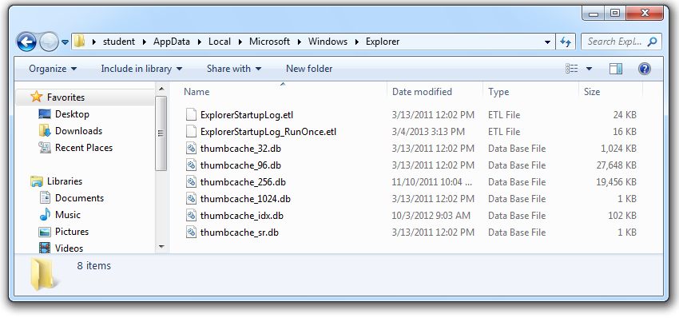
Getting Thumbcache Viewer
To view these files, open a Web browser and go to
https://code.google.com/p/thumbcache-viewer/
Click the Downloads tab.
Download the thumbcache_viewer.exe file and run it.
In "Thumbcache Viewer", click File, Open.
Navigate to C:\Users\Student\AppData\Local\Microsoft\Windows\Explorer and double-click thumbcache_256.db.
A list of files with long hexadecimal names appears, as shown, e.g. below:
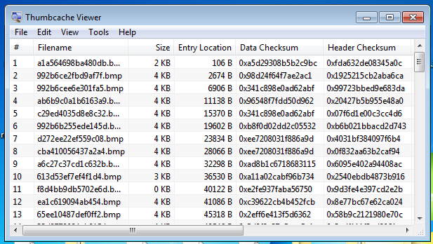
Many of the images have "Size" of zero. Click the gray Size column header to sort the list by size.
Click the largest image.
The image appears in Image Viewer, as shown, e.g. below:
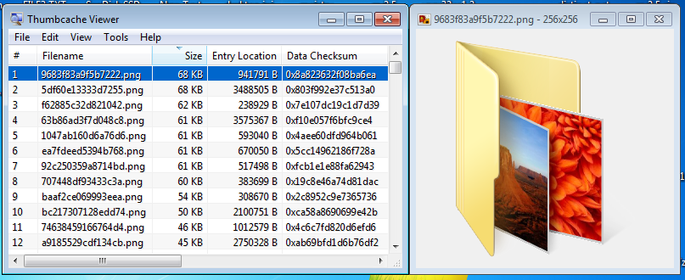
Press the down-arrow key to scroll through the images and find one with your name on it, as shown, e.g. below:
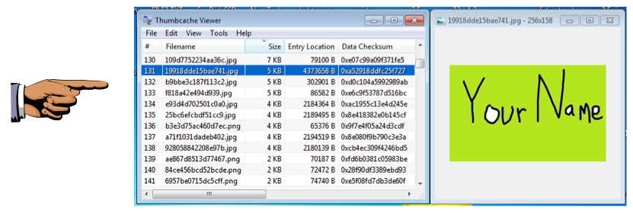
If you can't find the image, try the other thumbcache files.
Saving a Screen Image
Make sure your screen shows an image with your name on it.
Press the PrintScrn key in the upper-right portion of the keyboard. That will copy the whole desktop to the clipboard.
YOU MUST SUBMIT AN IMAGE OF THE WHOLE DESKTOP TO GET FULL CREDIT!
Open Paint and paste in the image.
Save the image with the filename "Your Name Lab-Proj 7". Use your real name.
Turning in your Project
Submit the images to: cms with a subject line of "Lab-Proj 7 From Your Name", replacing Your Name with your own first and last name.
Sources
http://escforensics.blogspot.com/2012/11/analyzing-thumbcache.html
https://code.google.com/p/thumbcache-viewer/
http://www.woanware.co.uk/?page_id=89
